Prediction of the In-Situ Shear Wave Velocity and Small Strain Shear Modulus using Consolidation Tests in Soft to Firm clays

**Sayed M. Ahmed**

Structural Engineering Department, Faculty of Engineering, Ain Shams University

1 El Sarayat St., Abbasseya, 11535, Cairo, Egypt

Email: sayed_mohamed@eng.asu.edu.eg

***Abstract* –** Theconsolidation test is one of the common laboratory tests in geotechnical investigations. It is the most acknowledged geotechnical laboratory test to assess the operative constrained modulus in clays. The moduli obtained from consolidation tests are utilized in the calculations of clay settlements under the loads of foundations and embankments. Recently, advanced numerical non-linear modelling become more common than ever in geotechnical engineering. The state-of-art advanced geotechnical analyses focus on consideration of the nonlinear variation of soil moduli with the stress and strain levels. One of the fundamental quantities in advanced non-linear geotechnical analyses is the small strain shear modulus. It is obtained by measuring the shear wave velocity using special tests or amendments to traditional tests. Such tests and/or amendments are generally much less common and more expensive than consolidation tests. In this paper, the shear wave velocity and small strain shear modulus of soft to firm clays are evaluated from results of consolidation tests. The site-specific constants that relate the void ratio to the in-situ shear wave velocity is attained from the undisturbed virgin compression curve acquired from a consolidation test. The in-situ shear wave velocities and small strain shear moduli are concluded from the water content measurements. The proposed approach is validated by analysing two well-reported case studies; namely Ariake and Singapore clays. The results of the analyses ensure the viability of the proposed approach as the estimated moduli compare favourably with the values inferred from the field measurements.

***Keywords*:** clay;consolidation test; shear wave velocity; small strain shear modulus.

# Introduction

Geotechnical design of foundations is largely controlled by the serviceability limit states. Hence, an accurate predictions of soil settlements due to the effect of loads is an indispensable undertaking in all engineering projects. Typically, the magnitude and rate of settlement in clays are estimated using consolidation tests that are conducted on undisturbed samples to determine the one-dimensional relationship that relates the void ratio (or, instead, the volumetric strain) to the vertical stresses acting on the laterally confined sample. Alternatively, soil stiffness is estimated using generic correlations with the penetration tests such as the CPT or SPT. Yet, several studies [1]–[3] have found that this typical task is more challenging than adopting these simple practices. Indeed, stiffness determined using conventional tests or correlations may yield inaccurate results for the following reasons:

* The stress-strain relationships for soils are commonly assumed as linear, despite, as a point of fact, these relationships are highly nonlinear.
* Influential soil characteristics such as granulometry, plasticity, mineralogy, state of in-situ effective stresses, anisotropy, aging, etc. may turn out to be distinctly different from those prevailing in the databases utilized to develop the utilized correlations. Each site is unique when the entirety of these factors is considered. Henceforth, site-specific correlations are in principle more reliable than generic correlations.
* Sample disturbances that occur during sampling and test preparation are practically inevitable.
* The stress path representing the effect of the structure/building may be entirely different from the stress path of the adopted lab or field test.
* The interactions of the interrelated factors affecting soil stiffness are vastly complex to be incorporated in geotechnical theories and formulations.

The previously mentioned considerations as well as the unprecedented recent developments in the computational geomechanics have been the main causes to utilize the nonlinear stress-strain relationships in geotechnical research and design. These relationships commonly utilize the small strain shear modulus *Go*, as a fundamental stiffness parameter, along with degradation functions that represent the reduction of the modulus with the strain level.

Jamiolkowski et al. [4] presented a special consolidation test in which the shear wave velocity is measured with the load progression. Shi and Lok [5] used similar apparatus in order to relate the shear wave velocity of reconstituted Macao marine clay to its void ratio. In this paper, the void ratio-vertical stress relationship resulting from the traditional one-dimensional consolidation test is utilized to determine the in-situ shear wave velocity and the small strain shear modulus as functions of the void ratio of the undisturbed clays.

# Methodology

## Formulation

The shear wave velocity *Vs* may be expressed as follows [6]–[8]:

|  |  |
| --- | --- |
| $$V_{sσ}=α∙{\left({σ_{a}^{'}}/{1 kPa}\right)}^{ β}$$ | (1) |
| $$V_{se}=a∙e^{b}$$ | (2) |

where *Vs* and *Vse* are the shear wave velocity estimates using the effective average stress * ’a* = (* ’v* +* ’h*)/2 = (1+*Ko*)* ’v* /2 and the void ratio *e*, respectively; the stresses * ’v*,*  ’h* are the effective vertical and horizontal stresses, respectively; the coefficient *Ko* is the at-rest coefficient of earth pressure.

The parameters ** ** *a* and *b* are the site-specific parameters. The site-specific parameters ** and *a* are related to ** and *b*, respectively, as follows [7], [8]:

|  |  |
| --- | --- |
| $$β=0.70-0.11\ln{(α})$$ | (3) |
| $$b=3.534-0.846\ln{(a)}$$ | (4) |

Eq. (3) represents the stress dependency of the shear wave velocity for lab tests in geomaterials [7]. Eq. (4) represents the general void ratio dependency for clays [8].

Accordingly, Eqs. (1) through (4) may be re-arranged as follows:

|  |  |
| --- | --- |
| $$V_{sσ}=580∙\exp{(-9.09 β)}∙{\left({σ_{a}^{'}}/{1 kPa}\right)}^{ β}$$ | (5) |
| $$V_{se}=65∙\exp{(-1.18 b)}∙ e^{b}$$ | (6) |

As *Vs* = *Vs*  = *Vse*, then following relationship between *e* and * ’a* can be put in the following form:

|  |  |
| --- | --- |
| $$e_{o}=I {\left({σ_{a}^{'}}/{1 kPa}\right)}^{-m}$$ | (7) |

where the void ratio exponent *b* is related to the exponent *m* and the parameter *I* as follows:

|  |  |
| --- | --- |
| $$b= {- 2.19}/{\left[1.18+9.09 m-\ln\left(I\right)\right]}$$ | (8) |

## Proposed Procedure

The following procedure is to be considered in order to determine the parameters *I* and *m* and hence, the void ratio exponent *b* can be estimated:

1. Draw the curve of *e*-log (* ’v*) as inferred from the consolidation test.
2. Draw the undisturbed virgin curve of *e*-log (* ’v*) to eliminate the effect of sample disturbance on the results in accordance with Schmertmann method [9].
3. Determine the coefficient of at-rest earth pressure *Ko,NC* for normally consolidated clay using an applicable correlation, such as the following correlation with the clay plasticity index *PI* as follows [10]:

|  |  |
| --- | --- |
| $$K_{o,NC}= 0.44+0.0042 PI$$ | (9) |

1. Estimate the average stress * ’a* = (1+*Ko*)* ’v* /2 and the void ratio *e* for the two points of the undisturbed virgin curve.
2. Estimate the parameters *I* and *m,* as defined inEq. (7), using the points of the undisturbed virgin curve.
3. Estimate *b* using Eq. (8).
4. Estimate the profile of the in-situ void ratio using the water content measurements *e*=*Gs wn* where *Gs* is the specific gravity and *wn* is the water content.
5. Estimate the shear wave velocity *Vs* using Eq. (6).
6. The small strain shear modulus *Go* can be estimated as follows:

|  |  |
| --- | --- |
| $$G_{o}= \frac{γ}{g} V_{s}^{2}$$ | (10) |

where ** is the soil unit weight and *g* is the gravity acceleration (≈ 9.81 m/s2).

# Validation case studies

## Ariake clay

Ariake clay is a soft and sensitive high plastic Holocene clay with a liquidity index that is generally higher than 100%. It is located around Ariake Bay, Kyushu Island, Japan. Ariake clay may be divided into two sublayers: the upper Ariake clay and the lower Ariake clay according to their geotechnical properties [11]. Fig. 1 shows the results of constant rate of strain (CRS) consolidation test conducted on a sample extracted from the upper Ariake clay. The virgin compression curve is also shown in Fig. 1 in accordance with Schmertmann [9].

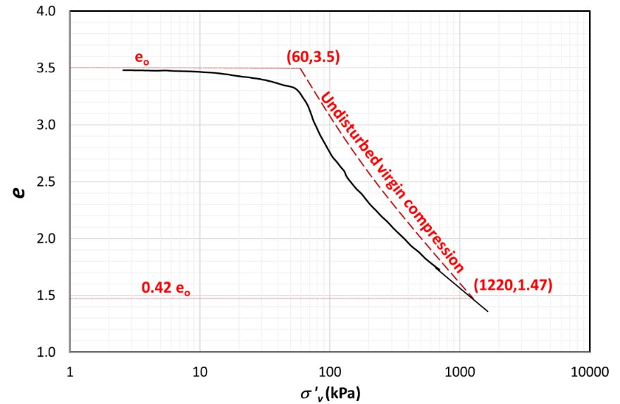

Fig. 1: Consolidation test results and undisturbed virgin compression for the upper Ariake clay.

Source of factual data: Tanaka et al. [11]

The plasticity index at the depth of the test is 69%. Hence the coefficient of at-rest earth pressure for the virgin curve *Ko,NC* = 0.73 in accordance with Eq. (8). The points of the virgin compression curve are used to obtain the parameters *I* and *m.* They were found to be 11 and 0.29, respectively. Hence, the void ratio exponent *b* equal to -1.54 in accordance with Eq. (8).

Using the void ratios that are inferred from the measured water contents the in-situ shear wave velocity and the small strain modulus are determined. The predicted small strain modulus is plotted versus the small strain modulus inferred from the shear wave velocity measurements in Fig. 2. A close agreement between the measured and the predicted small strain modulus is shown in that figure.

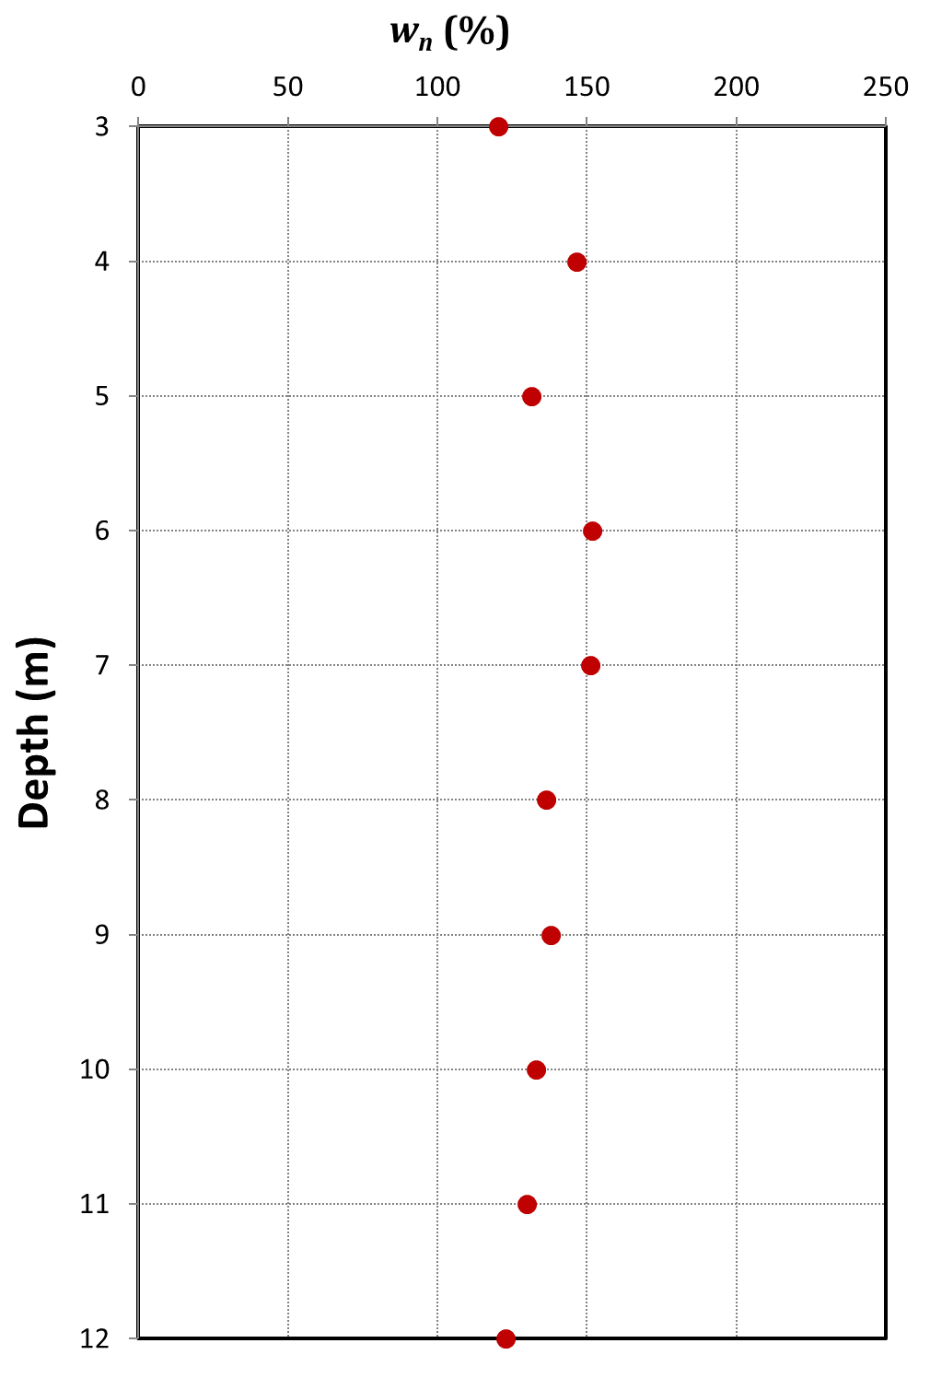 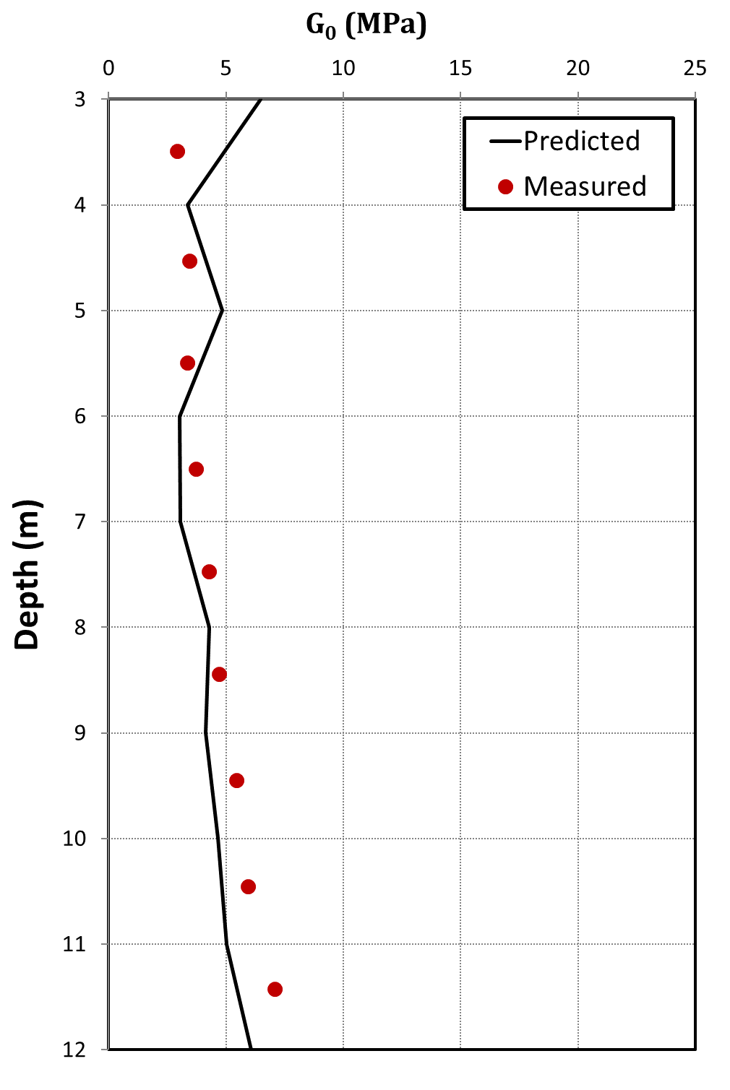

Fig. 2: Measured water contents and small strain shear modulus versus the predicted small strain shear modulus for the upper Ariake clay. Source of factual data: Tanaka et al. [11]

## Singapore clay

Singapore clay is a marine deposit that comprises two subunits; namely, an upper Holocene soft clay (known as the upper Singapore clay) underlain by a lower Pleistocene stiffer clay (known as the lower Singapore clay). A CRS consolidation test was carried out for the lower Singapore clay. The results of the test are shown in Fig. 3. The plasticity index at the depth of the test is 52%. Hence the coefficient of at-rest earth pressure for the virgin curve *Ko,NC* = 0.66 in accordance with Eq. (8).

The points of the virgin compression curve are used to obtain the parameters *I* and *m.* They were found to be 12.64 and 0.37, respectively. Hence, the void ratio exponent *b* equal to -1.1 in accordance with Eq. (8). Using the void ratios inferred from the measured water contents the in-situ shear wave velocity and the small strain modulus are determined. The predicted small strain modulus is plotted versus the small strain modulus inferred from the shear wave velocity measurements in Fig. 4. A close agreement between the measured and the predicted small strain modulus is shown in that Fig. 4.

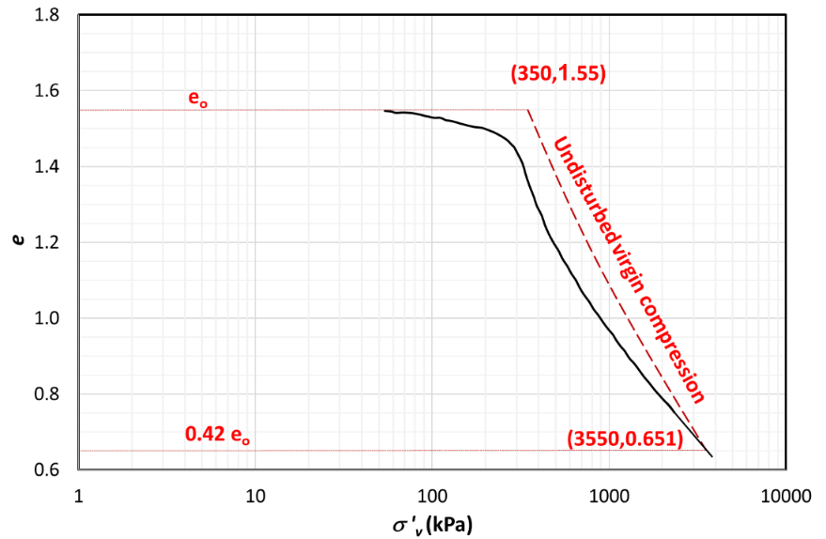

Fig. 3: Consolidation test results and undisturbed virgin compression for the lower Singapore clay.

Source of factual data: Tanaka et al. [11]

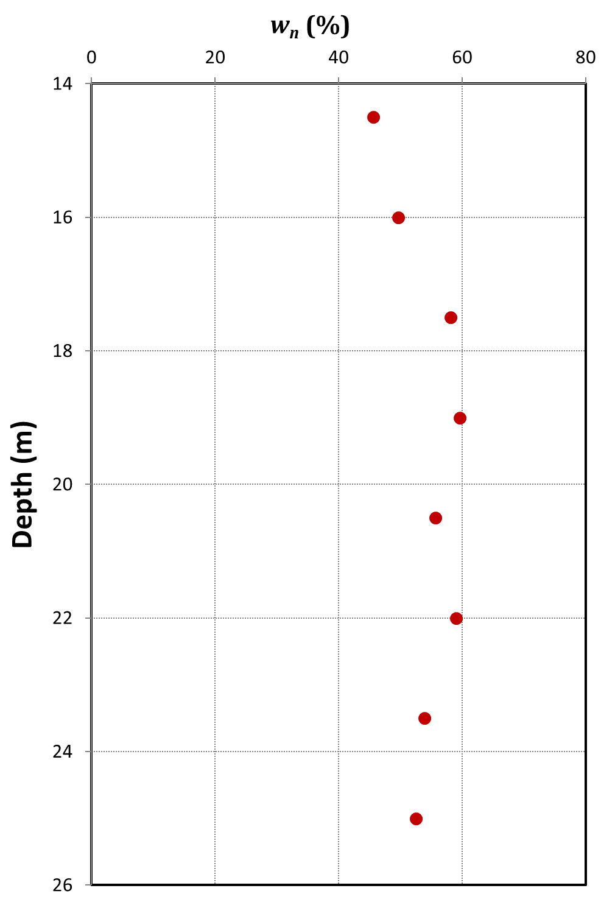 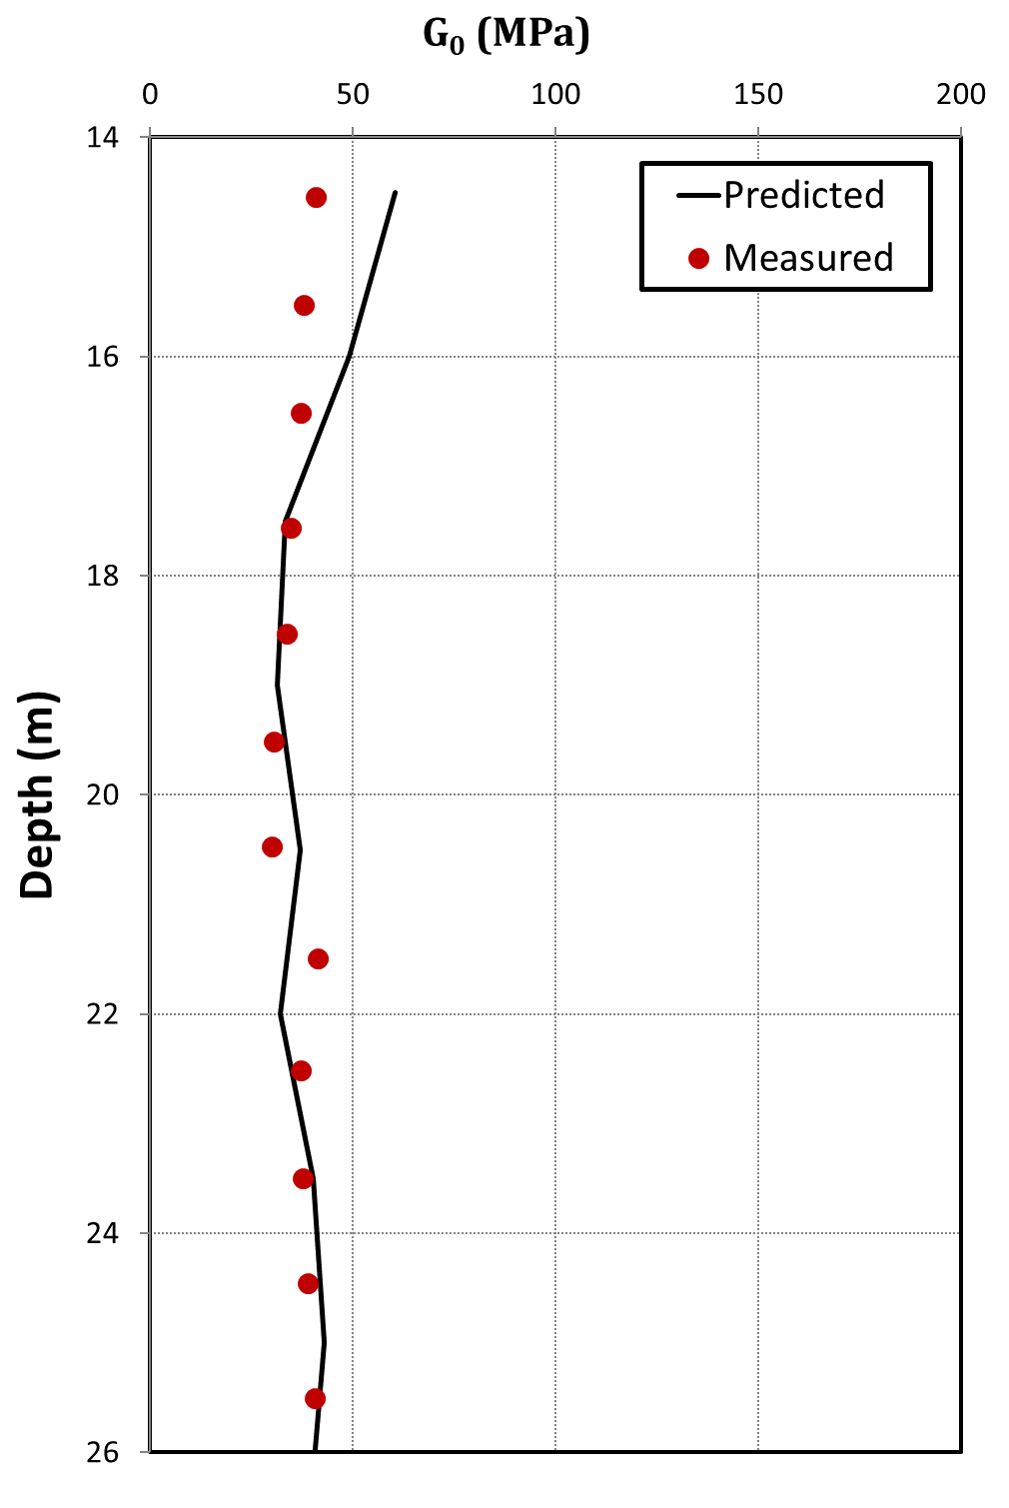

Fig. 4: Measured water contents and small strain shear modulus versus the predicted small strain shear modulus for the lower Singapore clay. Source of factual data: Tanaka et al. [11]

# Advantages and limitations of the proposed approach

The presented approach allows geotechnical engineers to broaden the conclusions drawn from consolidation tests carried out on soft to firm clays. A site-specific *Vs*-*e* relationship can be deduced from the test results in addition to the common quantification of the operative constrained modulus at different stress levels. The proposed analyses utilize the virgin compression curve, which required high quality undisturbed samples. Hence, low quality samples may yield unreliable results.

# Summary and conclusion

In this paper, a new approach is presented to link the results of consolidation tests to the site-specific parameters that relate the shear wave velocity to the void ratio. A power function linking the void ratio to the average effective stress is envisaged. The constants of the power function are determined using the undisturbed virgin compression odometer curve. Subsequently, the site-specific relationship between the shear wave velocity and the void ratio is determined. Moreover, the small strain shear modulus is determined from the inferred shear wave velocity.

Two case studies that were reported by Tanaka et al. [11] are analyzed to validate the proposed approach. The results of the analyses show a close agreement between the estimated small strain shear modulus values and the values inferred from field measurements of the shear wave velocity.

**References**

[1] R. J. Jardine, D. M. Potts, A. B. Fourie, and J. B. Burland, “Studies of the influence of non-linear stress--strain characteristics in soil--structure interaction,” *Geotechnique*, vol. 36, no. 3, pp. 377–396, 1986.

[2] J. B. Burland, “Ninth Laurits Bjerrum Memorial Lecture:‘ Small is beautiful’—the stiffness of soils at small strains,” *Can. Geotech. J.*, vol. 26, no. 4, pp. 499–516, 1989.

[3] H. G. Poulos and others, “Common Procedures for Foundation Settlement Analysis: Are They Adequate?,” in *Proceedings 8th Australia New Zealand Conference on Geomechanics: Consolidating Knowledge*, 1999, p. 3.

[4] M. Jamiolkowski, R. Lancellotta, and D. C. F. Lo Presti, “Remarks on the stiffness at small strains of six Italian clays,” in *Pre-failure deformation of geomaterials. Proceedings of the international symposium*, 1995, pp. 817–836.

[5] X. Shi and M. H. Lok, “Experimental study of variation of shear wave velocity of Macao marine clay during one dimensional consolidation,” in *17th International Conference on Soil Mechanics and Geotechnical Engineering*, 2009, pp. 377–379.

[6] J. C. Santamarina, K. A. Klein, and M. A. Fam, *Soils and waves: Particulate materials behavior, characterization and process monitoring*. J. Wiley & Sons, 2001.

[7] T. Ku, S. Subramanian, S.-W. Moon, and J. Jung, “Stress dependency of shear-wave velocity measurements in soils,” *J. Geotech. Geoenvironmental Eng.*, p. 4016092, Aug. 2016.

[8] S.-W. Moon and T. Ku, “Development of global correlation models between in situ stress-normalized shear wave velocity and soil unit weight for plastic soils,” *Can. Geotech. J.*, vol. 53, no. 10, pp. 1600–1611, Oct. 2016.

[9] J. H. Schmertmann, “The undisturbed consolidation behavior of clay,” *Trans. Am. Soc. Civ. Eng.*, vol. 120, pp. 1208–1216, 1953.

[10] K. R. Massarsch, “Lateral Earth pressure in normally consolidated clay, Design Parameters in Geotechnical Engineering,” in *7th European Conference of Soil Mechanics and Foundation Engineering*, 1979, vol. 2, pp. 245–249.

[11] H. Tanaka, J. Locat, S. Shibuya, T. T. Soon, and D. R. Shiwakoti, “Characterization of Singapore, Bangkok, and Ariake clays,” *Can. Geotech. J.*, vol. 38, no. 2, pp. 378–400, 2001.