May 20, 1986 Hualien Earthquake Time History Simulation Using EXSIM_V3

**Kristian Azul1**

1Institute of Civil Engineering, College of Engineering, University of the Philippines Diliman  
Diliman, Quezon City, Philippines

kmazul@up.edu.ph

***Abstract* -** Earthquakes are a natural phenomenon. Although historical studies are done extensively, it can only give us an approximate period when an earthquake source may produce another earthquake. Earthquakes can be very damaging depending on a lot of factors – earthquake source factors, source to site path factors, site factors and the structure itself. A simulation of the May 20, 1986 Hualien earthquake was done using EXSIM_V3 program. The program takes in data to describe the source parameters (fault size, orientation, etc.), path effect parameters, and site effect parameters to completely describe the earthquake record simulation. From the simulations, it was shown that the program was limited in simulating the recorded earthquake mainly due to the way the earthquake time record is shaped. The shape of the earthquake record is quite different and hard to simulate using the incorporated shaping method in the EXSIM_V3 program. Using the basic parts of the program to simulate the actual record proved to be difficult due to the previously mentioned reason. However, despite that, other parameters such as the frequency amplitude spectrum and response spectrum was approximated to a degree, when scaling methods incorporated in the program were used as well. 5 test simulations were done with the first 2 test simulations being the base simulations (i.e., no scaling was used to modify the output earthquake motion), while the other 3 simulations used the scaling methods to approximate specific target parameters (frequency content for simulation 3 and 4; response spectrum for simulation 5). Overall, the research shows that simulation of recorded motion is possible although limited by the program in some aspects, in this case, the shape of the earthquake record itself.

***Keywords*:** Earthquake, Simulation, Synthetic Earthquake, Response Spectrum

**1. Introduction**

The May 20, 1986 Hualien event was utilized as the event to be simulated for Taiwan. The earthquake and fault that generated it was well documented. Taiwan, in general, has more literature about certain parameters as well compared to the Philippines.

Chen and Wang (1986) stated that the earthquake occurred on May 20, 1986 at 5:25 GMT. Its location is 24.082°N, 121.592°E (located by Taiwan Telemetered Seismographic Network or TTSN), around 10 km north of Hualien City, thus the event name Hualien Earthquake [1]. Chen and Wang (1988) mentioned that the Surface Wave Magnitude (from USGS), MS, of the event is 6.3 [2]. This MS of 6.3 would translate to a MW of 6.3 as well based on the graph relating the different magnitudes to each other [3].

The recording station to be used is one located in the Lotung Large Scale Seismic Test (LLSST) site. The soil layer underlying the site must be modeled prior to simulation using EXSIM_V3 to include the site effect into the simulation. This was done in a previous paper.

**2. Review of Related Literature**

EXSIM_V3 is the main program used in simulating the earthquake event we are studying. EXSIM_V3 was made by Dr. Stephen Crane and Dr. Dariush Motazedian. EXSIM_V3 was derived from many different programs – some using point source modelling and some using finite fault modeling. A more detailed history of EXSIM_V3 can be found in the unpublished draft manual for EXSIM_V3. EXSIM_V3 uses Stochastic Finite-Fault Modeling (SFFM) to predict ground motions based on the characteristics of the source, path and site effects. The basic definitions of the variables can be found in the draft manual that came with EXSIM_V3, written by Dr. Stephen Crane and Dr. Dariush Motazedian [4] and will no longer be discussed in this paper.

After simulation of motion using EXSIM_V3, the motion will be sent down to the bedrock and through the site’s soil layer model using the EERA Program. EERA is a computer program used for Equivalent-Linear Earthquake Site Response Analyses of Layered Soil Deposit [5]. This program was developed from the same basic concepts as SHAKE [6], another program that has been around for some time and is commonly used as well. SHAKE has had a lot of newer versions too. Further details on the program, its theory and usage can be found in its manual and will no longer be discussed in this paper.

**3. Simulation Process**

First, EXSIM_V3 simulations were run using data gathered without using a site amplification file, thus assuming that the resulting simulation is on an outcrop. The simulations are then run through the soil layers using EERA and check whether the simulation’s topsoil counterpart is acceptable in comparison to actual record. If the result is unacceptable or can be improved, simulations were run again and certain parameters that can be adjusted are adjusted. Parameters that can be adjusted are stress input (to change the overall strength of the simulation result), minimum duration (to change the length of simulation and match the actual records’ duration), and low frequency scaling parameters (to change the frequency content to better match the original motion’s). If the result is acceptable, the graphs and processing of earthquake time history and response spectra are done and are compared to those of the actual records.

**4. EXSIM_V3 Input Parameters**

The EXSIM_V3 input parameters are discussed in the draft manual provided by Dr. Crane and Dr. Motazedian. The following parameter discussion will focus on parameters used and will no longer discuss how certain inputs are used by the program to keep discussion brief.

From Chen and Wang (1986) stated that the earthquake occurred on May 20, 1986 at 5:25 GMT. Its location is 24.082°N, 121.592°E (located by Taiwan Telemetered Seismographic Network or TTSN), around 10 km north of Hualien City, thus the event name Hualien Earthquake [1]. It’s focal depth 15.8 km and Signal Duration Magnitude, MD, is 5.9. The Seismic Moment, M0, is 2.5x1025 dyne-cm as estimated by USGS from long period surface [1]. From the Seismic Moment given, the Moment Magnitude, MW, was found to be almost 6.23 as computed from the relationship of Seismic Moment and Moment Magnitude [7]. Chen and Wang (1988) mentioned that the Surface Wave Magnitude (from USGS), MS, of the event is 6.3 [2]. This MS of 6.3 would translate to a MW of 6.3 as well based on the graph relating the different magnitudes to each other [3]. Kappa is suggested to be 0.03 [8].

From Chen and Wang (1986), the fault plane solution displayed a Thrust fault with a Strike of N35°E and a Dip of 60°SE. The fault has a length of 20 km and width of 25 km giving it an area of 500 km2 [1]. From the same paper, it was mentioned that the fault extends up to about 23km in depth. From the figures found in [1] and [2], the fault was mapped and idealized to be represented by a single straight fault line along with the epicentre of the motion. However, using the map and idealized fault trace created, it was found that the fault length is 22 km. From the fault length based on the idealized fault trace, width, and coordinates of start and end of the fault, we were able to create a model of the fault surface guided by the previous data that it extends to roughly 23 km in depth. From this, we also found that the upper edge of the fault is about 1.35 km from the ground surface. Using the idealized model of the fault and epicentre’s location, the hypocentre was located on the fault to be used as an input in the simulation.

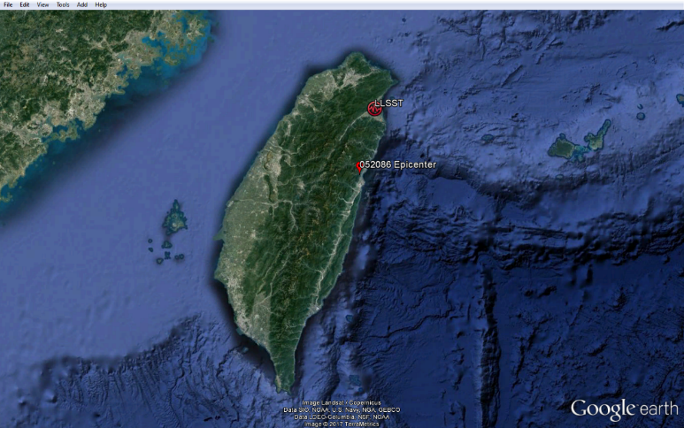

Figure 1: Map of Taiwan showing the Epicenter (red pin) and LLSST recording station (red circular logo with waveform).

[Map data: Google Earth; Image Landsat/Copernicus; Data SIO NOAA, U.S. Navy, NGA, GEBCO; Data LDEO-Columbia, NSF, NOAA; Image © 2017 TerraMetrics]

The depth of the event is 15.8 km [1] while Pezzopane and Wesnousky (1989) stated that the depth is 22 km [9]. However, upon constructing the idealized fault model, due to the idealization of the fault being planar, the depth became 19 km as shown in the idealized model below. The hypocenter location based on the fault model and 1 km subfault dimensions are (16, 21).

The input for the subfault length and width are both 1 km. However, the program does not necessarily use this but instead, divides the total length and width by the respective subfault dimension input, rounds down the result and uses that to divide the length and width evenly. With this in mind, after a preliminary run, the subfault length and width computed and used by the program is used again and the hypocenter location is adjusted as needed.

Other necessary values for the simulation are the shear wave velocity (β), density (ρ), ratio of rupture velocity to shear wave velocity (γ) and timestep (Δt). The values for the shear wave velocity (3.6 km/s) and density (2.8 g/cm3) are taken from Strong Ground Motion Source Scaling and Attenuation Models for Earthquakes Located in Different Source Zones in Taiwan by Sokolov et. al. (2006) [10]. The ratio of rupture velocity to shear wave velocity was taken to be 0.8 (the average value of the usual range of 0.7 – 0.9 from [11]) for simplicity. The timestep is the same as the time step of the actual record we got from Dr. Huang of Institute of Earth Science, Academia Sinica.

The geometrical spreading equations (R-b) follows a trilinear form (see Boore, 2003 [12]) with the b = 1 (for R < 50 km – 70 km), b = 0 (for 50 km – 70 km < R < 150 km – 170 km), and b = 0.5 (for R > 170 km), in general [10]. The same general form can be found in Sokolov, Loh, and Wen (2001) with a minor difference of the first segment applicable to R < 50 km [8]. For shallow earthquakes however, it was found that the form of the geometrical spreading having b = 1 (for R < 50), b = 0 (for R > 50 km) is suitable [10]. We employed the general equation with R boundaries at 50 km and 160 km, however, the effect will be the same as that of the form for the shallow earthquakes since any part of the fault will not be farther than 100 km to our observation site.

The quality factor function used is for shallow earthquakes is Q = 125f0.8 [8]. This is almost the same to the function Q = 120f0.8 prescribed for shallow earthquakes located to the east of the island [10]. From this data, we set the Qmin to be 0.

There is no available duration relation that follows the form used in EXSIM_V3 (generic form of [Minimum_Duration] + [Slope]*[Distance] but can account for pivots to become a piece-wise function) for our simulation case. The minimum duration value is adjusted accordingly to be able to get results comparable to the duration of the actual record also since the minimum duration will be affected by the size of the earthquake as empirical data has shown. The adjusted value of 15 is used for simplicity. As for the distance dependent property of duration, a study using the Chichi earthquake showed that the duration increases by 0.1 second for every km of distance [13]. Liu (2006) used the duration equation form found in Atkinson and Boore (1995) [14]. Since this is a path effect part of duration, it is possible to use this to complete the basic form of the duration equation for our simulation as well. Together, the 15 second minimum duration value and the 0.1 second increase per km gives a record just a few seconds longer than the actual.

For the crustal amplification files and values, since there is no literature stating what kind of bedrock is underlying the Lotung recording site, the site was assumed to have a NEHRP Type A Bedrock. Prior to the simulations, the soil layers on top of the bedrock underlying the site were already modelled. This was done in a previous paper.

One parameter to be adjusted is the stress drop that controls the levels of the spectrum in ranges usually greater than 1 Hz [15]. The range of stress drop for our event is ~65 bars to ~1100 bars considering the zone where Hualien is. The range for the Northeast Seismic Zone (Ilan-Hualien offshore source area) is determined from the equation 1 [16] below and from the data of the seismic moment being 2.5*1025. The same range can be seen if we use an M of 6.3 and compute the seismic moment based on the relation from EXSIM_V3 manual.

|  |  |  |
| --- | --- | --- |
|  |  | (1) |

For Bedrock A simulations, the stress used is 350, after several trials using the Test 01. The stress used was determined by trial and error until the simulation closely resembled the part of the actual time record that is considered. The low-frequency scaling values used are shown in the table below.

Table 2: Summary of stress value and low-frequency scaling parameters used for Hualien Bedrock A simulation.

|  |  |
| --- | --- |
| Bedrock A | |
| Stress (bars) | 350 |
| Test Case Input:  Low-Frequency Scaling, Low-Frequency Scaling Value, LowTaperStart, LowTaperEnd | |
|
| Test 01 | 0 , 1.00 , 0.10 , 0.10 |
| Test 02 | 2 , 1.00 , 0.10 , 0.10 |
| Test 03 | 2 , 5.00 , 0.30 , 1.20 |
| Test 04 | 2 , 3.50 , 0.20 , 3.00 |
| Test 05 | 2 , 5.00 , 0.20 , 1.80 |
| Test 06 | 2 , 5.00 , 0.20 , 3.30 |

The first 2 cases are what can be considered as base test simulations. Test 01 uses the Filter Function that aims to correct for the division of subfaults by the program. Test 02 uses the Empirical Function but with a multiplier of 1 in a non-existent frequency range (0.10 – 0.10). This serves as our guide in amplifying the frequency content for the next test cases. Test 03 to 06 utilizes the input of both test 01 and 02 (since only the scaling method differed in the first 2 cases). Test 03 to 06 can be thought of variations of test 02 where the scaling parameters are changed to achieve certain properties desired. Test 03 and 04 aim to approximate the frequency content (especially in the low frequencies as shown in the Fourier Amplitude Spectrum or FAS) of the EW and NS actual records, respectively. Test 05 is an attempt to get a result with an acceleration response spectrum that is in between that of the EW and NS absolute acceleration response spectrum. Test 06 is just like test 05 but it is an attempt to envelope the acceleration response spectrum this time.

**5. Test Case Results**

For the graphs that follow, the blue graphs are of the actual records while the red graphs are of the simulation discussed.

**5.1. Hualien Test 01 [And Test 02]**

Test 01 is the base test case and no amplification was applied other than the correction done by the Filter Function. As seen, there is a big deficiency in the frequency content in the low frequency range. The effect is seen as well in the responses as they, too, have significantly lower values at low frequencies. As seen, it is not possible to get the same shape as that of the actual record in this event as the actual record contains a very narrow peak, which can be considered to be more of a sudden spike, rather than the usual build up and decay of motion. As such, the starting values used for the simulation were such that the shape of the simulation approximated the actual record but disregarding the sudden spike. Test 02 yielded results very similar to that of test 01, and thus will no longer be discussed separately. As shown in the following graphs.

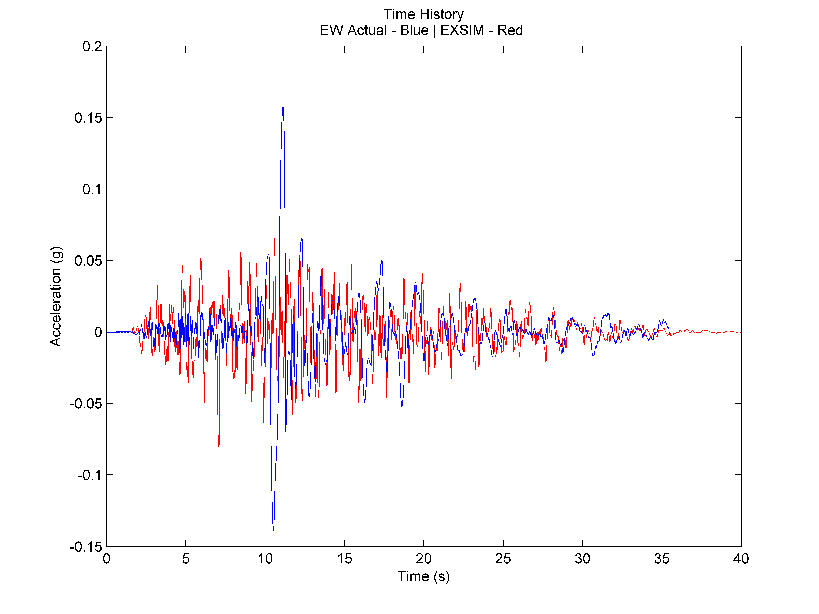 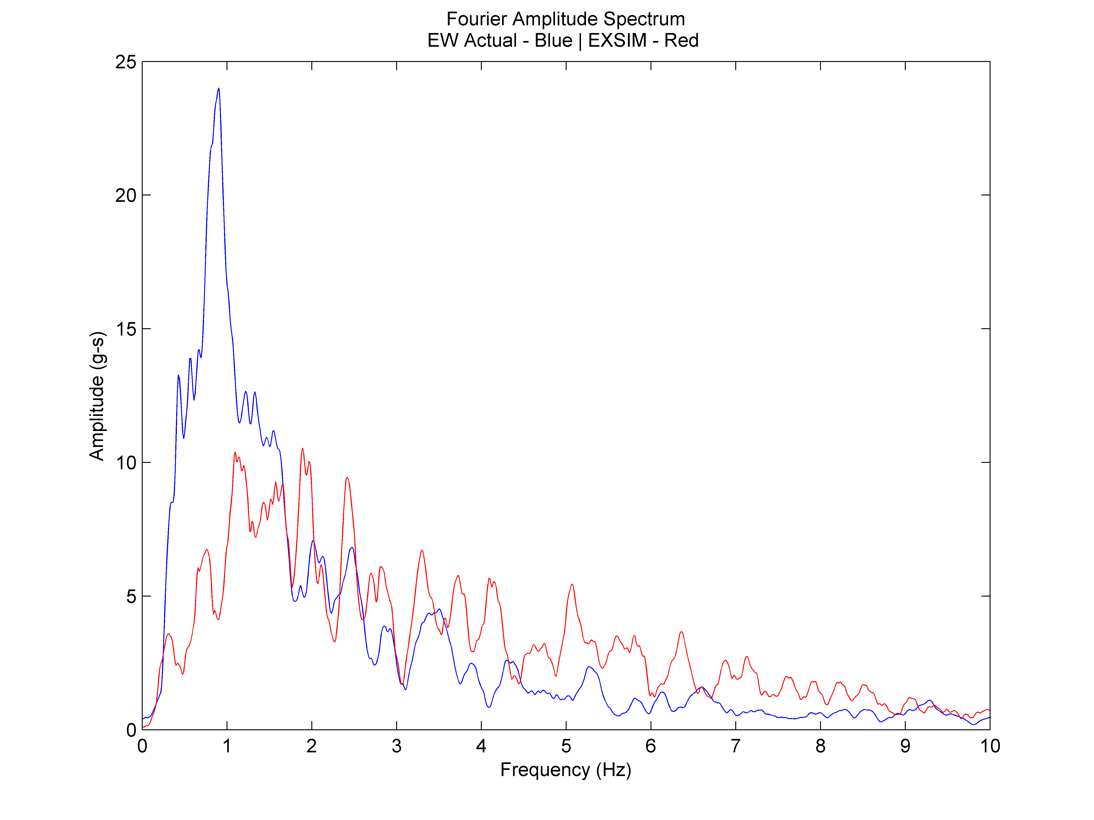 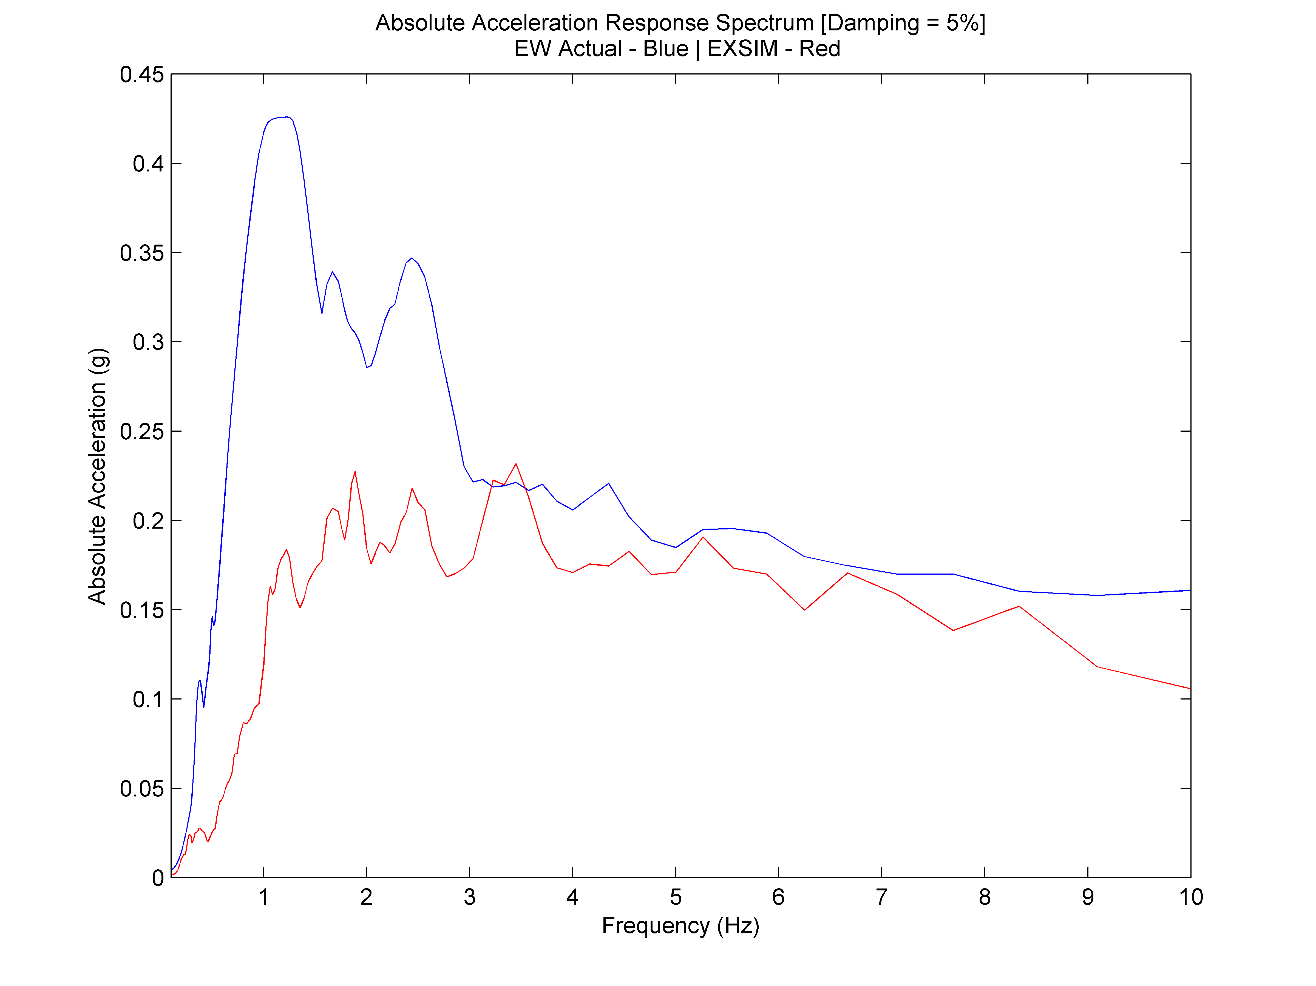

Figure 5: Actual Record (EW) VS Simulation: Time History (Left); FAS (Middle); Absolute Acceleration Response Spectrum (Right)

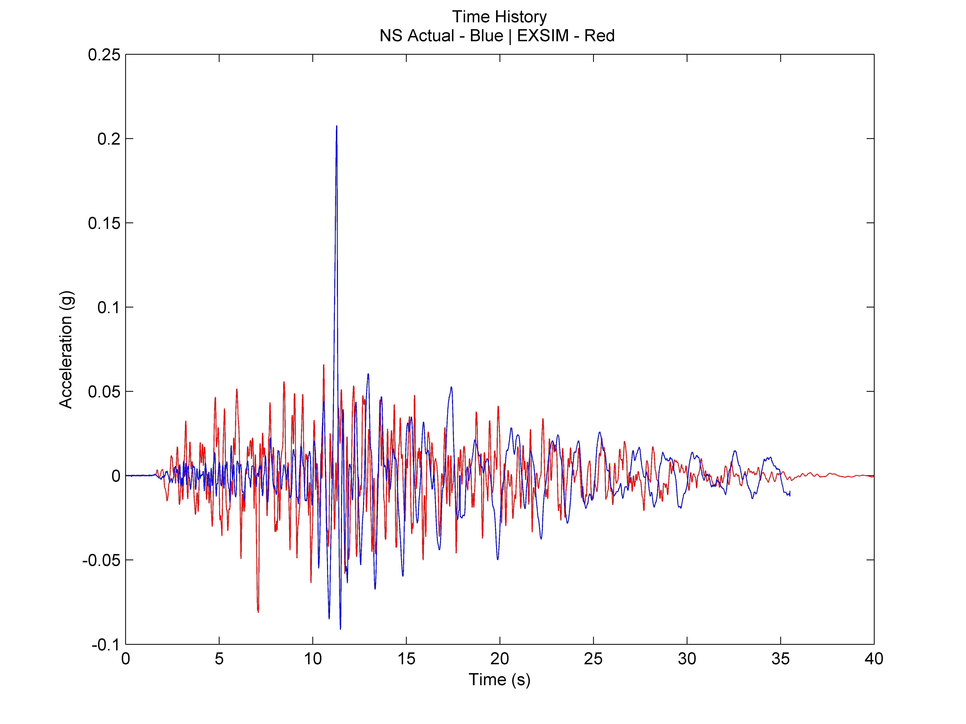 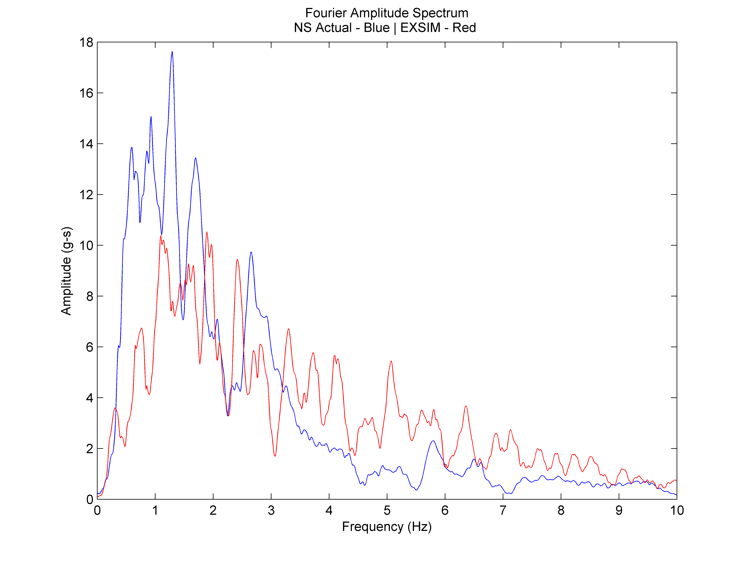 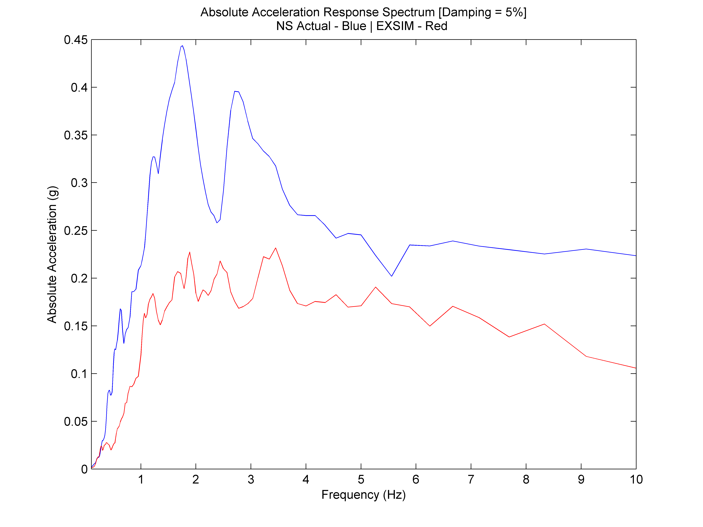

Figure 5: Actual Record (NS) VS Simulation: Time History (Left); FAS (Middle); Absolute Acceleration Response Spectrum (Right)

**5.2. Hualien Test 03**

Test 03 aimed to approximate the FAS in the low frequency range of the EW actual record. Despite applying scaling parameters to match the Fourier amplitude spectrum, the shape of the time history is not altered so much but an increase in peak values can be seen such that the envelope of the simulated motion is larger than the envelope of the actual time history record.

As can be seen in the graphs that follow, test 03 was amplified such that more of the amplitudes in the low frequency range is captured and match that of the EW actual record’s FAS. However, it can be seen that the peaks are ”shifted” from the actual record’s and despite using the maximum allowable scaling value, it is not enough to capture the height of the FAS of the actual record.

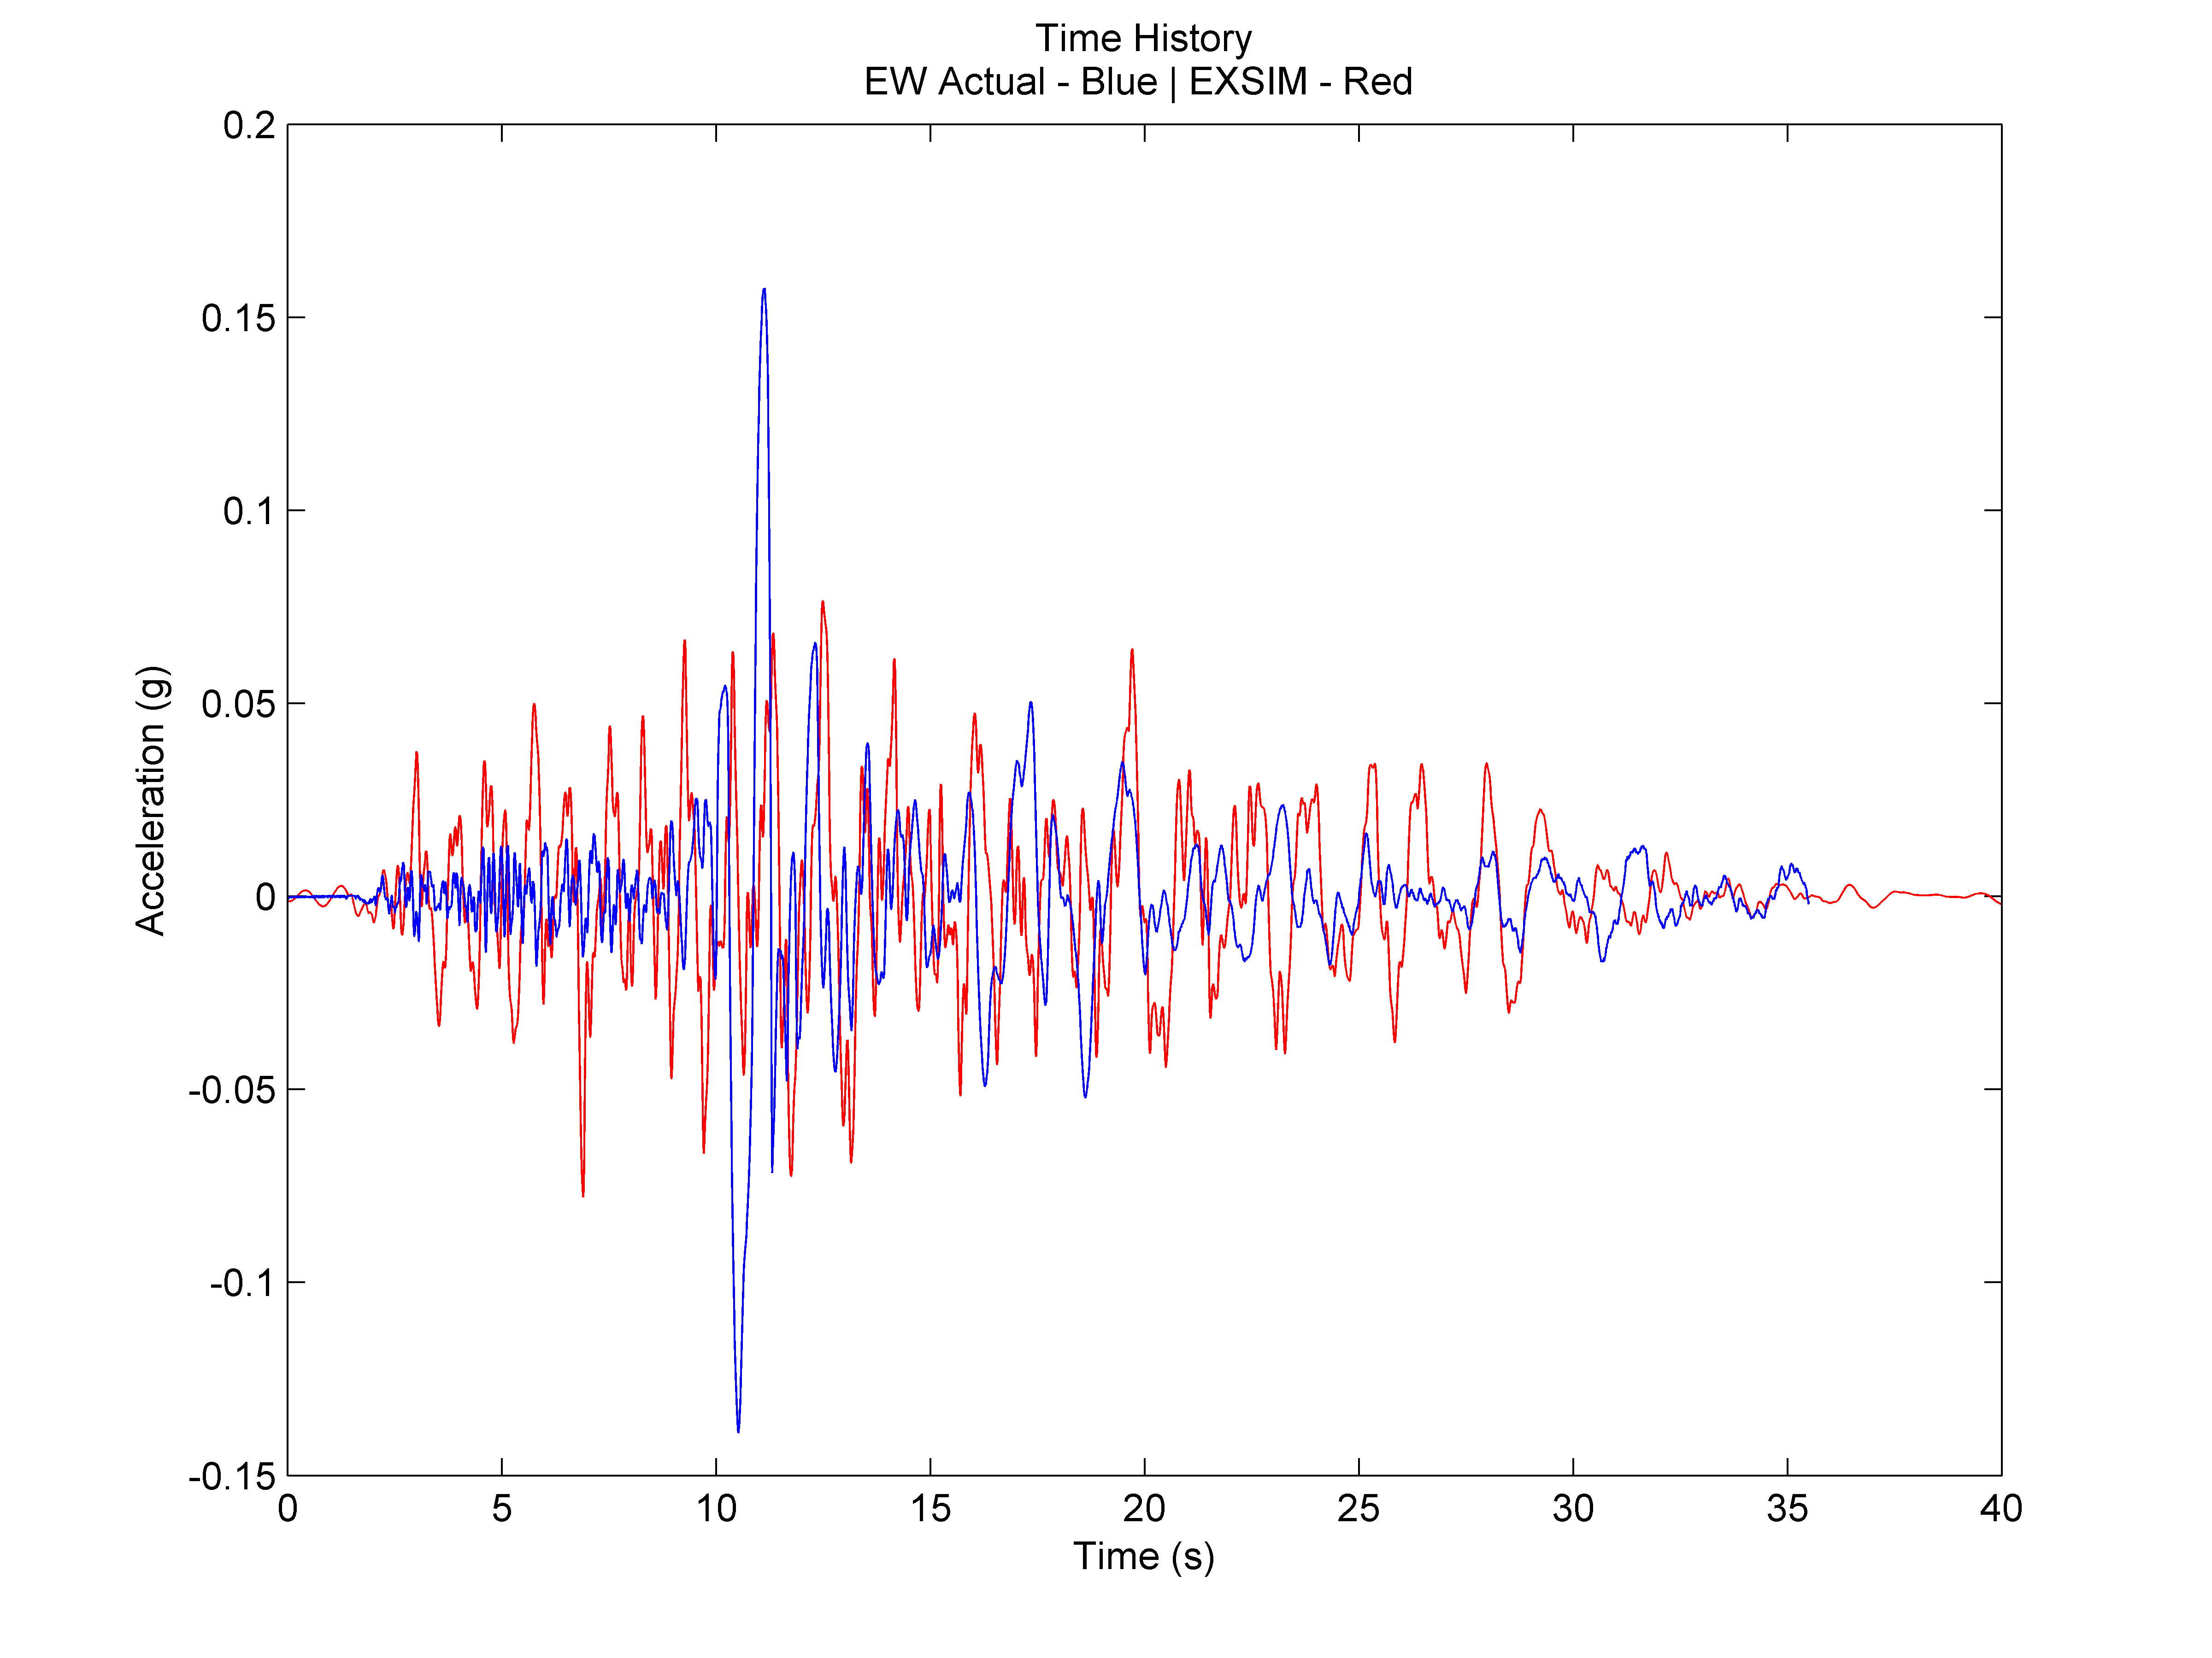 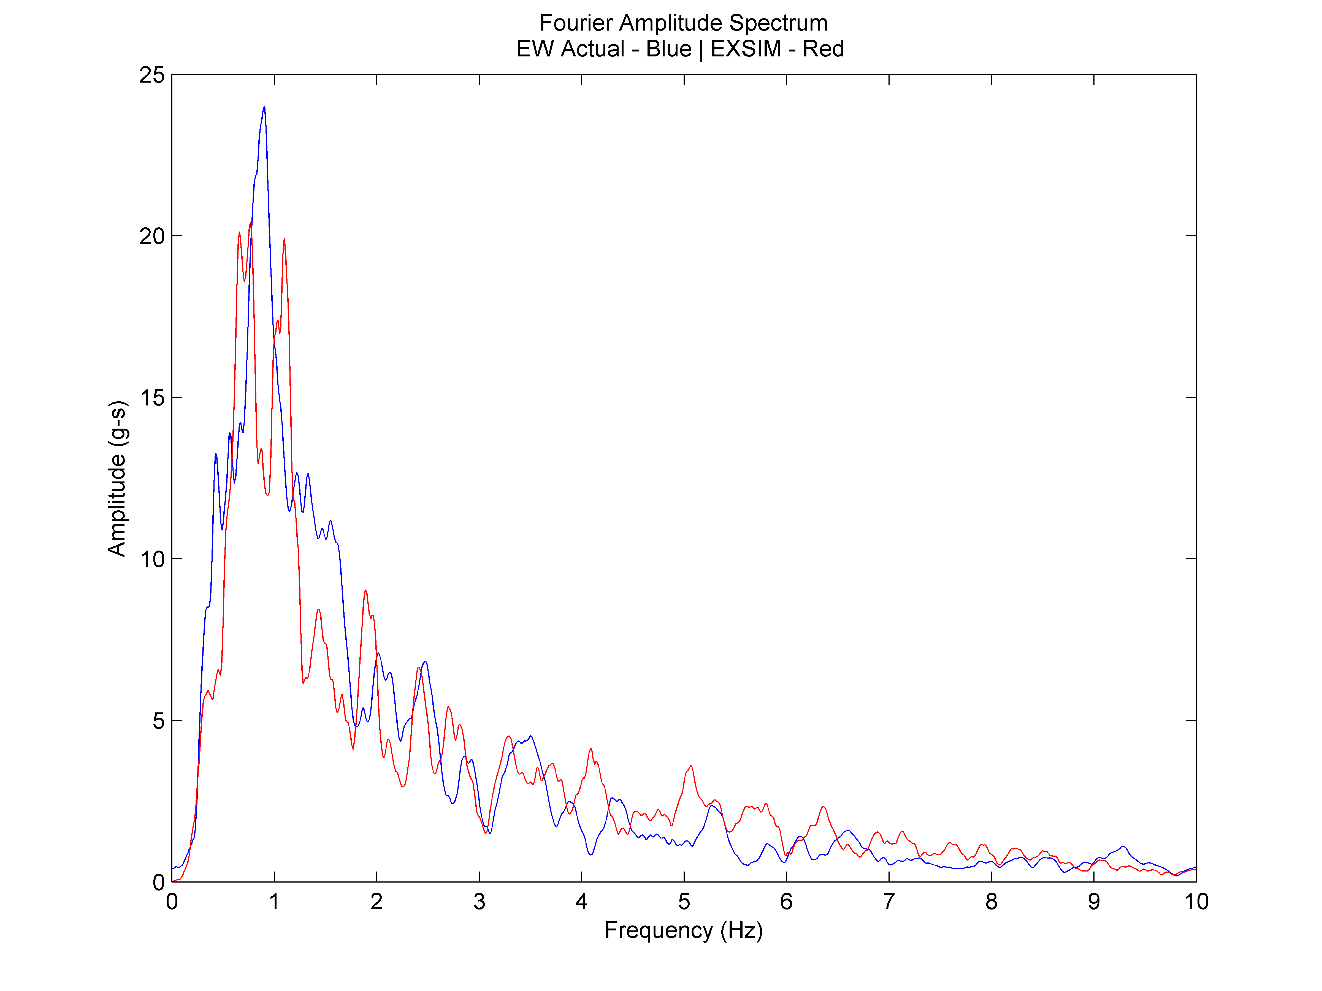 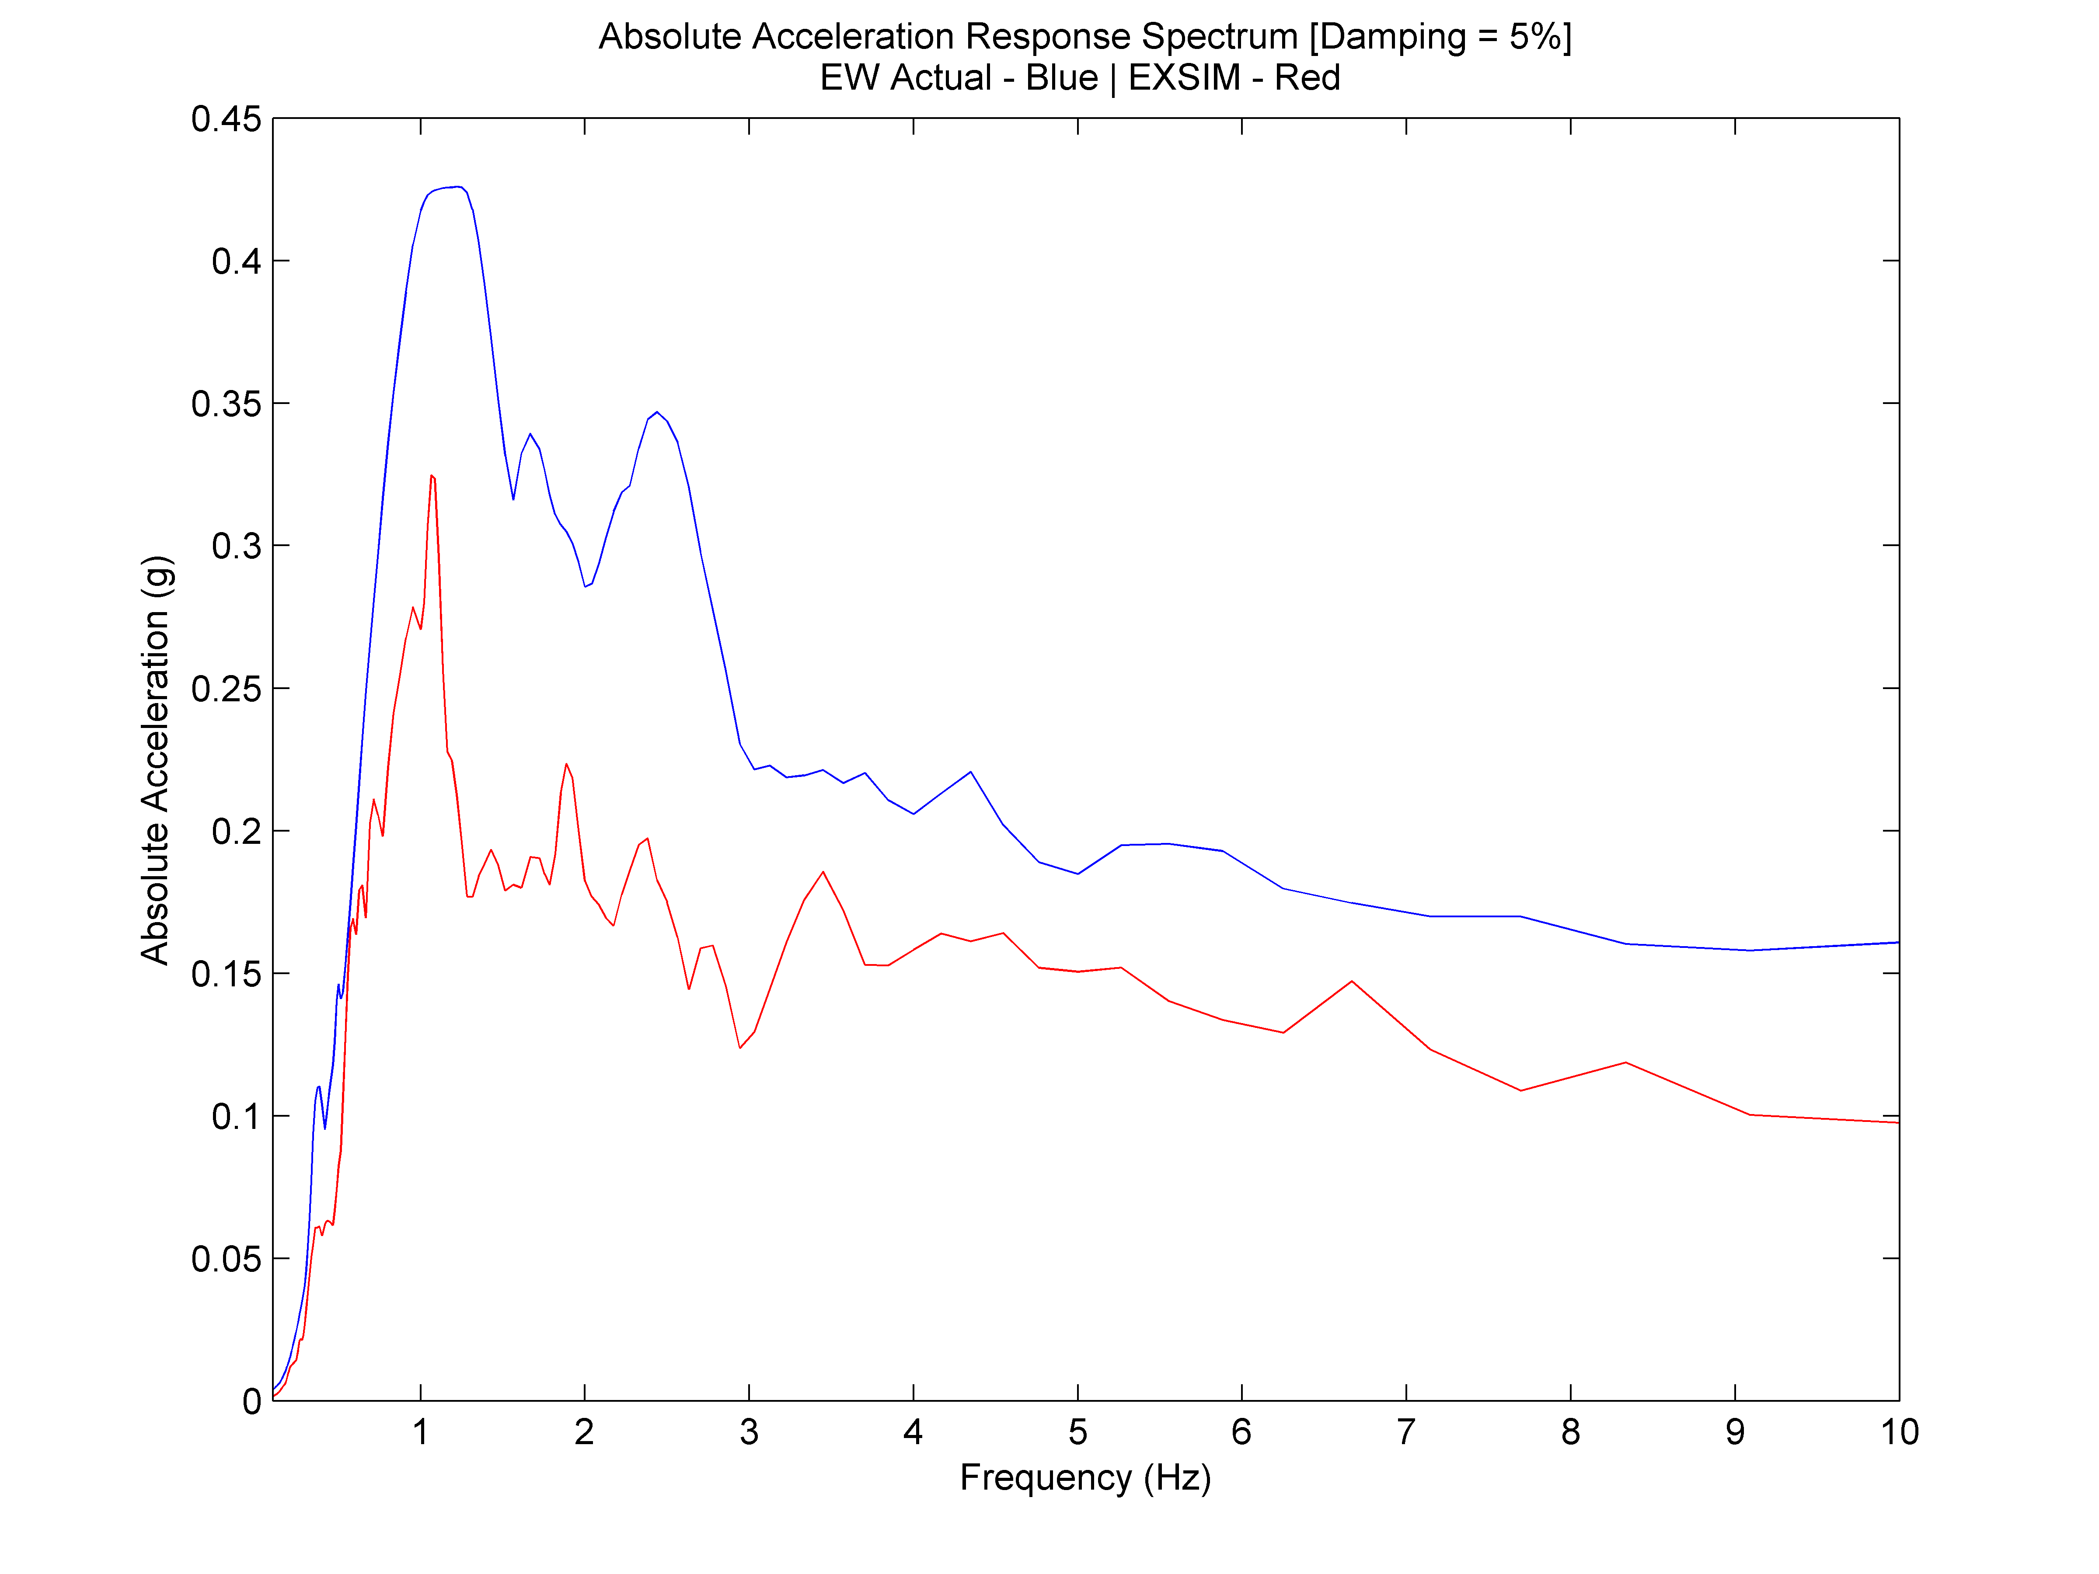

Figure 5: Actual Record (EW) VS Simulation: Time History (Left); FAS (Middle); Absolute Acceleration Response Spectrum (Right)

**5.3. Hualien Test 04**

Test case 04 aimed to approximate the FAS in the low frequency range of the NS actual record. The time history envelope of the simulated motion is still larger than the time history shape of the actual record due to the applied scaling parameters.

The FAS of the NS record is better approximated by test case 04 as seen below. This simulation was able to capture the NS actual record’s FAS compared to that of the one trying to capture the EW motion. This is due to the fact that the Fourier amplitude values of the NS actual record is smaller than that of the EW actual record. However, the problem of not having the “shifted” peak locations is still there.

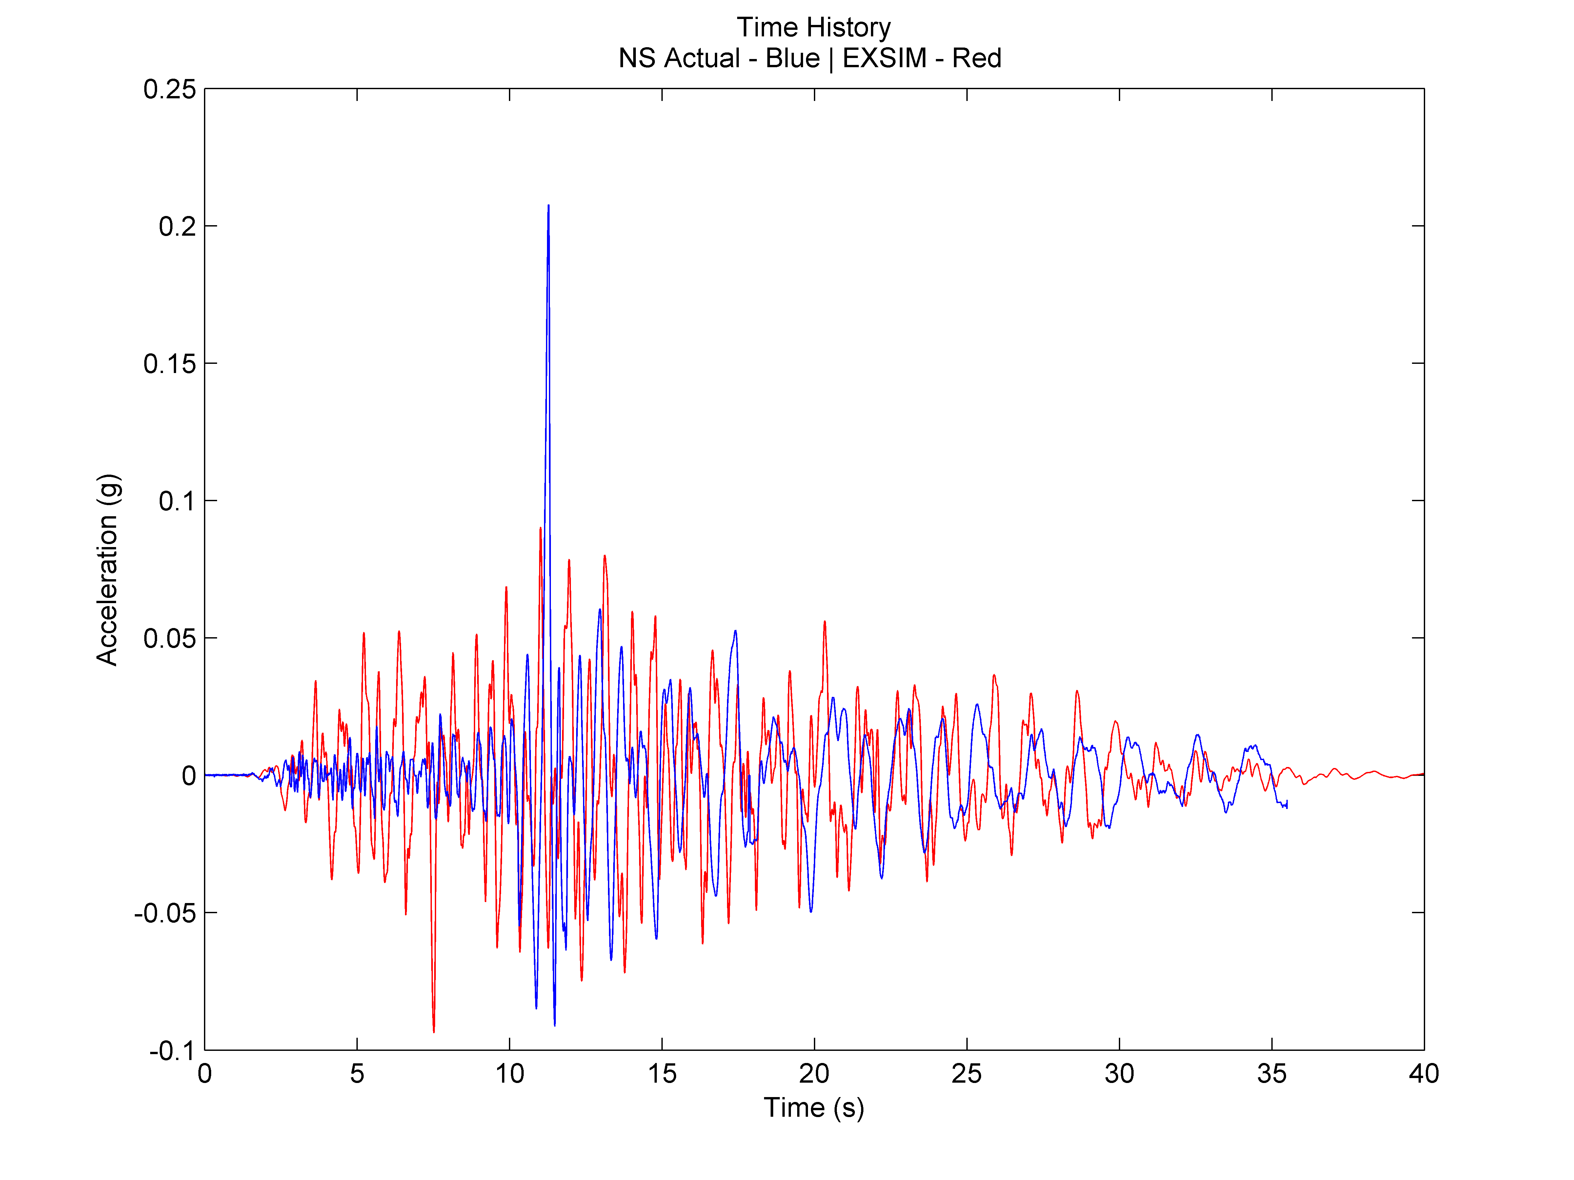 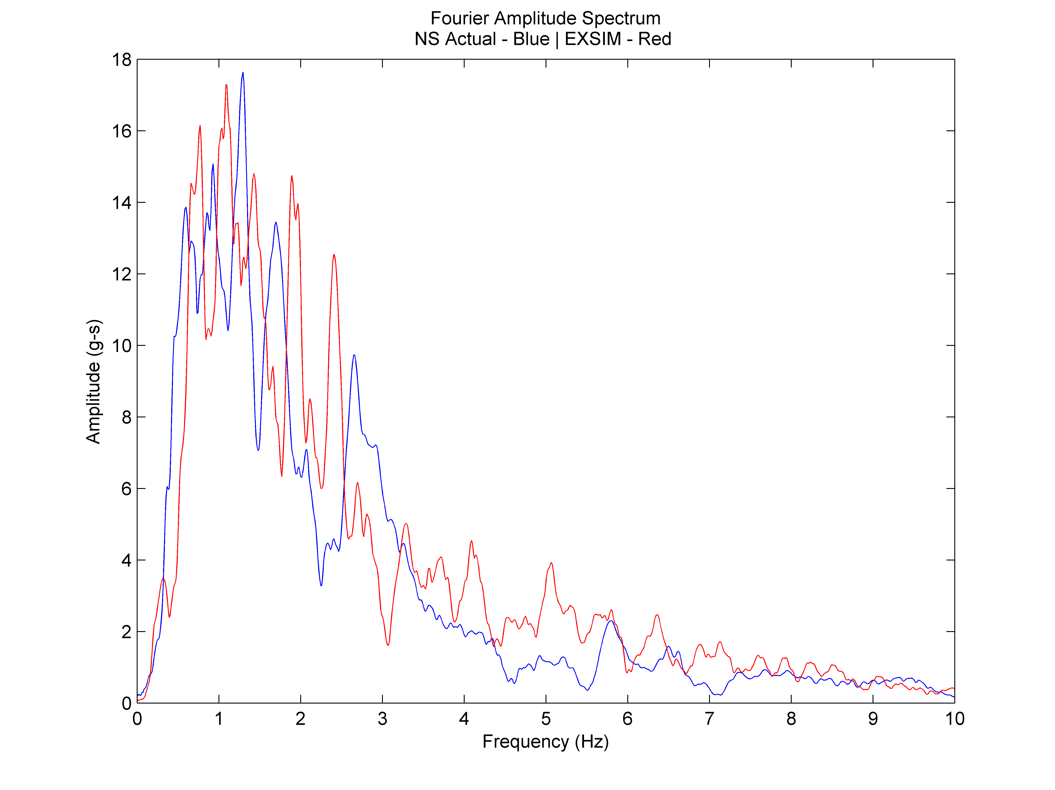 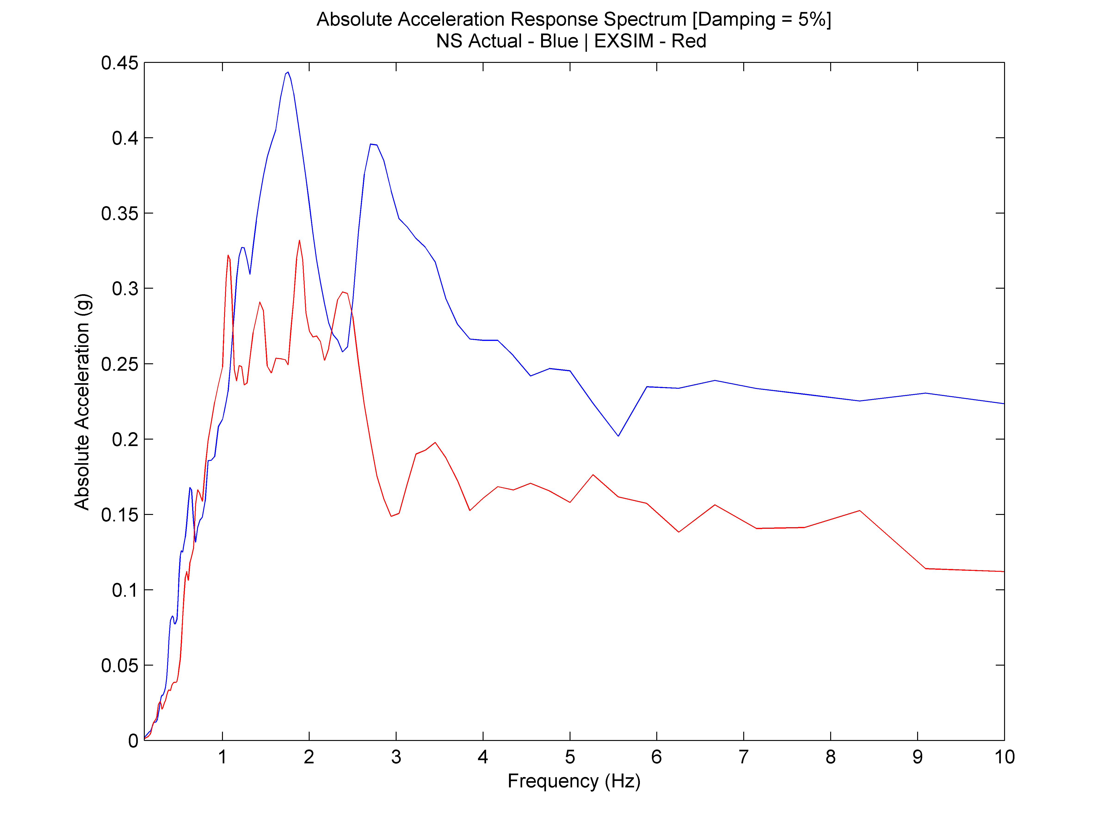

Figure 6: Actual Record (NS) VS Simulation: Time History (Left); FAS (Middle); Absolute Acceleration Response Spectrum (Right)

**5.4. Hualien Test 05**

As it was not possible to approximate both EW and NS record’s absolute acceleration response spectrum easily as they have different peaks, the simulation was aimed to have an absolute response spectrum that is somewhere in between the 2 records’ absolute acceleration response spectrum. The FAS of test case 05 can be seen as somewhat being in between the FAS of the EW and NS actual records.

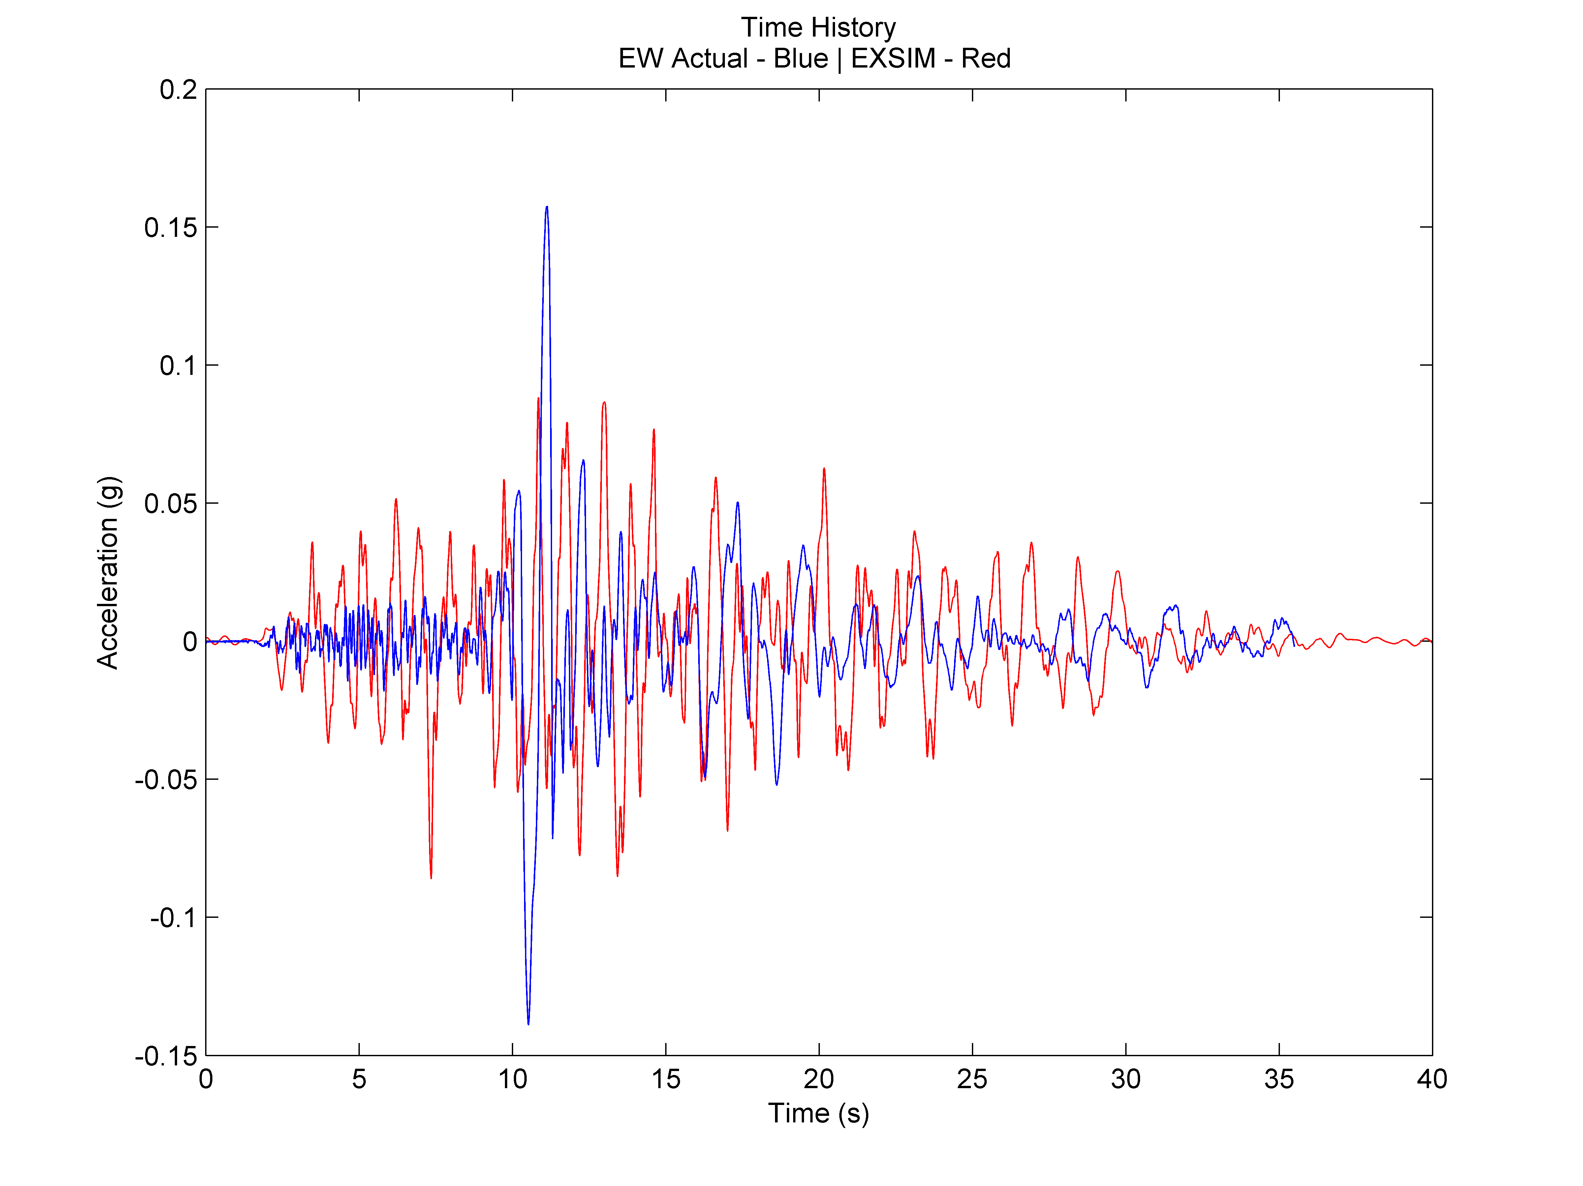 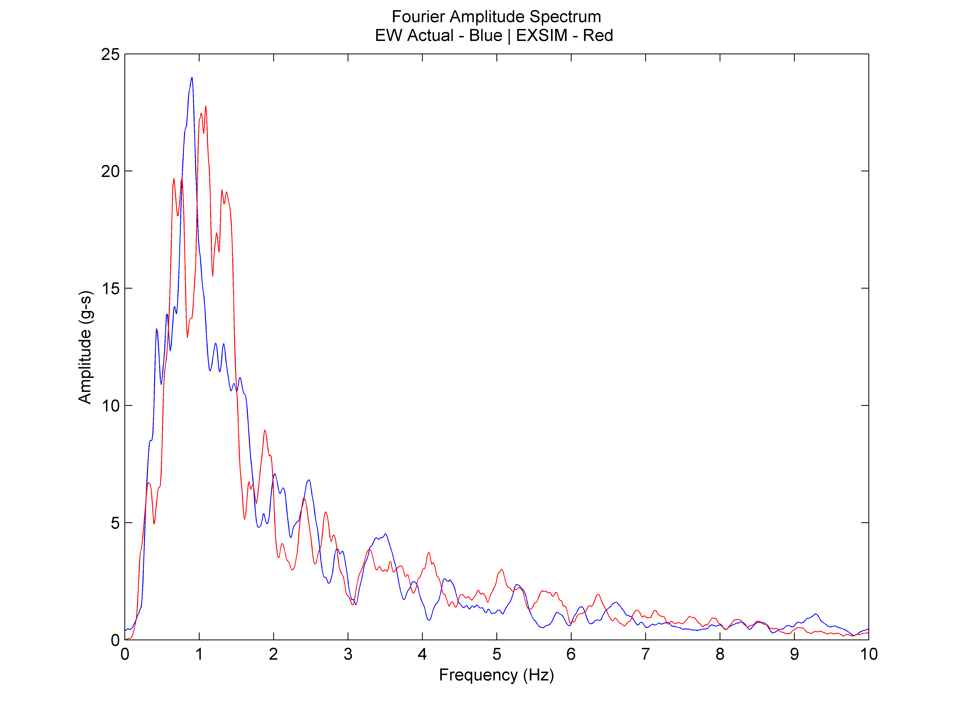 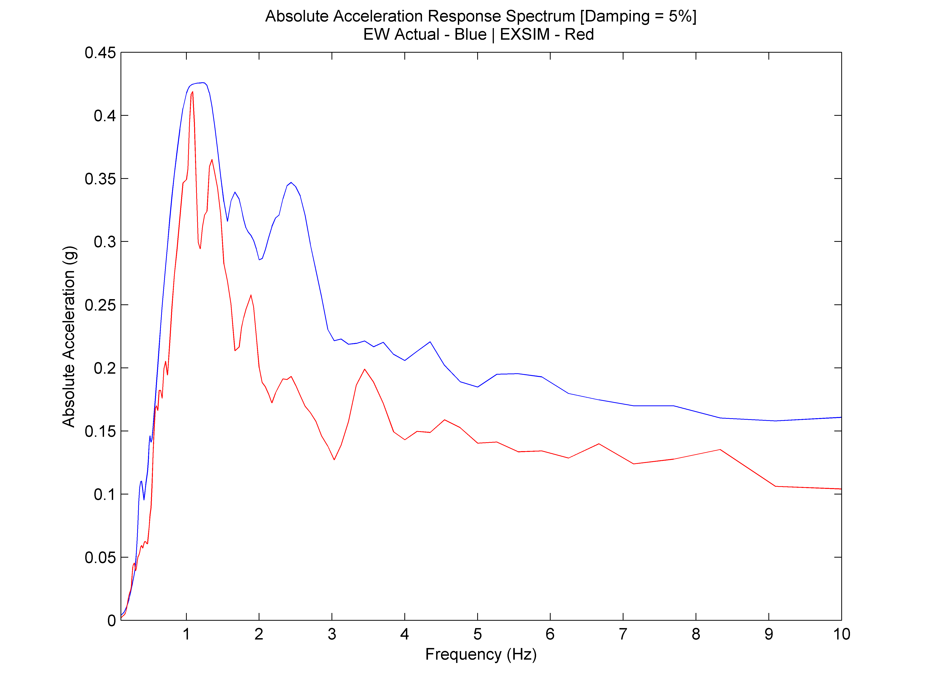

Figure 5: Actual Record (EW) VS Simulation: Time History (Left); FAS (Middle); Absolute Acceleration Response Spectrum (Right)

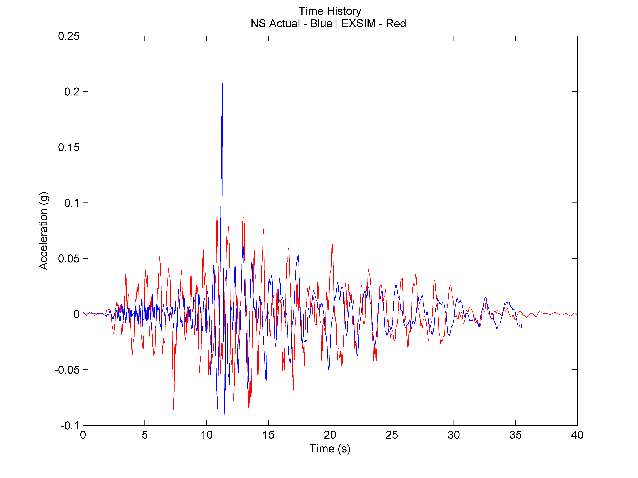 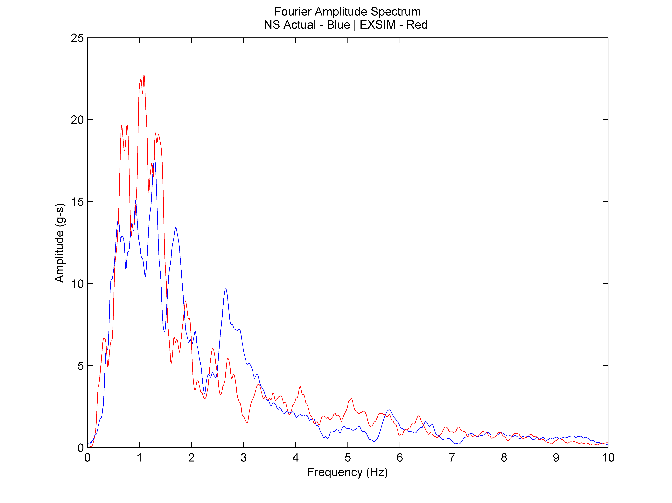 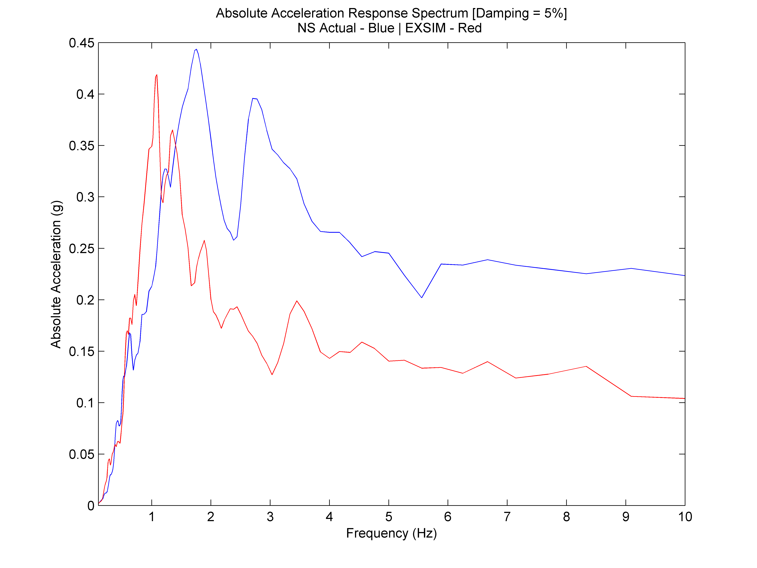

Figure 5: Actual Record (NS) VS Simulation: Time History (Left); FAS (Middle); Absolute Acceleration Response Spectrum (Right)

**6. Conclusion**

Based on the literature about the May 20, 1986 Hualien earthquake event, we were able to simulate the earthquake using the program EXSIM_V3. However, due to the shape of the time history of the earthquake event, simulation of it is not the best. Also, it required amplification in certain frequency ranges for the Fourier amplitude spectrum to be approximated to a degree (since the peaks do not exactly match that of the original earthquake time history). This was easily accomplished using the scaling routines included in the EXSIM_V3 program used. Overall, simulation of an actual record can be done using EXSIM_V3 with a certain degree of success depending on the data available for simulation, as well as some factors related to the limitation of the program – in this case, the capability to shape the simulated motion similarly to our actual record. This becomes a limitation in recreating actual records as some records do not fit the typical shape of an average earthquake which is employed in the program. Because of these limitations, a similarity in the frequency content of the simulation to the actual record is not a good indicator that other characteristics of interest – like the response spectrum – is going to be similar as well. However, it was shown that when targeted to be approximated separately, it is possible to create a simulation with frequency content or a certain response spectrum similar to that of the actual records.

**Acknowledgements**

I would like to acknowledge and thank Dr. Win-Gee Huang and Institute of Earth Science, Academia Sinica for providing the data I worked with for the May 20, 1986 Hualien earthquake. I would like to thank Ms. Li-Mei Chen, senior librarian of Institute of Earth Science of Academia Sinica, for helping me obtain precious and very vital journal papers for my research.

I would like to acknowledge and thank the Office of the Chancellor of the University of the Philippines Diliman through the Office of the Vice Chancellor for Research and Development, for funding support through the Thesis and Dissertation Grant.

I would like to acknowledge and thank the Commission on Higher Education for funding support through the Thesis Grant Program.

I would like to acknowledge and thank the Engineering Research and Development for Technology (ERDT) for support through the Faculty Research Grant to cover acquisition of key equipment for the research.

**References**

|  |  |
| --- | --- |
| [1] | K.-C. Chen and J.-H. Wang, “The May 20, 1986 Hualien Taiwan Earthquake and its Aftershocks,” Bulletin of the Institute of Earth Sciences, Academia Sinica, vol. 6, pp. 1-13, 1986. |
| [2] | K.-C. Chen and J.-H. Wang, “A Study on Aftershocks and Focal Mechanisms of Two 1986 Earthquakes in Hualien, Taiwan,” in Proceedings of Geological Society of China, 1988. |
| [3] | K. W. Campbell, “Strong Motion Attenuation Relations: A Ten-Year Perspective,” Earthquake Spectra, vol. 1, no. 4, pp. 759-804, 1985. |
| [4] | S. Crane and D. Motazedian, “A Guide for Using EXSIM_V3: A Stochastic Finite-Fault Modelling Technique with Low-Frequency Scaling,” Unpublished. |
| [5] | J. P. Bardet, K. Ichii and C. H. Lin, “EERA: A Computer Program for Equivalent-Linear Earthquake Site Response Analyses of Layered Soil Deposits,” Department of Civil Engineering - University of Southern California, 2000. |
| [6] | P. B. Schnabel, J. Lysmer and H. B. Seed, “SHAKE: A Computer Program for Earthquake Response Analysis of Horizontally Layered Sites,” Earthquake Engineering Research Center, University of California, Berkeley, 1972. |
| [7] | S. L. Kramer, Geotechnical Earthquake Engineering, New Jersey: Prentice-Hall, Inc., 1996. |
| [8] | V. Sokolov, C.-H. Loh and K.-L. Wen, “Site-dependent Design Input Ground Motion Estimations for the Taipei Area: A Probabilistic Approach,” Probabilistic Engineering Mechanics 16, pp. 177-191, 2001. |
| [9] | S. K. Pezzopane and S. G. Wesnousky, “Large Earthquakes and Crustal Deformation near Taiwan,” Journal of Geophysical Research, vol. 94, no. B6, pp. 7250-7264, 1989. |
| [10] | V. Sokolov, C.-H. Loh and W.-Y. Jean, “Strong Ground Motion Source Scaling and Attenuation Models for Earthquakes Located in Different Source Zones in Taiwan,” in 4th International Conference on Earthquake Engineering, Taipei, Taiwan, 2006. |
| [11] | R. Archuleta and C. Ji, “Moment Rate Scaling for Earthquakes 3.3<=M<=5.3 with Implications for Stress Drop,” Geophysical Research Letters, pp. 12004 - 12011, 2016. |
| [12] | D. M. Boore, “Simulation of Ground Motion Using the Stochastic Method,” Pure and Applied Geophysics, pp. 635-676, 2003. |
| [13] | C. Liu, Finite Fault Stochastic Modelling of the 1999 Chi-Chi Taiwan Earthquake, Ottawa, Ontario, 2006. |
| [14] | G. M. Atkinson and D. M. Boore, “New Ground Motion Relations for Eastern North America,” Bulleting of the Seismological Society of America, vol. 85, pp. 17 - 30, 1995. |
| [15] | H. Moghaddam, N. Fanaie and D. Motazedian, “Estimation of Stress Drop for Some Large Shallow Earthquakes Using Stochastic Point Source and Finite Fault Modelling,” Scientia Iranica, vol. 17, no. 3, pp. 217-235, 2010. |
| [16] | C.-C. P. Tsai, “Relationships of Seismic Source Scaling in the Taiwan Region,” Terrestrial, Atmospheric and Oceanic Sciences, vol. 8, no. 1, pp. 49-68, 1997. |