Effect of Polypropylene Fiber on Shear Strength Parameters of Sand

**Ahmad Darvishi1, Ayfer Erken2**

1Master of Geotechnical Engineering, Istanbul Technical University   
Istanbul, Turkey

ahmetdervisi@gmail.com; erken@itu.edu.tr

2 Civil Engineering Department, Istanbul Technical University,

İTÜ Ayazağa Campus 34469 Maslak, Istanbul, Turkey

***Abstract* -** Construction of building and structures on weak or soft soil is highly risky because such soil is susceptible to differential settlements, poor shear strength, and high compressibility. In the recent years by industrial development, soil improvement methods are developed by use of various additive materials. Soil reinforcements by fiber material is considered an effective ground improvement method because of its cost effectiveness, easy adaptability, and reproducibility. In this research the static behavior of fiber reinforced sand is determined by performing laboratory tests. In order to determine the shear strength parameters of unreinforced and reinforced sand specimen direct shear test was conducted. While the type of sand and fiber is kept constant, the effect of various percentage of polypropylene fiber on shear strength parameters of sand was tested in laboratory. The main aim is to find the influence of fiber inclusion on shear strength of dense sand specimen. For experimental study of the research, polypropylene fiber with different percentage was used and the effect of fiber reinforcement on shear strength parameters of sand was investigated. The experimental study mainly consists of direct shear tests that are conducted unreinforced and reinforced sand samples prepared at high relative density. The results show although, changes in shear strength is considerable but, there are modest changes in shear strength angle at peak and residual points. As the fiber content increased apparent cohesion of samples didn’t change for specimen with 0.1% polypropylene fiber, but for samples with 0.5% and 1.0% fiber content the cohesion values of 20kPa and 25kPa were recorded respectively at peak point. The recorded shear stress values increased with increasing fiber content and horizontal displacement. Whereas, increase in fiber amount in dry dense sand causes higher shear strength and also it causes cohesion in samples with increment of fiber content.

***Keywords*:** soil improvement, fiber reinforced sand, direct shear test

**1. Introduction**

Utilizing a tensile element within the soil mass, in order to improve the strength, has been employed a long time ago; more than 3000 years ago, Babylonians used reinforced soil (Jha and Mandal, 1988). Since 1970s, the use of geotextile as reinforcement has become more popular due to more satisfactory performance compared with metal reinforcement, which has been reported in several instances (Gray and Ohashi, 1983).

The beneficial effect of geosynthetic material is largely dependent on the form in which it is used as reinforcement. For example, same geosynthetic material, when used in planar layers or geocells or discrete fibers, comprising exactly the same quantity of material will give different strength improvements in different forms. This difference in strengths achieved is mainly due to the difference in mechanism of failure in the soil reinforced with geosynthetic material in different forms. Geotextiles, as reinforcing materials, not only increase shear strength but also improve ductility and provide smaller loss of post-peak strength in reinforced sand in comparison with unreinforced sand (S.M Haeri, R. Noorzad, A.M. Oskoorochi. March 2000).

A wide range of reinforcements has been used to improve soil performances. Increasing the soil strength has caused more interest in identifying new accessible resources for reinforcement. Although, the experimental results could not be used directly in the design of reinforced some ground structures, they provide an efficient, fast and economical method for investigating and understanding the behavior of reinforced soils. Short discrete fibers made of polymeric or natural material have been used to improve the shear strength of soil (Gray and Ohashi, 1983; Gray and Al-refeai, 1986; Maher and Gray, 1990).

Studies were performed recently using polymeric fibers (Nataraj and McManis, 1997; Santoni et al., 2001; Yetimoglu and Salbas, 2003; Tang et al., 2007). It has been suggested that natural resources may provide superior materials for improving soil structure, based on their cost-effectiveness and friendly environment aspects (Prabakar and Sridhar, 2002).

Randomly distributed fiber reinforced soils have recently attracted increasing attention in geotechnical engineering as a type of soil improvement. Discrete fibers are simply added and mixed with the soil, much like cement, lime, or other additives. Randomly distributed fibers offer strength isotropy and limit potential planes of weakness that can develop parallel to oriented reinforcement (Yetimoglu and Salbas, 2003).

Wei shao et al. (2014) investigated the effect of fiber orientations in the fiber-reinforced sand mixtures using ring shear test. It was used different percentages (0.1, 0.3, 0.6, and 0.9%) of fiber content. It was determined that the addition of fiber had significant effect on the shear strength of the sand and it had positive effects on improving the shear strength parameters (angle of internal friction and cohesion) of the mixtures.

Noorzad and Ghoreyshi Zarinkolaei (2015) performed laboratory triaxial and direct shear tests to determine the static stress-strain response of sands reinforced with discrete randomly distributed fibers. The tests results revealed that in both direct shear test and triaxial tests, the addition of fibers improved shear strength parameters (c and ), increased peak shear strength and axial strain at failure, and also limited the amount of post-peak reduction in shear resistance.

Eldesouky et al. (2015) studied about the effect of reinforcement on strength behavior of sand. The results showed that the fiber inclusion improved the shear strength and dilation. Moisture surpasses the fibers effect on the peak and post-peak shear strength.

Jin liu et al. (2017), researched about influence of polypropylene fiber stabilization on the unconfined, compressive strength and shear strength of sand. In the study different contents of polymer and polypropylene fiber were used as stabilizer materials. The results indicated that polymer-fiber mixture can improve strongly the strength of sand, and also the cohesion of samples increased with an increment in amount of fiber content and all the samples with polymer-fiber have slightly smaller internal friction angles than the one with unreinforced specimen.

The major aim of this paper is to present the results of direct shear tests on reinforced dry sand with polypropylene fiber as a type of available geotextile. For getting this purpose a series of direct shear tests were applied to investigate the effect of fiber content on the behavior of sand under different statics loads. In this study, Homopolymer Polypropylene (HP) fiber has been chosen as the reinforcement material, and it was randomly included into the sandy soil at three different percentages of fiber content, ie., 0.1%, 0.5%, and 1.0% by weight of soil.

**2. Test Materials and Method**

**2.1. Experimental Study**

The experimental study mainly consists of direct shear test that are conducted unreinforced and reinforced sand samples prepared at a relative density about 63%-74%. Three different fiber contents are tested at the same certain rate. The effects of fiber inclusion on the shear strength parameters are compared using the test results of direct shear test on dry samples. In direct shear test three different fiber contents are tested at the certain rate as unreinforced, 0.1%, 0.5%, and 1.0% fiber content by weight of soil sample. The laboratory testing program was performed in the Istanbul Technical University’s Prof. Dr. Hamdi Peynircioğlu Soil Mechanics Laboratory.

**2.2. Test Materials**

**2.2.1 Sand**

The Akpinar sand is used in the experimental study. The sand is first washed through ASTM # 10 sieve. According to the Unified Soil Classification System (USCS) with ASTM D2487 (ASTM, 2007), the sand has been classified as SP. The constant head permeability test is conducted at the Istanbul Technical University, Civil Engineering Faculty, and Construction Materials Laboratory have conducted analysis of the Akpinar sand. The results obtained from the binocular microscopes showed that sand particles are clean and semi-circular, semi-angular shaped. The composition mainly consists of quartz and it includes magnetite in small amounts. It has been shown in Fig.1, The grain size distribution of Akpinar sand is shown in Fig. 2. Moreover, the parameters of the sand are shown in Table 1.

Table 1: Properties of sand.

|  |  |
| --- | --- |
| **Property** | **value** |
| Specific Gravity | 2.69 |
| Maximum void ratio | 0.876 |
| Minimum void ratio | 0.547 |
| Permeability (m/sec) | 2.371x10-4 |
| Effective grain size D10 (mm) | 0.22 |
| D60 (mm) | 0.35 |
| D30 (mm) | 0.27 |
| Coefficient of uniformity Cu | 1.6 |
| Coefficient of Gradation Cc | 0.95 |

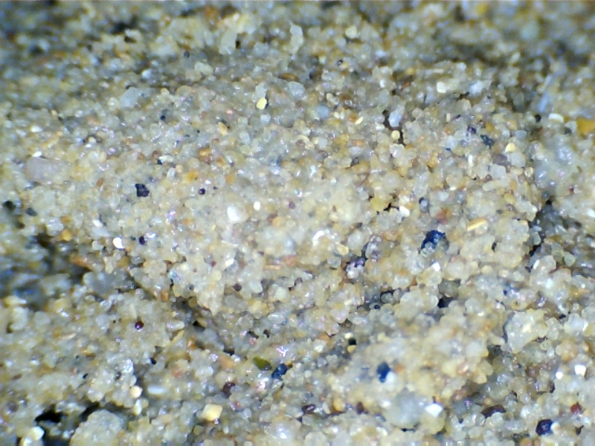

Fig. 1: Akpinar sand sample.

Fig. 2: Grain size distribution of the sand.

**2.3. Polypropylene Fiber**

The fiber which was used in this research is homopolymer polypropylene (HP). It is made of pure homopolymer polypropylene. This fiber is used in concrete reinforcement to reduce plastic and settlement shrinkage. The HP sample that was used for the study is FORTA Mighty-Mono Monofilament Microfiber that has shown in Fig. 3. Physical properties of the homopolymer polypropylene fiber has been shown in Table 2.

|  |  |
| --- | --- |
| Color | White |
| Structure | Single Fiber |
| Specific Weight (g/cm3) | 0.91 |
| Length | 19 mm |
| Water Absorption | 0 |
| Tensile Stress | 570-660 MPa |

Table 2: Physical properties of homopolymer polypropylene fiber.

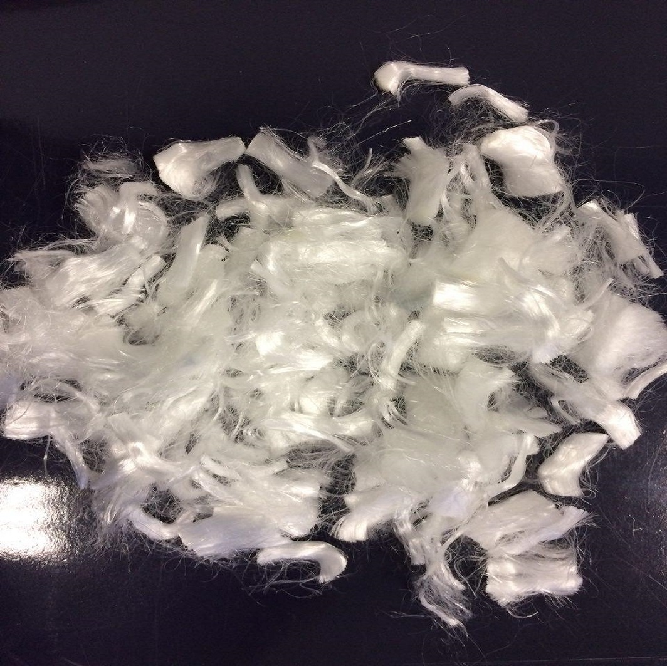

Fig. 3: Homopolymer polypropylene fiber.

**3. Specimen preparation**

The Direct shear test is performed to determine the effect of fibers on the shear strength parameters of sand. The test was conducted on samples of 60x60x25 mm rectangular cube, having a relative density of 65%. The amount of fiber added to the sand was taken as a percentage of the dry weight of sand. The fibers are accepted as part of the sand skeleton. The fiber content tested are 0.1%, 0.5% and 1.0%. For sample preparation, fibers were separated to enable a uniform mixture and they mixed with sand in the pan with hand and then put the admixtures in the shear box tamping slightly with spoon in five layers and compacted slightly to achieve a uniform sample. The porous papers are placed before and after the sample is placed in shear box mold of apparatus.

The normal stress of n=100, 200 and 300kPa are applied at unreinforced and reinforced sand samples and the loading rate was 0.12 mm/min for all tests. The settlement is recorded for 15 minutes after the sample is loaded. Shear stress were recorded as a function of horizontal displacement up to total displacement of 12 mm in order to observe the post failure behavior.

**4. Effect of fiber on shear stress of dense sand**

The shear stress of unreinforced and reinforced sand at peak point () and residual point () values is determined by direct shear box test. The peak shear stress and residual shear stress are calculated for normal stress of 100kPa, 200kPa, and 300kPa for samples with 0.0%, 0.1%, 0.5% and 1.0% fiber content. The results of the shear stress of direct shear box test are shown in Fig. 4 and Fig. 5. According to the results, the randomly distributed fiber addition affected the shear strength parameters of sand. As the fiber content increased, there has been an increase in shear stress values of reinforced sand with respect to the normal stress.

Fig. 4: Peak shear stress of unreinforced and reinforced sand versus fiber content.

With respect to the Fig. 4 and Fig. 5 it can be observed that there is an increase in shear stress of sand. The peak shear stress from 73kPa for unreinforced sample under 100kPa shear force illustrated a 37% increase and for samples under 200kPa and 300kPa increasing ratio are 16% and 23% respectively at peak point. These values for residual shear stress under 100kPa, 200kPa and 300kPa showed improvement of are 21%, 9% and 32% respectively.

Fig. 5: Residual shear stress of unreinforced and reinforced sand versus fiber content.

**5. Effect of fiber on peak and residual shear strength angle and apparent cohesion**

In the direct shear test, the peak shear strength angle () and apparent cohesion () parameters are calculated by linear regression analysis with correlation coefficients that are approximately equal to unity R2=0.97-0.999. The peak shear strength angle () and residual shear strength angle () were calculated from direct shear test are presented in Fig. 6 and Fig. 7 respectively. It is presented that changes in peak shear strength angle and residual strength angle are not considerable and these values change between 35o-36o and 31o-33o for peak and residual shear strength angle respectively.

Fig. 6: The peak shear strength angle.

Fig. 7: The residual shear strength angle.

On the other side regarding to the Fig. 8 and Fig. 9 apparent cohesion of unreinforced and reinforced sand can be calculated with respect to normal stress and shear stress values. As the fiber content increase, there is no change in apparent cohesion of sample with 0.1% fiber content admixture, but with increase in amount of fiber content up to 0.5% and 1.0% it can be seen that there is cohesion for the samples equal to 20kPa and 25kPa for samples with 0.5% and 1.0% fiber content respectively. It can be concluded that fiber addition in small amount did not affect the apparent cohesion of sand and in samples with more fiber content there is apparent cohesion in dense fiber reinforced sand samples.

Fig. 8: Peak shear stress and apparent cohesion values according to fiber content.

Fig. 9: Residual shear stress and apparent cohesion values according to fiber content.

**Conclusion**

In this paper the effect of reinforcement on shear strength parameters of dense sand was evaluated. In this study homopolymer polypropylene fiber was used as reinforcement material. Three different percentage of fiber (0.1%, 0.5% and 1.0% of dry weight of soil) were used in the laboratory test and behavior of randomly distributed fiber reinforced dense sand under shear box test was studied. According to the results, shear strength of reinforced sand samples was improved as fiber content increases and these results showed maximum improvement percentage of 37% for samples under 100kPa shear force at peak point and a maximum improvement of 32% for sample under 300kPa at residual point. Regarding to the results, the changes of angle of friction at peak and residual point were modest. Following, the amount of apparent cohesion of dry dense reinforced sand were calculated for both peak and residual points and it was concluded that there is no apparent cohesion for clean sand and fiber reinforced sand with 0.1% fiber content, but for samples with 0.5% and 1.0% fiber content it was seen improvement in amount of apparent cohesion. In conclusion, the randomly distributed homopolymer polypropylene fiber inclusion improved the strength of sand considerably. The results obtained from the experimental study are also consistent with the previous researches that are conducted on randomly distributed polypropylene fiber reinforced sands.

**References**

C. Tang, B. Shi, W. Gao, F. Chen, and Y. Cai, “Strength and mechanical behavior of short polypropylene fiber reinforced and cement stabilized clayey soil,” *Geotextiles and Geomembranes*, vol. 25, no. 3, pp. 194–202, 2007.

Gray, D. H. and Ohashi, H, “Mechanics of fiber reinforced in sand,” *Journal of Geotechnical Engineering, ASCE*, 109 (3): 335-353, 1983.

Gray, D.H., Al-Refeai, T., Behavior of fabric-versus fiber reinforced sand. *Journal of Geotechnical*

*Engineering*, ASCE 112 (8), 804–820, 1986.

Haeri S.M., Noorzad R., Oskoorouchi A.M., “Effect of geotextile reinforcement on the mechanical behavior of sand,” *Geotextiles and Geomembranes*, 18(6), 385–402, DOI:10.1016/S0266-1144(00)00005-4, 2000.

Hesham M. Eldesouky, Mohamed Ky, Mohamed M. Morsy, Mohamed F. Mansour., “Fiber reinforced sand strength and dilation characteristics,” *Ain Shams Engineering Journal*, 7, 517-526, 2016.

Jha, K. & Mandal, J. N., “A review of research and literature on the use of geosynthetics in the modern geotechnical world,” pp. 85-93, 1988.

Jin Liu., Qiao Feng, Yong Wang, Yuxia Bai, Jihong wei, and Zezhou song, “The effect of polymer-fiber stabilization on the unconfined compressive strength and shear strength of sand,” *Jounrnal of Advances in Materials Science and Engineerinng,* article ID:2370763, 9 pages, 2017.

Maher, M.H., Gray, D.H., “Static response of sands reinforced with randomly distributed fibers,” *Journal of Geotechnical Engineering*, ASCE 116 (11), 1661–1677, 1990.

M. S. Nataraj, and K. L. Mcmanis., “Strength and Deformation Properties of Soils Reinforced with Fibrillated Fibers,” *Journal of Geosynthetic International,* Vol 4 issue 1. pp: 65-79, 1997.

Prabakar J., Sridhar R. S., “Effect of random inclusion of sisal fibre on strength behaviour of soil,” *Journal of Construction and Building Materials*, 16, 123–131, 2002.

Reza Noorzad, and S. T. Ghoreyshi Zarinkolaei., “Comparison of mechanical properties of fiber-reinforced sand under triaxial compression and direct shear test,” *DE Gruyter open, Open Geosci*., 1: 547-558, 2015.

R Santoni R. L., Tingle J. S., Webster S. L., “Engineering properties of sand-fiber mixtures for road construction,” *Journal of Geotechnical and Geoenvironmental Engineering*, ASCE, 127, 258–268, 2001.

Santoni R. L., Tingle J. S., Webster S. L., “Engineering properties of sand-fiber mixtures for road construction,” *Journal of Geotechnical and Geoenvironmental Engineering*, ASCE, 127, 258–268, 2001.

Wei Sho., Bora Cetin., Yadong Li., Jingpei Li., Lin Li., “Experimental investigation of mechanical properties of sands reinforced with discrete randomly distributed fiber,” *Geotechnical and Geological Engineering*, 32: 901-910, 2014.

Yetimoglu, T., and Salbas, O. “A study on shear strength of sands reinforced with randomly distributed discrete fiber,” *Geotextiles and Geomembranes*, 21 (2): 103-110, 2003.