Comparison Between Theoretical and Practical Compression Capacities of Deep / Long Piles in Dubai

**Mohamed Nabil Omar, Abid Abu Tair**

British University in Dubai  
Academic City, Dubai, U.A.E

Eng_m_nabil@yahoo.com; abid.abu-tair@buid.ac.ae

British University in Dubai  
Academic City, Dubai, U.A.E

***Abstract* –** In most standards and codes of practice, the piles’ specifications and recommendations are stated for short piles which has a maximum depth range between 18.0 to 20.0 m [708.66 to 787.40 in]. In addition, the theoretical equations for pile design, charts and different soil parameters are based on old practical studies of short piles behaviour. In this research, a comparison was conducted between the theoretical pile compression capacity and the practical pile compression capacity which is derived from the results of pile’s static load test results. The study covered one case of bored pile constructed in Dubai, the pile has a depth equal to 34 m [1338.58 in]. For the accurate judgement, a finite element software "Plaxis 2D" has been used to model the pile and to find the numerical pile capacity which will be used in the comparison process. As a result of the research, the theoretical compression pile capacity was almost 70% of the practical and numerical pile capacity with the same specifications.

***Keywords*:** High raise buildings, piles, long piles, PLAXIS 2D, piling equipment

1. **Introduction**

Piles are structural element its function is to transfer the superstructure loads through the weak soil layers to the hard soil strata or the rock soil. The piles can be used to resist the uplift pressure, this is in case of high rise building subjected to overturning force or to support a structure subjected to uplift pressure due to high water table level, and the generated uplift pressure is greater than the structure’s weight. This type of piles is called tension piles. As well as, the piles may be used to resist a compression force from the superstructure and in this case the piles are classified as a comparison piles.

In terms of constructability and due to the significant development of the piling equipment, the concrete piles nowadays can be reached to a depth equal to 60 to 70 m. Generally, these types of deep piles are used in the construction of high rise buildings.

This research will provide a clear comparison between the theoretical and practical compression capacities of deep concrete piles. In addition, a finite element software PLAXIS 2D will be used to model the pile and to judge between the theoretical and practical capacities.

1. **Literature Review**
   1. **Ultimate Load Capacity of Single Piles**

The principle approach used to calculate the piles capacities to resist the compressive loads is the static or soil mechanics approach. During the past years, more research works done to express a method based on the practical soil mechanics theory. For example, the calculation of skin friction on a pile shaft was based on a simple relationship between the effective overburden pressure, the drained angle of shearing resistance of the soil and the coefficient of earth pressure at rest, but they realized through the results of the practical static tests and researches that the coefficient of earth pressure must be modified by a factor takes into consideration the installation method of the pile.

In the same way, the calculation of pile end bearing resistance was based on the undisturbed shearing resistance of the soil at the pile toe level, but they recognized the importance of the pile settlement at the working load and methods have been evolved to calculate this settlement, based on elastic theory and considering the transfer of load in shaft friction from the pile to the soil.

A pile is subjected to a progressively increasing compressive load at a steady rate of application, the resulting load - settlement relationship plotted in figure 1. There is a straight-line relationship up to point A on the curve, this is mean if the load released at any stage up to point ‘A’ the deformation or settlement of the pile head will return to its original condition. when the loading increased beyond point ‘A’ the relationship will have changed from linear to nonlinear relationship, and there will be yielding at the pile - soil interface till reaching the maximum shaft friction 'point ‘B’. In case of load releasing at this stage the pile head will have reached to point ‘C’. and the distance ‘OC’ will be the movement required to mobilize the maximum pile shaft resistance, usually this distance is equal to 0.3% to 1% of the pile diameter. The pile base resistance requires more downward movement to full mobilization, point 'D', that movement is based on the pile diameter, and it is ranged between 10% to 20% of the pile diameter. after point 'D' the pile will move downward without any increase in the load "failure point".

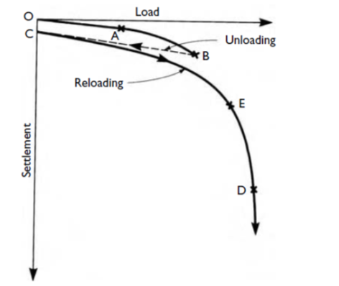

Fig. 1: Load/settlement curve for compressive load to failure on pile.

* 1. **Piles in Sand Soil**

The ultimate pile capacity *Pu* of a single pile is equal to the summation of the ultimate skin friction and end bearing resistances, less the pile weight:

(1)



Where,

= Ultimate pile skin friction resistance

= Ultimate pile end bearing resistance

= Pile weight

According to Michael Tomlinson and John Woodward (1977), the classical equation to calculate the compression pile capacity in the sand soil is:

(2)



Where,

effective soil overburden pressure at the pile base level.



pile bearing capacity factor.



the area of the pile base “cross sectional area”.



coefficient of the soil horizontal stress.



the angle of friction between pile and soil.



the area of the pile shaft.



The factors , are empirical factors have been obtained from the results of piles static load tests,  is obtained from the field test and laboratory tests on the friction angle between the different soil types and different pile materials as per table 2. The value of the empirical coefficient of the pile bearing  was by Berezantzev et al. (1961) and it has been found that this coefficient is based on the drained angle of shearing resistance  and the ratio between the pile penetration depth over the pile width (diameter), this relationship is shown in figure 2. Vesic (1967) confirmed that these values give results which is almost near to the practical conditions. Another criterion developed by Brinch Hansen to evaluate the factor of the pile bearing , but the values should be multiplying by a shape factor 1.3 for the square and circular pile’s base cross section.



Fig. 2: Pile bearing capacity factor

The second term in equation No. 2 is used to calculate the pile skin friction resistance to the compression loading. Table 1 shows the values of  related to  for different installation techniques. The value of the factoris very critical and difficult to evaluate, because it is depending on the stress history of the soil and the installation method of the piles. For example, the using of driven pile technique is increasing the horizontal soil stress from its original  value and the using of bored pile technique can loosen the soil, and reduce the horizontal soil stress. This factor is governed by the following items:

1. The stress history of the soil.
2. The ratio between the pile penetration depth and the pile width or diameter.
3. The shape and the stiffness of the pile.
4. The pile material.

Table 1. The coefficient of the soil horizontal stress, 

|  |  |
| --- | --- |
| Installation method |  |
| Driven piles, large displacement 15 mm | 1.00 – 2.00 |
| Driven piles, small displacement | 0.75 – 1.25 |
| Bored and cast-in-place piles | 0.70 – 1.00 |
| Jetted piles | 0.50 – 0.70 |

Table 2. Values of the angle of pile to soil friction for various interface conditions per Kulhawy (1984)

|  |  |
| --- | --- |
| Pile / soil interface condition | Angle of friction between pile and soil |
| Smooth (coated) steel/sand | (0.5 – 0.7) |
| Rough (corrugated) steel/sand | (0.7 – 0.9) |
| Precast concrete/sand | (0.9 – 1.0) |
| Cast-in-place concrete/sand | (1.0) |
| Timber/sand | (0.8 – 0.9) |

* 1. **Piles in Rock Soil**

For bored and cast-in-place piles which are drilled into rock soil layer act as friction and end bearing piles. Wyllie (1991) estimated the factors and coefficients which are governing the development of shaft friction through the rock socket depth. For the end bearing and pile settlement factors are summarized in the following items:

* 1. The socket length to the diameter ration.
  2. The strength and modulus of elasticity of the rock layer.
  3. The base condition of the drilled pile hole with respect to the removal of the drilled material.
  4. Creep of the material at the rock / concrete interface.
  5. Settlement of the pile in relation to the elastic limit of the side-wall.

Wyllie (1991) stated that if the bentonite slurry used in the drilling process of the pile, the rock socket shaft friction should be reduced by 25% compared to clean rock socket, unless pile load test done to verify the actual value of the friction resistance.

The shaft resistance of the pile in the rock soil, is depending on the bond between the pile material which is concrete and the rock soil. The bond between the concrete and the rock soil is depending on the unconfined compression strength of the rock soil, the rock socket bond stress has been developed by Horvarth (1978), Rosenberg and Journeaux (1976), and Williams and Pells (1981). The ultimate pile shaft resistance , in the rock soil can be calculated by the following equation;

(3)



Where:

reduction factor related to as shown in figure 3.



correction factor related to the discontinuity spacing in the rock mass as shown in figure 4.



The Williams and Pells (1981) curve in figure 3 is higher than the other two curves, but the  factor is having the same value in all curves and it is depending on the mass factor, , which is the ratio between the elastic modulus of the rock mass and the intact rock as shown in figure 4. In case if the mass factor  is not known from the loading test, it can be estimated with respect to the rock quality designation (RQD) or the discontinuity spacing quoted by Hobbs (1975) as follows:

Table 3. Mass factor j value with respect to RQD and the discontinuity spacing

|  |  |  |
| --- | --- | --- |
| RQD (%) | Fracture frequency per meter | Mass factor |
| 0 - 25 | 15 | 0.2 |
| 25 - 50 | 15 - 18 | 0.2 |
| 50 - 75 | 8 - 5 | 0.2 – 0.5 |
| 75 - 90 | 5 - 1 | 0.5 – 0.8 |
| 90 - 100 | 1 | 0.8 – 1.0 |

The method is used to calculate the pile ultimate bearing resistance assume that the pile capacity is a combination between shaft and base resistance. Both resistances are based on correlations between the pile static load test and the result of filed test in rock formations or laboratory tests. the following is the equation which is used to calculate the pile base resistance for the driven and bored piles:

 (4)

Where the bearing capacity factor is equal to:

 (5)



Fig. 3: Reduction factors for rock socket shaft friction

For the moderately weathered mudstones, siltstones and shales uniaxial compression tests should be made on the rock cores samples to obtain the compression strength. The base resistance can be calculated based on the uniaxial compression test results by using the relationship between  and RQD as shown in table 4:

Table 4. Ultimate base resistance of piles related to the uniaxial compression strength of the intact rock and the RQD of the rock mass

|  |  |  |  |
| --- | --- | --- | --- |
| **RQD (%)** |  |  |  |
| 0 - 70 |  |  | 30 |
| 70 - 100 |  |  | 30 - 60 |

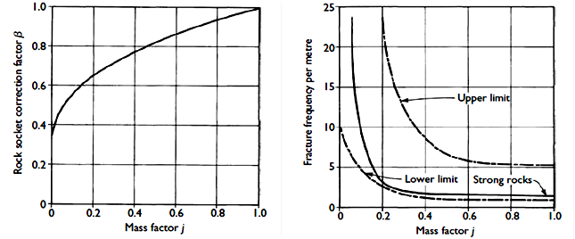

Fig. 4: Reduction factors for discontinuities in rock mass

* 1. **Prediction of Pile Capacity from Non-Destructive Static Load Test - Chin’s Method**

The pile static load test can be categorized to two categories; the first category is the failure load test where the pile is loaded until the failure. The failure load test is necessary to determine the pile's ultimate capacity. The second category is the proof test which is used to check the ability of the pile to support a specific service load, usually the loading is up to 1.5 to 2.0 times the design load. Most of time the proof test does not provide the pile's ultimate capacity, therefore this test is not providing a clear information about the pile capacity and it is not support the geotechnical engineers to do a cost saving in the foundation cost. Vesic (1977) stated that the scale of the load - settlement curve is based on the elastic deformation of the pile and is expressed as:

 (6)

Where:

elastic deformation of the pile.

applied load.

pile length.

 elastic modulus of the pile’s material.

 cross sectional area of the pile.

* 1. **Chin’s Method**

Chin's method (Chin and Vail, 1973) is the most developed method to predict the ultimate pile capacity from the results of non-failure static load test. It is assumed that the load-settlement relationship is hyperbolic, and the ultimate pile capacity can be predicted by plotting a curve between the settlement  / load  in the vertical axis and the settlement  in the horizontal axis. Then plot the best fit line through the data points. The ultimate pile capacity is derived from the inverse slopes of this line.

 (7)

 (8)

Where:

pile displacement.

ultimate pile capacity.

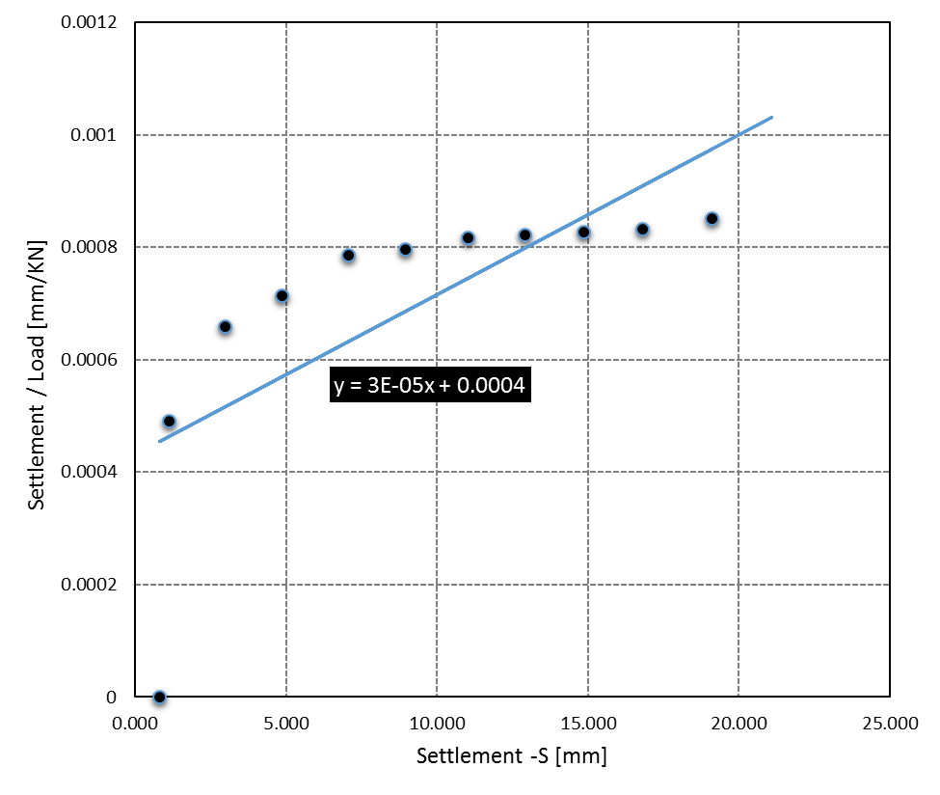

Fig. 5: Sample of Chin's Method Diagram

1. **Case of Study**

The following section will cover a case of study for long pile has been installed and tested in Dubai since 2015. The data was collected from the project consultant for the research purpose, and it is categorized as per the following items:

* 1. Project’s soil investigation report including the piling recommendations.
  2. Project’s piling drawings.
  3. Static load test report for the selected type of pile.
  4. **Research Methodology**

The following steps are the used methodology to compare between the theoretical, practical and numerical pile compression capacity.

* 1. Select one pile type from the case of study’s piles types.
  2. Collect all the required data from the soil investigation such as (soil layers’ classifications, soil parameters and piles recommendations).
  3. For the theoretical pile capacity, it can be extracted from the piles recommendation in the project's soil investigation report.
  4. For the practical pile capacity, it will be estimated form the results of the static load test by using Chin’s method (refer to section 2.2.1).
  5. For numerical pile capacity, a finite element model will be modelled by using PLAXIS 2D software to get the piles compression capacity.
  6. Comparison between piles capacities in the different cases will be discussed in details.
  7. **Theoretical Pile Capacity**

Reference to the soil investigation report from M/S Arab Centre (specialist soil test laboratory in Dubai) REF: SD14000067 dated on 31th December, 2014, the compression capacity of the pile with diameter equal to 900 mm and its toe level is -31.0 m from cut off level equal to +3.375 m was 9,015 KN. This compression capacity calculated by using set of theoretical and empirical equations which are used to calculate the skin friction and end bearing pile capacities in sand and rock soils (refer to equations 2,3 and 4). The following table summarize the selected pile details:

Table 5. Selected pile details

|  |  |  |  |
| --- | --- | --- | --- |
| Pile cut off level [m] | Pile Toe Level [m] | Pile Length [m] | Pile Diameter [mm] |
| + 3.375 DMD | - 31.0 DMD | 34.375 | 900 |

* 1. **Practical Pile Capacity**

Static load test has been done to the selected pile type by the piling specialist contractor (test No. PTP 02), and the test was monitored by M/S Arab Centre (specialist soil test laboratory). The static load test has been done by using Kent ledge blocks method. The purpose of the test was the critical evaluating of the following pile's characteristics:

* 1. Load settlement behaviour of the pile during the load test up to 250% of the pile’s working load.
  2. Load transfer and distribution along the pile shaft during the pile’s compression load test.
  3. Skin friction along pile shaft during pile load tests in compression.

The following table represent the static load test results of the selected pile:

Table 6. Static load test results of the selected pile

|  |  |  |
| --- | --- | --- |
| **Load - P [KN]** | **Settlement -S [mm]** | **Settlement / Load [mm/KN]** |
| 0 | 0.793 | 0 |
| 2240 | 1.100 | 0.000491071 |
| 4490 | 2.960 | 0.000659243 |
| 6780 | 4.850 | 0.000715339 |
| 8970 | 7.060 | 0.000787068 |
| 11210 | 8.935 | 0.000797056 |
| 13460 | 11.000 | 0.000817236 |
| 15690 | 12.900 | 0.00082218 |
| 17940 | 14.850 | 0.000827759 |
| 20180 | 16.800 | 0.000832507 |
| 22430 | 19.100 | 0.000851538 |

The pile did not reach to the failure point during that static load test. Therefore, Chin's method will be used to predict the pile capacity from Non-Destructive static load test (refer to section 2.2). Figure 5 illustrate the results of the static load test by plotting the settlement of the pile on the horizontal axis and the settlement / load on the vertical axis. By using Chin’s method technique, the practical pile capacity can be predicted by using equations 7 and 8 as follow:

 (9)

 (10)

 (11)

The practical pile capacity by using Chin’s method for Non-Destructive static load test is 13,333 KN. And the expected pile settlement under the working load from the results of the static load test is 10 mm.

* 1. **Numerical Pile Capacity**

Finite element software used to model the selected pile with the soil layers, the used software is PLAXIS 2D. The pile was modelled by using axisymmetric option, the soil layers were modelled by using Mohr-Coulomb as material model. Prescribed settlement will be applied to the pile head and the force – settlement curve will be plotted to predict the numerical pile capacity. The following are the model's boundaries which were used:

* + 1. **Pile and soil interface reduction factor**

One of the important factor which has a significant impact on the pile skin friction resistance is the pile and soil interface condition. There is a reduction factor should be used in the modelling of pile, this factor is based on some items as follow:

* 1. Soil layers’ classification.
  2. The pile material.
  3. The method of the installation, for example the using of bentonite slurry in the pile installation has a negative impact on the skin friction resistance because it generates a smooth surface between the pile and the surrounding soil. Therefore, the reduction factor in this case will be small compare to other installation techniques.

Generally, the reduction factor of skin friction resistance duo to interface condition has a value between 1.0 to 0.5, in this model the used reduction factor for the first two layers (sand soil) is 0.8 and the value of the other layers (rock soil) is 0.9 (refer to table 2).

* + 1. **Graphical boundaries.**

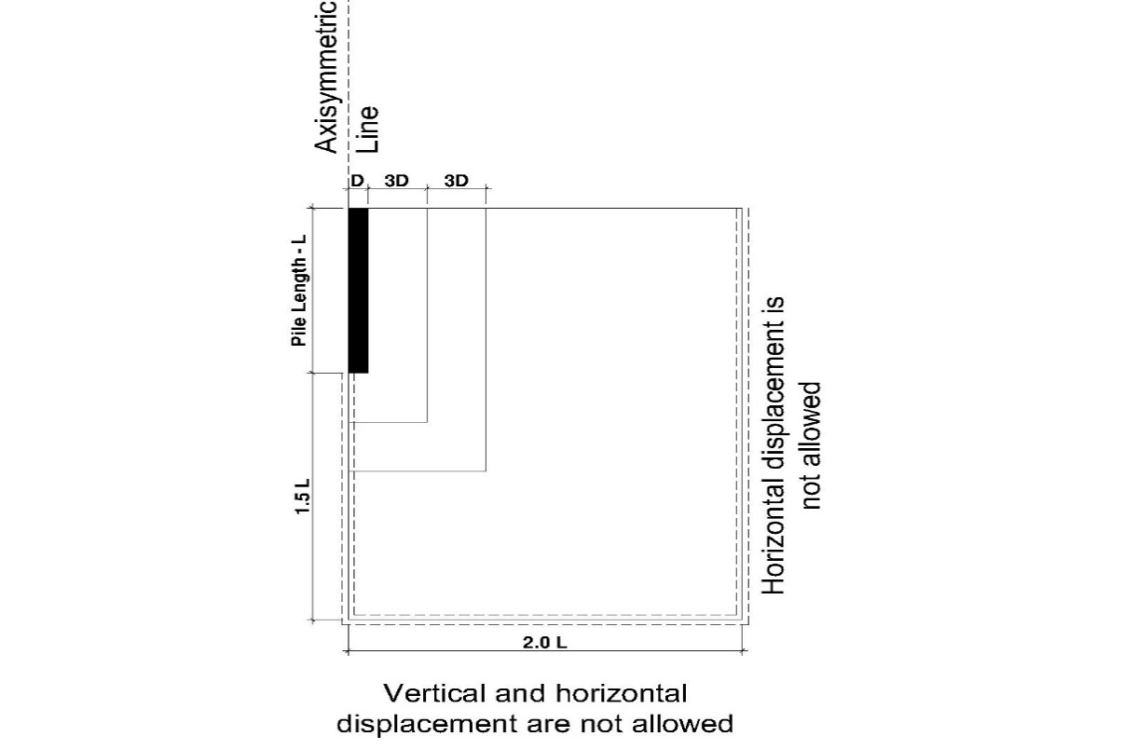

Fig. 6: Graphical boundaries

* + 1. **Soil layers’ classifications and soil parameters**

Table 7. Soil layers' classifications and soil parameters

|  |  |  |  |  |  |  |  |
| --- | --- | --- | --- | --- | --- | --- | --- |
| **Soil Layer** | **Layer Depth**  **m (DMD)** | | **Engineering Parameters** | | | | |
| **Depth**  **m** | **To** | **Unit Wt, KN/m3** | **E**  **MPa** | **Poison Ratio** | **C’ KPa** | **Ø** |
| Silty fine sand | 13.0 | -10.0 | 18 | 25 | 0.35 | 0 | 34 |
| Dense to very dense sand | 0.7 | -10.7 | 18 | 50 | 0.35 | 0 | 36 |
| Calac-renite / Sand-stone | 3.3 | -14.0 | 22 | 200 | 0.3 | 70 | 32 |
| 2.0 | -16.0 | 22 | 200 | 0.3 | 100 | 32 |
| 2.0 | -18.0 | 22 | 200 | 0.3 | 80 | 32 |
| 2.0 | -20.0 | 22 | 200 | 0.3 | 60 | 32 |
| 2.0 | -22.0 | 22 | 75 | 0.3 | 20 | 27 |
| 2.0 | -24.0 | 22 | 75 | 0.3 | 27 | 27 |
| 4.0 | -28.0 | 22 | 150 | 0.3 | 60 | 32 |
| 5.0 | -33.0 | 22 | 250 | 0.3 | 120 | 32 |
| 5.0 | -38.0 | 22 | 250 | 0.3 | 130 | 32 |
| Sand-stone | 5.0 | -43.0 | 22 | 400 | 0.3 | 85 | 34 |

Figure 10 illustrate the relation between the vertical displacement of the pile head on the vertical axis and radial force or resistance on the horizontal axis. Reference to the British standard BS 8004: 1986 defines that the ultimate pile capacity is the load at which the resistance of the soil becomes fully mobilized and goes on to state that this is generally taken as the load causing the head of the pile to settle a depth of 10% of the pile width or diameter (failure point).

* + - *  (pile diameter) = 90 mm.
      * From figure 7,  at displacement equal to 90 mm.
      * 
      * 

The numerical pile capacity by using PLAXIS 2D software to model the selected pile is 12,252 KN. And the expected pile settlement under the working load 1,950 KN/rad from figure 7 is 17mm.

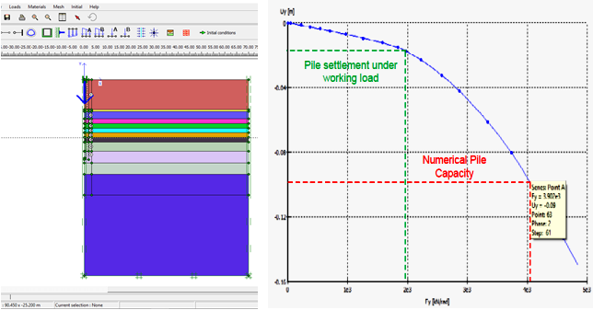

Fig. 7: Selected pile model by using PLAXIS 2D & Load - Displacement curve

* + 1. **Comparison Between Theoretical, Practical and Numerical Pile Capacities**

Figure 8 and table 8 summarize the predicted pile capacities for each case and illustrate the differences between them.

Table 8. Pile capacities details

|  |  |  |  |
| --- | --- | --- | --- |
| No. | Pile Capacity | Pile Capacity  [KN] | Percent |
| 1 | Theoretical pile capacity | 9,015 | 100% |
| 2 | Practical pile capacity | 13,333 | 147% |
| 3 | Numerical pile capacity | 12,252 | 135% |

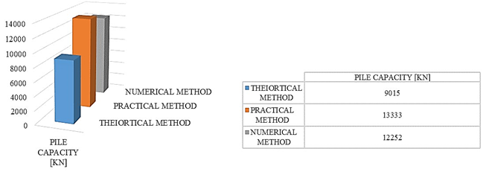

Fig. 8: Pile capacities chart

1. **Conclusion**

Proper soil investigation from specialist soil test laboratory during the design stage is essential, to provide a suitable information about the soil layers’ classifications and soil parameters such as soil unite weight, internal angle of friction, cohesion and the modulus of elasticity of each soil layer. All these parameters are very important during the design stage to design the pile foundation or to model it by using any geotechnical software and to achieve results near from the practical condition.

The theoretical equations which used to design the pile foundation are based on some parameters, these parameters have been estimated from the results of pile's static load test. This test has been done on piles have a short pile's depth not exceeding 20 m. But nowadays, the piling equipment has been developed to reach a depth equal to 60 to 80 m. This is to provide a suitable pile foundation system can be used to achieve the stability of the high rise buildings or to transfer the building load from the weak soil strata to the hard soil strata. Therefore, these equations need more development by using the results of long piles' static load tests and by using a finite element software to model the piles and the soil layers to have a better results compared to the theoretical method.

This research provides a comparison between the theoretical, practical and numerical pile capacities for one case of study has been installed and tested in Dubai. The research result is that the practical pile capacity is higher than the theoretical pile capacity by around 47%. And the numerical pile capacity is higher than the theoretical pile capacity by around 35%. As a result, the pile capacity from the theoretical equations should be increased by 30 to 40%. This will provide the ability to reduce the cost of the piles foundation system by around 30%. As well as, reducing the required pile's materials which is considered as a sustainable practice for our environment.

For further research, the pile model can be improved by using a non – soil material under the pile toe equal to 3 time the pile diameter, this to cancel the pile bearing resistance and to calculate the skin friction resistance from the numerical model. Base on that, the theoretical values of skin friction and end bearing pile resistance can be compared to the numerical values separately. This will lead to a significant improvement in the theoretical equations.

**References**

1. Aun, O. (1980). The loading behaviour of long piles. 1st ed. University of Sheffield.
2. Bowles, J. (1977). Foundation analysis and design. 1st ed. New York: McGraw-Hill.
3. Brinkgreve, R., Broere, W. and Al-Khoury, R. (2004). PLAXIS: 2D, version 8. 1st ed. Lisse: Balkema.
4. British standard code of practice for foundations. (1986). 1st ed. London: British Standards Institution.
5. Chellis, R. (1961). Pile foundations. 1st ed. New York: McGraw-Hill.
6. Poulos, H. and Davis, E. (1980). Pile foundation analysis and design. 1st ed. New York: Wiley.
7. Tomlinson, M. and Woodward, J. (2008). Pile design and construction practice. 1st ed. London: Taylor & Francis.
8. Cisneros, S. (1991). The house on Mango Street. New York: Vintage Books.
9. Cisneros, S. (1991). The house on Mango Street. New York: Vintage Books.
10. Das, B. (2007). Theoretical foundation engineering. 1st ed. Ft. Lauderdale, FL: J. Ross Pub.
11. Guo, W. (2013). Theory and practice of pile foundations. Boca Raton, FL: CRC Press, Taylor & Francis Group.
12. Liang, R. and Zhang, F. (2010). Deep Foundations and Geotechnical in Situ Testing. 1st ed. Reston: ASCE.
13. Look, B. (2007). Handbook of geotechnical investigation and design tables. London: Taylor & Francis.
14. Youventharan Duraisamy., (2009). Introduction to pile foundation. Kuantan: Penerbit University Malaysia Pahang.