**Numerical Evaluation and Comparison of the Tunnel Effect with Various Shapes and Dynamic Loading on the Seismic Response  
 and Amplification of the Surface of the Ground**

**Arash Rostami, Abdolreza S. Moghadam, Mahmoud Hosseini, Hamid Alielahi**

Department of Civil Engineering, Islamic Azad University, Central Tehran Branch,   
Tehran, Iran [Dr.Arash.Rostami@gmail.com](mailto:Dr.Arash.Rostami@gmail.com)

Associate professor, International Institute of Earthquake Engineering and Seismology,  
 Tehran, Iran [Moghadam@iiees.ac.ir](mailto:Moghadam@iiees.ac.ir)

Associate professor, International Institute of Earthquake Engineering and Seismology,  
 Tehran, Iran [Hosseini@iiees.ac.ir](mailto:Hosseini@iiees.ac.ir)

Department of Civil Engineering, Islamic Azad University, Zanjan Branch, Zanjan,  
 Iran [H.Alielahi@iau.ac.ir](mailto:H.Alielahi@iau.ac.ir)

**Abstract**

The use of underground spaces is increasing massively due to city expansions and urban transportation roads. AS a result ,this research will check out the consequences of amplification, seismic responses and soil-tunnel interaction on the surface regarding the tunnel types, it also will compare the results so these types of tunnels which have been used mostly in executive and practical projects are considered and are as follows: circular, rectangular and horseshoe. To begin with, a finite elements method model has been tested and due to providing acceptable results, this method is selected for the research. Following that, after going over the influential parameters we will study the details along with comparing the results of real accelerograms regarding empty ground and free field. This study shows that the amplification of ground surface is increased as a result of different tunnel shapes. The quantity of this amplification by rectangular shape is more than circular types that also causes more amplification that the horseshoe one. The least amount of amplification is caused by circular types however the most is a result of rectangular shape which is also known as box shape.

**Keywords**: Tunnel, Seismic Amplification, Dynamic Responses, Dynamic Interaction, Finite Element Method

**1. Introduction**

Due to fast city expansion and migration that causes the urban trips along with the fact that urban spaces and subsurface spaces. Amid all these the utilization of underground spaces has increased because of different reasons. Using underground stations, warehouses, parking, and subway are some of the reasons. Not very long ago we believed that underground structures were safer and firm facing forces like earthquakes but as a result of some earthquakes this idea is not as popular today [1-3]. However the amount of destruction among on-surface structures is a lot more compared to underground structures and this states the importance of the surface of the ground amplification has attracted experts and scientists. Since 70’s there have been some major studies on this course [4-12]. Pitilakis and et al. (2014) have studied about the seismic behavior of the circular tunnels caused by the interaction of the ground level structures and their focus was on the tunnel response so they prioritiesed tunnel behavior. The result of this study for all the tested subjects are that increasing dynamic responses of the tunnel by shape changing and lining in low depth tunnels has considerable effects [13]. AliElahi and et al. (2014) studied the effect of using boundary element method in time domain on ground seismic responses near a buried cylinder hole. Numerical results of this research shows that for a random SV wave of the buried cavity compared to the movement of empty ground, the horizontal component of the cavity on the ground level decreases [14]. Smerzini and et al. (2009) studied the interactional effects of ground’s surface responses and behavior of the surface of the ground in case of tunnel existence and underground cavity presence. Some formulas are the key features of this research which show that the wavelength of the related prevailing wave is six times the placement depth [15]. Yiouta-Mitra and et al. (2007) studied the effect of underground structures on the seismic design resistance of the ground level structures which included FDM and numerical method it was also limitedly focused on multiple frequencies. The result of this research was that harder lining generally reduces both ground and tunnel responses [16]. Baziar and et al. (2014) studied the effect of underground cavities on ground’s surface acceleration as well and they were satisfied with the structure responses. The observed results are that existence of underground tunnels reduces the natural system frequency which increases long periods and reduces shorter periods [17]. Tsinidis and et al. (2013) worked on the effect of rectangular cavities in soft soil which was done in both numerical and laboratory ways and studied the behavior of tunnels in this kind of soil. This research pointed out that it is possible for numerical models to have more accurate results by considering all of the uncertainties which are involved in the issue that rectangular tunnels responses in centrifuge are recorded [18]. Fattahi and Tabatabaeefar (2014) studied the seismic behavior of buildings on soft soil; they did not study anything else and were focused on behavior on soft soil. The result is that the differences between the results of base shear calculated by linear method and the non-linear method are inconsiderable [19]. Sica and et al. (2013) studied the extent of the ground surface due to underground cavities; behavior and domain of ground’s surface were their field of work. Results of this research demonstrate that numerical method states that the existence of buried cavities influence the ground’s response compared to empty ground responses this effect is not inconsiderable [20]. Tsaur and Deng (2012) researched on effects of flashing waves on soil and checked the behavior of underground cavities affected by the waves. The result shows that the reply in the ground’s frequency domain and cavity surfaces is done on the surface and subsurface like time domain movement analysis distribution [21]. Anastasopoulos and et al. (2007) studied on extreme nonlinear buried tunnel’s shakes responses and like other attempts, tunnel’s behavior is checked but the difference is that it is checked in a greater depth along with extreme shakes. Results are that due to research in the longitudinal direction of the tunnels there is no considerable shakes on the sea surface and the behavior of the system is mostly controlled by washer hardness and Gyna gasket [22]. Liu and et al. (2013) studied the buried tunnels by flashing SV and Riley P waves. Numerical results show that effects of buried tunnels, linear shear modulus compared to the average linear thickness of the tunnels are considerable amounts [23]. Luzhen and et al. (2010) used workshop experiments, shaking table and FEM method to research underground structure responses. Numerical results show that ground’s dynamic pressure which is caused by a seismic wave is the main reason of the underground tunnels destruction [24]. Rostami and et al. (2016) worked on structure responses and creating plastic joint in metal structures caused by circular tunnels, they concluded that plastic joints before tunnel’s creation are different compared to when there is a tunnel in the substructure [25]. AliElahi and Adam Pira (2017) studied on the effect of tunnel on hills and concluded that circular tunnel has a direct effect on hill responses [26]. Besharat and et al. (2014) researched on the seismic behavior of soil surface when there is a tunnel and when there is not .In this research which was done as a case study in Tehran results showed that MPGA must be used to design new buildings that are in a 5-20m range of a tunnel [27]. Also other researches on tunnels, different parameters and the effectiveness of these parameters on the surface of the ground responses in different conditions were done by researchers [28-32].

Even though there have been some attempts in different fields that are aligned with this research but there hasn’t been a comparative study on various tunnels shapes in a variety of information so far. Case studies have been done on a particular tunnel shape with environmental specifications (soil, ground quality, incoming forces) so we will check out this case by using FEM method and numerical method that are done by Abacus software. For this reason in this research we will study the ground’s surface amplification effects and we will also compare ground’s surface responses in interaction with different tunnel shapes and soil types under the pressure of dynamic forces and real earthquakes in the end we will get to a conclusion by comparing the results of numerical modeling.

**2- Introducing Parametric Studies Method**

In this section we will review the parametric studies method and modeling. Studied parameters are tunnel’s cross section shape, seismic loading, and frequency applied to the soil mass, soil type and lining hardness of the tunnel. In order to calculate the amount of amplification which is the subject of this article we use the division of the ground’s response spectrum when there is a tunnel, free field or there is not a tunnel. Figure 1 shows schematic overview of the model in which loading on the model floor is based on real earthquakes. We input sizes without dimensions so that in the end size of the model won’t affect the final results.

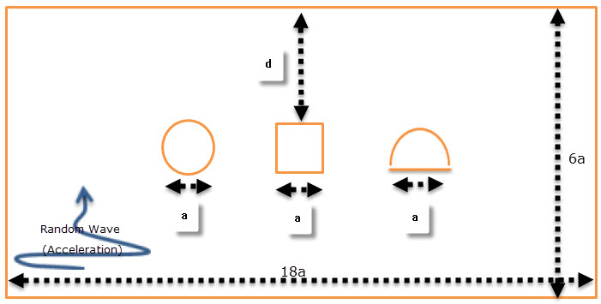

**Fig 1. Schematic Form of Dimensions of Soil and Rectangular, Circular and Horseshoe Tunnel**

Figure 1 shows the dimensions of the model. Measures of the soil mass that are extracted from source (13) are as follows: length of the mass in 180m and width is *60m* and the mass is formed of 4 layers of soil with different specifications. Sizes of the circular, rectangular and horseshoe tunnels are 10 meters which is shown in the image. In order to calculate accurate results all sizes are input without dimensions so that sizes and dimensions will not matter in the final result. Distance between earth’s center and top of the tunnel is shown with *d*. length of the rectangular tunnel equals *a* so as the diameter of circular and horseshoe models as a result length of the soil mass equals *18a* and height of the soil mass (*H*) equals *6a*. In this research the intended purpose of dimensionless frequency is the maximum side of the underground box structure of the shape a-excitation wavelength ratio *λ*, which is calculated by the formula below. In this formula *f* shows stimulation frequency and *Cs* is the environment shear wave velocity. It should be noted that the dimensionless period is the reverse of dimensionless frequency which shows the ratio between wavelength of the waves and tunnel sides.

(1)

Also *J*, tunnel coverage flexibility demonstrates the ratio of structure coverage hardness (tunnel lining) to the environment (soil) hardness. When this amount is less than a unit, it means that the structure coverage is more rigid compared to environment in this condition underground structure will transform much less under the effect of environment. By increasing the amount of *J*, structure rigidity will be decreased, until there is no coverage (lining) then the amount of this dimensionless parameter will become infinite. In circular shaped tunnels considering elastic behavior, the amount of this parameter compared to coverage flexibility can be calculated by the formula below:

(2)

In the equation number 2, *Esoil* and *Elining* are soil’s elasticity modules and tunnel’s coverage materials in order. *Vsoil* and *Vlining* are in order the soil’s poisson factor and tunnel coverage materials. *R* and *I* are radius and the moment of interia of the tunnel’s section as well. For the rectangular and box tunnels in which moment of interia of the ceiling is *Iw* and *IR* for the sides the formula below has been presented by researchers [33]. In this formula *W* and *H* in order are width and height of the underground structure.

(3)

**3- Modeling and Validation**

**3-1- Modeling Features**

In this study according to the reference article, first Ricker wavelet [34] is flashed towards the bottom of the model. In the next step in order to access the responses of the ground spectrum values in the presence of underground structures, 3 real accelerograms called El Sentro, San Fernando and San Luis which are far from fault have been used (Table 2). In the equation number 4, Ricker wavelet’s mathematical equation has been provided. In this equation, *Fp* is the dominant frequency, *Amax* is maximum time history and *t0* shows the point of time in which maximum amount of Reiger wavelet was created. In this research values of *Fp*, *Amax* and *t0* in order are 5 HZ, 1mm and 0.475s:

(4)

In order to validate the numerical modeling, at this part after introducing the numerical model it will be validated. In this regard the powerful abacus software was used for numerical modeling which is based on Finite Element Method. In figure 3, underground tunnel’s modeling process has been shown. In all the models, soil behavior has been considered as elastic-plastic or mohr-columbus and tetrahedron elements along with plane strain behavior for environment reticulation have been used. Soil attenuation has been considered the Riley way with a 2% ratio. Mesh sizes have been chosen small enough to be able to accurately stimulate the emissions. So based on Kuhlemeyer and Lysmer [35] advice size of the elements have been chosen lees that a tenth of shear wavelength (*Δl˃λ/10*). In order for the tunnel’s coverage modeling (lining), linear elements have been used and the interaction among this element and the environment soil has been modeled by linear elastic springs elements which don’t allow any slips between these two environments. Shear wave speed, soil density, soil’s poisson’s factor and other soil information are provided in the table 1. The tunnels are located distant (*d/h=0.64*) from the grounds surface center. Since incoming stimulation is applied to the base as strain, border energy absorber is used for the base modeling. Also in the side borders of the model, border free field is used so that return of the waves towards the model will be blocked. Border free field includes a soil column with a unit width that stimulates the infinite outdoor environment behavior of the model.

**Table 1. Mechanical properties of the soil deposits**

|  |  |  |
| --- | --- | --- |
|  | Soil profile | |
| Soil type B | Soil type C |
| Unit weight of volume, γ (kN/m3) | 20 | 20 |
| Coefficient of earth pressure at rest, Ko | 0.50 | 0.50 |
| Shear wave velocity, Vs (m/s) | Variable with depth (see Fig. 2) | |
| Damping, D (%) | 5% | 5% |
| Poisson ratio, v | 0.333 | 0.333 |
| Cohesion, c (kPa) | 20 | 10 |
| Friction angle, φ (deg) | Variable with depth:  0–30 (m): 350  30–60 (m): 450 | Variable with depth:  0–30 (m): 280  30–60 (m): 350 |

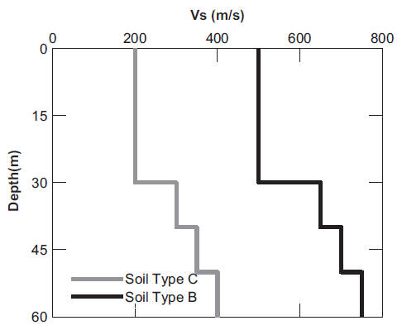

**Fig 2. Shear wave velocity profiles of the soil deposits**

**Table 2. Earthquake Records Characteristics (Peer site) [36]**

|  |  |  |  |  |  |
| --- | --- | --- | --- | --- | --- |
| Row | Record Name | Maximum Acceleration | Magnitue (Richter) | Distance from Fault (km) | Effective Movement Time (s) |
| 1 | Elcentro | 0.31 | 7.2 | 18.3 | 24.1 |
| 2 | Sanfernando | 0.27 | 6.61 | 19.33 | 16.71 |
| 3 | Sanluis | 0.011 | 6.19 | 63.34 | 17.84 |

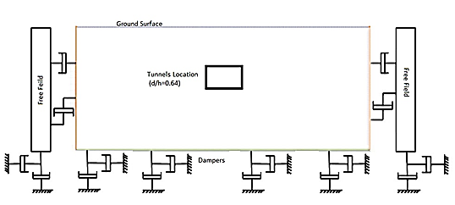

**Fig 3. A view of the numerical modeling in Abaqus software**

Most of the studies on tunnels were focused on this subject as an example the effects of rectangular and circular tunnels on the surface e of the ground in the study environment, studies were in the form of case and single studies and in nine of the listed items all of the tunnel shapes have been studied on the same range [Fig 4]. In the image bellow you can see the shapes and positions of the modeled tunnels by the Abaqus [37] software.

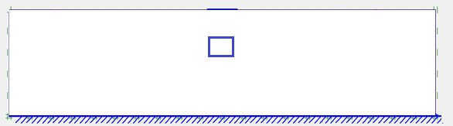

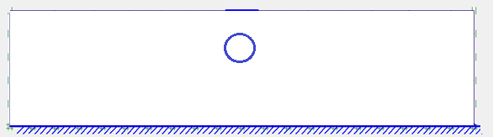

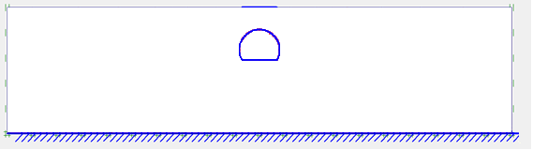

**Fig 4. Location schematic of various shapes of tunnels in the soil deposit.**

**3-2- Modeling Validation**

In this section we will go over the modeling validation based on the reference article [13]. In the validation done based on the article’s data, all of the input information is based on this article and the reference articles which are addressed in this article and in the end results with less than 3% difference are very similar to the reference article. In figures (6-5), vertical axis shows the depth of soil and horizontal axis shows the surface of the ground acceleration. The results of this research’s modeling confirm the validation, modeling and research process. As it is shown in figure 6 results of the validation is almost the same as the article results.

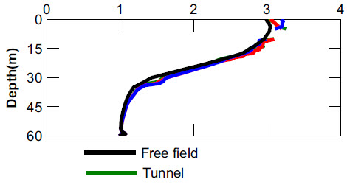

**Fig 5. Horizontal acceleration amplification (Base Paper)**

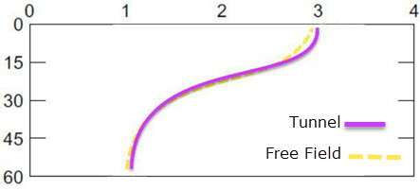

**Fig 6. Horizontal acceleration amplification (Verification Model)**

**4- Results of the analysis**

Table 2 shows the specifications of real earthquake records. In this table three records which are far from active faults and maximum acceleration along with their effective movement times are different are used. Maximum acceleration of all the records are scaled to 0.2g. In other words these three different records with maximum acceleration domain of 0.2g will be applied to the soil mass. First records scaled to 0.2g will be applied to the floor of soil mass in the abacus software after dynamically analyzing soil surface record on point A, which is on the surface of the ground and under the foundation center with (0,0.5) coordinates of tunnel axis will be obtained. Again by digging a circular tunnel in the soil layer, like the condition with no tunnels, records scaled to 0.2g will be applied to the floor of soil mass so the soil’s surface record will be obtained. In the end for both without tunnel and the one with a tunnel earthquake’s acceleration on soil’s surface, response spectrum and Fourier spectrum will be compared. In this research WO means without tunnel, Ct circular tunnel, HT horseshoe tunnel and RT is rectangular tunnel. Also El is El Santro earthquake, SANF San Fernando earthquake and SANL in the San Luis earthquake.

**4­-1- Acceleration on the surface**

Figures (7-15) show the surface of the soil acceleration in both without tunnel and the condition with a tunnel on different records. AS it is obvious, digging a tunnel will change the earthquake acceleration. According to mentioned images digging a circular tunnel will increase the maximum acceleration on all the records compared to without tunnel conditions.in this image value of *A* is obtained from equation number (5), in which *aT* is the maximum acceleration of the soil’s surface in a condition where there is a tunnel and *aWT* is the maximum acceleration of the soil’s surface in a without tunnel situation. Characterized form shows that in the El Santro earthquake the occurrence duration of acceleration is increased due to tunnel digging and in the San Fernando earthquake this duration is decreased however occurrence duration of the maximum acceleration in San Luis earthquake is the same in both without tunnel condition and the condition of a tunnel’s existence. In this figure the value of *t* is calculated by the number 6 equation in which *tT* is the time of maximum acceleration in a condition with tunnel existence and *tWT* in the time of maximum acceleration on the surface of soil in a without tunnel condition. The positive part of the vertical axis shows a percentage increase in the maximum acceleration time and the negative part shows the percentage decrease of the maximum acceleration time.



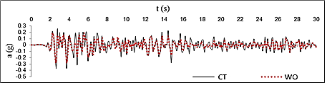

**Fig 7. Soil Surface Acceleration in condition of Tunnel and without Tunnel in EL-EQ in Circular Tunnel**

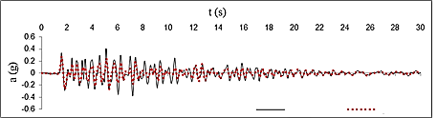

**Fig 8. Soil Surface Acceleration in condition of Tunnel and without Tunnel in SF-EQ in Circular Tunnel**

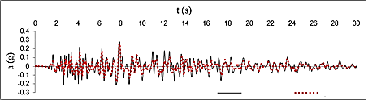

**Fig 9. Soil Surface Acceleration in condition of Tunnel and without Tunnel in SL-EQ in Circular Tunnel**

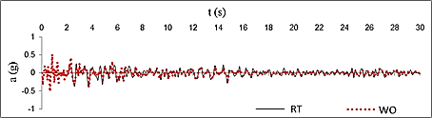 **Fig 10. Soil Surface Acceleration in condition of Tunnel and without Tunnel in EL-EQ in Rectangular Tunnel**

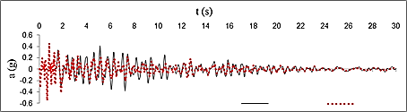

**Fig 11. Soil Surface Acceleration in condition of Tunnel and without Tunnel in SF-EQ in Rectangular Tunnel**

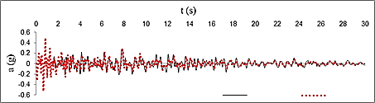

**Fig 12. Soil Surface Acceleration in condition of Tunnel and without Tunnel in SL-EQ in Rectangular Tunnel**

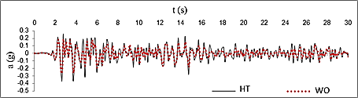

**Fig 13. Soil Surface Acceleration in condition of Tunnel and without Tunnel in EL-EQ in Horseshoe Tunnel**

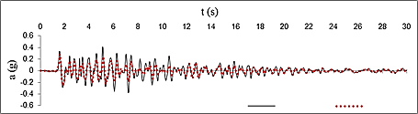

**Fig 14. Soil Surface Acceleration in condition of Tunnel and without Tunnel in SF-EQ in Horseshoe Tunnel**

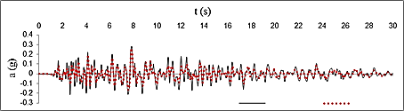

**Fig 15. Soil Surface Acceleration in condition of Tunnel and without Tunnel in SL-EQ in Horseshoe Tunnel**

**4-2- Surface of Ground Acceleration Spectrum**

In both tunnel existent and without tunnel conditions earth quake records are applied to the floor of the soil mass and by dynamic analysis done by abacus software, soil’s surface record is extracted. Surface of soil record will be signaled to the sizemo software and the ground’s surface acceleration spectrum will be drawn by 1 free degree. Figures (16-24) show the surface of the ground acceleration spectrum in a without tunnel and a tunnel existent condition. As its obvious digging a circular tunnel will cause a decrease in the acceleration spectrum of the surface of the ground.

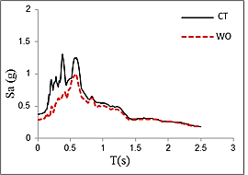

**Fig 16. The spectrum of Acceleration of the surface of the ground in El Sentro earthquake (circular tunnel)**

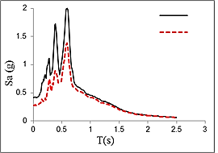

**Fig 17. The spectrum of Acceleration of the surface of the ground in San Fernando earthquake (circular tunnel)**

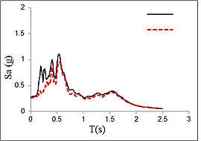

**Fig 18. Changes percentage of the duration of the effective motion time (circular tunnel**)

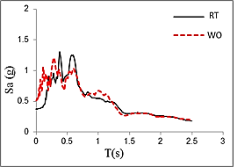

**Fig 19. The spectrum of Acceleration of the surface of the ground in El Sentro earthquake (Rectangular tunnel)**

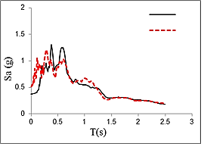

**Fig 20. The spectrum of Acceleration of the surface of the ground in San Fernando earthquake (Rectangular tunnel)**

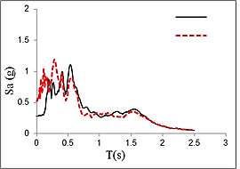

**Fig 21. The spectrum of Acceleration of the surface of the ground in San Luis earthquake (Rectangular tunnel)**

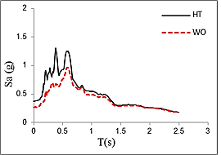

**Fig 22. The spectrum of Acceleration of the surface of the ground in El Sentro earthquake (Horseshoe tunnel)**

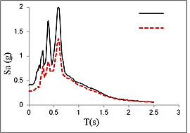

**Fig 23. The spectrum of Acceleration of the surface of the ground in San Fernando earthquake (Horseshoe tunnel)**

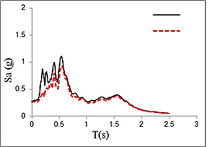

**Fig 24. The spectrum of Acceleration of the surface of the ground in San Luis earthquake (Horseshoe tunnel)**

**3-4- The duration of the effective movement time of record**

Each acceleration record has got duration of effective movement. The duration of effective movement is explained in different methods that their most important and the most accurate one is the energy method. In this method the period of releasing 5 to 95 percent of energy of the earthquake is measured. According to the figure, in El Sentro and San Fernando, digging a tunnel increased the duration of the effective movement time and in the earthquake of San Luis, the tunnel decreased the duration of the effective movement time. In this figure, the amount of the element has been calculated from equation number 7; in which *dT*represents the duration of the effective movement time in tunnel and *dWT*represents the duration of the effective movement time without tunnel. The positive part of the vertical axis, illustrates the percentage increase of maximum acceleration and the negative part of it shows the percentage decrease of maximum acceleration.

(5)

**4-4- The Fourier spectrum of the soil surface acceleration**

Figures (25-33) show the Fourier spectrum of the soil surface acceleration in both conditions of with tunnel and without tunnel under various records. As it is clear digging a tunnel would cause a change in the Fourier spectrum. According to the figures, digging circular tunnel would cause maximum increase in the domain of Fourier spectrum in all records in comparison to the without tunnel condition. In this figure amount of *FA* is calculated from equation number 8; in which *FAT*represents maximum domain of spectrum in with tunnel condition and FAWT represents maximum domain of the spectrum in without tunnel condition. Positive part of the vertical axis shows increase in maximum acceleration percentage and the negative part of the vertical axis shows decrease in maximum acceleration percentage. Figure (22) shows dominant frequency change in tunnel condition against the without tunnel condition. In El Santro and San Fernando earthquakes, dominant frequency in both conditions has been the same and hasn’t changed but in San Luis earthquake, the dominant frequency has decreased. In this figure amount of *f* is calculated from equation number (9); in which *fT*represents the dominant frequency in tunnel condition and *fWT*represents the dominant frequency in without tunnel condition. Positive part of the vertical axis shows increase in the time of maximum acceleration percentage and the negative part of the axis shows decrease in the time of maximum acceleration percentage.

(6)

(7)

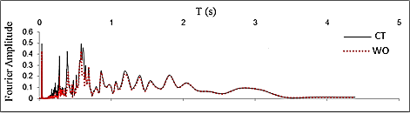

**Figure 25. Comparison of the Fourier spectrum of the surface of the soil in two conditions of with  
tunnel and without tunnel in El Santro earthquake (circular tunnel)**

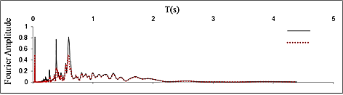

**Figure 26. Comparison of the Fourier spectrum of the surface of the soil in two conditions of with  
tunnel and without tunnel in San Fernando earthquake (circular tunnel)**

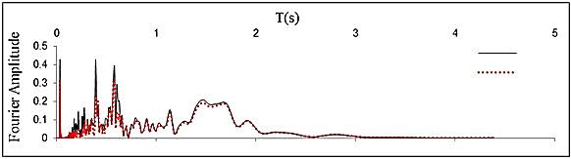

**Figure 27. Comparison of the Fourier spectrum of the surface of the soil in two conditions of with  
tunnel and without tunnel in San Luis earthquake (circular tunnel)**

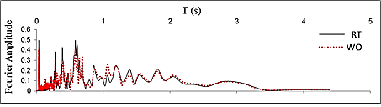

**Figure 28. Comparison of the Fourier spectrum of the surface of the soil in two conditions of with  
tunnel and without tunnel in El Santro earthquake (rectangular tunnel)**

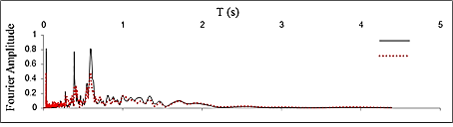

**Figure 29. Comparison of the Fourier spectrum of the surface of the soil in two conditions of with  
tunnel and without tunnel in San Fernando earthquake (rectangular tunnel)**

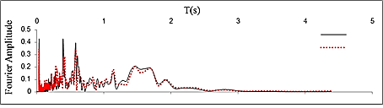

**Figure 30. Comparison of the Fourier spectrum of the surface of the soil in two conditions of with  
tunnel and without tunnel in San Luis earthquake (rectangular tunnel)**

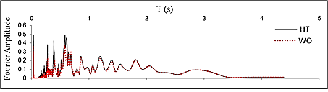

**Figure 31. Comparison of the Fourier spectrum of the surface of the soil in two conditions of with  
tunnel and without tunnel in El Santro earthquake (horseshoe tunnel)**

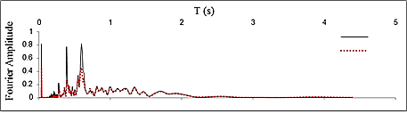

**Figure 32. Comparison of the Fourier spectrum of the surface of the soil in two conditions of with  
tunnel and without tunnel in San Fernando earthquake (horseshoe tunnel)**

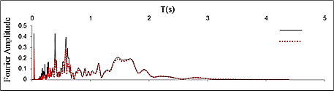

**Figure 33. Comparison of the Fourier spectrum of the surface of the soil in two conditions of with  
tunnel and without tunnel in San Luis earthquake (horseshoe tunnel)**

**4-5- The efficiency of the depth in the seismic response of the surface of the ground**

In this section we will evaluate amplification and tunnel effect in different depth on the seismic response of the surface of the ground. According to the figure (34) that shows the change rate of the seismic response in different depth, it can be observed that the amplification rate of the surface of the ground decreases with depth increase. As the buried depth of tunnel increase, the amount of amplification and the tunnel effect on the seismic response of the decreases. Also, on the other hand, based on given figures we can figure out that the decrease in tunnel depth on the seismic response of the surface of the ground follows specified pattern. This pattern illustrates that above the top of the tunnel, the amount of increase in seismic response becomes more and we move to the left or right in tunnel the response first increase then decreases. This decrease only exists in a few meters depth and then it fades.

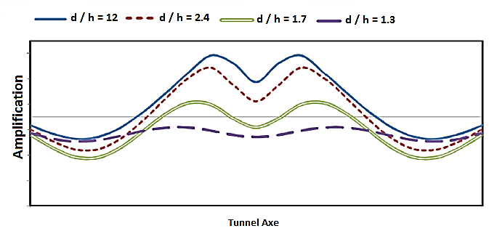

**Figure 34. The depth effect on the seismic response of the surface of the ground**

**4-6- Inserted Forces on Tunnel Coverage**

The forces acted on tunnel cross sections showed below. From the figures can understand that the maximum forces acted on rectangular tunnels. It is concluded by examining these figures that forces distribution in more homogenous in circular tunnel than other tunnels. In addition, the most shear force and flexural anchor happen for horseshoe tunnel in its low part and for rectangular tunnels on the corners. Inserted forces values on tunnel walls are shown in figure 35.







**Figure 35- General Scheme of Inserted Forces on Tunnels Walls from Right Side Includes Axial force, Flexural Anchor, and Shear Force (Circular, Horseshoe and Rectangular Tunnel)**

**5- Conclusion**

In this research, we compared and evaluated digging tunnel affected the underground cavities with various shapes including circular, rectangular and horseshoe which are the most common and the most used shapes in tunneling cross section under some conditions on the seismic response and the surface amplification. In this process we used the strong software of ABAQUS then after ensuring the accuracy of the verified modeling results, we modeled the goal of article. First we flashed the Ricker wavelet to soil mass and then to obtain real results, we flashed the accelerogram of active earthquakes which are far from fault to the bottom of the models and gained acceleration and the spectrum of acceleration of the surface of the ground. Considering the shapes and modeling graphs, these results have been achieved:

1. Digging tunnel in any shaped cross section has direct influence on the earthquake acceleration on surface of the ground.

2.The spectrum of the surface of the ground response in the conditions of with tunnel and without tunnel is different from each other so that in case of circular tunnel existence, the spectrum of response increases in comparison to the without tunnel condition.

3. With digging tunnel, the effective duration of movement record of the earthquake would be influenced on. Considering the type of the record this parameter may increase or decrease or even may remain the same without any change.

4. Digging a horseshoe tunnel affects directly the acceleration of the earthquake on the surface of the ground in a way that the maximum acceleration in all three records of earthquake will increase and its time of happening will be influenced on based on the type of the earthquake record.

5. The Fourier spectrum of record is also affected by digging tunnel. In case of digging tunnel, the maximum domain of the Fourier spectrum of records increase and the changes in the prevailing frequency would differ according to the type of the records.

6. Digging rectangular tunnel affects directly the earthquake acceleration on the surface of the ground, so that the maximum acceleration in all three records of the earthquake would increase and its time of happening would decrease.

7. The spectrum of response in the surface of the ground in two conditions on with tunnel and without tunnel is different with each other, as in case of the existence of rectangular tunnel, the spectrum of the response increases compared to the without tunnel condition in short time periods (less than 0.5 second) and in long time periods (over 0.5 second), it quiet decreases.

8. The amplification amount on the top of the surface of the ground is directly affected by the depth of the tunnel and in case of increasing depth of the tunnel the response rate decreases and with decreasing depth, the response amount increases.

9. The seismic response amount on the surface of the ground with increasing the tunnel center would firs increase and then decrease and eventually the tunnel effect would fade.

Generally it can be expressed that if the soil characteristics and the tunnel characteristics are invariant, digging tunnel would cause changes in record specifications on the surface of the ground but the amount of these changes is directly connected to the earthquake records. With choosing each different record, different responses would be derived compared to other records. But these records, generally in tunnel existent condition compared to without tunnel condition would cause amplification and increase in the seismic response on the surface of the ground. According to obtained results, the most important conclusion of this research is the direction of constructing masonry structures on the areas which the tunnel crossed under the built structures of the surface, considering that built structures on the surface are designed based on the acceleration of each area, performing danger analytical studies and reviewing them in designs is very vital.

**References**

1. Nakamura, S., Yoshida, N., and Iwatate, T. (1996) Damage to Daikai Subway Station During the 1995 Hyogoken-Nambu Earthquake and Its Investigation. Japan Society of Civil Engineers, Committee of Earthquake Engineering, 287-295.

2. Hashash, Y.M.A., Hook, J.J., Schmidt, B., and Yao, J.I. (2001) Seismic design and analysis of underground structures. Tunnelling and Underground Space Technology, 16, 247–293.

3. Youd, T.L. and Beckman, C.J. (1996) Highway culvert performance during past earthquakes. National Center for Earthquake Engineering Research, Buffalo. Technical Report NCEER-96-0015.

4. Gizzi, F.T. and Masini, N. (2006) Historical damage pattern and differential seismic effects in a town with ground cavities: a case study from Southern Italy. Engineering Geology, 88, 41-58.

5. Grasso, S. and Maugeri, M. (2009) The road map for seismic risk analysis in a Mediterranean city. Soil Dynamic and Earthquake Engineering, 29, 1034-1045.

6. Lee, V.W. (1977) On deformations near a circular underground cavity subjected to incident plane SH-waves. Proceedings of the Application of Computer Methods in Engineering Conference. Los Angeles, California, U.S.A., II, 951-62.

7. Lee, V.W. and Trifunac, M.D. (1979) Response of tunnels to incident SH-waves. Journal of Engineering Mechanics Divison, 105(4), 643-59.

8. Lee, V.W. (1988) Three-dimensional diffraction of elastic waves by a spherical cavity in an elastic half-space. International Journal of Soil Dynamic and Earthquake Engineering, 7(3), 149-161.

9. Lee, V.W. and Karl, J. (1993) Diffraction of SV waves by underground, circular, cylindrical cavities. International Journal of Soil Dynamic and Earthquake Engineering, 11(8), 445-56.

10. Manoogian, M.E. and Lee, V.W. (1996) Diffraction of SH-waves by sub-surface inclusions of arbitrary shape. Journal of Engineering Mechanics, 122, 122-129.

11. Lee, V W., Chen, S., and Hsu, I.R. (1999) Antiplane diffraction from canyon above a subsurface unlined tunnel. Journal of Engineering Mechanics, 25(6), 668-675.

12. Datta, S.K. and Shah, A.H. (1982) Scattering of SH waves by embedded cavities. Wave Motion, 4(3), 265-283.

13. Pitilakis, K. (2014) Seismic Behavior of Circular Tunnels Accounting for above Ground Structures Interaction Effects. Soil Dynamics and Earthquake Engineering, 67, 1-15. doi:10.1016/j.soildyn.2014.08.009.

14. Alielahi Hamid – 2014 - Applying a time-domain boundary element method for study of seismic ground response in the vicinity of embedded cylindrical cavity - International Journal of Civil Engineering - Vol. 11, No. 1, May 2014.

15. Smerzini, C., Aviles, J., Sanchez-Sesma, F.J, and Paolucci, R. (2009) Effect of Underground Cavities on Surface Earthquake Ground Motion under SH Wave Propagation. Earthquake Engineering and Structural Dynamics, 32(12), 1441-1460.

16. Yiouta-Mitra, P., Kouretzis, G., Bouckovalas, G., and Sofianos, A. (2007) Effect of underground structures in earthquake resistant design of surface structures. Dynamic Response and Soil Properties. Geo-Denver: New Peaksin Geotechnics.

17. Baziar, M.H., Rabeti Moghadam, M., Kim, D.S., and Choo, Y.W. (2014) Effect of underground tunnel on the ground surface acceleration. Tunnelling and Underground Space Technology, 44, 10-22.

18. Tsinidis Grigorios – 2013 - EXPERIMENTAL AND NUMERICAL INVESTIGATION OF THE SEISMIC BEHAVIOR OF RECTANGULAR TUNNELS IN SOFT SOILS - Computational Methods in Structural Dynamics and Earthquake Engineering.

19. Sica Stefania – 2013 - Ground motion amplification due to shallow cavities in nonlinear soils - Springer Science - DOI 10.1007/s11069-013-0989-z.

20. Fatahi Behzad – 2014 - Fully Nonlinear versus Equivalent Linear Computation Method for Seismic Analysis of Midrise Buildings on Soft Soils - International Journal of Geomechanics - ASCE, ISSN 1532-3641/04014016(15)

21. Tsaur Deng-How – 2012 - MULTIPLE SCATTERING OF SH WAVES BY AN EMBEDDED TRUNCATED CIRCULAR CAVITY - Journal of Marine Science and Technology - Vol. 20, No. 1, pp. 73-81.

22. Anastasopoulos Ioannis – 2007 - Nonlinear Response of Deep Immersed Tunnel to Strong Seismic Shaking- JOURNAL OF GEOTECHNICAL AND GEOENVIRONMENTAL ENGINEERING - ISSN 1090-0241/2007/9-1067–1090

23. Liu Qijian – 2013 - Scattering of plane P, SV or Rayleigh waves by a shallow lined tunnel in an elastic half space – Elsevier - 10.1016/j.soildyn.2013.02.007.

24. Luzhen Jiang – 2010 - Seismic response of underground utility tunnels: shaking table testing and FEM analysis - EARTHQUAKE ENGINEERING AND ENGINEERING VIBRATION - Vol.9, No.4.

25. Rostami Arash, Hamid Alielahi, A.S Sarvaghad Moghadam, Mahmood Hosseini. “Steel Buildings’ Seismic andInteraction Behavior, Under Different Shapes of Tunnel Drilling” . International Journal of Geotechnical Earthquake Engineering. Volume 7 • Issue 2 • July-December 2016. DOI: 10.4018/IJGEE.2016070101.

26. Hamid Alielahi. Mohamad Adampira. “Evaluation of 2D Seismic Site Response due to Hill-Cavity Interaction Using Boundary Element Technique”. Journal of Earthquake Engineering · April 2017. DOI: 10.1080/13632469.2016.1277437.

27. Besharat Vahab – 2014 – Springer - Variations in Ground Surface Responses Under Different Seismic Input Motions Due the Presence of a Tunnel - DOI 10.1007/s13369-014-1260-y

28. Rostami, A., Alielahi, H., Zare, M., & Haghighi, K. (2016). Frequency and Surface Slopes Effects on the Surface Displacement by Drilling Shallow and Deep Tunnels under Dynamic Loads. Open Journal of Marine Science, 6(03), 353–370. doi:10.4236/ojms.2016.63030.

29. Rostami, A., Asghari, N., Ziarati, M. A., Jahani, S., & Shahi, B. (2016). Investigating Effect of Tunnel Gate Shapes with Similar Cross Section on Inserted Forces on Its Coverage and Soil Surface Settlement. Open Journal of Civil Engineering, 6(03), 358–369. doi:10.4236/ojce.2016.63030.

30. Rostami, A., Dehkordi, P. K., Ziarati, M. A., Jahani, S., & Lotfi, K. (2016). The Types of Tunnels Maintenance in Umbrella Arch Method. Open Journal of Civil Engineering, 6(02), 156–162. doi:10.4236/ojce.2016.62014.

31. Rostami, A., Firoozfar, A., Adhami, B., & Asghari, N. (2016). Impact of Soil Type Used in Tunneling on Land Subsidence and Mobility Effective Time under Different Earthquake Records. Open Journal of Geology, 6(11), 1469–1480. doi:10.4236/ojg.2016.611104.

32. Rostami, A., Ziarati, M. A., Shahi, B., & Jahani, S. (2016). Evaluation of Seismic Behavior and Earths Surface Acceleration, by Interaction of Tunnels with Different Shapes and Different Types of Soils. Open Journal of Civil Engineering, 6(02), 242–253. doi:10.4236/ojce.2016.62022.

33. Wang, J.N. (1993) Seismic Design of Tunnels: A Simple State of the Art Design Approach. Parsons Brinckerhoff Inc., New York.

34. Ricker, N. (1960) The form and laws of propagation of seismic wavelets. Geophysics, 18(1), 10-40.

35. Kuhlemeyer R.L. and Lysmer J. (1973) Finite element method accuracy for wave propagation problems. Journal of Soil Mechanics and Foundations, ASCE, 99(SM5), 421-427.

36. P.E.E.R. (n. d.). Retrieved from <http://peer.berkeley.edu>

37. Systemes, D. (n. d.). ABAQUS FEA Software User’s Manual, V. 6.14.2.