**Udemy Project Report**

**Objective**: Find Opportunities for Generating Revenue.

**The Problem**

The company Udemy wants to increase the revenue in the next quarter, so it requires the insights and trends from the operating course modules. In order to make decisions, a dataset was given which has the information of all courses and their content, rating, pricing, number of subscribers and some other information about the courses from 2011-17. With the data provided, it was called for identifying the opportunities to increase the revenue in next quarter.

**Design**

The data provided is raw and it needs to be clean, so I imported the data into spreadsheet and renamed the columns in detail for better understanding. I created a ***filter*** and removed all the empty rows in the data set and also check for any name errors and I replaced those with the correct spellings using ***Find & Replace.***  I created a new column called *‘Date’* and added the dates that are separated from Time stamp using the ***Right function.*** Then I created a new column called ‘Free or Paid’ and added the values to it using the ***IF*** function by taking the condition, if value in the ‘*Price’* column is 0 then it returns FREE or else PAID. I sorted the data by ‘Number of Subscribers’ and Copied the Top 20 course names and pasted them in a new sheet. Then with the help of ***VLOOKUP***, gathered all the necessary information from the main sheet pertaining to the top 20 subscribed courses. Then from this new sheet of Top 20 subscribed courses I’ve made Pivot tables and some visualizations from the sheet as the Viz’s are great tools for easy understanding of details. Finally, I used Tableau for EDA (Exploratory Data Analysis) on this data sets and found some hidden insights.

**Findings**

From a total of 11,760,483 subscribers; following is the breakdown of subscribers grouped by subjects.

❖ Business Finance 1,868,711

❖ Graphic Design 1,063,148

❖ Musical Instruments 846,689

❖ Web Development 7,981,935

Figure 1: Total Number of Subscribers by Subject

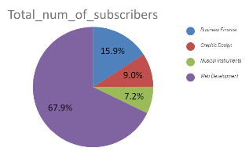

From this finding it is suggested that the subscribers are more inclined towards learning Web Development courses compared to other courses.

Given in the data, every course is classified based on their level of understanding and there lies 4 levels

* Beginner Level
* Intermediate level
* Expert level
* All levels

Cost is varying for every level for every subject.

Figure 2: Average cost per Subject at each level

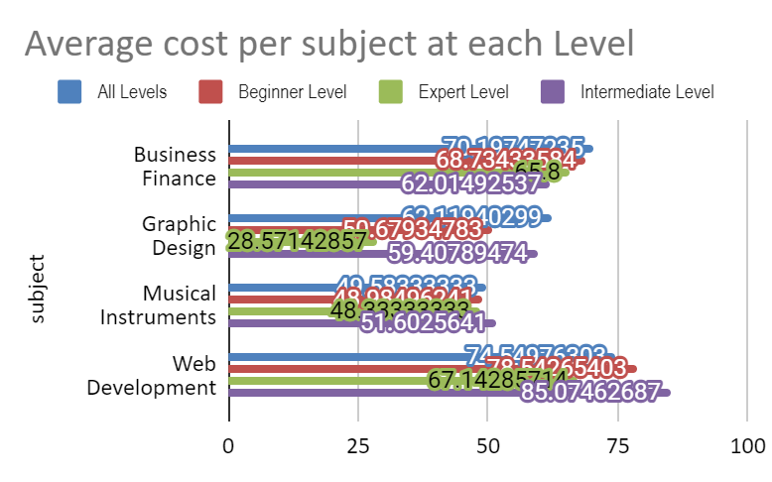

It is found that most of the subscribers chose All Levels as their Level of understanding and following depicts it

Figure 3: Number of subscribers at each level

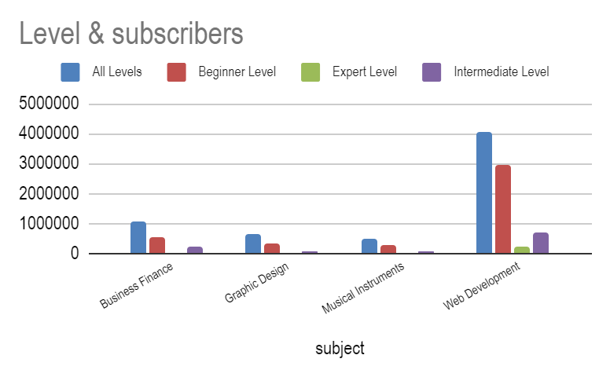

Following are the findings from EDA on Tableau

**Business Finance**

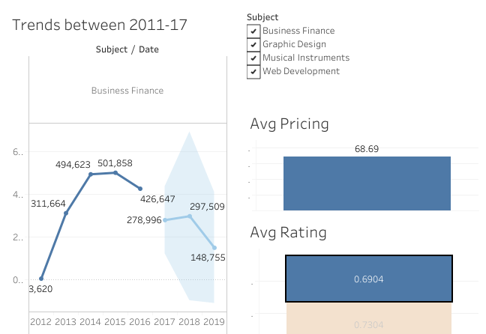

**Graphic Design**

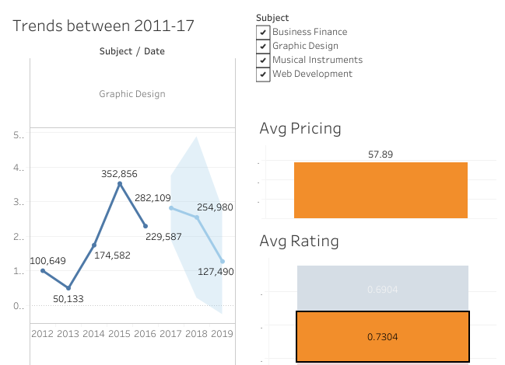

**Musical Instruments**

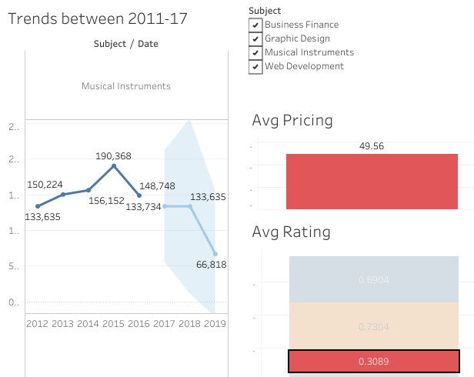

**Web Development**

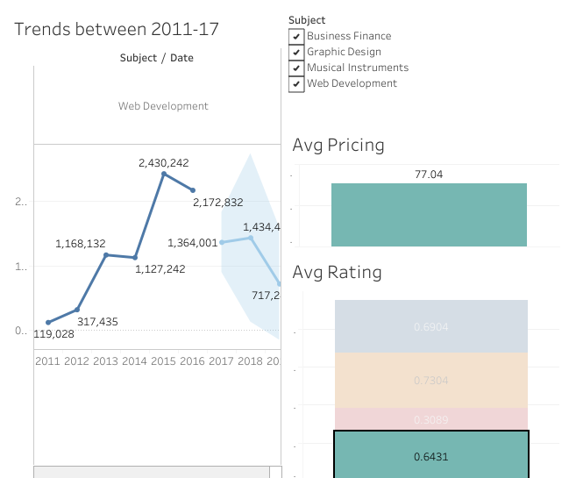

**ANALYSIS**

To find the solution to a problem it’s better to know the cause of the problem, therefore the **Root Cause Analysis (RCA**) was applied.

**Problem Statement**

Find the opportunities to increase revenue and track the performance of courses.

**Why is the Revenue not generated more in the past 2 quarters of the year 2017?**

The number of Subscribers was decreasing and from past 8 quarters there’s a decline in subscription of paid courses**.**

**Why is there a Decline in number of subscribers?**

The addition of new Courses was reduced in last 3 quarters compared to the previous years and so the updated content is not available, as a result the subscribers were less.

**Why were more courses not added in this year?**

Most of the viewed content of the subscribers was from the years 2013-15 so not many new courses were added.

**Why Subscribers were watching most of the courses from period between 2013-15?**

Majority of the subscribers are subscribed to web development and business Finance; between the years 2013-2015 there were many web development & Business Finance courses with better pricing and good ratings.

**Why most of the subscribers subscribed to Web Development courses?**

Among the 4 subjects, web development has major number of courses and most of the courses were beginner friendly and had positive reviews and ratings.

**CONCLUSION**

To generate more revenue, new courses with updated content and beginner friendly modules should be introduced. More than 60% of top 20 subscribed courses were free and to generate revenue these has to be made to paid courses with a course fee. Web Development has a constant retention of subscribers from past trends and so it is advised to add courses of this content. Business Finance and Graphic Design has more Avg Ratings than Web Development so it is better to add new courses related to these subjects and make high rated free courses to paid. The Content of paid courses with negative ratings should be reviewed and updated. The Musical Instrument subject is expected to lose more subscribers because of the poor reviews and content. So, these courses have to be replaced with new courses and better content. Graphic Design Courses has greater ratings and so the customer retention is also more. We can increase the pricing of these courses.

**Reference Links:**

You can view these findings and cleaned data through the link below.

* <https://docs.google.com/spreadsheets/d/1eCuAv8jLlH_qaQN6cukK_sXhAzYXMSp2/edit?usp=sharing&ouid=111379117912233518647&rtpof=true&sd=true>

For Interacting with the Tableau dashboard after EDA

* <https://public.tableau.com/views/Udemy_project/Dashboard1?:language=en-US&:display_count=n&:origin=viz_share_link>