Surveillance System

Alexandra Albu, Mathe Emese June, 2018

1. **Repository**

The project codebase, history, diagrams can be found at the following git repository:

<https://github.com/eme11/Ms-Project>

1. **User requirements**
2. The system must be activated from power supply.
3. The system must notify the user when it was last active
4. The system must save last footage before it went out.
5. While active, the system must continuously stream a live video on Youtube.
6. The system must be able to record videos.
7. The system must detect movement.
8. When movement is detected, the system must notify the user.
9. The system must be able to send e-mail with both video and text data.
10. **Use cases**
11. The user wants to permanently monitor an area, online and offline.
12. The user wants to detect movement in an area.
13. The user wants to be informed when movement is recognized in the monitored area.
14. **System overview**

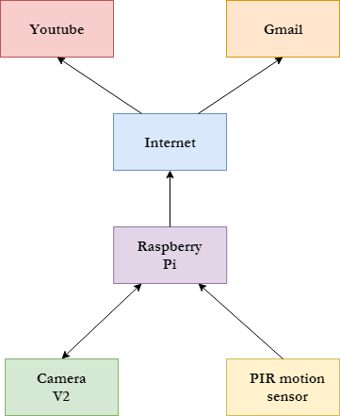

* System overview:

1. The system is activated from power supply.
2. The user is notified via an e-mail containing the last streamed video and the timestamp of when it was last active.
3. While active, the camera module continuously records a video and sends it to RPi.
4. The RPi starts a live stream on user’s Youtube channel via Internet connection.
5. When the motion sensor detects movement, it notifies the RPi.
6. The RPi notifies the user via an e-mail containing a warning text message and link to the video stream.
7. **Circuit design**

The hardware view of the system is depicted in the following figure:

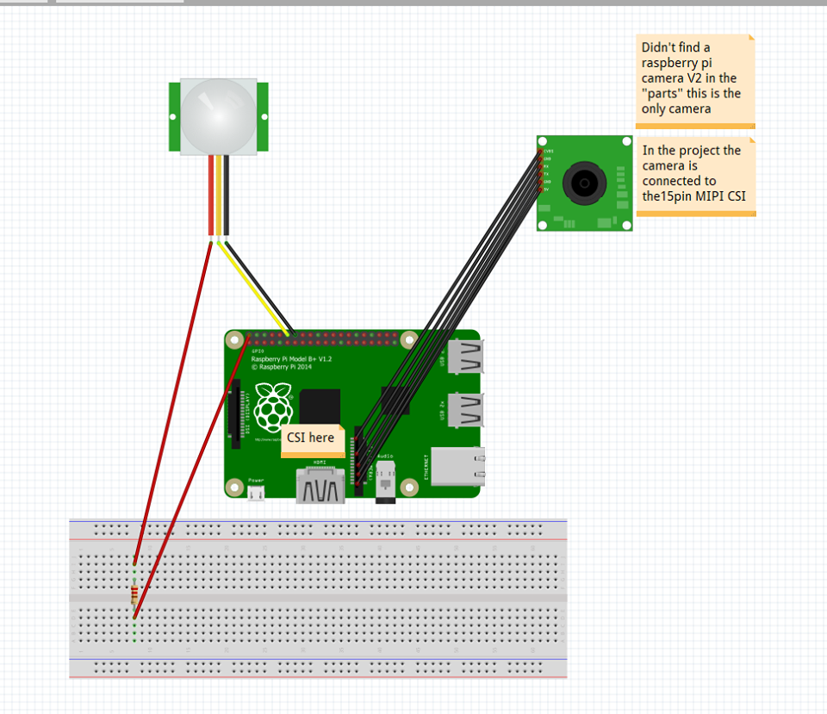

Camera Module v2

The components used in the project are the following:

* *RPi 3* – Raspberry Pi 3 is both faster and more capable than its predecessor. According to benchmark observations, RPi 3’s CPU has a 50-60% better performance. Real-world applications have seen a performance increase of more than 20 times when video playback is accelerated by the chip’s NEON engine. RPi3 is capable of playing 1080p MP5 video at 60 frames per second. It can also support wireless internet, with built-in Wi-Fi and Bluetooth.
* *RPi Camera Module v2* - The Raspberry Pi Camera Module was replaced in 2016 with the v2 version. The difference is the sensors of the Camera Modules, v1 has 5 megapixel OmniVision OV5647, while v2 has a Sony IMX219 8-megapixel sensor. It can be used to take HD videos, photographs, time-lapse, slow-motion and so on. It is accessed via MIPI CSI interface.
* *MIPI CSI* – It’s one of the most widely used hardware interface for deploying camera and imaging components in devices. It is used for complex imagining and vision systems.
* *PIR Motion Sensor –* This is a Passive Infrared Motion sensor, consisting of fresnel lens, an infrared detector and supporting detection circuitry. It outputs a 5V signal for a period of 1 minute as soon as it detects a body’s infrared heat, which it pickes up. The range of detection if about 6-7 meters. When the PIR motion sensor detects a person, it outputs a 5V signal to the RPi through its GPIO.
* *Wiring* -The wiring of the components is done via one wire interface.

1. **Software design**

The software components and data flow are depicted in the following diagram:

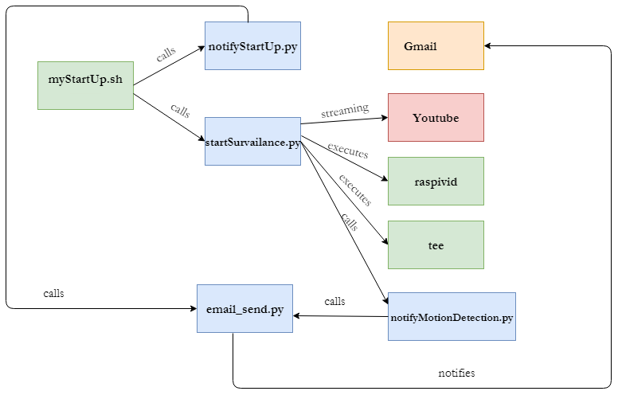

1. *Gmail* – user’s gmail account will be used for e-mail communication from RPi.
2. *Youtube* *Live Streaming API*– user’s youtube account will be used for live streaming the recorded footage using Youtube Live Streaming API.
3. *Scripts: myStartUp.sh* – called when system is activated by power supply. It is located in /etc/profile.d/. It executes notifyStartUp.py and startSurveilance.py, basically starting the whole system.
4. **Python modules**
5. *notifyStartUp.py* – notifies user that the system is active by sending an e-mail containing the last recorded video and when it was last active.
6. *startSurveilance.py* – captures video via raspivid command and records footage on device via tee command. Also starts live streaming on Youtube using Youtube Live Streaming API.
7. *notifyMotionDetection.py* – called when PIR detects movement. It sends a warning text message to the user via e-mail.
8. **Further work**

* Make an Android app to see live stream.
* Add remote access, via the Android app.
* Add take photo functionality in Android app.
* Edit video recording in slow motion.
* Add slow motion and timelapse feature.
* Integrate facial recognition software.

1. **References**
2. <https://www.zdnet.com/article/what-is-the-raspberry-pi-3-everything-you-need-to-know-about-the-tiny-low-cost-computer/>
3. <https://www.raspberrypi.org/products/camera-module-v2/>
4. <https://maker.pro/raspberry-pi/tutorial/how-to-interface-a-pir-motion-sensor-with-raspberry-pi-gpio>
5. <https://www.vision-systems.com/articles/2017/12/new-specification-from-mipi-alliance-streamlines-integration-of-image-sensors-in-mobile-devices.html>