SE/WE Course Project
Clinic Management System

Islamic University of Gaza
Faculty of Information Technology
CSCI2313 / WDMM3314
Submitted to: Dr. Abdelkareem Alashqar
Submitted by: Eman Mohammad Fathy Higazi
Student ID: 220211091
Semester: 1st Semester 2025/2026
Date: January 2026

Project Links
GitHub Repository: [PASTE YOUR PUBLIC GITHUB LINK HERE]
Project Video (Google Drive/YouTube): [PASTE YOUR VIDEO LINK HERE]

Abstract
This document presents the analysis, design, implementation, and testing of the Clinic Management System. The system supports clinic staff in managing patient records efficiently through a secure web-based application. The project follows the Waterfall software process model and applies Unified Modeling Language (UML) techniques to analyze and design the system. The system is implemented using PHP and MySQL without using any software frameworks. The report covers project planning, system requirements, UML diagrams, implementation details, and testing activities conducted to ensure system correctness and quality.

Note: You may generate the Table of Contents in MS Word: References -> Table of Contents.

Chapter 1. Project Plan

1.1 Project Overview
The Clinic Management System is a web-based application designed to help clinics manage patient records and daily workflows. It improves efficiency, reduces paperwork, and supports staff and doctors in delivering better services.

1.2 Problem Statement
Many clinics still depend on manual paperwork which leads to lost records, slow appointment handling, and administrative errors. A digital system is needed to organize operations, improve accuracy, and reduce delays.

1.3 Project Objectives
- Automate patient record management to reduce errors.
- Provide doctors with quick access to patient data during consultations.
- Reduce paperwork and minimize common administrative mistakes.
- Store clinic data securely in one centralized database.

1.4 Software Process Model
The Waterfall Model is selected for this project because the requirements are clear and stable. Each phase is completed before moving to the next, which makes the process structured and easy to manage.

1.5 Team Organization
This project is completed individually. All tasks of analysis, design, implementation, and testing are handled by the student.

1.6 Risk Analysis
- Requirement changes: Clear communication and documentation; keep scope focused.
- Technical issues: Use familiar tools and test features incrementally.
- Data loss: Regular backups and version control (Git).
- Limited time: Follow a realistic schedule and prioritize core features.

1.7 Hardware and Software Resource Requirements
Hardware: Laptop/PC and stable internet connection.
Software: PHP, MySQL, VS Code (or any IDE), web browser, and draw.io for UML diagrams.

1.8 Project Schedule
Main tasks: Requirements gathering, analysis, UML design, implementation, testing, and final report.

Chapter 2. System Requirements

2.1 System Overall Description
The Clinic Management System is a web-based application designed to help clinic staff organize and manage patient records. Authorized staff members can add, view, update, and delete patient information. Doctors can view patient records during consultations. The system improves workflow efficiency and minimizes administrative errors by storing patient data securely in a centralized MySQL database.

2.2 Main Use Case Diagram
Actors: Staff (Receptionist) and Doctor. Staff can log in and manage patient records. Doctor can log in and view patient records.

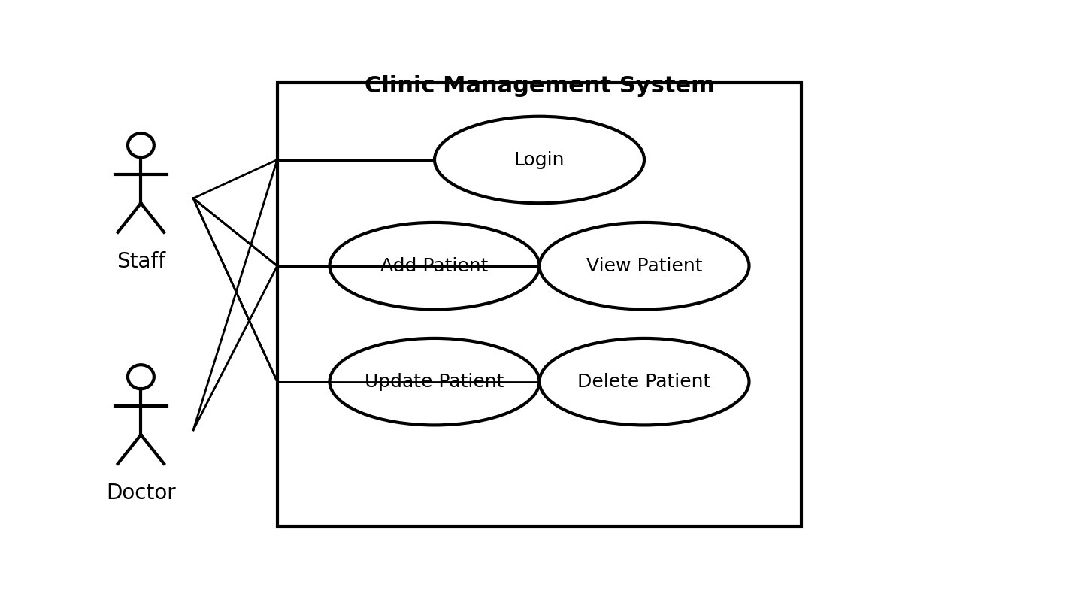

2.3 System Specific Requirements

2.3.1 Function Scenario for Login
ID | 1
Name | Login
Description | Allows staff or doctor to access the system using valid credentials.
Priority | Must have (1)
Actors | Staff, Doctor
Pre-Conditions | User account exists in the system database.
Normal Flow | 1) Open login page. 2) Enter username and password. 3) System validates credentials. 4) On success, system creates a session and redirects to dashboard.
Alternative Flow | A1) Invalid credentials: system shows error and allows retry. A2) Empty fields: system prompts user to fill required fields.
Post-Conditions | User is authenticated and a session is started.

2.3.1.1 Sequence Diagram for Login
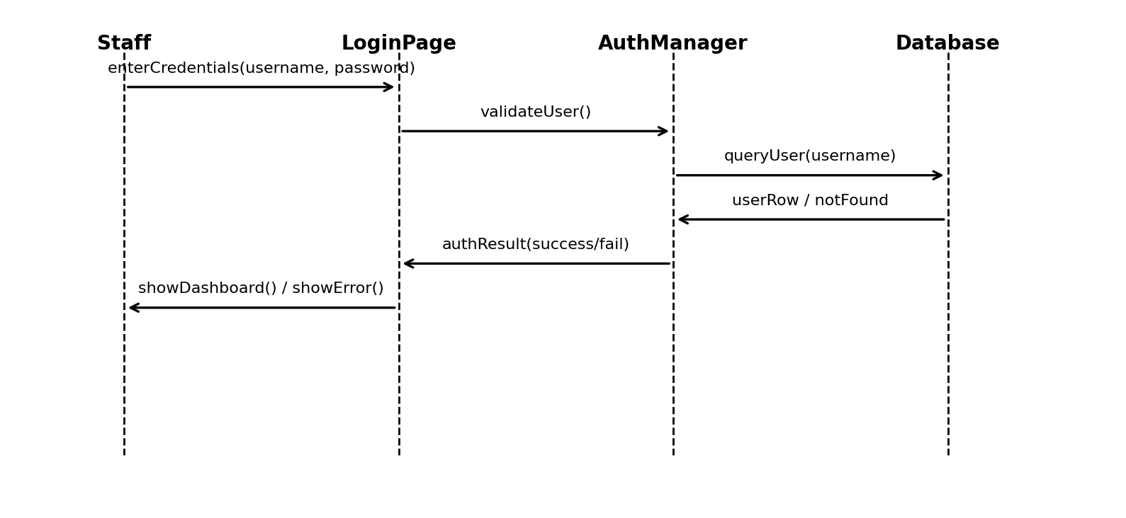

2.3.2 Function Scenario for Add Patient Record
ID | 2
Name | Add Patient Record
Description | Allows staff to add a new patient record.
Priority | Must have (1)
Actors | Staff
Pre-Conditions | Staff is logged in.
Normal Flow | 1) Open Add Patient form. 2) Enter patient data. 3) System validates input. 4) System stores patient record in database. 5) System shows success message.
Alternative Flow | A1) Missing required fields: system shows validation errors. A2) Duplicate patient (optional check): system warns user.
Post-Conditions | New patient record is saved and can be retrieved later.

2.3.2.1 Sequence Diagram for Add Patient Record
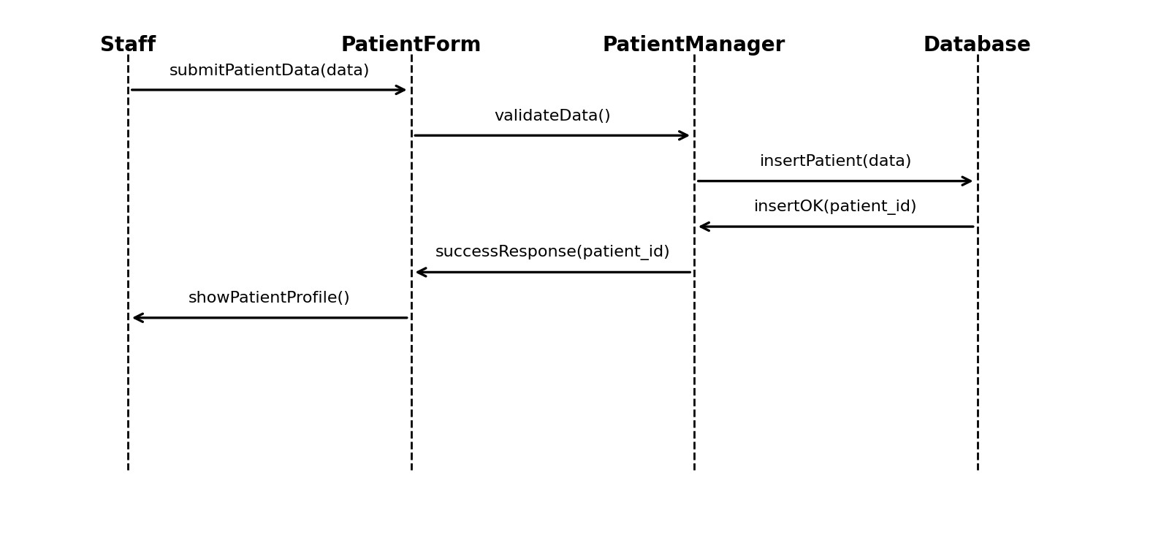

2.3.3 Function Scenario for View Patient Record
ID | 3
Name | View Patient Record
Description | Allows staff/doctor to view patient information.
Priority | Must have (1)
Actors | Staff, Doctor
Pre-Conditions | User is logged in; patient exists.
Normal Flow | 1) Search/select patient. 2) System retrieves patient data. 3) System displays patient profile.
Alternative Flow | A1) Patient not found: system shows “No results found”.
Post-Conditions | Patient information is displayed without modification.

2.3.4 Function Scenario for Update Patient Record
ID | 4
Name | Update Patient Record
Description | Allows staff to update an existing patient record.
Priority | Must have (1)
Actors | Staff
Pre-Conditions | Staff is logged in; patient exists.
Normal Flow | 1) Open patient profile. 2) Click Edit. 3) Update fields and submit. 4) System validates input. 5) System updates record and shows confirmation.
Alternative Flow | A1) Validation fails: system shows errors and keeps user on edit page.
Post-Conditions | Patient record is updated in database.

2.3.5 Function Scenario for Delete Patient Record
ID | 5
Name | Delete Patient Record
Description | Allows staff to delete a patient record after confirmation.
Priority | Should have (2)
Actors | Staff
Pre-Conditions | Staff is logged in; patient exists.
Normal Flow | 1) Open patient profile. 2) Click Delete. 3) Confirm deletion. 4) System deletes record and returns to patients list.
Alternative Flow | A1) User cancels confirmation: no deletion occurs.
Post-Conditions | Patient record is removed from the system (or marked inactive if soft delete is used).

2.4 List of Classes

2.4.1 Interface (Boundary) Classes
- LoginPage
- DashboardPage
- PatientListPage
- PatientCreatePage
- PatientEditPage
- PatientViewPage
- PatientDeleteConfirmationPage

2.4.2 Entity Classes
- User
- Patient

2.4.3 Control (Manager) Classes
- AuthManager
- PatientManager
- DatabaseConnection
- UserRepository
- PatientRepository

2.5 Non-Functional Requirements
- Security: store passwords using secure hashing; only authenticated users can access protected pages; role-based access for staff and doctor.
- Performance: patient search and profile display should respond within acceptable time under normal clinic load.
- Usability: clear forms with validation messages for incorrect inputs.
- Reliability: prevent saving incomplete required data and handle database errors gracefully.
- Maintainability: organize code into separate modules (auth, patients, config) to simplify updates.

Chapter 3. System Design

3.1 Application Architecture using Package Diagram
The system is decomposed into three main packages: Authentication, Patient Management, and Database. Authentication and Patient Management depend on the Database package for data storage and retrieval.

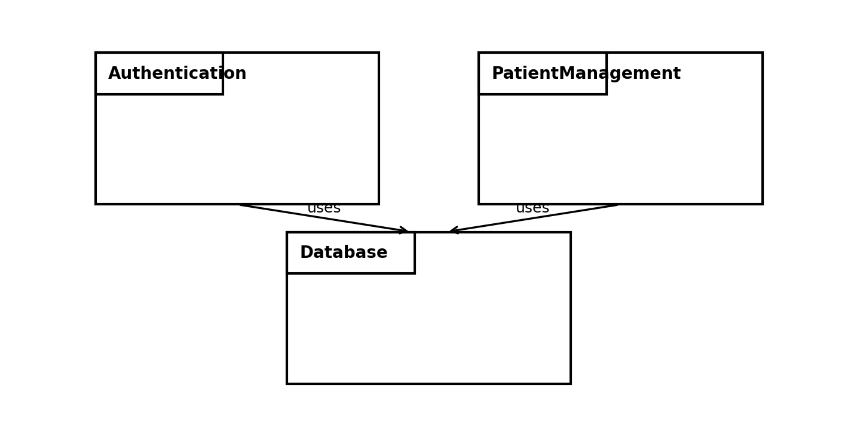

3.2 Modules (Packages) Descriptions

3.2.1 Authentication Package
Responsible for login, session handling, and access control.
Classes: LoginPage, AuthManager, User, UserRepository.

3.2.2 Patient Management Package
Responsible for patient CRUD operations and displaying patient information.
Classes: Patient, PatientManager, PatientListPage, PatientCreatePage, PatientEditPage, PatientViewPage, PatientRepository.

3.2.3 Database Package
Responsible for MySQL connectivity and executing SQL queries safely.
Classes: DatabaseConnection.

Class Diagram (main classes)
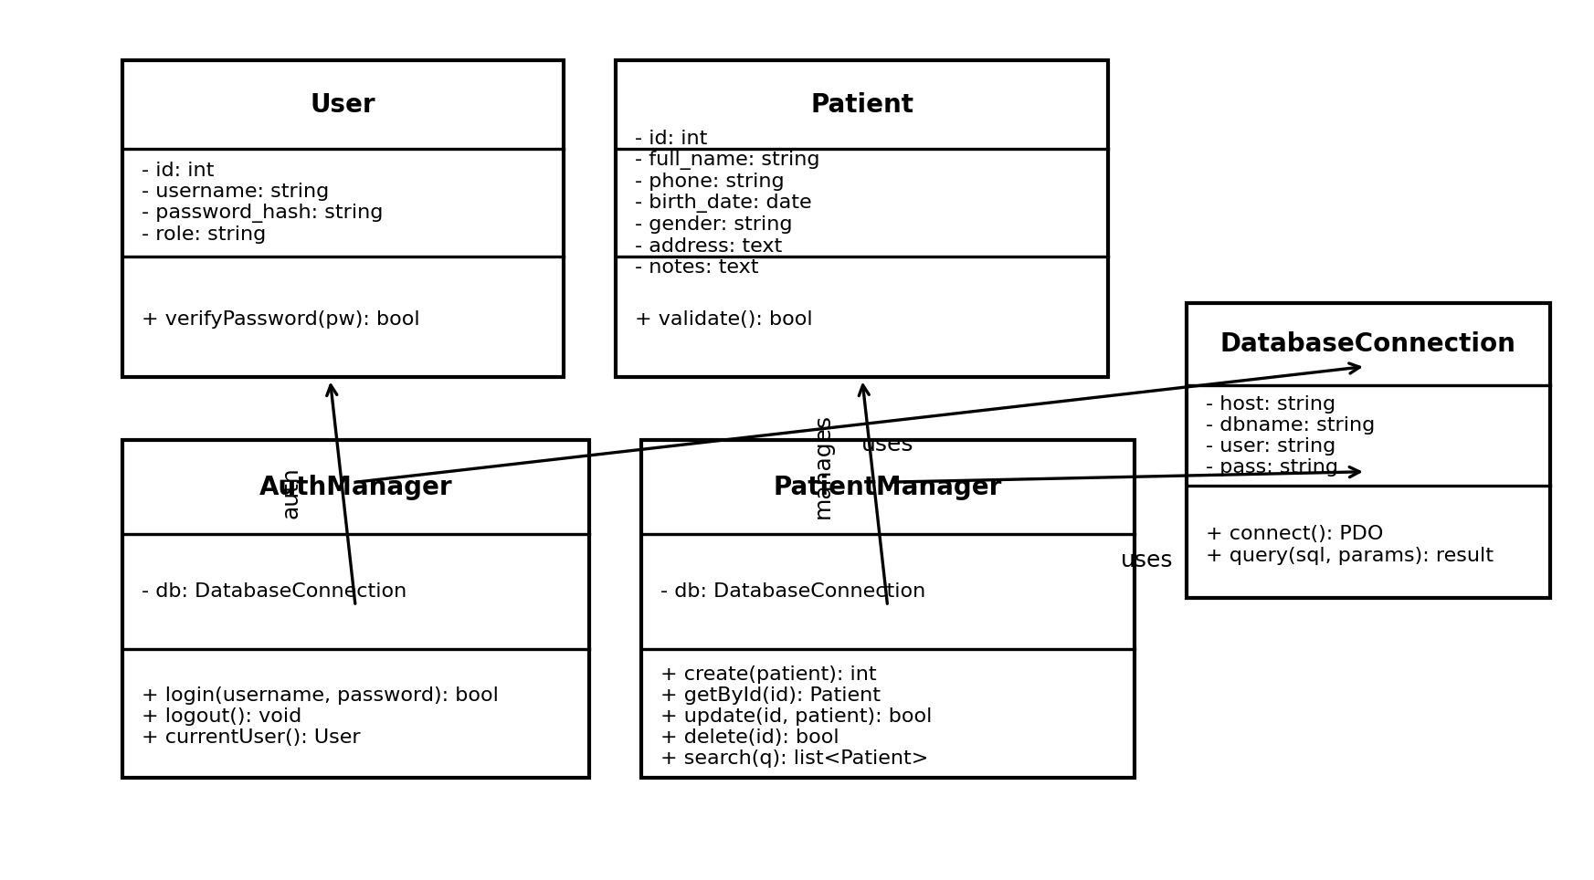

Chapter 4. System Implementation and Testing

4.1 Coding and Coding Standards
The system is implemented using PHP with MySQL database connectivity. The code is written from scratch without using any software frameworks. Files are organized by functionality (config, auth, patients). SQL queries use prepared statements to reduce SQL injection risks. Code is commented where needed for clarity.

4.1.1 Database Schema (MySQL)
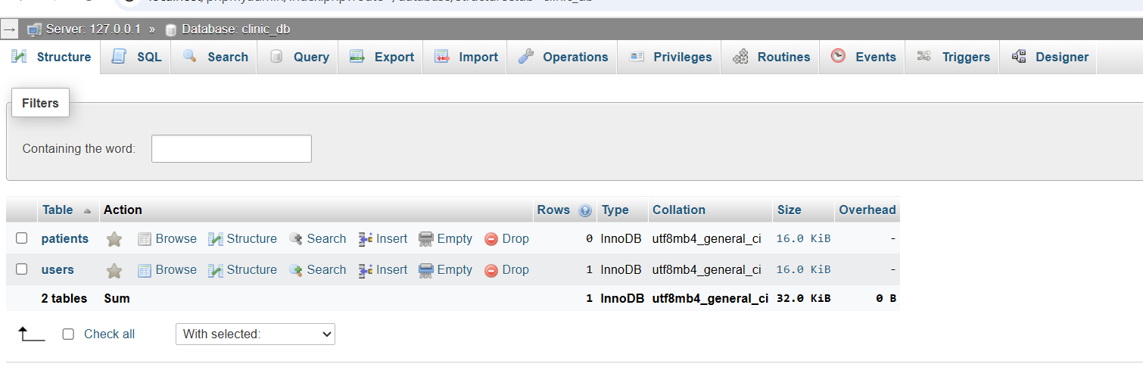

4.1.2 Database Connection (config/db.php)
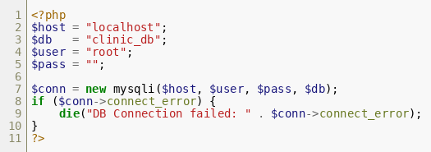

4.1.3 Login Implementation (auth/login.php)
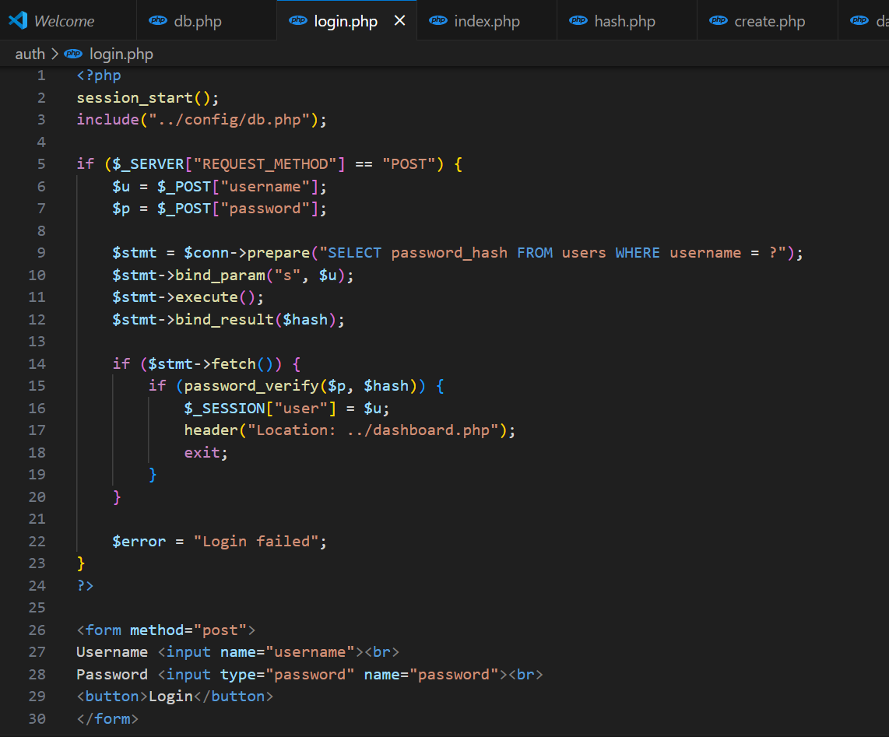

4.1.4 Authentication Check (includes/auth_check.php)
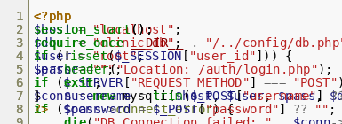

4.1.5 Patients List (patients/index.php)
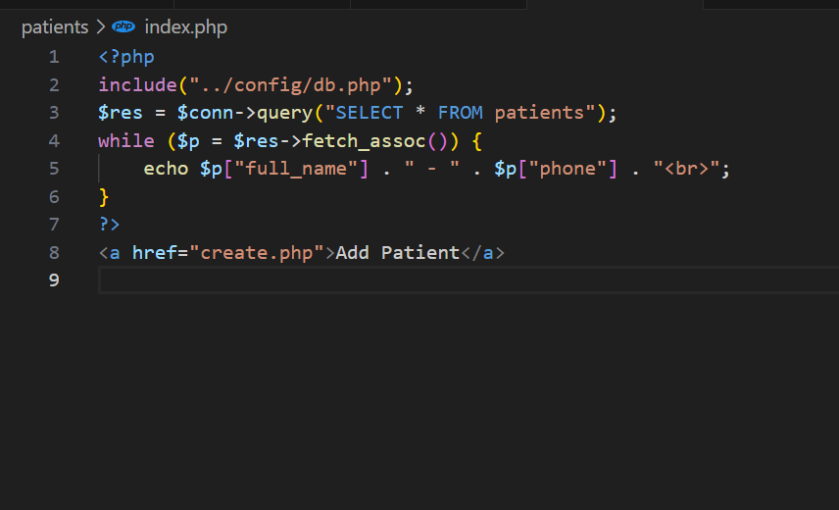

4.1.6 Add Patient (patients/create.php)
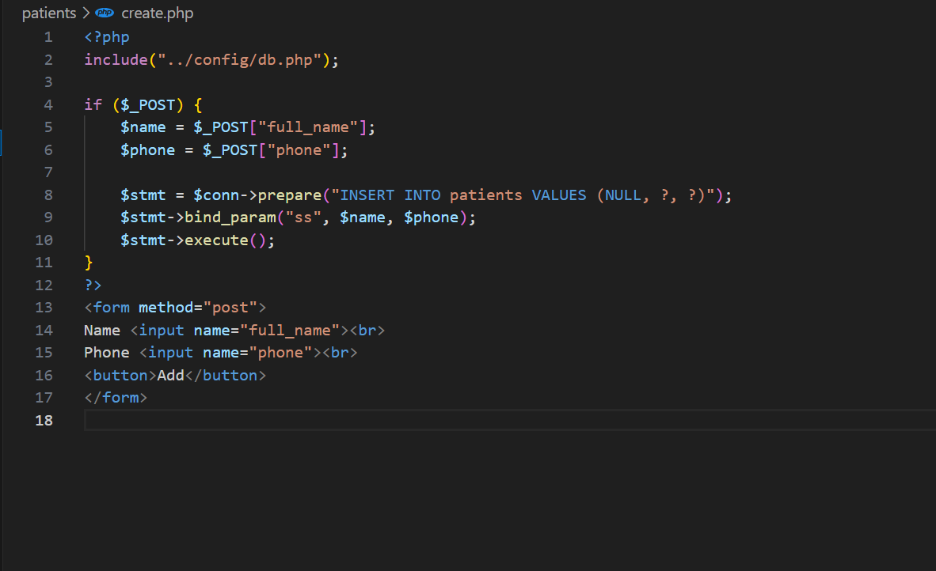

4.2 System Testing
Testing activities include unit testing for individual functions (e.g., validation and database operations), system testing for end-to-end flows (login and patient CRUD), and acceptance testing to ensure the system meets staff needs.

4.2.1 Test Cases
# | Function | Test Steps | Test Data | Expected Results | Actual Results | Status
1 | Login | Enter valid credentials and submit | username=admin, valid password | Dashboard is displayed | As expected | Pass
2 | Login | Enter invalid password and submit | username=admin, wrong password | Error message is shown | As expected | Pass
3 | Add Patient | Open Add Patient and submit valid data | full_name, phone | Patient is added and appears in list | As expected | Pass
4 | View Patient | Open patient from list | existing patient id | Patient profile displayed | As expected | Pass
5 | Update Patient | Edit patient and save | updated phone | Patient updated in database | As expected | Pass
6 | Delete Patient | Delete patient with confirmation | existing patient id | Patient removed from list | As expected | Pass

References
- Ian Sommerville, Software Engineering, 10th Edition, Pearson, 2016.
- PHP Manual, php.net documentation.
- MySQL 8.0 Reference Manual, dev.mysql.com documentation.
- Object Management Group (OMG), Unified Modeling Language (UML) Specification.

الصور المأخوذة من تنفيذ المشروع (Screenshots)
واجهة تسجيل الدخول (Login Page)
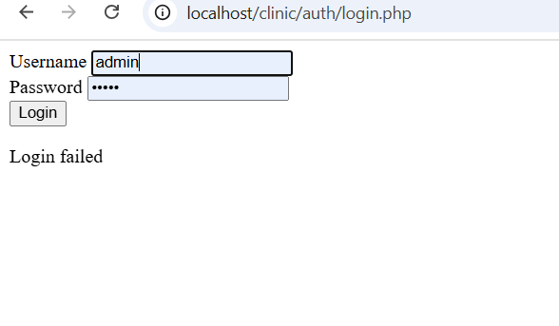
جدول المستخدمين في قاعدة البيانات (users table)
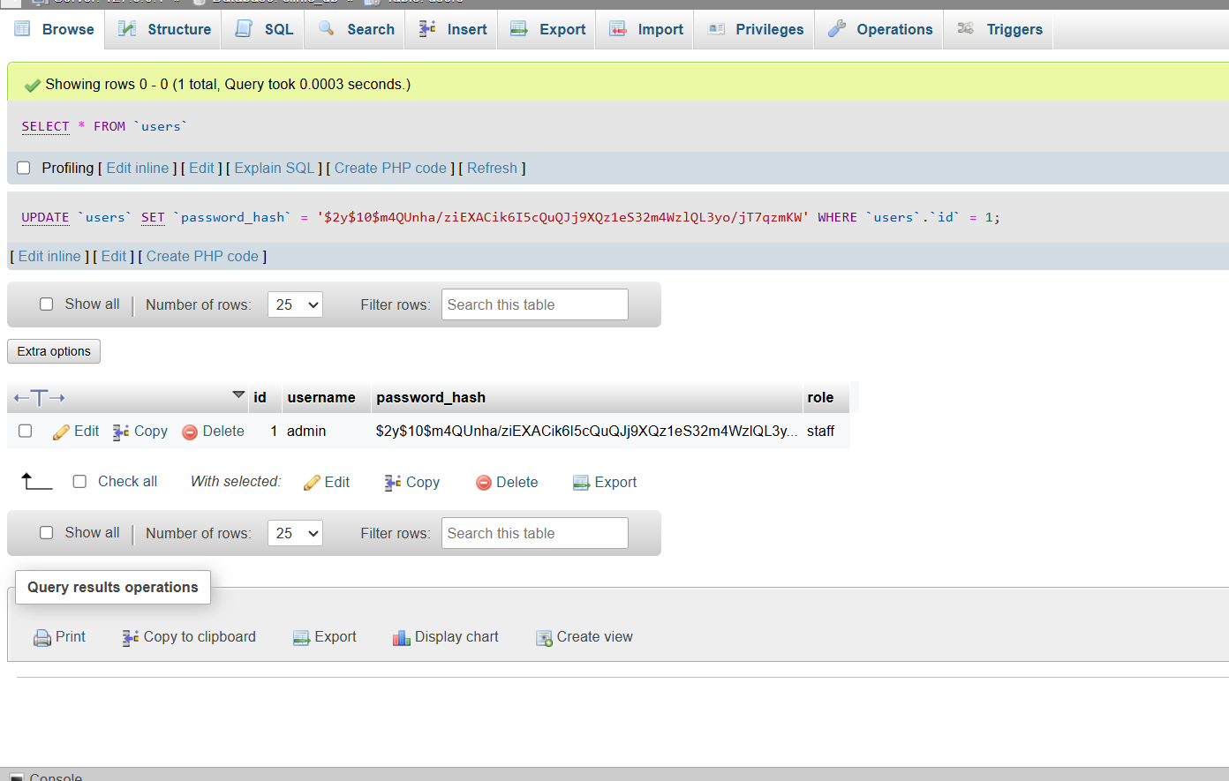
لوحة التحكم بعد تسجيل الدخول (Dashboard)
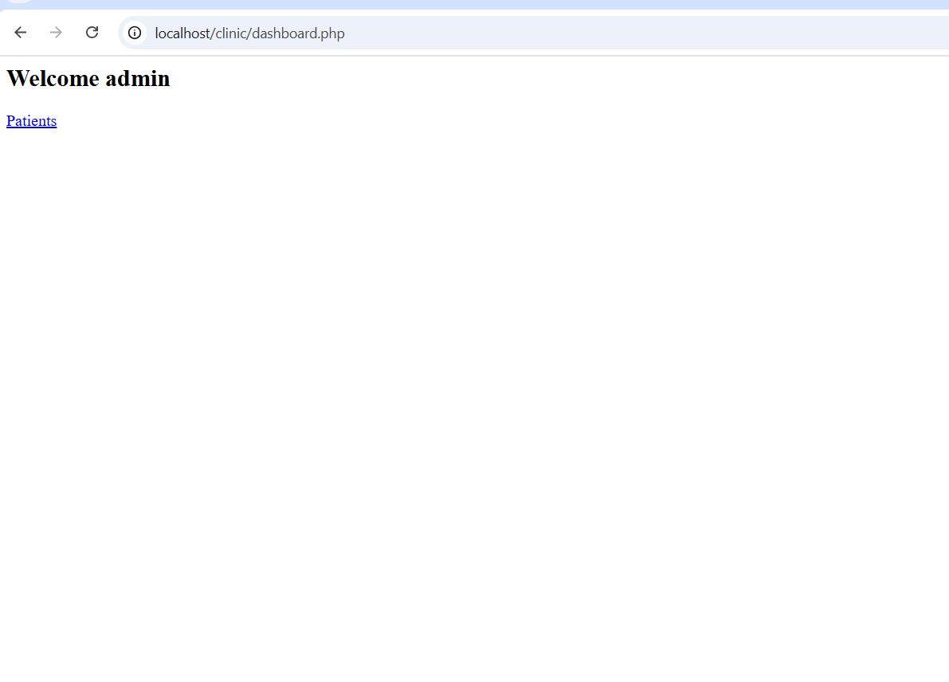

إدارة المرضى (Patients Management)
صفحة عرض المرضى (Patients Page)
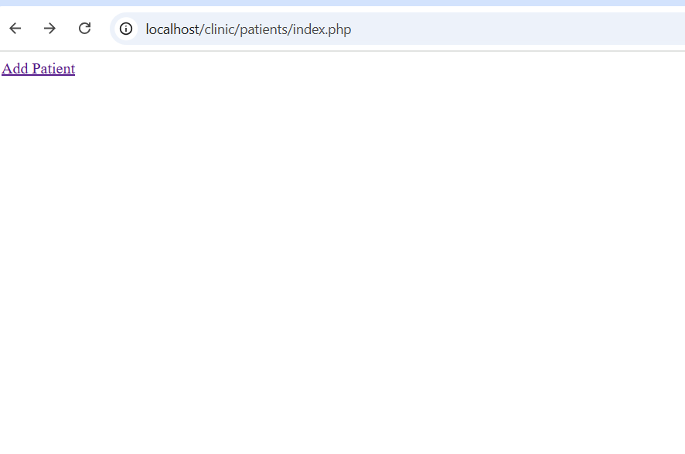
صفحة إضافة مريض جديد (Add Patient)
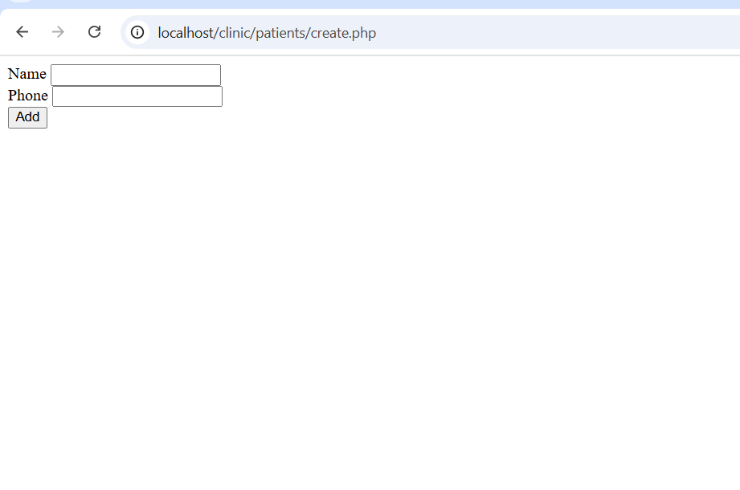

هيكل قاعدة البيانات (Database Structure)
هيكل قاعدة البيانات clinic_db ويظهر جداول users و patients

