H730 Audio Instructions
V0.3 – March 24, 2021
How to use this crazy thing

What is it?
The H730 Audio board is a general purpose audio / DSP development system with the following features:
- STM32H730 MCU
  - 550MHz ARM Cortex M7 CPU
  - 128kB flash memory
  - 564kB SRAM
  - Range of peripherals – USB, SD, SPI, I2C, I2S, ADC, PDM, etc.
- WM8731 Stereo Audio Codec
  - 48/96 kSPS
  - 16 / 24 bit
  - Line level In / Out
  - Headphone Out
  - Mic In
- 240x240 0.96” IPS LCD display
- Rotary Encoder w/ pushbutton
- 8MB QSPI PSRAM (up to 43s delays for audio)
- 32kB I2C EEPROM for user settings
- Micro USB jack for power and firmware updates
- SD Card slot w/ power control
- 8-channel GPIO terminal block (for ADC, DAC or digital I/O)
  - Note that voltages between 0V to +3.3V are supported. There is some protection circuitry to guard against values outside this range, but it’s best to ensure these boundaries are not exceeded.
- Power & Status LEDs
- Reset and Bootloader buttons

Tour
Boot & Reset buttons
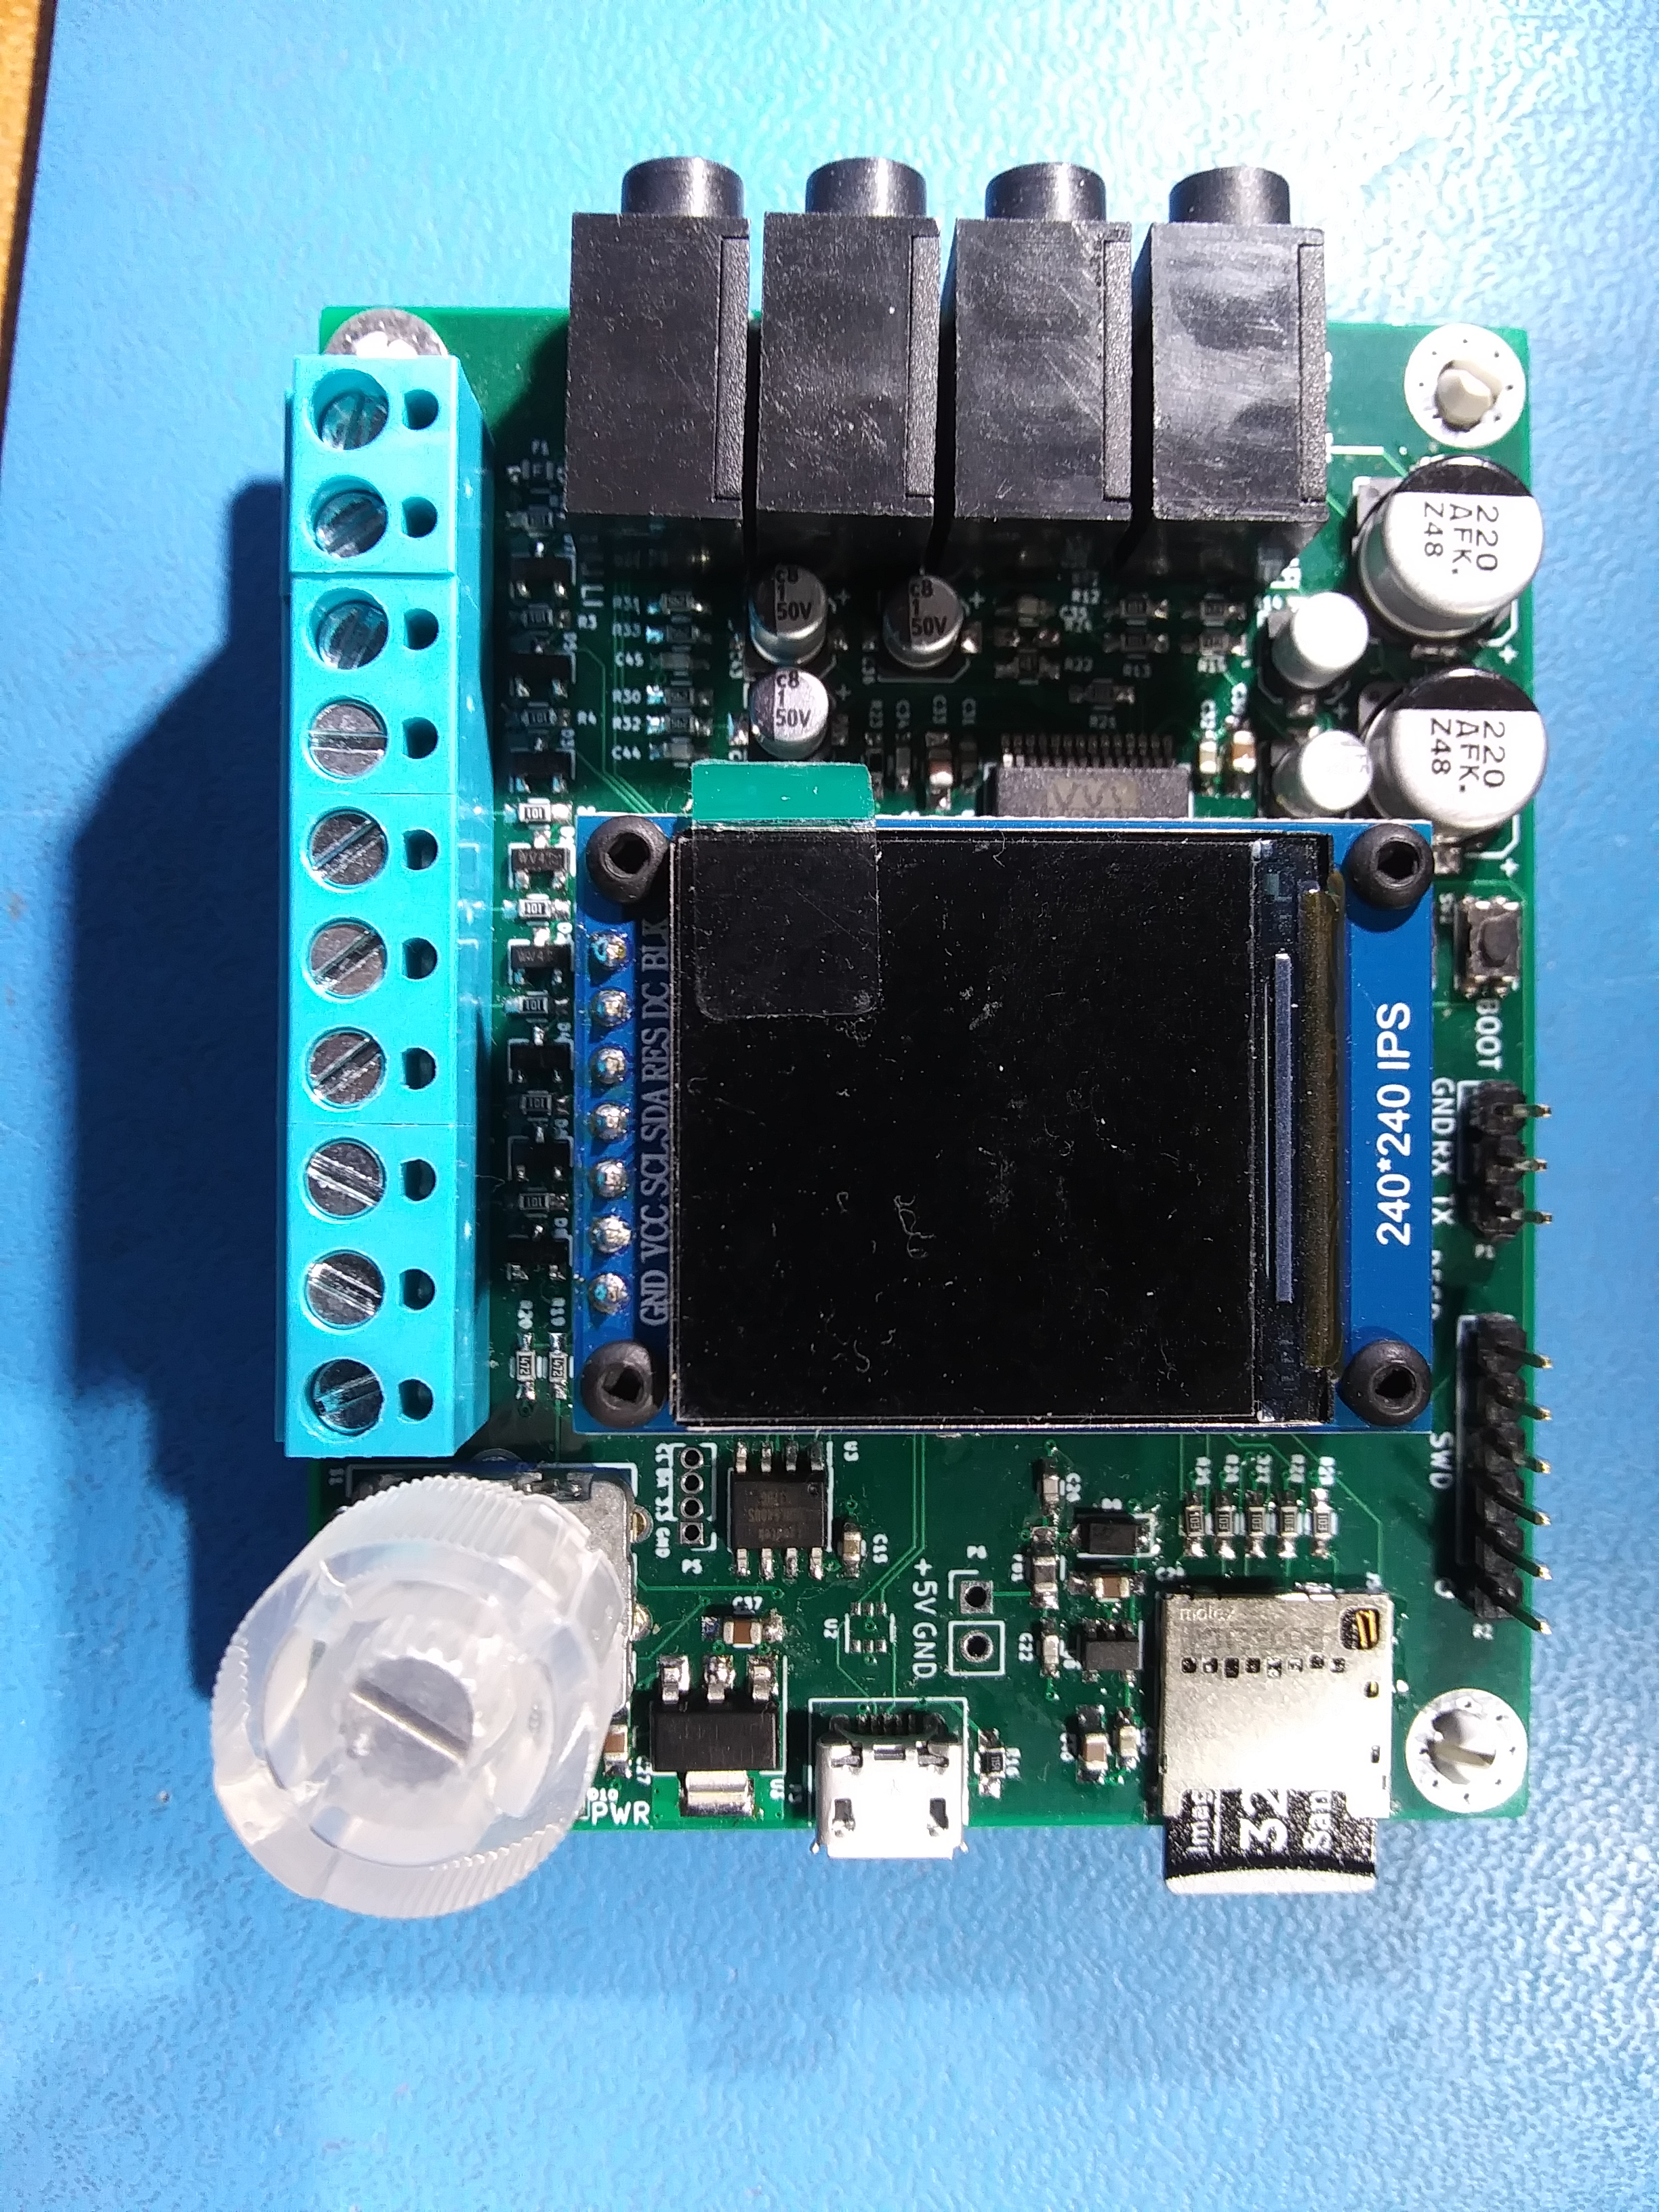
Principle I/O of the H730 Audio board
Headphone
Line Out
Mic In
Line In
SD Card
USB
3.3V
GND
PA7
PA6
PA5
PA4
PA3
PA2
PA1
PA0
Encoder + Button
Power LED (red)
Status LED (green)
Program
Header
The photo above shows the location of jacks and controls on the H730 board. Some of these labels can also be found in the silkscreen on the back of the board.

Setup
- Hook up 3.5mm stereo audio in / out cables
  - Choose either Line In/Out or Headphone / Mic. Line / Headphone outputs are always active, but Line / Mic inputs are only active for algorithms that require input.
  - Headphone output volume can be adjusted. Line output is not adjustable.
  - Line Input gain is adjustable. Mic input gain is only adjustable at two settings (0dB / 20dB)
  - Mic input is not stereo. Instead, the tip is the audio signal, ring is bias and shield is ground. This is compatible with standard PC microphones and headsets.
- Hook up control voltages to the terminal block as required.
  - Not all algorithms will use control voltages.
  - Use the +3.3V and GND terminals as required.
  - Note that the +3.3V terminal is provided with a self-resetting thermal fuse, but try to avoid shorting it to GND.
- Apply 5V power via the USB jack
- Observe the LCD for the title of the algorithm
- Note the Status (green) LED flashing at 1Hz
- Use the Encoder and button to select menu items and edit values to configure the application

Firmware Updates
Firmware for the H730 Audio board can be loaded either via the 6-pin SWD header using an ST-Link adapter, or via the USB jack and the built-in USB DFU class bootloader. To use the USB DFU you will be provided with a .dfu file that the bootloader can accept. Follow these steps:
- Connect the H730 Audio with a USB cable to a host computer which can run the dfu-util application (usually a Raspberry Pi or other Linux-based system.)
- Press the BOOT button and hold it. It may be easier to do this with a blunt tool, like a pen.
- Press and release the RST button. The green status LED should NOT be flashing after this point.
- Release the BOOT button.
- Run the dfu-util program with the proper command parameters on the host computer. Typically something like: dfu-util -a 0 -s 0x8000000 -D <firmware filename>
- The dfu-util program will provide progress reports and should complete after about a minute, reporting success with the line “File downloaded successfully”, after which you may press RST again (without simultaneously pressing BOOT) to resume normal operation.

Applications
There are currently two different end-use applications in development for the H730 Audio board:

Cloud Generator
This is a cloud generator in the same class as the Synthtech E340, E352 or E370. It supports 4 voices or “groups” of up to 16 oscillators with independent frequency, amplitude, spread, chaos, waveform and stereo panning. Frequency and amplitude can be controlled by control voltages applied to the ADC inputs on the terminal block.

Menu
Use the Encoder knob to navigate the 2-level menu. At power up the menu will be in the top page. Turn the knob to select a sub-page and press the knob to enter. Within sub-pages use the encoder to select editable items or to exit back to the top page.
The menu consists of
- Top – the main navigation page from which all other pages are chosen
  - Visual – a real-time graphic display of the frequency, amplitude and spread of the oscillator groups. Frequency is marked across the bottom of the graph and ranges from about 10Hz to over 10kHz. Amplitude ranges from 0dBfs at the top down to -64dBfs at the bottom. Amplitudes less than -64dBfs will still display a tiny nub near the bottom. Each cloud group is rendered in a different color and a color legend is shown above the graph.
  - Group 1-4 – the setup pages from which the parameters of each group are controlled
    - Frequency – the base frequency of the group ranges from ~8Hz to ~13kHz in equally tempered steps.
    - Frequency Scale – the sensitivity of the frequency to the CV input. Ranges +/-99% in 2% steps. A value of 0% means that the frequency is not affected by the CV.
    - Amplitude – the base amplitude of the group ranges fro 0dBfs to -99dBfs. A value of 0dBfs is loudest.
    - Amplitude Scale - the sensitivity of the amplitude to the CV input. Ranges +/-99% in 2% steps. A value of 0% means that the amplitude is not affected by the CV.
    - Spread - the bandwidth of the cloud. All the oscillators in the group will be evenly spread out across this range.
    - Kaos – the amount and rate of random frequency variation applied to each oscillator in the group.
    - Nosc – number of oscillators in the group. Ranges from 0 to 16 (0 disables the group).
    - Wave – the waveform for the oscillators. Can be Sine, Saw, Pulse. Note that the Saw and Pulse waves are not “bandlimited” and can alias noticeably at high frequencies.
    - Pan – the distribution of the group across the Left / Right stereo channels.
  - Prefs – sets some global parameters of the Cloud Generator
    - HPF – corner frequency of a 2nd-order HPF on the combined output.
    - LPF – corner frequency of a 2nd-order LPF on the combined output.
    - HPVol – volume control for the headphone output.
    - Pull – selects the type of pull resistor to engage on the CV inputs. Options are:
      - Off – no pull resistor.
      - Down – a pull to ground is enabled. This is a good choice for solar cells that are referenced to the GND input terminal.
      - Up – a pull to 3.3V is enabled this may be useful for some situations.
  - About – displays some pertinent info about the running application, including
    - Time, Date and Version of the firmware build
    - Current status of the 8 CV inputs
    - USB Bus voltage – usually between 4.5-5.0V
    - Reference voltage – should be 3.3V always.
    - Temp – the STM32H730 die temperature. Usually around 50C.
At the top of each menu page is a header with the name of the page, the current CPU load and the EEPROM status indicator which is green when the EEPROM is up-to-date and turns red for a few seconds when the EEPROM is about to be updated due to a parameter change.

Terminal
The 8 CV inputs on the terminal block are allocated thus:
- PA0 – Frequency for Group 1
- PA1 – Amplitude for Group 1
- PA2 – Frequency for Group 2
- PA3 – Amplitude for Group 2
- PA4 – Frequency for Group 3
- PA5 – Amplitude for Group 3
- PA6 – Frequency for Group 4
- PA7 – Amplitude for Group 4

Delay
The Delay application is a simple 48ksps stereo audio delay line that provides delay times in excess of 24 hours using a non-volatile SD card as the buffer. Audio data is stored on the SD card in eight WAV files, so the previous 24 hours of recorded audio can be captured and used offline – the files can be pasted together without glitches at the splices for extended recordings.

Menu
Use the Encoder knob to navigate the 2-level menu. At power up the menu will be in the top page. Turn the knob to select a sub-page and press the knob to enter. Within sub-pages use the encoder to select editable items or to exit back to the top page.
The menu consists of
- Top – the main navigation page from which all other pages are chosen
  - Delay – the main control page for the Delay.
    - There are five editable parameters:
      - Delay, arranged in three items on one line:
        - HH – the number of hours in the total amount of delay
        - MM – the number of minutes in the total amount of delay
        - SS – the number of seconds in the total amount of delay
      - Mix – Dry/Wet mix amount, where 0% is full dry (undelayed) and 100% is full wet (delayed) signal.
      - Fbk – feedback amount, where 0% is no feedback and 100% is full feedback with no attenuation.
    - There are a number of status displays
      - Level meters – audio signal level meters for left & right input & output are displayed as colored bar-graphs. Best operation is obtained with signal levels in the green or yellow regions. When signal levels are in the red region then clipping is likely to occur.
      - dly – the total amount of delay, displayed in HH:MM:SS format. Regardless of the user settings this value will not exceed the maximum allowed by the active delay buffer – either 43 seconds for the QSPI RAM or 24:51:18 for the SD card.
      - wpt – the current location of the write pointer (same as the record head) in the delay buffer, displayed in HH:MM:SS format.
      - rpt – the current location of the read pointer (same as playback head) in the delay buffer, displayed in HH:MM:SS format.
      - len – the total length of the buffer, displayed in HH:MM:SS format. For a properly formatted SD card this should read 24:51:18, but if the SD card is not present or isn’t correctly formatted then it will read 00:00:43 for the duration of the on-board QSPI RAM.
      - File – the current file and percentage of the write pointer. This is just a different way of looking at the “wpt” value above and can help to understand where the wrap-around point in the buffer is when using the recorded data externally.
  - Prefs – sets some global parameters of the Delay
    - HPF – corner frequency of a 2nd-order HPF on the combined output.
    - LPF – corner frequency of a 2nd-order LPF on the combined output.
    - HPVl – volume control for the headphone output.
    - Inpt – input source, either Line or Mic
    - InVl – input volume control for the line input.
    - Mbst – mic boost, either 0dB or 20dB.
    - Pull – selects the type of pull resistor to engage on the CV inputs. Options are:
      - Off – no pull resistor.
      - Down – a pull to ground is enabled. This is a good choice for solar cells that are referenced to the GND input terminal.
      - Up – a pull to 3.3V is enabled this may be useful for some situations.
    - Lmtr – a limiter on the input signal level which can prevent external feedback from causing the signal to become too strong. There are three levels available:
      - Soft (default) - -3dBfs threshold and slow response.
      - Med - -6dBfs threshold and medium response.
      - Fast - -12dBfs response and fast response.
      - Off – limiter disabled.
  - About – displays some pertinent info about the running application, including
    - Time, Date and Version of the firmware build
    - Current status of the 8 CV inputs
    - USB Bus voltage – usually between 4.5-5.0V
    - Reference voltage – should be 3.3V always.
    - Temp – the STM32H730 die temperature. Usually around 50C.
At the top of each menu page is a header with the name of the page, the current CPU load, the type of memory in use (either a red “Q” for the on-board QSPI RAM or a green “S” for the SD card) and the EEPROM status indicator which is green when the EEPROM is up-to-date and turns red for a few seconds when the EEPROM is about to be updated due to a parameter change.

Operation
When first powered on the Delay firmware will check to see if there is an SD card present which has been properly set up to use as a delay buffer. During this step a text box that says “Checking Files” will be displayed for 2 – 20 seconds depending on what it discovers. The process flows like this:
- Check if there is an SD card present
  - If no SD card is found then the on-board QSPI RAM is used for the delay buffer. This is only 8MB in size so the maximum delay available is 43 seconds.
- If an SD card is present, check to see if the card is large enough.
  - If the card is not large enough a warning “SD card too small” will be displayed and the QSPI RAM will be used. Try again with a card of 32GB in size.
- If the card is large enough, check to see that the eight 2.1GB WAV files have already been set up.
  - If the files are present they are put into use.
  - If the files are not present then the software attempts to create them. Creating the files requires a lot of operations on the SD card and can take several seconds per file.
    - Note that if the card has previously been used for other purposes it may not be possible to create the files. If this happens then a warning “File Error” will be displayed and it will be necessary to remove the card and reformat it to provide a clean filesystem.
- After all the files have be either found or created then the Delay firmware will proceed to the Top menu.
At power up the Delay begins writing into the audio buffer memory at the beginning and will not start playing back until the read pointer enters a region of the buffer with known-good audio. Since the firmware doesn’t have any way to know if the SD card files contain previously recorded sounds there will always be a period of silence that lasts for the duration of the chosen delay.

Files
Buffered Audio data is stored in eight 2.1GB 16-bit stereo WAV files named “AUDIO0.WAV” – “AUDIO7.WAV”. To use the recorded audio data simply power down the board, remove the SD card and connect it to a PC or Mac with an SD card reader.
These files should only be copied or read from the SD card. Under no circumstances should you attempt to create or overwrite these files on a PC or Mac as this disturbs the special formatting. If the files are accidentally disturbed then it’s best to reformat the card to wipe it clean and let the Delay firmware recreate the files from scratch.
The format of these files should be compatible with well-designed audio production and playback software, but there are some unique characteristics of the WAV header that are necessary for the firmware to access the SD card quickly, so it is possible that some software may have difficulty reading these files. The WAV files have been used successfully with the following software:
- Audacity
- SOX
- VLC
If you experience difficulties with reading the WAV files, try importing and exporting the files with a known-good application such as those listed above.

Terminal
The Delay firmware does not use any of the analog input connections. Port pins 4, 6 and 7 are used for some diagnostic outputs but these are not useful in normal operation.

Power
In order to prevent corrupting the SD card, the Delay firmware has been designed to detect when 5V power is removed and quickly enter a “safe” mode during which all firmware activity is disabled and the green LED will flash at ~10Hz. Because of this, it is very sensitive to low voltage or poorly regulated supplies. If you plug the USB power supply in and the red power LED lights up and the green LED flashes at a fast rate but the display does not light, or the firmware appears to lock up then it is possible that the supply voltage is too low. Please ensure that you use a supply with at least 5V @ 1A rating.

