BCC_SDR Design
Eric Brombaugh KC7GXA
Tom King KA6SOX

Overview

Motivation
Software Defined Radio (SDR) is becoming more commonly used in all facets of communications, both in research, commercial and amateur applications. There are numerous proprietary products available, as well as an increasing number of open source designs suitable for learning and applying the technology, both at the low and high-ends of the price range. Unfortunately, a compact, high-performance solution in the middle price range with readily available hardware and good documentation is harder to find. The BCC_SDR board attempts to address this with a reasonably priced open source hardware solution.

Top-level system architecture
A complete BCC_SDR system consists of a Beaglebone Linux-based embedded computer coupled with a Blank Canvas Cape S6 FPGA daughtercard which then connects to the BCC_SDR board. All three boards have the same 2.2”x3.4” rounded shape and together form a 3-board stack. The Beaglebone may communicate with the FPGA via SPI, GPMC, PRU or I2S ports and the FPGA then controls the BCC_SDR board through 32 flexible I/O signals. The FPGA design may constitute a general-purpose receiver for audio or specific digital modem logic or any combination thereof.

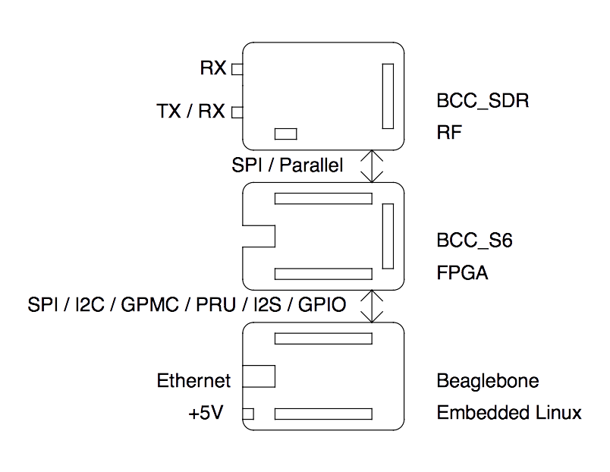

Design Goals
- Direct Conversion LF, MF, HF multi-mode SDR Modem. (150khz-30mhz)
- VHF and UHF Single Conversion SDR Modem. (50mhz-450mhz)
- Internet Connected SDR Receiver(Transmitter)
- Ham Bands focus (160m-70cm)
- Open Source Hardware and Software
- 0.2uV RX, +10dbm TX
- Simplex, Half-Duplex or Full Duplex (including split band for Satellite work)

HARDWARE

Block Diagramme
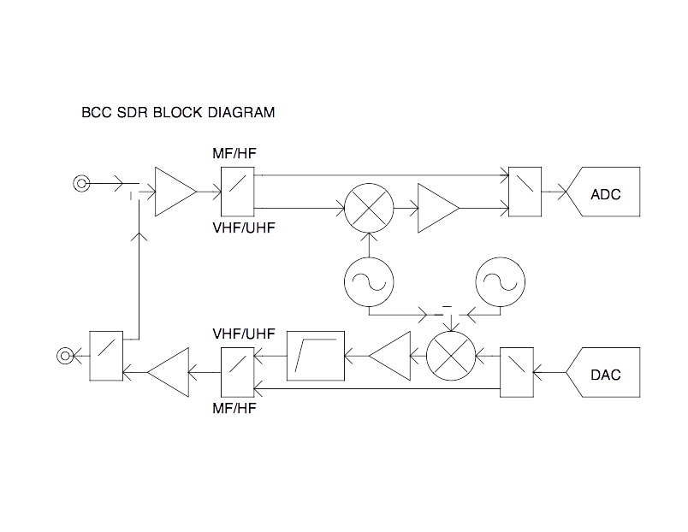

Digital Section

Off Board Connector
The BCC SDR system interfaces to the Blank Canvas Cape Spartan 6 (BCC S6) via a 40-pin Hirose FX2 connector which carries the following signals:
Pin | Name | Function
1 | GND
2 | NC
3 | JA4 | T/R Switch
4 | JA5 | TX CLOCK (driven from AD9865)
5 | JA6 | PGA0
6 | JA7 | PGA2
7 | JB4 | PGA4
8 | JB5 | AD9865 SPI Chip Enable (active low)
9 | JB6 | SPI MISO
10 | JB7 | TX Enable
11 | JC4 | RX0
12 | JC5 | RX2
13 | JC6 | RX4
14 | JC7 | TX0
15 | JD4 | TX2
16 | JD5 | TX4
17 | JD6 | PLL Latch Enable 0 (TX & RX synth, or optional TX only)
18 | JD7 | CLKOUT2 (driven from AD9865)
19 | +5V
20 | GND
21 | GND
22 | NC
23 | JA0 | SPI Port Expander Chip Select (active low)
24 | JA1 | RX CLOCK (driven from AD9865)
25 | JA2 | Reset (active low)
26 | JA3 | PGA1
27 | JB0 | PGA3
28 | JB1 | PGA5
29 | JB2 | SPI Clock
30 | JB3 | SPI MOSI
31 | JC0 | RX Enable
32 | JC1 | RX1
33 | JC2 | RX3
34 | JC3 | RX5
35 | JD0 | TX1
36 | JD1 | TX3
37 | JD2 | TX5
38 | JD3 | PLL Latch Enable 1 (Optional separate RX synth)
39 | +5V
40 | GND

FPGA Interfaces
The FPGA interface consists of the high-speed parallel connection to the AD9865 ADC / DAC, a SPI port with four possible targets (the AD9865, an 8-bit SPI port expander and two PLL synthesizers) and a high-speed T/R switch control.

AD9865 Digital Ports

TX Data Bus
The AD9865 Transmit Data bus is a 6-bit parallel data bus, along with SYNC/ENABLE and Clock signals which carries data to the transmit DAC. The function of this bus is described in detail in the AD9865 data sheet.

RX Data Bus
The AD9865 Receive Data bus is a 6-bit parallel data bus, along with SYNC/ENABL and Clock signals which carry data from the receive ADC. The function of this bus is described in detail in the AD9865 data sheet.

PGA Bus
The AD9865 PGA bus is a 6-bit parallel data bus which can control the RX gain in real-time for fast AGC functions. The function of this bus is described in detail in the AD9865 data sheet.

SPI Control Bus
The AD9865 SPI Control bus is a 4-pin serial bus which is used to access internal status and control registers. It is used set up the operation of the device and monitor operating state. Because it is a serial bus, it is not suitable for fast updates. The function of this bus is described in detail in the AD9865 data sheet.

Static Control
Three static control signals are driven by the SPI Port Expander (described below) which affect global operations of the AD9865. Mode, Config and PDN pins are all described in detail in the AD9865 data sheet.

MCP23S08 SPI Port Expander
The MCP 23S08 SPI port expander generates low-speed configuration signals for the AD9865 and the HF / VHF switch controls. It contains eight bi-directional bits which are allocated as follows:
Bit | Function
0 | Receive path HF / VHF switch output
1 | Transmit path HF / VHF switch output
2 | PLL 0 Lock detect input
3 | PLL 1 Lock detect input
4 | PLL 1 & 0 Chip Enable
5 | AD9865 Mode control output
6 | AD9865 Config control output
7 | AD9865 Power Down output

Receive path switch
This output bit selects either the direct HF input path, or the VHF/UHF path which passes through the downconverter.

Transmit path switch
This output bit selects either the direct HF output path, or the VHF/UHF path which passes through the upconverter.

PLL 0 Lock Dectect
This input bit contains the lock detect state of PLL 0 which is may drive both the TX and RX VHF/UHF conversion circuits if only one PLL is present, or just the TX upconverter if both PLLs are available. When this bit reads '1', the PLL is locked and ready for use.

PLL 1 Lock Dectect
This input bit contains the lock detect state of PLL 1 which drives the RX downconverter if both PLLs are available. When this bit reads '1', the PLL is locked and ready for use.

PLL 0 & 1 Chip Enable.
Setting this bit to '0' powers down the PLLs.

AD9865 Mode control
Selects Half-Duplex or Full-Duplex operation of the AD9865 parallel busses.

AD9865 Config control
Controls the power-up configuration of the SPI control registers.

AD9865 Power Down
Powers down the AD9865.

ADF4351 PLL Synthesizers
The ADF4351 PLL synthesizer(s) generate the TX and RX Local Oscillator frequencies. These devices provide wide bandwidth (35-4400MHz) operation – well beyond the capability of the VHF/UHF circuits that they drive.
One or two ADF4351 PLL synthesizers are provided. If just one is available then the TX and RX LO frequencies will be related by powers-of-two. If both PLLs are available then the TX and RX LO frequencies may be arbitrary and unrelated.
The PLL chips are controlled with a simple 3-wire SPI-like serial interface and contain multiple internal control registers. The interface is fully described in detail in the ADF4351 data sheet.

Reference Oscillator
The AD9865 and ADF4351 chips both require a reference oscillator. A single 40MHz oscillator drives the AD9865 and it passes a copy of this signal on to the AD4351 chip(s). Two options are provided:

Simple Crystal Oscillator
A 40MHz parallel resonant crystal oscillator footprint along with loading capacitors are provided which operate in conjunction with drive circuits in the AD9865 chip to generate a stable 40MHz clock. The simple crystal oscillator can provide frequency accuracy of approx 100ppm.

Temperature Compensated Crystal Oscillator
A footprint for a TCXO is provided which can be used when greater frequency accuracy than that provided by the simple crystal oscillator is required.

Power Supply
An NCP1532 dual switch-mode regulator is provided which generates separate 3.3V supplies for the analog and digital circuits from the +5V input. Each section of the power supply can provide up to 1000ma current at efficiencies approaching 97% for overall reduced heat generation.
The smps operates as a PWM driver at a nominal switching frequency of 2.25MHz. Sufficient filtering is provided to reduce the high-frequency ripple below the level which could interfere with operation of the RF circuits.

Analogue Section

Receiver

Jumper/RX SMA
The RX SMA is chosen by a solder jumper for Full-duplex operations and bypassed when the TX/RX Switch is used.

Preamp
Preamp is a Mini-Circuits Labs PSA4-5043+ with 0.65db NF and 21.5db of gain across the entire MF/HF/VHF/UHF spectrum.

HF path: bypass switches, to 9865 rx transformer
The HF Path is direct to the AD9865 via the RX transformer utiliiing the bypass switches. The PGA in the AD9865 has sufficient dynamic range and gain to allow 0.1uV sensitivity for narrowband operations at MF/HF and 120db of Dynamic range without compression.

VHF/UHF path: Switch, RX Mixer, IF Amp, Switch to 9865 rx transformer.
The VHF/UHF path is via the bypass switches into the Mixer, a MCL ADE-1, with a 7db conversion loss. A 15db pad stabilizes the output of the mixer. The IF amplifier is another PSA4-5043+ that makes up the loss of the switches, mixer, and pad.

Transmitter

2.4.2.1 HF Path: 9865 TX transformer, bypass switches to TX Amp, TX/RX switch TX(rx) SMA
The Modulated signal from the 9865 is routed thru the bypass switches to the TX Amp, a Mini-Circuits PSA4-5043+, providing up to +10dbm of output with a 10db crest factor. The signal is then passed thru the TX/RX switch to the TX(RX) SMA Connector.

2.4.2.2 VHF/UHF path: 9865 TX transformer, switch to TX mixer, Post amp with HPF, switch to TX Amp, TX/RX switch, TX(rx) SMA
The Modulated signal from the 9865 is routed thru the bypass switch to the TX mixer, a Mini-circuits ADE-1, and then to a 6db pad that stabilizes the output before being amplifed by the Post Mixer amp, a Mini-Circuits PSA4-5043+ to make up the losses of the switches, mixer, pad and High Pass Filter. The signal is then passed thru a 40mhz 7-pole Butterworth Filter, to filter out the IF signal, before being sent on to the PA Ampifier. The TX Amp is a Mini-Circuits PSA4-5043+, providing up to +10dbm of output with a 10db crest factor.
The signal is then passed thru the TX/RX switch to the TX(RX) SMA Connector.

Local Oscillators

Only used for VHF/UHF, 35-500mhz Single for Simplex only operation, 2 for Duplex/Split Band operation. Each Local Oscillator has 2 separate outputs and is capable of +5dbm to drive the mixers.
They are controlled via a SPI like interface.

SOFTWARE
The complete BCC SDR system consists of a Beaglebone embedded Linux computer, Blank Canvas Cape S6 FPGA board and the BCC SDR RF board. Software running as a Linux user application on the Beaglebone controls the entire system via the BCC S6 FPGA. The overall software system is described below:

Control
Prior to any radio operations, the Beaglebone must boot to a running Linux system and execute the user application. The user application loads the FPGA bitstream into the BCC S6 board and uses the SPI bus to configure the AD9865 and ADF4351 chips. Once all static configuration information is loaded into the BCC SDR chips then RF operation begins.
User applications are developed using a simple library of interface functions that supports configuration and control of the BCC S6 FPGA via the Beaglebone SPI and I2C interfaces. Once the FPGA is configured, further interfaces between the FPGA and Beaglebone may be established, including parallel GPMC, high-speed PRU or I2S for serial audio.

FPGA
The FPGA bitstream is developed using Xilinx's free ISE Webkit targeting the XC6SLX9 device on the BCC S6 board. The FPGA design may be written in either VHDL or Verilog, along with configuration files provided which define the pre-existing interfaces between the Beaglebone, FPGA and BCC SDR board. The FPGA on the BCC S6 board contains sufficient resources to support a wide variety of data and voice/audio RF waveforms.

Data/Audio

REFERENCE DOCUMENTS

AD9865 Data Sheet
http://www.analog.com/static/imported-files/data_sheets/AD9865.pdf

MCP23S08 Data Sheet
http://ww1.microchip.com/downloads/en/DeviceDoc/21919e.pdf

ADF4351 Data Sheet
http://www.analog.com/static/imported-files/data_sheets/ADF4351.pdf

NCP1532 Data Sheet
http://www.onsemi.com/pub/Collateral/NCP1532-D.PDF

Mini-Circuits ADE-1 Data Sheet
http://www.minicircuits.com/pdfs/ADE-1.pdf

Mini-Circuits PSA4-5043+ Data Sheet

http://www.minicircuits.com/pdfs/PSA4-5043+.pdf

