Ipv4 – int 32 bits
ipv6 – arranjo - 16 bytes – 128 bits

c nao existe super classe, mas podemos passar um ponteiro de uma super classe.

Struct sockaddr_storage – e’ grande, alocar espaço e escolhe o tipo de endereço que vamos usar

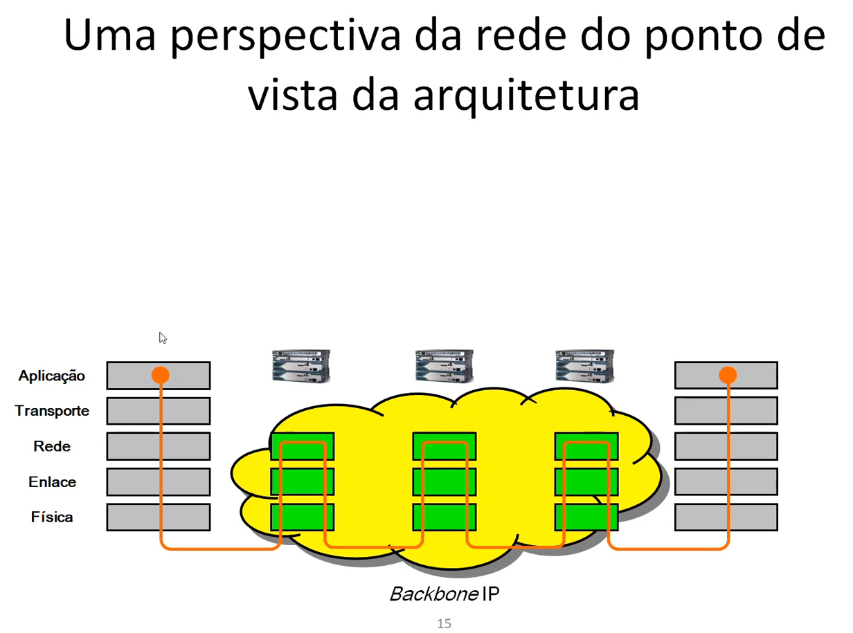

Pegar arquivo – enviar arquivo pela rede (enlace)
receber arquivo do outro lado.

1a coisa – enquadramento – ler dados do disco
2¹⁶ – ate 16 bits

Codificação
enquadramento
e correção de erros – checksum

para mandar dados – converter dados emm letras

PROCESSAR O QUADRO E GRAVAR
E aquela dica

Dica: A função [encode16] deve ser a última função chamada antes de transmitir dados na rede e a função [decode16] deve ser a primeira função chamada antes de receber dados da rede.

Serve pras questoes de unicode por conta de formulação tbm?

O base16 nao trata o dado, ele le o dado e coloca no dado,

struct – pack/unpack – construir dados na memória do jeito que ta assim. Constroi vetor de bytes

sequenciamento – um pacote por vez!

Nessa parte de codificação, modulação e eficiência, fala-se sobre códigos de correção de erro. Uma forma de correção seria trocar a modulação dinamicamente ou seria os esquemas NRZ,/NRZI/etc? Isso nao ficou explícito pra mim.

Nos satélites, o custo de transmissão de uma mensa-
gem é independente da distância percorrida. O serviço de
uma chamada transcontinental não custa mais do que uma
chamada entre um lado e outro da rua.

P77

satélites

Direcionalidade

SIMPLEX – transmissão possível somente em um sentido
utilizando fótons na informação, fibra ótica, TV, Rádio, CCD, GPS

HALF – DUPLEX - transmissão alternada entre sentidos
rádio amador, protocolos requisição, não da pra transmitir e receber ao mesmo tempo

FULL – DUPLEX – transmissão SIMULTÂNEA
telefone, modem

Acesso Múltiplo

Multiplexação – divisão dos recursos do meio, maximiza o número de conexões.
Presente na camada física e enlace (mais dinâmica)

FDM – Frequency Division Multiplexing
canais de televisão, tv a cabo, config. roteador de wifi – canais lógicos dividem o espectro de frequência. Coexistência de transmissão

WDM – Wavelength Division Multiplexing
Separam a luz por comprimento de onda, fibra multimodo

TDM – Time Division Multiplexing
tempo é dividido em canais de tempo fixo/janelas.
WiMax – cria ideia de alocação tanto no tempo quanto na frequência

Os satélites de comunicações possuem algumas pro-
priedades interessantes, que os tornam atraentes para mui-
tas aplicações. Em sua forma mais simples, um satélite de
comunicações pode ser considerado um grande repetidor
de micro-ondas no céu. Ele contém diversos transpon-
ders; cada um deles ouve uma parte do espectro, amplifica
os sinais de entrada e os transmite novamente em outra
frequência, para evitar interferência com o sinal de entra-
da. Esse modo de operação é conhecido como um canal
em curva (bent pipe). O processamento digital pode ser
acrescentado para manipular ou redirecionar separada-
mente os feixes de dados na banda geral, ou informações
digitais ainda podem ser recebidas pelo satélite e retransmi-
tidas. A regeneração de sinais dessa maneira melhora o de-
sempenho em comparação com um canal em curva, pois o
satélite não amplifica o ruído no sinal ascendente. Os feixes
descendentes podem ser largos, cobrindo uma fração subs-
tancial da superfície terrestre, ou estreitos, cobrindo uma
área com apenas centenas de quilômetros de diâmetro

socket é um manipulador que usamos para comunicar com um sistema operacional para fazer a comunicação em rede!

A socket is an abstraction through which an application may send and receive data, in much
the same way as an open-file handle allows an application to read and write data to stable
storage. A socket allows an application to plug in to the network and communicate with other
applications that are plugged in to the same network. Information written to the socket by
an application on one machine can be read by an application on a different machine and vice
versa.
Different types of sockets correspond to different underlying protocol suites and differ-
ent stacks of protocols within a suite. This book deals only with the TCP/IP protocol suite.
The main types of sockets in TCP/IP today are stream sockets and datagram sockets. Stream
sockets use TCP as the end-to-end protocol (with IP underneath) and thus provide a reliable
byte-stream service. A TCP/IP stream socket represents one end of a TCP connection. Data-
gram sockets use UDP (again, with IP underneath) and thus provide a best-effort datagram
service that applications can use to send individual messages up to about 65,500 bytes in
length. Stream and datagram sockets are also supported by other protocol suites, but this
book deals only with TCP stream sockets and UDP datagram sockets. A TCP/IP socket is
uniquely identified by an Internet address, an end-to-end protocol (TCP or UDP), and a port
number. As you proceed, you will encounter several ways for a socket to become bound to
an address.

telnet program available on most systems. This is a command-line tool that
connects to a server, sends whatever text you type, and prints the response. Telnet takes
two parameters: the server and port. For example, to telnet to our example echo server from
above, try
% telnet 169.1.1.1 5000
Now type your string to echo and telnet will print the server response. The behavior of telnet
differs between implementations, so you may need to research the specifics of its use on your
system.

Applications using sockets need to be able to identify the remote endpoint(s) with which they
will communicate. We’ve already seen that a client must specify the address and port number
of the server application with which it needs to communicate. In addition, the sockets layer
sometimes needs to pass addresses to the application. For example, a feature analogous to
“Caller ID” in the telephone network lets a server know the address and port number of each
client that communicates with it.
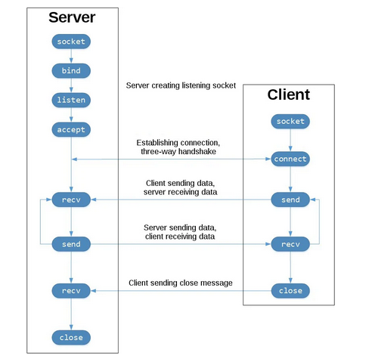

A TCP socket must be connected to another socket before any data can be sent through it. In
this sense using TCP sockets is something like using the telephone network. Before you can
talk, you have to specify the number you want, and a connection must be established; if the
connection cannot be established, you have to try again later. The connection establishment
process is the biggest difference between clients and servers: The client initiates the connection
while the server waits passively for clients to connect to it. (For additional details about the
connection process and how it relates to the API functions, see Section 7.4.) To establish a
connection with a server, we call connect() on the socket

int connect(int socket, const struct sockaddr *foreignAddress, socklen_t addressLength)
The first argument, socket, is the descriptor created by socket(). foreignAddress is
declared to be a pointer to a sockaddr because the Sockets API is generic; for our purposes,
it will always be a pointer to either a sockaddr_in or sockaddr_in6 containing the Internet
address and port of the server. addressLength specifies the length of the address structure,
typically given as sizeof(struct sockaddr_in) or sizeof(struct sockaddr_in6). When connect()
returns, the socket is connected, and communication can proceed with calls to send() and
recv().

int bind(int socket, struct sockaddr *localAddress, socklen_t addressSize)
The first parameter is the descriptor returned by an earlier call to socket(). As with
connect(), the address parameter is declared as a pointer to a sockaddr, but for TCP/IP appli-
cations, it will always point to a sockaddr_in (for IPv4) or sockaddr_in6 (for IPv6), containing
the Internet address of the local interface and the port to listen on. The addressSize parameter
is the size of the address structure. bind() returns 0 on success and −1 on failure.
It is important to realize that it is not possible for a program to bind a socket to an
arbitrary Internet address—if a specific Internet address is given (of either type), the call
will only succeed if that address is assigned to the host on which the program is running.
A server on a host with multiple Internet addresses might bind to a specific one because it
only wants to accept connections that arrive to that address. Typically, however, the server
wants to accept connections sent to any of the host’s addresses, and so sets the address part
of the sockaddr to the “wildcard” address inaddr_any for IPv4 or in6addr_any for IPv6. The
semantics of the wildcard address are that it matches any specific address. For a server, this
means that it will receive connections addressed to any of the host’s addresses (of the specified
type).

ssize_t send(int socket, const void *msg, size_t msgLength, int flags)
ssize_t recv(int socket, void *rcvBuffer, size_t bufferLength, int flags)
These functions have very similar arguments. The first parameter socket is the descrip-
tor for the connected socket through which data is to be sent or received. For send(), msg
points to the sequence of bytes to be sent, and msgLength is the number of bytes to send. The
default behavior for send() is to block until all of the data is sent. (We revisit this behavior
in Section 6.3 and Chapter 7.) For recv(), rcvBuffer points to the buffer—that is, an area in
memory such as a character array—where received data will be placed, and bufferLength gives
the length of the buffer, which is the maximum number of bytes that can be received at once.
The default behavior for recv() is to block until at least some bytes can be transferred. (On
most systems, the minimum amount of data that will cause the caller of recv() to unblock is
1 byte.)
The flags parameter in both send() and recv() provides a way to change some aspects
of the default behavior of the socket call. Setting flags to 0 specifies the default behavior.
send() and recv() return the number of bytes sent or received or −1 for failure. (See also
Section 6.3.)
Remember: TCP is a byte-stream protocol, so send() boundaries are not preserved. The
number of bytes read in a single call to recv on the receiver is not necessarily determined
by the number of bytes written by a single call to send()

The TCP/IP protocols transport bytes of user data without examining or modifying them.
This allows applications great flexibility in how they encode their information for transmission.
Most application protocols are defined in terms of discrete messages made up of sequences
of fields. Each field contains a specific piece of information encoded as a sequence of bits. The
application protocol specifies exactly how these sequences of bits are to be arranged by the
sender and interpreted, or parsed, by the receiver so that the latter can extract the meaning
of each field. About the only constraint imposed by TCP/IP is that information must be sent
and received in chunks whose length in bits is a multiple of eight. So from now on we consider
messages to be sequences of bytes. Given this, it may be helpful to think of a transmitted
message as a sequence or array of numbers, each between 0 and 255. That corresponds to the
range of binary values that can be encoded in 8 bits: 00000000 for zero, 00000001 for one,
00000010 for two, and so on, up to 11111111 for 255.
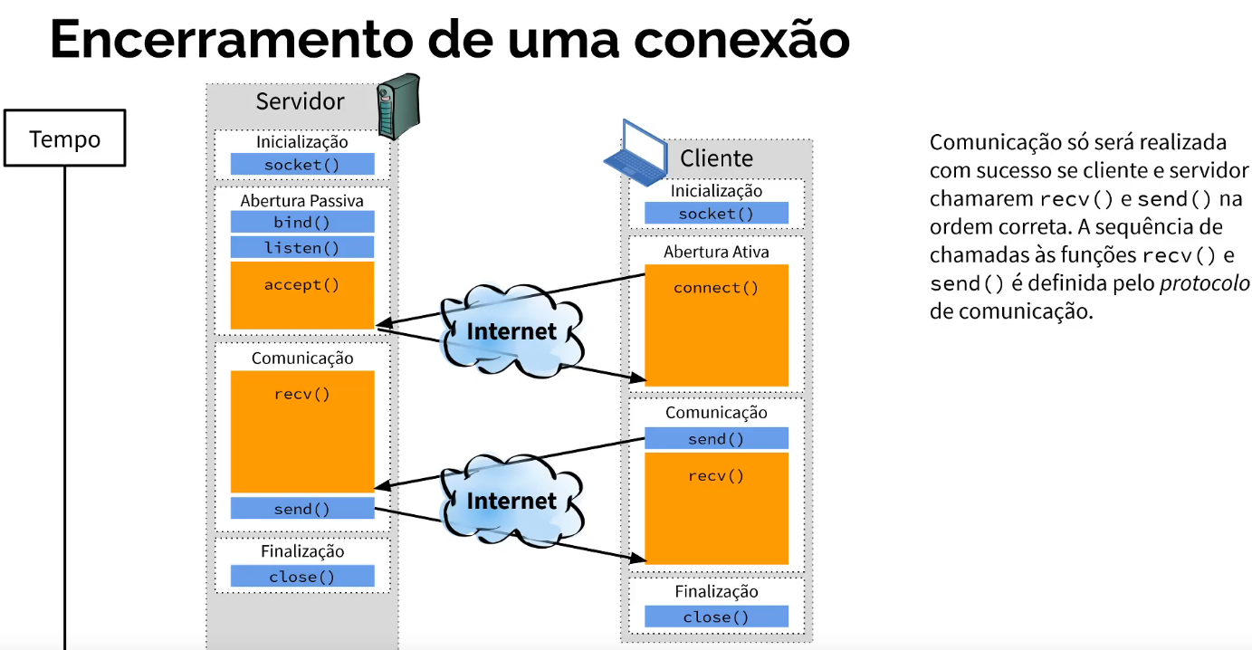
pg35

We have seen that TCP and UDP sockets transmit sequences of bytes: groups of 8 bits, which
can contain whole number values in the range 0–255. Sometimes it is necessary to send integers
whose value might be bigger than 255; such integers must be encoded using multiple bytes.
To exchange fixed-size, multibyte integers, the sender and receiver have to agree in advance
on several things. The first is the size (in bytes) of each integer to be sent.
For example, an int might be stored as a 32-bit quantity. In addition to int, the C language
defines several other integer types: short, char, and long; the idea is that these integers can
be different sizes, and the programmer can use the one that fits the application. Unlike some
languages, however, the C language does not specify the exact size of each of these primitive
types. Instead, that is left up to the implementation. Thus, the size of a short integer can vary
from platform to platform. 1 The C language specification does say that a char is no bigger than
a short, which is no bigger than an int, which is no bigger than a long, which is no bigger than
a long long. However, the specification does not require that these types actually be different
sizes—it is technically possible for a char to be the same size as a long! On most platforms,
however, the sizes do differ, and it is a safe bet that they do on yours, too.

#-----------------------------------
#1. Create a TCP socket using socket().
#We convert the port number from string to numeric value using atoi(); if the first argu-
#ment is not a number, atoi() will return 0, which will cause an error later when we call
#bind().
#On the server, we need to associate our server socket with an address and port number
#so that client connections get to the right place. Since we are writing for IPv4, we use
#a sockaddr_in structure for this. Because we don’t much care which address we are
#on (any one assigned to the machine the server is running on will be OK), we let the
#system pick it by specifying the wildcard address inaddr_any as our desired Internet
#address. (This is usually the right thing to do for servers, and it saves the server from
#having to find out any actual Internet address.) Before setting both address and port
#number in the sockaddr_in, we convert each to network byte order using htonl() and
#htons().

#-----------------------------------
#2. Assign a port number to the socket with bind().
#As noted above, the server’s socket needs to be associated with a local address and
#port; the function that accomplishes this is bind(). Notice that while the client has to
#supply the server’s address to connect(), the server has to specify its own address to
#bind(). It is this piece of information (i.e., the server’s address and port) that they have
#to agree on to communicate; neither one really needs to know the client’s address. Note
#that bind() may fail for various reasons; one of the most important is that some other
#socket is already bound to the specified port
#-----------------------------------
#3. Tell the system to allow connections to be made to that port, using listen().
#The listen() call tells the TCP implementation to allow incoming connections from
#clients. Before the call to listen(), any incoming connection requests to the socket’s
#address would be silently rejected—that is, the connect() would fail at the client.

#-----------------------------------
#4. Repeatedly do the following:
#• Call accept() to get a new socket for each client connection.
#• Communicate with the client via that new socket using send() and recv().
#• Close the client connection using close().

