Microbiology Reporting Plan
eClinicPlus+ (EMR_Dev) - test-wise result types and reporting-page changes
Status: Planning | Scope: Lab result entry, approval and patient report | Date: 27 Sep 2026

1. Summary
Microbiology master configuration is complete: organisms, antibiotics, antibiotic panels with reporting tiers, expert rules, breakpoints, picklist values, reference ranges and all microbiology tests. Booking and sample collection already work for every microbiology test.
The gap is reporting. Every existing result screen, and the patient PDF, loads results for a single Reporting Type (Numeric or Image). Microbiology uses four types, so most microbiology results either do not appear on any screen or do not print. This plan lists each test's type mix and the reporting changes needed.
Area | Status
Master configuration | Done
Booking and sample collection | Works
Result entry, approval and print | Partial - changes in Section 5

2. Reporting types used by microbiology
Every investigation (and every parameter inside a profile) has one Reporting Type. It decides which entry screen shows the result and how it is flagged.
Reporting Type | What the user enters | Abnormal flag | Used for
Numeric | A measured number | Compared with Reference Range Master (H / L) | pH, cell counts, sperm count, CSF protein
Select (picklist) | One value from a fixed list | Is_Abnormal on the chosen option (Parameter Option Master) | Colour, Protein grade, AFB grade
Descriptive | Narrative text from a template | None (pathologist wording) | Gram, KOH, Wet Mount, India Ink, Albert stains
Culture | Growth, organism(s), antibiotic S / I / R | Expert rules, breakpoints | All Culture & Sensitivity tests
Image | Narrative text from a template | None | Radiology only (not microbiology)

3. Test-wise combination

3.1 Profile tests (mixed Numeric + Select)
These are ordered as one test but reported as several parameters. Sample collection creates one result row per parameter.
Test (profile) | Numeric parameters | Select parameters | Total
Urine Routine & Microscopy | 5: pH, Specific Gravity, Pus cells, RBC, Epithelial cells | 15: Colour, Appearance, Protein, Sugar, Ketone, Bile salts, Bile pigments, Urobilinogen, Blood, Nitrite, Leukocyte esterase, Casts, Crystals, Bacteria, Yeast | 20
Stool Routine Examination | 2: Pus cells, RBC | 9: Colour, Consistency, Mucus, Visible blood, Reaction, Occult blood, Ova, Cysts, Trophozoites | 11
Semen Analysis (WHO 6th ed.) | 11: Volume, pH, Concentration, Total count, Progressive motility, Non-progressive, Immotile, Morphology, Vitality, Round cells, WBC | 4: Appearance, Liquefaction, Viscosity, Agglutination | 15
CSF Analysis | 6: Protein, Glucose, Chloride, Total cells, Lymphocytes, Neutrophils | 2: Appearance, Coagulum | 8
Body Fluid Analysis (Pleural / Ascitic) | 7: Protein, Glucose, LDH, ADA, Total cells, Lymphocytes, Neutrophils | 1: Appearance | 8

3.2 Single tests
Test | Reporting Type | Result
Sputum for AFB (ZN Stain) | Select | Grade: Negative / Scanty / 1+ / 2+ / 3+
Gram Stain | Descriptive | Template: Specimen, Microscopy findings, Impression
KOH Mount (Fungal Elements) | Descriptive | Template
Wet Mount Examination | Descriptive | Template
India Ink Preparation (CSF) | Descriptive | Template
Albert Stain (C. diphtheriae) | Descriptive | Template
Urine Culture & Sensitivity | Culture | Growth, colony count, organism(s), S / I / R
Blood Culture & Sensitivity | Culture | Same as above
Sputum Culture & Sensitivity | Culture | Same as above
Pus / Wound Culture & Sensitivity | Culture | Same as above
Stool Culture & Sensitivity | Culture | Same as above
CSF Culture & Sensitivity | Culture | Same as above
Body Fluid Culture & Sensitivity | Culture | Same as above

4. Current reporting scenario

4.1 How reporting works today
- Result rows come from sample collection. One row per investigation; profiles are expanded into their parameters (usp_CreateSampleCollectionFromLabOrder).
- Each screen loads a single Reporting Type. usp_LabReporting_GetDetail returns only rows whose type equals the requested value.
- Lab Report Entry requests Numeric.
- Lab Image Reporting requests Image.
- Patient PDF uses the default, which is also Numeric.
- Worklist (usp_LabReporting_GetHeaderList) filters by type in the same way.
- Numeric entry blocks a parameter that has no reference range, and flags H / L by comparing numbers.

4.2 What happens to each test today
Test type | Book & collect | Result entry | Print | Works today?
Urine / Stool / Semen / CSF / Body Fluid | Yes | Numeric parameters only; Select parameters hidden | Numeric only | Partial
Sputum AFB (Select) | Yes | Not on any screen | No | No
Stains (Descriptive) | Yes | Not on any screen (Image page loads Image only) | No | No
Culture & Sensitivity | Yes | Not on any screen; no storage for organisms / S / I / R | No | No

Reference ranges for all 31 numeric microbiology parameters are already loaded, so numeric parameters are no longer blocked on entry.
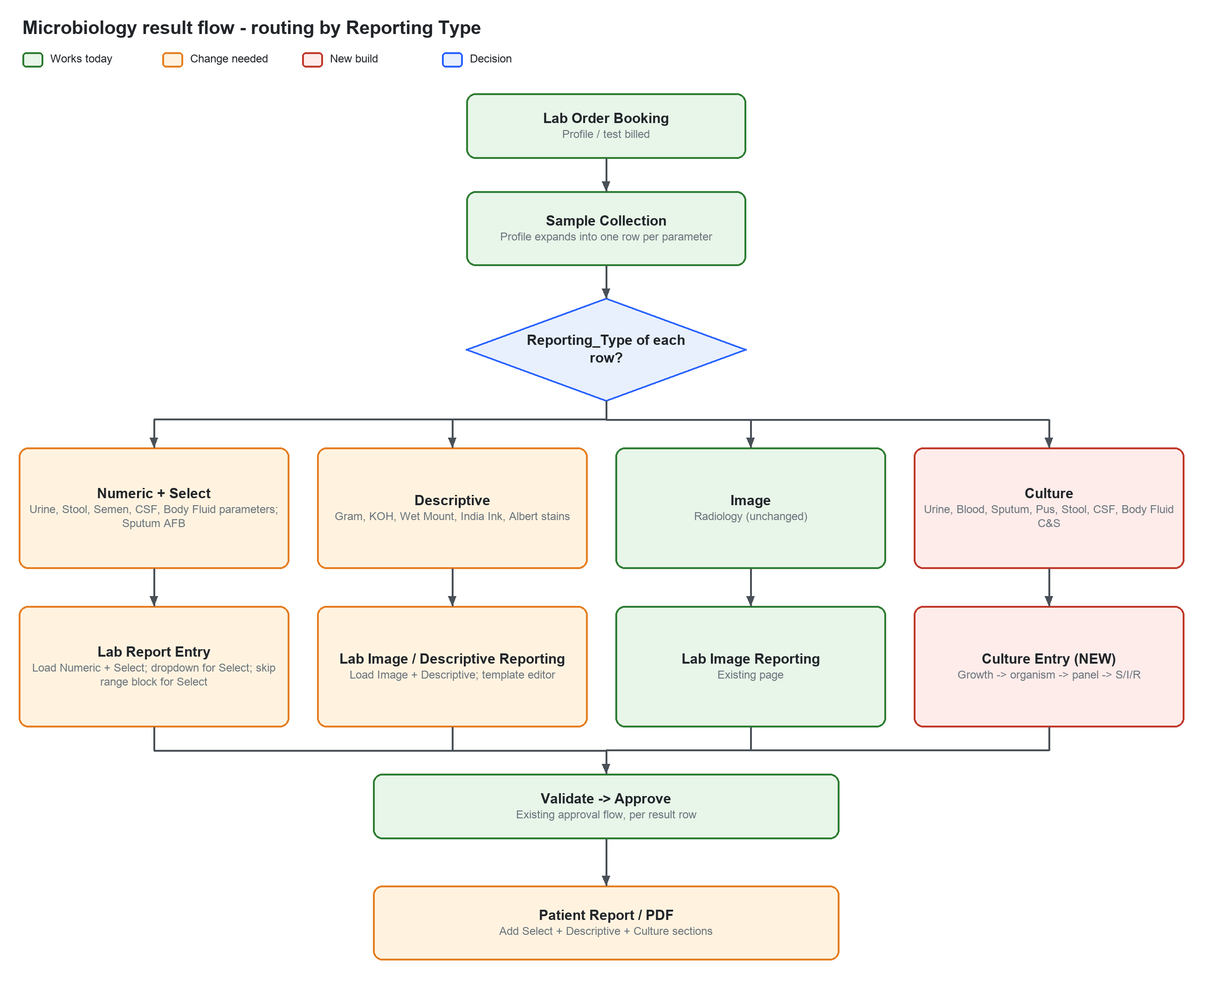
Figure 1 - Routing by Reporting Type: green works today, orange needs change, red is a new build.

5. Changes needed in the reporting pages

Step 1 - Configuration (done)
- Reference ranges and units for the 31 numeric parameters (script 2150).
- Pathologist to review CSF age bands and body-fluid cut-offs before go-live.

Step 2 - Descriptive stains (small)
Change | Where
Accept a list of reporting types instead of one value | usp_LabReporting_GetDetail, usp_LabReporting_GetHeaderList, usp_Api_LabReport_GetSignoffPanel
Request Image + Descriptive | LabImageReportingController (all GetDetailAsync / GetHeaderListAsync calls)
Page title / menu wording to cover narrative reports | LabImageReporting views

Alternative with no code change: set the 5 stains back to Image. Not recommended - the type label would be wrong.

Step 3 - Select (picklist) parameters (medium)
Change | Where
Load Numeric + Select on entry, save, submit and approve | LabReportingController (FilterNumericReportingOnly and GetDetailAsync calls)
Return each Select parameter's options (text, default, abnormal flag) | usp_LabReporting_GetDetail (new result set) + LabReportingItemDto
Render a dropdown instead of the number box for Select rows | Views/LabReporting/_LabReportingEntryRow.cshtml
Exempt Select rows from the "no reference range" block | _LabReportingEntryRow.cshtml (noRefRange rule)
Flag abnormal from the option's Is_Abnormal, not numeric comparison | Entry page JavaScript; save request sets AbnormalFlag
Print Select results with their flag | LabReportPdfService / LabReportPrintBuilder (request Numeric + Select)
Show orders that contain Select parameters in the worklist | usp_LabReporting_GetHeaderList (type list)

Saving needs no schema change: the chosen option text is stored in labentrydetails.TestValue, the same column used for numbers.
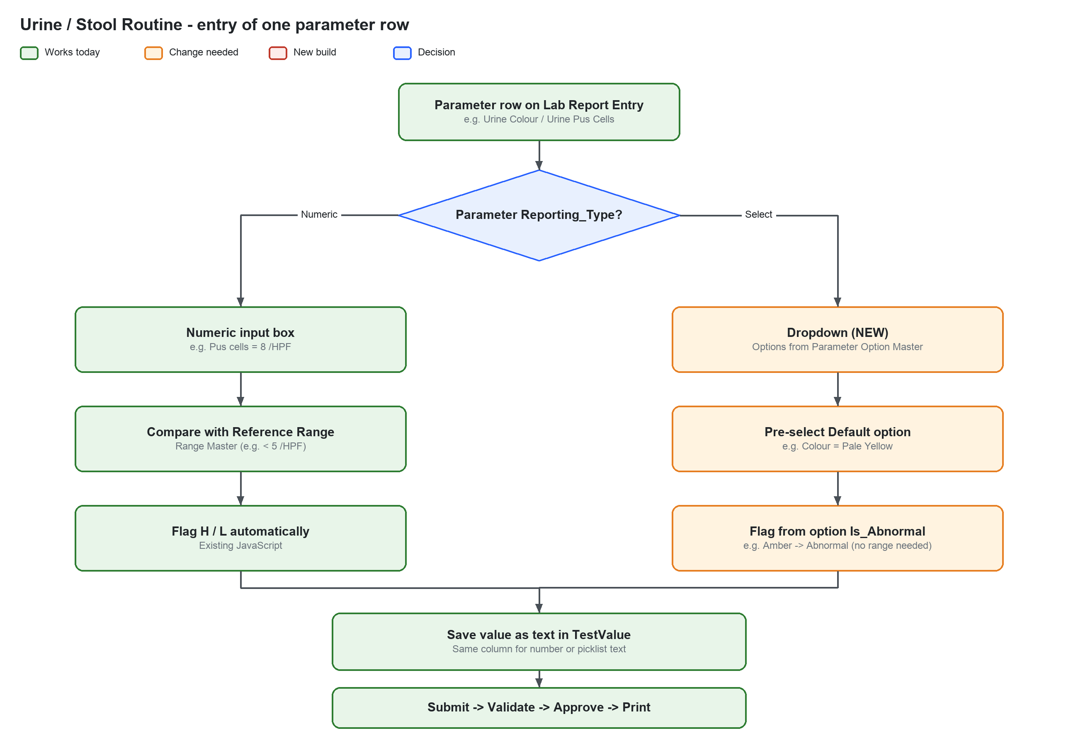
Figure 2 - Urine / Stool Routine: how one parameter row is entered after Step 3.

Step 4 - Culture & Sensitivity (large, new page)
Culture results do not fit a single value per row, so this step adds storage, a new entry page and a PDF section.
Component | Detail
New tables | Culture result (per test: growth status, colony count, incubation, remarks) -> Isolate (organism) -> Sensitivity (antibiotic, S / I / R, MIC or zone, tier)
New entry page | Culture Reporting: worklist + entry, same approval statuses as existing pages
Panel selection | Specimen + organism category -> category -> Gram type (Antibiotic Panel Master)
AST entry | S / I / R directly, or MIC / zone interpreted with Breakpoint Master (per client)
Expert rules | Warn, report as R, or block approval (Expert Rule Master)
Cascade reporting | Tier 1 always printed; Tier 2-4 printed only when the cascade rule is met
Patient PDF | Culture section: growth, colony count, organism(s), sensitivity table, rule comments
Worklist | Include Culture in the type list

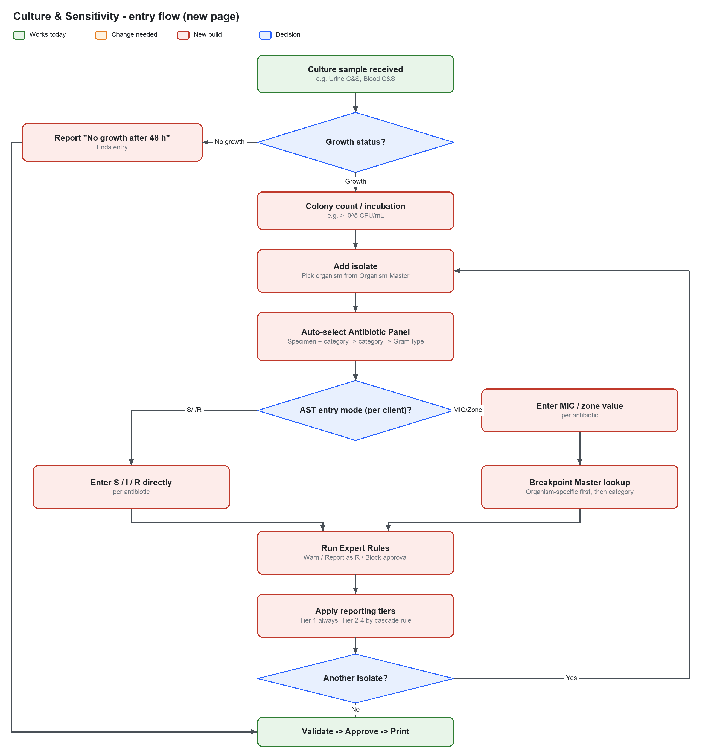
Figure 3 - Culture & Sensitivity entry flow on the new page.

6. Recommended sequence
Order | Step | Unlocks | Effort
1 | Configuration (done) | Numeric parameters can be entered | Done
2 | Descriptive stains | Gram, KOH, Wet Mount, India Ink, Albert | Small
3 | Select parameters | Urine, Stool, Semen, CSF, Body Fluid fully; Sputum AFB | Medium
4 | Culture & Sensitivity | All 7 culture tests | Large

7. Verification checklist
- Book Urine Routine; confirm one container / barcode for all 20 parameters at collection.
- Enter all 20 Urine parameters; confirm Numeric flags from ranges and Select flags from options.
- Submit, validate, approve; confirm the PDF shows both Numeric and Select results with flags.
- Book Gram Stain; confirm it appears on the narrative reporting page with its template.
- Book Urine C&S; confirm growth, organism, panel, S / I / R, rules, tiers and PDF section.
- Confirm an order with only microbiology tests appears in the relevant worklist.

8. Open decisions
Decision | Options
AST entry mode per client | S / I / R direct | MIC / zone | both
Breakpoint standard and version | CLSI M100 edition | EUCAST version
Cascade reporting | Used / not used
Stains page | Extend Image page to Descriptive (recommended) | revert stains to Image

