**Design a Parking Lot using OOP**

A parking lot or car park is a designated open space designed for the purpose of parking vehicles. In regions where automobiles serve as a primary means of transportation, you can typically find parking lots in both urban and suburban areas. These parking areas are commonly seen at locations such as shopping centers, sports stadiums, large churches, and similar venues, often covering extensive areas.

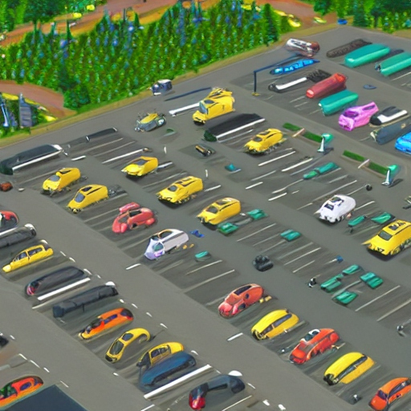

1. System Requirements
2. Use Case Diagram
3. Class Diagram
4. Page Flow Diagram
5. Code

# System Requirements

1. The parking facility must incorporate a multi-level structure to accommodate customer vehicles.
2. There should be numerous entry and exit points distributed across the parking lot.
3. Customers should have the option to obtain a parking ticket upon entering and settle the parking fee when exiting via designated payment points.
4. Payment options should include both cash and credit cards for customer convenience.
5. The parking management system should display a message on the entrance panel and the ground floor parking display board when the capacity limit is reached.
6. Each parking level must feature a variety of parking spot types, including Compact, Large, Handicapped, Motorcycle, etc., catering to different vehicle sizes and needs.
7. The system should support diverse vehicle types, encompassing cars, trucks, vans, motorcycles, and more.
8. Each parking floor must be equipped with a display board that provides real-time information about the availability of parking spots for each spot type.
9. Fare Calculation: The system should calculate parking fees based on the duration of the vehicle's stay in the parking lot. Different rates may apply for various vehicle types and parking spot categories.
10. "Find My Car" feature that allows customers to locate their parked vehicles easily. Customers can enter their ticket number or use a mobile app to pinpoint the exact location of their car within the parking facility.
11. Membership Plans: Introduce membership plans for frequent visitors. Customers can opt for different membership tiers with benefits such as priority access.
12. Priority for People with Disabilities: Ensure priority parking spaces close to entrances are reserved exclusively for individuals with disabilities.

# Use Case Diagram

Here are the main Actors in our system:

1. Admin: Mainly responsible for adding and modifying parking floors, parking spots, entrance, and exit panels, adding/removing parking attendants, etc.
2. Customer: All customers can get a parking ticket and pay for it.
3. Parking Attendant: Parking attendants can do all the activities on the customer’s behalf, and can take cash for ticket payment.
4. System: To display messages on different info panels, as well as assigning and removing a vehicle from a parking spot.

Here are the top use cases for Parking Lot:

1. Add/Remove parking floor: To add, remove or modify a parking floor
2. from the system. Each floor can have its own display board to show free parking spots.
3. Add/Remove parking spot: To add, remove or modify a parking spot on a parking floor.
4. Add/Remove a parking attendant: To add or remove a parking attendant from the system.
5. Create/Modify Account: To create or modify a parking attendant’s account
6. Take ticket: To provide customers with a new parking ticket when entering the parking lot.
7. Scan ticket: To scan a ticket to find out the total charge.
8. Calculate/Modify parking rate: To allow admin to add or modify the hourly parking rate.
9. Find My Car: To request one’s car position on the parking lot

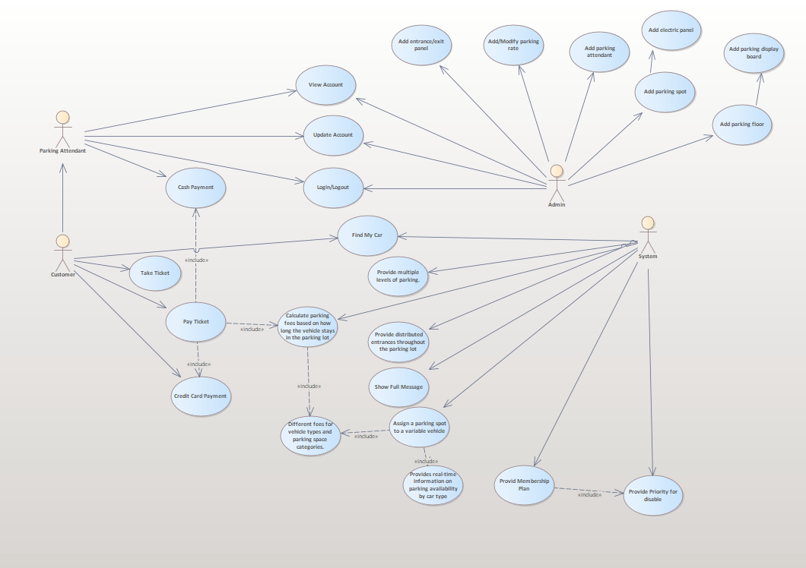

# Class Diagram

Here are the main classes of our Parking Lot System:

1. ParkingLot: The central part of the organization for which this software has been designed. It has attributes like ‘id’ to distinguish it from any other parking lots and ‘Address’ to define its location.
2. ParkingFloor: The parking lot will have many parking floors.
3. ParkingSpot: Each parking floor will have many parking spots. Our system will support different parking spots 1) Handicapped, 2) Compact, 3) Large, 4) Motorcycle
4. Account: We will have two types of accounts in the system: one for an Admin, and the other for a parking attendant.
5. Parking ticket: This class will encapsulate a parking ticket. Customers will take a ticket when they enter the parking lot.
6. Vehicle: Vehicles will be parked in the parking spots. Our system will support different types of vehicles 1) Car, 2) Truck, 3) Van and 4) Motorcycle. It will have an additional application for find my car function.
7. EntrancePanel and ExitPanel: EntrancePanel will print tickets, and ExitPanel will facilitate payment of the ticket fee.
8. Payment: This class will be responsible for making payments. The system will support credit card and cash transactions.
9. ParkingRate: This class will keep track of the hourly parking rates. It will specify a dollar amount for each hour.
10. ParkingDisplayBoard: Each parking floor will have a display board to show available parking spots for each spot type. This class will be responsible for displaying the latest availability of free parking spots to the customers.

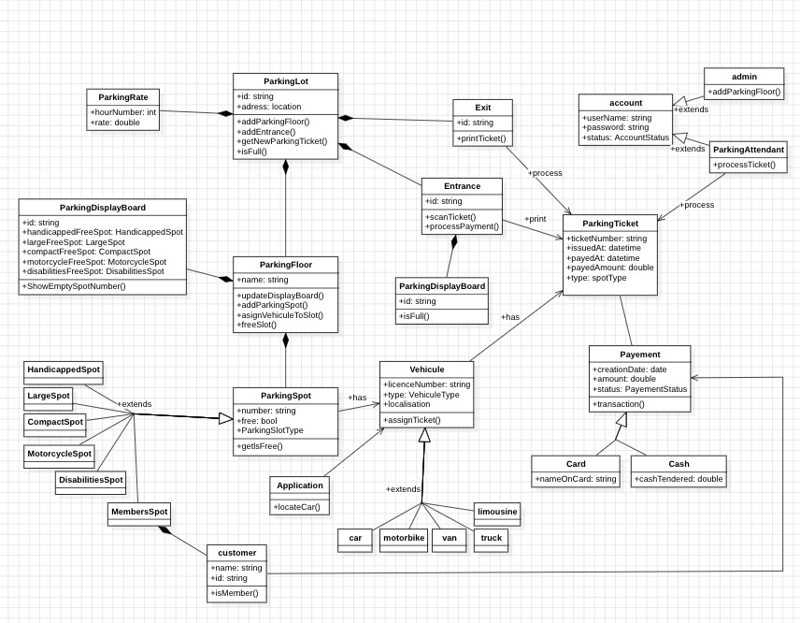

# Page Flow Diagram

A diagram that illustrates the relationship between pages in application

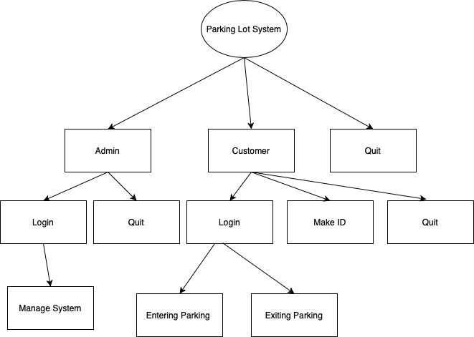

# Code

Constants.py

Three enumerations were defined: VehicleType, ParkingSpotType, and UserRole.

from enum import Enum, IntEnum  
  
  
class VehicleType(Enum):  
 CAR = 1  
 TRUCK = 2  
 VAN = 3  
 MOTORBIKE = 4  
  
class ParkingSpotType(Enum):  
 HANDICAPPED = 1  
 COMPACT = 2  
 LARGE = 3  
 MOTORBIKE = 4  
  
  
class UserRole(IntEnum):  
 ADMIN = 1  
 USER = 2  
 NULL = 3

Account.py

This class takes three parameters in its constructor: id, password, and user_role, and contains a method called ComparePassword to compare the password.

from enum import Enum, IntEnum  
from Constants import *  
  
class Account:  
 def __init__(self, id, password, user_role: UserRole):  
 self.id = id  
 self.password = password  
 self.user_role = user_role  
  
 def ComparePassword(self,password):  
 return self.password == password

Admin.py

Represent an administrative user in a parking management system.

From Constants import *  
from ParkingFloor import *  
from Account import *  
from ParkingLot import *  
  
  
class Admin:  
 _instance = None  
  
 def __new__(cls, id, password):  
 if cls._instance is None:  
 cls._instance = super(Admin, cls).__new__(cls)  
 cls._instance.initialized = False  
 return cls._instance  
  
 def __init__(self, id, password):  
 if not self.initialized:  
 self.__Account = Account(id, password, UserRole.ADMIN)  
 self.initialized = True  
 self.parkingLot = ParkingLot()  
  
 def viewAdminPage(self):  
 while True:  
 print(“Admin Menu:”)  
 print(“1. Add Parking Floor”)  
 print(“2. Display Parking Lot”)  
 print(“3. Return to Main Menu”)  
  
 choice = input(“Enter your choice (1/2/3): “)  
  
 print(“------------------------------------------“)  
  
 if choice == “1”:  
 self.addParkingFloor()  
 elif choice == “2”:  
 self.displayParkingFloors()  
 elif choice == “3”:  
 break  
 else:  
 print(“Invalid choice. Please try again.”)  
  
 def checkAccount(self):  
 print(“------------------------------------------“)  
 inputId = input(“Admin ID: “)  
 inputPassword = input(“Admin Password: “)  
 print(“------------------------------------------“)  
  
 if inputId == self.__Account.id and inputPassword == self.__Account.password:  
 print(“Successfully Logged In”)  
 return True  
 else:  
 return False  
  
 def displayParkingFloors(self):  
 if not self.parkingLot.parkingFloors:  
 print(“No parking floors available.”)  
 else:  
 print(“Parking Floors and Spots:”)  
 for floor_number, floor in enumerate(self.parkingLot.parkingFloors, start=1):  
 floor.ShowAllParkingFloor()  
 print()  
  
 def addParkingFloor(self):  
 try:  
 spotCounts = {}  
 spotCounts[ParkingSpotType.HANDICAPPED] = int(input(“Enter the number of handicapped spots: “))  
 spotCounts[ParkingSpotType.COMPACT] = int(input(“Enter the number of compact spots: “))  
 spotCounts[ParkingSpotType.LARGE] = int(input(“Enter the number of large spots: “))  
 spotCounts[ParkingSpotType.MOTORBIKE] = int(input(“Enter the number of motorbike spots: “))  
  
 if any(count < 0 for count in spotCounts.values()):  
 print(“Spot counts cannot be negative.”)  
 return  
  
 floorNumber = len(self.parkingLot.parkingFloors) + 1  
 floor = ParkingFloor(floorNumber)  
  
 for spot_type, count in spotCounts.items():  
 for _ in range(count):  
 floor.AddParkingSpot(spot_type)  
  
 self.parkingLot.parkingFloors.append(floor)  
 print(f”Added a new floor (Floor {floorNumber}) with the specified parking spots.”)  
 except ValueError:  
 print(“Invalid input. Please enter valid spot counts.”

User.py

Represent a customer user in a parking management system.

from Account import Account  
from Constants import *  
from ParkingLot import ParkingLot  
from ParkingSpot import ParkingSpot  
import datetime  
  
class User:  
 def __init__(self,id,password,isDisable,carName,carType):  
 self.parkingLot = ParkingLot()  
 self.account = Account(id,password,UserRole.USER)  
 self.car = Car(carName,carType)  
 self.isDiable = isDisable  
   
 def ComparePassword(self,password):  
 return self.account.ComparePassword(password)  
  
 def ShowUserPage(self):  
 while True:  
 print("User Menu:")  
 print("1. Enter Parking Lot")  
 print("2. Exit Parking Lot")  
 print("3. Return to Main Menu")  
  
 choice = input("Enter your choice (1/2/3): ")  
 if choice == "1":  
 self.EnterParkingLot()  
 elif choice == "2":  
 self.ExitParkingLot()  
 elif choice == "3":  
 break  
 else:  
 print("Invalid choice. Please try again.")  
  
 def EnterParkingLot(self):  
 for floor in self.parkingLot.parkingFloors:  
 # Check for empty spots of the specified car type on the current floor  
 if self.isDiable == True:  
 for spot in floor.handicappedSpots():  
 if floor.handicappedSpots()[spot].isFree():  
 floor.handicappedSpots()[spot].assignVehicle( self.car )  
 self.car.SetEnterTime(datetime.datetime.now())  
 print(f"A { self.car.vehicleType } has entered the parking lot and parked in Compact Spot {spot} on the {floor.floornumber()} floor")  
 self.car.SetSpotInfo(floor.floornumber(),spot,ParkingSpotType.HANDICAPPED)  
 self.car.__isParked = True  
 return  
  
 elif self.car.vehicleType == VehicleType.CAR and len(floor.compactSpots()) > 0:  
 # Assign the car to the first available compact spot  
 for spot in floor.compactSpots():  
 if floor.compactSpots()[spot].isFree():  
 floor.compactSpots()[spot].assignVehicle( self.car )  
 self.car.SetEnterTime(datetime.datetime.now())  
 print(f"A { self.car.vehicleType } has entered the parking lot and parked in Compact Spot {spot} on the {floor.floornumber()} floor")  
 self.car.SetSpotInfo(floor.floornumber(),spot,ParkingSpotType.COMPACT)  
 self.car.__isParked = True  
 return  
   
 elif self.car.vehicleType == VehicleType.TRUCK and len(floor.largeSpots()) > 0:  
 # Assign the truck to the first available large spot  
 for spot in floor.largeSpots():  
 if floor.largeSpots()[spot].isFree():  
 floor.largeSpots()[spot].assignVehicle( self.car )  
 self.car.SetEnterTime(datetime.datetime.now())  
 print(f"A { self.car.vehicleType } has entered the parking lot and parked in Large Spot {spot} on the {floor.floornumber()} floor")  
 self.car.SetSpotInfo(floor.floornumber(),spot,ParkingSpotType.LARGE)  
 self.car.__isParked = True  
 return  
  
 elif self.car.vehicleType == VehicleType.VAN and len(floor.largeSpots()) > 0:  
 # Assign the van to the first available large spot  
 for spot in floor.largeSpots():  
 if floor.largeSpots()[spot].isFree():  
 floor.largeSpots()[spot].assignVehicle( self.car )  
 self.car.SetEnterTime(datetime.datetime.now())  
 print(f"A { self.car.vehicleType } has entered the parking lot and parked in Large Spot {spot} on the {floor.floornumber()} floor")  
 self.car.SetSpotInfo(floor.floornumber(),spot,ParkingSpotType.LARGE)  
 self.car.__isParked = True   
 return  
  
 elif self.car.vehicleType == VehicleType.MOTORBIKE and len(floor.motorbikeSpots()) > 0:  
 # Assign the motorbike to the first available large spot  
 for spot in floor.motorbikeSpots():  
 if floor.motorbikeSpots()[spot].isFree():  
 floor.motorbikeSpots()[spot].assignVehicle( self.car.vehicleType )  
 self.car.SetEnterTime(datetime.datetime.now())  
 print(f"A { self.car.vehicleType } has entered the parking lot and parked in Motorbike Spot {spot} on the {floor.floornumber()} floor")  
 self.car.SetSpotInfo(floor.floornumber(),spot,ParkingSpotType.MOTORBIKE)  
 return  
   
 def ExitParkingLot(self):  
 # if floorNum == 1 -> that means 0st array  
 floor = self.parkingLot.parkingFloors[self.car.floorNum - 1]  
  
 spot = None  
 if self.car.spotType == ParkingSpotType.COMPACT:  
 spot = floor.compactSpots()[self.car.spotNum]  
 elif self.car.spotType == ParkingSpotType.LARGE:  
 spot = floor.largeSpots()[self.car.spotNum]  
 elif self.car.spotType == ParkingSpotType.MOTORBIKE:  
 spot = floor.motorbikeSpots()[self.car.spotNum]  
 elif self.car.spotType == ParkingSpotType.HANDICAPPED:  
 spot = floor.handicappedSpots()[self.car.spotNum]  
  
 self.car.SetExitTime(datetime.datetime.now())  
 spot.removeVehicle()  
 self.car.__isParked = False  
  
 self.car.CalculateFee()  
   
  
class Car:  
 def __init__(self,name,vehicleType):  
 self.__name = name  
 self.vehicleType = vehicleType  
  
 self.__enterTime = None  
 self.__exitTime = None  
 self.__isParked = False  
  
 self.floorNum = None  
 self.spotNum = None  
 self.spotType = None  
  
 def SetEnterTime(self, enterTime):  
 self.__enterTime = enterTime  
   
 def SetExitTime(self, exitTime):  
 self.__exitTime = exitTime  
  
 def FindMyCar(self):  
 if(self.__isParked == False):  
 print("Your Car not Parked")  
 return  
   
 else:  
 print("Car Parked {} floor {} spot".format(self.floorNum,self.spotNum))  
  
 def SetSpotInfo(self,floorNum,spotNum,spotType):  
 self.floorNum = floorNum  
 self.spotNum = spotNum  
 self.spotType = spotType  
  
 print("Car Parked {} floor {} spot".format(floorNum,spotNum))  
  
 def CalculateFee(self):  
 parking_duration = self.__exitTime - self.__enterTime  
 hour_parked = parking_duration.total_seconds() / 3600  
 if(self.vehicleType == 1):  
 if(hour_parked <= 1):  
 parking_fee = 4  
 elif(hour_parked <= 3):  
 parking_fee = 4 + 3.5*(hour_parked - 1)  
 else:  
 parking_fee = 4 + 3.5*2 + 2.5*(hour_parked - 3)  
  
 elif(self.vehicleType == 2 or self.vehicleType == 3):  
 if(hour_parked <= 1):  
 parking_fee = 5  
 elif(hour_parked <= 3):  
 parking_fee = 5 + 4.5*(hour_parked - 1)  
 else:  
 parking_fee = 5 + 4.5*2 + 3*(hour_parked - 3)  
  
 else:  
 if(hour_parked <= 1):  
 parking_fee = 3  
 elif(hour_parked <= 3):  
 parking_fee = 3 + 2.5*(hour_parked - 1)  
 else:  
 parking_fee = 3 + 2.5*2 + 2*(hour_parked - 3)  
  
 print(f"You used parking spot for {hour_parked:.3f} hours and the Parking Fee is ${parking_fee}.")

Parkinglot.py

Class responsible for saving data regarding parking lot

from ParkingFloor import ParkingFloor  
from Constants import *  
  
class ParkingLot:  
 _instance = None  
  
 def __new__(cls):  
 if cls._instance is None:  
 cls._instance = super(ParkingLot, cls).__new__(cls)  
 cls._instance.initialized = False  
 return cls._instance  
  
 def __init__(self):  
 if not self.initialized:  
 self.initialized = True  
 self.parkingFloors = []

Parkingfloor.py

Class responsible for containing data regarding each floor separately

from ParkingSpot import *  
from Constants import *  
  
  
class ParkingFloor():  
 def __init__(self, floorNumber):  
 self.__spotCount = 0  
 self.__floorNumber = floorNumber  
 self.__handicappedSpots = {}  
 self.__compactSpots = {}  
 self.__largeSpots = {}  
 self.__motorbikeSpots = {}  
  
  
 def floornumber(self):  
 return self.__floorNumber  
  
 def handicappedSpots(self):  
 return self.__handicappedSpots  
  
 def compactSpots(self):  
 return self.__compactSpots  
  
 def largeSpots(self):  
 return self.__largeSpots  
  
 def motorbikeSpots(self):  
 return self.__motorbikeSpots  
  
 def AddParkingSpot(self, spotType: ParkingSpotType):  
 self.__spotCount += 1  
 # Determine the next spot number for the given spot type  
 if spotType == ParkingSpotType.HANDICAPPED:  
 next_spot_number = len(self.__handicappedSpots) + 1  
 parkingSpot = HandicappedSpot(next_spot_number,self.__floorNumber)  
 self.__handicappedSpots[next_spot_number] = parkingSpot  
 elif spotType == ParkingSpotType.COMPACT:  
 next_spot_number = len(self.__compactSpots) + 1  
 parkingSpot = CompactSpot(next_spot_number,self.__floorNumber)  
 self.__compactSpots[next_spot_number] = parkingSpot  
 elif spotType == ParkingSpotType.LARGE:  
 next_spot_number = len(self.__largeSpots) + 1  
 parkingSpot = LargeSpot(next_spot_number,self.__floorNumber)  
 self.__largeSpots[next_spot_number] = parkingSpot  
 elif spotType == ParkingSpotType.MOTORBIKE:  
 next_spot_number = len(self.__motorbikeSpots) + 1  
 parkingSpot = MotorbikeSpot(next_spot_number,self.__floorNumber)  
 self.__motorbikeSpots[next_spot_number] = parkingSpot  
  
  
 def ShowAllParkingFloor(self):  
 print(f"Floor {self.__floorNumber} - Parking Spots:")  
 print(f"Total Spots: {self.__spotCount}")  
 print(f"Handicapped Spots: {len(self.__handicappedSpots)}")  
 for spot_number, spot in self.__handicappedSpots.items():  
 print(f" - Spot {spot_number}: {spot.isFree()}")  
  
 print(f"Compact Spots: {len(self.__compactSpots)}")  
 for spot_number, spot in self.__compactSpots.items():  
 print(f" - Spot {spot_number}: {spot.isFree()}")  
  
 print(f"Large Spots: {len(self.__largeSpots)}")  
 for spot_number, spot in self.__largeSpots.items():  
 print(f" - Spot {spot_number}: {spot.isFree()}")  
  
 print(f"Motorbike Spots: {len(self.__motorbikeSpots)}")  
 for spot_number, spot in self.__motorbikeSpots.items():  
 print(f" - Spot {spot_number}: {spot.isFree()}")  
  
 print()

Parkingspot.py

Class containing information regarding each individual spot

from Constants import *  
import datetime  
  
class ParkingSpot:  
 def __init__(self, spotNumber, parkingSpotType,floorNum):  
 self.__free = True  
 self.__vehicle = None  
 self.__parkingSpotType = parkingSpotType  
 self.floorNum = floorNum  
 self.spotNum = spotNumber  
  
 def isFree(self):  
 return self.__free  
  
 def assignVehicle(self, vehicle):  
 self.__vehicle = vehicle  
 self.__free = False  
 self.__vehicle.parkedSpot = self  
 self.__vehicle.enterTime = datetime.datetime.now()  
  
  
 def removeVehicle(self):  
 self.__vehicle.exitTime = datetime.datetime.now()  
 self.__vehicle.parkedSpot = None  
 self.__vehicle = None  
 self.__free = True  
  
 def ShowSpotInfo(self):  
 print("Floor : {self.floorNum}, spotType = {self.__parkingSpotType}, spotNum : {self.spotNum}")  
  
class HandicappedSpot(ParkingSpot):  
 def __init__(self, number,floorNum):  
 super().__init__(number, ParkingSpotType.HANDICAPPED,floorNum)  
  
class CompactSpot(ParkingSpot):  
 def __init__(self, number,floorNum):  
 super().__init__(number, ParkingSpotType.COMPACT,floorNum)  
  
class LargeSpot(ParkingSpot):  
 def __init__(self, number,floorNum):  
 super().__init__(number, ParkingSpotType.LARGE,floorNum)  
  
class MotorbikeSpot(ParkingSpot):  
 def __init__(self, number,floorNum):  
 super().__init__(number, ParkingSpotType.MOTORBIKE,floorNum)

# Output

An example of how code is working. A sample output

