CS 255 Business Requirements Document Template

System Components and Design

Purpose
- The purpose of this project is to build a comprehensive training and scheduling system for DriverPass, a company aiming to reduce the high failure rate of DMV driving exams.
- The client requires a platform that allows students to access online practice exams and schedule on-the-road training sessions.

System Background
- DriverPass identified that a significant number of students fail their driving tests due to inadequate preparation.
- The client needs a system to offer online classes, practice tests, and manage on-the-road training appointments.
- The system must facilitate user registration, track student progress, schedule physical vehicles and drivers, and handle administrative management.

Objectives and Goals
- Provide a platform where customers can take online classes and practice tests.
- Allow management to access data online and offline, including downloading reports for external use in Excel.
- Track all system modifications to maintain an accurate audit log of who made, canceled, or modified reservations.
- Manage a fleet of 10 cars and corresponding drivers by accurately pairing them with scheduled students.

Requirements

Nonfunctional Requirements

Performance Requirements
- The system must operate as a cloud-based web application to eliminate the need for local client backups.
- The platform must be highly available to allow customers to schedule appointments online at any time.

Platform Constraints
- The system must be accessible via any web browser on desktop or mobile devices.
- Data exports must be compatible with standard spreadsheet software, such as Microsoft Excel.

Accuracy and Precision
- The system must strictly prevent double-booking by ensuring specific drivers and cars are accurately matched to a single customer per time slot.
- The system must properly allocate two-hour time blocks for all driving sessions based on the selected package.

Adaptability
- The system must allow the business owner to dynamically disable existing training packages to prevent new registrations.
- The system must integrate a connection to the local DMV to receive automated notifications regarding new rules, policies, or sample questions.

Security
- The IT officer must have full administrative access to reset user passwords and block account access.
- The system must provide an automated password reset feature for customers.
- The system must log all user activity, specifically tracking who creates, modifies, or cancels appointments for audit reports.

Functional Requirements
- The system shall allow the owner to download system data into offline reports.
- The system shall allow customers to create, modify, and cancel driving lesson appointments online.
- The system shall allow the secretary to create, modify, and cancel driving lesson appointments manually.
- The system shall collect and store customer registration data, including first name, last name, address, phone number, state, credit card details, and pickup/drop-off locations.
- The system shall assign customers to one of three specific training packages (six hours, eight hours, or twelve hours).
- The system shall track and display online test progress, indicating the test name, time taken, score, and status (not taken, in progress, failed, passed).
- The system shall display a table of driver notes detailing lesson start hours, end hours, and specific driver comments.

User Interface
- The interface must serve four distinct user roles: the Owner, the IT Officer, the Secretary, and the Customer.
- The primary dashboard must include a company logo, an online test progress module, and a student information form.
- The interface must display dedicated sections for driver notes, special needs, driver photos, and student photos.
- Customers will interact with the system via web and mobile browsers to update their information and manage their schedules.

Assumptions
- It is assumed that customers have reliable internet access and compatible devices to utilize the online courses and scheduling tools.
- It is assumed that the DMV has an existing API or notification system capable of pushing updates to third-party applications.
- It is assumed that the 10 cars and their respective drivers operate on a standard, predictable weekly schedule.

Limitations
- The system cannot support the addition or removal of entirely new training modules without the intervention of a software developer in a future release.
- The system relies entirely on cloud infrastructure; localized internet outages will prevent access to real-time scheduling.

Gantt Chart
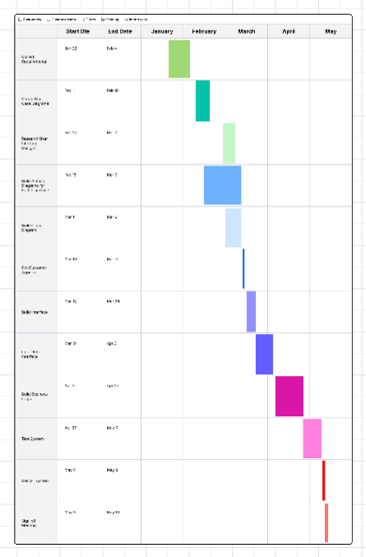
AI Acknowledgement Generative AI (Gemini) was utilized as a brainstorming and formatting assistant to help structure the Business Requirements Document and the Model Application Short Paper, ensuring all required elements were addressed in accordance with SNHU's AI usage guidelines.

