DriverPass System Design Document

Eva Mehler
Southern New Hampshire University
CS 255: System Analysis and Design
Aline Yurik
October 14, 2026

UML Diagrams

UML Use Case Diagram
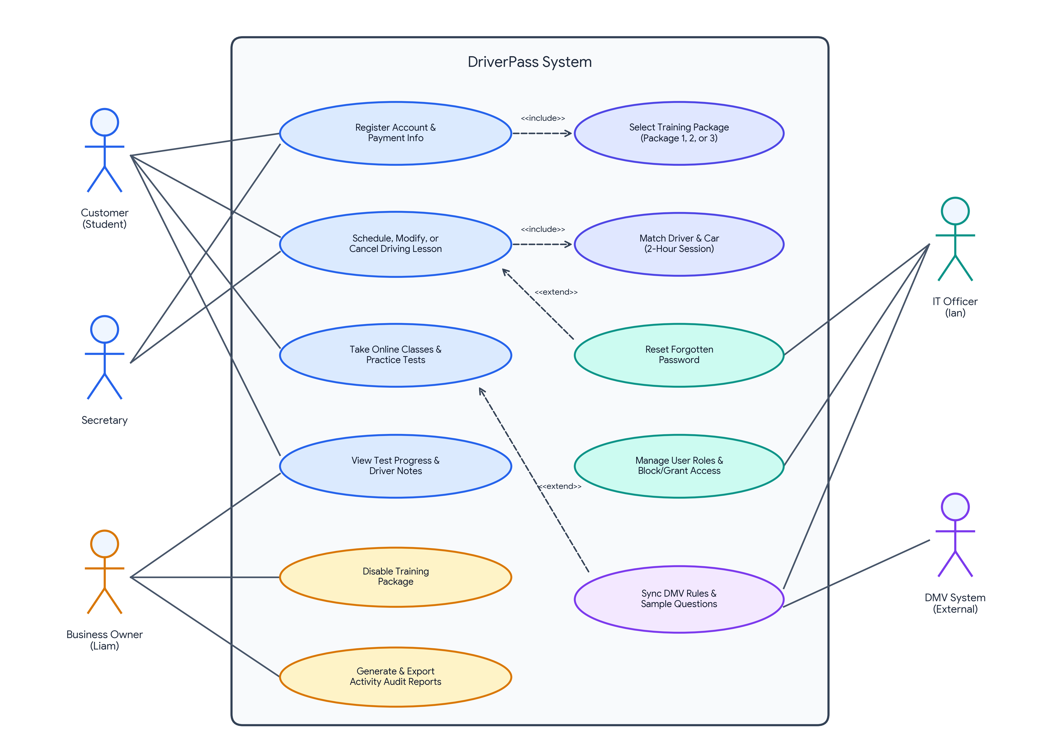
Looking at DriverPass's operational model from both a business and systems perspective, the UML Use Case Diagram establishes the functional boundary of the platform across four internal user roles—the Customer (Student), Secretary, Business Owner (Liam), and IT Officer (Ian)—alongside the DMV System as an external actor (Southern New Hampshire University, n.d.).
• Customer and Secretary Interactions: Both customers (via the self-service web portal) and the office secretary (handling phone or walk-in inquiries) can register new student profiles with payment and pickup/drop-off details, as well as schedule, modify, or cancel two-hour driving lessons. Using the <<include>> relationship, registering an account always requires selecting one of DriverPass's three training packages (Package One with 6 hours, Package Two with 8 hours plus an in-person DMV policy class, or Package Three with 12 hours, the in-person class, and online coursework/practice tests). Similarly, scheduling a lesson automatically includes matching the student with an available trainer and one of the company's 10 vehicles.
• Self-Service Recovery and Online Learning: Customers enrolled in the online coursework can take DMV practice tests and view their real-time test progress and instructor feedback. If a customer forgets their login credentials, the Reset Forgotten Password use case extends the standard scheduling and login flow so they can recover access automatically without tying up office staff.
• Administrative and Compliance Controls: Liam (Business Owner) has dedicated use cases to review student progress and driver notes, disable outdated training packages so new customers cannot register for them, and generate downloadable activity audit reports to see exactly who booked, modified, or canceled a reservation. Ian (IT Officer) manages user roles and account permissions—including resetting employee accounts or blocking access when staff members leave—while overseeing the connection with the external DMV system so new rules, policies, and sample questions automatically extend into the online test bank (Southern New Hampshire University, n.d.).

UML Activity Diagrams
Activity Diagram 1: Schedule Driving Lesson Appointment
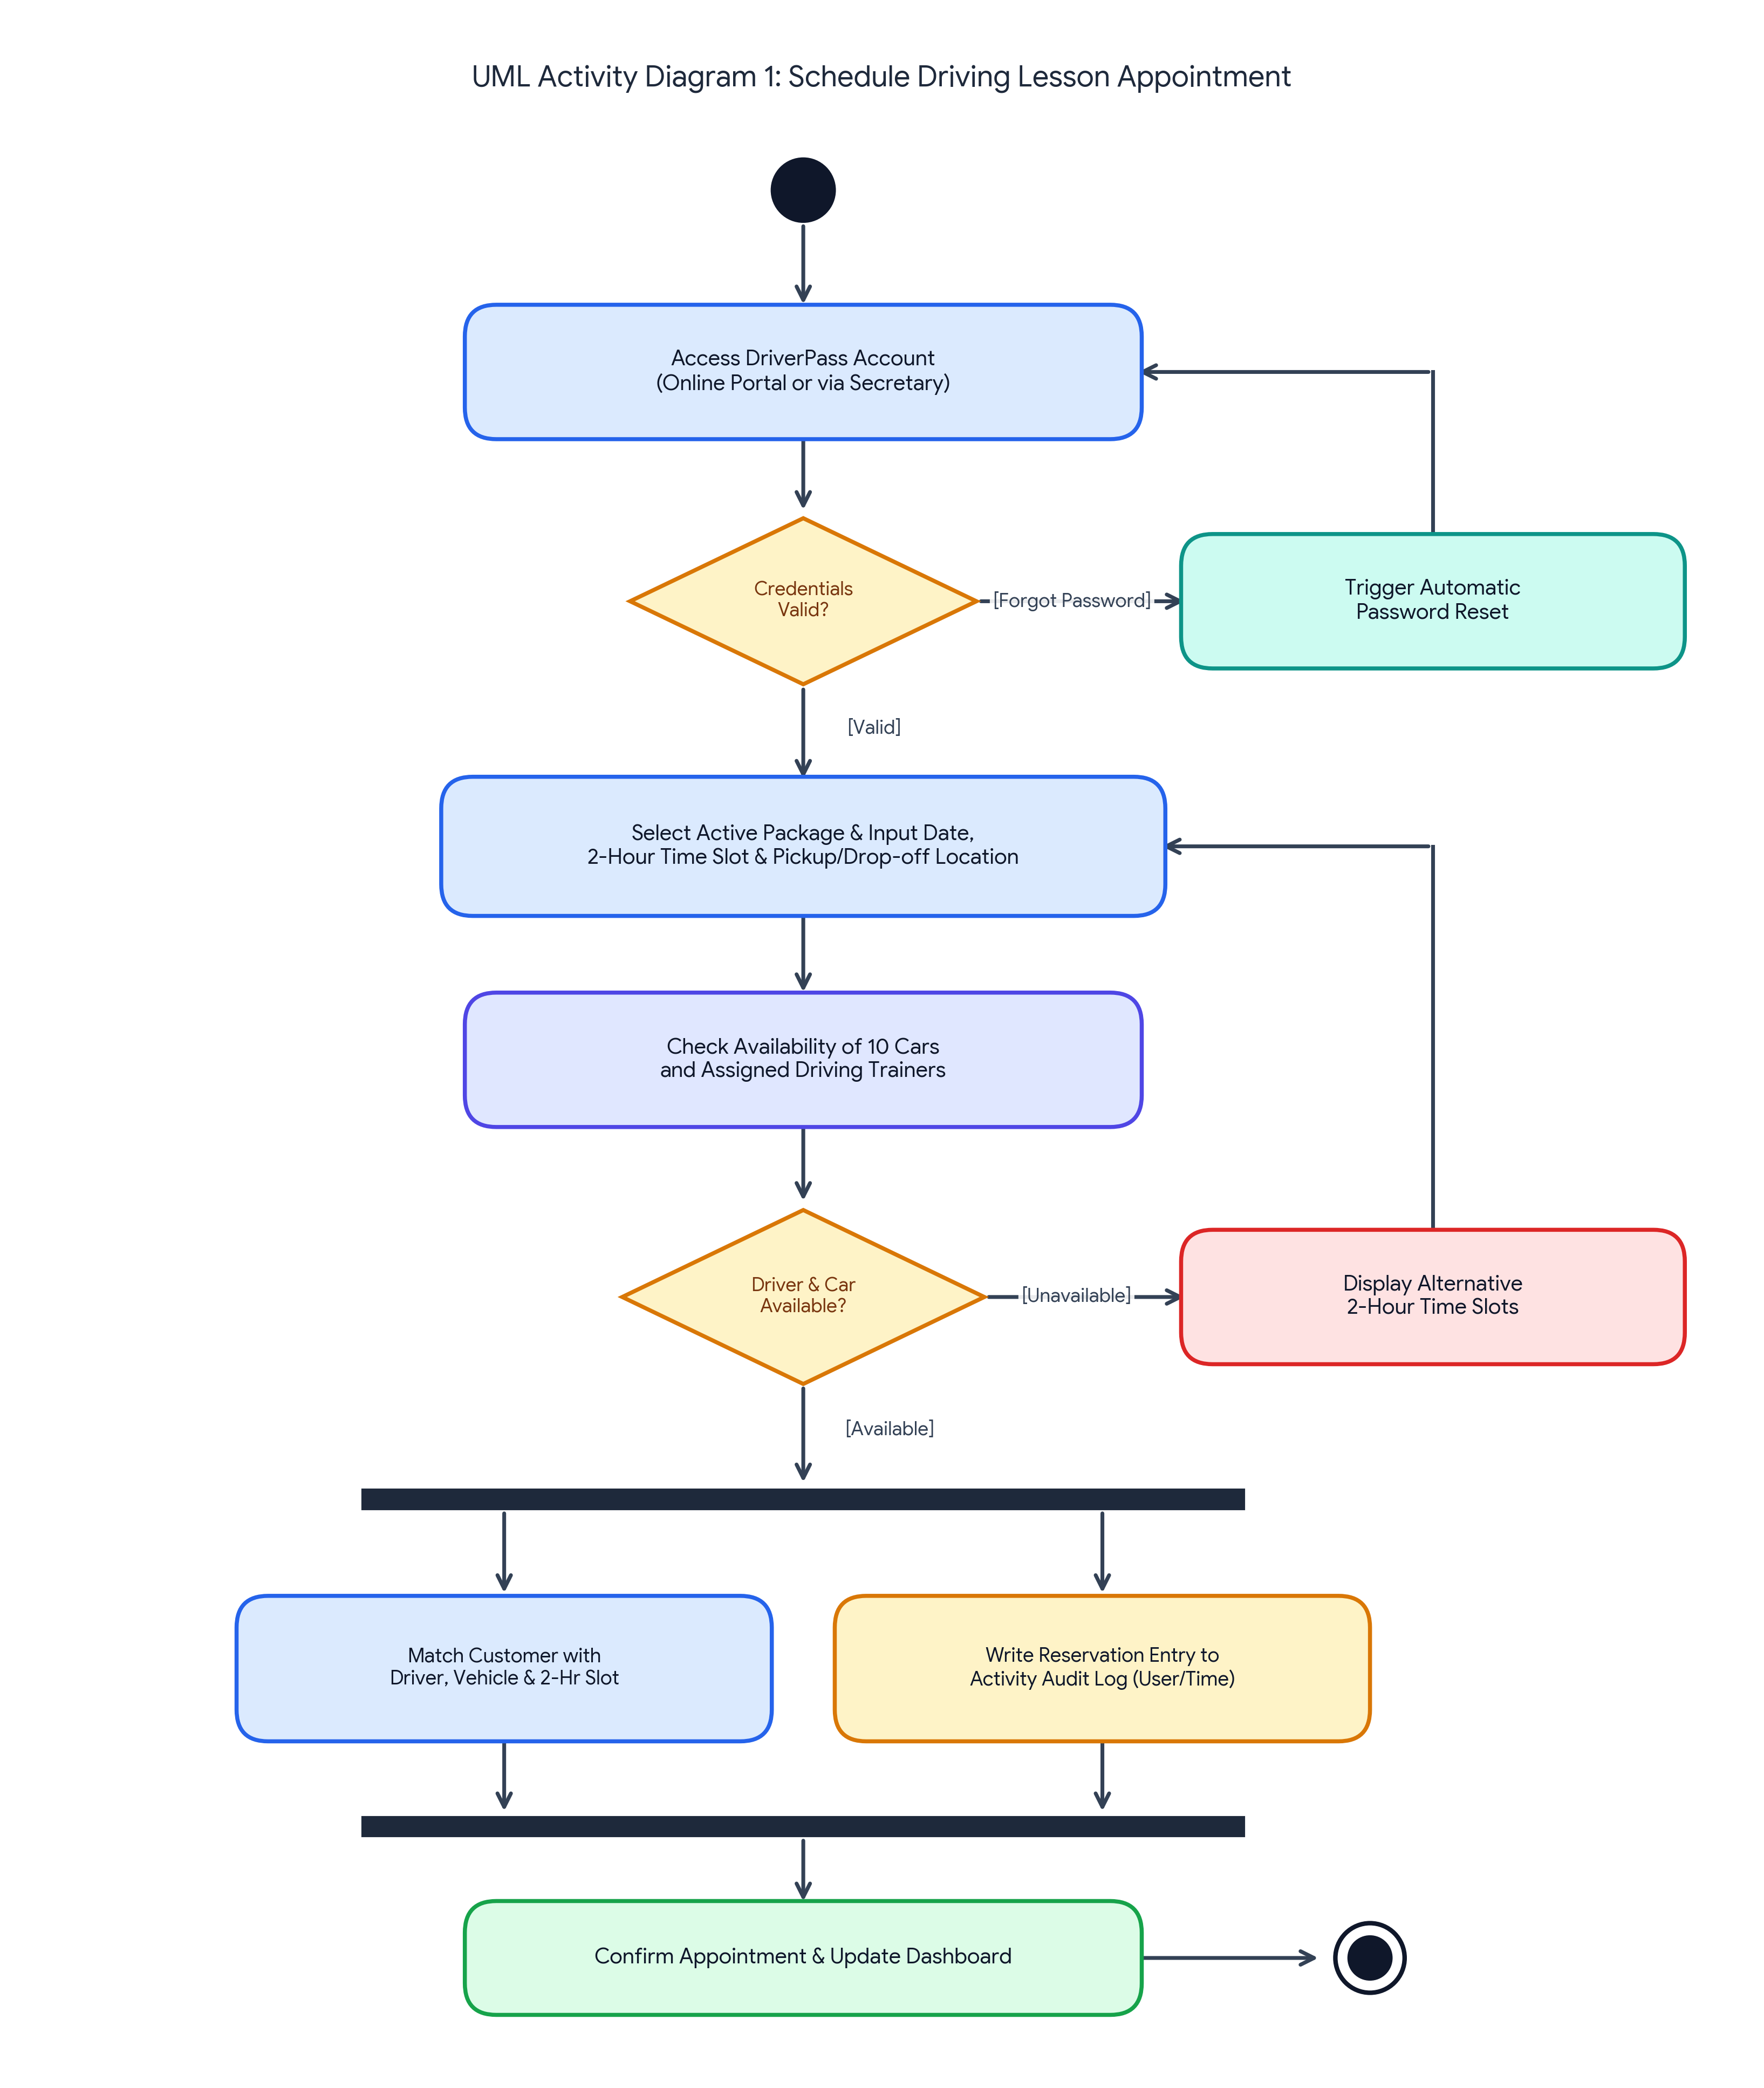
This first activity diagram models the end-to-end operational workflow for booking a two-hour behind-the-wheel training session (Southern New Hampshire University, n.d.).
• Authentication and Password Recovery: The workflow begins when a customer or the secretary accesses the DriverPass portal. A decision node verifies whether the login credentials are valid; if a customer forgets their password, the system branches to an automated password reset before returning them to the login screen.
• Fleet and Trainer Matching: Once authenticated, the user selects their active training package and inputs their preferred date, two-hour lesson window, and identical pickup/drop-off location. Because DriverPass operates a fleet of 10 cars where each vehicle is paired with a specific trainer, the system checks real-time schedule availability before confirming the slot. If the requested time or driver is already booked, the decision node routes the user back to select an alternative two-hour window.
• Parallel Booking and Audit Tracking: When an open slot is confirmed, a synchronization fork bar splits the workflow into two simultaneous actions: (1) matching and locking in the customer, driver, vehicle, and time slot, and (2) writing a timestamped entry to the activity audit log recording which user created the reservation. Once both parallel tasks finish at the join bar, the system updates the student's dashboard and completes the transaction.
Activity Diagram 2: Take Online Practice Test & Track Progress
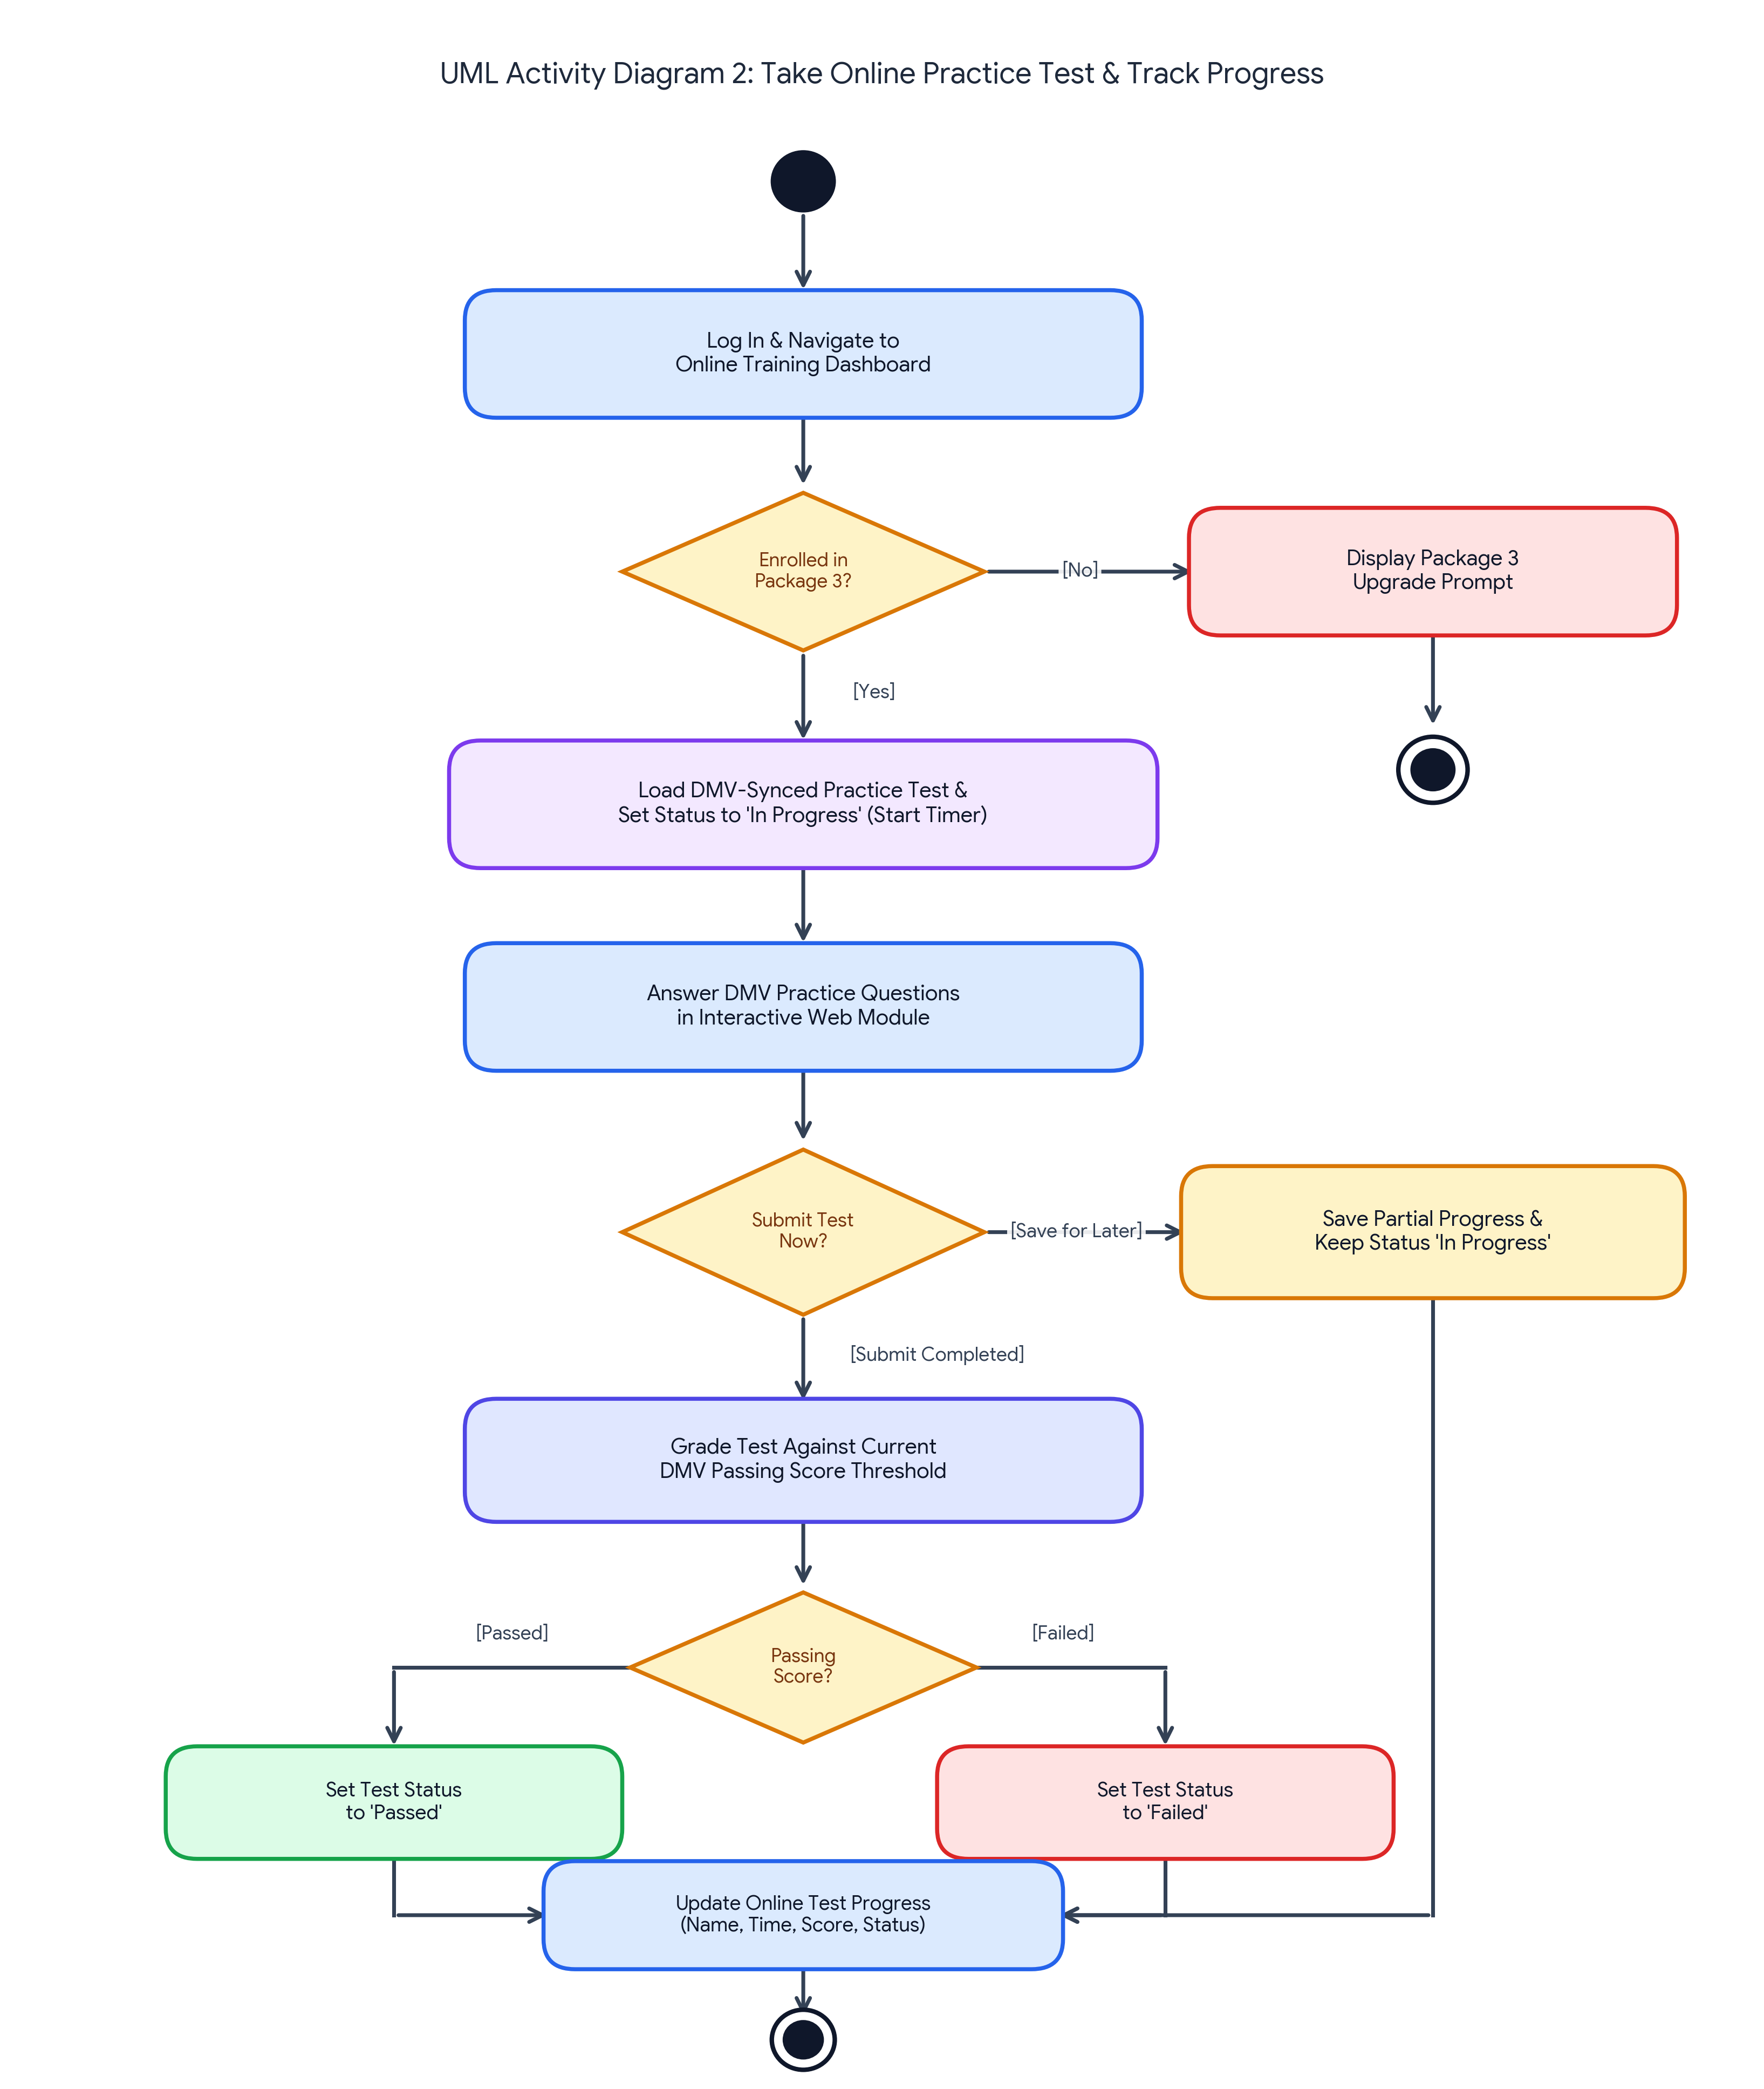
This second activity diagram models how students enrolled in Package Three interact with the online DMV practice test module and how the system populates the progress table Liam sketched during the requirements interview (Southern New Hampshire University, n.d.).
• Package Verification and DMV Synchronization: After the student logs in and navigates to the online training dashboard, a decision diamond checks whether their account is enrolled in Package Three. If not, the system displays an upgrade prompt and ends the flow. For eligible Package Three students, the system loads the latest DMV-synced practice test, starts the session timer, and changes the test status from 'Not Taken' to 'In Progress'.
• Saving Partial Work vs. Grading: As the student answers questions, a decision node handles two realistic scenarios: if the student needs to pause and leave early, the [Save for Later] branch stores their partial answers and elapsed time while keeping the status as 'In Progress'. If the student submits the completed exam, the system grades the responses against current DMV passing standards and branches to set the status to either 'Passed' or 'Failed'.
• Dashboard Update: All paths converge to update the student's Online Test Progress table with the four exact fields Liam requested—Test Name, Time Taken, Score, and Status—before closing the activity (Southern New Hampshire University, n.d.).

UML Sequence Diagram
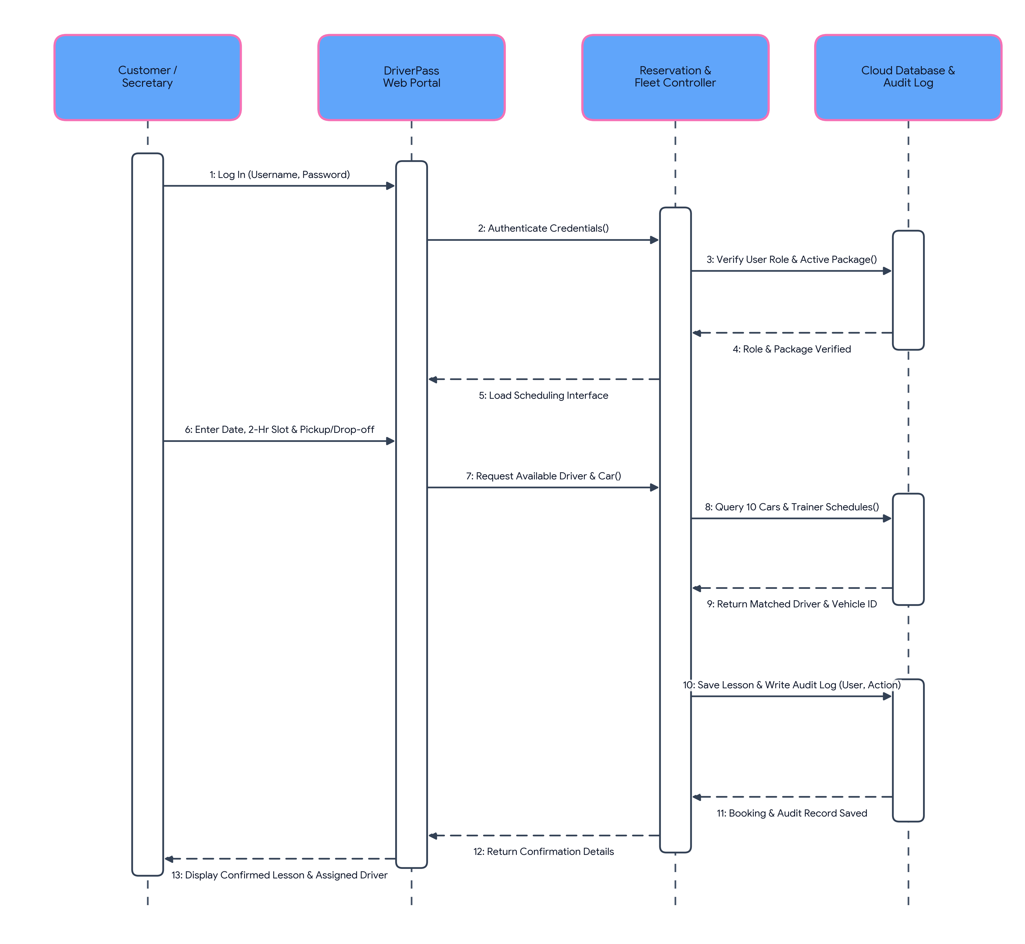
To illustrate how the system components communicate over time during a lesson reservation, this sequence diagram maps the chronological message exchange across four lifelines: Customer / Secretary, DriverPass Web Portal, Reservation & Fleet Controller, and Cloud Database & Audit Log (Southern New Hampshire University, n.d.).
• 1. Authentication Handshake (Messages 1–5): The user submits their login credentials to the DriverPass Web Portal, which forwards an authentication request to the Reservation & Fleet Controller. The controller queries the Cloud Database & Audit Log to verify the user's role permissions and active training package, returning a dashed confirmation message that loads the scheduling interface.
• 2. Fleet Verification (Messages 6–9): The user enters their desired date, two-hour lesson window, and pickup/drop-off address. Rather than blindly accepting the booking, the Reservation & Fleet Controller queries the database across DriverPass's 10 cars and assigned trainers, receiving back the matched driverID and vehicleID.
• 3. Transactional Persistence and Audit Logging (Messages 10–13): Before returning confirmation to the user, the controller executes a synchronous write operation to the database that saves both the reservation record and the mandatory accountability log (recording who created or modified the appointment). Once the database confirms the commit, dashed reply messages propagate back to the portal to display the confirmed lesson and assigned instructor.

UML Class Diagram
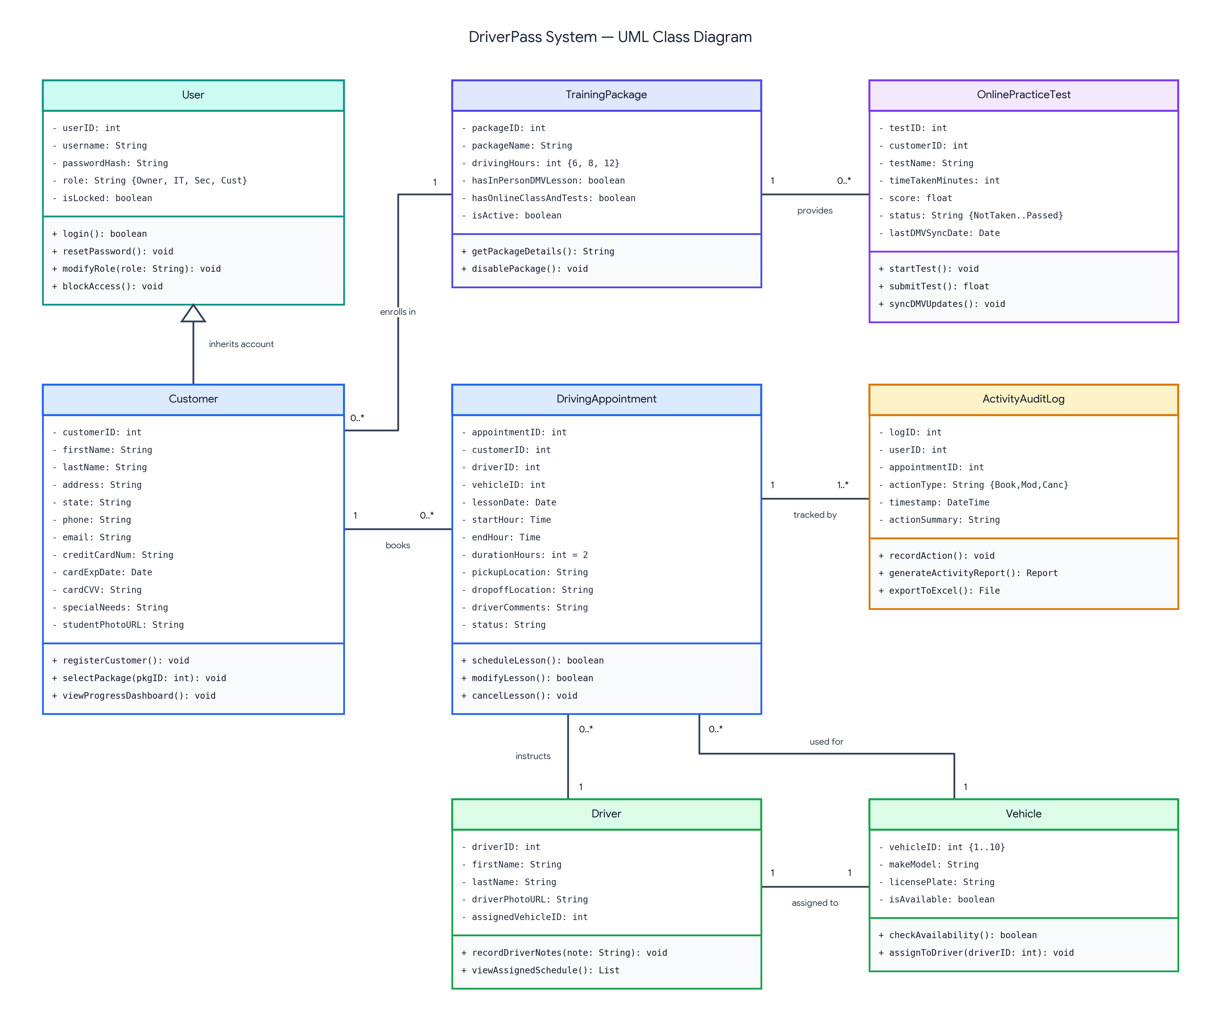
Because our team adopted a blended modeling approach, the UML Class Diagram defines the underlying object-oriented data structures, attributes, and methods that support the process workflows above (Southern New Hampshire University, n.d.).
• User Hierarchy and Role Security (User and Customer): The base User class stores core authentication and security attributes (userID, username, passwordHash, role, and isLocked) along with methods for logging in, resetting passwords, modifying roles, and blocking access when an employee leaves. The Customer class inherits from User and adds the specific registration fields Liam requested: firstName, lastName, address, state, phone, email, credit card billing attributes (creditCardNum, cardExpDate, cardCVV), specialNeeds, and studentPhotoURL.
• Packages and Online Testing (TrainingPackage and OnlinePracticeTest): Many customers (0..*) can enroll in one (1) TrainingPackage, which tracks the package tier (6, 8, or 12 driving hours), whether in-person and online modules are included, and an isActive boolean flag with a +disablePackage() method so Liam can retire a package without needing developer intervention. A TrainingPackage (1) provides zero or many (0..*) OnlinePracticeTest instances, which store testName, timeTakenMinutes, score, status (Not Taken, In Progress, Failed, Passed), and lastDMVSyncDate.
• Scheduling, Fleet Management, and Auditing (DrivingAppointment, Driver, Vehicle, and ActivityAuditLog): A Customer (1) books zero or many (0..*) DrivingAppointment records, each enforcing a 2-hour duration (startHour, endHour, durationHours = 2), identical pickup/drop-off locations, and driverComments to populate the driver notes table on the student dashboard. Each Driver (1) is paired one-to-one (1) with one of the 10 Vehicle objects and instructs zero or many (0..*) DrivingAppointment sessions. Finally, every DrivingAppointment (1) is tracked by one or more (1..*) ActivityAuditLog entries, which capture the responsible userID, actionType (Booked, Modified, Canceled), and timestamp, and provide methods (+generateActivityReport() and +exportToExcel()) so Liam can work on reports offline in Microsoft Excel (Southern New Hampshire University, n.d.).

Technical Requirements
To translate these UML models into a reliable, production-ready platform that satisfies DriverPass's functional and nonfunctional requirements from Project One, the proposed system requires the following hardware, software, development tools, and cloud infrastructure (Southern New Hampshire University, n.d.).

1. Hardware Requirements
Because Ian explicitly requested a cloud-hosted web system so DriverPass does not have to maintain local servers or manage physical backups, on-premise server hardware is intentionally eliminated. Instead, the hardware footprint is divided between cloud-provisioned compute resources and standard client-side devices:
• Cloud Server Hardware (Managed by Cloud Provider): Auto-scaling virtual server instances configured with at least 4 vCPUs and 16 GB of RAM per node for the web/application tier, load-balanced to handle concurrent logins from students taking practice tests, trainers entering lesson notes, and staff managing appointments. The database tier utilizes dedicated cloud database instances with 4 vCPUs, 32 GB RAM, and redundant NVMe solid-state drives (SSDs) configured with multi-zone replication to prevent data loss and eliminate data redundancy across servers.
• Office Workstations (Liam, Ian, and Secretary): Standard desktop or laptop computers equipped with a dual-core processor or higher, 8 GB RAM, 1080p display, broadband internet connection, and an office printer for printing activity audit reports.
• Mobile Devices and Tablets (Trainers and Students): Any modern smartphone, tablet (iOS or Android), or personal computer capable of running a standard web browser, allowing Liam to access reports from home, trainers to log lesson comments on the road, and students to book appointments or take practice tests from anywhere.

2. Software Requirements
• Operating Systems & Runtime Environments: Ubuntu Linux LTS (Long-Term Support) on the cloud server tier running containerized services for stability and automated security patching, paired with cross-platform client browser support across Windows 11, macOS, iOS, and Android.
• Front-End Web Interface: HTML5, CSS3, and React.js to deliver a responsive, mobile-friendly user interface that implements Liam's custom dashboard layout (displaying student contact info, special needs, student/driver photos, the Online Test Progress table, and the Driver Notes table).
• Back-End Business Logic Layer: Node.js (Express) or Python (Django/FastAPI) RESTful application server enforcing Role-Based Access Control (RBAC), two-hour lesson scheduling validation, package activation/deactivation toggles, and automated email/SMS password reset workflows.
• Relational Database Management System (RDBMS): PostgreSQL (hosted via managed cloud service) to enforce strict ACID (Atomicity, Consistency, Isolation, Durability) transactions. This guarantees that live data modifications only happen online against a single source of truth, preventing duplicate reservations or data redundancy.
• Reporting & Office Software Integration: Server-side spreadsheet export engine (SheetJS / OpenPyXL) and client-side compatibility with Microsoft Excel (.xlsx and .csv formats) so Liam can download reservation and activity reports to analyze offline at home (Southern New Hampshire University, n.d.).

3. Tools (Development, Modeling, Security, and Integration)
• CASE & Modeling Tools: Lucidchart for maintaining UML Use Case, Activity, Sequence, and Class diagrams as the system evolves toward future releases.
• Version Control & CI/CD Pipeline: Git and GitHub for source code management and automated deployment pipelines, ensuring future feature modules (such as custom package creation) can be added cleanly by developers in subsequent releases.
• Payment & Security Tools: A PCI-DSS compliant payment gateway API (such as Stripe or Authorize.Net) to tokenize and encrypt customer credit card numbers, expiration dates, and security codes during registration, alongside bcrypt password hashing, JSON Web Tokens (JWT) for session security, and an automated self-service password reset email service.
• External Compliance Integration (DMV API Connector): A scheduled REST API synchronization service and webhook listener that connects to the state DMV feed, automatically pulling updated driving rules, policies, and sample test questions and sending real-time notifications to DriverPass whenever DMV requirements change.

4. Infrastructure Requirements
• Cloud Hosting Architecture (PaaS/IaaS): Hosted on a managed enterprise cloud platform (such as Amazon Web Services [AWS] or Microsoft Azure). Utilizing managed cloud services directly fulfills Ian's requirement that DriverPass should not have to deal with manual server maintenance, hardware failures, or security infrastructure.
• Network & Online Synchronization Policy: High-availability HTTPS internet connectivity protected by TLS 1.3 encryption in transit and AES-256 encryption at rest. While Liam can download exported reports for offline viewing in Excel, all live creates, updates, and cancellations require an active internet connection so the cloud database remains synchronized in real time.
• Automated Backup & Disaster Recovery Infrastructure: Automated daily cloud snapshots with point-in-time recovery and a Web Application Firewall (WAF) managed entirely by the cloud provider, keeping DriverPass's daily focus on training students rather than troubleshooting IT issues (Southern New Hampshire University, n.d.).

5. Requirements-to-Design Traceability Summary
The table below summarizes how each functional and nonfunctional requirement collected in Project One maps directly to the UML models and technical components in this design:
Client Requirement (Project One) | UML Model Coverage | Technical Stack Component
Customer registration with contact, credit card, and matching pickup/drop-off locations | Use Case Diagram (Register Account); Class Diagram (Customer attributes) | React.js Input Forms, PostgreSQL DB, PCI-DSS Payment Gateway (Stripe API)
Three training packages (6, 8, or 12 hrs) & owner ability to disable packages | Use Case Diagram (Select/Disable Package); Class Diagram (TrainingPackage) | Back-End Business Logic Layer (+disablePackage toggle in PostgreSQL)
2-hour lesson scheduling matched across 10 cars and assigned trainers | Use Case, Activity Diagram 1, Sequence Diagram, Class Diagram (Driver/Vehicle) | Reservation & Fleet Controller, ACID Database Transactions
Online DMV classes, practice tests, progress table, and driver notes table | Use Case Diagram; Activity Diagram 2; Class Diagram (OnlinePracticeTest) | React.js Student Dashboard, DMV Webhook/REST API Connector
Role-based security, IT account blocking, and automatic password resets | Use Case Diagram; Activity Diagram 1; Class Diagram (User hierarchy) | RBAC Middleware, bcrypt Hashing, Automated Email Reset Service
Full reservation audit tracking & downloadable offline Excel reports | Use Case, Activity 1, Sequence, and Class Diagram (ActivityAuditLog) | Immutable Audit Log Table, SheetJS/Excel (.xlsx) Export Engine
Cloud-hosted web access with hands-off security and automated backups | Sequence Diagram (Cloud DB); All web-accessible actor interactions | AWS/Azure Managed Cloud Infrastructure, TLS 1.3, Daily Cloud Snapshots

References
Southern New Hampshire University. (n.d.). CS 255 DriverPass interview transcript.
AI Acknowledgement: Generative AI (Gemini) was utilized as a brainstorming, diagram-structuring, and formatting assistant to help organize this system design document and refine the technical requirements, in accordance with SNHU's AI usage guidelines.

