**ELEC 4700**

**ASSIGNMENT 1 – MONTE-CARLO MODELLING OF ELECTRON TRANSPORT**

**SUBMITTED BY: EMEKA PETERS 100953293**

**DATE SUBMITTED: 04/02/2018**

**Introduction**

This assignment experiment involved the modelling of electron motion in a semi-conductor device with the size of 200nm x 200nm. The experiment involved modelling the electron motion with monte-carlo techniques, using random numbers to estimate behavioral values such as average temperature, thermal velocity, mean free time and mean free path. After modelling the electron motion and adding the requested enhancements, plots of electron density and average temperature were obtained.

**Electron Modelling**

The thermal velocity of a particle is the velocity that the particle would have if its kinetic energy was almost the same as that of the average energy of the whole system. The thermal velocity was found by implementing the following equation on Matlab:

Where k is the Boltsman constant, T is temperature (300 Kelvin) and m is the effective mass of the electron.

If the mean free time is 0.2ps, the mean free path is just the mean free time multiplied by the average velocity of the particles, vth. A sample calculation is:

Mfp = 13.2 x 0.2ps = 2.65 x 10-12 m

A sample plot of the particle trajectories is shown in figure 1 below:

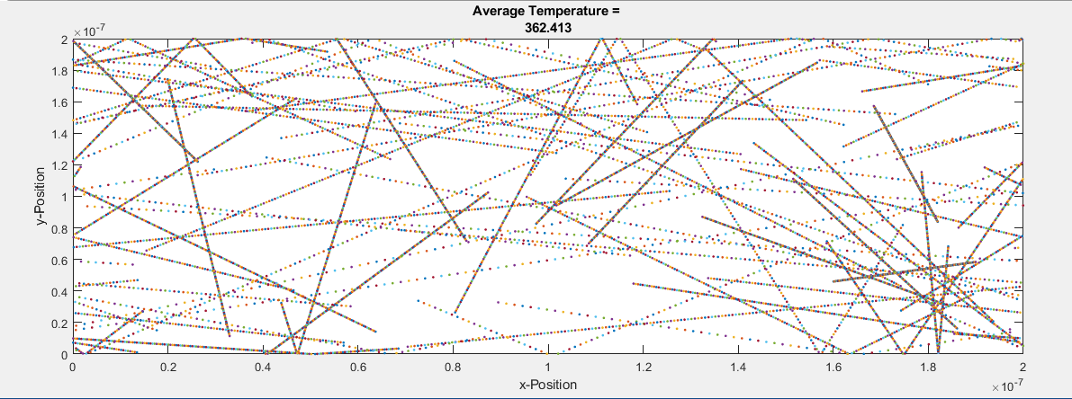

Figure 1: 2D sample plot of particle trajectories

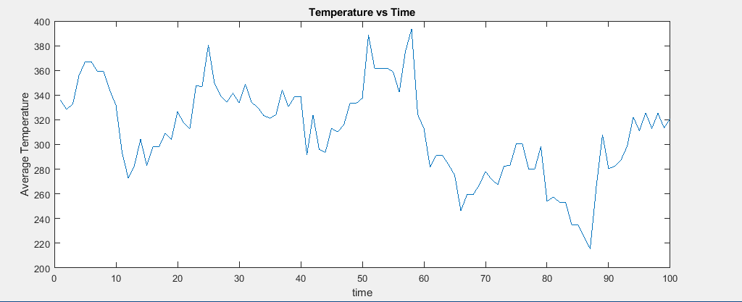

Figure 2: Temperature plot vs time (with scattering done in part 2)

The histogram showing the distribution of the speed is shown below:

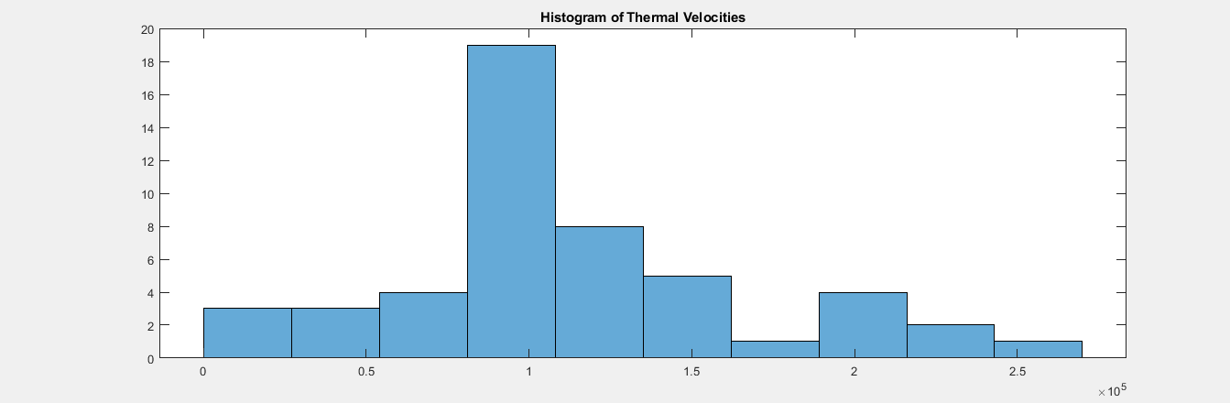

Figure3: Histogram showing velocity distribution (100 iterations and 50 particles)

**Collisions with Mean Free Path**

A random velocity was assigned to each particle at the start using a Maxwell-Boltsmann distribution. This was attained by giving each particle a velocity in the x and y direction from a normal distribution ad multiplying by a standard deviation which was equal to the thermal velocity divided by the square root of 2. The overall magnitude from combining the x and y velocities followed a Maxwell-Boltsmann distribution behavior. The following snippet of Matlab code was used to attain this:

stdv = vTherm/(sqrt(2)); %Standard deviation for x and y velocities

%%Question 2 - Assigning a Random Velocity to the particles, following a

%Maxwell-Boltsmann distribution

velx = randn(1, size) .* stdv;

vely = randn(1, size) .* stdv;

vrms = sqrt((velx .^ 2) + (vely .^ 2));

The probability of scattering was calculated using the provided formula and obtained as 0.03.

A check was done at the beginning of every iteration to check if scattering should occur then a random velocity was assigned to each particle. This was done with MATLAB’s logical indexing as the following code snippet shows:

is = pscat > rand(1,size);

velx(is) = randn .* stdv;

vely(is) = randn .* stdv;

The average temperature fluctuates over time between values centered around 300K. The temperature range decreases over time and converges at around 300K.

Figure 4 below shows a sample particle trajectory with scattering:

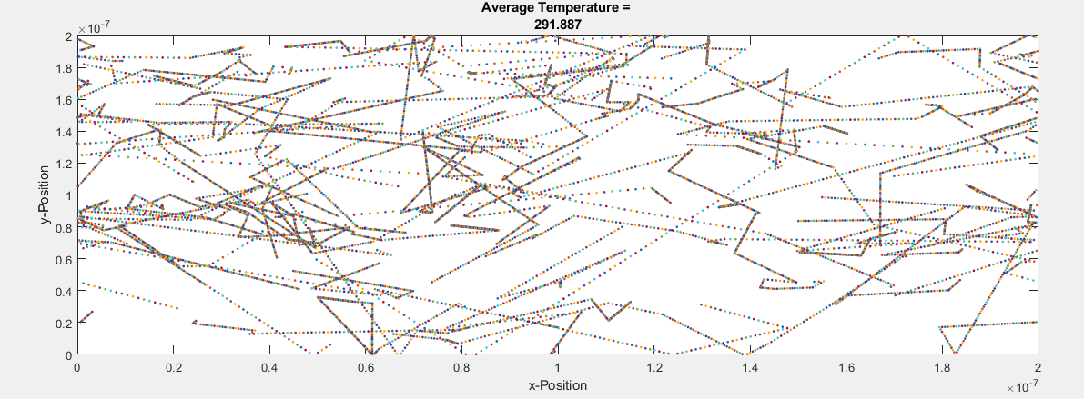

Figure 4: Sample particle trajectory with scattering

**Enhancements**

An inner rectangle bottle-neck was added to the boundaries from 0.85 times half of the width to 1.15 times half of the width of the region. The y-boundaries of the bottle-neck were drawn at one-third of the length of the region and two-thirds of the length of the region.

The boundaries were made specular or diffusive as requested. When the boundaries were diffusive, particles were re-assigned a random velocity upon hitting the boundaries.

The electron density map is shown in figure 5 below:

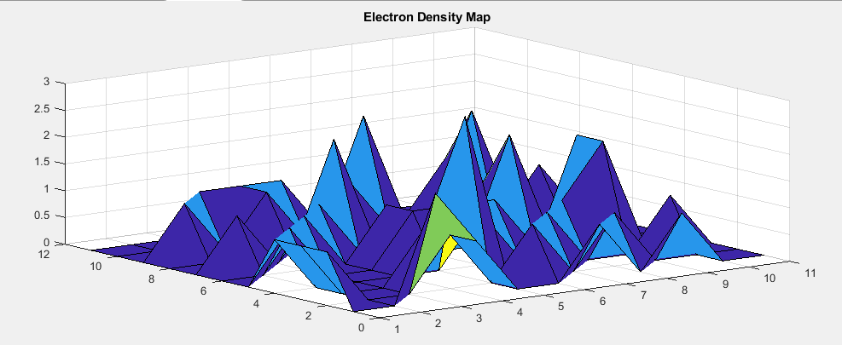

Figure 5: Electron density Map

The temperature map is shown in figure 6 below:

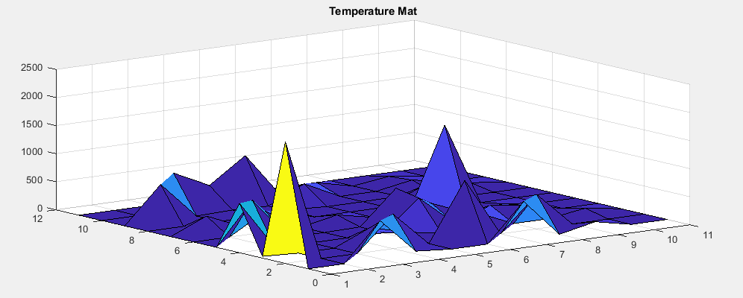

Figure 6: Temperature Map

Final 2D plot of particle trajectories is shown in figure 7 below:

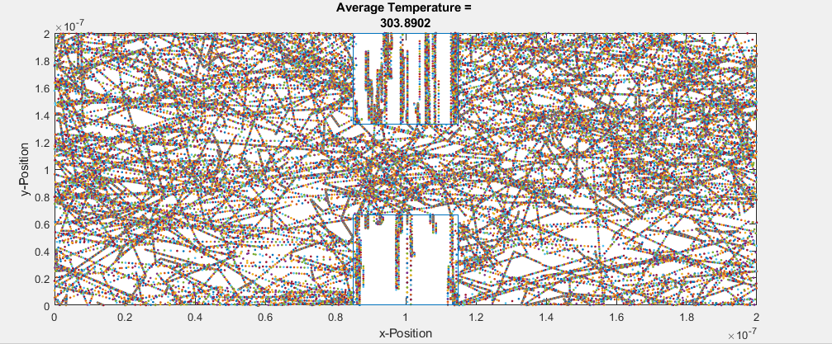

Figure 7: Final 2D plot of particle trajectories

**Conclusion**

The experiment was successful and educative. The overall MATLAB code works to specification except that the mean free path mean free time calculation does not work. In the final model including the rectangular bottle-necks, some electrons still leak into the rectangular boundaries.