**ELEC 4700**

**ASSIGNMENT 3 – MONTE CARLO/ FINITE DIFFERENCE METHOD**

**Submitted By:**

**Emeka Peters – 100953293**

**Date Submitted:**

**19/03/2018**

**Introduction**

This experiment involves combining the Monte-Carlo simulation that was done in assignment1, combined with the finite difference method that was used in assignment 2. The simulation was first done with Monte-Carlo simulation with an electric field applied. The second part of the experiment involved using the finite difference method to calculate the electric field to be applied to the electrons in the Monte Carlo simulation. The third part of the experiment involved applying the electric field in part 2 to the simulation in part 1.

**Part 1: Monte-Carlo Simulation**

1. The electric field is the voltage applied across, divided by the distance. In this part, the width of the material is 0.2µm and the electric field applied was 0.1V. Therefore, the electric field is = 0.1/0.2µm = 500,000V/m.
2. The force is the charge times the electric field = q x E = 1.602e-19 * 500000 = 8.01e-14
3. This part was done with code that was submitted on guithub along with the assignment report. Example calculation:

a = F/m

a = (8.01e-14)/(9.11e-31) = 8.79m/s2

1. The drift current is directly proportional to the average carrier velocity.

I = nAvQ

Where;

*I is the electric current*

*n is number of charged particles per unit volume (or charge carrier density)*

*A is the cross-sectional area of the conductor*

*v is the drift velocity, and*

*Q is the charge on each particle.*

1. The requested plots are shown below:

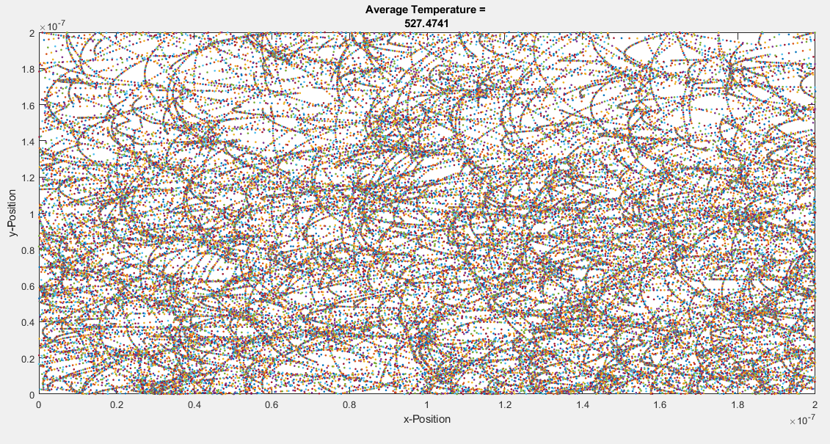

Figure 1: Sample Trajectory Path after 1000 Steps

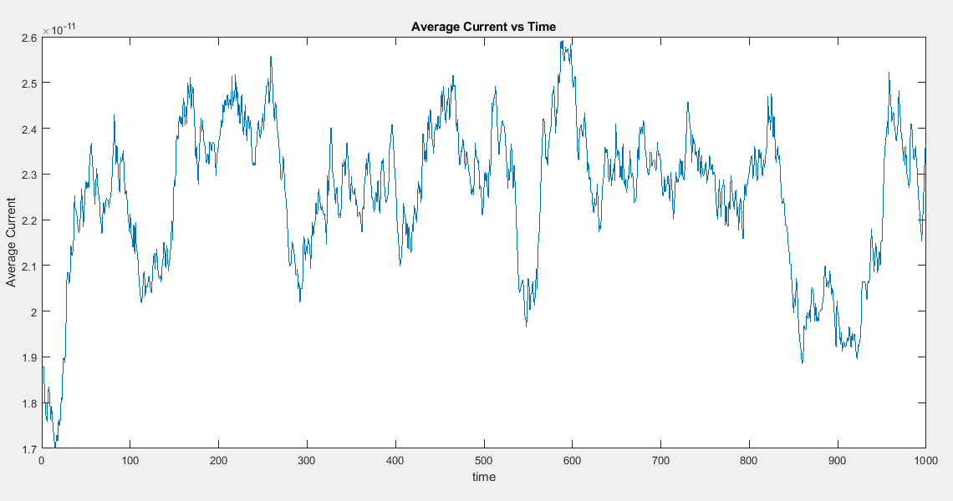

Figure 2: Average Current vs Time

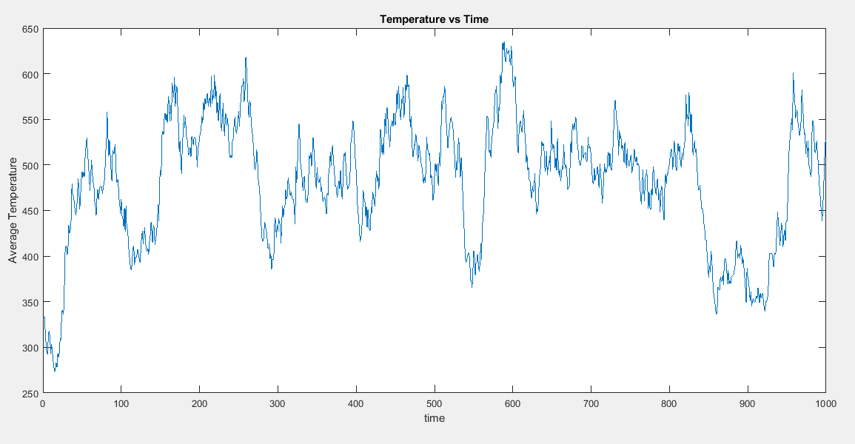

Figure 3: Average Temperature vs Time

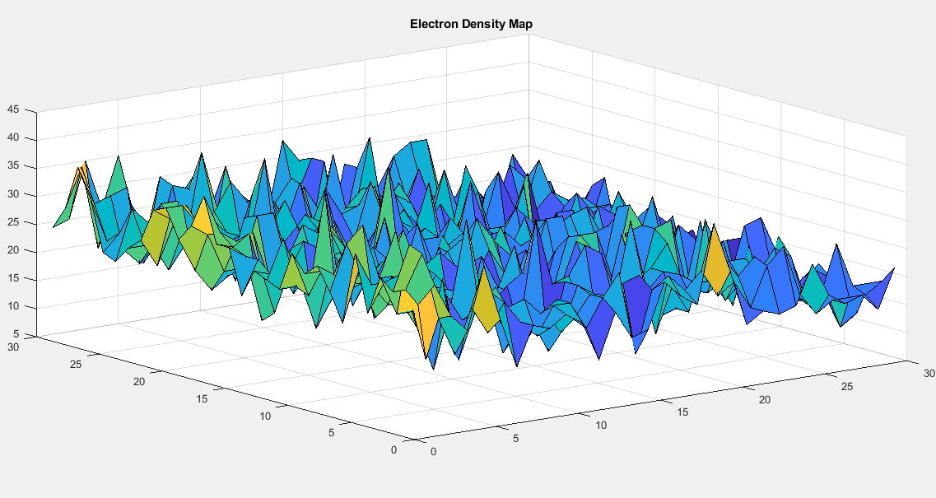

Figure 4: Final Electron Density Map

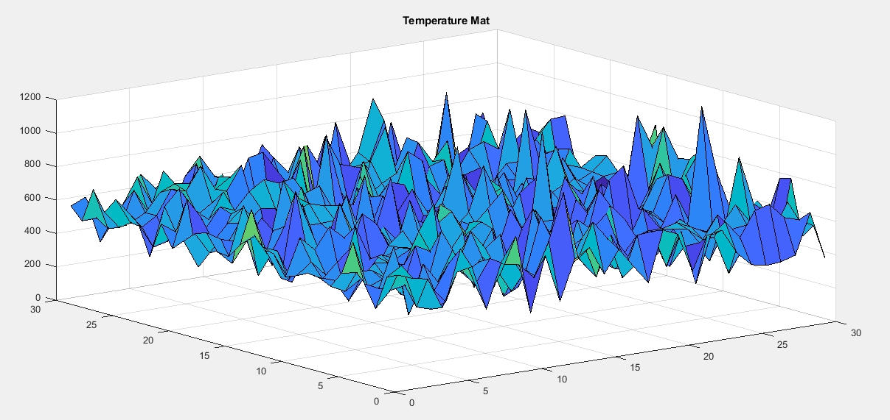

Figure 5: Final Temperature Map

**Part 2: Finite Difference Method**

This part involved calculating a voltage and electric field using the finite difference method that was taught in this course.

The requested voltage and electric field plots are shown below:

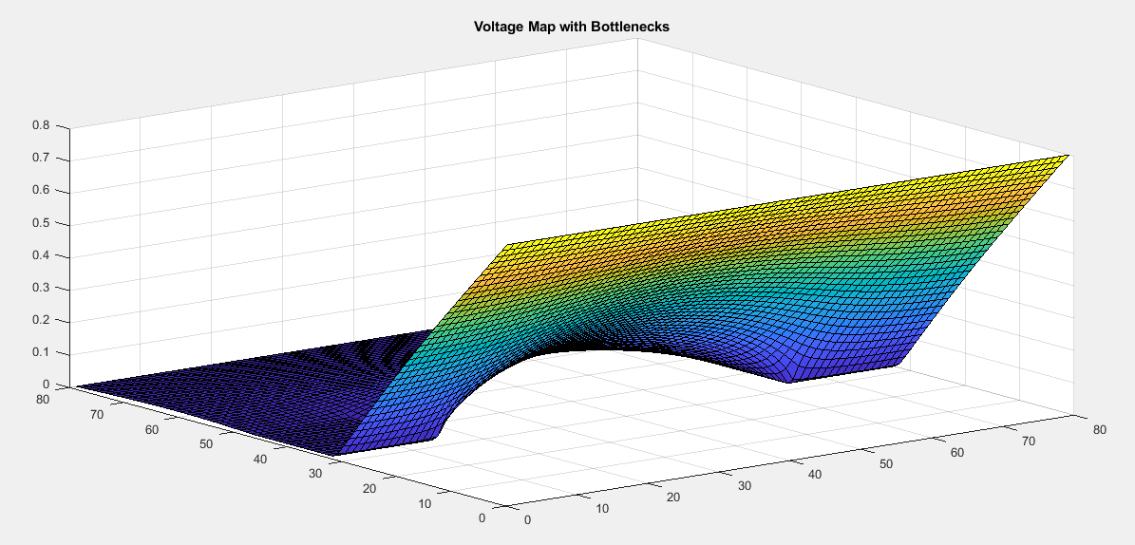

Figure 6: Voltage Surface Plot

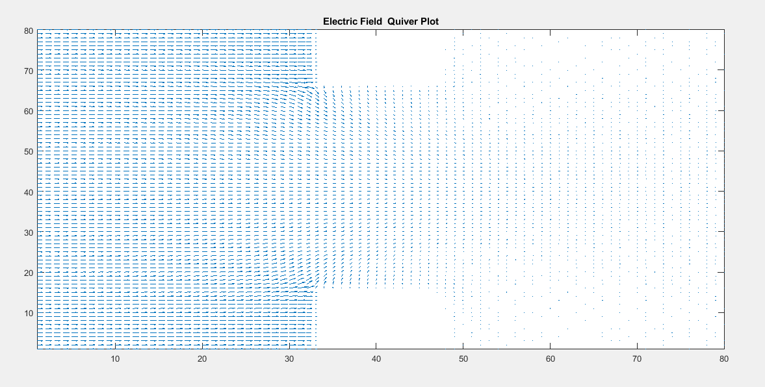

Figure 7: Electric Field Quiver Plot

**Part 3: Monte-Carlo Simulation and Finite Difference Method**

This part involved combining the simulation in part 1 with the electric field gotten in part 2, with the added bottlenecks. The 2D plot of the particle trajectories is shown below:

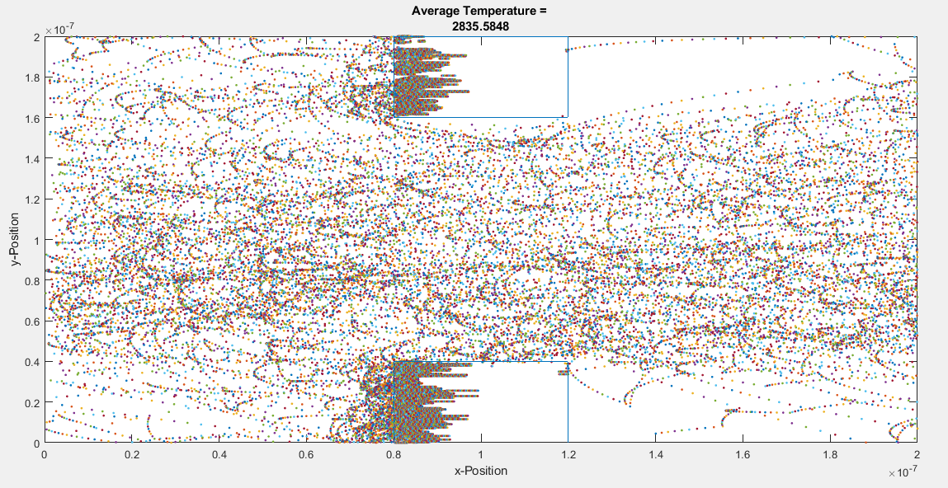

Figure 8: Sample 2D plot after 1000 timesteps

The electrons are concentrated on one side of the insulator and cannot escape due to the electric field (x-direction). **Some electrons are leaking into the boxes**.

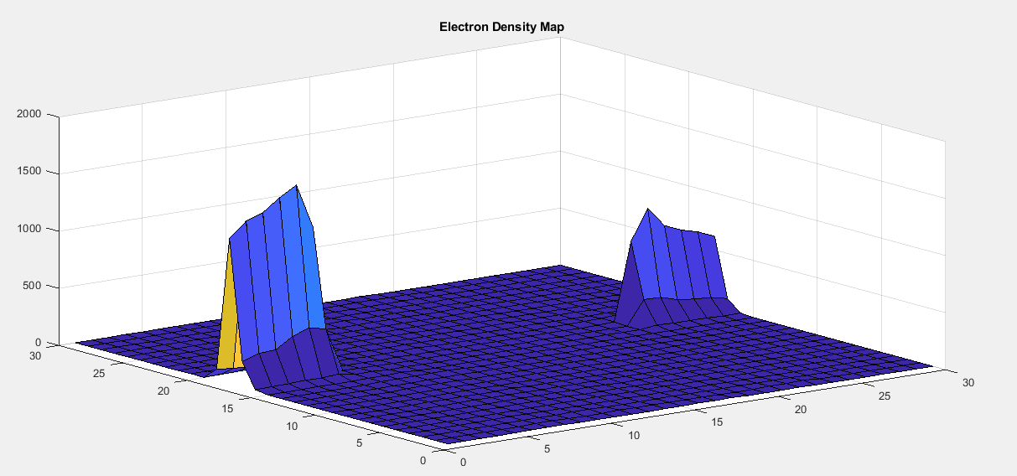

Figure 9: Final Electron Density Map

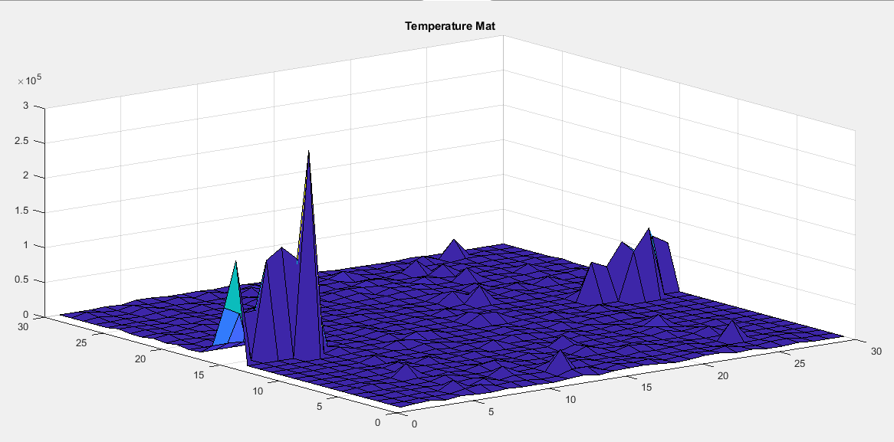

Figure 8: Final Temperature Map

The electrons are concentrated on one side of the insulators due to the electric field, and they cannot escape. This is because the electric field keeps pushing them towards the sides of the insulators, and the insulators keep trying to bounce them off. This makes the electrons to get concentrated on those sides of the insulators and hence, also a temperature increase on those sides of the insulators because of the electron concentration and repeated movement due to the electric field and bouncing of the insulator walls.

The next step to make the simulation more accurate would be to add more electrons, increase the number of meshes used in calculating the density and temperature, adding more parameters.

**Conclusion**

The experiment was successful. The first part was successfully modelled with an electric field in the x-direction, causing the particle trajectories to be curved as expected, and boundary conditions were obeyed. The second part of the experiment was also successful, the voltage was successfully modelled, and the electric field was solved for successfully. The third part of the experiment went well, some electrons leaked into the insulators, but kept on moving around one side of both bottlenecks, due to the electric field. This would mean that the insulators would be hot, if touched. Overall, the experiment was very educative and successful.