**ELEC 4700**

**ASSIGNMENT 4**

**CIRCUIT MODELING**

**Submitted By:** Emeka Peters

**Date Submitted:** 09/04/2018

**Question 1**

The differential equations and matrices were obtained from PA9 and are shown below:

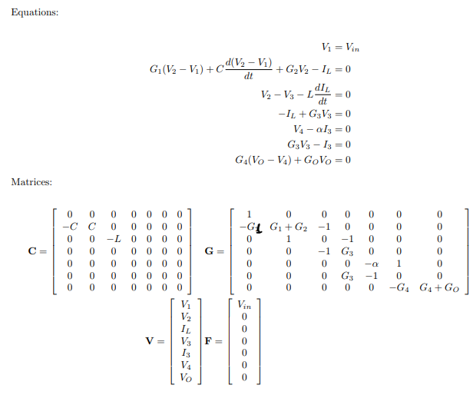

The matrices can also be seen in the MATLAB code that was submitted along with the lab report.

The DC Sweep Vin and Vout plots, along with the frequency spectrums can be seen in figures 1 to 3 below:

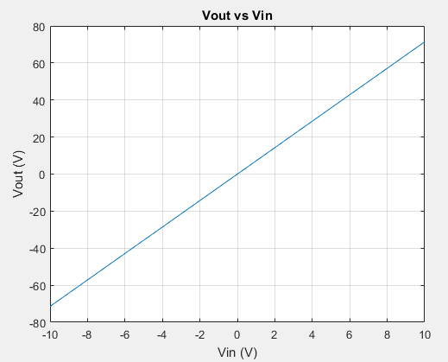

Figure 1: DC Sweep Vout vs Vin

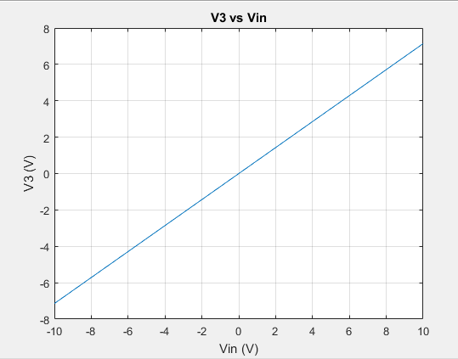

Figure 2: V2 vs Vin

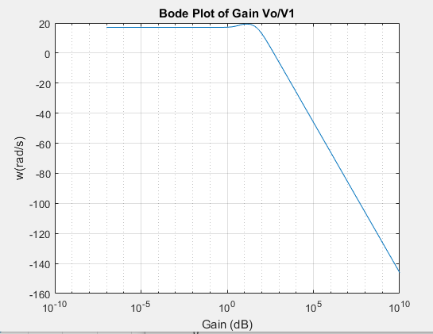

Figure 3: Bode Plot of Gain Vout/Vin

The requested histogram of gain can be found in figure 4 below:

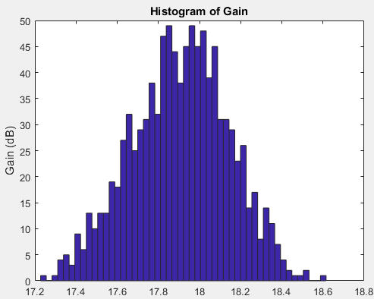

Figure 4: Gain Histogram

**Question 2:**

This part of the experiment involved simulating the circuit with different types of input signals for 1s (In 1000 timesteps).

1. The input in this part of the experiment was a step that goes from 0 to 1 at 0.03s. The time domain and frequency domain input and output plots are shown in the figures below:

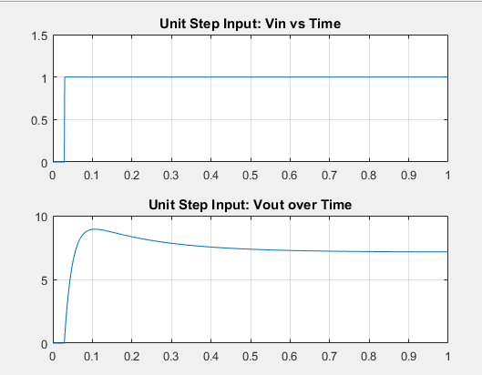

Figure 5: Vin and Vout Time domain plots for Unit step function

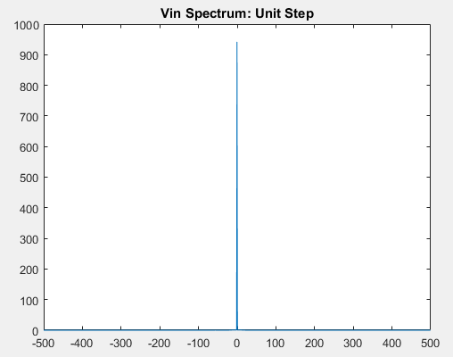

Figure 6: Vin Frequency Spectrum for unit step function

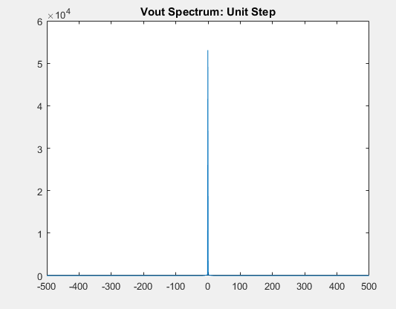

Figure 7: Vout Frequency Spectrum for unit step function

1. This part of the experiment involved simulating the circuit wiyth an input signal of sin(2πft) where f = 1/0.03

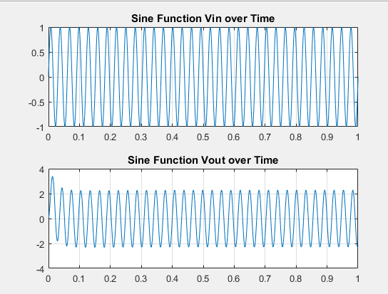

Figure 8: Vin and Vout Time domain plots for sine function

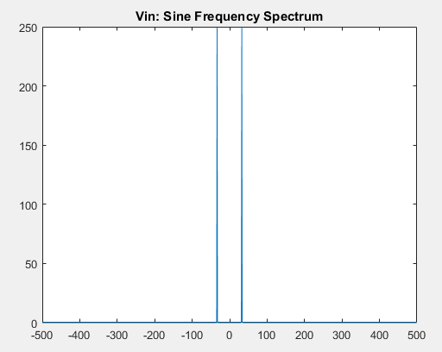

Figure 9: Vin Frequency Spectrum for sine function

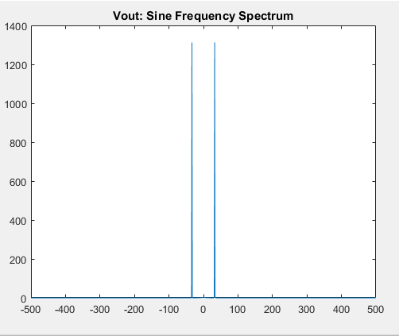

Figure 10: Vout Frequency Spectrum for sine function

1. This part of the experiment involved simulating the circuit with a Gaussian input with standard deviation of 0.03s and delay of 0.06s. The requested plots are shown below:

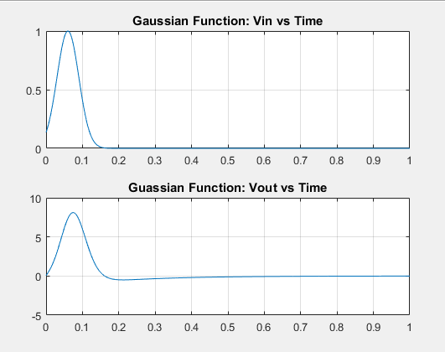

Figure 11: Vin and Vout Time domain plots for gaussian function

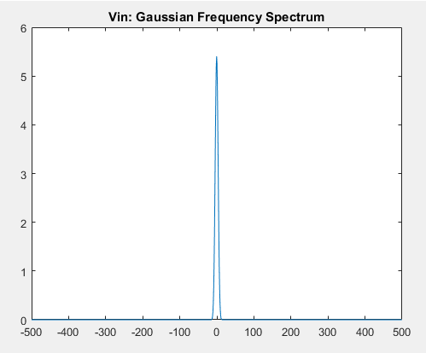

Figure 12: Vin Frequency Spectrum for gaussian function



Figure 13: Vout Frequency Spectrum for gaussian function

1. When the timestep is increased, the signal becomes less properly modelled in the time domain, the signals seem a bit distorted.

**Question 3:**

This part of the experiment involved simulating the circuit with a current source representing noise in a resistor.

1. The current source was added as an extra term in the G, C, F, and V matrices, increasing their sizes from 7 elements (equations) to 8. The updated G matrix from MATLAB is shown below:

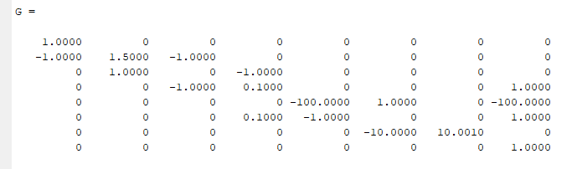

1. The updated C Matrix is shown below

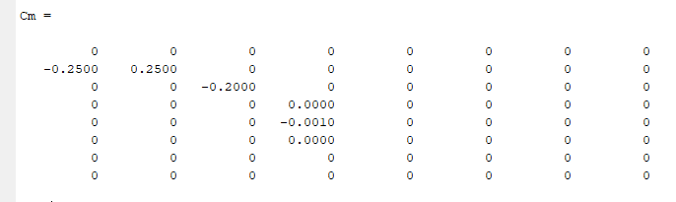

1. When the circuit was simulated, the signal looked noisy. The noisy output signal plot, along with the frequency spectrum plots are shown below:

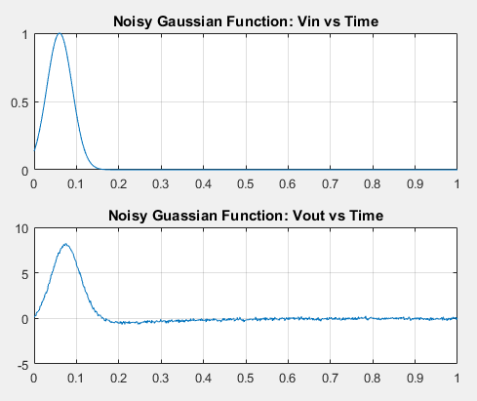

Figure 11: Vin and Vout Time domain plots for gaussian function

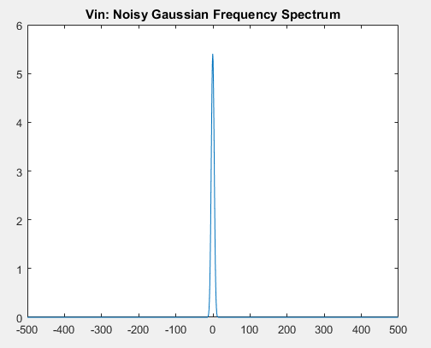

Figure 12: Vin Frequency Spectrum for gaussian function

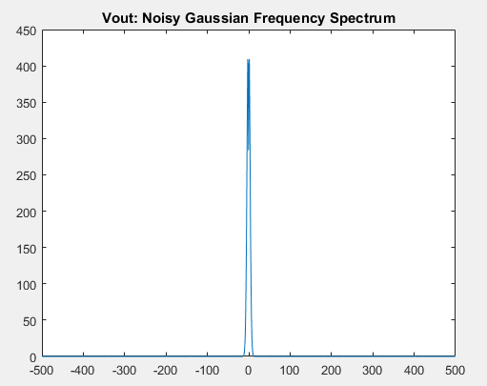

Figure 13: Vout Frequency Spectrum for gaussian function

The plots with the varying capacitance values are shown below:

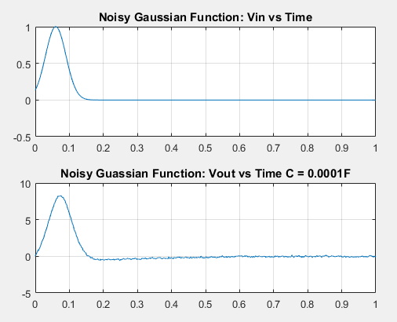

Figure 17: Vin and Vout with C = 0.0001F

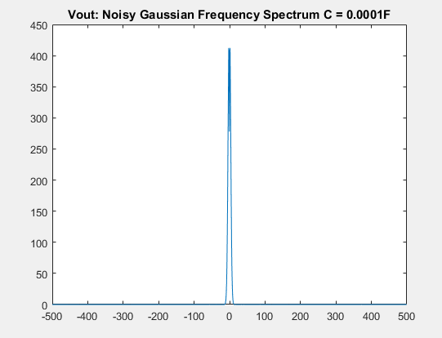

Figure 18: Vout Frequency Spectrum with C = 0.0001F

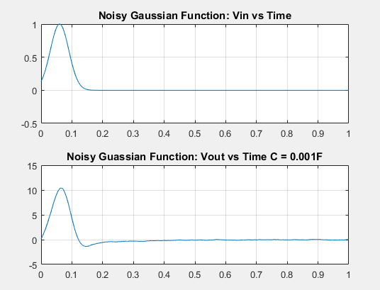

Figure 17: Vin and Vout with C = 0.001F

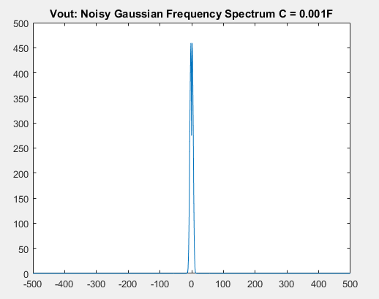

Figure 18: Vout Frequency Spectrum with C = 0.0001F

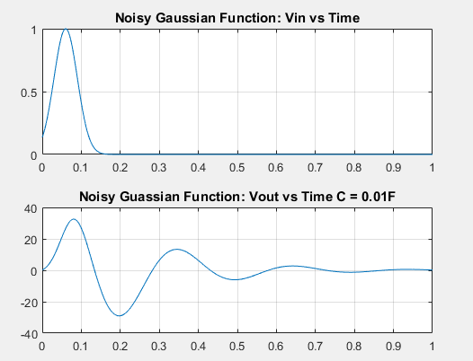

Figure 17: Vin and Vout with C = 0.01F

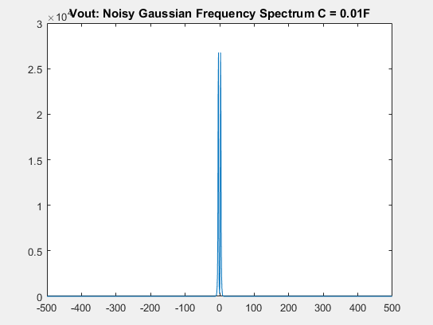

Figure 18: Vout Frequency Spectrum with C = 0.01F

As Cn increases, there seems to be a separation in the middle of the frequency spectrum curve.

The plots of Vout with 2 different timesteps are shown in the figures below:

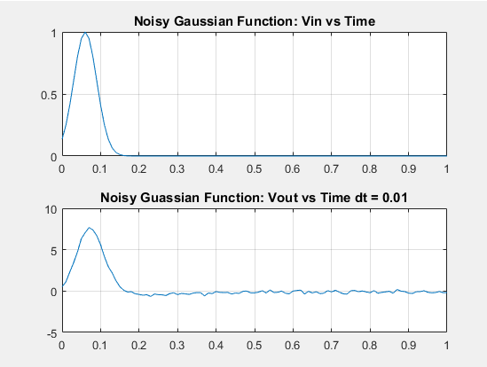

Figure 2X: Vin and Vout with dt = 0.01s

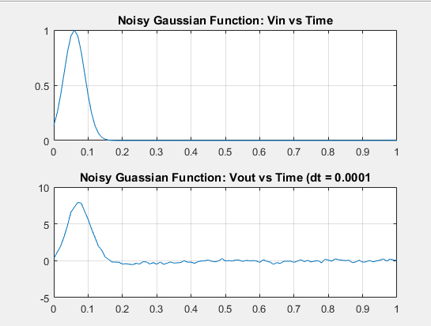

Figure 2X: Vin and Vout with dt = 0.0001s

**Question 4:**

1. A Jacobian (J) matrix will need to be made, along with a B matrix, to solve the problem by iteration and differentiation. The simulation will need to be done with two loops, instead of one as before. This is shown in the submitted code.

The non-linear gain would add more spikes (harmonics to the Vout signal) But the implementation did not work properly and the output was not as expected.