Department of Computer Science and Business Systems AY: 2025-26 Sem: II

Mini Project Report On

Weather Data Visualization and Machine Learning Application

Submitted by :
Ambadas Tonkakate (RBT24CB015)
Narsing Mane (RBT24CB017)

Under the guidance of

Prof. Pallavi Waghmare

Course:

Data Analysis and Visualization Lab

Academic Year: 2025–26 (Semester IV)

Table of Contents
- Abstract 4
- Introduction 6
- Literature Survey / Existing System 7
- Proposed System 8
- Methodology / Implementation 10
- Results and Discussion 13
- Conclusion and Future Scope 16
- References 17
- Appendix (Optional) 18
- Course Outcomes:
CO1: Apply Python programming to organize and process real-world data, and use descriptive statistics to analyse and interpret it effectively

CO2: Perform data pre-processing and visualize data using charts and dashboards.

CO3: Use Principal Component Analysis (PCA), Linear Discriminant Analysis (LDA), and Factor Analysis (FA) to classify, group, and analyze data.

CO4 : Develop Python web apps (Flask/Django) to display, add, and summarize dataset records with visualizations

PO Mapped
PO1, PO2, PO3, PO4, PO5, PO8, PO9, and PO11

PSO Mapped
PSO1, PSO2, and PSO3

SDG Goals Mapped
  - SDG 13 (Climate Action)
  - SDG 11 (Sustainable Cities and Communities)
  - SDG 3 (Good Health and Well-being)

Abstract

This project presents a Weather Data Analysis and Prediction System developed using Python and Streamlit. The main objective of this system is to analyze weather datasets and provide meaningful insights through visualization and machine learning techniques. The application allows users to upload weather-related datasets and performs preprocessing such as handling missing values and encoding categorical data. It includes various visualization tools such as heatmaps, histograms, box plots, scatter plots, and pair plots to understand weather patterns. Dimensionality reduction techniques like Principal Component Analysis (PCA) and Linear Discriminant Analysis (LDA) are implemented to reduce data complexity. The system also applies machine learning models like Linear Regression, Logistic Regression, Decision Tree, and Random Forest to predict weather- related outcomes. The results are displayed through an interactive web interface, making the system useful for students and researchers in analyzing weather data efficiently.

Introduction
In recent years, the availability of large-scale weather data has increased significantly due to advancements in sensors, satellites, and data collection technologies. Weather data plays a crucial role in various domains such as environmental monitoring, agriculture, disaster management, and urban planning. However, analyzing such large and complex datasets manually is difficult and time-consuming.
Weather datasets often contain multiple parameters such as temperature, humidity, air quality index (AQI), and pollutant levels, which require proper preprocessing and visualization to extract meaningful insights. Traditional tools either require advanced technical knowledge or do not provide an integrated environment for data analysis and machine learning.
The main problem addressed in this project is the lack of a simple and interactive platform that can perform comprehensive weather data analysis, visualization, and prediction in a single system. To overcome this, a web-based application is developed using Streamlit, which allows users to upload weather datasets and perform various operations easily.
The objectives of this project are:
- To preprocess weather data by handling missing values and encoding categorical variables
- To visualize weather patterns using graphs such as heatmaps, histograms, box plots, and scatter plots
- To apply dimensionality reduction techniques like Principal Component Analysis (PCA) and Linear Discriminant Analysis (LDA)
- To implement machine learning models for prediction and classification
- To provide an interactive and user-friendly interface for data analysis
This system helps users understand weather data more effectively and supports better decision- making through data-driven insights.

Literature Survey / Existing System
Various tools and technologies are available for data analysis and visualization, especially for handling datasets like weather data. Commonly used tools include Jupyter Notebook, Microsoft Excel, and business intelligence tools such as Power BI and Tableau.

Jupyter Notebook is widely used by data analysts and researchers for performing data analysis using Python libraries like Pandas, NumPy, and Matplotlib. It provides flexibility and powerful features, but it requires programming knowledge and is not user-friendly for beginners.
Microsoft Excel is a basic tool used for data analysis and visualization. It is easy to use but has limitations when handling large datasets and performing advanced machine learning operations.

Power BI and Tableau are advanced visualization tools that provide interactive dashboards and graphical representations of data. However, they are primarily focused on visualization and lack built-in support for implementing machine learning algorithms directly.
In the context of weather data analysis, many existing systems focus either on visualization or prediction, but very few provide an integrated platform that combines preprocessing, visualization, dimensionality reduction, and machine learning in a single interface.
Gaps Identified:
- Lack of a unified platform combining analysis, visualization, and prediction
- Requirement of technical expertise in most tools
- Limited support for machine learning in visualization tools
- Difficulty in handling large and complex weather datasets

o

Proposed System

System Overview
The proposed system is a Weather Data Analysis and Prediction Web Application developed using Python and Streamlit. The system provides an interactive platform where users can upload weather datasets and perform data analysis, visualization, and machine learning operations in a simple and efficient manner.
The application automates preprocessing tasks such as handling missing values and encoding categorical data. It enables users to visualize weather patterns using various plots like heatmaps, histograms, box plots, scatter plots, and pair plots. Additionally, it supports dimensionality reduction techniques such as Principal Component Analysis (PCA) and Linear Discriminant Analysis (LDA) to simplify complex datasets.
The system also integrates machine learning models like Linear Regression, Logistic Regression, Decision Tree, and Random Forest to perform prediction and classification tasks on weather data.

Features of the System
- Upload weather dataset (CSV format)
- Automatic data preprocessing
- Visualization tools (heatmap, histogram, box plot, scatter plot, pair plot)
- Dimensionality reduction (PCA & LDA)
- Machine learning model implementation
- Model comparison (accuracy-based)
- User-friendly web interface

Scope of the System
- Can be used for analyzing weather and air quality data
- Useful for students, researchers, and beginners
- Helps in understanding patterns and trends in weather data
- Provides basic prediction using machine learning

System Architecture
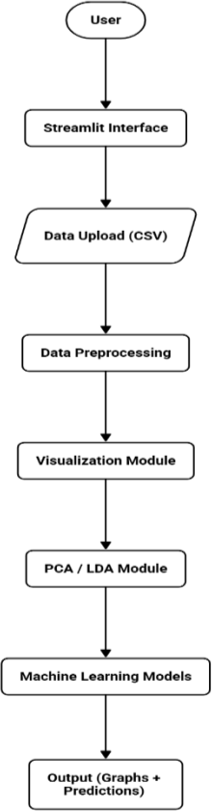

Explanation of Architecture
- User uploads dataset through Streamlit UI
- Data is processed and cleaned
- Visualization helps understand patterns
- PCA/LDA reduce dimensionality
- ML models generate predictions
- Results are displayed interactively

Methodology / Implementation

Overview
The system is implemented using Python and Streamlit to provide an interactive platform for weather data analysis. The methodology follows a step-by-step pipeline approach starting from data input to final output generation.

Tools and Technologies Used
- Programming Language: Python
- Framework: Streamlit

Libraries:
  - Pandas (data handling)
  - NumPy (numerical operations)
  - Matplotlib & Seaborn (visualization)
  - Scikit-learn (machine learning algorithms)

Modules Description

Data Upload Module
  - User uploads a CSV file containing weather data
  - Data is loaded using Pandas

Data Preprocessing Module
  - Missing values are handled:
    - Numerical → replaced with mean
    - Categorical → replaced with mode
  - Categorical data is converted using Label Encoding

Visualization Module
Different plots are generated to understand weather data:
  - Heatmap: shows correlation between features
  - Histogram: shows data distribution
  - Box Plot: detects outliers
  - Scatter Plot: shows relationship between variables
  - Pair Plot: shows pairwise relationships (optimized using sampling)

Dimensionality Reduction Module
  - PCA (Principal Component Analysis):
    - Reduces number of features
    - Works without target variable

LDA (Linear Discriminant Analysis):
    - Used for classification
    - Requires target variable

Machine Learning Module
Dataset is divided into:
  - Training data
  - Testing data Models used:
  - Linear Regression (for prediction)
  - Logistic Regression (for classification)
  - Decision Tree
  - Random Forest

Model Evaluation Module
  - Accuracy score is calculated
  - Confusion matrix is displayed
  - Models are compared based on performance

Results and Discussion

Outputs Achieved
The system successfully performed weather data analysis and generated meaningful outputs through visualization and machine learning models. After uploading the dataset, the application displayed:
- Dataset preview and statistical summary
- Correlation heatmap showing relationships between weather parameters
- Histograms representing data distribution
- Box plots for identifying outliers
- Scatter plots for understanding relationships between variables
- Pair plots (optimized for performance)
Dimensionality reduction techniques such as PCA and LDA were applied, which helped in reducing data complexity and visualizing high-dimensional data in fewer components.
Machine learning models including Logistic Regression, Decision Tree, and Random Forest were implemented. The models were trained and tested on the dataset, and their performance was evaluated using accuracy score and confusion matrix.

Performance Analysis
- The system efficiently handled medium-sized weather datasets
- Visualization helped in identifying patterns and correlations
- Random Forest generally provided better accuracy compared to other models
- PCA improved visualization by reducing dimensionality
Comparison with Existing Systems

Feature | Existing Tools | Proposed System
Data Preprocessing | Manual | Automatic
Visualization | Limited / Separate tools | Integrated
Machine Learning | Limited | Included
Ease of Use | Moderate | High

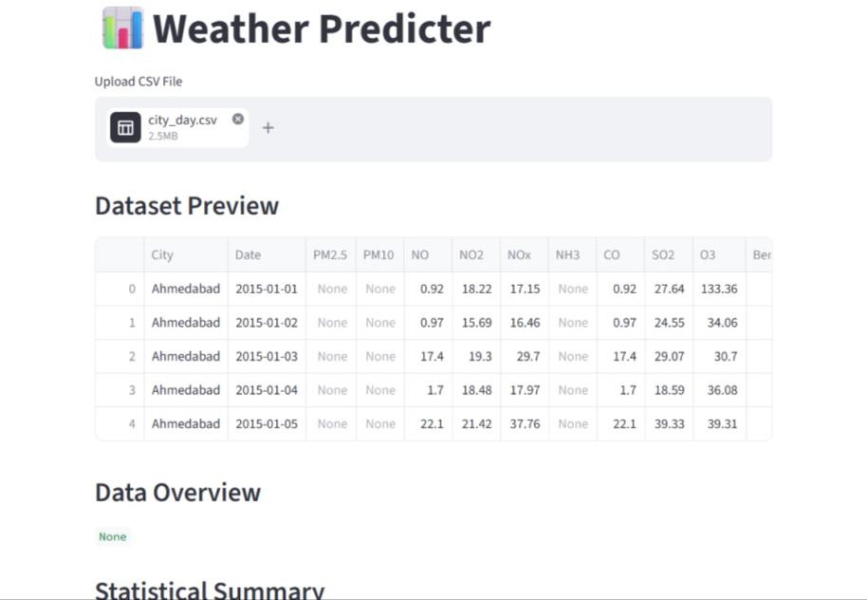

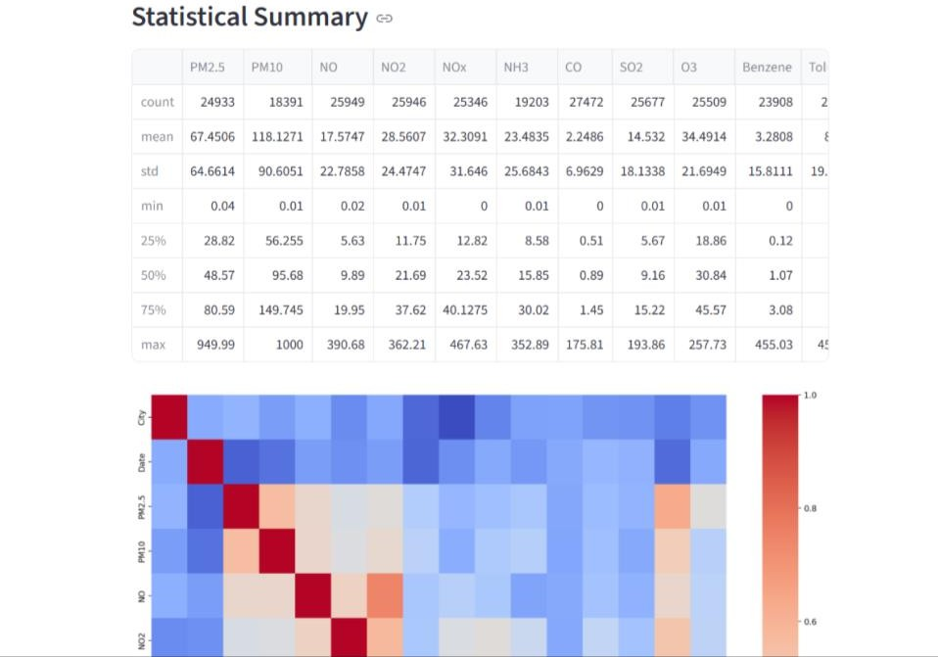

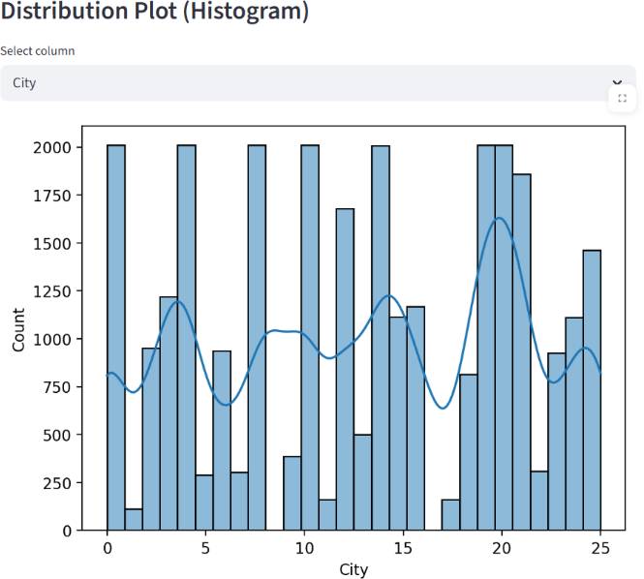

Conclusion and Future Scope

Conclusion
The Weather Data Analysis and Prediction System was successfully developed using Python and Streamlit. The system provides a complete platform for analyzing weather datasets through preprocessing, visualization, dimensionality reduction, and machine learning techniques. It simplifies complex data analysis tasks and makes them accessible through an interactive interface. The project achieved its objective of creating a user-friendly and efficient data analysis tool.

Future Scope
- Integration of deep learning models for better prediction
- Deployment of the application on cloud platforms
- Addition of real-time weather data integration
- Support for multiple file formats such as Excel and JSON
- Improved user interface with advanced dashboard features

References

- Official documentation of Streamlit https://streamlit.io
- Documentation of Scikit-learn https://scikit-learn.org
- Documentation of Pandas https://pandas.pydata.org
- Documentation of NumPy https://numpy.org
- Documentation of Seaborn https://seaborn.pydata.org
- Documentation of Matplotlib https://matplotlib.org
- Géron, A. (2019). Hands-On Machine Learning with Scikit-Learn, Keras, and TensorFlow. O’Reilly Media.
- Han, J., Kamber, M., & Pei, J. (2011). Data Mining: Concepts and Techniques. Morgan Kaufmann.
- Weather dataset reference (Kaggle / open dataset platforms) https://www.kaggle.com

12. Appendix (Optional)

Sample Code Snippet

Below is a part of the implementation used for data preprocessing:

for col in df.columns:
if df[col].dtype == 'object': df[col].fillna(df[col].mode()[0], inplace=True)
else:
df[col].fillna(df[col].mean(), inplace=True)

Visualization Code Example

import seaborn as sns
import matplotlib.pyplot as plt

plt.figure(figsize=(10,6)) sns.heatmap(df.corr(), cmap="coolwarm") plt.show()

Machine Learning Model Example

from sklearn.ensemble import RandomForestClassifier

model = RandomForestClassifier() model.fit(X_train, y_train) preds = model.predict(X_test)

