MemoryCacheTestApp.exe TEST result

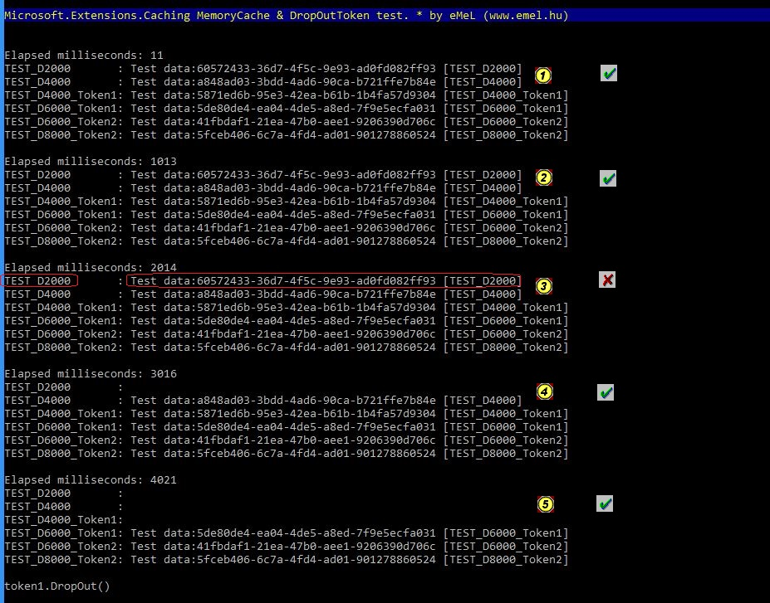

and is OK. Elapsed time < 2000 ms and smallest time is 2000 ms in TEST_D2000.

Have a problem. Elapsed time > 2000 ms (than TEST_D2000 lifetime is 2000 ms).

OK. Previous problem solved. [It is not an error, it is a feature :) ]

OK. TEST_D2000, TEST_D4000, TEST_D4000_Token1 are dropped out, because elapted time is more the 4000 ms.
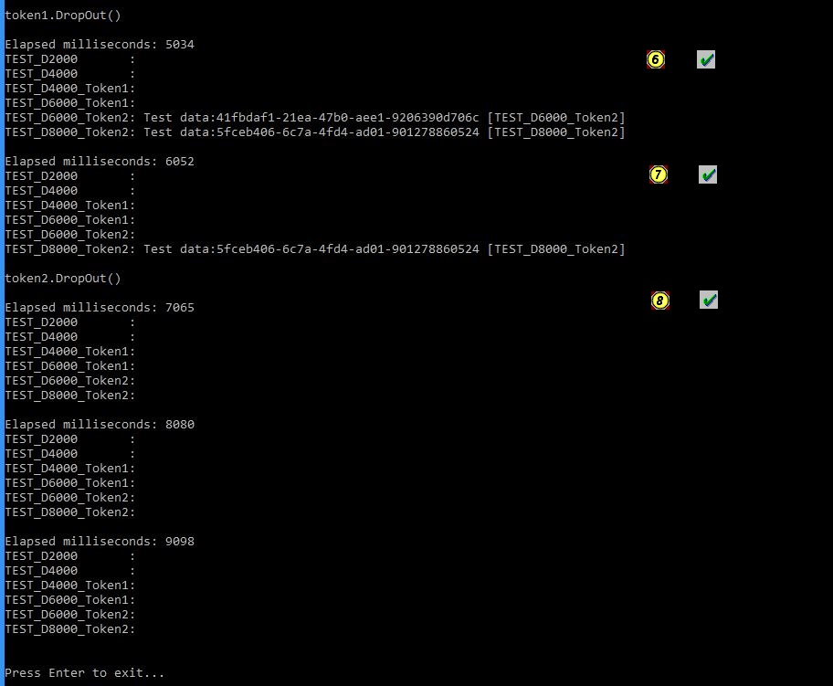
OK. token1.DropOut() worked. Elapted time only 5034 ms but TEST_6000_Token1 is dropped out though lifetime of TEST_6000_Token1 is 6000 ms.

OK. TEST_6000_Token2 is dropped out when elapted time is 6052 ms.

OK. TEST_8000_Token2 is dropped out when elapted time is 7065 ms but happened token2.DropOut().

Test PASSED

