1. Make sure MySQL is installed on your computer. One easy way is to download XAMPP from here <https://www.apachefriends.org/download.html>, Install to C:\xampp, after installing, search for “xampp” in the start menu and open the control panel and start MySQL

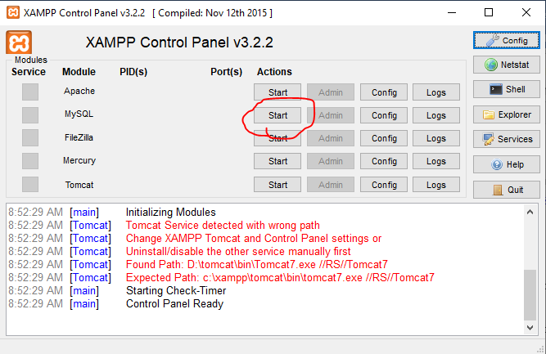

1. Open terminal on windows, copy the command below and paste into your opened terminal

/xampp/mysql/bin/mysql -u root –p

This starts MySQL, when prompted for password, hit enter.

1. Visit <https://github.com/emeli-frank/pick_go/blob/master/pkg/storage/mysql/.db_setup/db.sql>, just copy the content of the file and paste it to the opened terminal window and hit enter, this will create the required MySQL database for you.
2. Download the zip file named pick.zip from the link <https://drive.google.com/open?id=1_XKYCLdM4v1xr53yVN8Mvd4SfgB5y4iQ> and extract to a folder. In this folder you should now have 2 files; main.exe, cli.exe and a folder named scripts like below  
   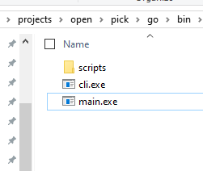
3. Navigate to the directory where you placed your cli.exe file and start it by double clicking on it, this creates the relevant tables and seeds the database for you.
4. After seeding creating the relevant tables, you want to start the application backend server by double clicking the main.exe file. This starts the server at localhost:4242