We have created one WPF single app for generating license for new TenantMNG. Application works on some assumption that we will have client installing machine physical address and serial number and published website code. Once entering details it will create license and essential changes in webconfig file for key.

This application performs following output.

1. Generate encrypted license file in Bin folder.
2. Add key in webconfig file.
3. Last it maintains one csv file for all licensing details.

Please find screenshot of License Generator and details of fields according to number.

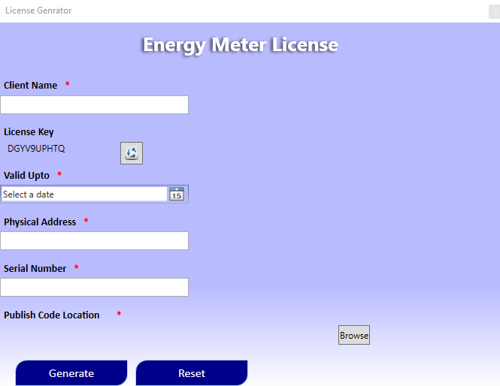

**5**

**6**

**7**

**1**

**2**

**3**

**4**

**8**

Fig 1: Screenshot of License Generator.

|  |  |  |
| --- | --- | --- |
| **Order** | **Field Name** | **Details of fields** |
| 1 | Client Name | Client name or any other unique name for client to whom software is license so, that it is maintained in record. |
| 2 | License Key | It is auto-generated alphanumeric treating as key, if user wants to change than click on refresh. |
| 3 | Valid Upto | Date picker for selecting date up to when license will be valid. |
| 4 | Physical Address | It is unique physical address of client system where software will be installing. Please find command and steps to be given to client for fetching physical address from there machine in Appendix A |
| 5 | Serial Number | It is unique serial number of client system where software will be installing. Please find command and steps to be given to client for fetching serial number from there machine in Appendix B |
| 6 | Publish Code location | It is location of published code which will be given to client for installation. Assuming that it will be always latest and on same system or network having write permission to location. |
| 7 | Generate | Generate button will generate all above outputs as stated above, it will ask for confirmation before proceeding. If user want to correct then can say no to confirmation. After correcting than user can generate. |
| 8 | Reset | Reset button will reset all the details. |

**Appendix – A**

Command and steps for fetching Physical address of machine.

1. Click the Run button in the Windows Start Menu.

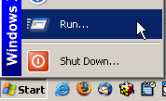

1. Type cmd in the Open prompt of the Run menu and click OK to launch a command prompt window.

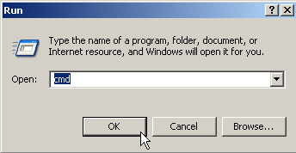

1. Type **ipconfig /all** at the command prompt to check the network card settings.

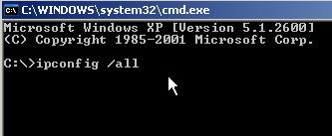

1. The IP number and MAC address are listed by ipconfig under IP Address and Physical Address.
2. You can copy the Physical Address and IP Address from the command prompt by right clicking in the command prompt and clicking Mark. Then select the text you want to copy with the mouse and hit the enter key.

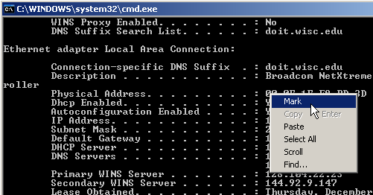

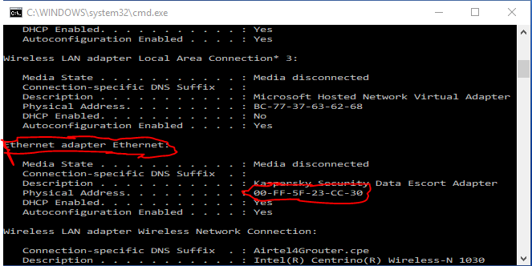

User can use selected Physical address or remove dash and enter in License Generator App.

**Appendix – B**

Command and steps for fetching Serial number of machine

1. Navigate to the Command Prompt Window in your computer.

2. Scroll to the right till you get to Command Prompt.

3. On the Command Prompt window, type **wmic bios get serialnumber** and hit enter.

5. Service Tag would be displayed. Refer to the image below:

