Northeastern Parking Lot Management System
Alex Pavlukov, Douglas Aldridge, Emely Andrade
Northeastern University, INFO 5100 - Jones, Yu
Abstract
The aim of this project is to develop an efficient and user-friendly application for vehicle parking management system by determining the compatibility between different vehicle attributes and available parking spots. Our program established a foundation comprising four initial distinct vehicle categories: Truck, Van, Motorcycle, and Standard Car. Each vehicle type was then associated with specific characteristics, which facilitated the matching of vehicles to appropriately sized and powered parking spots, optimizing the use of available space.
To effectively manage the data associated with these vehicles, parking lots, and parking spots, we employed various Java topics covered during the lessons learned in this semester, and used an intuitive user interface to assist with visual representation of capabilities of the application. The interface, designed using Java FX and Scene Builder, exemplified the process for parking management through the simulation of Northeastern University campus parking lots. Throughout the implementation, our focus was placed on covering and practicing various skills learned throughout this class and ensuring they provide a representative solution and demonstrating how various Java techniques can be used together to create an effective solution for addressing dirrent tasks faced in a parking management system design process.
Problem description
Problem 1: A common issue in parking lots is the inefficient use of available parking spots. Larger vehicles like trucks and vans may need larger parking spaces, whereas smaller vehicles like motorcycles do not.
Problem 2: Manually tracking which spots are free and assigning them can be confusing and error-prone, especially in larger parking facilities.
Problem 3: Parking lot operators often need to keep track of which vehicle is parked in which spot. In case of emergencies or maintenance, having accurate information is crucial.
Problem 4: Removing a vehicle from a spot and updating the system accordingly is often prone to human error when you are not able to visualize the process, especially when the parking facility gets busy.
The Parking Lot Management system is designed to tackle several challenges, ranging from space efficiency to streamlined vehicle tracking.
One of the foremost issues is the inefficient use of parking space. Traditional parking lots often struggle to accommodate the diversity of vehicles, from bulky trucks to compact motorcycles. Larger vehicles demand more room, while smaller ones can be tucked away more efficiently, yet the lack of precise management leads to wasted or mismatched parking allocations.
Additionally, manual tracking of available spots proves cumbersome and error-prone, particularly in expansive facilities. The constant shuffling of vehicles and limited visibility over which spots are free creates confusion, leading to inefficient space use and customer frustration.
Furthermore, parking lot operators face the challenge of tracking vehicle locations with precision. Having up-to-date and accurate information about each vehicle's location is crucial to ensuring safety and efficiency.
Lastly, the unparking process introduces its own complexities. When vehicle removal isn’t systematically updated or visualized clearly, the chance of human error increases - especially during busy rush hours in the day.
Analysis
When evaluating the requirements for this project, it was crucial for us to identify an idea that would enable us to develop a system showcasing a series of smaller tasks that would ultimately contribute to a larger, real-world application. The goal was to create a system that demonstrates a wide range of capabilities and tasks that can be addressed using Java. Parking Management System appeared to have fit the bill perfectly.
Our technical research began with exploring the optimal methods for storing lists of objects, especially for scenarios involving various classes working together cohesively to accomplish multiple tasks. This involved understanding the behavior of different types of loops and data storage methods. Given the dynamic nature of our system, we needed a consistent and reliable way to store and validate user input. Initially, we considered using standard string comparison methods such as toString() for validation, which helped with printing and verifying the stored information.
However, through further discussion and reading, we discovered more efficient solutions, like hashmaps, which provided greater flexibility for data storage and allowed for future enhancements. We also evaluated multiple data structures, such as array lists, maps, and hash sets. Ultimately, hash sets were chosen due to their efficient handling of unique keys, crucial for avoiding duplicate entries.
We also focused on understanding exactly how users would interact with the system, and how we could improve their experience. We had to balance automation with user control. This meant that while we aimed for an intuitive and automated parking system, we also provided sufficient options for user input, such as selecting specific parking lots or spots.
We researched various parking allocation strategies. We first started with the traditional approach of allowing users selecting their own parking spot. We then pivoted to a First Fit and Best Fit approach which would place the vehicle in a first available suitable spot across all of the managed parking lots. Finally, we settled in the middle with allowing the users to select the parking lot and having the system automatically find the spot for the vehicle entered within that lot.
Our focus on data integrity intensified as we faced our initial issues with maintaining consistent information across the system. As we created the initial versions of the UI interactions with our program we have discovered a number of issues related to data integrity, such as user being able to park the same vehicle several times or vehicle being parked in a spot that is already occupied. With that we had to introduce a number of enhancements to validate the inputs and enforce data integrity across the system.
We also conducted an analysis to ensure our implementation aligned with real-world requirements, including license plates, vehicle types and sizes, and parking management standards.
This comprehensive effort allowed us to design a parking system that not only solves a number of parking management challenges but also maintains data integrity and enhances user experience.
System Design
The design of our system evolved through multiple phases, each adding a layer of complexity to create a robust, efficient parking management solution. Our first step involved gathering and constructing a UML diagram, which is attached to this report. This diagram was crucial for laying the foundation of our system and visualizing the connections between its components before diving into the actual algorithm.
The fundamental architecture was built upon the concept of a "ParkingLot" that would serve as a container holding a list of "ParkingSpot" objects. With this in mind, we began by creating the ParkingLot and ParkingSpot classes, which provided the initial infrastructure for holding and managing vehicles. At this stage, these classes acted as placeholders for the vehicles that would eventually be associated with specific spots.
Building on this initial structure, we created a "Vehicle" superclass that served as a model for different types of vehicles, including trucks, vans, motorcycles, and standard cars. These were implemented as subclasses, each inheriting essential properties from the Vehicle superclass, such as the license plate number, state, and whether the vehicle was electric (EV). Defining these attributes at an early stage was critical because they later became instrumental in determining compatibility between vehicles and parking spots.
In the early stages, we established basic allocation logic: parking lots with predefined numbers of empty parking spots, and vehicles that needed to be assigned to those spots. The introduction of vehicle subclasses allowed for more detailed tracking and assignment logic. The Van, Truck, Car, and Motorcycle classes all shared core attributes but allowed us to account for different parking requirements (such as size or EV compatibility) based on vehicle type. This gave us the ability to validate which vehicles could park in specific spots.
The next phase of our project involved implementing a dynamic tracking mechanism to ensure seamless, accurate vehicle and spot management. To this end, we introduced an algorithm that incorporated user input for selecting parking lots and vehicle attributes. Predefined parking lots were set up to mimic actual parking lots on the Northeastern Campus. Users could provide essential vehicle details (such as type and energy source) using dropdown menus, which ensured that we gathered the necessary data for the cross-validation process. The cross-validation phase was crucial in determining the compatibility of each parking spot with a particular vehicle and selecting the first available, most suitable spot.
Ensuring accuracy in tracking required a method to uniquely identify each vehicle and validate its allocation dynamically. To achieve this, we implemented a unique key mechanism based on the vehicle's license plate and state. This approach enabled us to ensure that each vehicle was unique within the system, using its license plate and state combination as a unique identifier. The system would check whether this key existed before proceeding with the parking process, thus avoiding duplicate entries and ensuring that the state of both the vehicle and parking lot remained consistent.
We further developed validation processes that not only verified spot compatibility and availability but also confirmed whether the vehicle itself was distinct in the system which ultimately resulted in a cohesive mechanism that minimized inconsistencies.
Finally, we implemented methods to enhance the user experience, such as incorporating dropdown menus to select parking lots and vehicle attributes and creating a method to find the first available compatible spot within a specific parking lot. This led to the introduction of both the "findFirstAvailableSpot()" and "findFirstAvailableSpotInLot()" methods, where the first method pre-populated parking spots for demonstration purposes and the latter allowed users to assign vehicles to spots within their chosen parking lot dynamically.
A good representation of our program can be seen in UML supplemented in a separate PDF file. The UML diagram for this project showcases a well-organized, object-oriented design where the core Vehicle class serves as the foundation. This abstract class defines shared attributes like plateNumber, state, and isElectric, which are extended by concrete subclasses such as Car, Truck, Motorcycle, and Van. Each subclass implements the makeSound() method, contributing unique behaviors that reflect their specific characteristics. This hierarchical approach enhances code reuse while ensuring specialization where needed. The ParkingLot, ParkingSpot, and ParkingLotSpot classes are integral to managing vehicle allocation. ParkingLot acts as a container for ParkingSpot objects, representing spaces that vary in size and electric compatibility, while ParkingLotSpot facilitates linking parking spots to their respective lots. The composition relationship between ParkingLot and ParkingSpot underlines the structured ownership of spaces within lots.
The MainController class acts as the central hub, connecting the user interface and backend logic. Through FXML components such as combo boxes and buttons, MainController manages actions like parking, unparking, and updating lot statuses dynamically. It uses a Set<String> (parkedVehicles) to maintain unique keys for vehicles—ensuring no duplicates are parked in multiple locations. Methods like handleParkAction(), handleUnParkAction(), and isVehicleAlreadyParked() validate inputs, find suitable parking spots, and keep the system’s data consistent. Additionally, the use of the Parkable interface promotes flexibility, allowing for shared parking methods (park() and unpark()) across classes, enabling a more modular and scalable design.
In conclusion, our project started from a simple idea of managing parking spots and evolved into a more complex system capable of handling dynamic data, validating user input, and interactive interface providing the user with the feedback messages and overall status of each spot in the parking lots . Our design incorporated various levels of validation and tracking mechanisms to ensure accuracy, reliability, and ease of use. The integration of key verification methods, cross-validation processes, and user-friendly interfaces all contributed to building a system that can adapt to various parking needs and continue to grow in complexity while remaining manageable.
Evaluation
First version: The first iteration of our program focused on establishing a foundational architecture, starting with the core objective of efficiently storing vehicles within a designated parking lot. This initial development stage required creating and integrating multiple components, including Main.java, which acted as the central controller, orchestrating connections between the key classes - ParkingLot.java, ParkingSpot.java, and the vehicle subclasses such as Car.java and Truck.java.
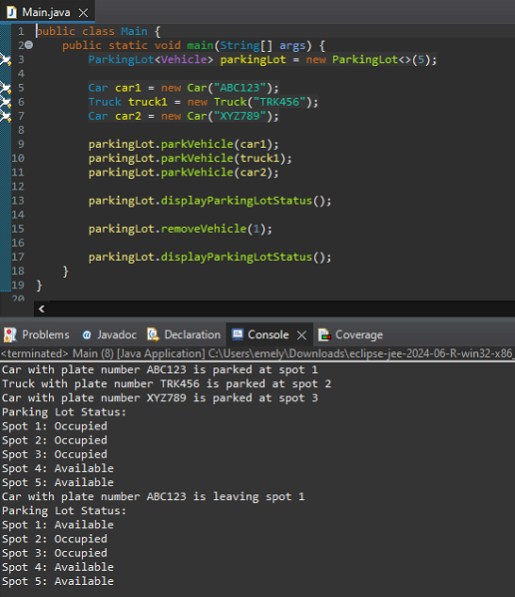
During our initial testing phase, we validated that the program could successfully store two different types of vehicles. These vehicles were instantiated using the respective subclasses (Car and Truck) while also invoking the superclass (Vehicle) for shared attributes. This demonstrated that inheritance was effectively used, ensuring that the vehicle creation process was both efficient and logically sound.
The ParkingLot.java class also demonstrated functionality by employing the parkVehicle() method, which enabled us to store vehicles in specific parking spots. The successful use of displayParkingLotStatus() allowed us to display the current state of the parking lot through the console. This confirmed that the program was correctly tracking and storing vehicles within the intended parking structure, providing clear visual feedback of the system's operational status.
Additionally, our testing verified that both ParkingLot and ParkingSpot classes interacted seamlessly. For instance, the removeVehicle() method in ParkingLot was called to free a parking space. Behind the scenes, this action involved delegating the removal to ParkingSpot.java for further validation. This two-step validation process ensured that each vehicle was thoroughly tracked and could be properly removed, providing an additional layer of robustness to the system.
Version 2:
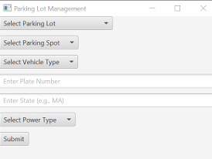
Following the successful implementation of the first version of our program, we shifted our focus to introducing an interactive UI to facilitate ease of interaction. This was achieved by incorporating drop-down boxes into the UI, arranged using a VBox for vertical alignment. This implementation allowed us to transform previously console-based interactions into a more visual, intuitive interface.
The drop-down menus were introduced for core components (Parking Lot, Parking Spot, and Vehicle Type) which replaced the earlier console output by providing an interactive means to select and associate these elements. This development phase marked a significant milestone, as it made the system much more accessible, allowing users to make selections directly through the interface.
This version also introduced ComboBox event-driven programming, which allowed us to efficiently capture the values selected by users in real time. These selections were subsequently used to create vehicles, building upon the logic previously established in version one. By leveraging event-driven programming, we were able to dynamically update the options presented to users based on their interactions, ensuring a seamless workflow.
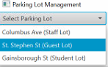
For instance, selecting a Parking Lot from the drop-down menu dynamically populated the Parking Spot drop-down with the available spots specific to that lot. This interactive relationship between dropdowns significantly enhanced the functionality and user flow, ensuring users could easily track the spots associated with a selected parking lot. This interactive design was underpinned by a robust connection with the underlying data structure, which was initialized by default through Main.java.
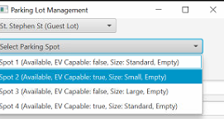
Moreover, this version expanded the system’s capabilities by introducing the concept of fuel type (Electric (EV) or Gas) for each vehicle. This attribute not only provided a richer context for each vehicle but also enabled us to introduce our first cross-validation check via the isCompatible() method. This compatibility check ensured that vehicles were assigned to suitable parking spots, taking into account specific attributes like fuel type, thereby laying the foundation for a more comprehensive compatibility feature.
The introduction of the interactive UI and initial compatibility validation significantly improved the program’s usability, setting the stage for subsequent enhancements. These additions were key in transforming the program into an interactive and engaging application.
Version 3
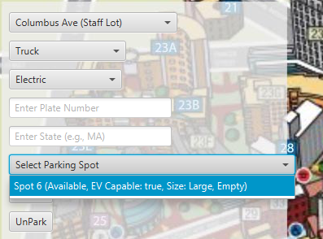
Building upon the improvements made in version two, our third iteration of the program incorporated further advancements aimed at enhancing user experience, transparency of the parking lots and status, and functionality. This version introduced a more interactive filtering mechanism, increased transparency within the user interface, and added additional functionalities such as the ability to unpark vehicles.
The initial inspiration for this iteration stemmed from the idea of implementing dynamic drop-down menus that would automatically update based on user selections. For example, as users selected a vehicle type, such as an Electric Truck, the available parking spots were filtered accordingly to only show options that were compatible in terms of size and power type. This functionality significantly improved the user interface, providing an intuitive mechanism for users to quickly find and select a compatible parking spot, saving time and ensuring accuracy.
This version also brought about a major new feature - an Unpark button, which added flexibility for users to remove a vehicle from a parking spot once needed, but unfortunately removed our filtering system. This feature not only enhanced the user interface but also introduced a robust logic for vehicle removal. Users could visually identify the parking lot, spot, and vehicle plate number, ensuring the process was clear and straightforward. In addition, a double-layered validation was integrated to verify that the details of the vehicle being unparked (e.g., license plate number and state) matched those in the system. This ensured that only intentional removals could take place, improving the overall integrity of the system.
The Unpark button was designed to work in tandem with the ParkingSpot.java class, specifically leveraging the removeVehicle(), getPlateNumber(), and getState() methods. This allowed for a seamless flow between checking the vehicle details, validating the information, and successfully updating the system to reflect the newly vacated spot.
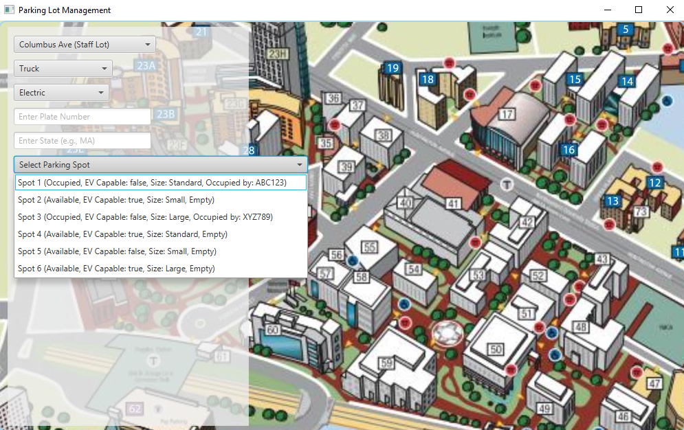
Furthermore, to better demonstrate system functionality, pre-filled parking spots were introduced for the purpose of a demonstration. This allowed us to showcase how the user interface would visually reflect occupied spots, as well as how it would properly trigger an error message if a user attempted to park in an already-occupied or incompatible location. By making the occupied status explicit in the user interface, we improved transparency, ensuring that users always had clear feedback regarding the availability of each parking space.
Version 4
In our next iteration, we consolidated many of our core concepts into a robust and cohesive solution, while still leaving room for future improvements. With the fundamental functionality of our parking management system in place, our focus turned towards refining the user experience and enhancing the visual appeal of the interface.
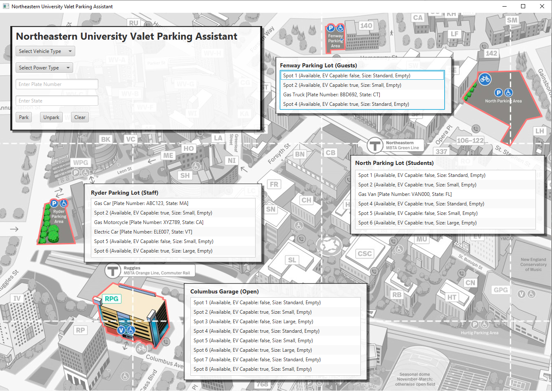
We began by integrating our JavaFX-based layout with the interactive and user-friendly features provided by Scene Builder. This combination allowed us to create a visually enhanced user interface, designed to provide an intuitive experience for users. One of the key features of the final version was the incorporation of an accurate map of the Northeastern University campus parking lots, with a focus on clarity and ease of navigation. By highlighting each parking lot clearly and associating them with their respective attributes, users are able to quickly identify and interact with specific parking locations.
Visibility and ease of use were further improved by ensuring that all parking slots were not only accessible but also visibly indicated EV capabilities and lot sizes. This visual differentiation provided users with a comprehensive overview of the parking options available at a glance, minimizing decision-making time and enhancing overall efficiency.
We also added a “Clear” button to the interface, a quality-of-life feature that allowed users to easily reset all current input fields with a single click. This improvement made the system more forgiving to user errors and significantly reduced the time required to make corrections or start over.
Finally, to enhance the clarity of the campus map, we applied a grayscale effect to a background image for less relevant areas of the map, while keeping the distinctive parking lots highlighted. This selective visual emphasis guided user attention towards the critical interactive elements and reduced visual clutter, making the interface more intuitive.
Final Version 5
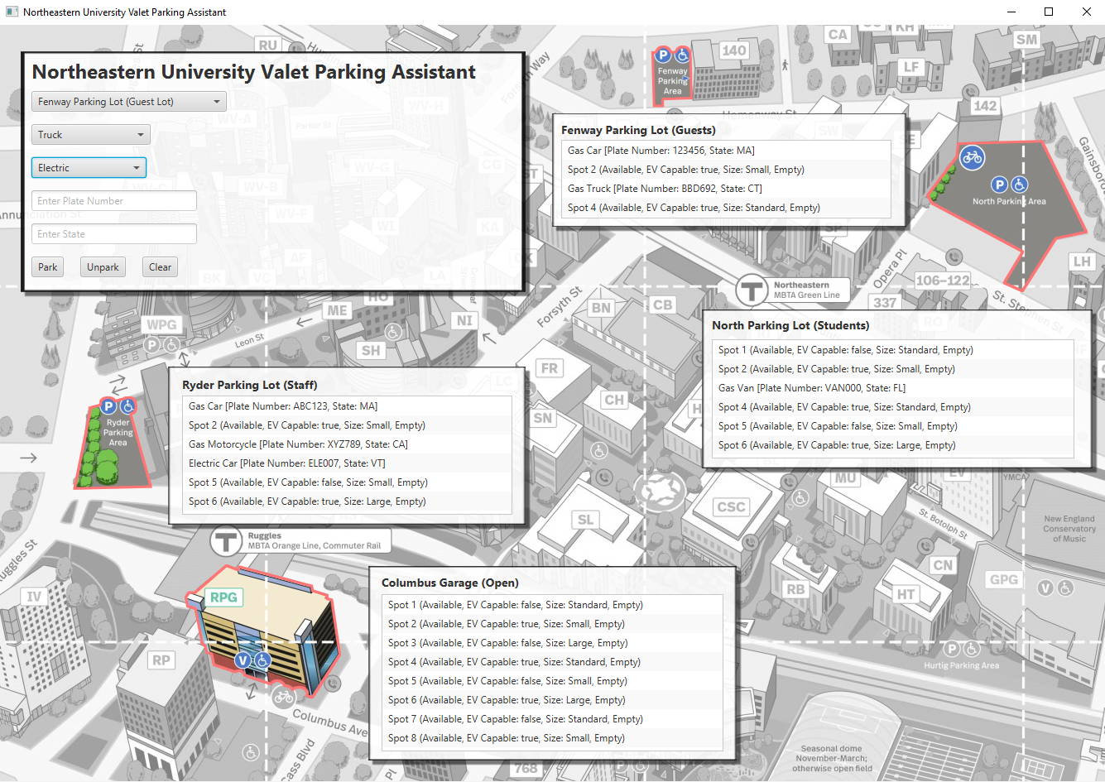
In this iteration, we addressed inconsistencies in vehicle tracking and synchronization between parking spots and the internal data structures. To resolve these issues, we introduced the isVehicleAlreadyParked() method, which was pivotal in maintaining accurate, consistent records of vehicle locations.
Previously, we encountered an inconsistency where the tracking key for a vehicle was being incorrectly associated with specific parking spots instead of being managed effectively through the parkedVehicles hash set. This discrepancy caused the system to allow duplicate entries under certain conditions. To address this, the isVehicleAlreadyParked() method was implemented to ensure that updates occurred on both ends, the occupied parking spot and the hash set of unique keys, ensuring that no duplicates were mistakenly recorded. This change enhanced consistency in vehicle tracking, synchronizing information across ParkingSpot, ParkingLot, and the parkedVehicles hash set.
Additionally, we updated the handleUnParkAction() method, which was also contributing to inconsistent vehicle removal. The previous implementation did not reliably update both the physical parking spot and the internal tracking set, causing a secondary issue with duplicates. After further testing, we identified that duplicates were still being created even after our initial fix. This prompted a more robust solution: ensuring the parked vehicle key set (parkedVehicles) and the parking lot always reflected the same state through cross-verification, rather than relying solely on direct validation.
Another enhancement in this version was the reintroduction of the dropdown box for selecting a parking lot. With this improvement, users can now select a desired parking lot, and the system will automatically find the most suitable spot and park the vehicle in a randomly available position within the chosen lot. To support this feature, we introduced the findFirstAvailableSpotInLot() method. This method, along with the existing findFirstAvailableSpot(), ensures that default vehicles can be pre-populated during demonstrations, allowing us to showcase existing occupied spots without manual intervention. Both methods are now integral to managing parking allocation effectively, balancing demonstration capabilities with user-driven selections.
In conclusion, the final version of our parking management system brought together functional improvements with a refined user interface. Through the combination of a detailed visual layout, intuitive controls, and practical enhancements, we achieved a seamless parking solution. While this version represents a significant step forward, it also opens up future opportunities for further enhancements, such as additional interactive elements, aesthetic improvements, and greater system flexibility.
Implementation
Throughout the implementation phase of this project, as mentioned earlier, our application underwent multiple iterations before reaching the final presentation. This was due to the discovery of existing problems and nuances in parking management and our goal to improve the application, making it more reflective of real-life scenarios. We also learned new skills and Java topics, and as we progressed throughout this semester, we made a conscious effort to incorporate these newly acquired concepts into our design, further enhancing the application's functionality and reflecting our growing understanding of Java. The final program incorporates the following java topics:
- Class definition
- Inheritance and polymorphism
- Abstract class
- Interface
- Generics, collections and iterators
- Lists
- Set
- Class definition: there are multiple classes like ParkingLot, Vehicle, Car, Truck and others created in our program. Each of these classes define a blue print for creating objects with specific attributes and methods.
- Inheritance: Vehicle class is defined as an abstract class, which serves as a base class for other classes like Car, Truck and Van. Class Car inherits from Vehicle which means it automatically gest the plateNumber, state and isElectric properties.
Polymorphism: represented when we call method vehicle.makeSound(). The method is referenced as a Vehicle object, however, it has different implementations for Truck or Car, for example.
- Abstract: the Vehicle class is abstract, which means it cannot be instantiated on its own. It is extended by Truck, van, etc, and it has abstract method makeSound()
- Interface: we have created a Parkable interface which defines methods that implementing class ParkingSpot must provide. ParkingSpot class provides implementation to parkVehicle, removeVhicle, and isAvailable.
- Generics, iterators: there are several places we are using generics and collections in our program – Combobox <X> - generics used for the drop down menus (i.e. vehicle type, plate combo); Iterators: In the findFirstAvailableSpot method, we are using an iterator to loop through each ParkingLot in the parkingLots list.
- Lists: We are using List<ParkingLot> - to store and manage multiple parking lots in a list collection. We then add instances of ParkingLot to this list using parkingLots.add.(lot1). Similar approach is used for List<Vehicle>
- Set: we are using set to keep track of parked vehicles. Private Set <String> parkedVehicles=new Hashset<>(). This set is used to store unique identifiers for vehicles (plate number+state), which allows to ensure that a vehicle is not parked more than once.
Discussion on future opportunities
In reflecting on the project outcomes, several opportunities for enhancement and expansion emerged that could further improve the functionality and user experience of our vehicle parking system. One major area for enhancement lies in streamlining user navigation by introducing multiple interactive windows within the interface. By adding additional scenes with enhanced functionality, we could guide users more intuitively through the various features of the program, thereby increasing ease of use.
Further potential improvements involve expanding existing object attributes to accommodate a more nuanced representation of parking structures. For instance, incorporating floor-level attributes into the parking lot object - such as "1" for the first floor or "2" for the second floor. This could provide a more accurate depiction of the parking environment, particularly in multi-story facilities.
The same idea could also apply to vehicle attributes. Expanding the program to include additional vehicle elements, such as permits, make, and color, would enhance its realism and improve its suitability for specific parking spots and parking lots.
Recognizing the scalability challenges of the current system, particularly in larger parking facilities with thousands of vehicles, we also identified the need for more efficient data management and most importantly data storage, high availability and data recovery. Incorporating sophisticated data structures or integrating a database system could enhance the performance, enabling faster queries and smoother data retrieval for larger-scale operations.
Another valuable enhancement could be the use of data-driven approaches to determine the optimal parking arrangement. Leveraging data such as occupancy trends and vehicle arrival patterns could enable the system to suggest the most compatible parking spots, thereby reducing congestion and enhancing efficiency. We have slightly introduced this with our implementation of “findFirstAvailableSpot”
Concurrency is another important topic that is worth considering in this application. Since it’s likely that our program may need to be used by multiple users and it may need to handle multiple vehicles entering and exiting at once, a consideration must be given to using synchronization mechanisms or concurrent data structures.
The integration of payment options through digital gateways also offers an avenue for improving user convenience, allowing for a seamless cashless payment experience.
Lastly, the inclusion of distinct user roles, such as administrators, attendants, and customers, with tailored levels of access and control, could facilitate a more effective delegation of responsibilities. This would empower administrators to manage overall configurations while attendants focus on daily operations, thereby fostering a structured and secure management environment.
Conclusion
Solution 1: The system allows users to enter relevant vehicle information and picks the appropriate parking spot based on the vehicle attributes (car, truck, motorcycle, van) and other elements like size and power type (Electric/Gas). The system ensures that each vehicle is parked in an appropriate spot, preventing wastage of space and optimizing the parking arrangement.
Solution 2: The system has a user interface to guide attendants or drivers to appropriate parking lots and spots. It automatically updates the availability of spots and keeps track of which vehicles are parked where. This helps make the allocation process smooth, avoiding overlaps or errors.
Solution 3: The project stores information about each vehicle, such as plate number, state, and whether the vehicle is electric or gas-powered. This information can be easily accessed to identify vehicles, which is useful for management or in the event of incidents like emergencies or vehicle owners losing their keys.
Solution 4: The system provides an "UnPark" button, which allows easy removal of vehicles. This action updates the status of the parking spot and makes it available for other vehicles, ensuring that the system is always up-to-date.
The Parking Lot Management System provides a seamless solution for organizing and optimizing vehicle parking by considering the distinct needs of different vehicle types. Categorizing vehicles based on their type( whether car, truck, motorcycle, or van) as well as their size and power source (electric or gas-powered), the system ensures that every vehicle is assigned to a spot that fits it perfectly, avoiding wasted space and maximizing efficiency across the parking lot selected.
The user-friendly interface plays a crucial role in guiding both attendants and drivers to the appropriate parking lots and spots. As vehicles come and go, the system dynamically updates the availability of spots, keeping accurate track of which spaces are occupied. This automated feature reduces the chance of errors or overlaps, resulting in a smooth and orderly parking experience.
The system keeps records of important details such as vehicle plate numbers, states of registration, and power type. This capability provides quick access to vehicle information, which is immensely beneficial for efficient management and particularly vital in situations like emergencies or when assisting owners who have misplaced their vehicles.
And finally, the integration of an intuitive "Unpark" button enables easy removal of parked vehicles, instantly updating the status of the vacated spot. This ensures the lot remains current, always reflecting the real-time status of available spaces.
Job assignments and contributions
Over the past several weeks, we collaborated closely to ensure an even distribution of work and to allow each of us to contribute to and practice various areas of the Java topics and the project as a whole. Our approach involved group discussions to set weekly goals and deliverables, followed by team members volunteering to tackle different tasks. At the end of each week, we reviewed the outcomes, progress, challenges, and rotated tasks to ensure everyone gained experience in various aspects of the code.
For example, while one person focused on creating the initial set of classes, another researched the wireframe, and another worked on evaluating required methods and brainstorming ways to incorporate different topics into our design. We also went through several rounds of code refactoring, with each team member evaluating and updating each other’s work and contributing to different parts of that process. Additionally, everyone spent time developing and consolidating various methods that contributed to the overall functionality.
Since we started building the UI with JavaFX and wanted to practice our Scene Builder skills, we dedicated time to refactor some classes to integrate them into the tool. Each of us also identified and addressed bugs in the system, ensuring that inefficiencies were discussed, documented, and resolved in the next version of the program. We had a lot of creative discussions and enjoyed working on the visually appealing UI design, ensuring that the backend objects and messages were properly projected onto the screen.
In the final stages, we conducted a thorough review of the code, cleaned up the structure, and added comments to ensure that we were ready for presentation. It was truly a team effort with great collaboration and each member contributions that lead us to successfully complete the deliverable for this final project.

