StorePulse Analytics – SQL Business Intelligence Project
📌 Project Overview
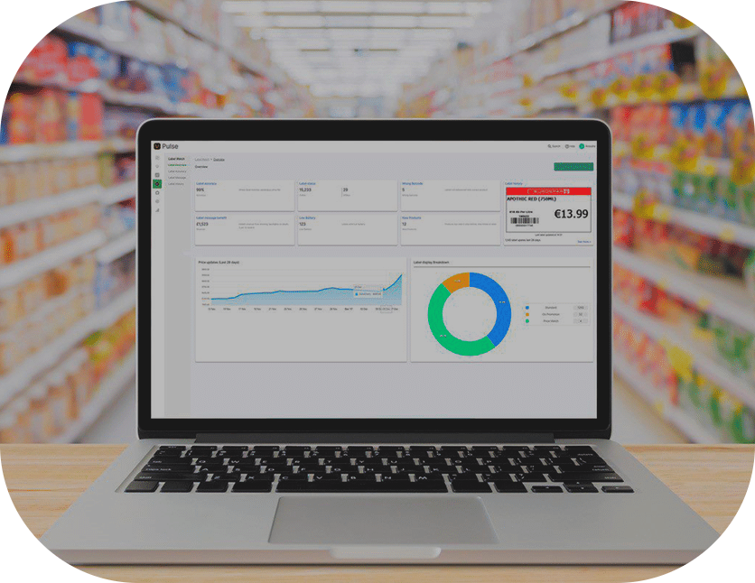
This project analyzes a structured commerce database to extract business insights related to revenue performance, customer behavior, and product trends using advanced SQL techniques.
The goal of this project is to simulate real-world data analysis tasks performed by data analysts in retail and e-commerce environments.

_ Database Schema :
The project is built using three relational tables:
1️⃣ Customers
- customer_id (Primary Key)
- name
- city
- join_date
2️⃣ Products
- product_id (Primary Key)
- product_name
- category
- price
3️⃣ Orders
- order_id (Primary Key)
- customer_id (Foreign Key)
- product_id (Foreign Key)
- quantity
- order_date
The tables are linked through foreign key relationships between customers, products, and orders.

_ Business Questions Answered :
This project answers 24 business-oriented analytical questions including:
- What is the total store revenue?
- Who are the top spending customers?
- What is the customer lifetime value?
- Which product categories generate the highest revenue?
- What is the monthly revenue trend?
- How does revenue grow month-over-month?
- Which customers purchased all products in a category?
- What are the sales decline periods?

_SQL Concepts Used:
This project demonstrates the use of:
- INNER JOIN / LEFT JOIN
- GROUP BY and HAVING
- Aggregate functions (SUM, AVG, COUNT)
- Subqueries
- Window Functions (ROW_NUMBER, RANK, LAG)
- PARTITION BY
- Revenue growth calculations
- Customer segmentation logic
_Key Insights :
- Revenue is primarily driven by the Tech category.
- A small group of customers contributes the majority of total revenue.
- Month-over-month revenue shows growth with occasional decline periods.
- Certain products dominate sales performance within their categories.

_ Skills Demonstrated
- Business-oriented SQL analysis
- Data modeling understanding
- KPI calculation
- Analytical thinking
- Window function implementation
- Structured query organization

_ Tools Used :
- PostgreSQL
- SQL
- Git & GitHub

📈Project Purpose:
This project is designed as a portfolio demonstration of intermediate to advanced SQL skills, focusing on practical business analytics use cases.

