Tenant Information, Billing and Property Management System for Casa Sherlin.

A Capstone Project Proposal
Presented to the Faculty of the
Information and Communications Technology Program
STI College of Santa Rosa

In Partial Fulfilment
of the Requirements for the Degree
Bachelor of Science in Information Technology

Dugay, Shielo Grace T.
Maron, Luke Ryan P.
Zoleta, M-Jay L.

May 2026
ENDORSEMENT FORM FOR PROPOSAL DEFENSE

TITLE OF RESEARCH: Tenant Information, Billing and Property
Management System for Casa Sherlin

NAME OF PROPONENTS: Dugay, Shielo Grace T.
Maron, Luke Ryan P.
Zoleta, M-Jay L.
Abiva, John Carlo

In Partial Fulfilment of the Requirements
for the degree Bachelor of Science in Information Technology
has been examined and is recommended for Proposal Defense.

ENDORSED BY:

Mr. Jeff Francis Chavez
Capstone Project Adviser

APPROVED FOR PROPOSAL DEFENSE:

Ms. Meljoi L. Retita
Capstone Project Coordinator

NOTED BY:

Mr. Rostelito N. Lazaga
Program Head

MAY 2026

APPROVAL SHEET

This capstone project proposal titled Tenant Information, Billing and Property Management System for Casa Sherlin, prepared and submitted by Dugay, Shielo Grace T., Maron, Luke Ryan P., and Zoleta, M-Jay L., in partial fulfillment of the requirements for the degree of Bachelor of Science in Information Technology, has been examined and is recommended for acceptance and approval.

Mr. Jeffrey Francis Chavez
Capstone Project Adviser

Accepted and approved by the Capstone Project Review Panel
in partial fulfillment of the requirements for the degree of
Bachelor of Science in Information Technology

Ms. Meljoi L. Retita | Mr. Jaycey M. Velandres
Panel Member | Panel Member

Ms. Madelyn B. Navallo
Lead Panelist

Noted:

Ms. Meljoi L. Retita | Mr. Rostelito N. Lazaga
Capstone Project Coordinator | Program Head

May 2026

TABLE OF CONTENTS
 |  | Page
Title Page |  | i
Endorsement form for Proposal Defense |  | ii
Approval Sheet |  | iii
Table of Contents |  | iv
Introduction |  | 1
 | Project Context | 1
 | Purpose and Description | 3
 | Objectives | 4
 | Scope and Limitations of the Study  Review of Related Literature/Studies/Systems | 5
 |  | 8
Methodology
 | Technical Background | 20
 | Requirements Analysis | 27
 | Requirements Documentation | 31
 | Design of Software, System, Product, and/or Processes | 33
References |  | 42
Appendices |  | 44
 | Resource Persons | 50
 | Personal Technical Vitae | 51

INTRODUCTION

Project Context
Apartment rental businesses play an important role in providing housing for individuals and families, especially in growing urban areas. As cities continue to develop, the demand for rental apartments increases. In places such as Santa Rosa, many small and medium apartment businesses operate to provide affordable living spaces for residents, workers, and students. Because of this growing demand, apartment owners and managers need efficient ways to manage their rental operations, including tenant records, apartment units, rental payments, and maintenance concerns.
Casa Sherlin’s Apartment, located in Santa Rosa, is one example of a rental property that manages a total of 24 apartment units for tenants. Like many small apartment businesses, the management of records and daily operations may still rely on traditional methods such as notebooks, paper files, or spreadsheets. Some rental arrangements may also rely on informal or verbal agreements between the landlord and tenants instead of properly documented lease contracts. While these methods may work at the beginning, they can become difficult to manage as the number of tenants and transactions increases. Manual record keeping may lead to disorganized files, difficulty in tracking tenant information, and delays in monitoring rental payments or contract expiration.
One of the common problems experienced in manual apartment management is the difficulty in tracking rent payments and billing information. Apartment managers often need to manually check payment records, compute monthly rent, and verify whether tenants have already paid or still have pending balances. This process can be time-consuming and may result in errors or missed payments if records are not updated regularly.
Another challenge is monitoring tenant agreements and maintenance concerns. When records are stored manually, managers may forget agreement expiration dates or fail to respond quickly to maintenance requests submitted by tenants. In some cases, tenants may prefer to hire their own maintenance personnel to repair damages or concerns within their apartment unit, which may also require proper coordination and documentation with the management. Without an organized system, maintenance concerns and repair updates may not be properly monitored. As a result, tenants may experience delays in repairs or poor communication with the management. These situations may lead to dissatisfaction among tenants and inefficiency in apartment operations.
With the continuous advancement of technology, many businesses now use web-based information systems to improve their efficiency and organization. Web-based systems allow businesses to store data digitally, automate repetitive tasks, and easily access important information through an internet browser. In property management, a web-based system can simplify the process of managing tenants, monitoring apartment units, tracking rental payments, and generating reports in a more accessible and centralized manner.
An integrated tenant information, billing, and property management system combines different management functions into one centralized platform. Instead of using separate records for tenants, payments, maintenance requests, and agreements, an integrated system allows these processes to work together within one system. This integration helps improve data accuracy, reduces manual work, and allows managers to easily monitor apartment operations in real time through a web-based platform that can be accessed anytime and anywhere with internet connection. The system can also help management create and store digital lease contracts for better documentation and monitoring of tenant agreements.
Therefore, this study proposes the development of the Tenant Information, Billing and Property Management System for Casa Sherlin. The proposed web-based system aims to improve the management of apartment records by organizing tenant information, handling billing transactions and payment tracking, monitoring tenant agreements, and tracking maintenance requests. Through this system, apartment management can become more efficient, organized, accessible, and reliable.

Purpose and Description
The purpose of this project is to develop the Tenant Information, Billing and Property Management System for Casa Sherlin to assist the management of Casa Sherlin’s Apartment in managing apartment operations through a web-based platform. The system aims to improve how tenant records, billing transactions, apartment unit monitoring, tenant agreements, and maintenance requests are handled by replacing manual processes with a more organized and integrated digital system.
The system will allow administrators to manage tenant information such as tenant names, contact details, apartment unit assignments, and move-in dates. It will also provide a way to monitor apartment units by identifying whether they are vacant or occupied. Through this feature, the management can easily track available units and manage tenant assignments more efficiently.
One important feature of the system is the billing and payment monitoring function. This feature will allow the system to generate billing records for tenants and monitor their payment status. The system will help administrators track whether payments are paid, unpaid, or partially paid. This helps reduce manual computation, improve payment monitoring, and maintain accurate financial records.
The system will also include a tenant agreement monitoring feature that allows the management to record and monitor lease agreements between tenants and the apartment owner. The system can help administrators track agreement durations and expiration dates, making it easier to manage renewals and tenant transitions. The proposed system may also support the creation and storage of digital lease contracts for better documentation and organization.
Another feature of the system is the maintenance request management function. Tenants can submit maintenance concerns such as plumbing, electrical, or repair issues through the system. The administrator can monitor the status of these requests and manage repair updates more efficiently. In some situations, tenants may also choose to hire their own maintenance personnel to repair damages within their apartment unit, subject to coordination and approval from the management. The system can help document and monitor these maintenance-related activities for proper record keeping and communication.
What makes this system unique is its integrated web-based design. Instead of managing tenant information, payments, maintenance requests, and agreements separately using manual records, the system combines these functions into one centralized platform. This integration helps improve efficiency, reduce record-keeping errors, increase accessibility, and make apartment management more organized and reliable. Overall, the proposed system aims to help the management of Casa Sherlin’s Apartment improve their daily operations and provide better service to tenants.
Objectives
The main objective of this project is to develop the Tenant Information, Billing and Property Management System for Casa Sherlin to improve the management of tenant records, apartment units, billing transactions, tenant agreements, and maintenance requests at Casa Sherlin’s Apartment. The system aims to provide a more organized, efficient, accessible, and reliable way of handling apartment operations through the use of an integrated web-based platform.

Specific Objectives
The project specifically aims to:
- To improve the management of tenant records through a centralized digital system.
- To develop a tenant agreement monitoring feature that tracks agreement start and end dates.
- To enhance the accuracy and efficiency of billing and payment transaction monitoring.
- To streamline communication between tenants and administrators through a maintenance request system.

Scope and Limitations

Scope of the Study
This study focuses on the development and implementation of the Tenant Information, Billing and Property Management System for Casa Sherlin. The system aims to improve the management of apartment operations by organizing records through a web-based computerized platform.
The scope of the study includes the following:
- Web-Based Platform Accessibility: The system is developed as a web-based platform that can be accessed through devices with an internet browser such as computers, laptops, tablets, and smartphones. This allows users to access the system anytime and anywhere with internet connection.

User Roles and Access Control: The system supports two types of users: administrators and tenants. Administrators can manage records, billing, tenant agreements, and maintenance requests, while tenants can view billing information, receive notifications, and submit maintenance requests.
- Tenant Management System: The system allows the administrator to manage tenant records by adding, updating, viewing, and deleting tenant information. It stores important details such as tenant name, contact information, assigned unit number, and move-in date.
- Billing Transaction Management and Payment Monitoring: The system allows the administrator to manually record and monitor tenant payments. It displays the payment status of tenants, whether paid, unpaid, or partially paid, to help organize and track rental records efficiently.
- Tenant Agreement Monitoring Feature
The system stores tenant agreement details and monitors the duration of each agreement. It provides alerts or notifications to inform the administrator when an agreement is about to expire, allowing proper planning for renewal or tenant transfer. The system notifies both the administrator and tenant approximately two months before expiration, followed by a final reminder one month before the end date. This allows enough time for tenants to decide whether to renew or move out and for the administrator to prepare necessary actions.

Maintenance Request Tracking System
The system allows tenants to submit maintenance requests for apartment concerns such as plumbing issues, electrical repairs, and other maintenance needs. The administrator can monitor and update the status of each request as pending, in progress, or completed. In some cases, tenants may choose to hire their own maintenance personnel to repair damages within their apartment unit, subject to coordination and approval from the management.
- Notification and Alert System
The system sends notifications for payment reminders, maintenance updates, and contract expiration to keep both tenants and administrators informed.
Limitations of the Study
Although the proposed system offers several benefits for apartment management, the study has certain limitations that must be considered.
- Limited to a specific apartment business
The system is designed specifically for Casa Sherlin’s Apartment in Santa Rosa, Laguna. It may not fully support the needs of larger or multi-branch property management systems with more complex operational structures.
- Dependence on internet and system availability
The system requires a stable internet connection to access and update records. Any network interruptions or system downtime may affect the accessibility and real-time updating of data.
- Limited Payment Processing (Cash and Online Payments Outside the System)
The system does not automatically process or confirm payments. Tenants must submit proof of payment, and the administrator is responsible for manually verifying and updating the payment status in the system.

Manual Handling of Maintenance Services
The system allows tenants to submit maintenance requests, but it does not directly assign. The administrator must manually coordinate and contact maintenance workers to address reported issues. Maintenance activities handled by tenants’ own maintenance personnel are also subject to management approval and coordination outside the system.

Limited Development Scope and Scalability
The system is developed within a limited timeframe, resources, and technical capacity. In addition, the system does not include an automated forgotten password recovery feature, requiring users to contact the developer or administrator for account recovery assistance. It is designed only for Casa Sherlin’s Apartment and may require enhancements if expanded to support larger or more complex property management operations.
Review of Related Literature/Studies/Systems
This chapter presents the review of related literature and studies that provide relevant concepts, theories, and systems associated with the development of the Tenant Information, Billing and Property Management System for Casa Sherlin. These related works offer insights into tenant management, billing and payment monitoring, and property management systems to improve the efficiency, organization, and accessibility of apartment management operations.
Foreign Studies
Apartment Rental Management System for Real-Time Transaction and Task Organization
According to Magno, Pelayo, and Soberano (2024) in their study titled “Apartment Rental Management System for Real-Time Transaction and Task Organization,” they developed a computerized apartment rental management system aimed at improving the efficiency and accuracy of rental operations through real-time transaction processing and better task organization. The study explains that many apartment establishments continue to rely on traditional manual and paper-based methods in handling tenant records, billing, and payment monitoring. These conventional practices often result in several operational problems such as inaccurate data encoding, delayed updates of tenant information, difficulty in tracking payment histories, and limited accessibility of records for both tenants and administrators. As a result, these issues may cause miscommunication between property managers and tenants and may also slow down the overall management process.Furthermore, the researchers emphasized that efficient property management requires a centralized and automated system that can handle multiple functions in a single platform. To address these challenges, they proposed a system that integrates essential modules such as tenant information management, billing computation, payment tracking, and tenant status monitoring. Through these features, administrators are able to easily update tenant records, generate billing statements accurately, and monitor payments in real time. The system also improves data organization by reducing redundancy and minimizing human errors commonly found in manual processes. In addition, the study highlights that real-time updates significantly enhance transparency between tenants and administrators, allowing faster resolution of concerns and improved communication within rental operations.Overall, the study demonstrates that adopting a computerized apartment rental management system can significantly improve operational efficiency, accuracy of records, and speed of transaction processing in property management environments. It also shows how integrating core rental functions into a single system can modernize traditional apartment management practices and reduce administrative workload.
A Study on Automated Property Management in Commercial Real Estate: A Case of India
According to Kaur and Solomon (2021) in their study titled “A Study on Automated Property Management in Commercial Real Estate: A Case of India,” they examined the use of automated systems in commercial real estate management and how these technologies improve overall operational efficiency. The study explains that many traditional property management practices still depend heavily on manual processes, which often lead to inefficiencies such as delayed transactions, inconsistent data records, and difficulties in managing multiple property-related tasks. These problems can affect the smooth flow of operations and reduce the effectiveness of property administration.Furthermore, the researchers highlighted that automated property management systems help address these issues by combining essential functions such as tenant information management, rent collection, maintenance tracking, and reporting into a single centralized platform. This integration allows property managers to access real-time and accurate data, minimize human errors, and simplify routine administrative tasks. The study also emphasizes that automation improves the speed and reliability of operations, making property management more organized and efficient compared to traditional methods.In addition, the study discusses how automated systems contribute to better transparency and accountability in property operations. With digital records, property managers can easily monitor transactions, track lease agreements, and maintain proper documentation of all activities. It also notes that tenant satisfaction improves because maintenance requests are addressed faster and communication between tenants and management becomes more efficient and responsive.Overall, the study shows that adopting automated property management systems significantly improves efficiency, accuracy, and communication in real estate operations.
Maintenance Workflow Management Using an Automated Multi-Agent Facility Management System
According to Yousefli, Nasiri, and Moselhi (2021) in their study titled “Maintenance Workflow Management Using an Automated Multi-Agent Facility Management System,” they developed an automated facility maintenance management system that uses a multi-agent approach to improve the efficiency of maintenance workflow processes. The study explains that traditional maintenance management systems often depend on manual coordination and disconnected data sources, which commonly lead to several operational issues such as delayed response to maintenance requests, inefficient assignment of tasks, and poor monitoring of ongoing repair activities. These limitations reduce the overall effectiveness of facility management and affect service quality provided to tenants or users.Furthermore, the researchers proposed an automated system that integrates intelligent agents to handle maintenance operations more efficiently. These agents are responsible for monitoring system conditions, managing maintenance requests, and coordinating workflows in real time. Through automation, the system improves the accuracy of task scheduling, enhances resource allocation, and ensures faster response times for maintenance concerns. The study also emphasizes that real-time monitoring plays a significant role in improving maintenance operations, as it allows administrators to have better visibility of ongoing and completed tasks.In addition, the study highlights the importance of centralized data management in facility maintenance. With a unified system, administrators can easily track maintenance activities, monitor progress, and evaluate completed tasks, which leads to improved operational efficiency and better service delivery. The findings show that automated maintenance systems significantly enhance organization, responsiveness, and overall management quality in facility operations.
Property Management Software (PMS) Application Effect Toward Property Management Operation in Johor Bahru
According to Azman and Ishak (2024) in their study titled “Property Management Software (PMS) Application Effect Toward Property Management Operation in Johor Bahru,” they examined how the use of Property Management Software affects the efficiency and effectiveness of property management operations. The study explains that many traditional property management practices still rely on manual processes, which often result in inefficiencies such as disorganized records, slower processing of transactions, and reduced overall tenant satisfaction. These issues can negatively affect the quality of service provided by property managers and create difficulties in handling daily operational tasks.Furthermore, the researchers found that the implementation of Property Management Software significantly improves operational efficiency by automating routine tasks and organizing large volumes of property-related data in a centralized system. This allows property managers to reduce errors, minimize redundant work, and lower operational costs. The study also highlights that PMS enhances tenant experience by improving communication between tenants and administrators, enabling faster responses to inquiries, and ensuring more efficient handling of maintenance and other property-related concerns.In addition, the study emphasizes that modern property management systems are more effective when multiple functions are integrated into a single platform. These functions include tenant management, billing processes, and maintenance tracking, which help create a more organized and streamlined workflow. The findings suggest that integrated systems contribute to better decision-making and improved overall management performance.
Developing a Smart Real Property Management System: A Case Study in Hangzhou, China
According to Zhou et al. (2022) in their study titled “Developing a Smart Real Property Management System: A Case Study in Hangzhou, China,” they developed a smart property management system designed to improve the overall management of real estate assets through the use of modern digital technologies and a structured system architecture. The study introduces the implementation of a platform called “OneMap,” which serves as an integrated system for managing various real estate functions in a centralized environment. This includes property security monitoring, rental and sales transactions, facility management, and housing-related services.Furthermore, the study explains that traditional property management systems often face challenges such as fragmented data, inefficient coordination, and delays in information sharing among stakeholders. These limitations can affect the accuracy and speed of decision-making in property operations. To address these issues, the proposed smart system integrates multiple property functions into a unified platform, allowing real-time access to information and improved management of property-related activities.In addition, the findings of the study show that the use of digital technologies significantly enhances coordination among stakeholders, improves the efficiency of data sharing, and supports faster and more accurate decision-making processes. The centralized system also improves transparency and ensures that property managers and other users can easily monitor and manage real estate operations in an organized manner.
Society Sync – Digitalize Society Management Systems with Artificial Intelligence Technologies
According to Saxena et al. (2022) in their study titled “Society Sync – Digitalize Society Management Systems with Artificial Intelligence Technologies,” they developed a digital society management system that integrates artificial intelligence technologies to improve residential and housing management operations. The study explains that many traditional residential management systems still rely on manual processes, which often lead to inconsistent records, delayed transactions, and inefficient handling of tenant concerns. These issues reduce the effectiveness of property management and negatively affect service delivery in residential communities.Furthermore, the researchers proposed a centralized digital platform that combines multiple essential functions such as visitor monitoring, complaint management, communication handling, and data storage. By integrating these features into a single system, the platform improves organization and allows for more efficient management of residential operations. The study also highlights the use of artificial intelligence technologies such as Optical Character Recognition (OCR) and automated monitoring systems, which help enhance accuracy, improve security, and reduce manual workload in administrative processes.In addition, the findings show that digitalized management systems significantly improve communication between administrators and residents by providing real-time access to information and faster response to concerns. The automation of processes also ensures more consistent and accurate data storage while improving overall operational efficiency. The study concludes that integrating AI-based technologies into residential management systems leads to better service quality, improved transparency, and more effective management of housing operations.
Supporting Tenant Relocation in Social Housing Management: Development of the Dedicated Geoinformation System in Poland
According to Źróbek et al. (2021) in their study titled “Supporting Tenant Relocation in Social Housing Management: Development of the Dedicated Geoinformation System in Poland,” they developed a geoinformation system designed to improve tenant relocation and housing management processes in social housing settings. The study explains that inefficient handling of tenant data and housing records in traditional systems can lead to disorganized information, reduced operational efficiency, and difficulties in managing residential property allocations. These issues can negatively affect the overall performance of housing management operations and limit effective decision-making.Furthermore, the researchers proposed a dedicated geoinformation system that integrates centralized databases with digital mapping technologies to support better organization and management of housing information. The system is designed to monitor tenant allocation, organize housing records, and assist administrators in making more accurate and informed decisions regarding residential property management. By centralizing data, the system improves accessibility and coordination among housing administrators.In addition, the study highlights that digital systems enhance the monitoring of tenant-related information and improve the consistency and accuracy of housing data. The use of computerized systems also promotes operational transparency, reduces errors in record-keeping, and improves the overall quality of service in housing management. The findings show that implementing digital solutions significantly improves efficiency and organization in managing residential properties.

Apartment Management System: A Review
According to Rathod and Kumar (2022) in their study titled “Apartment Management System: A Review,” the researchers discussed the need for an automated apartment management system to address the inefficiencies of traditional manual processes used in apartment operations. The study explains that many apartment establishments still rely on paper-based systems for handling tenant information, billing, complaints, and maintenance requests, which often leads to delays, data inaccuracy, and difficulty in managing records efficiently. These problems affect both tenants and administrators by reducing the speed and reliability of property management services.Furthermore, the study reviews the development of an online apartment management system that aims to digitize and centralize property-related operations. The proposed system integrates key functionalities such as tenant information management, online billing and payment processing, complaint handling, and record updating. It emphasizes that using a computerized system improves efficiency by making transactions paperless, reducing manual workload, and allowing faster access to information. The study also highlights that database-driven systems enhance accuracy, organization, and communication between tenants and management.In addition, the researchers conclude that adopting an automated apartment management system significantly improves operational efficiency, transparency, and service delivery in residential property management. The use of web-based technologies allows better coordination of tasks and ensures that property-related processes are handled in a more systematic and reliable manner.
Local Studies
Cloud-Based Property Management and Smart Building Systems
According to a study published in the Journal of Building Engineering (2022) on cloud-based property management and smart building systems, the researchers discussed how modern real estate operations are increasingly shifting toward cloud-based platforms to improve efficiency, accessibility, and overall service delivery. The study explains that traditional property management systems often suffer from limited accessibility, fragmented data storage, and delays in processing property-related transactions such as tenant records, billing, and maintenance requests. These limitations can reduce operational efficiency and make it difficult for administrators to manage large volumes of property data effectively.Furthermore, the study emphasizes that cloud-based property management systems address these issues by providing a centralized digital platform where all property-related information can be stored, updated, and accessed in real time. This includes tenant profiles, rental payments, maintenance requests, and building operational data. The system allows multiple users such as administrators, tenants, and service providers to interact within a unified environment, improving coordination and communication. In addition, cloud integration enhances system scalability and flexibility, making it easier for property managers to handle growing data and expanding operations without compromising performance.Moreover, the study highlights that cloud-based systems improve data accuracy, reduce manual encoding errors, and support faster decision-making through real-time access to updated information. It also contributes to better transparency and accountability in property management operations, as all transactions and activities are properly recorded and monitored within the system.
CapSU Pilar Dormitory Information and Management System
According to Arroyo, Bedo, and Vibora (2024), their study focused on the design and development of a dormitory information and management system at Capiz State University Pilar Campus. The researchers observed that dormitory management in many institutions is still commonly handled using manual processes. These include paper-based documentation for tenant registration, room assignments, billing records, and maintenance requests.The study explained that these traditional methods often lead to several operational problems. One of the major issues identified was inefficiency in handling transactions, especially when processing tenant information and updating records. Manual systems also made it difficult for administrators to quickly retrieve important data, leading to delays in decision-making and service delivery. In addition, the reliance on handwritten or manually encoded records increased the risk of data duplication, missing files, and inaccurate information.To address these challenges, the researchers developed a centralized dormitory information and management system. The system was designed to integrate key administrative functions such as tenant registration, room allocation, billing management, maintenance tracking, and report generation. By digitizing these processes, the system improved the organization of records and allowed faster access to information. It also helped reduce human errors and improved the overall efficiency of dormitory operations by automating tasks that were previously done manually.
Cloud-Based Property Management System: Enhancing Real Estate Operation and Tenant Experience
According to Caparos, Gabriel, Prudente, and Romero (2025), their study examined the implementation of a cloud-based property management system designed to improve real estate operations and enhance tenant experience. The researchers highlighted that many traditional property management practices still rely on manual or semi-digital processes, which create several operational challenges.These challenges include inefficient record-keeping, fragmented or scattered data storage, and delays in processing tenant-related transactions such as payments, inquiries, and maintenance requests. Because information is not stored in a centralized system, administrators often experience difficulty in managing and updating records accurately and efficiently. This also affects the overall quality of service provided to tenants.To address these issues, the researchers proposed a cloud-based property management system that consolidates all property-related data and processes into a single centralized platform. The system enables real-time access to important information such as tenant profiles, payment histories, billing records, and maintenance requests. This allows property managers to monitor operations more efficiently and respond to tenant concerns more quickly.The study found that implementing a cloud-based system significantly improves operational efficiency by reducing manual workload and streamlining processes. It also enhances data accuracy by minimizing encoding errors and duplication of records. In addition, the system improves security through controlled access to information and backup features. Most importantly, it contributes to higher tenant satisfaction due to faster and more organized service delivery.
Development of an Online Boarding House Management System
According to Reyes and Santos (2023), they conducted a study at Laguna State Polytechnic University focusing on the development of an online boarding house management system aimed at improving tenant monitoring, billing management, and record organization in residential rental operations. The study emphasized the need to modernize how boarding houses and apartment businesses handle their daily administrative tasks.The researchers identified that many boarding houses still rely on manual systems in managing tenant registration, payment tracking, and maintenance concerns. These traditional processes often lead to several operational difficulties such as delayed updates of records, inaccurate or incomplete data, and inefficient workflow in managing tenant-related transactions. As the number of tenants increases, manual systems become even more difficult to maintain and control effectively.To address these issues, the researchers developed a computerized management system that centralizes tenant information and automates key processes such as billing and occupancy monitoring. The system allows real-time updating of records, making it easier for administrators to track payments, manage tenant data, and monitor room occupancy. It also improves communication between tenants and administrators by providing faster and more accessible access to important information and transaction records.The study revealed that implementing a digital management system significantly improves operational efficiency by reducing manual workload and speeding up processing time. It also minimizes human errors commonly associated with manual encoding and enhances the overall organization and accuracy of data within residential rental operations.
Property Management Practices Implementation and Cost Measures Efficiency in the City Government of Calamba
According to Dela Cruz (2024), the study examined the implementation of property management practices and the efficiency of cost measures within the City Government of Calamba. The research focused on how public sector property and asset management is handled and how effective systems influence operational and financial performance.The study emphasized that ineffective management of properties and assets can lead to various operational inefficiencies. These include delays in maintenance activities, poor allocation of resources, and difficulties in tracking and updating property-related records. When property data is not properly organized or systematically managed, it becomes challenging for administrators to ensure accuracy and timely decision-making.The researcher also highlighted the importance of adopting systematic approaches and integrating technological support in property management processes. With proper systems in place, organizations are better able to monitor assets, organize records, and manage operations in a more structured manner. The findings of the study revealed that effective property management systems contribute to improved financial efficiency, better resource utilization, and enhanced overall organizational performance.
Development of an Automated Rental and Billing System for Residential Complexes
According to Bautista and Santos (2021), their study focused on the development of an automated rental and billing system designed to improve the efficiency of financial transaction management in residential complexes. The research highlighted the need to modernize billing and payment processes commonly used in property management.The study identified that many property administrators still depend on manual methods such as handwritten ledgers and spreadsheet-based systems in recording rental payments and monitoring tenant accounts. These traditional approaches often lead to several problems, including delayed payment processing, inaccurate or incomplete financial records, and difficulty in tracking tenant payment histories over time. As the number of tenants increases, these issues become more evident and harder to manage effectively.To address these challenges, the researchers developed an automated rental and billing system that integrates financial processes into a centralized digital platform. The system was designed to streamline billing operations by automatically recording payments, updating tenant balances, and organizing financial data in a structured and accessible manner. This reduces the need for repetitive manual encoding and improves the reliability of financial records.The study concluded that the implementation of an automated system significantly enhances the efficiency of billing and payment processes. It reduces administrative workload, minimizes human errors in financial encoding, and improves transparency in monitoring transactions between tenants and property administrators.
Synthesis
The reviewed literature and studies consistently show that many property and apartment management systems still rely on manual or partially digital processes, which create significant operational challenges. These include inefficient record handling, delayed updates of tenant information, errors in billing and payment tracking, fragmented data storage, and difficulty in managing maintenance and tenant-related requests. As property operations grow, these problems become more evident and can negatively affect both administrative performance and tenant satisfaction. Across all studies, a common solution is the shift toward automated, computerized, and centralized property management systems. These systems integrate key functions such as tenant information management, billing and payment processing, maintenance tracking, and report generation into a single platform. By doing so, they improve the accuracy, speed, and organization of data handling while reducing the reliance on manual encoding and paperwork. This integration also helps minimize human errors and ensures that records are consistently updated and easily accessible.In addition, the literature highlights that modern systems—especially those using cloud-based or real-time technologies—enhance communication between tenants and administrators. They allow faster response to concerns, better monitoring of transactions, and improved transparency in property operations. Some studies also emphasize that automation leads to improved decision-making, reduced administrative workload, and better resource allocation.Overall, the findings from the reviewed studies strongly support the development of a centralized and automated system for property management. This directly aligns with the proposed Tenant Information, Billing and Property Management System for Casa Sherlin, which aims to improve efficiency, accuracy, and overall management of tenant and property operations through an integrated digital platform.

METHODOLOGY
Technical Background
This section presents the technologies used in developing the Tenant Information, Billing and Property Management System for Casa Sherlin. It includes an overview of the tools and systems used for web development, and database management. These technologies are selected to ensure the system is efficient, secure, and capable of improving the apartment’s current manual management processes.
Technologies to be Used
The researchers utilized modern web development technologies to improve the manual apartment management processes of Casa Sherlin. The proposed Casa Sherlin Web-Based Apartment Management System was designed to provide convenience, accessibility, and improved management for both tenants and administrators. The system helps simplify apartment operations such as tenant management, billing and payment tracking, contract monitoring, maintenance requests, and announcements while ensuring organized and accurate record-keeping.
The front-end of the system was developed using Visual Studio Code with HTML, CSS, JavaScript, and React.js to create a responsive and user-friendly web interface. Interactive components such as dashboards, billing pages, maintenance request forms, and notification panels were implemented to provide smooth and efficient system navigation for users.

Visual Studio Code
A source-code editor used for developing and managing the web application. It provides tools for coding, debugging, and testing the system efficiently. In this study, it is used to develop the front-end and integrate different system functionalities.

HTML
A standard markup language used to structure the content and layout of web pages. It is used in this study to create the basic structure of the system interface, including forms, dashboards, and navigation components.

CSS
A stylesheet language used to design and enhance the appearance of web pages. It is utilized to improve the visual presentation, layout, colors, and responsiveness of the web-based apartment management system.

JavaScript
A programming language used to create interactive and dynamic website features. In this study, JavaScript is used to handle user interactions, system functions, and page behaviors within the application.

React.js
A JavaScript library used for building responsive and interactive user interfaces. It helps improve system performance by organizing components efficiently and allowing faster page updates and smoother user experience.

Firebase
A cloud-based platform used for the system’s backend services and database management. In this study, Firebase is used to store and manage tenant records, billing information, contracts, maintenance requests, and announcements. It also supports real-time data synchronization and helps ensure secure and organized record management within the system.

Firebase Firestore
A cloud-based NoSQL database provided by Firebase that stores and synchronizes application data in real time. It is used in this study to maintain organized and accessible records while allowing administrators and tenants to access updated information efficiently through the web application.
Calendar of Activities
In the first week of February, we engaged in brainstorming sessions to determine the project we would pursue. By the second week, we chose a topic or project and formulated a potential title to present to our Capstone Adviser. During the third week of February, we focused on analyzing and developing interview questions for our client. In the fourth week of February, we conducted initial data gathering by interviewing the client and requesting pertinent information that would help us achieve the objectives of the study. From the first to the second week of March, we started searching for related literature and studies and began writing summaries that highlighted the similarities and differences among the gathered references. By the second week of March, we conducted our Capstone Title/Proposal Defense, where we presented our proposed system and received feedback and recommendations from the panel. Following the defense, we revised and improved our study based on the suggestions provided. During the third to the fourth week of March, we evaluated the hardware and software requirements needed for the project, including the client’s recommended specifications. We also started working on Chapter 1, which includes the project context, purpose and description, objectives, and scope and limitations. During the first to the third week of April, we focused on developing and analyzing the system’s flowcharts and diagrams, as well as identifying the most appropriate approach for system development. In the fourth week of April, we worked on completing Chapter 2 and refining our documentation.
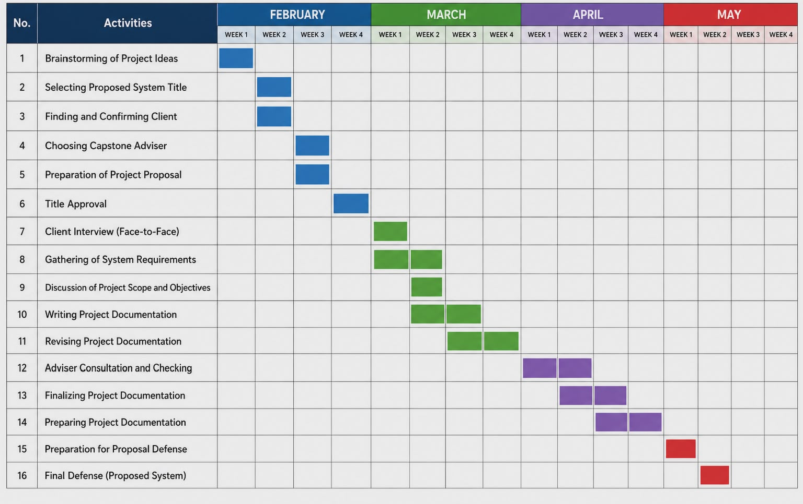
Figure 1.Gantt Chart of Activities

Resources
This section presents the resources required for the development and implementation of the proposed Tenant Information, Billing and Property Management System for Casa Sherlin. These include the hardware and software components needed to support system operations, data processing, record management, and overall functionality.
Hardware Components
These hardware requirements are essential because they provide the physical devices and equipment needed to develop, access, and operate the proposed system. These components ensure that the system performs efficiently, supports smooth communication, and allows users to access the system properly.
Table 1. Hardware Component Specifications
Components | Specifications
Developer Workstation | Laptop/Desktop with at least Intel Core i5 / Ryzen 5 processor, 8 GB RAM, 256 GB SSD, and stable internet connection
Admin/Owner Device | Laptop, desktop, tablet, or smartphone with updated operating system and stable internet connection
Tenant Device | Smartphone, tablet, laptop, or desktop capable of accessing the web-based system
Server/Cloud Infrastructure | Cloud-based server and database storage with reliable internet connectivity
Network Equipment | Wi-Fi router or mobile data connection with stable broadband internet access
Software Components
These software requirements are essential because they provide the necessary programs, platforms, and technologies used to develop, manage, and run the proposed system. These software components help ensure proper system functionality, efficient performance, data management, and user interaction.
Table 2. Software Component Specifications
Components | Specifications
Operating System | Windows 10/11, Android, iOS, macOS, or Linux
Code Editor | Visual Studio Code
Front-End Technologies | HTML, CSS, JavaScript, React.js
Back-End Technologies | Firebase
Database | Firebase Firestore cloud database

Software Methodology

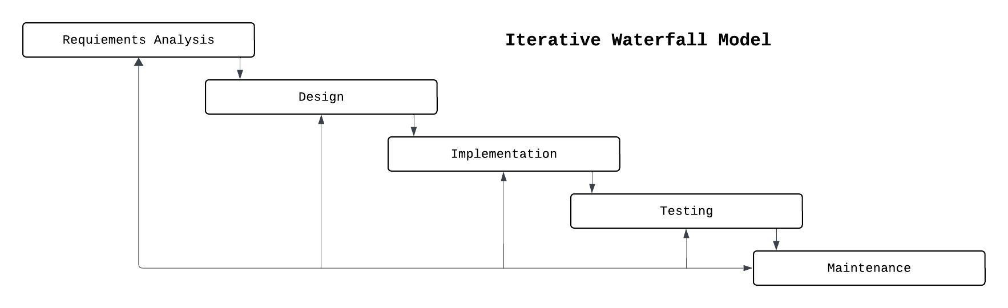
Figure 2. Iterative Waterfall Model
The researchers will use the Iterative Waterfall Model as the software development model for the proposed Tenant Information, Billing and Property Management System for Casa Sherlin. This model follows a structured and sequential process while allowing revisions and improvements when necessary. The development process includes planning, requirements analysis, system design, development, testing, implementation, and maintenance. During the planning and analysis phases, the researchers will gather and analyze information regarding tenant management, billing, contract monitoring, maintenance requests, and announcements. In the design and development phases, the researchers will create the database, web interface, and different system modules using technologies such as Visual Studio Code, HTML, CSS, JavaScript, React.js, and Firebase Firestore. The system will then undergo testing to identify and correct errors before implementation. After deployment, the system will continue to be monitored and improved through maintenance. The iterative nature of the model allows the researchers to revisit previous phases whenever revisions or improvements are needed to ensure the quality and functionality of the system.

Requirements Analysis
Who:
The proposed Tenant Information, Billing and Property Management System for Casa Sherlin involves the apartment administrator and tenants of Casa Sherlin’s Apartment in Santa Rosa, Laguna. The administrator manages tenant records, billing information, contracts, maintenance requests, and announcements through the web-based system. Tenants can access features such as viewing billing information, receiving notifications, and submitting maintenance requests. The system helps improve communication, accessibility, and efficiency among users.
What:
The system supports the daily activities involved in apartment management, including tenant information management, billing and payment tracking, contract monitoring, maintenance request handling, and announcement posting. By automating these processes, the system helps reduce manual work, improve record organization, and increase operational efficiency.
Where:
The system will be implemented at Casa Sherlin’s Apartment in Santa Rosa, Laguna. It will operate as a web-based system accessible through devices such as laptops, desktops, tablets, and smartphones with internet connectivity. Administrators may manage the system within the apartment office, while tenants can access selected features remotely through web browsers.
When:
The system will be used during the daily operations of the apartment. Administrators will regularly manage tenant records, billing information, maintenance requests, and contracts. Billing and announcements may be updated regularly, while tenants can access the system anytime through internet connection.
How:
Currently, apartment operations are handled manually, which may cause disorganized records and delays. The proposed system improves these processes through a centralized web-based platform for tenant management, billing, contracts, and maintenance requests.
Use Case Model of the Current System of Casa Sherlin Apartment
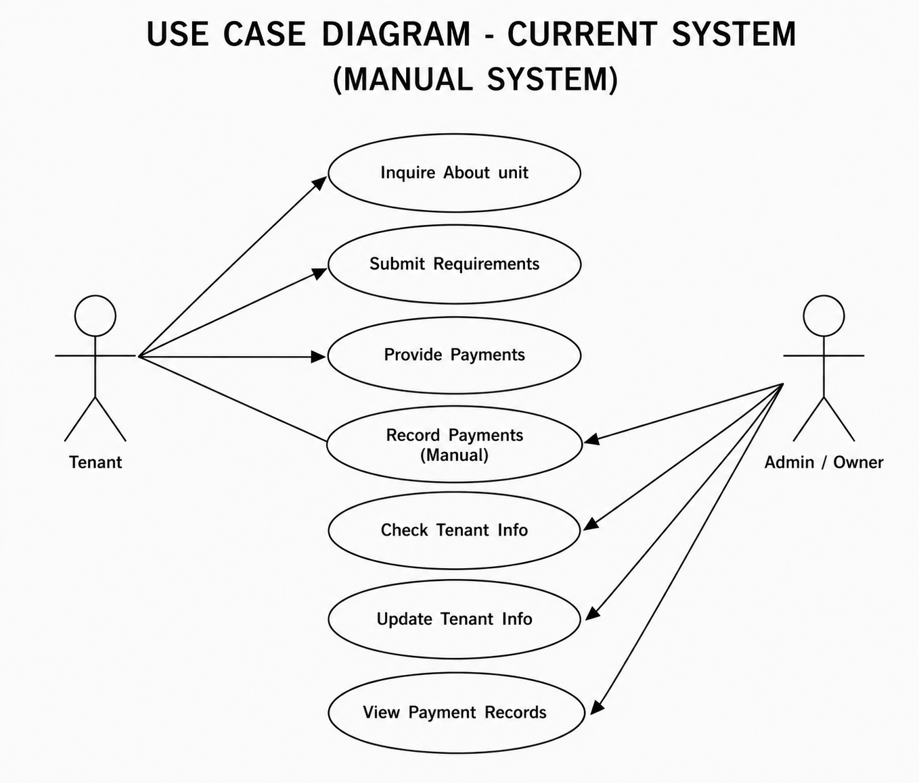
Figure 3: Use Case Model of the Current System
The current system of Casa Sherlin’s Apartment follows a manual process for handling tenant transactions and apartment records. Tenant inquiries, payments, and record management are performed using paper documents, notebooks, and manual monitoring procedures. This process may cause delays, disorganized records, and possible human errors in handling apartment operations.

Actors:

Tenant: Responsible for inquiring about apartment units, submitting requirements, and providing rental payments to the apartment administrator or owner.

Admin / Owner: Responsible for manually managing tenant information, recording payments, updating records, and monitoring payment transactions within the apartment.

Tenant Use Cases:

Inquire About Unit: The tenant personally asks for information regarding apartment unit availability, rental details, and requirements.

Submit Requirements: The tenant submits necessary documents and requirements manually to the apartment administrator or owner.

Provide Payments: The tenant manually provides rental payments to the administrator or owner for recording and monitoring.

Admin / Owner Use Cases:

Record Payments (Manual): The administrator or owner manually records tenant payments using paper records, notebooks, or spreadsheets.

Check Tenant Info: The administrator or owner manually checks tenant information and records when needed.

Update Tenant Info: The administrator or owner manually updates tenant records and related information.

View Payment Records: The administrator or owner reviews and monitors payment records manually for billing and tracking purposes.

Data Flow Diagram of the Current System of Casa Sherlin Apartment
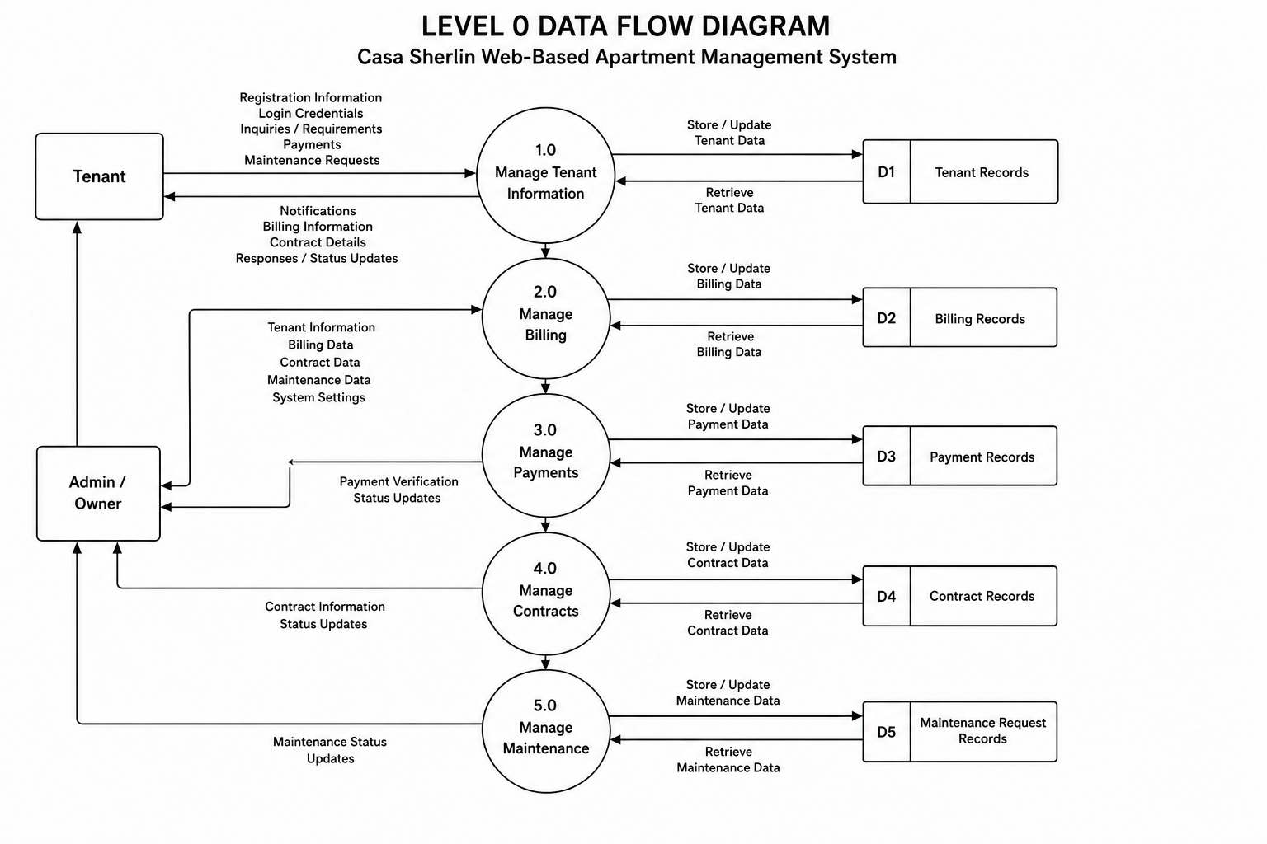
Figure 4: Data Flow Diagram of the Current System
The Level 0 Data Flow Diagram (DFD) illustrates how data moves within the proposed Tenant Information, Billing and Property Management System for Casa Sherlin. The diagram shows the interaction between the Tenant, the Admin/Owner, the system processes, and the data records stored in the web-based apartment management system. The tenant interacts with the system by registering, logging in, viewing billing information, making payments, viewing contract details, and submitting maintenance requests. In return, the tenant receives notifications, billing updates, contract information, and maintenance status updates from the system. The Admin/Owner manages tenant records, billing information, payment verification, contracts, and maintenance concerns through the system. The system is divided into major processes such as Manage Tenant Information, Manage Billing, Manage Payments, Manage Contracts, and Manage Maintenance. Each process stores and retrieves information from its corresponding data records, including Tenant Records, Billing Records, Payment Records, Contract Records, and Maintenance Request Records. Overall, the diagram shows how the proposed web-based system centralizes apartment operations by automating data processing, improving record organization, and allowing easier communication between tenants and the Admin/Owner.

Requirements Documentation
The proposed Tenant Information, Billing and Property Management System for Casa Sherlin is designed to transform the current manual apartment management process into a centralized and automated web-based platform. The primary goal of the developers is to eliminate inefficiencies caused by paper-based records, manual billing, delayed updates, and traditional monitoring procedures by providing an integrated system for tenant management, billing, contracts, maintenance requests, and announcements. Through a role-based access structure, the system allows administrators and tenants to interact with interfaces tailored to their specific functions, improving accessibility, organization, and accountability.

Client Requirements and Functional Goals:

Elimination of Manual Record Management: The client requires the transition from paper-based records and spreadsheets to a centralized digital records management system. The developers aim to implement a cloud-based database that securely stores tenant information, billing records, contracts, maintenance requests, and announcements to improve organization, accessibility, and data accuracy.

Automated Billing and Payment Monitoring: To address delays and inconsistencies in billing management, the system will provide automated billing generation and payment monitoring features. The developers aim to implement functions that allow administrators to monitor tenant balances and payment status efficiently, while tenants can view billing information and upload proof of payment through the web-based platform.

Centralized Contract Monitoring: The client requires an organized method of monitoring lease contracts and rental agreements. The system will provide contract tracking features that monitor contract start dates, end dates, and status updates to help administrators manage active and expiring contracts more effectively.

Maintenance Request Coordination: To improve maintenance management and communication, the system will include a maintenance request module where tenants can submit repair concerns online. The developers aim to create a centralized process that allows administrators to monitor, manage, and respond to maintenance requests efficiently and in real time.

Real-Time Notifications and Announcements: The client requires improved communication between administrators and tenants. The developers will implement a notification and announcement system that provides reminders for billing due dates, maintenance updates, and apartment announcements to ensure users receive important information promptly.

Data Integrity and Accessibility: A major goal of the system is the digital transformation of apartment operations and records. The system will maintain organized and secure cloud-based data management to reduce human errors, prevent data loss, and allow authorized users to access updated information anytime through the web-based platform.

Design of Software, System, Product, and/or Processes
Use Case Model of the Proposed System of Casa Sherlin Apartment
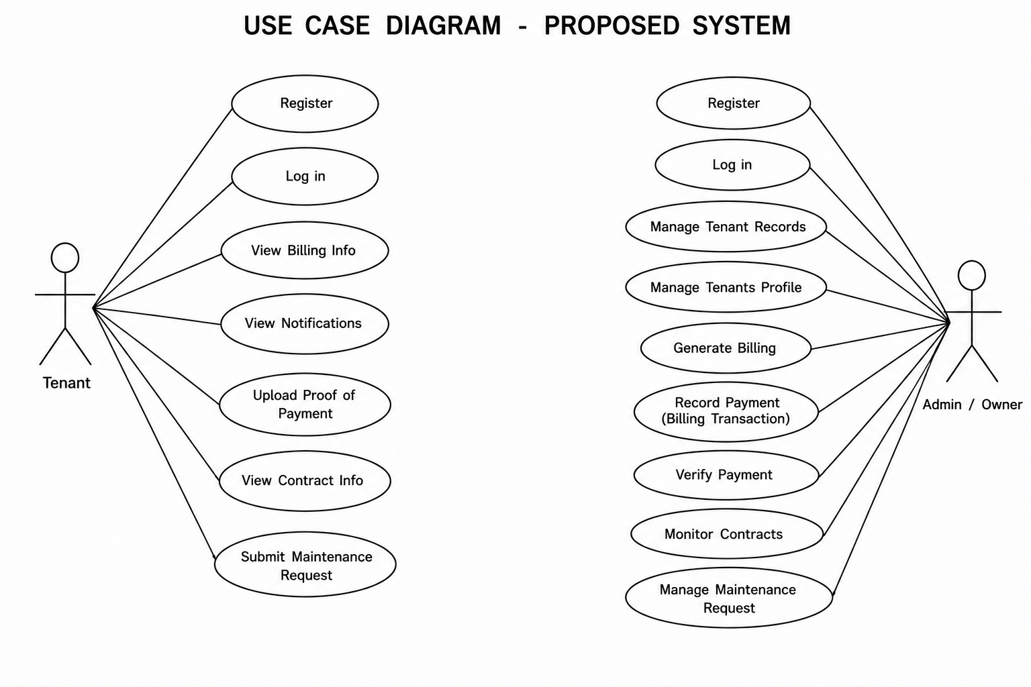
Figure 5: Use Case Model of the Proposed System
The proposed Tenant Information, Billing and Property Management System for Casa Sherlin replaces the current manual apartment management process used at Casa Sherlin’s Apartment. The system introduces a centralized and automated web-based platform that allows tenants to access billing information, receive notifications, upload proof of payment, monitor contracts, and submit maintenance requests online. It also enables administrators to manage tenant records, generate billing information, verify payments, monitor contracts, and handle maintenance concerns more efficiently. The system improves organization, accessibility, communication, and overall apartment management operations.

Actors:

Tenant: Responsible for accessing apartment-related information and services such as billing, notifications, contracts, and maintenance requests through the web-based system.

Admin / Owner: Responsible for managing apartment operations, tenant records, billing transactions, contracts, payments, and maintenance concerns within the system.

Tenant Use Cases:

Register: The tenant creates an account to access the web-based apartment management system.

Log in: The tenant logs into the system using a username and password to access system features.

View Billing Info: The tenant views billing details, payment status, and due dates through the system.

View Notifications: The tenant receives announcements, reminders, and important updates from the administrator.

Upload Proof of Payment: The tenant uploads proof or screenshots of payment for billing verification.

View Contract Info: The tenant views rental contract details such as contract duration and status.

Submit Maintenance Request: The tenant submits maintenance concerns or repair requests through the system.

Admin / Owner Use Cases:

Register: The administrator creates an account for system access and management functions.

Log in: The administrator logs into the web-based system to access management features.

Manage Tenant Records: The administrator adds, updates, organizes, and monitors tenant information and records.

Manage Tenant Profile: The administrator manages and updates tenant account details and profile information.

Generate Billing: The administrator creates billing records and monthly payment dues for tenants.

Record Payment (Billing Transaction): The administrator records payment transactions and updates billing information.

Verify Payment: The administrator verifies uploaded proofs of payment submitted by tenants.

Monitor Contracts: The administrator tracks active, completed, and expiring tenant contracts.

Manage Maintenance Request: The administrator reviews, monitors, and responds to maintenance concerns submitted by tenants.

Data Flow Diagram of the Proposed System of Casa Sherlin Apartment
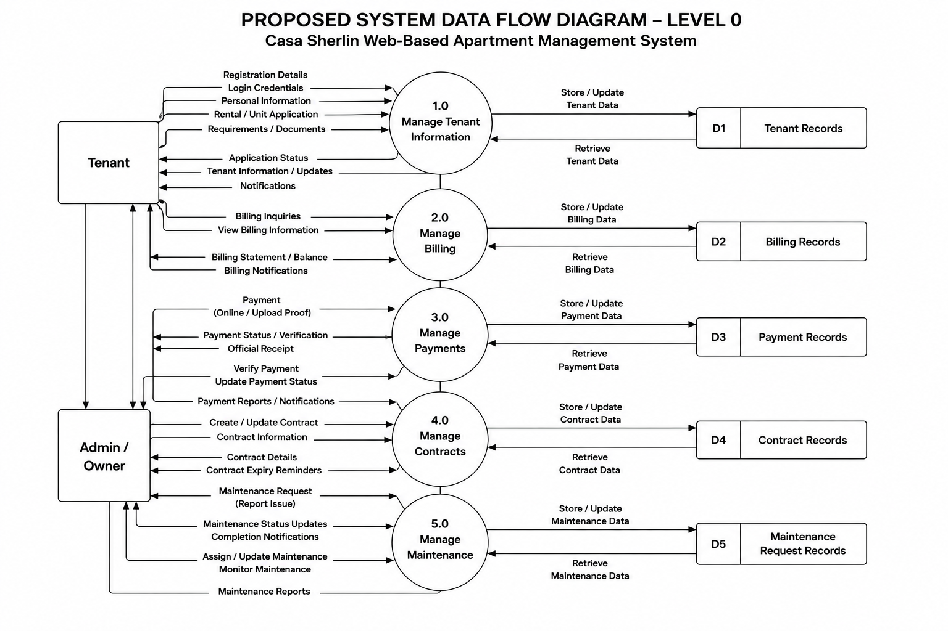
Figure 6: Data Flow Diagram of the Proposed System
The proposed Level 0 Data Flow Diagram (DFD) illustrates how data moves within the Tenant Information, Billing and Property Management System for Casa Sherlin. The diagram shows the interaction between the Tenant, the Admin/Owner, the system processes, and the different data records stored in the web-based apartment management system. The system is divided into five major processes: Manage Tenant Information, Manage Billing, Manage Payments, Manage Contracts, and Manage Maintenance.
The process starts when the tenant submits registration details, login credentials, personal information, rental applications, and required documents to the system through the Manage Tenant Information process. The system then stores and retrieves tenant information from the Tenant Records database (D1). The tenant also receives updates such as application status, tenant information updates, and notifications from the system.
For billing management, the tenant can send billing inquiries and view billing information through the Manage Billing process. The system stores and retrieves billing data from the Billing Records database (D2). The tenant receives billing statements, balance information, and billing notifications from the system.
In the Manage Payments process, the tenant submits payments and uploads proof of payment online. The system records payment transactions, verifies payments, updates payment status, and stores payment information in the Payment Records database (D3). The Admin/Owner can verify payments and receive payment reports and notifications from the system.
The Manage Contracts process handles contract creation, updates, and monitoring. The system stores and retrieves contract data from the Contract Records database (D4). The Admin/Owner manages contract information, while tenants receive contract details and contract expiration reminders.
Lastly, the Manage Maintenance process handles maintenance requests submitted by tenants. The system stores and retrieves maintenance information from the Maintenance Request Records database (D5). The Admin/Owner can assign and monitor maintenance tasks, while tenants receive maintenance status updates and completion notifications.
Overall, the proposed web-based system centralizes apartment operations by automating record management, improving data organization, simplifying communication between tenants and the Admin/Owner, and reducing manual processes and human errors.

System Interface & User Flow
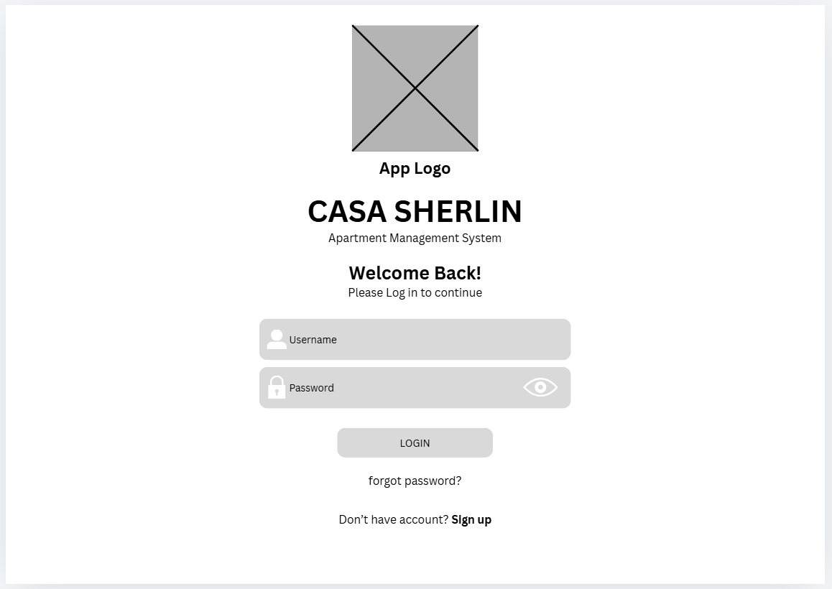
Figure 7: Login Module
Allows tenants to securely log into the system using their username and password. It also includes sign up and forgot password options.
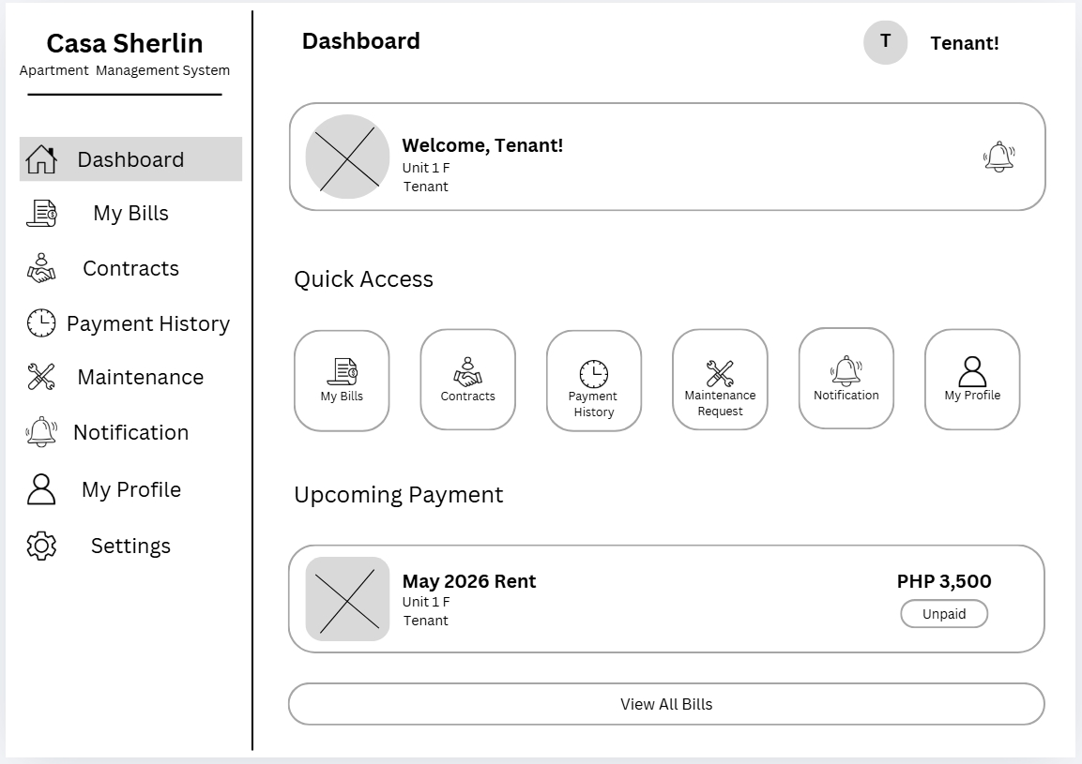
Figure 8: Tenant Dashboard Module
Serves as the main homepage where tenants can quickly access bills, contracts, maintenance requests, notifications, and other system features.
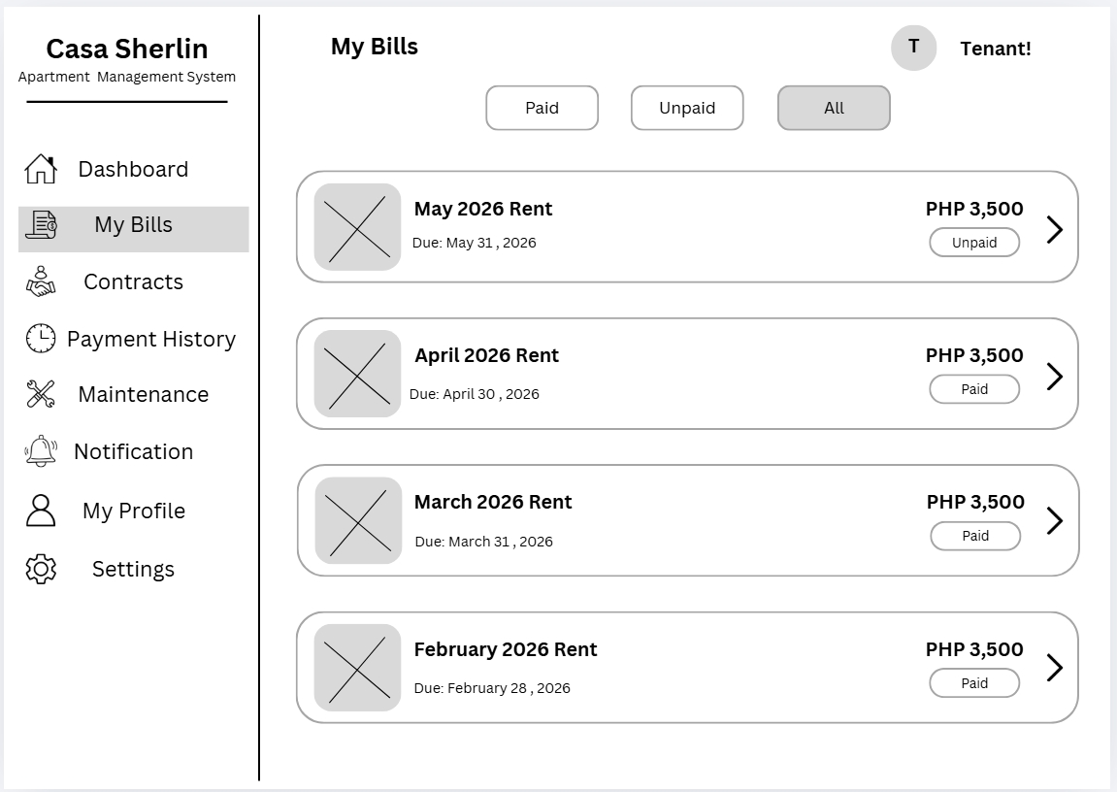
Figure 9: Billing and Payment Tracking Module
Displays billing records, payment status, due dates, and rental amounts to help tenants track their payments.
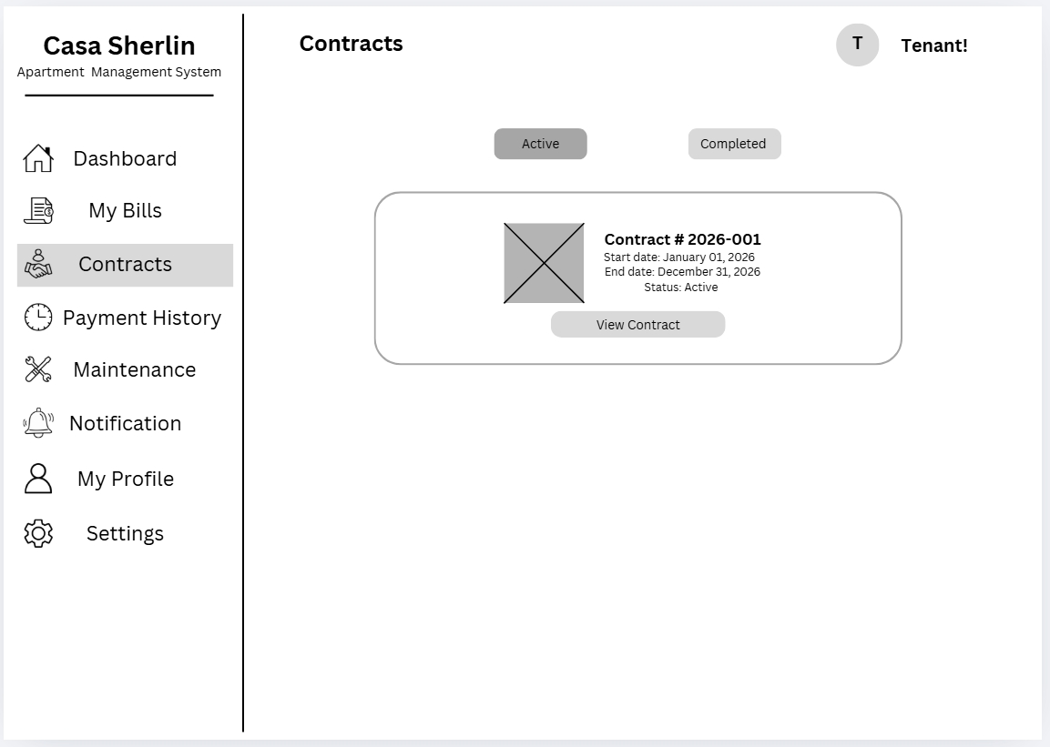
Figure 10: Contracts Module
Shows lease contract details such as contract number, start date, end date, and contract status.
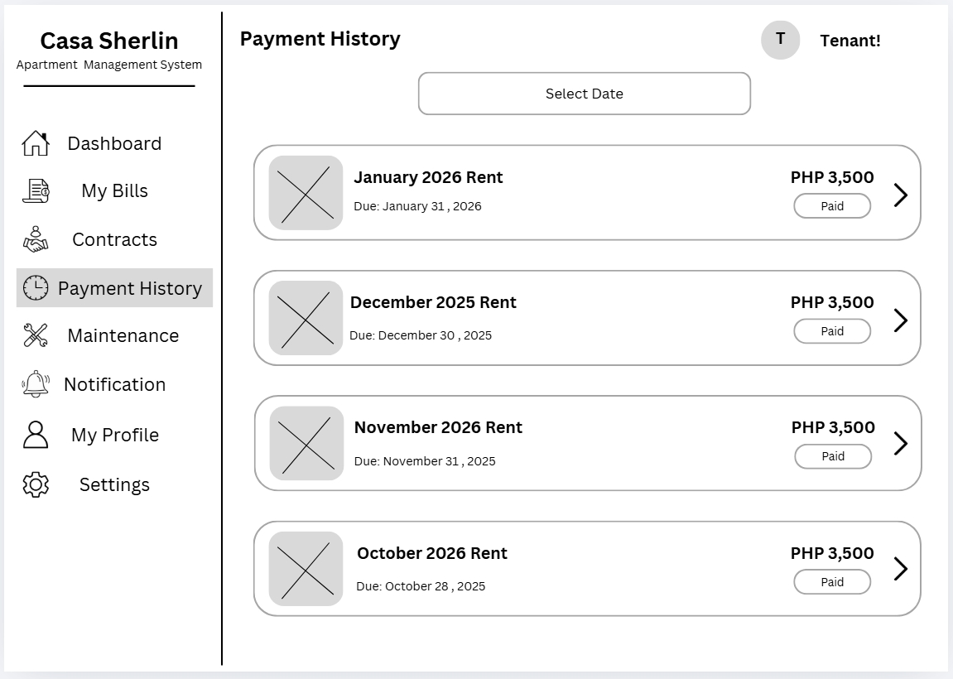
Figure 11: History Module
Allows tenants to view their previous payment transactions and payment records.
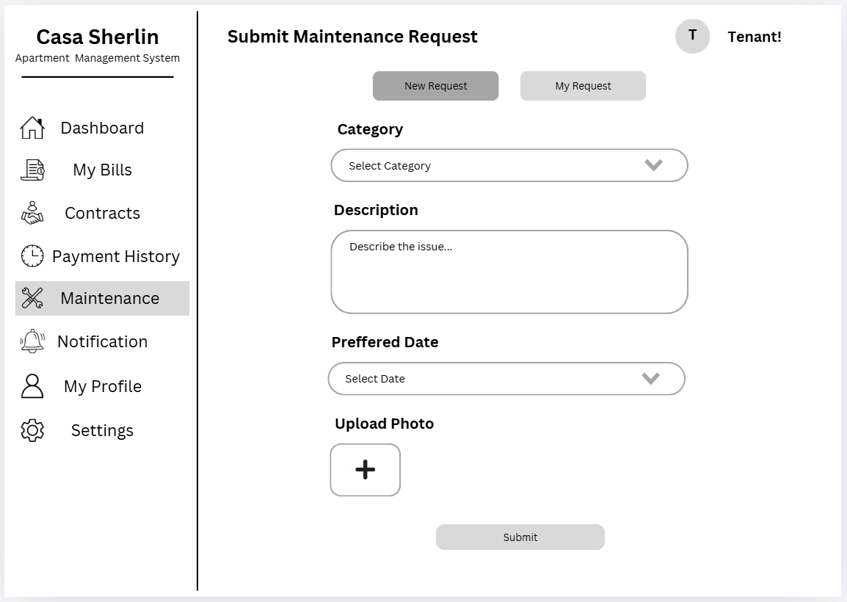
Figure 12: Maintenance Request Module
Enables tenants to submit repair and maintenance concerns by providing issue details and preferred schedules.
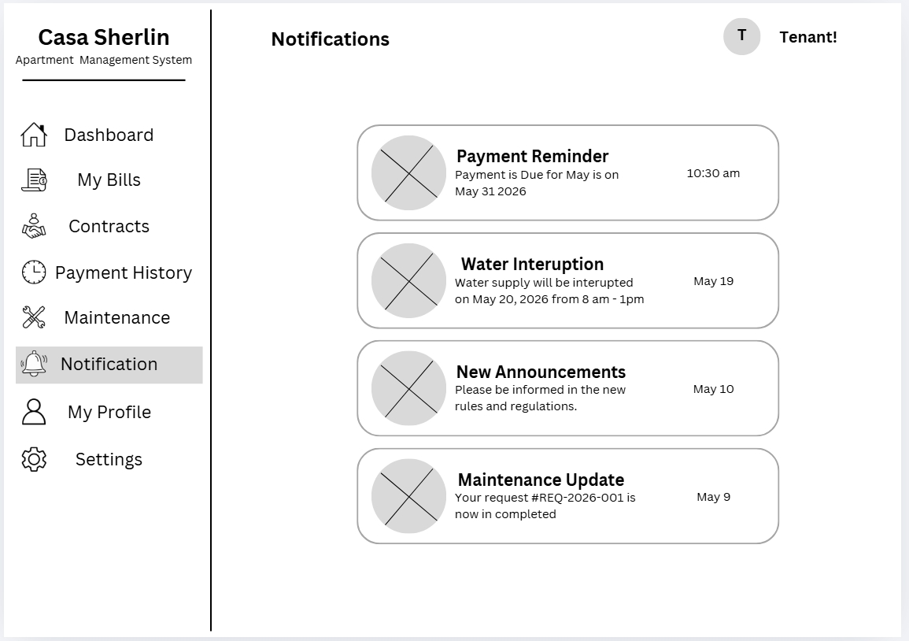
Figure 13: Notifications Module
Provides important updates such as payment reminders, announcements, and maintenance updates.
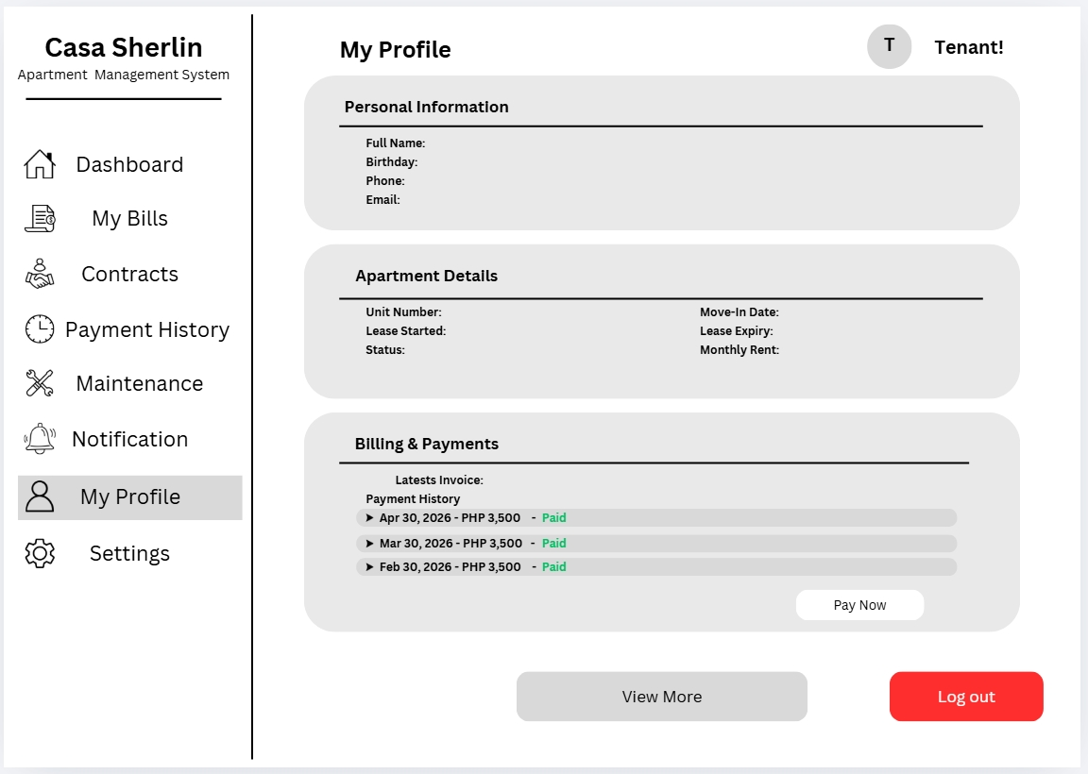
Figure 14: My Profile Module
Displays tenant personal information, apartment details, and billing information within the system.
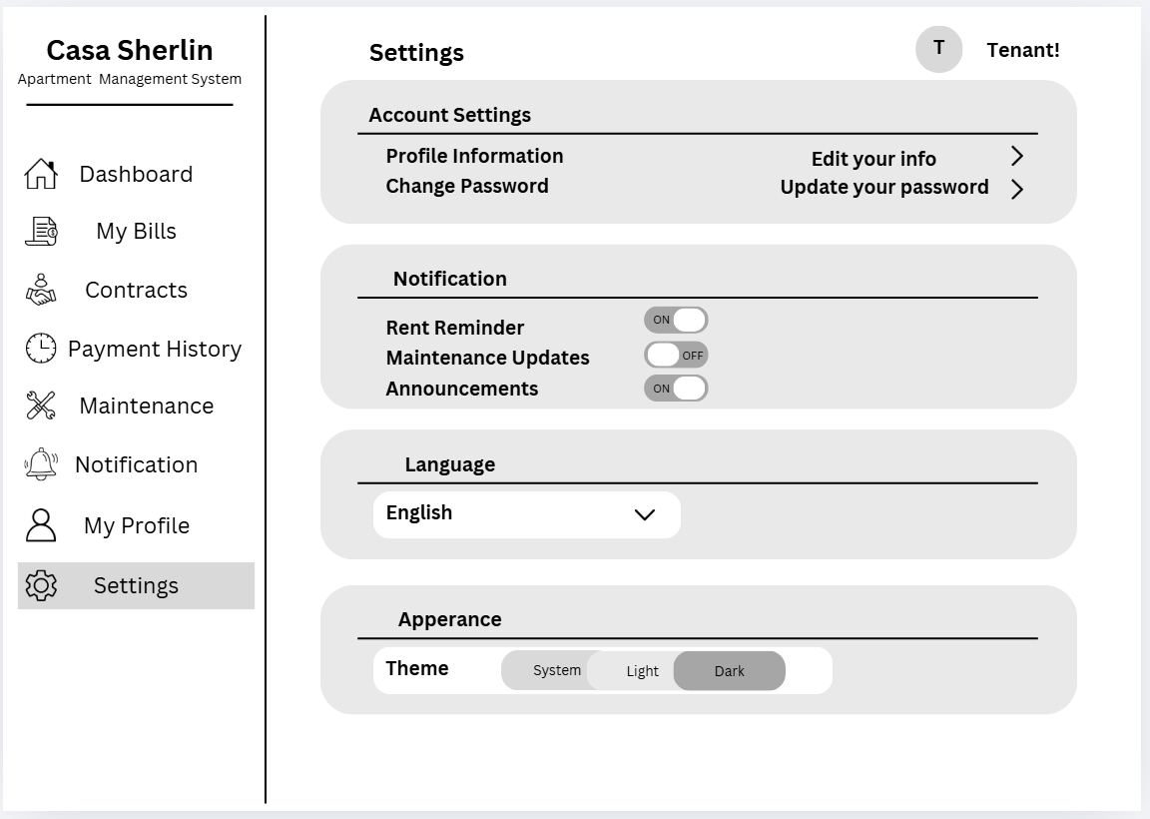
Figure 15: Settings Module
Allows tenants to manage account settings, notification preferences, passwords, language, and appearance options.

REFERENCES
Magno, J. M., Pelayo, R. S., & Soberano, K. T. (2024). Apartment rental management system for real-time transaction and task organization. International Journal of Multidisciplinary Research and Analysis.
Kaur, T., & Solomon, S. (2021). A study on automated property management in commercial real estate: A case of India. International Journal of Research in Engineering and Science.
Yousefli, Z., Nasiri, F., & Moselhi, O. (2021). Maintenance workflow management using an automated multi-agent facility management system. Automation in Construction, 132, 103948.
Azman, N., & Ishak, S. (2024). Property management software (PMS) application effect toward property management operation in Johor Bahru. Journal of Property Management and Real Estate Studies.
Zhou, Y., Zhang, L., Wang, H., & Chen, X. (2022). Developing a smart real property management system: A case study in Hangzhou, China. Journal of Real Estate Technology and Smart City Development.
Saxena, A., Sharma, R., Gupta, P., & Verma, S. (2022). Society Sync: Digitalize society management systems with artificial intelligence technologies. International Journal of Computer Applications and Information Technology.
Źróbek, R., Źróbek-Sokolnik, A., Dynowski, P., & Trojanek, R. (2021). Supporting tenant relocation in social housing management: Development of the dedicated geoinformation system in Poland. Land, 10(8), 813.
Rathod, P., & Kumar, S. (2022). Apartment management system: A review. International Journal of Advanced Research in Computer Science and Software Engineering.
Journal of Building Engineering. (2022). Cloud-based property management and smart building systems. Journal of Building Engineering, 50, 104185.
Arroyo, J. P., Bedo, M. A., & Vibora, K. L. (2024). CapSU Pilar dormitory information and management system [Undergraduate thesis, Capiz State University].
Caparos, J. M., Gabriel, R. T., Prudente, A. S., & Romero, C. D. (2025). Cloud-based property management system: Enhancing real estate operation and tenant experience. Philippine Journal of Information Systems Research.
Reyes, M. A., & Santos, R. P. (2023). Development of an online boarding house management system [Undergraduate thesis, Laguna State Polytechnic University].
Dela Cruz, J. P. (2024). Property management practices implementation and cost measures efficiency in the City Government of Calamba. Journal of Public Administration and Governance Studies.
Bautista, R. M., & Santos, L. A. (2021). Development of an automated rental and billing system for residential complexes. Philippine Information Technology Journal.

APPENDICES
APPENDIX A. RESOURCE PERSONS
Client Conforme
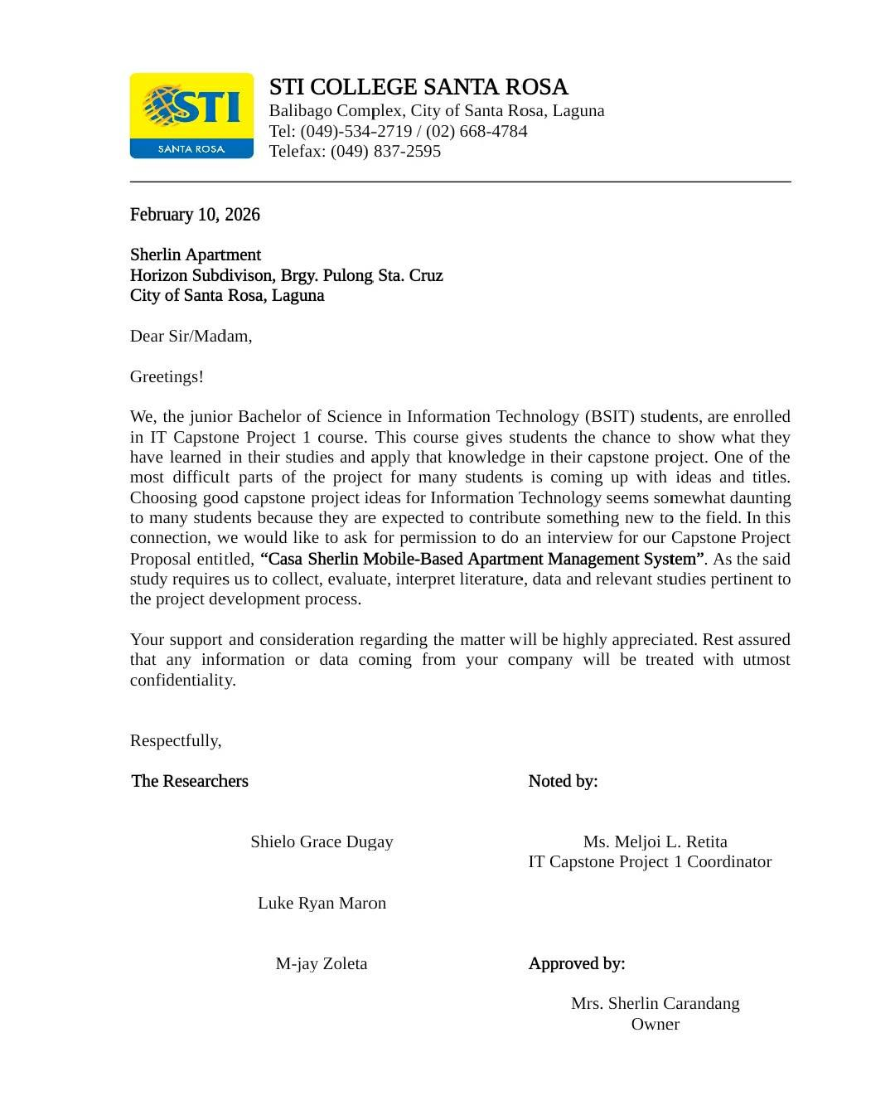

Photo Documentation of Client Interview
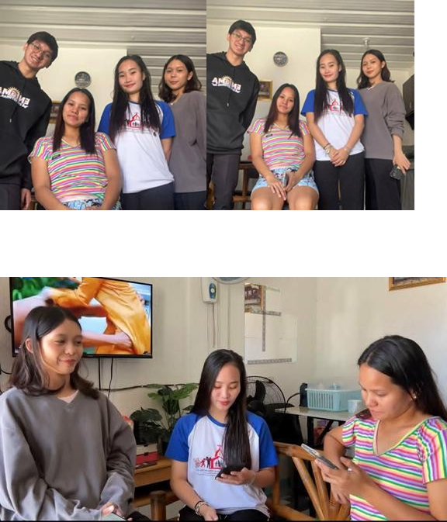
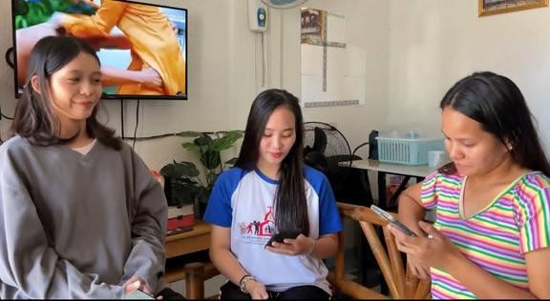

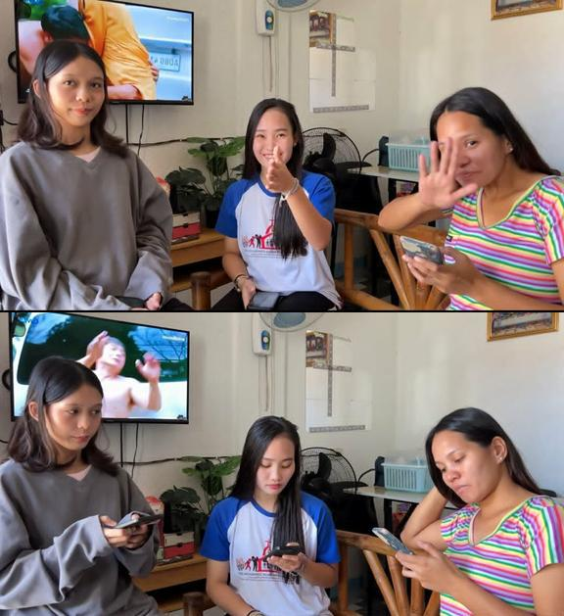

Client Interview Transcript
Date of Interview: February 10, 2026
Student: Good afternoon po Ma’am Sherlin, kami po yung students na gagawa ng proposed Web-Based Apartment Management System para po sa apartment ninyo. Gusto lang po sana namin malaman yung current process ninyo at mga problems na nae-encounter para mas maintindihan namin kung ano yung mga features na kailangan sa system. Okay lang po ba magtanong?
Ma’am Sherlin: Ah yes, sure naman. Sige lang.
Student: Ma’am, kailan po kayo nag-start nitong apartment business ninyo?
Ma’am Sherlin: Around 2018 pa kami nagsimula magpa-rent ng apartment.
Student: Sa ngayon po Ma’am, paano po kayo nagre-record ng tenant information and payments?
Ma’am Sherlin: Manual lang talaga, gumagamit kami ng logbook at notebook. Kapag may nagbayad, sinusulat lang yung date at amount.
Student: Ano po usually yung mga problems na nae-encounter ninyo sa manual na pagre-record?
Ma’am Sherlin: Minsan nakakalimutan kung sino na yung nakabayad at hindi pa. Kapag marami nang tenants, mahirap hanapin yung records sa logbook.
Student: Ano-ano pong information yung kinukuha ninyo sa mga tenants?
Ma’am Sherlin: Name, contact number, address, valid ID, at kung ilan yung titira sa room. Kinukuha rin yung advance at deposit payment.
Student: Sa ngayon po Ma’am, mga ilan na po yung tenants ninyo?
Ma’am Sherlin: Around 24 units na rin kami ngayon.
Student: Sa 24 units po, magkakaparehas po ba sila ng size at type?
Ma’am Sherlin: Single bedroom lang po silang lahat, may sala at sariling CR.
Student: May parking po ba ang apartment?
Ma’am Sherlin: Wala po.
Student: May sari-sarili po ba silang metro?
Ma’am Sherlin: Meron po.
Student: May kanya-kanya po ba silang address?
Ma’am Sherlin: Iisa lang ang address pero iba-iba ang meter number ng kuryente.
Student: Ilang tenants po ang allowed per unit?
Ma’am Sherlin: Hanggang 5 lang, kapag sumobra may additional bayad.
Student: Magkano po ang renta per unit?
Ma’am Sherlin:
• 2nd Floor – ₱4,000 (renovated)
• 1st Floor – ₱3,500
• 3rd Floor – ₱3,500
Student: Ilan po ang units per floor?
Ma’am Sherlin:
Main building:
• 1st Floor – 5 units
• 2nd Floor – 5 units
• 3rd Floor – 4 units
Back building:
• 1st Floor – 4 units
• 2nd Floor – 3 units
• 3rd Floor – 3 units
Student: May business permit po ba kayo?
Ma’am Sherlin: Meron po, yearly nagbabayad ng tax.
Student: May advance and deposit po ba?
Ma’am Sherlin: Oo, 1 month advance at 1 month deposit.
Student: May Wi-Fi po ba?
Ma’am Sherlin: Wala po, sari-sarili ng tenants.
Student: Ilang taon na po ang pinakamatagal na tenant?
Ma’am Sherlin: 4 years na po.
Student: Sino po ang nag-aasikaso ng maintenance repair?
Ma’am Sherlin: Puwedeng tenant o admin depende sa concern.
Student: Sino po sumasagot ng bayad sa repair?
Ma’am Sherlin: Depende. Kapag major like tubo ako, pero kapag simpleng sira tulad ng bumbilya, tenant ang sumasagot.
Student: May contract po ba kayo sa tenants? Paano po ang process nito, lalo na sa lease start at lease end?
Ma’am Sherlin: Oo, meron po. Bago sila lumipat, pinapapirmahan muna namin sila ng lease contract. Nakalagay doon yung lease start date at lease end date, kasama na rin yung monthly rent, rules ng apartment, at agreement ng tenant. Kapag nag-start na yung occupancy, doon na rin nagsisimula yung billing ng renta. Pag malapit na matapos yung contract, chine-check namin kung magre-renew pa sila o magva-vacate na ng unit. Kapag aalis na, chine-check din namin yung unit bago i-close yung contract.
Student: Paano po kapag umalis yung tenant bago matapos ang contract?
Ma’am Sherlin: Kapag umalis before matapos ang contract, chine-check muna namin kung ano reason. Depende sa agreement, puwedeng ma-forfeit ang deposit. Ini-inspect din muna yung unit bago ibalik ang deposit at i-close yung record.
Student: Kapag naman po may sira sa room tulad ng ilaw, gripo, or kuryente, paano po kayo sinasabihan ng tenants?
Ma’am Sherlin: Usually chinachat lang nila ako o sinasabi personally.
Student: Nagkakaroon po ba minsan ng problem sa pag-track ng repair requests?
Ma’am Sherlin: Oo, minsan nakakalimutan lalo na kapag sabay-sabay ang concerns.
Student: If ever po sa web-based system, gusto niyo po ba na may feature para makita yung pending, ongoing, at completed repair requests?
Ma’am Sherlin: Oo, maganda yun para mas organized at madaling ma-monitor.
Student: Ano pa pong features yung gusto ninyo sana magkaroon sa system?
Ma’am Sherlin: Sana madaling makita yung tenant records, payments, at kung sino yung may balance. Maganda rin kung may reports at receipts.
Student: Okay lang po ba sa inyo kung may notification or reminder feature para sa due dates ng payments?
Ma’am Sherlin: Oo, mas okay yun para hindi na mano-mano ang pagremind sa tenants.
Student: Important po ba sa inyo na may login account and password ang system?
Ma’am Sherlin: Oo, syempre para secure ang records.
Student: Anong klaseng reports po ang gusto ninyo makita sa system?
Ma’am Sherlin: Monthly income, tenant list, at list ng may remaining balance.
Student: Importante rin po ba na may backup ang records?
Ma’am Sherlin: Oo, importante yun kasi minsan nawawala o nasisira ang notebook.
Student: Since web-based po ang system, okay lang po ba sa inyo na computer or phone ang pwedeng gamitin para ma-access ang system?
Ma’am Sherlin: Oo, mas convenient po kung accessible sa phone at computer.
Student: Ano po ang inaasahan ninyong magiging benefits ng proposed system?
Ma’am Sherlin: Mas mapapadali ang trabaho, less hassle, mas organized ang records, at mas mabilis makita ang payments at tenant information.
Student: Thank you po Ma’am Sherlin sa pagpayag na ma-interview namin kayo. Malaking tulong po ito sa development ng proposed Web-Based Apartment Management System.
Ma’am Sherlin: Sige, good luck sa project ninyo.

Curriculum Vitae of
DUGAY, SHIELO GRACE T.
725 Purok 3 Barangay Caingin City of Santa Rosa Laguna
shielodugay4@gmail.com
09935450349

EDUCATIONAL BACKGROUND
Level | Inclusive Dates | Name of school/ Institution
Tertiary | 2022-Present | STI College Santa Rosa
Vocational/Technical | 2021-2023 | Asia Technological School of Science and Arts
High School | 2017-2021 | Laguna Eastern Academy of Santa Rosa Incorporated
Elementary | 2012-2017 | Caingin Elementary School

PROFESSIONAL OR VOLUNTEER EXPERIENCE
Inclusive Dates | Nature of Experience/  Job Title | Name and Address of Company or Organization
— | — | —
AFFILIATIONS
Inclusive Dates | Name of Organization | Position
— | — | —
SKILLS
SKILLS | Level of Competency | Date Acquired
Java | Beginner | 2023
SQL Server  HTML | Beginner  Beginner | 2024  2025
TRAININGS, SEMINARS, OR WORKSHOPS ATTENDED
Inclusive Dates | Title of Training, Seminar, or Workshop
— | —

Curriculum Vitae of
MARON, LUKE RYAN P.
B6 L20 Cuidad Grande Barangay Labas City of Santa Rosa Laguna
Lukeryanmaron@gmail.com
09354286840

EDUCATIONAL BACKGROUND
Level | Inclusive Dates | Name of school/ Institution
Tertiary | 2023- Present | STI College Santa Rosa
Vocational/Technical | 2021-2023 | St. Ignatius Technical Institute of Business and Arts
High School | 2017-2021 | Aplaya National School Extension
Elementary | 2012-2017 | Colegio de Santa Rosa Elementary School

PROFESSIONAL OR VOLUNTEER EXPERIENCE
Inclusive Dates | Nature of Experience/  Job Title | Name and Address of Company or Organization
— | — | —
AFFILIATIONS
Inclusive Dates | Name of Organization | Position
— | — | —
SKILLS
SKILLS | Level of Competency | Date Acquired
Java | Intermediate | 2023

TRAININGS, SEMINARS, OR WORKSHOPS ATTENDED
— | —

APPENDIX B. PERSONAL TECHNICAL VITAE
Curriculum Vitae of
ZOLETA, M-JAY L.
Barangay Pulong Sta Cruz, Santa Rosa Laguna
zoletaem@gmail.com
09480294831

EDUCATIONAL BACKGROUND
Level | Inclusive Dates | Name of school/ Institution
Tertiary | 2023-Present | STI College Santa Rosa
Vocational/Technical | 2021-2023 | St. Ignatius Technical Institute of Business and Arts
High School | 2017-2021 | St. Lawrence Academy
Elementary | 2012-2017 | San Pedro National High School

PROFESSIONAL OR VOLUNTEER EXPERIENCE
Inclusive Dates | Nature of Experience/  Job Title | Name and Address of Company or Organization
— | — | —
AFFILIATIONS
Inclusive Dates | Name of Organization | Position
— | — | —
SKILLS
SKILLS | Level of Competency | Date Acquired
Communication Skills | Intermediate | June 2023
Android Studio Basic  Teamwork and Collaboration | Beginner  Intermediate | March 2026  June 2022
TRAININGS, SEMINARS, OR WORKSHOPS ATTENDED
Inclusive Dates | Title of Training, Seminar, or Workshop
— | —

