Smart Parking Platform
Project Management Document
Prepared by: Emilia Menz
Course: CIS 4374
Project repository: CIS Smart Parking Platform
Academic term: Fall 2026
Homework 1: Project Documentation
Homework 2: Work Breakdown Structure and Draft Timeline
Homework 3: Product Backlog and Sprint Planning
Homework 4: Risk Management and Communications Planning
Homework 5: Bereavement
Homework 6: Tools and Technology
Homework 7: Managing Stakeholders
Homework 8: Closure Homework Report Draft

Document Overview
This document presents the semester project plan for a Smart Parking Platform. Homework 1 defines the existing software landscape, project vision, scope, and system use cases. Homework 2 breaks the work into manageable packages and schedules the work across a 12-week semester timeline.

Contents
Homework 1 Project Documentation 3
1. Research and Existing Software Landscape 3
2. Vision and Scope 4
3. Software Requirements Specification 5
4. References and Project Repository 10
Homework 2 Work Breakdown Structure and Timeline 11
5. Work Breakdown Structure 11
6. Draft Project Timeline 13
7. Gantt Chart 14
8. Milestones and Scheduling Notes 15

Project Summary
The platform will help drivers locate, reserve, and pay for parking spaces in real time through mobile and web applications. It will also give parking operators tools to manage availability, pricing, reservations, occupancy data, and reports. The project uses separate mobile, web, backend/API, mapping, payment, and quality-assurance work streams.

Homework 1 Project Documentation

1. Research and Existing Software Landscape
Drivers often lose time searching for parking, especially near campuses, business districts, airports, and event venues. This creates frustration, contributes to congestion, and makes it difficult for parking operators to use their spaces efficiently. A smart parking platform can reduce this problem by showing available locations, supporting reservations and digital payments, and providing clear directions before a driver arrives.
Several established products already address parts of this problem. ParkMobile allows drivers to find, reserve, and pay for parking, while its provider tools include dashboards, reservations, payments, management, and insights. SpotHero focuses on comparing parking options and making prepaid reservations for garages, lots, airports, and events. PayByPhone emphasizes digital payment, session extensions, receipts, and parking alerts. These products show that users expect parking technology to be fast, mobile-friendly, and connected to secure payment services.
The proposed Smart Parking Platform would combine driver and operator functions in one coordinated system. Drivers would use a mobile or web application to search an interactive map, view real-time availability, reserve a space, pay digitally, receive alerts, and access receipts. Operators would use an administrative dashboard to update parking information, review reservations, monitor occupancy, manage pricing, and generate reports. The project does not assume that existing parking tools lack these features; instead, it uses the existing market to identify the functions users and operators are likely to expect.

Competitive Comparison
Platform | Driver Focus | Notable Functions | Project Lesson
ParkMobile | Parking now and advance reservations | Search, payment, reservations, provider tools | Combine driver services with operator management.
SpotHero | Advance parking reservations | Compare locations and prices, prepaid passes, reservation management | Make search, comparison, and confirmation simple.
PayByPhone | Digital parking sessions | Payments, extensions, receipts, and alerts | Support convenient payments and timely notifications.
Proposed Platform | Drivers and parking operators | Real-time availability, maps, reservations, payments, dashboards, and analytics | Connect the complete parking process in one system.
Table 1. Comparison of existing parking platforms and the proposed system.

2. Vision and Scope

2.1 Project Context
WE ARE Software Corp. is planning the Smart Parking Platform as a semester software-development project. The platform will serve drivers, vehicle owners, parking facility operators, city transportation departments, system administrators, finance personnel, and mobile application users. Development will be divided among mobile, web, backend/API, mapping and location services, payment integration, and quality-assurance teams.

2.2 Project Vision
The vision is to create a dependable platform that helps drivers move from searching to parking with fewer delays. The same system will help operators maintain accurate availability information, manage reservations and payments, and understand how their parking facilities are being used. Information should be easy to find, current, and appropriate to each user’s role.

2.3 Project Scope
The first release will include user registration and authentication, real-time parking availability, an interactive map, reservations, digital payments, receipts and reservation history, alerts, external navigation integration, an operator dashboard, and occupancy analytics. The web and mobile applications will use shared backend services so information remains consistent across the platform.
The project includes planning, requirements gathering, stakeholder analysis, system design, development, integration, testing, deployment preparation, documentation, and handoff. It assumes an unlimited theoretical development budget but must fit within the semester schedule. The project also depends on third-party mapping and payment services and must consider security, privacy, city ordinances, and applicable laws.

2.4 Scope Boundaries
- The platform will provide parking information and reservations but will not control traffic signals or city roadway operations.
- Payments will be processed through an approved third-party provider rather than storing complete payment-card information in the platform.
- Availability accuracy will depend on timely information from parking operators, sensors, gates, or connected facility systems.
- The initial release will support the defined semester features; advanced forecasting and dynamic pricing may be considered later.

3. Software Requirements Specification
The following use cases describe the primary interactions required for the first release. Together, they cover driver accounts, parking search, reservations, payments, navigation, notifications, operator tools, analytics, and administrative control.

Use Case 1: Register User Account
Actor | Driver or Parking Operator
Goal | Create an authorized platform account.
Precondition | The user is not currently registered.
Main Flow | The user enters contact information, creates credentials, selects the appropriate account type, and accepts required terms. The system validates the information and creates the account.
Postcondition | The account is created and ready for verification or login.

Use Case 2: Log In to the Platform
Actor | Registered User
Goal | Securely access features permitted for the user’s role.
Precondition | The user has an active account.
Main Flow | The user enters credentials. The system verifies the information, creates a secure session, and opens the correct driver, operator, or administrator interface.
Postcondition | The user is authenticated with role-based access.

Use Case 3: Search for Parking
Actor | Driver
Goal | Find parking near a destination for a selected date and time.
Precondition | The driver is using the mobile or web application.
Main Flow | The driver enters a destination, date, and time. The system searches available parking locations and returns matching results.
Postcondition | A list of matching parking options is displayed.

Use Case 4: View Real-Time Availability on Map
Actor | Driver
Goal | See available parking locations visually.
Precondition | Parking availability and mapping data are available.
Main Flow | The driver opens the interactive map. The system displays parking locations, availability status, distance, and map markers that update when new data is received.
Postcondition | The driver can compare available locations on the map.

Use Case 5: View Parking Location Details
Actor | Driver
Goal | Review a location before selecting it.
Precondition | The driver has opened a parking result.
Main Flow | The system displays the address, operating hours, price, availability, entrance instructions, restrictions, and accessibility information supplied by the operator.
Postcondition | The driver has enough information to select or reject the location.

Use Case 6: Reserve a Parking Space
Actor | Driver
Goal | Reserve parking for a selected time period.
Precondition | The driver is logged in and the location accepts reservations.
Main Flow | The driver selects a location and time period. The system verifies availability, temporarily holds capacity, presents the price, and requests confirmation.
Postcondition | A pending reservation is created for payment.

Use Case 7: Complete Digital Payment
Actor | Driver
Goal | Pay securely for a reservation or parking session.
Precondition | A payable reservation or session exists.
Main Flow | The driver selects a payment method. The platform sends the transaction to the approved payment provider and receives the result.
Postcondition | A successful payment confirms the reservation and creates a transaction record.

Use Case 8: Navigate to Parking Location
Actor | Driver
Goal | Receive directions to the selected parking facility.
Precondition | The driver has selected or reserved a location.
Main Flow | The driver chooses navigation. The platform transfers the destination to the connected mapping or navigation service and displays available route information.
Postcondition | Navigation begins with the correct parking destination.

Use Case 9: Modify or Cancel Reservation
Actor | Driver
Goal | Change or cancel an eligible reservation.
Precondition | The reservation exists and the policy allows changes.
Main Flow | The driver opens the reservation, chooses an available action, and confirms the change. The system updates capacity and sends any required payment or refund request.
Postcondition | The reservation and availability records are updated.

Use Case 10: View Reservation History and Receipt
Actor | Driver
Goal | Review previous and upcoming parking activity.
Precondition | The driver is logged in and has reservation or payment history.
Main Flow | The driver opens account history and selects a record. The system displays dates, location, amount, payment status, and a downloadable receipt.
Postcondition | The requested history or receipt is available.

Use Case 11: Receive Parking Alerts
Actor | Driver
Goal | Receive useful updates about parking activity.
Precondition | The driver has enabled notifications or has an active reservation.
Main Flow | The system sends confirmations, reminders, expiration warnings, changes, cancellations, or facility instructions through the selected notification channel.
Postcondition | The driver receives a timely record of the event.

Use Case 12: View Operator Dashboard
Actor | Parking Facility Operator
Goal | Monitor current parking operations from one screen.
Precondition | The operator is logged in with facility access.
Main Flow | The system displays facility status, available capacity, active reservations, recent payments, alerts, and key occupancy measures.
Postcondition | The operator receives a current overview of assigned facilities.

Use Case 13: Update Parking Inventory and Pricing
Actor | Parking Facility Operator
Goal | Keep availability, facility details, and prices accurate.
Precondition | The operator has permission to manage the facility.
Main Flow | The operator selects a facility or parking area, edits capacity, closures, hours, restrictions, or pricing, and submits the change. The system validates and publishes the update.
Postcondition | Driver-facing parking information reflects the approved update.

Use Case 14: Generate Occupancy and Revenue Report
Actor | Parking Operator or Finance Personnel
Goal | Analyze parking use and financial activity.
Precondition | Historical facility, reservation, and payment data are available.
Main Flow | The user selects a facility, date range, and report type. The system summarizes occupancy, reservations, cancellations, payments, and revenue and allows export.
Postcondition | A report is available for review or export.

Use Case 15: Manage Users and Facilities
Actor | System Administrator
Goal | Control accounts, roles, permissions, and facility records.
Precondition | The administrator is authenticated.
Main Flow | The administrator searches for a user or facility, adds or edits approved information, assigns roles, changes access, or deactivates a record. The system records the administrative action.
Postcondition | Platform access and facility ownership remain current and controlled.

4. References and Project Repository

4.1 References
- ParkMobile. “The Smarter Way to Park.”
- SpotHero. “How SpotHero Works.”
- PayByPhone. “Simplify Your Journey.”

4.2 Project Repository
The project repository stores the progressively updated project-management document and related project files.
GitHub repository: https://github.com/emenz-lab/CIS-Smart-Parking-Platform

Homework 2 Work Breakdown Structure and Timeline
Homework 2 converts the approved parking-platform scope into assignable work packages and a coordinated semester schedule. The WBS and timeline use the same deliverables so scope, ownership, dependencies, and timing remain consistent.

5. Work Breakdown Structure
Level 1 represents the full project, Level 2 identifies major deliverables, and Level 3 defines assignable work packages. Selected Level 3 packages include Level 4 tasks to clarify the work further.

WBS ID | Deliverable or Work Package | Level | Primary Owner
1.0 | Smart Parking Platform | Entire Project | Project Manager
1.1 | Project Planning and Requirements | Level 2 Deliverable | Project Manager
1.1.1 | Stakeholder and user analysis | Level 3 Work Package | Project Manager
1.1.2 | Requirements elicitation and validation | Level 3 Work Package | Project Manager / All Teams
1.1.3 | Competitive analysis of parking solutions | Level 3 Work Package | Business Analyst
1.1.4 | Scope, risk, and compliance plan | Level 3 Work Package | Project Manager
1.2 | System and Experience Design | Level 2 Deliverable | Architecture / UX
1.2.1 | System architecture and database design | Level 3 Work Package | Backend/API Team
1.2.2 | Mobile and web interface prototypes | Level 3 Work Package | Mobile / Web Teams
1.2.3 | Security, privacy, and access design | Level 3 Work Package | Backend/API Team
1.3 | Core Platform Development | Level 2 Deliverable | Development Teams
1.3.1 | Identity and account services | Level 3 Work Package | Backend/API Team
1.3.1.1 | Registration, login, and session management | Level 4 Task | Backend/API Team
1.3.1.2 | Driver, operator, and administrator roles | Level 4 Task | Backend/API Team
1.3.2 | Parking inventory and availability services | Level 3 Work Package | Backend/API Team
1.3.2.1 | Facility and parking-space records | Level 4 Task | Backend/API Team
1.3.2.2 | Real-time occupancy status updates | Level 4 Task | Backend/API Team
1.3.3 | Reservation services | Level 3 Work Package | Backend/API Team
1.3.4 | Mobile driver application | Level 3 Work Package | Mobile Application Team
1.3.5 | Web driver application | Level 3 Work Package | Web Application Team
1.3.6 | Operator dashboard and administration | Level 3 Work Package | Web / Backend Teams
1.3.7 | Reporting and occupancy analytics | Level 3 Work Package | Web / Backend Teams
1.4 | External Integrations | Level 2 Deliverable | Integration Teams
1.4.1 | Interactive map and location search | Level 3 Work Package | Mapping & Location Team
1.4.2 | External navigation service integration | Level 3 Work Package | Mapping & Location Team
1.4.3 | Digital payment processing | Level 3 Work Package | Payment Integration Team
1.4.4 | Receipts and transaction history | Level 3 Work Package | Payment / Backend Teams
1.4.5 | Notifications and alerts | Level 3 Work Package | Backend / Mobile Teams
1.5 | Quality Assurance and Release | Level 2 Deliverable | QA & Testing Team
1.5.1 | Test planning and test-case design | Level 3 Work Package | QA & Testing Team
1.5.2 | Functional and integration testing | Level 3 Work Package | QA & Testing Team
1.5.3 | Security, privacy, and performance testing | Level 3 Work Package | QA & Testing Team
1.5.4 | User acceptance testing and defect fixes | Level 3 Work Package | QA / All Teams
1.5.5 | Deployment, documentation, and handoff | Level 3 Work Package | Project Manager / All Teams
Table 2. Work Breakdown Structure for the Smart Parking Platform.

6. Draft Project Timeline
The schedule uses overlapping work streams so specialized teams can work in parallel. Project management, stakeholder communication, risk monitoring, and status reporting continue throughout all 12 weeks.
ID | Activity | Weeks | Owner | Depends On
T1 | Initiation, stakeholder analysis, and competitive research | 1-2 | Project Manager | None
T2 | Requirements validation, scope, risk, and compliance plan | 1-3 | Project Manager / All Teams | T1
T3 | Architecture, database, security, and UX design | 2-4 | Backend / Mobile / Web | T2
T4 | Identity, account roles, and authentication services | 4-5 | Backend/API Team | T3
T5 | Parking inventory, availability, and reservation services | 4-7 | Backend/API Team | T3
T6 | Mobile driver application | 5-8 | Mobile Application Team | T3, T4
T7 | Web driver application | 5-8 | Web Application Team | T3, T4
T8 | Map, location search, and navigation integrations | 5-7 | Mapping & Location Team | T3, T5
T9 | Payments, receipts, and transaction history | 6-8 | Payment / Backend Teams | T4, T5
T10 | Operator dashboard, reporting, and analytics | 6-9 | Web / Backend Teams | T5
T11 | Notifications and alerts | 7-9 | Backend / Mobile Teams | T4, T5
T12 | QA planning and continuous feature testing | 3-9 | QA & Testing Team | T2
T13 | System integration, security, privacy, and performance testing | 9-10 | QA & Testing Team | T6-T11
T14 | User acceptance testing and defect resolution | 10-11 | QA / All Teams | T13
T15 | Deployment preparation, documentation, and final handoff | 11-12 | Project Manager / All Teams | T14
Table 3. Draft timeline and task dependencies.

7. Gantt Chart
The chart schedules the same activities listed in Table 3. Orange represents planning, purple represents design, blue represents development and integration, green represents testing, and teal represents release work.
ID | Activity | W1 | W2 | W3 | W4 | W5 | W6 | W7 | W8 | W9 | W10 | W11 | W12
T1 | Initiation, stakeholder analysis, and competitive research | ● | ●
T2 | Requirements validation, scope, risk, and compliance plan | ● | ● | ●
T3 | Architecture, database, security, and UX design |  | ● | ● | ●
T4 | Identity, account roles, and authentication services |  |  |  | ● | ●
T5 | Parking inventory, availability, and reservation services |  |  |  | ● | ● | ● | ●
T6 | Mobile driver application |  |  |  |  | ● | ● | ● | ●
T7 | Web driver application |  |  |  |  | ● | ● | ● | ●
T8 | Map, location search, and navigation integrations |  |  |  |  | ● | ● | ●
T9 | Payments, receipts, and transaction history |  |  |  |  |  | ● | ● | ●
T10 | Operator dashboard, reporting, and analytics |  |  |  |  |  | ● | ● | ● | ●
T11 | Notifications and alerts |  |  |  |  |  |  | ● | ● | ●
T12 | QA planning and continuous feature testing |  |  | ● | ● | ● | ● | ● | ● | ●
T13 | System integration, security, privacy, and performance testing |  |  |  |  |  |  |  |  | ● | ●
T14 | User acceptance testing and defect resolution |  |  |  |  |  |  |  |  |  | ● | ●
T15 | Deployment preparation, documentation, and final handoff |  |  |  |  |  |  |  |  |  |  | ● | ●
Figure 1. Twelve-week Gantt chart for Smart Parking Platform delivery.

8. Milestones and Scheduling Notes
Milestone | Exit Condition
End of Week 2 | Stakeholders identified and competitive research completed.
End of Week 3 | Requirements baseline, initial scope, risks, and compliance needs approved.
End of Week 4 | Architecture, data model, security approach, and interface prototypes approved.
End of Week 8 | Driver applications and major external integrations are feature-complete.
End of Week 9 | Operator dashboard, analytics, and notification functions are feature-complete.
End of Week 10 | Integrated system passes security, privacy, and performance testing.
End of Week 11 | User acceptance testing is complete and critical defects are resolved.
End of Week 12 | Release candidate, documentation, and final handoff are complete.

Scheduling Notes
- Backend services begin before most user-facing development because the mobile and web applications depend on shared account, parking, and reservation APIs.
- Mapping and payment integrations are scheduled early enough to correct third-party service problems before final testing.
- QA starts during Week 3 and continues alongside development instead of waiting until all features are complete.
- Weeks 10 and 11 focus on user acceptance testing and defect correction before the Week 12 release.
- Project management, team coordination, risk tracking, and stakeholder communication continue throughout the schedule.

WBS to Schedule Traceability
The schedule covers each Level 2 WBS deliverable: Planning and Requirements (T1-T2), System and Experience Design (T3), Core Platform Development (T4-T7 and T10), External Integrations (T8-T9 and T11), and Quality Assurance and Release (T12-T15).

Homework 3– Product Backlog and Sprint 1 Planning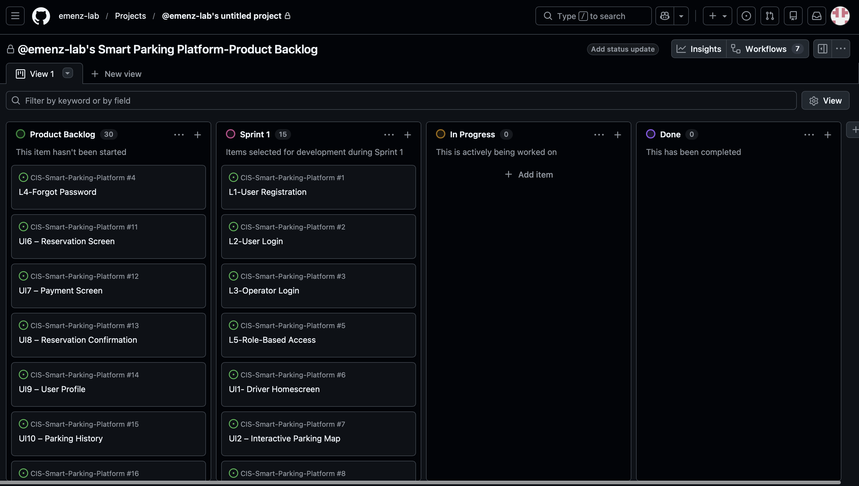
Description: For the Smart Parking Platform project, I created a product backlog containing 45 total backlog items. The backlog includes 5 login items, 15 user/operator UI items, 15 backend process items, and 10 reporting items. After creating the product backlog, I selected 15 high-priority items for Sprint 1. Sprint 1 focuses on establishing the basic foundation of the platform, including user and operator login, role-based access, the driver interface, parking availability features, and the backend processes needed to support them. The remaining 30 items will stay in the Product Backlog for future sprints.

Homework 4: Risk Management and Communication Planning
Project: Smart Parking App
This update identifies possible risks that could affect the Smart Parking App and explains how the team will communicate if problems come up. The goal is to catch issues early instead of waiting until they affect the final product.
1. Risk Identification
Technical Risks
- Parking sensors or location data may report an incorrect space as available.
- The mobile app may have bugs, crashes, or compatibility problems on different devices.
- The database or server may become unavailable and prevent real-time parking updates.
- User account, payment, or location information could be exposed by a security issue.
Schedule Risks
- Development tasks may take longer than originally estimated.
- Testing may reveal bugs late in the sprint and delay completion.
- Dependencies between app, database, and sensor work may block other tasks.
- Team members may have school or work conflicts that reduce available project time.
Financial Risks
- Sensor, hosting, API, or software costs may be higher than expected.
- Unexpected replacement or maintenance costs may increase the project budget.
- Additional development time may require more resources than planned.
- Scaling the system to more parking areas may cost more than the initial prototype.
People Risks
- A team member may be unavailable during an important sprint or deadline.
- Poor communication may cause duplicated work or missed requirements.
- Team members may disagree about priorities or who owns a task.
- A knowledge gap in a technical area may slow development or testing.
2. Risk Register
The register below prioritizes the risks that are most important to monitor during development.
ID | Category | Risk | Likelihood | Impact | Response / Mitigation | Owner
R1 | Technical | Incorrect parking availability data | High | High | Validate sensor/API data and test updates before release. | Development Team
R2 | Technical | App bugs or crashes | Medium | High | Use QA testing, bug tracking, and device testing before release. | Development / QA
R3 | Technical | Server or database outage | Medium | High | Use backups, monitoring, and a recovery/rollback plan. | Development Team
R4 | Technical | Security or privacy issue | Medium | High | Use secure authentication, limited data access, and security testing. | Development Team
R5 | Schedule | Development tasks run late | Medium | Medium | Review sprint progress weekly and adjust priorities early. | Project Manager
R6 | Schedule | Late bugs delay release | Medium | High | Test throughout the sprint instead of waiting until the end. | QA / Development
R7 | Schedule | Dependent tasks block progress | Medium | Medium | Identify dependencies during sprint planning and track blockers. | Project Manager
R8 | Financial | Hosting/API costs exceed estimate | Low | Medium | Track usage and costs and use low-cost options for the prototype. | Project Manager
R9 | People | Team member becomes unavailable | Medium | Medium | Document work and cross-train so another member can take over. | Entire Team
R10 | People | Poor team communication | Medium | High | Use scheduled check-ins and document decisions in the repository. | Entire Team
3. Communication Plan
The communication plan gives each group a regular way to share progress, report problems, and document decisions. Urgent risks or blockers should be reported as soon as they are discovered instead of waiting for the next meeting.
Team / Audience | Cadence | Method | What Is Reported | Responsible Person
Full Project Team | Weekly | Team meeting / video call | Sprint progress, blockers, major risks, upcoming deadlines | Project Manager
Development Team | Twice per week | Short stand-up + GitHub | Coding progress, technical blockers, pull requests, bugs | Development Lead
QA / Testing | Weekly; more often before release | Testing check-in + issue tracker | Test results, defects, retesting status, release concerns | QA Lead
Project Manager / Stakeholders | Weekly or at major milestone | Status update / project document | Schedule, risk status, completed work, decisions needed | Project Manager
Urgent Issues | As needed | Team message + GitHub issue | Critical bug, outage, security concern, or schedule blocker | Person who finds issue
Reporting Methods
- GitHub repository: store updated project documents, track changes, and keep the current version of project work.
- GitHub issues: record technical problems, bugs, owners, and status.
- Team meetings/check-ins: discuss progress, blockers, risks, and next steps.
- Status updates: summarize completed work, current risks, and anything that needs attention.
Homework 4 Update Summary
For Homework 4, the Smart Parking App project was updated with four risks in each required category: technical, schedule, financial, and people. A 10-entry risk register was created to show likelihood, impact, response actions, and ownership. A communication plan was also added so the team has a clear schedule for meetings and a consistent way to report progress and problems.

Homework 5: Resource and Cost Management

Resource and Cost Management Plan | TLIM 3371
Planning assumptions: This is a three-month student project. Team members are fictional, and all costs and work allocations are estimates for this homework.
1. Roles & Resources
The project will help students find available campus parking spaces. Each team member has a different job. Allocation means the percentage of their available working time dedicated to this project.
Team member | Role | Skill level | Allocation
Emilia | Project Manager | Intermediate | 30%
James | Software Developer | Advanced | 50%
Sarah | UI/UX Designer | Intermediate | 30%
Michael | System Tester | Intermediate | 25%
2. Resource & Cost Plan
I used a bottom-up estimate by estimating each project resource separately and adding the costs to get the total budget.
Resource | Estimated cost
Project management | $1,500
Software development | $4,000
UI/UX design | $1,200
System testing | $1,000
Software and hosting | $500
TOTAL | $8,200
Monthly Budgeted Cash Flow
Month | Main activity | Planned spending
Month 1 | Planning and design | $2,000
Month 2 | Development | $3,500
Month 3 | Testing and launch | $2,700
TOTAL |  | $8,200
The project is planned for three months. Development takes the largest share of the budget because creating the software requires the most work.
3. RACI Matrix
R = Responsible (does the work); A = Accountable (owns the result); C = Consulted (gives input); I = Informed (receives updates). A/R means the person does the work and owns the result.
Project task | Emilia | James | Sarah | Michael
Project planning | A/R | C | C | I
Interface design | A | C | R | I
Software development | A | R | C | I
System testing | A | C | I | R
Final launch | A/R | R | C | C
The RACI matrix makes it clear who completes each task and who is responsible for the result.

Homework 6 — Lecture 7: Tools and Technology
Project update as of October 29, 2026. This section updates the existing project plan rather than adding a new scope chapter. Items below are planning updates; they do not claim software features have been implemented or tested.

1. SRS and User Stories
The existing 15 use cases remain the requirements baseline. Registration now explicitly requires full name, email, password, field validation, unique email addresses, secure password hashing, and registration confirmation. These are acceptance criteria for implementation, not completed features.
User story L1 — User Registration: As a new user, I want to create an account so that I can access the Smart Parking Platform. Priority: High. Sprint: Sprint 1. Current project-board status: In Progress.
Acceptance criteria: required name, email and password fields; invalid inputs flagged; duplicate emails rejected; passwords securely hashed; confirmation displayed after registration.

2. WBS, Schedule and Gantt Update
WBS work package 1.3.1.1 (registration, login and session management) is decomposed into a registration form design task and subsequent implementation/validation work. This refines the original scope without changing the 12-week baseline.
Work item | Baseline window | Current planning update
T3 — UX and architecture | Weeks 2–4 | Registration form design added as a child task of L1.
T4 — Identity and authentication | Weeks 4–5 | Registration acceptance criteria clarified; implementation and tests remain pending.
T12 — QA planning/testing | Weeks 3–9 | Add checks for required fields, duplicate emails, hashing and confirmation.
Gantt chart note: Keep the existing 12-week Gantt chart on page 10 as the schedule baseline. The added design task fits under T3, and its follow-on work fits under T4/T12; no unsupported schedule completion is assumed.

3. Product Backlog and Sprint Status
The original Homework 3 baseline recorded 45 items, with 15 in Sprint 1 and 30 in the backlog. The more recent GitHub board screenshots show an additional sub-issue #46, Design User Registration Form, and issue #47, Stakeholder Communication and Engagement Plan. These change the displayed board counts; do not describe the original 45-item snapshot as the current total.
GitHub item | Status supported by screenshots | Next action
L1 — User Registration #1 | In Progress | Design and test registration process
Design User Registration Form #46 | Sprint 1; open sub-issue of #1 | Prepare form design for development/testing
Stakeholder Communication and Engagement Plan #47 | Product Backlog; open | Review stakeholder communication plan
Evidence: Screenshots of the GitHub board and issues #1, #46 and #47 were supplied in the conversation. Insert the latest screenshots into this document or the repository if required by the instructor.

4. Risk Register and Communication Update
Existing risk | Update / response | Owner
R4 — Security or privacy issue | Test account validation, secure password storage and role access before release. | Development / QA
R5 — Development tasks run late | Review issue #46 and its dependencies during sprint check-ins. | Project Manager
R10 — Poor team communication | Use the stakeholder communication plan issue #47 and weekly project updates. | Entire Team
The existing communication cadence remains weekly for the full project team, twice weekly for development, and as needed for urgent issues. GitHub issues are used to document blockers and status.

5. Roles, Costs and RACI Update
Existing estimated roles and allocations are unchanged: Emilia (Project Manager, 30%), James (Developer, 50%), Sarah (UI/UX Designer, 30%) and Michael (Tester, 25%). These team members are fictional for the course project. The planned budget remains $8,200: $2,000 in Month 1, $3,500 in Month 2 and $2,700 in Month 3. No actual expenditures are claimed.
Added/refined activity | Emilia | James | Sarah | Michael
Registration form design | A | C | R | I
Registration implementation | A | R | C | C
Registration validation/testing | A | C | C | R
Stakeholder communications | A/R | I | I | I
R = Responsible; A = Accountable; C = Consulted; I = Informed. The new rows supplement, rather than replace, the original RACI matrix.
GITHUB Update:
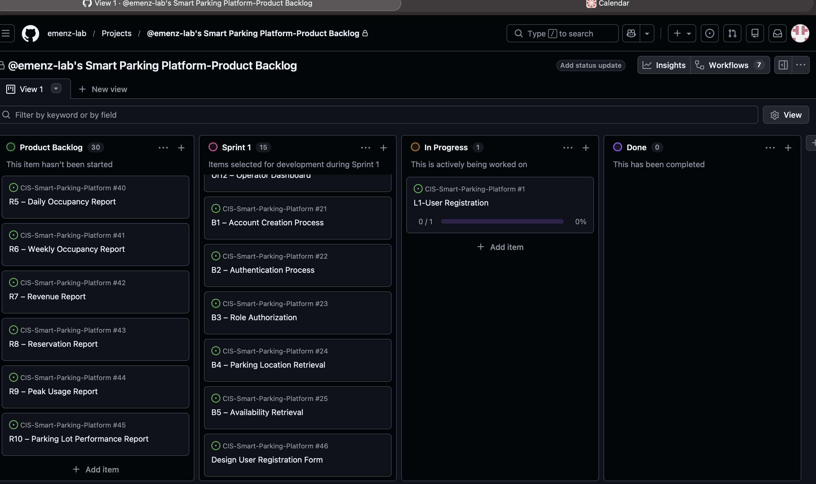

Homework 7 — Lecture 8: Managing Teams and Stakeholders

1. Stakeholder Analysis: Power–Interest Grid
The following grid is a planning assessment for the proposed Smart Parking Platform, not the result of stakeholder interviews.
Power / Interest | High interest | Low interest
High power | MANAGE CLOSELY: Parking facility operators; project sponsor / instructor | KEEP SATISFIED: City transportation / regulatory authorities
Low power | KEEP INFORMED: Drivers and mobile/web users; development and QA team | MONITOR: General community members not currently using the platform
Engagement approach: meet regularly with operators and the sponsor; consult regulators on compliance; obtain driver feedback on search, booking and payments; provide development/QA progress updates; monitor broader community concerns.

2. Team Charter
Team name: Smart Parking Platform Project Team. Purpose: Plan and coordinate a mobile/web parking service with reliable availability, reservations, digital payments and operator reporting.
Role | Member | Responsibility
Project Manager | Emilia | Scope, schedule, backlog, communication and final coordination
Software Developer | James | Backend/application implementation and technical issue resolution
UI/UX Designer | Sarah | Driver and operator interface designs and usability
System Tester | Michael | Test plans, validation, defect reporting and retesting
Working agreements: weekly team check-ins; development updates twice per week; document assignments and blockers in GitHub; raise urgent security or schedule issues immediately; review changes against the scope and 12-week timeline. Decisions are discussed with affected members, then documented by the Project Manager. Conflicts are handled through direct discussion and escalated to the sponsor/instructor if unresolved. A deliverable is considered ready only after review against its acceptance criteria.

3. Project Charter
Charter element | Project definition
Project title | Smart Parking Platform
Project sponsor | Course sponsor/instructor (planning role; name not specified)
Project manager | Emilia
Business need | Reduce the difficulty of locating, reserving and paying for parking while improving operator visibility.
Objective | Plan a first release with driver search/map, availability, reservations, payments, alerts, and operator dashboard/reporting.
Scope boundaries | No control of traffic signals; third-party payment processing; availability depends on external facility data.
Timeline | 12-week semester baseline, ending with testing, documentation and handoff.
Estimated budget | $8,200 student-project estimate; not actual spending.
Key risks | Inaccurate availability, bugs, security/privacy issues, schedule dependencies and communication gaps.
Success criteria | Requirements traceable to deliverables; working features validated against acceptance criteria; documented test and handoff results.

Homework 8 — Project Closure Report Draft (Internal)
Project: Smart Parking Platform | Prepared by: Emilia Menz | CIS 4374
INTERNAL — Draft planning closeout. This report summarizes documented project-management work, not a verified software launch.

1. Executive Summary
The Smart Parking Platform is a proposed mobile and web service intended to help drivers find available parking, reserve spaces, and pay digitally, while giving parking operators tools to manage availability and reports. Over the semester, I developed a structured project-management plan covering the project vision, 15 system use cases, a work breakdown structure, a 12-week schedule, a product backlog, risk and communication plans, resource estimates, and stakeholder responsibilities. This closure report reviews the planning work documented so far. It does not claim that the application has been built, tested, accepted, or deployed.

2. Achievements and Shortfalls
The main achievement was organizing a broad idea into manageable deliverables. The original product backlog included 45 items, with 15 selected for Sprint 1. I also defined a 12-week project timeline, identified important risks such as inaccurate parking availability and security problems, and created a communication plan for reporting issues. The estimated project budget is $8,200, but this is a classroom estimate, not actual spending. More recent updates clarified user registration requirements and added GitHub items for registration form design and stakeholder communication.
The biggest shortfall is that the documentation does not establish completion of the working software. The latest recorded user-registration story is in progress, with design, implementation, and testing still pending. There are also no verified final acceptance-test results, actual expenditures, or formal stakeholder sign-off in the submitted document. Because of that, this is a draft closure of the planning effort, not proof that the full product is ready for release.

3. Lessons Learned
One lesson I learned is that planning a technology project requires more than listing features. The parking platform depends on several connected pieces, including account access, accurate parking data, mapping, reservations, and payments. If one part is delayed, other tasks can be affected. I also learned that writing clear acceptance criteria matters. Breaking user registration into smaller tasks made it easier to see what still needs to be designed and tested. Finally, keeping the GitHub board and project document updated is important because the original backlog count no longer tells the full story after new issues are added.

4. Recommendations for Future Projects
For a future version, I would prioritize a smaller minimum viable product: user registration, a basic parking search, and a simple reservation workflow before adding every planned feature. I would also check the project board weekly, record evidence when a task is completed, and connect each major deliverable to testing and acceptance criteria. Early feedback from drivers and parking operators would help confirm whether the planned features are useful. Before any real launch, the team should verify data accuracy, privacy and payment safeguards, accessibility, and reliability. A final release should only be approved after test results, stakeholder acceptance, and an actual handoff are documented.

5. Closure Status and Outstanding Actions
Status: Planning documentation substantially developed; software delivery and formal acceptance not verified. Outstanding actions: complete implementation and testing; collect acceptance evidence; verify actual costs and deliverables; obtain stakeholder sign-off; archive final project files and repository links. These items must be addressed before describing the full Smart Parking Platform as closed or launched.

