STICK Z BOW

INTRODUCTION

**Stick Z Bow - Super Stickman Legend** is an intense physic-based archery game, has a dynamic roster of hero with many unique abilities. Drag and drop, aim and shoot arrows at the enemies. A clear headshot can completely destroy an enemy or even two.  
How to play:  
- Drag and drop, aim and shoot arrows at the enemies.  
- Fight to get more and more coin to buy new heroes  
Feature:  
- Easy control with addictive gameplay  
- A roster of heroes with unique abilities.  
- Various weapons to choose.  
- Minimalistic graphics and theater animations  
  
Download Stick Z Bow game for free and be the best stickman warrior. Keep in touch with us if you like Stick Z Bow and do not forget to comment about Stickman Fighting game. We would love to hear from you!

PROJECT SETUP

* Using Unity 2018.3.1f1 or newer
* Start play at 01.Scenes/GamePlay

PROJECT’S STRUCTURE

* All of the project’s scripts are in Scripts folder.
* Reskin art at Images folder.

HOW TO CHANGE ID ADS?

* Open Scenes/GamePlay
* Input Admob Ads info:

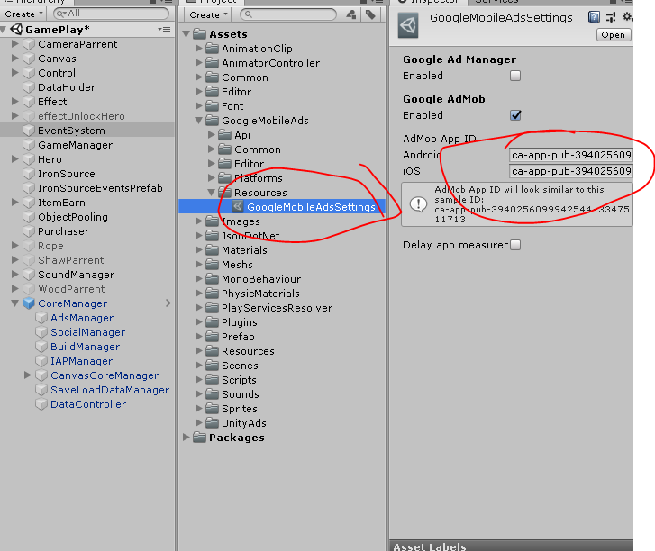

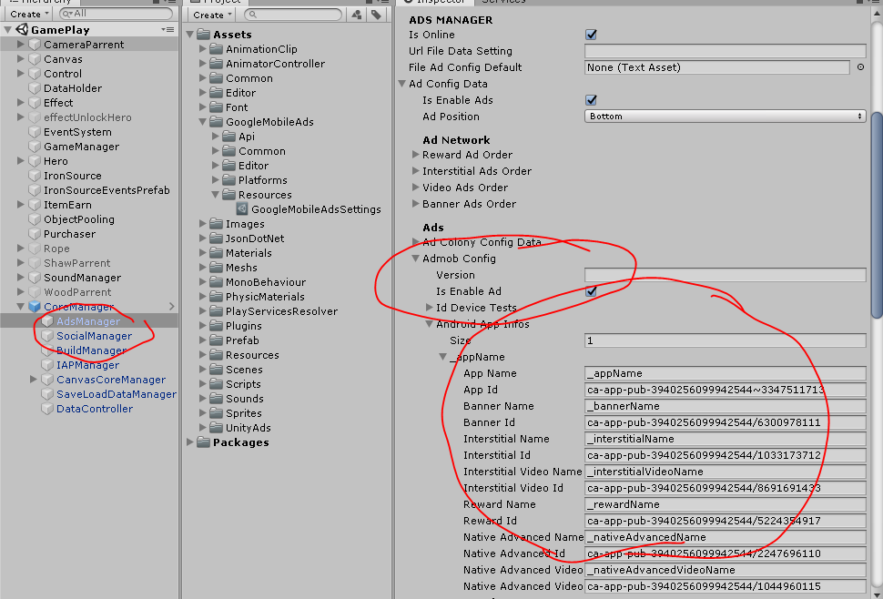

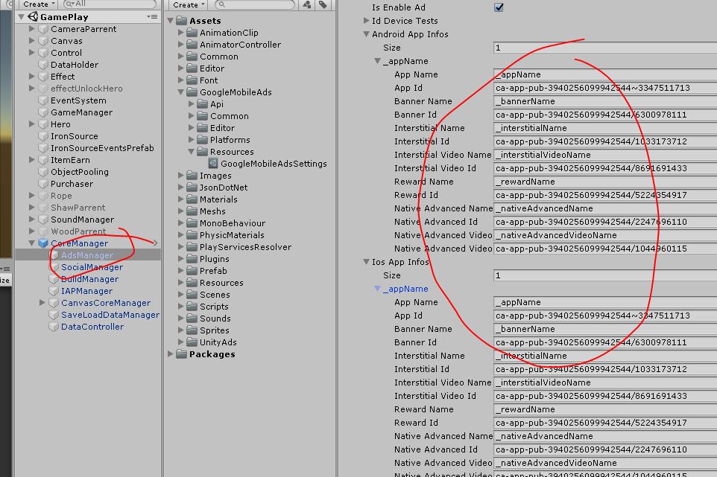

* Change UnityAds id:

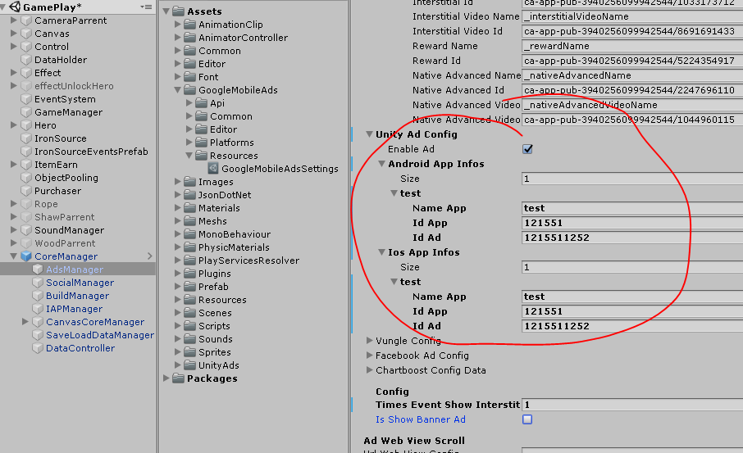

HOW TO CHANGE IN APP PURCHASES

* Open script Scripts/Purchaser

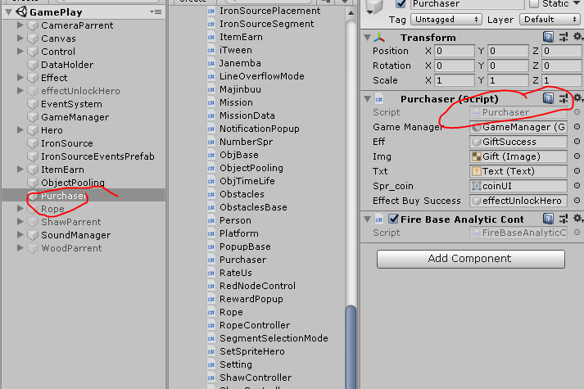

Change info In App Purchase at here

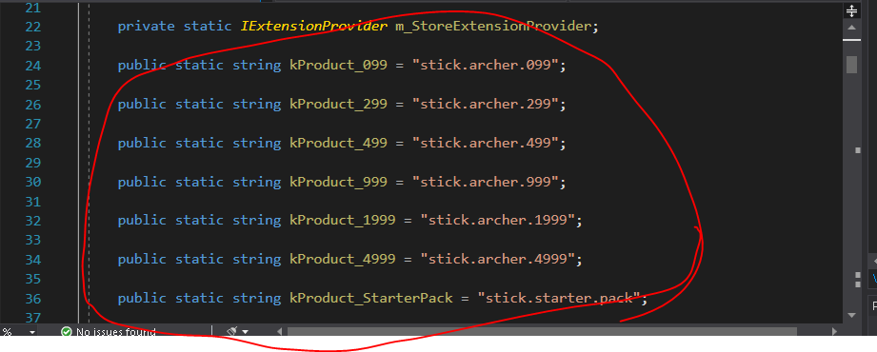

CONTACT INFORMATION

If there are any issues, or problem encountered, you can reach me at sellunitysources.feedback@gmail.com

FREELANCE WORK

Yes, we accept freelance work, and since we live in a third world country, the price is not as high US, but please be noted that our price is not cheap comparing to the same service in our area. But we have some experience working with any games, don't be afraid to contact us.

COMPLETE GAME PROJECT

This is a sub-project extracted from our main game. We don’t have much marketing experience, hence we figure we could release some part of it to make a living. If you are interested in a complete game, then drop us an email. We will happy to talk.