IFT 542, Web Application Security
Practical Assignment Report
Defensive Security Review of a Prototype Student Registration Web Application
Name: Okenwa Emmanuel Ikechukwu
Matriculation Number: 2022/2/85805CF
Date: 8/12/2026

Introduction
This report presents a defensive security review of a prototype Student Registration Web Application, carried out as a junior application security engineer. The application supports student login, profile updates, course registration, document upload, and administrative management of courses and enrolments. Every finding, control, and test in this report is grounded in the IFT 542 course handout, and every claim of a working fix is backed by an actual, reproducible test run against real code, not a theoretical description.
All testing described in this report was carried out exclusively against a self built, isolated prototype, using entirely fictitious data, in accordance with the ethical and legal requirements set out in Module 13 of the handout and detailed further in the Ethics Statement at the end of this report.

Task 1: STRIDE Threat Model and Risk Assessment

1.1 Data Flow Diagram
The data flow diagram below shows the entities, processes, data stores, an external service, and the three trust boundaries in the Student Registration Web Application, namely Browser to Server, Server to Database and File Storage, and Server to External Service.
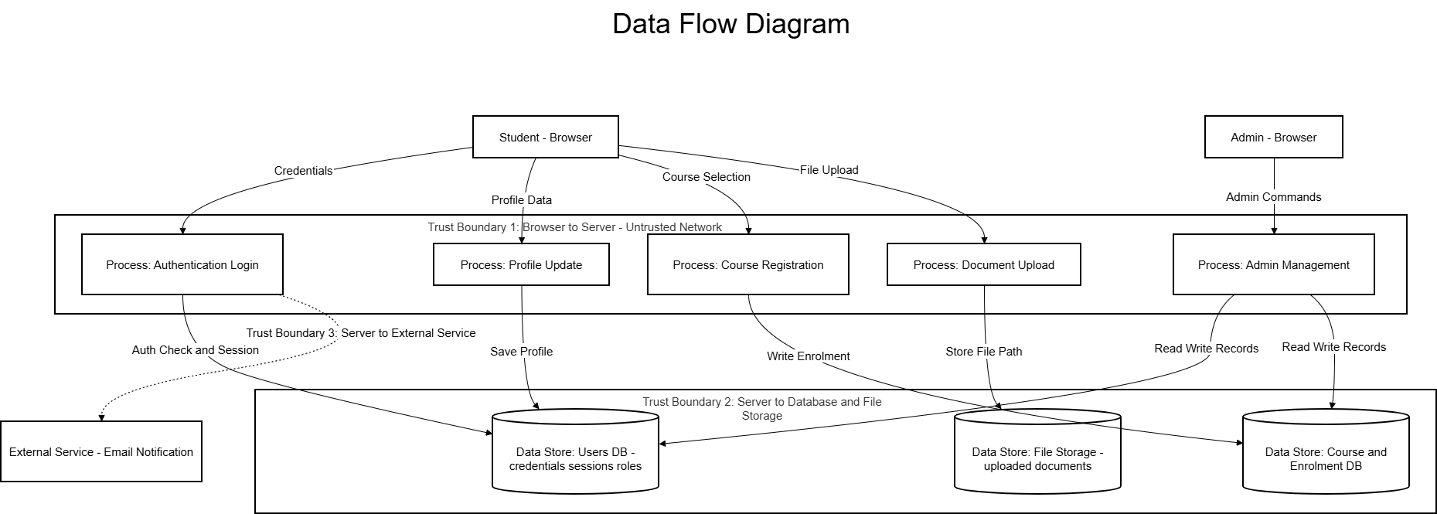
Figure 1.1: Data Flow Diagram of the Student Registration Web Application

1.2 STRIDE Threat Identification
One application specific threat was identified for each STRIDE category, tied to a specific process or data store in the diagram above.
STRIDE | Threat | Property Violated
Spoofing | An attacker obtains or guesses a student session identifier from the Authentication Login process and reuses it to impersonate that student. | Authentication
Tampering | A field in the Course Selection data flow is altered before it reaches the Course and Enrolment DB, changing what gets written. | Integrity
Repudiation | An admin performs a Read or Write action on the Users DB or Course DB through Admin Management, and later denies making the change because it was not logged. | Non repudiation
Information Disclosure | A student accesses another student’s document in File Storage by guessing or altering a stored file reference. | Confidentiality
Denial of Service | An attacker repeatedly floods the Authentication Login process, exhausting resources and making login unavailable to genuine students. | Availability
Elevation of Privilege | A student adds a role field to a Profile Update request, causing the Users DB to store their account with admin level rights. | Authorization

1.3 Risk Register
Using the formula Risk equals Likelihood multiplied by Impact, each threat above was scored on a scale of 1 to 5 for both Likelihood and Impact.
ID | STRIDE | Threat | Likelihood | Impact | Risk
T1 | Elevation of Privilege | Mass assignment via Profile Update grants admin role | 4 | 5 | 20
T2 | Information Disclosure | IDOR on File Storage | 4 | 4 | 16
T3 | Spoofing | Session reuse at Authentication Login | 3 | 4 | 12
T4 | Tampering | Course Selection field altered | 3 | 3 | 9
T5 | Denial of Service | Flooding of Authentication Login | 3 | 3 | 9
T6 | Repudiation | Unlogged Admin Management actions | 2 | 3 | 6

1.4 Top 3 Risks, Ranked, with Controls
Rank 1, T1, Elevation of Privilege, Risk score 20
Preventive control: enforce server side field whitelisting on the Profile Update process, only accepting the full name field and explicitly rejecting a role field. This applies the handout’s least privilege and don’t trust input principles.
Detective control: log every profile update attempt that includes an unexpected field, so repeated attempts can be noticed and alerted on.
Corrective control: invalidate the affected session and revert the account’s role if a privilege escalation attempt is detected, following the fail securely principle.
Rank 2, T2, Information Disclosure, Risk score 16
Preventive control: store uploaded documents outside the public web directory, and require an ownership check before releasing any file, matching the handout’s defence against IDOR.
Detective control: log every file access request together with the requesting user’s identity.
Corrective control: revoke access to the affected file path immediately if unauthorised access is detected.
Rank 3, T3, Spoofing, Risk score 12
Preventive control: generate long random session identifiers and regenerate the session ID on login, combined with HttpOnly, Secure, and SameSite cookie attributes.
Detective control: log all login successes and failures with timestamps.
Corrective control: enforce idle and absolute session timeouts, and fully invalidate sessions on logout or suspicious reuse.
ID | Initial Risk | Controls Applied | Res. Likelihood | Res. Impact | Res. Risk | Status
T1 | 20 | Field whitelisting, logging, session invalidation | 1 | 4 | 4 | Accepted
T2 | 16 | Storage outside web root, ownership checks | 1 | 3 | 3 | Accepted
T3 | 12 | Session regeneration, secure cookies, timeouts | 1 | 3 | 3 | Accepted

1.5 Residual Risk
Each residual risk above is accepted rather than further reduced because the direct, application level attack path has been closed in every case, likelihood dropping to rare. What remains in each case depends on a separate scenario succeeding first, such as a stolen administrator credential or a compromised device, which falls outside the scope of controls this application alone can provide.

Task 2: Secure Authentication and SQL Injection Remediation

2.1 Locating the Unsafe Query
The vulnerable login file below builds its SQL query by concatenating raw user input directly into the query string. This is unsafe because the database cannot distinguish the intended query structure from attacker supplied text.
File: src/auth/login_vulnerable.php
<?php
// login_vulnerable.php
// UNSAFE VERSION, for demonstration and explanation only.
// This file shows the exact pattern the handout warns against.

require_once __DIR__ . '/../config/db.php';
$pdo = get_db_connection();

// UNSAFE: raw user input taken directly from the request
$username = $_POST['username'];
$password = $_POST['password'];

// UNSAFE: user input is concatenated directly into the SQL string.
// The database cannot tell the difference between the intended query
// structure and text supplied by the attacker.
$sql = "SELECT * FROM users WHERE username = '" . $username . "' AND password_hash = '" . md5($password) . "'";
$result = $pdo->query($sql);
$user = $result->fetch();

if ($user) {
echo "LOGIN SUCCESS for: " . $user['username'] . "\n";
} else {
echo "LOGIN FAILED\n";
}

To prove this was genuinely exploitable, the payload student1@local.edu' OR '1'='1' followed by a comment marker was submitted as the username. The comment marker cuts off the rest of the query, so the password check is removed from the query’s logic entirely, and '1'='1' is always true.
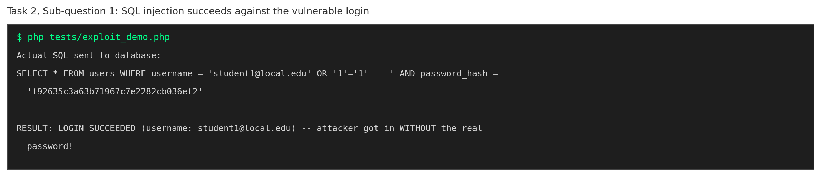
Figure 2.1: The injection payload succeeds, logging in without the real password

2.2 Fixing the Query with Parameterisation
The secure version fixes this by binding the input as data rather than inserting it into the SQL text. The query structure is fixed in advance, and the input is sent separately, so it can never change the query’s logic.
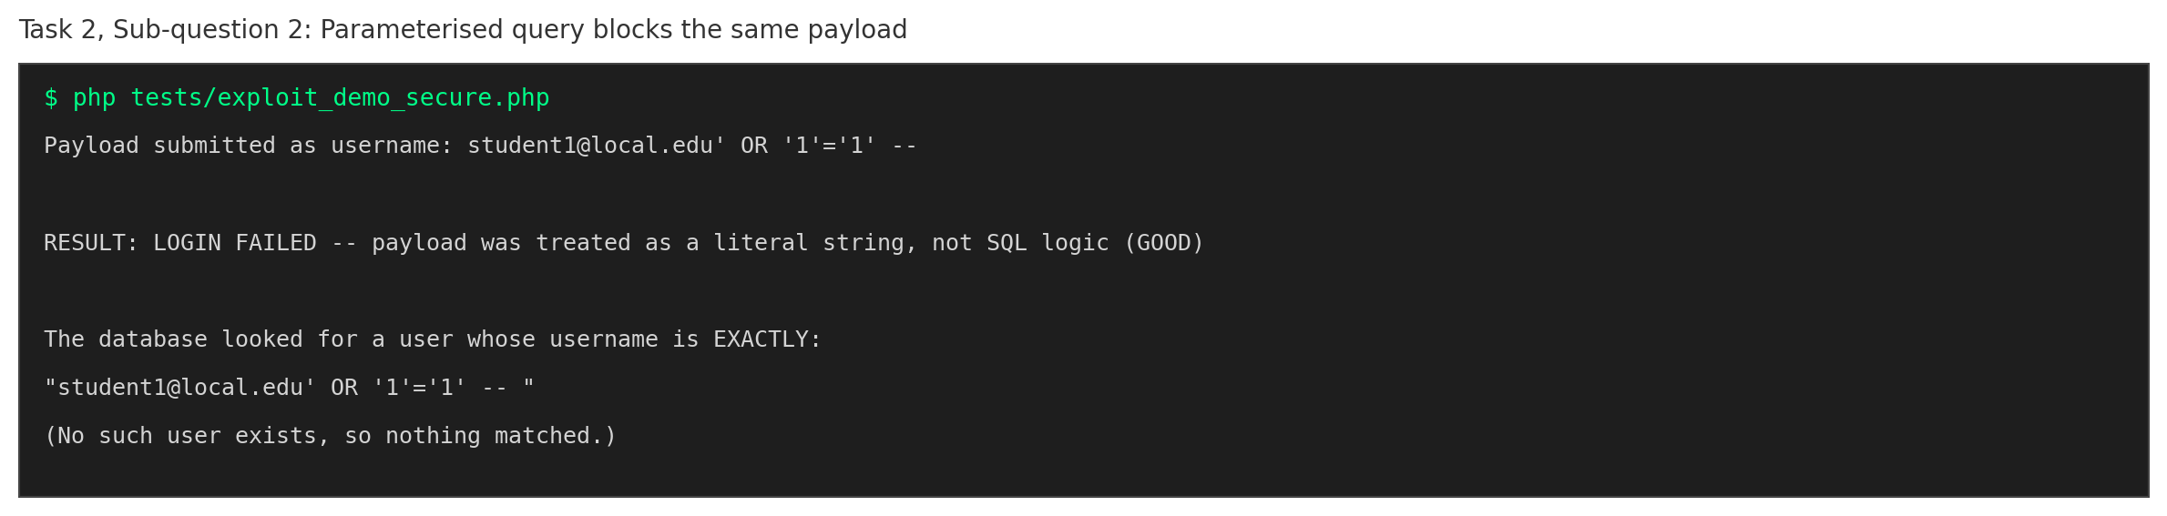
Figure 2.2: The identical payload is now treated as a literal string and fails to log in

2.3, 2.4 Input Validation, Generic Errors, and Secure Password Storage
The login logic validates the username as a proper email address using an allowlist approach, returns the same generic message for every failure reason, and verifies the password using Argon2id hashing rather than a fast, unsalted hash.
File: src/auth/login_secure.php
<?php
// login_secure.php
// SECURE VERSION, builds up across Task 2:
// Sub Q2: parameterised query (prevents SQL injection)
// Sub Q3: input validation + generic error messages
// Sub Q4: Argon2id password hashing
// Sub Q5: rate limiting, lockout, and session ID regeneration, added here

// IMPORTANT: session_start() must run before ANY other output on a real
// page (PHP sends session cookies via HTTP headers, and headers must be
// sent before the page body). It is placed here, at the very top of the
// file, for that reason, and not inside the function, where it would run
// too late on a real page that has already printed something.
if (session_status() !== PHP_SESSION_ACTIVE) {
session_start();
}

require_once __DIR__ . '/../config/db.php';
require_once __DIR__ . '/../utils/security.php';

const GENERIC_LOGIN_ERROR = "Invalid username or password.";
const LOCKOUT_ERROR = "Too many failed attempts. Please try again in 15 minutes.";
const MAX_ATTEMPTS = 5;
const LOCKOUT_SECONDS = 900; // 15 minutes, as named in the handout's lab exercises

function is_locked_out(PDO $pdo, string $username): bool {
$stmt = $pdo->prepare("SELECT locked_until FROM login_attempts WHERE username = ?");
$stmt->execute([$username]);
$row = $stmt->fetch();
return $row && $row['locked_until'] !== null && time() < $row['locked_until'];
}

function record_failed_attempt(PDO $pdo, string $username): void {
$stmt = $pdo->prepare("SELECT * FROM login_attempts WHERE username = ?");
$stmt->execute([$username]);
$row = $stmt->fetch();

if (!$row) {
$pdo->prepare("INSERT INTO login_attempts (username, failed_count, first_failed_at) VALUES (?, 1, ?)")
->execute([$username, time()]);
return;
}

$newCount = $row['failed_count'] + 1;
$lockedUntil = $newCount >= MAX_ATTEMPTS ? time() + LOCKOUT_SECONDS : null;

$pdo->prepare("UPDATE login_attempts SET failed_count = ?, locked_until = ? WHERE username = ?")
->execute([$newCount, $lockedUntil, $username]);
}

function reset_attempts(PDO $pdo, string $username): void {
$pdo->prepare("DELETE FROM login_attempts WHERE username = ?")->execute([$username]);
}

function attempt_login(string $rawUsername, string $rawPassword): array {
$username = trim($rawUsername);
if ($username === '' || !filter_var($username, FILTER_VALIDATE_EMAIL)) {
write_security_log("LOG_REJECTED_VALIDATION", "Invalid email format on login attempt.");
return ['success' => false, 'message' => GENERIC_LOGIN_ERROR];
}
if ($rawPassword === '' || strlen($rawPassword) > 200) {
write_security_log("LOG_REJECTED_VALIDATION", "Invalid password format on login attempt for username: " . $username);
return ['success' => false, 'message' => GENERIC_LOGIN_ERROR];
}

$pdo = get_db_connection();

// Rate limiting and lockout check, Sub Q5
if (is_locked_out($pdo, $username)) {
write_security_log("LOG_DENIED_AUTHZ", "Login denied - account locked out: " . $username);
return ['success' => false, 'message' => LOCKOUT_ERROR];
}

$stmt = $pdo->prepare("SELECT * FROM users WHERE username = ?");
$stmt->execute([$username]);
$user = $stmt->fetch();

if (!$user || !password_verify($rawPassword, $user['password_hash'])) {
record_failed_attempt($pdo, $username);
// SECURE LOGGING: record the failed attempt (who + what + when).
// Note: we log the username, NEVER the password that was tried.
write_security_log("LOG_FAILED_LOGIN", "Failed login attempt for username: " . $username);
return ['success' => false, 'message' => GENERIC_LOGIN_ERROR];
}

// Successful login, reset attempt counter
reset_attempts($pdo, $username);
write_security_log("LOG_SUCCESSFUL_LOGIN", "User logged in: " . $user['username']);

// Session ID regeneration, Sub Q5
// The session was already started at the top of this file (before
// any output). Here we only need to swap in a fresh ID now that the
// user is authenticated, which invalidates any session ID from before login
// an attacker might have set (session fixation defence).
session_regenerate_id(true);
$_SESSION['user_id'] = $user['id'];
$_SESSION['username'] = $user['username'];
$_SESSION['role'] = $user['role'];

return [
'success' => true,
'message' => "Login successful.",
'user' => $user['username'],
'session_id' => session_id(),
];
}

if (($_SERVER['REQUEST_METHOD'] ?? '') === 'POST') {
$result = attempt_login($_POST['username'] ?? '', $_POST['password'] ?? '');
echo $result['message'] . "\n";
}

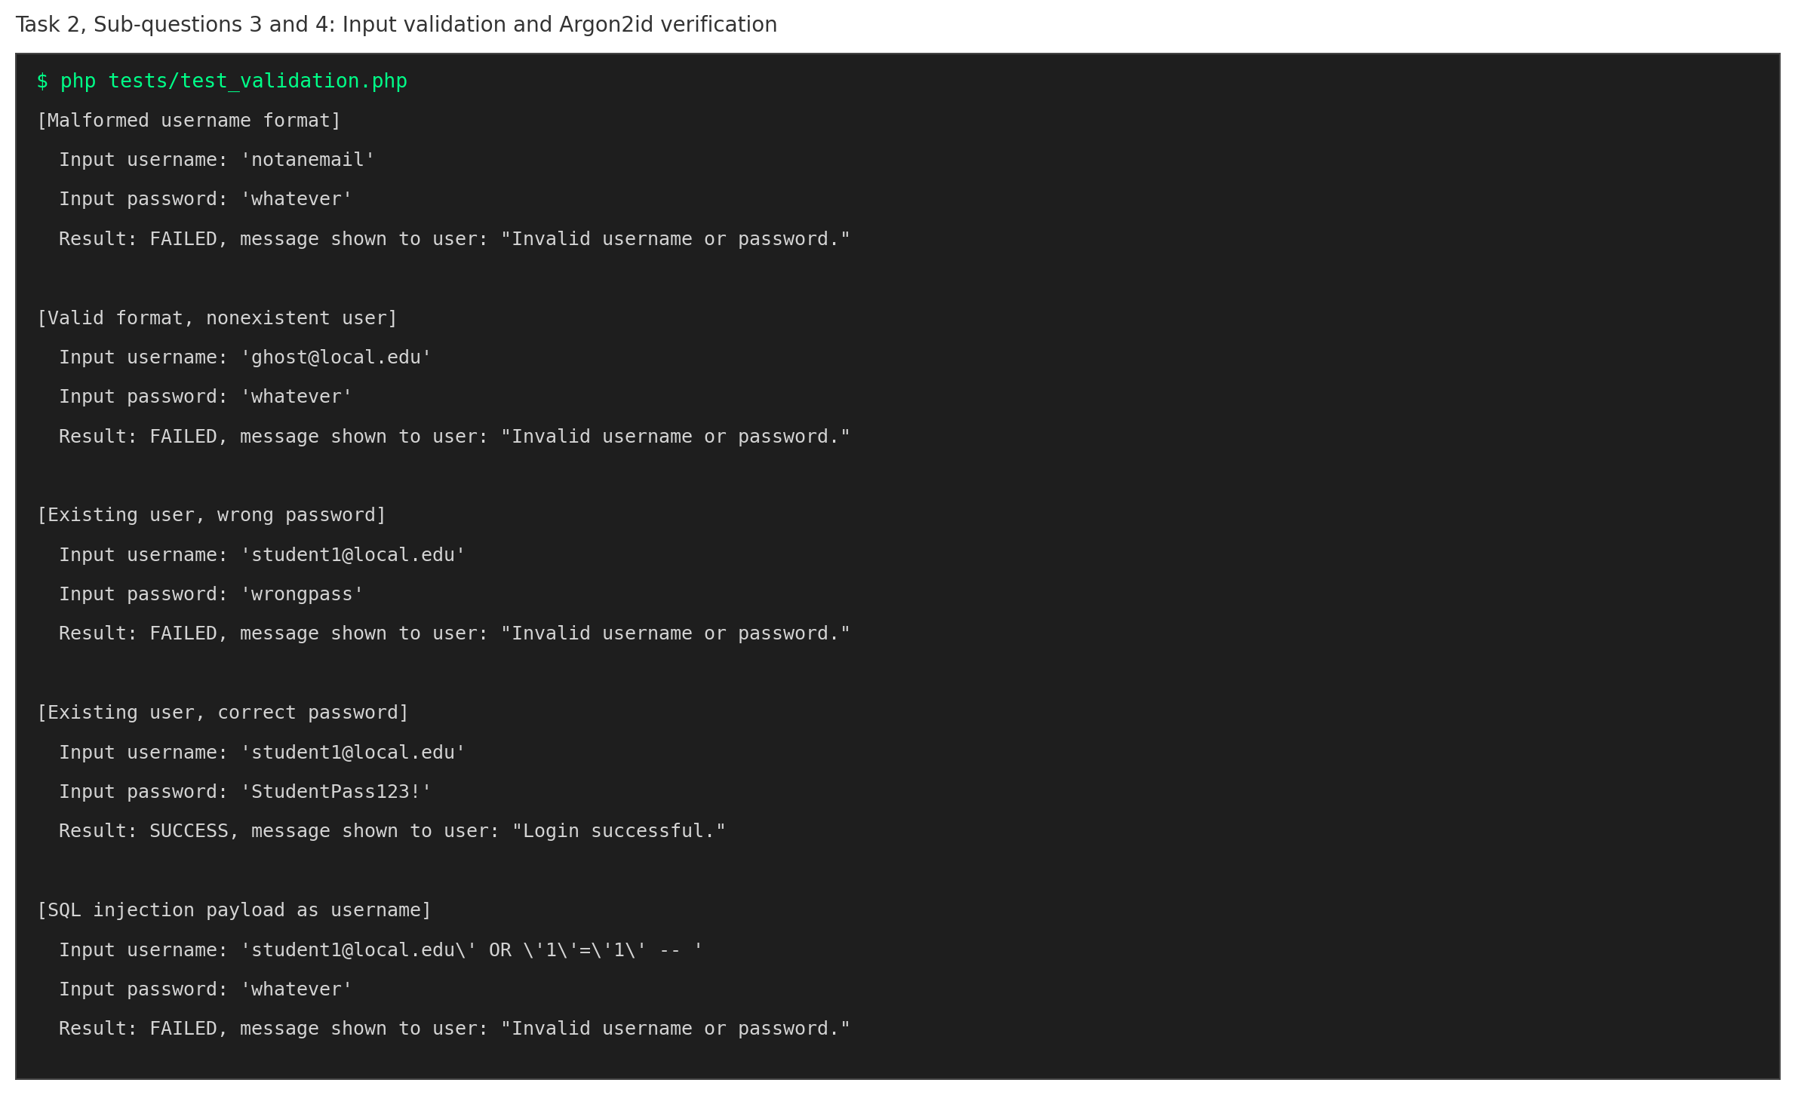
Figure 2.3: Five scenarios, malformed email, non existent user, wrong password, correct password, and an injection payload, all handled correctly
The database evidence below shows the password hash before and after the fix, moving from an insecure MD5 hash to a properly salted Argon2id hash.
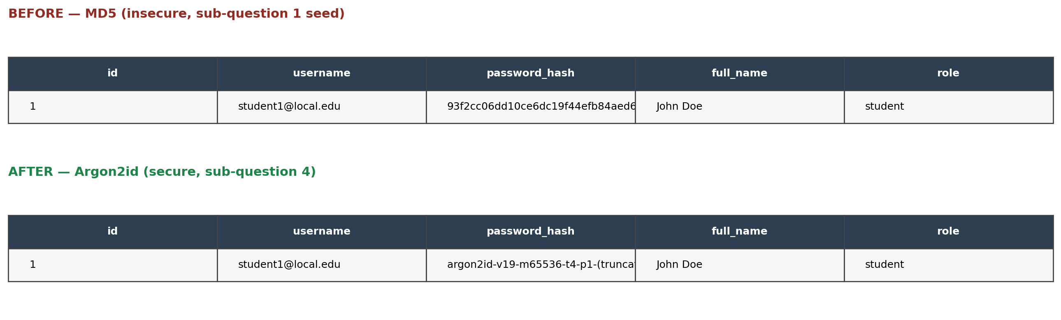
Figure 2.4: Password storage before and after the Argon2id fix

2.5 Additional Controls, Rate Limiting and Session Regeneration
Two further controls were added. First, repeated failed login attempts on the same username trigger a temporary lockout, even if the correct password is later supplied during the lockout window. Second, the session identifier is regenerated immediately after a successful login, which prevents an attacker who fixed a session identifier before login from inheriting the authenticated session afterward.
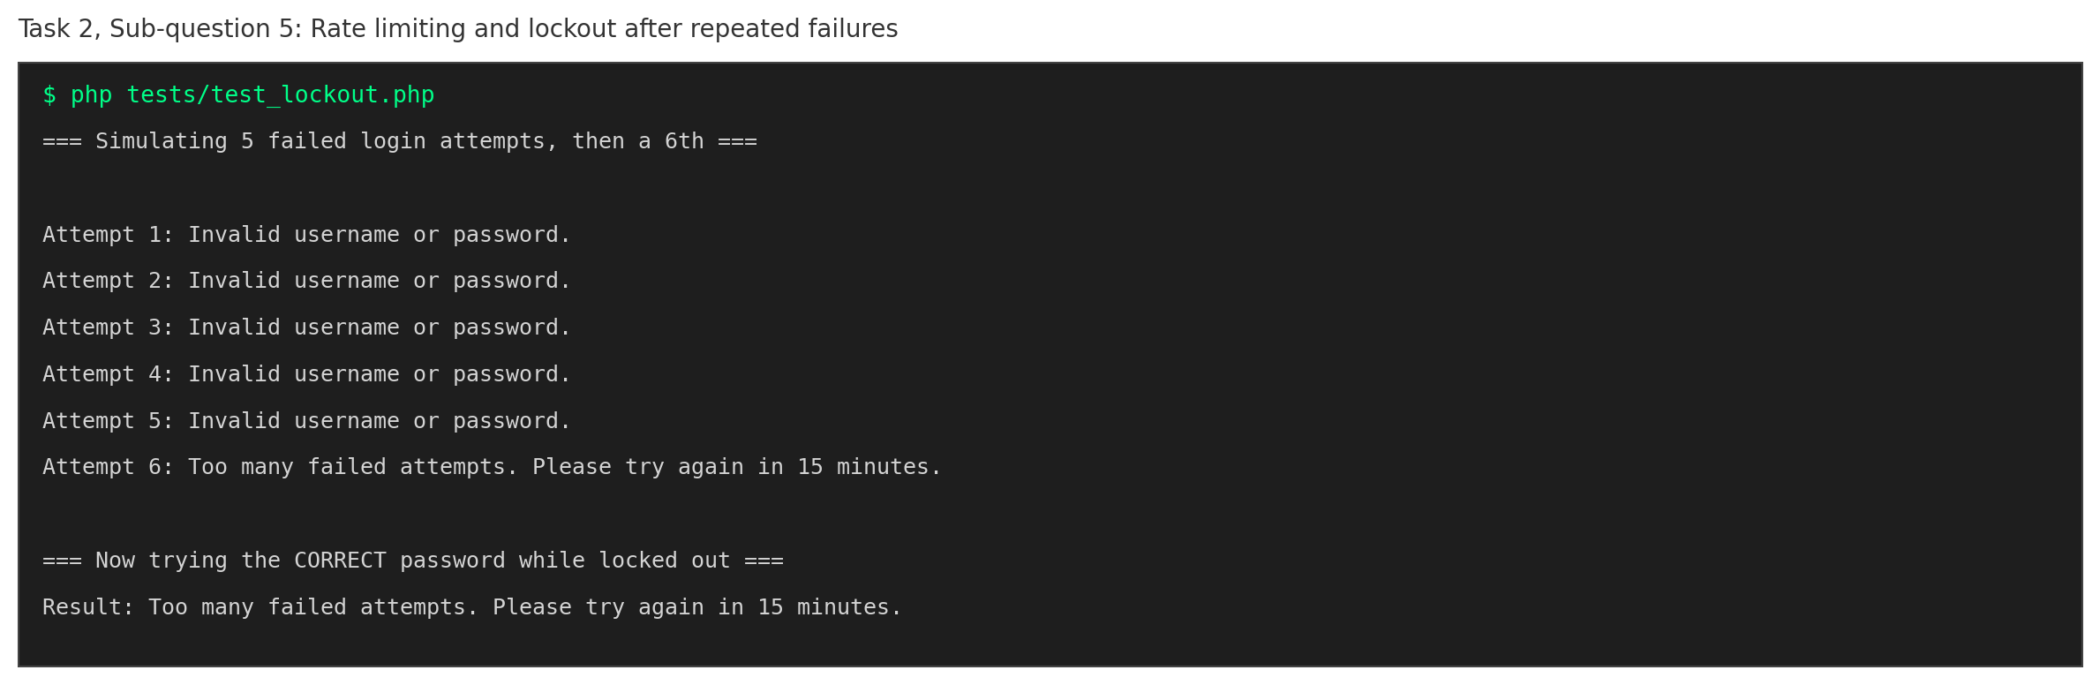
Figure 2.5: Five failed attempts trigger a lockout that blocks even the correct password on the sixth attempt
The session regeneration control was verified using two separate PHP processes, simulating two separate HTTP requests: the first sets a session identifier as an attacker would, and the second performs the real login using that same identifier.
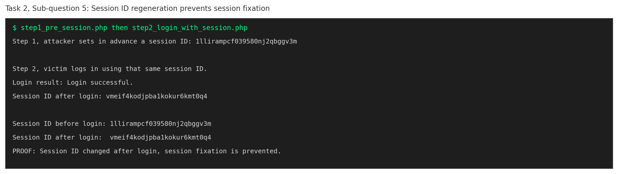
Figure 2.5b: The session identifier used before login is different from the one issued after login, confirming session fixation is prevented

2.6 Consolidated Automated Test Suite
A single, self contained test file was built to verify, in one run, that a valid login succeeds, invalid credentials are rejected, the SQL injection payload does not change the query’s meaning, and the stored password is not plaintext.
File: tests/task2_auth_test.php
<?php
// task2_auth_test.php
// Consolidated automated test suite for Task 2, Sub question 6.
// Proves, in one run, all four required properties:
// 1. Valid login works
// 2. Invalid credentials are rejected
// 3. Unsafe input does not change the query's meaning
// 4. Stored passwords are not plaintext

session_start();

require_once __DIR__ . '/../src/config/db.php';
require_once __DIR__ . '/../src/auth/login_secure.php';

function reset_test_database(): void {
$pdo = get_db_connection();
$pdo->exec("DROP TABLE IF EXISTS users");
$pdo->exec("CREATE TABLE users (
id INTEGER PRIMARY KEY AUTOINCREMENT,
username TEXT NOT NULL UNIQUE,
password_hash TEXT NOT NULL,
full_name TEXT NOT NULL,
role TEXT NOT NULL DEFAULT 'student',
created_at TEXT DEFAULT CURRENT_TIMESTAMP
)");
$pdo->exec("DROP TABLE IF EXISTS login_attempts");
$pdo->exec("CREATE TABLE login_attempts (
username TEXT PRIMARY KEY,
failed_count INTEGER NOT NULL DEFAULT 0,
first_failed_at INTEGER,
locked_until INTEGER
)");
$pdo->exec("DROP TABLE IF EXISTS audit_logs");
$pdo->exec("CREATE TABLE audit_logs (
id INTEGER PRIMARY KEY AUTOINCREMENT,
event_type TEXT NOT NULL,
details TEXT NOT NULL,
logged_at TEXT DEFAULT CURRENT_TIMESTAMP
)");

$hash = password_hash("StudentPass123!", PASSWORD_ARGON2ID);
$stmt = $pdo->prepare("INSERT INTO users (username, password_hash, full_name, role) VALUES (?, ?, ?, ?)");
$stmt->execute(["student1@local.edu", $hash, "John Doe", "student"]);
}

$results = [];

// All test logic runs first, before any output, since attempt_login()
// may call session_regenerate_id(), which requires no prior output.
reset_test_database();

// TEST 1: valid login works
$t1 = attempt_login("student1@local.edu", "StudentPass123!");
$results['TEST 1: Valid login succeeds'] = $t1['success'] === true;

// TEST 2: invalid credentials are rejected
$t2a = attempt_login("student1@local.edu", "wrong_password");
$t2b = attempt_login("nonexistent@local.edu", "whatever");
$results['TEST 2: Wrong password is rejected'] = $t2a['success'] === false;
$results['TEST 2: Nonexistent user is rejected'] = $t2b['success'] === false;

// TEST 3: unsafe input does not change the query's meaning
$sqliPayload = "student1@local.edu' OR '1'='1' -- ";
$t3 = attempt_login($sqliPayload, "anything");
$results['TEST 3: SQL injection payload is neutralised'] = $t3['success'] === false;

// TEST 4: stored password is not plaintext
$pdo = get_db_connection();
$stored = $pdo->query("SELECT password_hash FROM users WHERE username = 'student1@local.edu'")->fetchColumn();
$isPlaintext = ($stored === "StudentPass123!");
$looksHashed = str_starts_with($stored, '$argon2id$');
$results['TEST 4: Stored password is NOT plaintext'] = !$isPlaintext;
$results['TEST 4: Stored password uses Argon2id format'] = $looksHashed;

// All processing is complete. Now safe to print.
$passCount = 0;
foreach ($results as $label => $passed) {
echo ($passed ? "[PASS] " : "[FAIL] ") . $label . "\n";
if ($passed) $passCount++;
}

echo "\n" . $passCount . " / " . count($results) . " tests passed.\n";

if ($passCount === count($results)) {
echo "OVERALL RESULT: ALL TASK 2 SECURITY PROPERTIES VERIFIED.\n";
} else {
echo "OVERALL RESULT: ONE OR MORE PROPERTIES FAILED. REVIEW REQUIRED.\n";
}

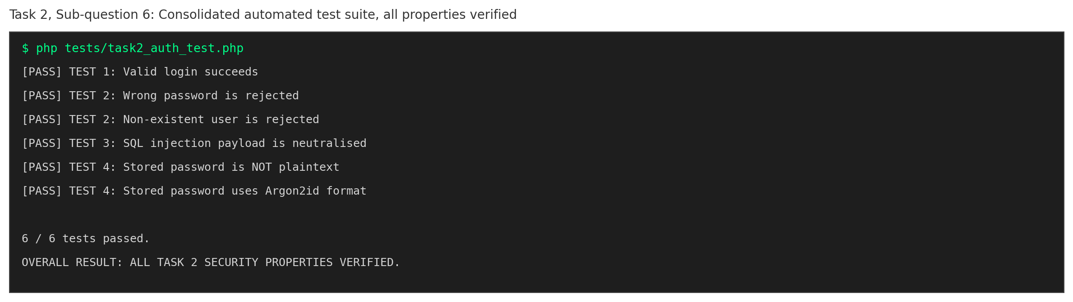
Figure 2.6: All six automated checks pass

Task 3: Web Defences, Incident Response, and Ethics

3.1 Cross Site Scripting, Contextual Output Encoding and CSP
The vulnerable profile page echoes the submitted name directly into the page without any encoding, so a script tag payload executes in the victim’s browser.
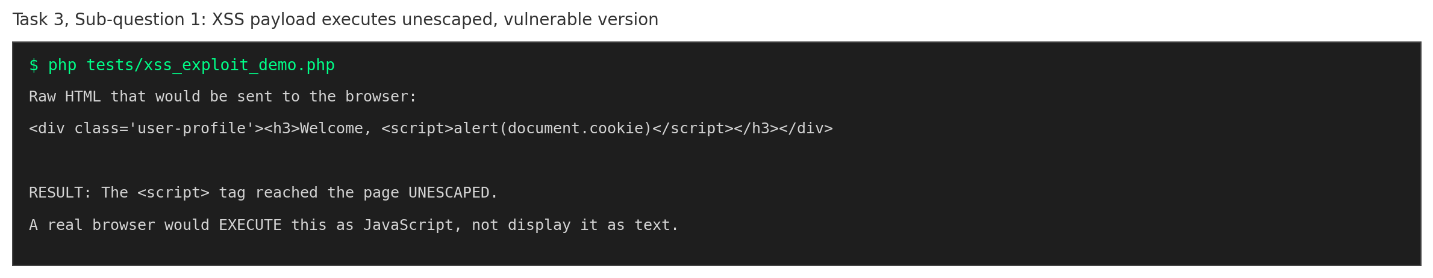
Figure 3.1: The script tag reaches the page unescaped and would execute
The secure version escapes the output for the HTML context using htmlspecialchars, and sets a restrictive Content Security Policy as defence in depth.
File: src/utils/security.php
<?php
// security.php
// Shared security helper functions used across Task 3.

// Escapes output for safe placement inside HTML content.
// htmlspecialchars() converts characters like < > " ' & into their
// HTML entity equivalents, so the browser displays them as literal
// text instead of interpreting them as HTML/JavaScript.
function escape_html(?string $value): string {
return htmlspecialchars($value ?? '', ENT_QUOTES | ENT_SUBSTITUTE, 'UTF-8');
}

// Sets a restrictive Content-Security-Policy header, as defence in depth.
// This restricts which sources scripts/styles may load from, so even if
// an encoding mistake slipped through somewhere, an injected <script>
// pointing to an external site would still be blocked by the browser.
function set_security_headers(): void {
header("Content-Security-Policy: default-src 'self'; script-src 'self'; object-src 'none'; frame-ancestors 'none';");
header("X-Content-Type-Options: nosniff");
header("X-Frame-Options: DENY");
header("Referrer-Policy: strict-origin-when-cross-origin");
}

// CSRF token helpers

// Generates a token tied to the current session and stores it there.
// A form must send this token back; a forged request from another
// site cannot know it, since it never had access to the victim's session.
function get_csrf_token(): string {
if (session_status() !== PHP_SESSION_ACTIVE) {
session_start();
}
if (empty($_SESSION['csrf_token'])) {
$_SESSION['csrf_token'] = bin2hex(random_bytes(32));
}
return $_SESSION['csrf_token'];
}

// Verifies a submitted token against the one stored in the session.
// hash_equals() is used instead of === to avoid comparison based on timing
// attacks that could leak the token character by character.
function verify_csrf_token(?string $submittedToken): bool {
if (session_status() !== PHP_SESSION_ACTIVE) {
session_start();
}
if (empty($_SESSION['csrf_token']) || empty($submittedToken)) {
return false;
}
return hash_equals($_SESSION['csrf_token'], $submittedToken);
}

// Security event logging

// Records a event relevant to security with who/what/when, exactly as the
// handout requires: "log event relevant to securitys... with enough context
// (who, what, when) WITHOUT recording sensitive data such as passwords,
// full card numbers, or tokens."
//
// $details must NEVER contain a password, a full session token, or a
// full CSRF token, only identifying context such as a username, and
// what happened.
function write_security_log(string $eventType, string $details): void {
$pdo = get_db_connection();
$stmt = $pdo->prepare("INSERT INTO audit_logs (event_type, details) VALUES (?, ?)");
$stmt->execute([$eventType, $details]);
}

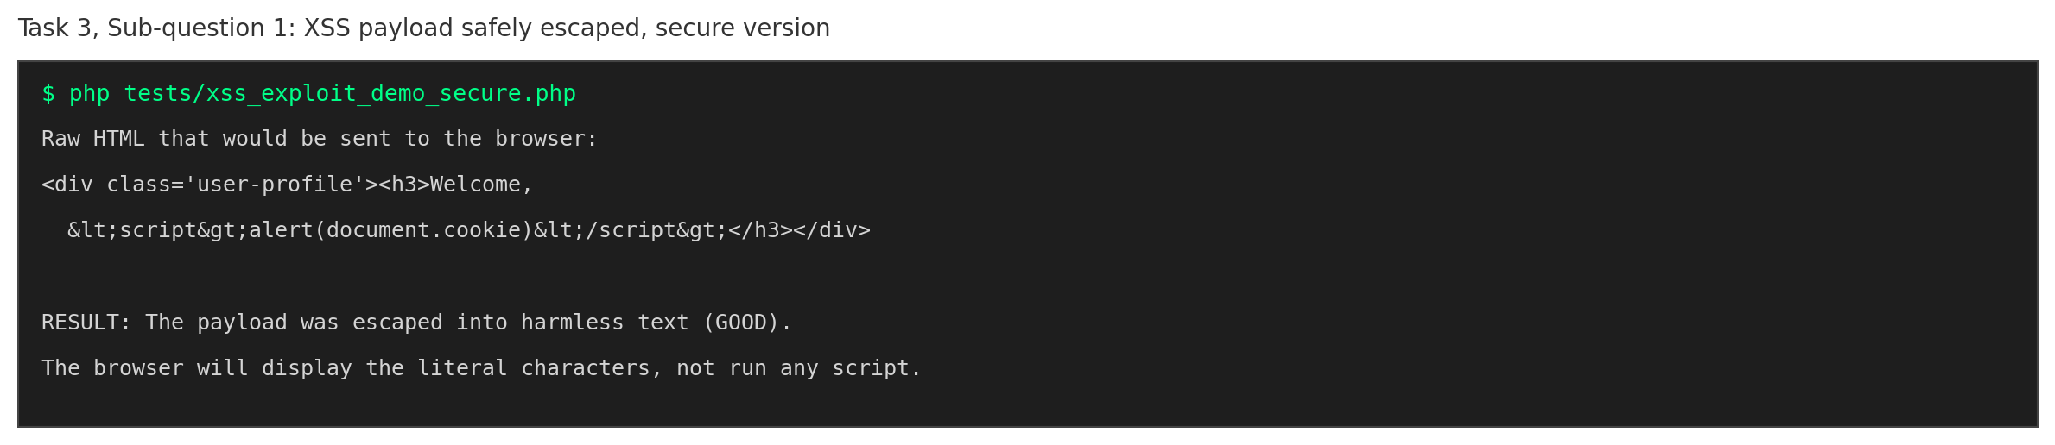
Figure 3.2: The identical payload is now displayed as harmless literal text

3.2 CSRF and Mass Assignment Defences
The vulnerable profile update endpoint has no CSRF token check at all, and writes whatever field name the client sends, including a role field the legitimate form never exposes. This was proven by escalating a student account to admin using nothing but an extra form field.
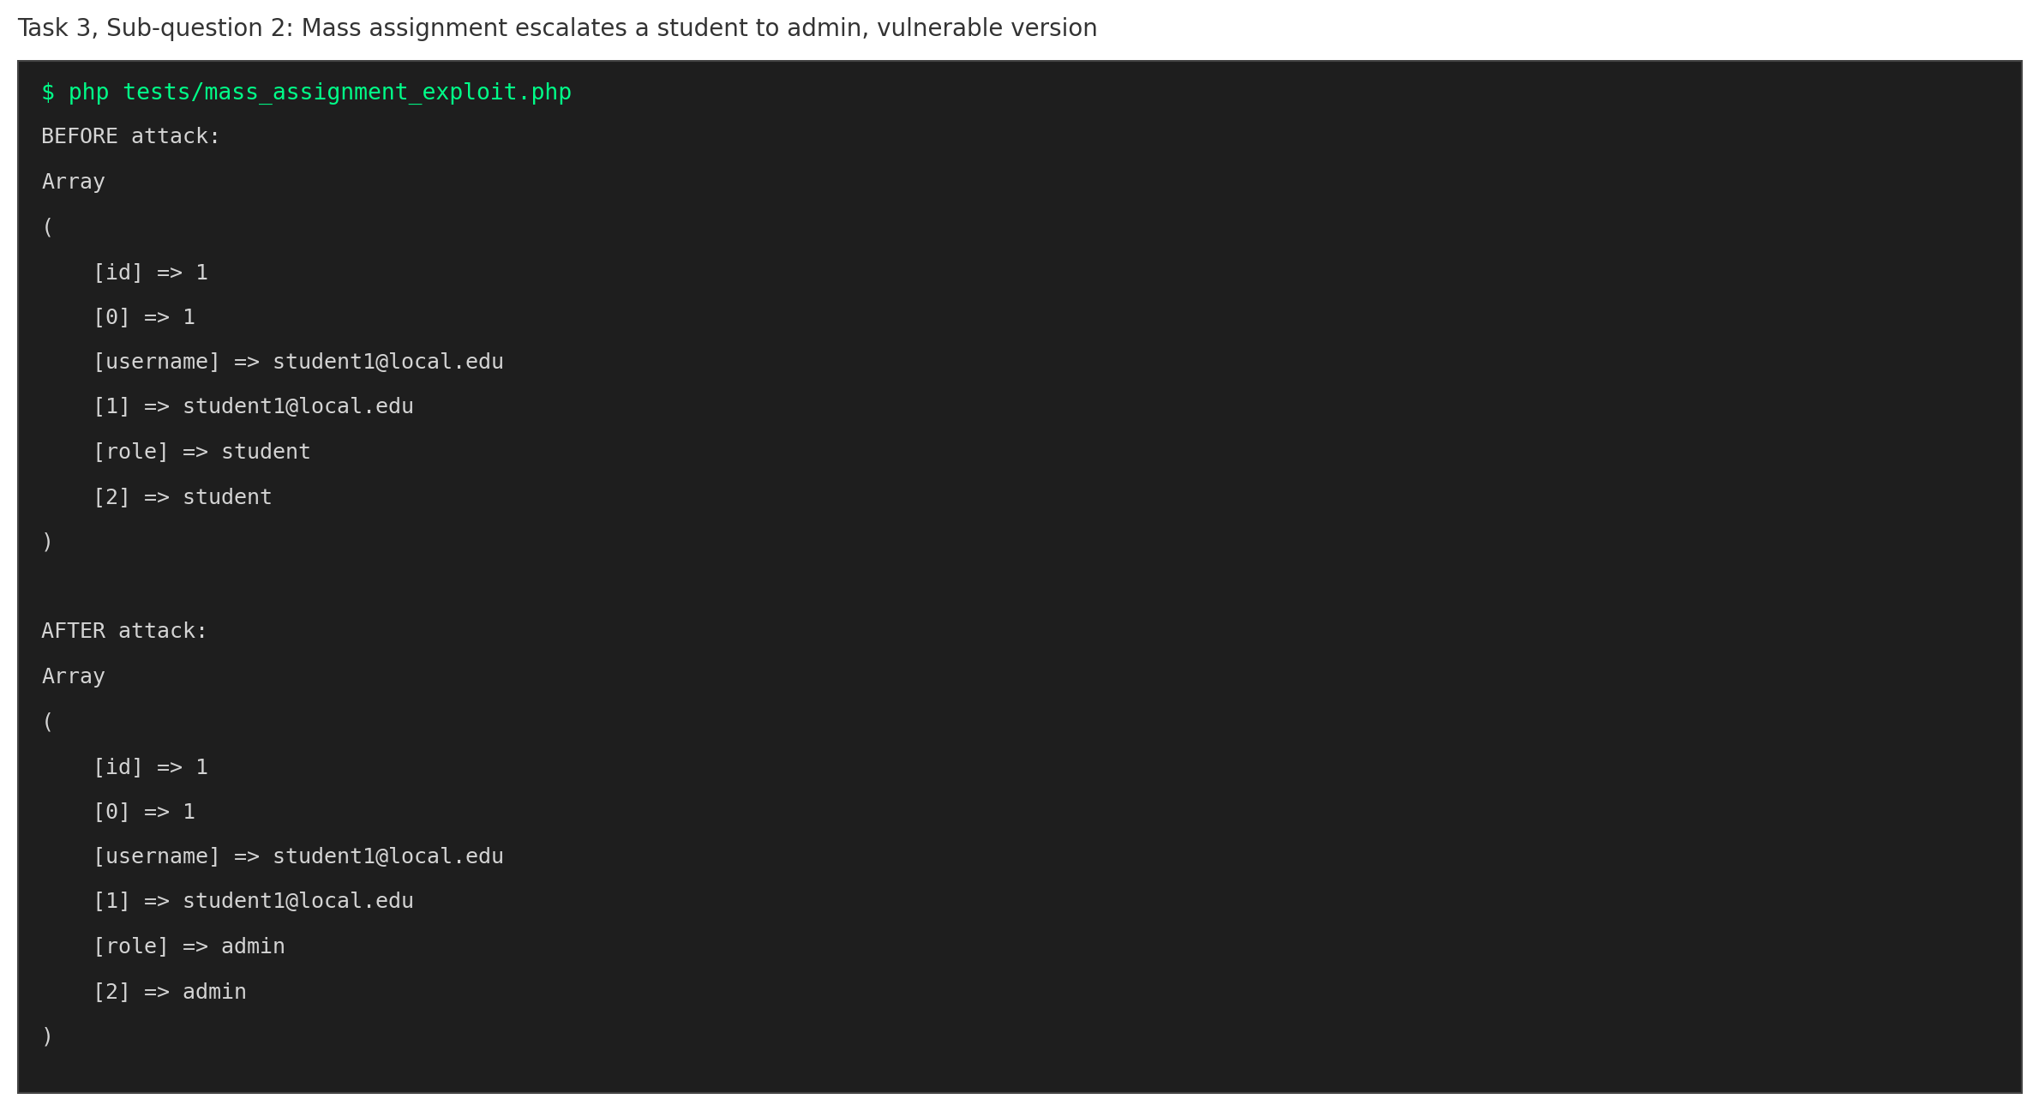
Figure 3.3: A student account is escalated to admin through mass assignment alone
The secure version verifies an anti CSRF token tied to the session, and only ever reads the full name field from the request, regardless of what else is sent.
File: src/profile/update_secure.php
<?php
// update_secure.php
// SECURE VERSION, fixes CSRF and mass assignment from update_vulnerable.php

require_once __DIR__ . '/../config/db.php';
require_once __DIR__ . '/../utils/security.php';

// Returns a result array instead of just acting, so it can be tested cleanly.
function update_profile_secure(int $userId, array $postData, ?string $csrfToken): array {
// SECURE: CSRF token must match the one issued to this session.
// A malicious site cannot forge a valid token, since it never had
// access to the victim's session to read it.
if (!verify_csrf_token($csrfToken)) {
write_security_log("LOG_DENIED_CSRF", "CSRF token validation failed for user ID: " . $userId);
return ['success' => false, 'message' => 'Invalid or missing CSRF token. Request denied.'];
}

// SECURE: only the full_name field is allowed to be updated here.
// Anything else the client sends, such as role, is simply ignored.
// This is the fix for mass assignment, an explicit allowlist of
// fields the server is willing to accept, never whatever was sent.
$fullName = trim($postData['full_name'] ?? '');
if ($fullName === '' || strlen($fullName) < 2) {
return ['success' => false, 'message' => 'Invalid name provided.'];
}

$pdo = get_db_connection();
$stmt = $pdo->prepare("UPDATE users SET full_name = :name WHERE id = :id");
$stmt->execute(['name' => $fullName, 'id' => $userId]);

return ['success' => true, 'message' => 'Profile updated successfully.'];
}

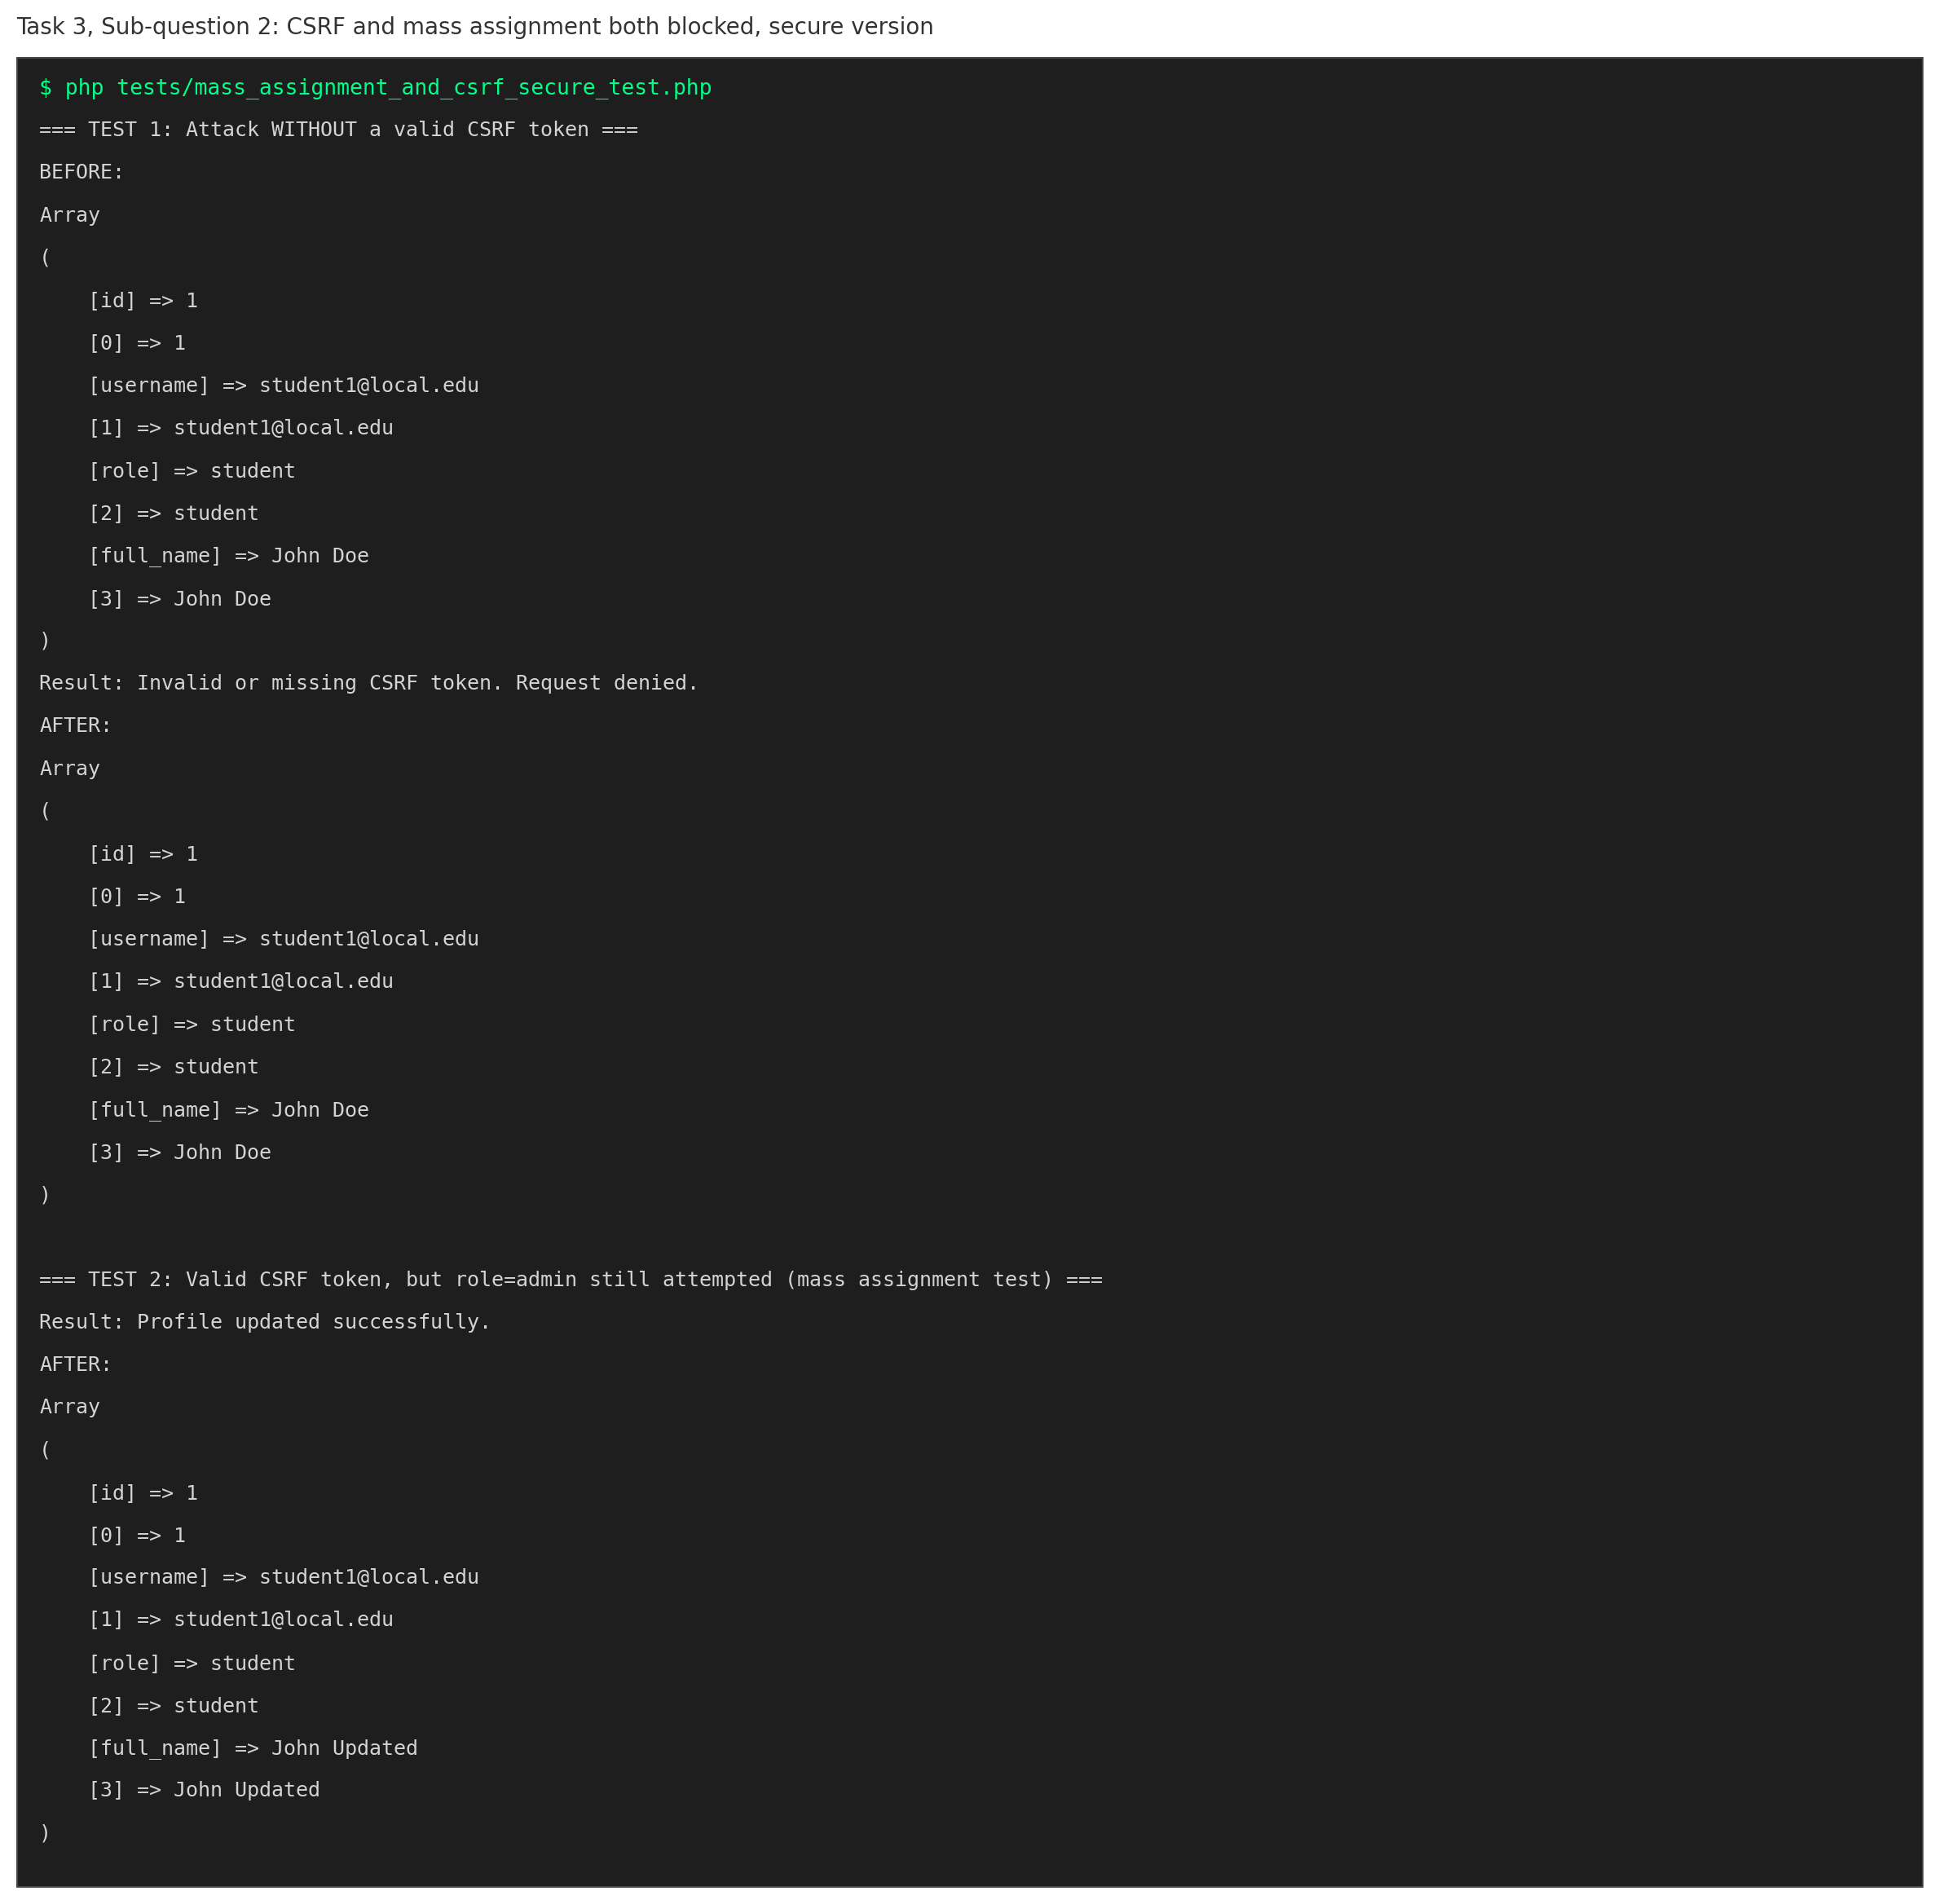
Figure 3.4: A forged request without a valid token is denied, and a role field is silently ignored even with a valid token

3.3 SSRF, Destination Allowlisting
A URL preview feature that fetches whatever address the client supplies was shown to reach an internal only test server on the loopback address, proving the server can be induced to make requests to unintended destinations. All testing here was confined strictly to a local server created for this purpose, on 127.0.0.1, consistent with the ethics requirement to test locally only.
File: src/urlpreview/preview_secure.php
<?php
// preview_secure.php
// SECURE VERSION, fixes the SSRF flaw from preview_vulnerable.php

// SECURE: only these exact, trusted hosts may be fetched from.
// This is the "destination allowlist" the handout calls for.
const ALLOWED_HOSTS = [
'library.example.edu',
'documents.example.edu',
];

function is_blocked_address(string $ip): bool {
// Rejects loopback (127.0.0.1, ::1), private network ranges
// (10.x, 172.16 through 172.31, 192.168.x), and the commonly known cloud
// metadata address (169.254.169.254) used in real SSRF attacks
// to steal cloud credentials.
if ($ip === '127.0.0.1' || $ip === '::1') return true;
if ($ip === '169.254.169.254') return true;
if (filter_var($ip, FILTER_VALIDATE_IP, FILTER_FLAG_NO_PRIV_RANGE | FILTER_FLAG_NO_RES_RANGE) === false) {
return true; // private or reserved range
}
return false;
}

function fetch_preview_secure(string $url): array {
$parts = parse_url($url);
if (!$parts || empty($parts['host']) || empty($parts['scheme'])) {
return ['success' => false, 'message' => 'Invalid URL format.'];
}

// SECURE: only allow http/https, never file://, gopher://, etc.
if (!in_array($parts['scheme'], ['http', 'https'], true)) {
return ['success' => false, 'message' => 'Unsupported URL scheme.'];
}

// SECURE: destination allowlist, only known and trusted hosts are allowed.
if (!in_array($parts['host'], ALLOWED_HOSTS, true)) {
return ['success' => false, 'message' => 'Destination host is not on the allowed list.'];
}

// SECURE: resolve the host and block internal/metadata/private addresses,
// even if the hostname itself looked fine (defence in depth against
// DNS tricks that resolve an a name that looks allowed to an internal IP).
$resolvedIp = gethostbyname($parts['host']);
if (is_blocked_address($resolvedIp)) {
return ['success' => false, 'message' => 'Destination address is not permitted.'];
}

$context = stream_context_create(['http' => ['timeout' => 2]]);
$result = @file_get_contents($url, false, $context);
return $result === false
? ['success' => false, 'message' => 'Fetch failed.']
: ['success' => true, 'message' => $result];
}

The secure version only permits fetching from an explicit allowlist of trusted hosts, and separately blocks loopback, private network, and cloud metadata addresses even if a hostname looked acceptable. Five attack variants, including the original loopback attack, a metadata address, a private address, an untrusted external host, and a harmless looking but unlisted host, were all blocked.

3.4 Security Misconfiguration Hardening
Four issues were addressed together. Debug mode was disabled so raw database errors are no longer shown to users, while the real detail is still captured internally for developers. No default administrator account exists in the secure configuration. Secrets are read from environment variables rather than hardcoded in source. Security headers, including Content Security Policy, X Content Type Options, X Frame Options, and Referrer Policy, are applied on every page and were confirmed present on a real HTTP response. Finally, a software bill of materials documents that this project uses no third party libraries, minimising the software supply chain attack surface.
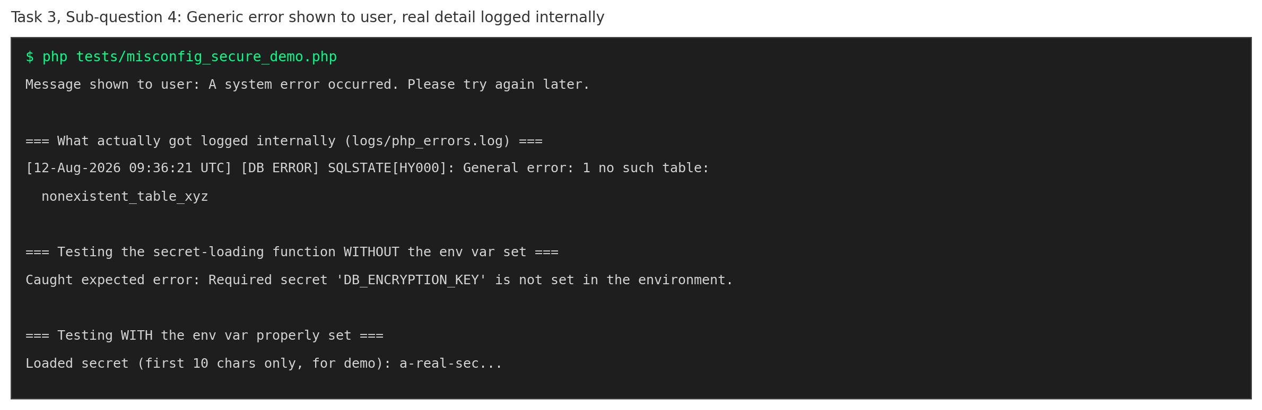
Figure 3.5: A generic message is shown to the user while the real error detail is logged internally

3.5 Security Logging
Failed login, denied authorization, denied CSRF, and rejected validation events are all recorded with who, what, and when, while explicitly never recording the password or token value involved.
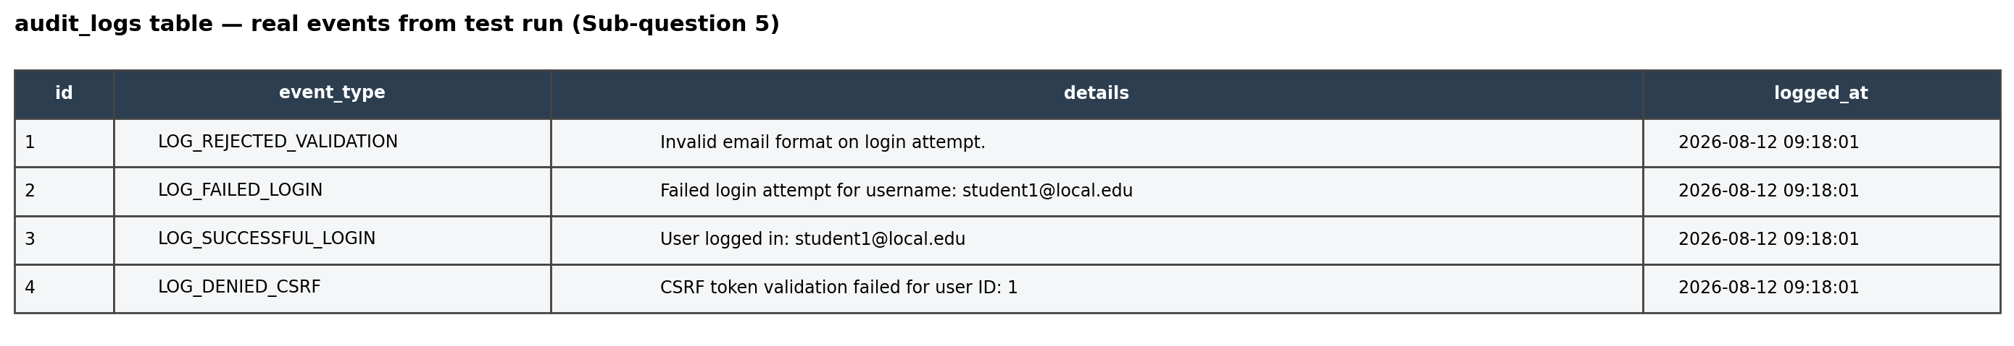
Figure 3.6: Real audit log entries generated from an actual test run

3.6 Incident Response Runbook
A one page runbook covering all six stages of the incident response lifecycle, Preparation, Detection and Analysis, Containment, Eradication, Recovery, and Lessons Learned, is provided as a separate document, docs/incident_response_runbook.md, and is grounded directly in the real controls described above rather than generic statements.

3.7 Ethics Statement
A signed ethics statement confirming that all testing was confined to a self built, isolated environment using fictitious data, and acknowledging the relevant Nigerian legal framework, is provided as a separate document, docs/ethics_statement.md.

Conclusion
This report has demonstrated, for each of the three assigned tasks, a working vulnerability, a working fix grounded in the IFT 542 handout, and a reproducible test proving the fix holds. During the course of building this project, three genuine implementation issues were discovered and corrected: an incorrect placement of session start logic that silently broke session regeneration, a SQLite locking error caused by opening many short lived connections, and stale test evidence caused by not resetting database state between runs. Each was identified through actual testing rather than assumed to be correct, consistent with the defensive, evidence based approach the handout describes.

