URBAN GREENING EXPLORER
An Interactive Dashboard for Exploring Vancouver’s Public Trees

Student Name: Lakshantha Dissanayake
Student ID: 300392299
Course: CSIS 4495 – Applied Research Project
Section Number: 071
Table of Contents
Introduction 4
Background 4
Problem Statement 4
Research Gap 4
Assumptions 5
Potential Benefits 5
Proposed Research Project 6
Objectives 6
Methodology and Justification 6
Data Sources 7
Data Analytics 8
Indicators and “Green Comfort Zones” 8
Technology Stack 9
Expected Results 9
Project Planning and Timeline 10
Implemented Feature 1 – Explore Trees Dashboard 12
Introduction 12
Details of Implemented Feature 12
Implemented Feature 2 – Sidebar Filters, Key Stats, and Distributions 14
Introduction 14
Details of Implemented Feature 14
Implemented Feature 3 – Neighbourhood Overview Tab 16
Introduction 16
Details of Implemented Feature 16
Implemented Feature 4 – Green Comfort Zones Tab and AI Summary 18
Introduction 18
Details of Implemented Feature 18
Lessons Learned and Future Work 20
Concluding Remarks 21
Appendix 22
Appendix A: Installation Guide 22
Appendix B: User Guide 23
Main Features 23
How to Use 23
Appendix C: Dataset and API Used 24
Datasets 24
API 24
Appendix D: Software and Architecture 24
Software Stack 24
System Architecture Overview 25
Appendix E: Code Explanation 25
References 26

Introduction

Background
Urban trees are critical green infrastructure. They clean the air, capture carbon, absorb rainwater, providing habitat, improving our health and well-being, protect the city from storms, extreme heat, and the impacts of climate change (City of Vancouver, 2025a). Vancouver maintains extensive open datasets on its public trees and neighbourhoods, yet this information is distributed across portals and is not packaged for interactive, neighbourhood-level exploration by students, community groups, or planners. An interactive dashboard can address this gap by combining point-level exploration of individual trees with neighbourhood summaries and density-based comparisons.

Problem Statement
While the datasets exist, they are not designed for everyday exploration. For example, a resident may wish to know which trees are in their local area, what species are most common, or how their neighbourhood compares to others in terms of greenery. Existing static reports do not support this kind of place-based inquiry. The proposed Urban Greening Explorer will respond to this need through three interactive views: a point map of trees (Explore Trees), neighbourhood-level choropleths and rankings (Neighbourhood Overview), and a simple density-based lens (Green Comfort Zones) that highlights where greenery is most concentrated. The final application further addresses interpretability by including an AI-generated summary feature that explains the patterns observed in the Green Comfort Zones tab.

Research Gap
Previous work on Vancouver’s canopy tends to present citywide summaries or high-level targets but rarely connects individual tree records to neighbourhood polygons for analysis. There is also limited effort to present these insights in a public-friendly, interactive format. This project fills the gap by building a reproducible workflow that joins tree points to Local Areas, computes density and basic indicators, and visualizes them through choropleths, rankings, and quantile-based comfort zones. This approach is intentionally descriptive, offering transparency into current patterns without making prescriptive planting recommendations. The additional integration of AI summaries further extends the state of the project from static analysis to narrative-driven insight generation.

Assumptions
This project assumes that only public trees are included in the dataset, since private trees are excluded from the City of Vancouver’s inventory. Records without valid geographic coordinates are assumed unusable and therefore excluded from analysis. It is also assumed that the Local Area Boundaries provided by the city are accurate representations of Vancouver’s neighbourhoods and can be treated as consistent spatial units for comparison. Although the public tree dataset refreshes monthly, some attributes such as planting date or diameter may not reflect the most current field conditions.
For the purposes of this research, the dataset is treated as sufficiently accurate and representative to support exploratory neighbourhood-level analysis. The AI summary feature assumes that the OpenAI model will generate text that is coherent, relevant, and aligned with the numerical summary provided. The application treats the AI output as an interpretive aid rather than a definitive scientific conclusion.

Potential Benefits
The Urban Greening Explorer will make Vancouver’s open data more accessible and interpretable to a broad audience by transforming raw records into interactive maps and comparisons. For community members, it offers an intuitive way to explore their local trees and better understand patterns of greenery in their neighbourhoods. For planners and students, it provides a reproducible workflow for spatial analysis that highlights disparities in tree density across the city. The inclusion of Green Comfort Zones encourages public discussion about environmental equity, livability, and resilience to urban heat.
The introduction of AI-generated summaries adds an additional layer of benefit. Users who may not be comfortable interpreting tables and choropleths can rely on concise textual explanations of which neighbourhoods stand out, how density and species richness interact, and why these patterns might matter. By framing the tool as exploratory and research-oriented, the project contributes to civic data literacy and fosters new opportunities for public engagement with environmental sustainability.

Proposed Research Project

Objectives
The overarching objective of this project is to create an interactive, research-oriented dashboard that allows the exploration of Vancouver’s public tree dataset in ways that are both scientifically meaningful and publicly accessible.

The first objective is to develop an interactive map interface (Explore Trees) that enables users to view individual tree records, filter by attributes such as species, planting year, and average diameter, and understand micro-level patterns in the city’s tree distribution.

The second objective is to conduct spatial joins between tree locations and Local Area boundaries in order to compute neighbourhood-level indicators such as total trees, unique species and density (trees per km²). These will be presented through choropleth maps, rankings, and comparative tables to provide a meso-level lens on urban greening (Neighbourhood Overview).

The third objective is to define and visualize Green Comfort Zones by identifying neighbourhoods in the top quantile of tree density. This perspective offers a macro-level understanding of where greenery is most concentrated, providing insights into potential environmental and social benefits associated with higher tree density.

The fourth objective is to integrate a narrative AI summary module that converts the Green Comfort Zones table into a plain-language interpretation, explaining which neighbourhoods stand out and what patterns are visible.

The final objective is to deploy the complete application on Streamlit Cloud, making it easily accessible for demonstration, defense, and public exploration.

Methodology and Justification
The app follows a clear spatial data analysis process. First, the tree dataset is read in a way that correctly identifies location information, even if it is stored under different column names. Second, neighbourhood boundaries are loaded from a digital map file and converted into a standard format so they can be displayed and measured accurately. Third, each tree is matched to the neighbourhood it falls within. Fourth, neighbourhood-level statistics are calculated, including the total number of trees, the number of different species (by scientific name), the average trunk diameter, and the earliest and most recent planting years. Finally, tree density is calculated as:
trees per km² = tree count ÷ neighbourhood area (km²).
This is a standard, interpretable metric in urban forestry and spatial planning for comparing green presence across bounded areas.
The “Green Comfort Zones” concept is intentionally simple and descriptive: neighbourhoods at or above a user-specified percentile of tree density are highlighted as relatively greener places under current conditions. The approach is grounded in common cartographic and exploratory data analysis practice using quantiles to make density differences legible without asserting health causality or recommending interventions. This design is justified by Vancouver’s Urban Forest Strategy emphasis on public understanding of tree benefits (City of Vancouver, 2025a), and established GIS practice for neighbourhood comparisons using polygon areas, spatial joins, and choropleth visualization (Longley et al., 2015). The addition of an AI summary step is justified by recent work in data storytelling and generative AI, where narrative explanations help bridge the gap between numerical analysis and human interpretation.

Data Sources
This project continues to use local copies of open datasets from the City of Vancouver, complemented by one external API source for the AI summary feature.
The core datasets are:
- Public Trees (CSV)
  - Source: City of Vancouver Open Data Portal – Public Trees dataset (City of Vancouver, 2025b).
This file contains individual records of public trees, including species names, common names, diameters, planting dates, and geographic coordinates.
- Local Area Boundaries (GeoJSON)
  - Source: City of Vancouver Open Data Portal – Local Area Boundary dataset (City of Vancouver, 2025c).
This file defines the polygon boundaries of neighbourhoods (Local Areas) used for aggregation and comparison.
These files are stored within the project repository under a data/ directory and are loaded from disk at runtime. All spatial and tabular computations occur locally within the Streamlit application environment, which simplifies reproducibility and avoids dependence on changing external schemas.

For the AI-generated summary of Green Comfort Zones, the project uses:
- OpenAI API (Model: GPT-5-mini)
  - Source: OpenAI API platform.
The application sends a compact textual representation of the Green Comfort Zones table to the model and receives a short narrative summary in return. No raw tree data, coordinates, or personally identifiable information are sent. Only aggregated neighbourhood-level statistics are included.

Data Analytics
The data processing begins by ensuring that only tree records with valid geographic coordinates are included, since some records in the City of Vancouver’s inventory may be incomplete. Each tree is then assigned to a Local Area Boundary, which allows the data to be aggregated and compared across neighbourhoods. To ensure that density calculations are accurate, neighbourhood areas are measured using a consistent projection that converts boundaries into square kilometres. From this foundation, summary tables are generated that show, for each Local Area, the total number of trees, the diversity of species, the average diameter, and the range of planting years. These processed results provide the basis for the dashboard’s maps, rankings, and comfort zone visualizations. In the Green Comfort Zones tab, additional analytics compute quantile thresholds and derive the subset of neighbourhoods that qualify as comfort zones under the current slider setting.

Indicators and “Green Comfort Zones”
Neighbourhood indicators in this project include total trees, unique species, average diameter (inches), and planting year range. Tree density, defined as trees per square kilometre, is the central metric for comparing greenery across neighbourhoods in a standardized way.
Building on this, the app computes Green Comfort Zones, which highlight neighbourhoods at or above a user-selected percentile of tree density. The default threshold is the 80th percentile (top 20 percent of neighbourhoods by density), but users can adjust this threshold using a slider ranging between 50 percent and 95 percent. This design allows users to decide how strict or inclusive the definition of “comfort” should be and to see how the set of qualifying neighbourhoods changes as the threshold moves.
While this measure does not directly capture oxygen levels or air quality, these zones can be understood as areas with relatively higher concentrations of trees that are likely to provide more shade, localized cooling, and stormwater absorption. They also serve as an intuitive way for residents to recognize greener spaces that may contribute to community well-being, aesthetic value, and resilience against urban heat.
From a research perspective, the comfort zones provide a transparent, reproducible lens for interpreting current patterns of tree distribution. They reveal disparities across neighbourhoods, making it easier to reflect on questions of environmental equity without engaging in prescriptive planning or recommending specific planting actions. The AI summary adds a complementary narrative layer by describing which neighbourhoods stand out and how density and species richness interact, while leaving interpretation and action to the user.

Technology Stack
The application is written in Python, using Streamlit for the user interface and orchestration of interactive components. Pandas and NumPy are used for tabular data operations, while GeoPandas handle spatial processing and geometric operations. Pyproj is used implicitly through GeoPandas for coordinate reference system transforms and area calculations. Folium, together with streamlit-folium, renders interactive web maps within the Streamlit layout. Altair provides bar charts and histograms for summary visualizations.
For the AI summary feature, the application uses the official OpenAI Python client. This integration can be enabled by providing an API key through Streamlit secrets. This stack was chosen to maximize productivity for a single developer while producing publication-quality, browser-based outputs that are easy to reproduce, share, and deploy.

Expected Results
The project delivers a functioning Urban Greening Explorer dashboard with three main tabs: Explore Trees, Neighbourhood Overview, and Green Comfort Zones.
The Explore Trees tab renders point markers with tooltips for species, planting date, diameter, and neighbourhood and allows filtering by local area, species, common name, planting year, and minimum diameter using an inline left-hand filter panel.
The Neighbourhood Overview tab presents a tree density choropleth and a sortable ranking table of Local Areas by trees per km², including total trees, unique species, average diameter, and planting year range.
The Green Comfort Zones tab highlights neighbourhoods in the top density quantile (as defined by the user’s slider setting) and lists them in a table, alongside a map that shades only these comfort zones. An AI summary feature generates a short narrative interpretation of the comfort zones that can assist with understanding patterns and communicating insights.
Beyond the software deliverable, the project contributes a reproducible workflow for transforming open civic data into interpretable neighbourhood comparisons, advancing applied research on urban sustainability and public data use. The tool demonstrates applied spatial analysis and illustrates how generative AI can be incorporated into a geospatial dashboard to support data storytelling.

Project Planning and Timeline
The timeline for this project is structured across distinct phases, beginning with the proposal drafting and revision, and progressing through data wrangling, exploratory analysis, dashboard development, and final reporting. Table 1 summarizes these phases, their timing, milestones, and expected deliverables.

Table 1. Summary of Project Phases, Milestones, and Deliverables

Phase | Dates | Milestones | Deliverables
Proposal Phase (Initial) | Sept 6 – Sept 17, 2025 | Brainstorm project ideas, explore and review datasets, drafted proposal according to the requirements and submitted. | Initial version of proposal submitted.
Proposal Revision | Sept 20 – Sept 27, 2025 | Incorporated professor’s feedback and removed bullet points, improved citations, removed “Tree Planning,” expanded “Explore Trees.” | Final revised proposal submitted.
Data Wrangling & Spatial Join | Sept 28 – Oct 2, 2025 | Robust CSV parsing, polygon normalization, projections, spatial join. | Cleaned tree & boundary datasets.
Exploratory Analysis & Visualizations | Oct 3 – Oct 10, 2025 | Species counts, planting years, initial charts, sanity checks. | Summary visualizations.
Dashboard Explore Trees Tab | Oct 11 – Oct 19, 2025 | Point map and filters/tooltips, stats panels, distributions, sampling logic. | Prototype Explore tab.
Midterm Report & Demo | Oct 20 – Oct 25, 2025 | Submit midterm report, present Explore Trees tab with preliminary neighbourhood table, record a midterm video demo showcasing the implementation so far. | Midterm report, demo, and midterm video submission
Neighbourhood Choropleth & Ranks | Oct 26 – Nov 5, 2025 | Area-based density, choropleth, sortable ranking table. | Draft Neighbourhood Overview tab.
Green Comfort Zones | Nov 6 – Nov 12, 2025 | Implement ≥80th percentile threshold, shaded map, supporting list/table. | Comfort Zones tab.
Testing & Usability | Nov 13 – Nov 20, 2025 | Debug, UI polish, performance, legends/accessibility, reproducibility check. | Refined dashboard.
Result Synthesis | Nov 21 – Nov 28, 2025 | Summarize insights and limitations, draft findings narrative. | Draft findings & rankings.
Final Report Writing | Nov 29 – Dec 7, 2025 | Methods, results, discussion, screenshots, and reproducibility notes. | Completed final report.
Defense Preparation | Dec 8 – Dec 15, 2025 | Slides, final app polish, rehearsal of live demo narrative. | Final defense presentation and working app.

Figure 1. Gantt Chart
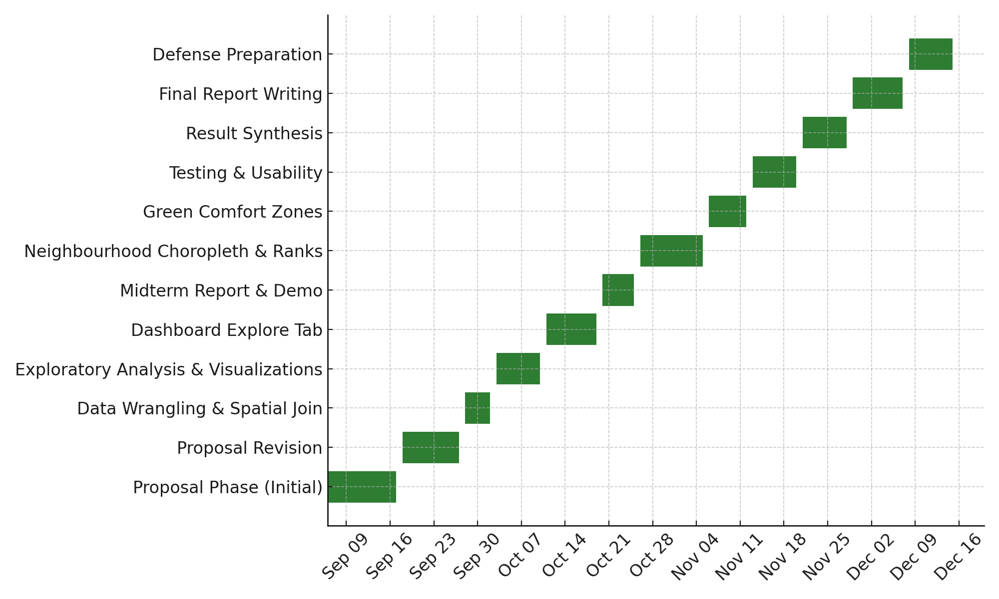
(Figure 1: Gantt chart for project planning timeline)

Implemented Feature 1 – Explore Trees Dashboard

Introduction
The first implemented feature, Explore Trees, represents a major milestone in transitioning from backend data wrangling to an interactive, map-based dashboard. This feature aligns with the first major objective of the proposal, which is to visualize Vancouver’s public tree data interactively at both point and neighbourhood levels.
The overall direction remained consistent with the proposal. However, several refinements were made during implementation. There was no significant change of direction, as all planned components, including the map, filters, and statistics were delivered successfully. Only valid tree records containing latitude and longitude were plotted, as incomplete coordinates could not be reliably mapped. Before development, several mapping libraries such as Folium, Pydeck, and Kepler.gl were compared. Folium was selected for its simplicity, Streamlit integration, and ability to render GeoJSON overlays efficiently.

Details of Implemented Feature
The Explore Trees tab provides an interactive Folium map embedded within a Streamlit web application. It integrates two datasets, Public Trees (CSV) and Local Area Boundaries (GeoJSON), both obtained from the City of Vancouver Open Data Portal. A Folium map is initialized, centered on Vancouver, and styled using the CartoDB Positron base layer for visual clarity. Neighbourhood boundaries are overlaid using Local Area polygons, and when a user selects a neighbourhood via the sidebar, its outline is highlighted in green for emphasis. Each tree record is represented as a circular marker of uniform size, and to maintain responsiveness for large datasets, a sampling mechanism limits the display to 6,000 points at a time.
Each marker contains an interactive tooltip showing the tree’s common name, scientific name, planting year, trunk diameter (in inches), and neighbourhood. This design allows users to obtain detailed information without leaving the map interface. A layer control widget enables toggling between neighbourhood boundaries and point layers. The map dynamically adjusts zoom and centering based on the filtered dataset, while caching (@st.cache_data) ensures smooth interaction and rapid data reloading. This implementation successfully transforms static CSV and GeoJSON data into an exploratory spatial visualization that users can navigate intuitively.
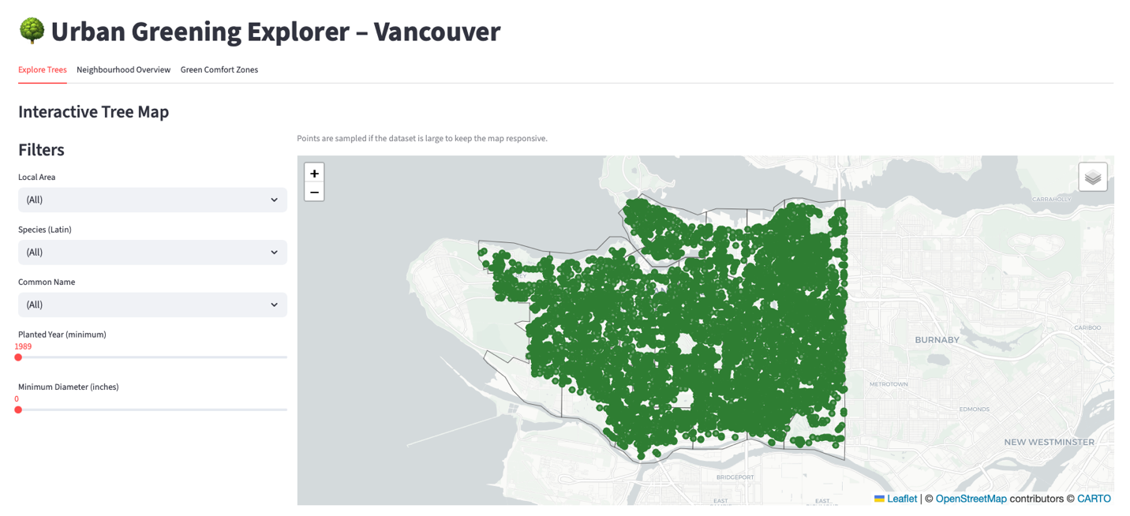
(Figure 2: Explore Trees Map View with Local Area Overlay)
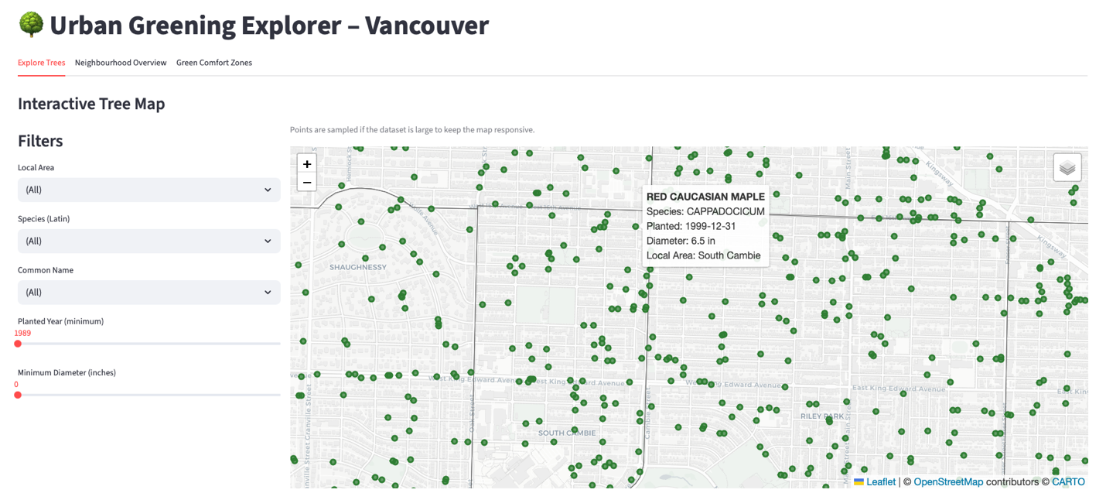
(Figure 3: Example Tooltip Displaying Tree Attributes)

Implemented Feature 2 – Sidebar Filters, Key Stats, and Distributions

Introduction
The second implemented feature focuses on the data exploration interface, combining filters, summary statistics, and visual analytics into an integrated workflow. This part of the dashboard translates the processed tree data into meaningful insights through a responsive and intuitive layout. It allows users to explore Vancouver’s tree data from multiple perspectives, such as species, location, planting year, and size, all in real time.
The direction of development remained consistent with the original plan, though greater attention was given to layout clarity and user experience after early testing. The overall goal of this component is to make civic data interpretation straightforward and engaging for both public and academic audiences.

Details of Implemented Feature
The sidebar enables users to dynamically filter and refine the dataset, instantly updating the map and visual outputs. It provides dropdown selectors for Local Area, species (Latin), and common name, as well as sliders for minimum planting year and minimum diameter. These controls make it possible to focus on specific subsets of data, such as large trees planted after a certain year or species that dominate certain neighbourhoods.
Below the map, a Key Statistics panel summarizes essential information based on the active filters, including the number of trees displayed, unique species count, average diameter, and range of planting years. This section updates instantly as filters change, providing a clear snapshot of the dataset in context.
Two exploratory visualizations, built with Altair, complement these statistics. The first is a bar chart showing the top 15 most common tree species, and the second is a histogram illustrating the distribution of planting years. Together, these charts reveal species dominance and planting trends across decades. The interface is organized using Streamlit’s column layout, ensuring a balanced structure where the map, metrics, and charts flow naturally on the page. All captions, labels, and tooltips were revised for consistency and clarity. Performance testing confirmed that responsiveness remained smooth even with multiple filters applied simultaneously.
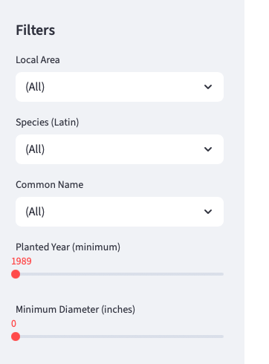
(Figure 4: Sidebar Filter Options)
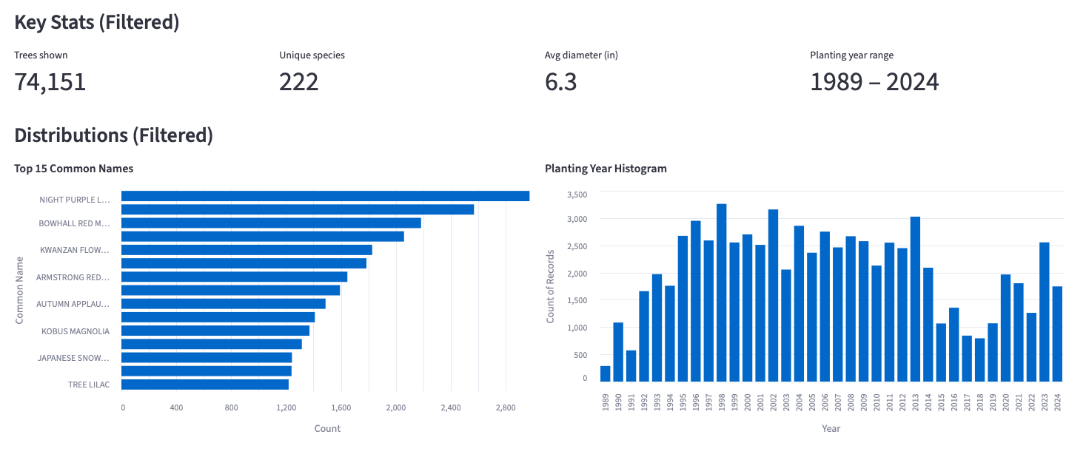
(Figure 5: Key Stats Panel and Charts Displaying Top Species and Planting Years)

Implemented Feature 3 – Neighbourhood Overview Tab

Introduction
The third implemented feature introduces the Neighbourhood Overview tab, which provides a citywide, neighbourhood-level perspective on tree distribution and diversity. The midterm version of this tab included only a sortable table of neighbourhood metrics. In the final version, this tab has been expanded to include a choropleth map that visualizes tree density across Local Areas.
This feature directly supports the second main objective of the project, which is to compute and present greening indicators at the neighbourhood level in a way that supports comparison and reflection on spatial equity. The implementation remained aligned with the proposal, with an emphasis on clear, interpretable visualizations and robust handling of density bins.

Details of Implemented Feature
The Neighbourhood Overview tab is built on a precomputed summary DataFrame that aggregates the tree dataset by LOCAL_AREA and joins the results with area measurements from the Local Area Boundaries layer. The metrics include total trees, unique species, average diameter, oldest and newest planting years, neighbourhood area (km²), and tree density (trees per km²).
The tab consists of two main components:
- Tree Density Choropleth Map
A Folium map is initialized with Vancouver as the base view. Neighbourhood polygons are merged with the summary metrics and passed to a make_area_choropleth() function, which constructs a choropleth using tree density as the key metric. Quantile-based bins are computed using a robust helper function that ensures meaningful breakpoints even in the presence of skewed distributions or missing values.
Each polygon is shaded using a YlGn colour ramp, with darker shades representing higher density. A legend is included to interpret the density ranges. Hovering over any neighbourhood reveals a tooltip with the Local Area name, density, total trees, and unique species. This design provides an at-a-glance view of which neighbourhoods are relatively greener and how they compare to one another.
- Neighbourhood Ranking Table
Below the map, a sortable ranking table is generated using st.dataframe(). The table presents all metrics in a tabular format, with columns renamed for readability (for example, “Trees/km²” instead of trees_per_km2). The table is sorted by density in descending order by default, so the densest neighbourhoods appear at the top. Users can click on column headers to re-sort by other metrics, such as total trees or unique species.
By combining the choropleth and the ranking table, the Neighbourhood Overview tab bridges visual and numerical analysis. Users can first scan the map for spatial patterns, then use the table to read specific values or perform more detailed comparisons. This feature lays the foundation for the subsequent Green Comfort Zones tab, which selects a subset of neighbourhoods based on density percentile.
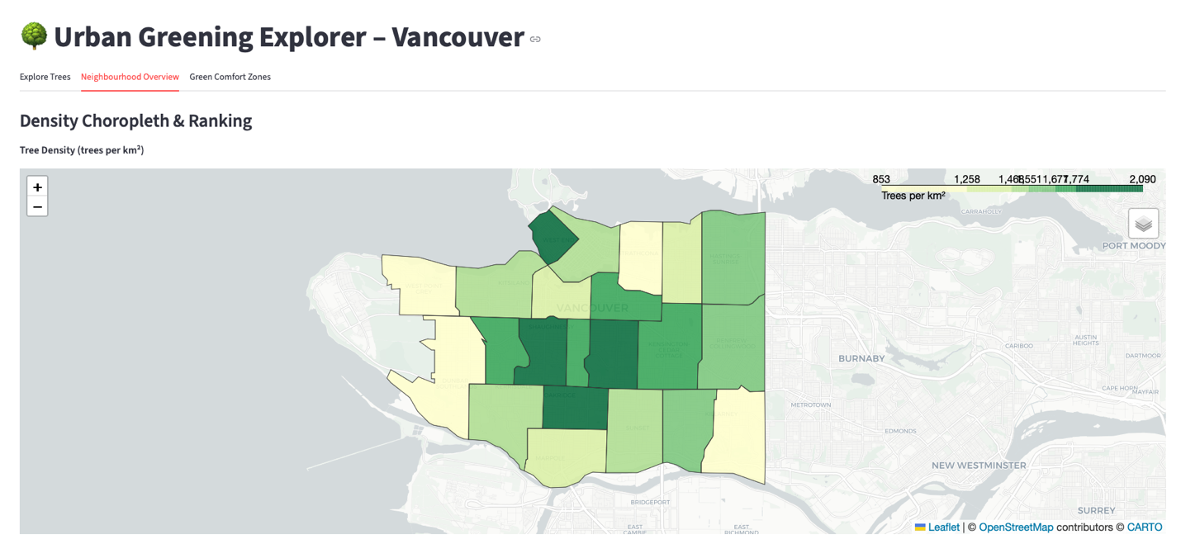
(Figure 6: Neighbourhood Overview tab showing tree density choropleth.)
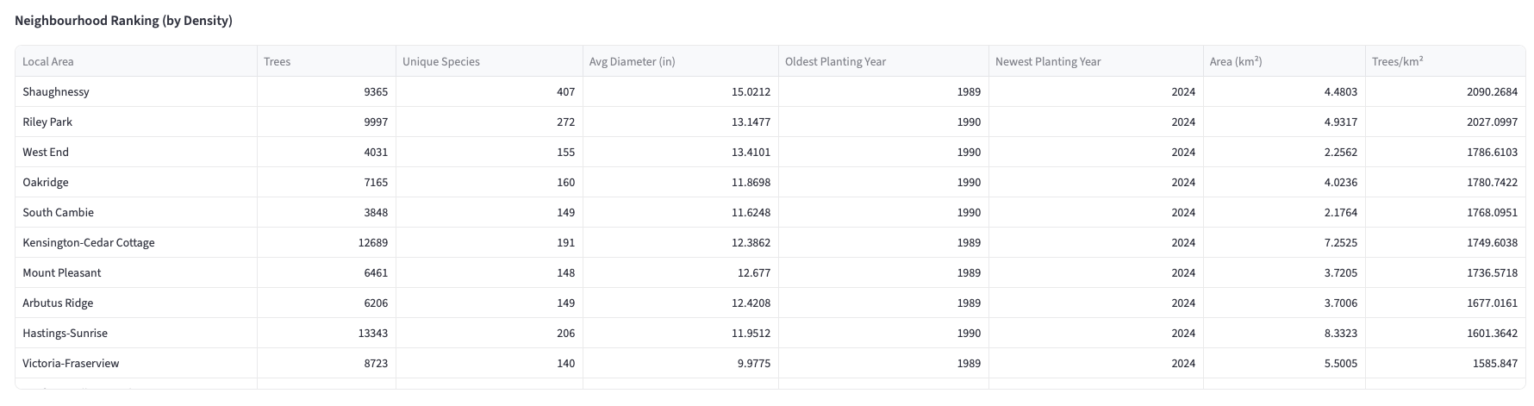
(Figure 7: Neighbourhood ranking table with density, species, and planting-year metrics.)

Implemented Feature 4 – Green Comfort Zones Tab and AI Summary

Introduction
The fourth implemented feature encompasses the Green Comfort Zones tab and the AI Summary component. Together, they provide a macro-level view of Vancouver’s greening patterns and demonstrate how AI can assist in interpreting environmental data.
The Green Comfort Zones concept was introduced in the proposal as a simple, quantile-based way to highlight neighbourhoods with especially high tree density. During implementation, the feature was expanded with a user-configurable density threshold slider and an AI-generated narrative summary. This enhancement allows users to experiment with different definitions of “comfort” and receive concise textual explanations of the resulting patterns.

Details of Implemented Feature
The Green Comfort Zones tab begins with a title and a brief description of its purpose. It then presents a slider that lets users choose the percentile threshold for defining Green Comfort Zones. The slider typically ranges from 0.5 (50th percentile) to 0.95 (95th percentile), with a default of 0.8 (80th percentile). Changing this threshold immediately affects which neighbourhoods qualify as comfort zones.
Once the threshold is selected, the application computes the actual density value at that percentile, a Boolean mask identifying which neighbourhoods have densities at or above that value and a subset DataFrame (winners) containing these neighbourhoods and their associated metrics. A small metrics panel summarizes the results as the number of comfort zones found versus total local areas, the numeric density threshold used (for example, 350 trees/km²) and the median density across all neighbourhoods, providing context.
A dedicated map is then rendered showing only the Green Comfort Zones. The polygons of qualifying neighbourhoods are styled with a green fill and moderate opacity. Hover-tooltips provide name, trees per km², total trees, and unique species for each comfort zone. This visualization gives an immediate sense of where greener neighbourhoods are concentrated spatially. Below the map, a table lists all Green Comfort Zones in descending order of density, showing Local Area names, total trees, unique species, area (km²), and trees per km². This tabular view offers a detailed complement to the map, suitable for inspection.
The AI Summary section appears after the table. It includes a short explanation that the summary uses an OpenAI GPT model to interpret the Green Comfort Zones, conditional logic that checks whether the openai package is installed and whether an OPENAI_API_KEY is configured in Streamlit secrets. If not, informative messages guide the user on how to enable the feature, and a “Generate AI Summary” button, which triggers the API call.
When the button is clicked, the application converts the comfort-zone table into a compact textual format that lists each neighbourhood with its tree counts, species counts, area, and density. This text is combined with a prompt that instructs the model to write a short, clear summary (2–3 paragraphs) explaining:
- Which neighbourhoods stand out and why.
- Any patterns in density and species richness.
- How such patterns might be useful for urban planning or public communication.
The OpenAI client then sends this prompt to the specified model and receives a response. The resulting text is displayed in the Streamlit interface, providing users with an interpretive narrative that complements the quantitative results.
Error handling ensures that any issues with the API (such as missing keys or network problems) are communicated to the user without crashing the app. This feature illustrates how generative AI can be integrated into a geospatial dashboard to enhance interpretability and storytelling.
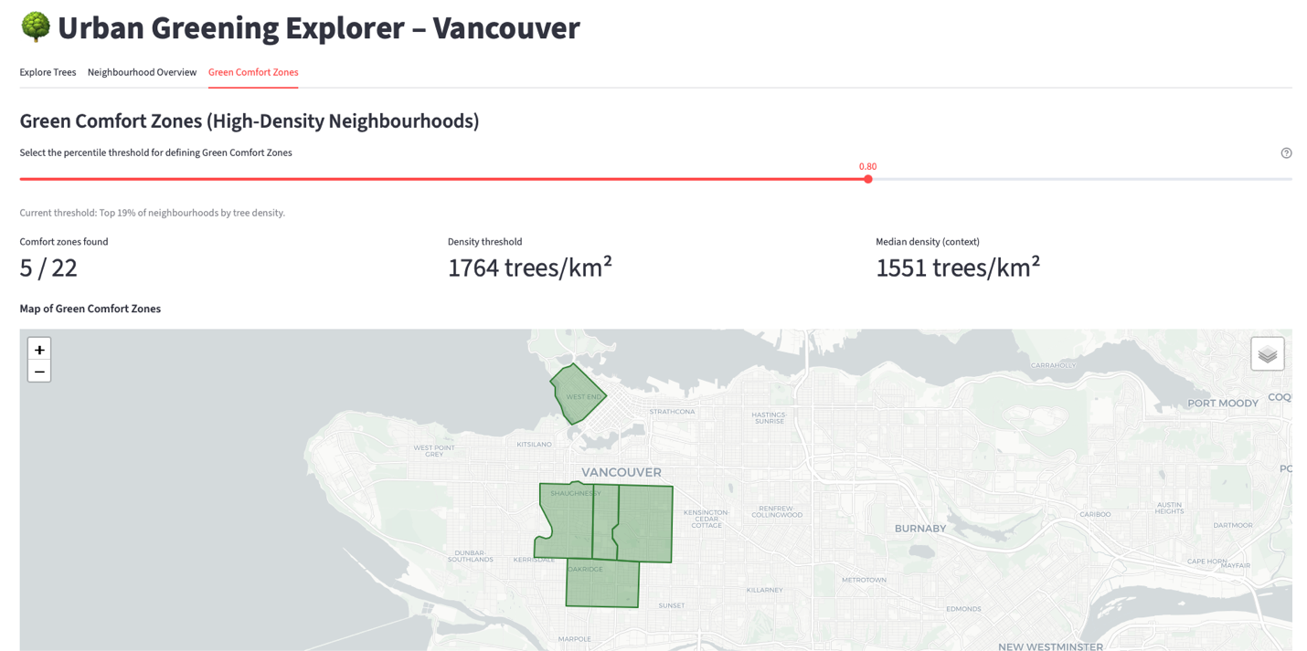
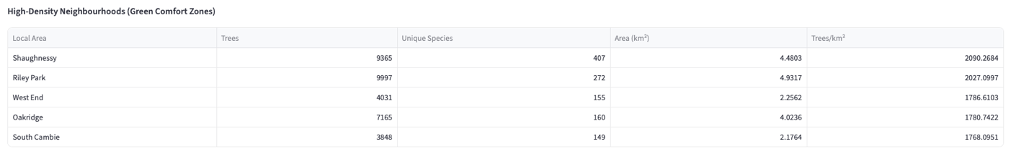
(Figure 8: Green Comfort Zones map highlighting high-density neighbourhoods.)

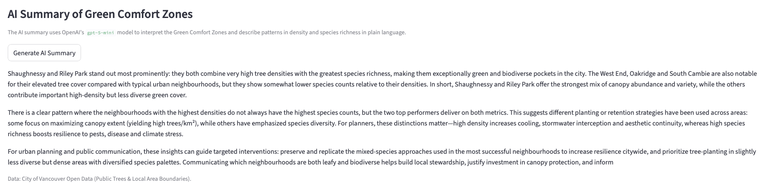
(Figure 9: AI-generated narrative summary explaining patterns in Green Comfort Zones.)

Lessons Learned and Future Work
Developing the Urban Greening Explorer has been an intensive learning experience that connected concepts from data analytics, geospatial processing, interactive web development, and AI integration. Several key lessons emerged over the course of the project.
First, working with real-world spatial data requires careful attention to coordinate systems, projections, and geometric accuracy. Converting between coordinate reference systems and ensuring that areas are computed in an appropriate projection were crucial steps for reliable density calculations. The experience reinforced the importance of reproducible data pipelines and modular functions that encapsulate common transformations.
Second, performance and usability are tightly linked. Rendering tens of thousands of points in a browser can easily overload the client if not managed carefully. Implementing sampling, caching, and efficient spatial joins significantly improved responsiveness. Moving the filters into an inline left-hand panel for the Explore Trees tab also improved user experience by visually tying the controls to the content they affect.
Third, integrating AI into an analytical dashboard requires thoughtful prompt design and careful scoping of the data passed to the model. It was important to send only aggregated statistics rather than raw records, both for performance and for good data practice. The AI summaries proved to be a powerful tool for communicating patterns but also highlighted the need for the human user to remain critical and interpret the narrative considering the underlying numbers.
Looking ahead, there are several potential future enhancements:
- Additional Layers: Incorporating other datasets such as land use, heat vulnerability indexes, or air quality could further support environmental equity analysis.
- Temporal Animation: Adding an option to animate planting trends over time might reveal how the urban forest has developed across decades.
- User Annotations: Allowing users to add notes or save views could support classroom use or participatory planning workshops.
- Mobile Optimization: Further refinements to layout and map controls for small screens would make the app more accessible on phones and tablets.
This project has strengthened my technical foundation for a future career in data-driven environmental analytics and embedded AI. The experience of combining spatial analysis, web dashboards, and generative AI has been particularly valuable, as it reflects current trends in both industry and research.

Concluding Remarks
The Urban Greening Explorer demonstrates how open civic data can be transformed into an accessible, interactive tool for understanding urban greenery. By connecting individual tree records with neighbourhood-level indicators, the project offers both micro- and macro-level perspectives on Vancouver’s public trees. The final dashboard allows users to explore species diversity, planting trends, tree density, and Green Comfort Zones, while the AI-generated summary feature helps interpret complex patterns in a narrative form.
Compared to the midterm milestone, the project has advanced significantly. The Neighbourhood Overview now includes a choropleth map, the Green Comfort Zones tab is fully implemented with a user-configurable threshold, filters have been refined, and the entire application is deployed on Streamlit Cloud with AI-powered summaries. The project meets and slightly exceeds the original objectives, providing a working example of how geospatial analytics, web technologies, and generative AI can be combined to support environmental understanding and public engagement.
I would like to acknowledge Douglas College, my instructor Dr. Bambang A. B. Sarif, and my peers for their ongoing feedback and support. Their guidance has helped refine both the technical implementation and the communication of results, making this project a meaningful contribution at the intersection of urban data science, visualization, and AI-assisted storytelling.

Appendix
The appendix provides supporting materials that help readers understand the Urban Greening Explorer project more thoroughly. It includes installation instructions, a user guide, dataset and software details, and a brief code explanation to ensure reproducibility.

Appendix A: Installation Guide
You can either install the application locally or access a ready-to-go deployed version on Streamlit Cloud.

To access the deployed version, please follow the link below:
https://urban-greening-planner-yrriwequn3kemqmvmdfihd.streamlit.app
However, if you want to run the application locally, please follow the steps below:

Prerequisites
Make sure Python3 is installed on the system.

Clone the app
git clone https://github.com/emergingTechExplorer/F2025_4495_071_LDi299
cd F2025_4495_071_LDi299/Implementation

Create a Python virtual environment
python3 -m venv env
source env/bin/activate

Install necessary packages
pip install -r requirements.txt

Create a Streamlit secrets file
mkdir .streamlit
touch .streamlit/secrets.toml

Add the following entries inside the secrets file
OPENAI_API_KEY = “<your_openai_api_key>”
OPENAI_MODEL = “gpt-5-mini”
If this configuration is omitted, all the functionalities of the application remain intact, but AI summaries are disabled.
Run the app
streamlit run app.py

The application will open automatically in your default browser at http://localhost:8501

Appendix B: User Guide
The Urban Greening Explorer is a Streamlit-based web application designed for interactive exploration of Vancouver’s public tree dataset.

Main Features
- Explore Trees Tab:
  - Displays a Folium map with tree markers and neighbourhood boundaries. Users can filter trees by neighbourhood, species, common name, planting year, and minimum diameter.
- Neighbourhood Overview Tab:
  - Shows a sortable summary table with aggregated greening indicators such as tree count, unique species, average diameter, planting year range, and trees per square kilometre.
- Green Comfort Zones Tab.
  - This tab highlights neighbourhoods in the upper quantiles of tree density. A slider allows the user to choose the percentile threshold (for example, 80th percentile). A metrics panel, a dedicated comfort-zone map, and a table of qualifying neighbourhoods are provided. An optional AI Summary button generates a narrative description of the comfort zones.

How to Use
- Launch the app either locally (using Streamlit) or via the Streamlit Cloud link provided in “Appendix A”.
- Start on the Explore Trees tab. Use the left-hand filter panel to refine the dataset by neighbourhood, species, common name, planting year, and diameter. Observe how the map, Key Stats, and charts update in response. Hover over points on the map to view detailed tooltips about individual trees.
- Switch to the Neighbourhood Overview tab to see citywide patterns. Use the choropleth map to identify greener neighbourhoods visually, and consult the ranking table below to compare specific indicator values, such as the number of trees, density, or unique species.
- Move to the Green Comfort Zones tab to explore quantile-based density thresholds. Adjust the percentile slider to change the definition of a comfort zone and observe how the set of qualifying neighbourhoods and their map representation change. Review the comfort-zone table to see quantitative metrics for each highlighted area.
- Press the “Generate AI Summary” button to receive a short narrative explanation of the current comfort zones, including which neighbourhoods stand out and how density and species richness patterns might be interpreted.

Appendix C: Dataset and API Used
This project uses open data provided by the City of Vancouver Open Data Portal. All data used for tree and neighbourhood metrics is downloaded and processed locally to ensure reproducibility and offline access. A single external API is used for the optional AI summary.

Datasets
- Public Trees (CSV)
  - Source: City of Vancouver – Public Trees
- Local Area Boundaries (GeoJSON)
  - Source: City of Vancouver – Local Area Boundary

API
- OpenAI API
  - Source: OpenAI platform

Appendix D: Software and Architecture

Software Stack
- Programming Language: Python.
- Web Framework: Streamlit, used for layout, user interaction, and integration of maps and charts.
- Mapping Library: Folium with streamlit-folium integration, used to render interactive maps and choropleths.
- Data Processing: Pandas, GeoPandas and NumPy for tabular and spatial operations, including spatial joins and area calculations.
- Visualization: Altair for bar charts and histograms complementing the map-based views.
- AI Integration: OpenAI Python client for generating narrative summaries in the Green Comfort Zones tab.
- Version Control and Deployment: Git and GitHub for source control, and Streamlit Cloud for hosting and public access.

System Architecture Overview
The application follows a straightforward client–server-style architecture, where Streamlit runs on a Python backend that handles data loading, processing, and view generation, and the browser renders the resulting components. When the app starts, data-loading functions read the local CSV and GeoJSON files, perform projections and spatial joins, and compute neighbourhood summaries.
These summaries are cached to speed up subsequent runs. User interactions in the browser, such as changing filters or adjusting the Green Comfort Zones slider, trigger Python callbacks that regenerate the relevant views (maps, tables, and charts) with new subsets of the data. When the AI summary feature is invoked, the backend constructs a prompt, sends an HTTP request to the OpenAI API, and returns the model’s response to be rendered as text in the interface.
All computation, except for the AI summary, is performed locally on the host machine or Streamlit Cloud container, which helps maintain reproducibility.

Appendix E: Code Explanation
The project’s main codebase resides in app.py. Key functions include:
- load_trees_from_csv()
  - Reads and cleans the Public Trees dataset, ensuring valid latitude and longitude coordinates and standardizing column names.
- load_local_areas()
  - Loads Local Area polygons from GeoJSON using GeoPandas, performs CRS projection to UTM for area computation, and returns a standardized GeoDataFrame.
- Spatial Join Logic
  - Combines tree points with their respective Local Area polygons to enable neighbourhood-level summaries. Tree density (trees/km²) is computed using area-based normalization.
- Map and Chart Rendering
  - Uses Folium for map visualization (with CartoDB Positron tiles) and Altair for bar and histogram charts.
  - Caching (@st.cache_data) ensures smooth updates when filters change.
- Explore Trees, Neighbourhood Overview and Green Comfort Zones Tabs
  - Each tab’s layout is implemented using Streamlit’s column and tab components. The Explore Trees tab integrates the filter panel, map, Key Stats, and charts. The Neighbourhood Overview tab displays the choropleth and ranking table. The Green Comfort Zones tab implements the threshold slider, comfort-zone map, metrics panel, detailed table, and AI Summary button.
All functions are modular and sufficiently commented to enhance readability and maintainability, ensuring that future extensions, such as additional datasets or new indicators, can be added with minimal disruption to the existing structure.

References
- City of Vancouver. (2025a). Vancouver’s Urban Forest Strategy. Retrieved from https://vancouver.ca/parks-recreation-culture/urban-forest-strategy.aspx
- City of Vancouver. (2025b). Public Trees (dataset). Open Data Portal. Retrieved from https://opendata.vancouver.ca/explore/dataset/public-trees
- City of Vancouver. (2025c). Local Area Boundary (GeoJSON) (dataset). Open Data Portal. Retrieved from https://opendata.vancouver.ca/explore/dataset/local-area-boundary
- Longley, P. A., Goodchild, M. F., Maguire, D. J., & Rhind, D. W. (2015). Geographic Information Science and Systems (4th ed.). Wiley. (spatial joins, projections, andchoropleths)
- OpenAI. (2025). OpenAI API Documentation. Retrieved from https://platform.openai.com/docs

