1) Boot with HDMI cabled plugged into GPU, keyboard, mouse and BIOS usb stick in USB ports and a Network cable plugged in.
2) press DEL key repeatedly until you get into BIOS screen
3) Press F12 to go to BIOS Flash
4) Press Enter on “fs0”, then Enter again on B25DF222.BSS
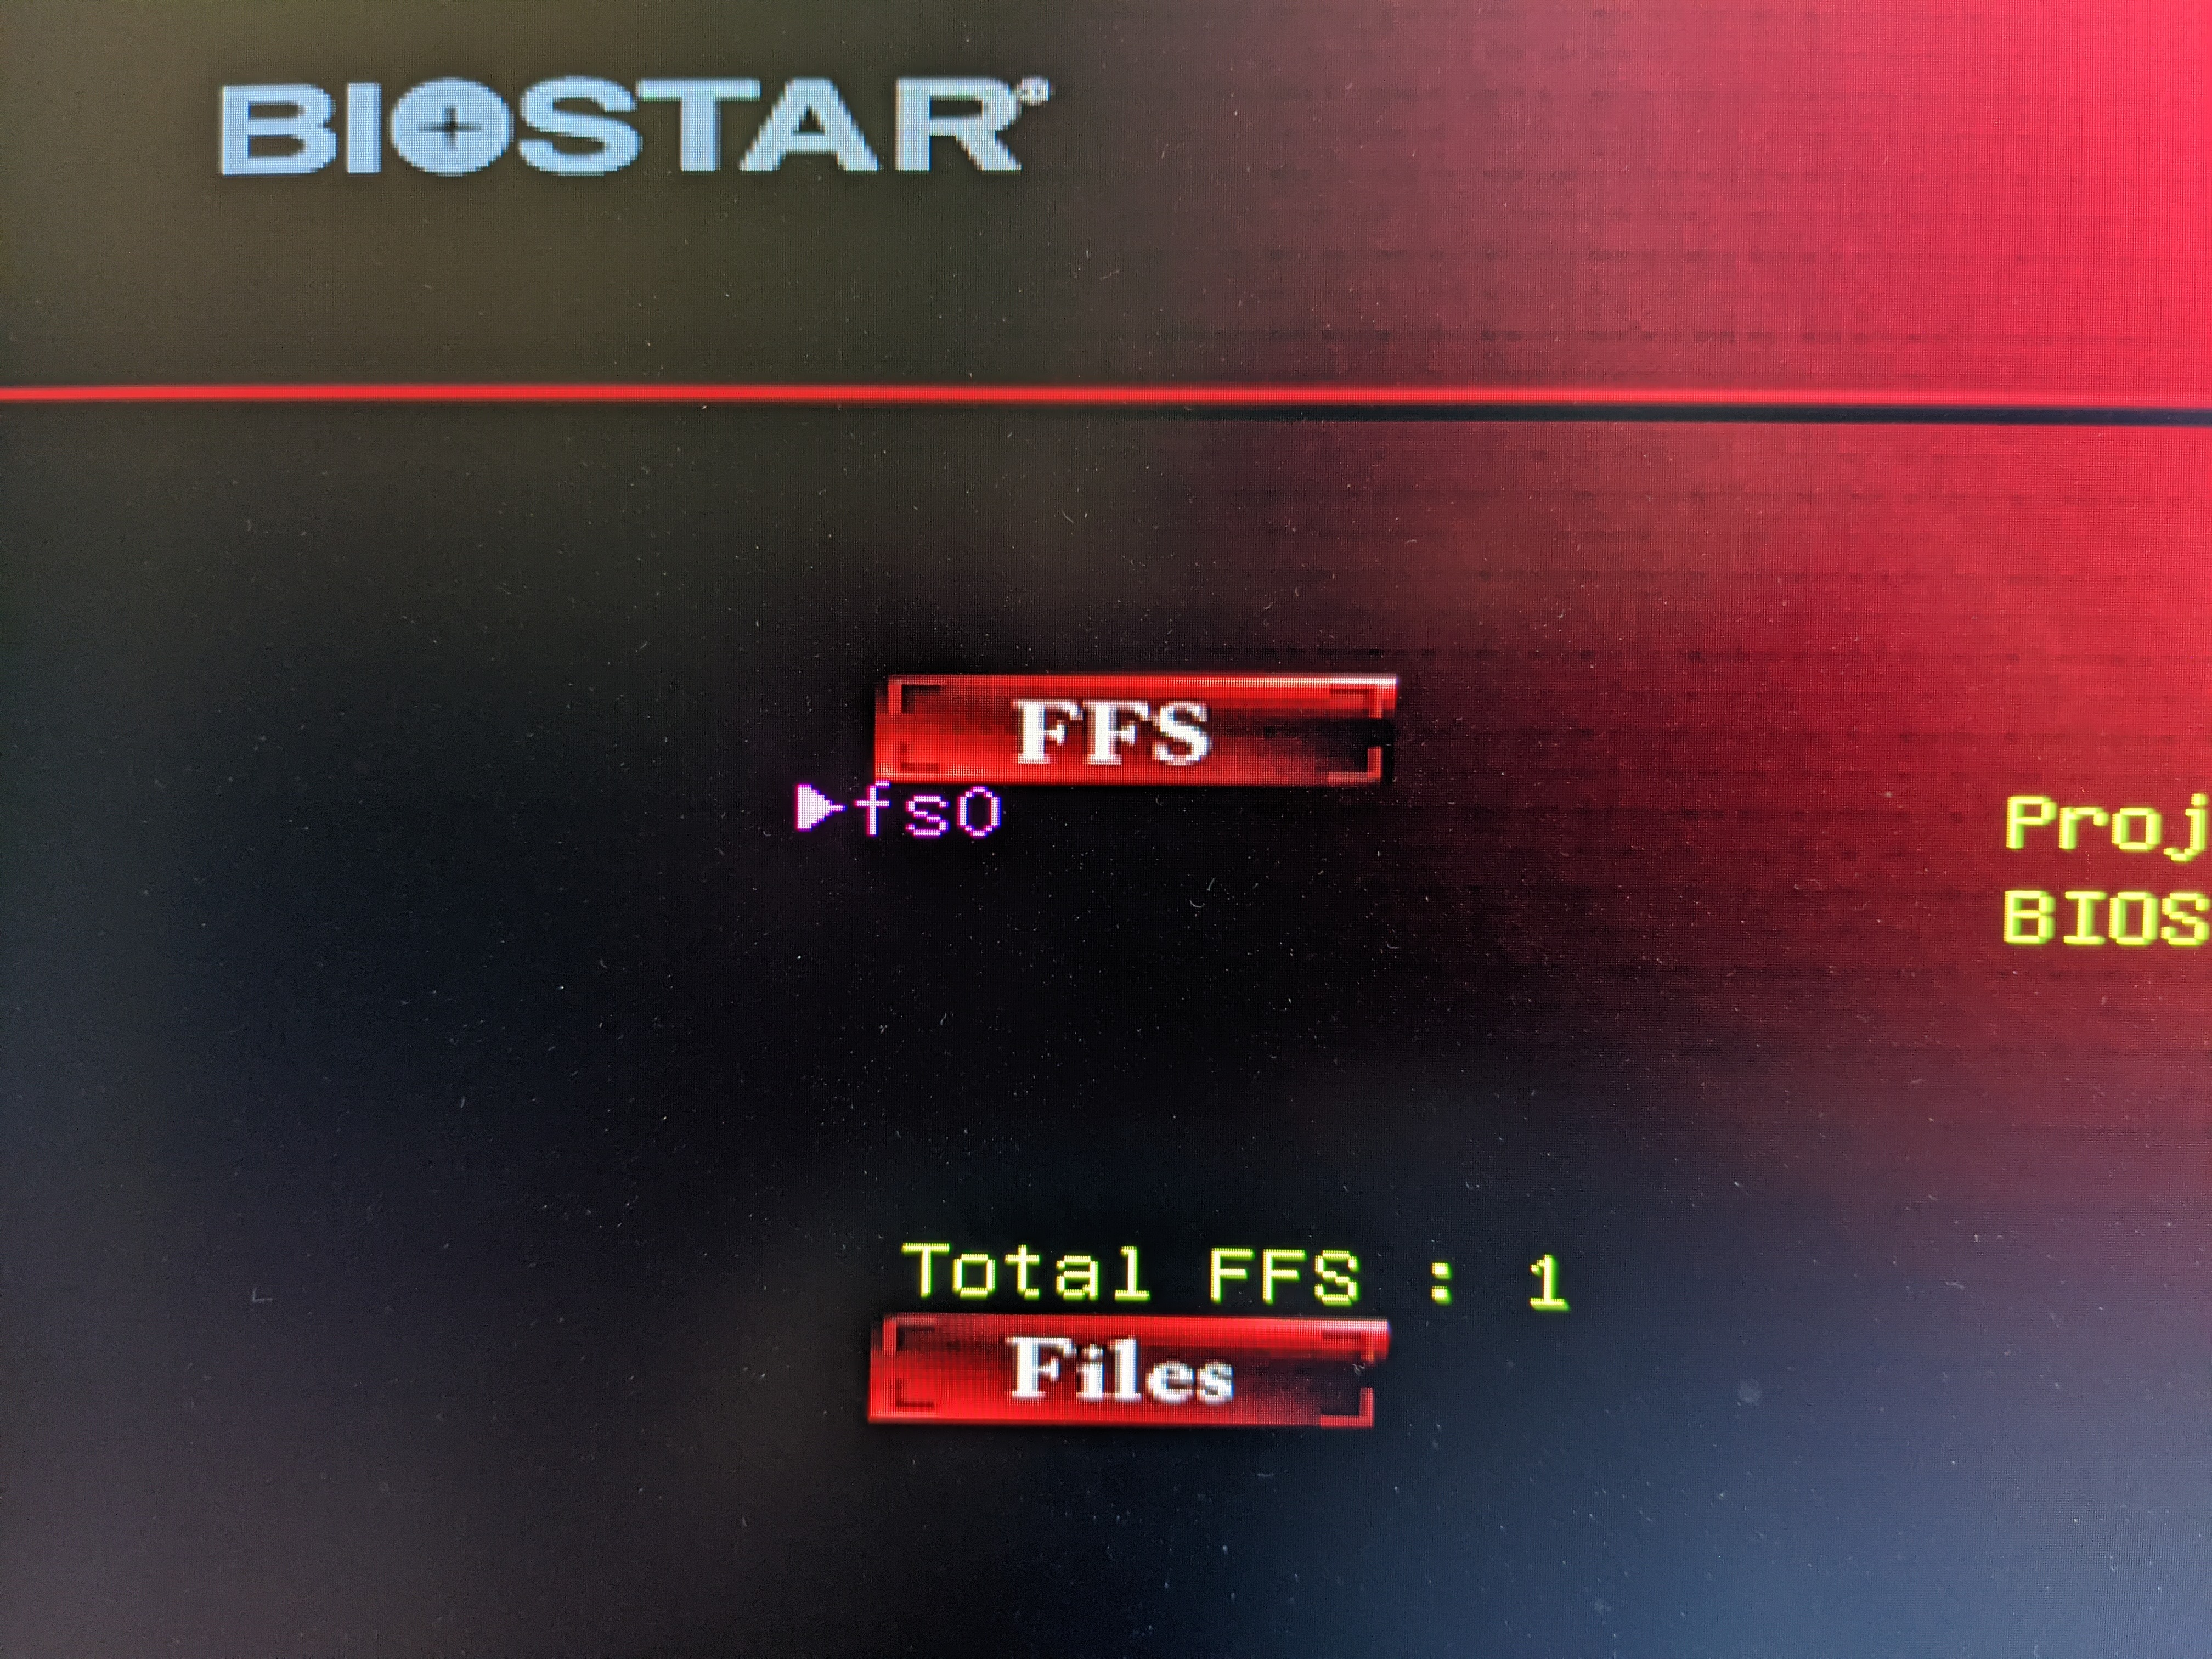

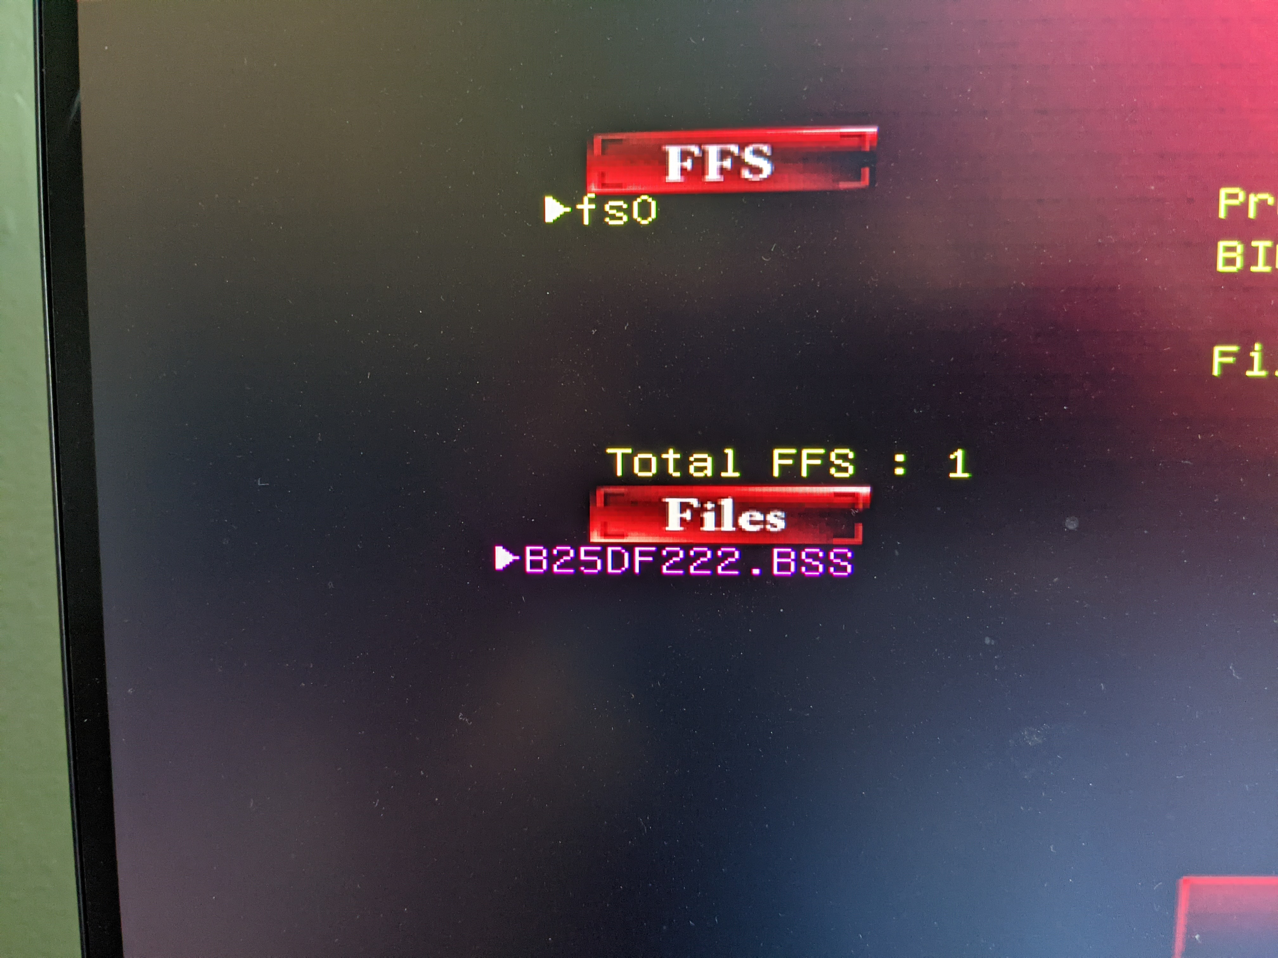

5) Press “Y” for are you sure.
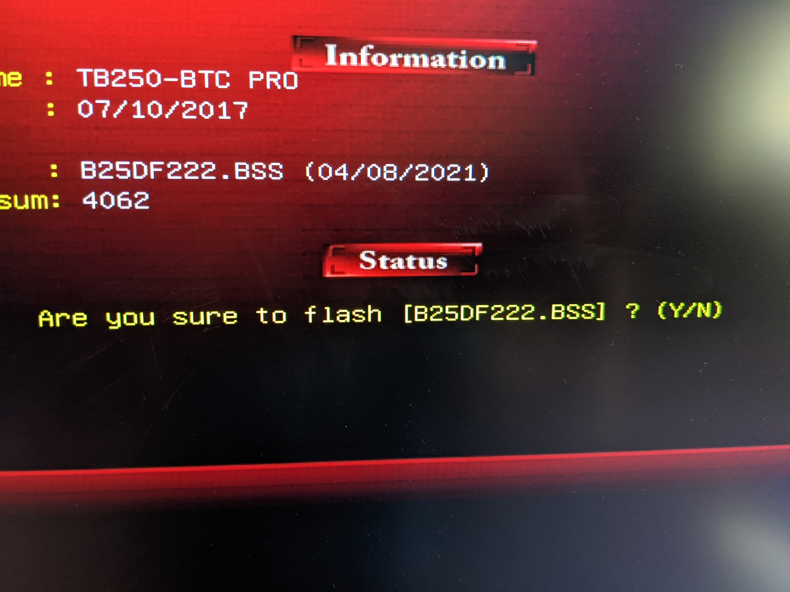

6) BIOS should start upgrading. Let it finish
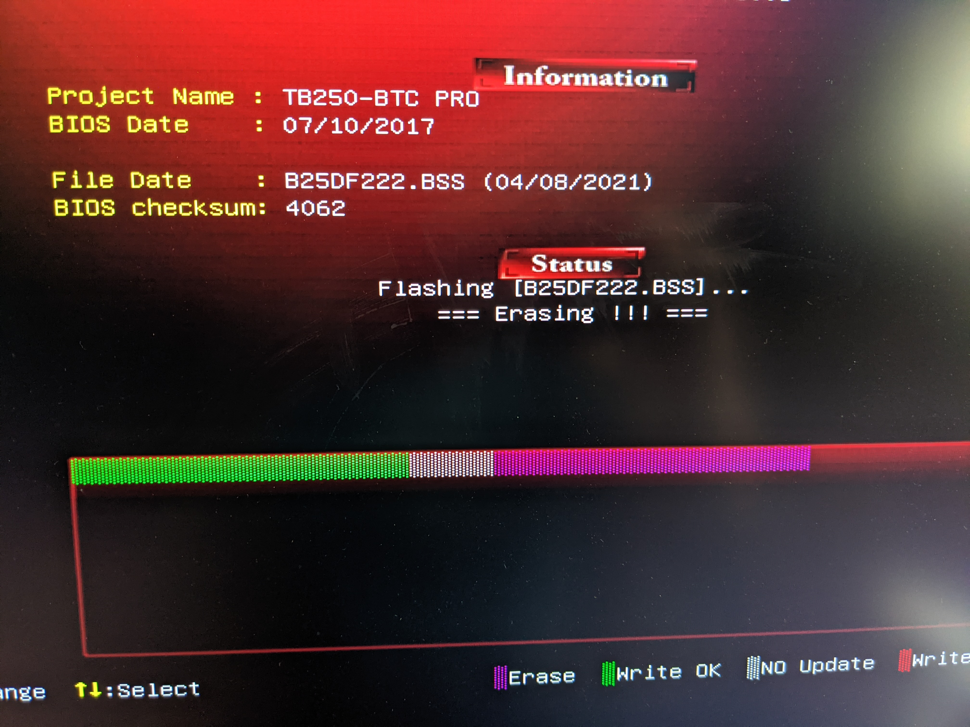
7) Press “Y” on Reset System. System will reboot. Take BIOS USB stick out of USB port.
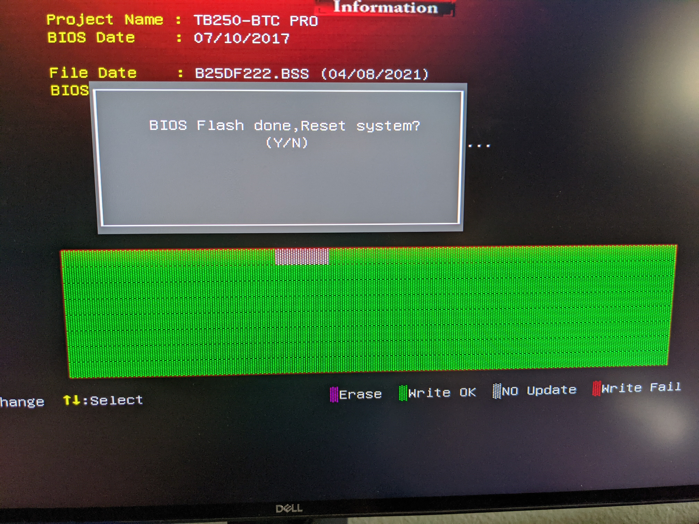

8) Go into BIOS again at reboot and change settings:
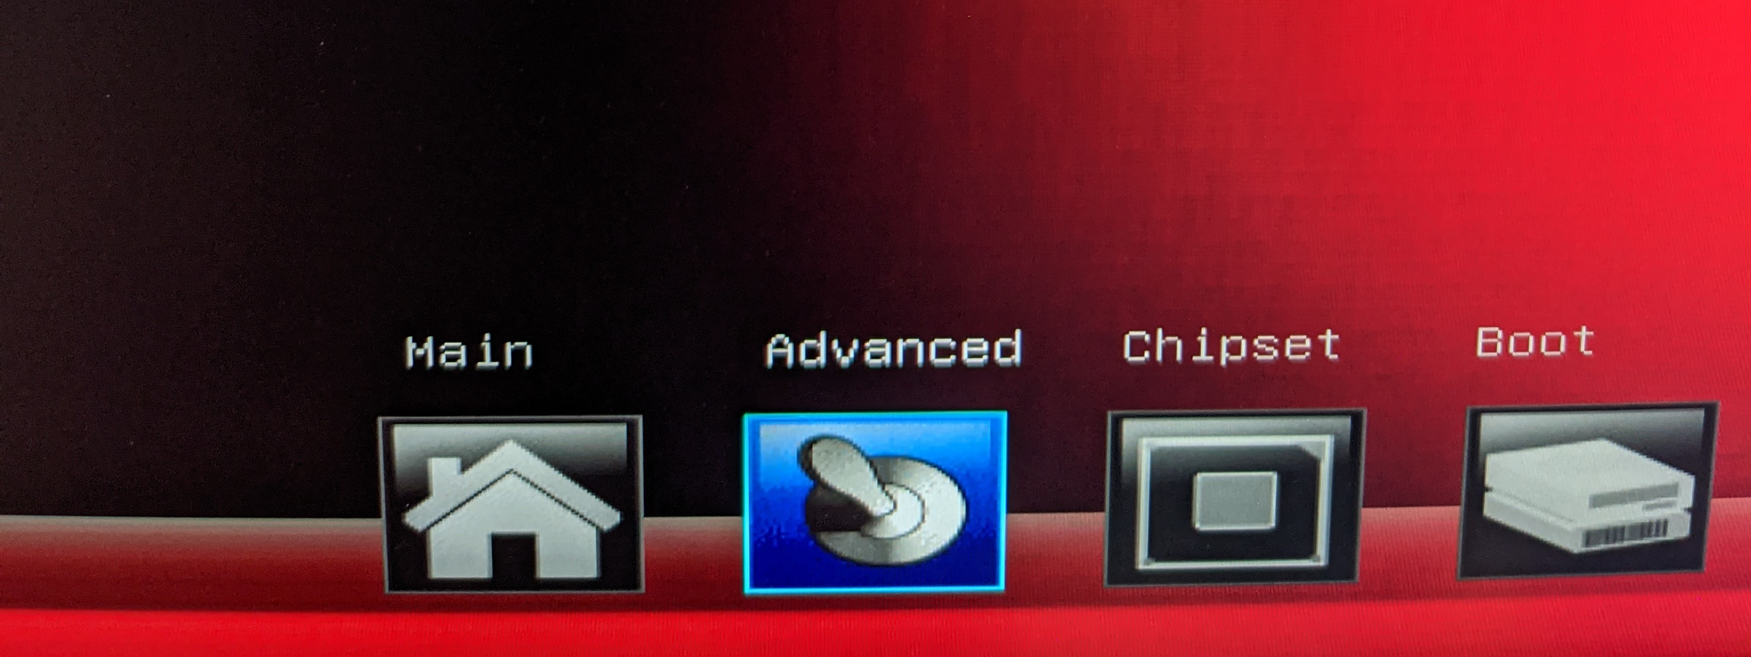

Under Advanced:
Smart Fan Control
CPU Smart Fan1 : Auto
Under Chipset
Mining Mode : Enabled
PCH-IO Configuration
PCI Express Configuration
(ensure all ports are Enabled and set to Auto for Speed)
HD Audio : Disabled
System Agent (SA) Configuration
Internal Graphics : Auto
Primary Display : Auto
Under Boot
CSM Support : Enabled (if you have any AMD gpus), Disabled (if you have only Nvidia)

9) Press F10 to Save and Exit.
10) Insert ArchLinux USB installer stick and click “Yes” on the Save & reset prompt.
11) While rebooting, continually press F9 to select the ArchLinux installer usb stick. Select:
“UEFI: General USB Flash Disk, Partition 2”

Install ArchLinux
1) When “Please select boot device” comes up, select :UEFI: General USB Flash Disk 1100, Partition 2”
2) When Presented with an Arch boot menu, just press Enter
3) When it boots up, create a USB directory

mkdir usb

4) Mount the USB installer

mount /dev/sdb3 usb

5) Run the installer

usb/setup

6) When prompted for the “allset” user password, enter “allset”, press enter, then enter “allset” again and press enter

7) Type in Wallet ID when prompted, or just hit enter to take the default.

8) When installer completes, press enter to reboot. Pull the USB stick out after pressing enter.

