**Final Project Report Submission Date:** December 17, 2014

**Application Name:** Neuromotor Control Lab - Human Subject Participant Database

**Author:** Emerson Fang

**Final Project Proposal**

**Statement of the problem and purpose of the Project:** The project’s purpose is to create a database application for a Neuromotor Control Lab at a “Big University” to track the volunteer subjects’ information, experiments that they have participated in, the cash payments they receive for running an experiment, and survey data and measurements that the lab retrieves from the subjects. Someone I know is currently employed as a lab technician at “Big University,” and he helps the professor and PhD students keep track of the aforementioned information for further analysis. The lab studies how people learn new movements in a simulated, videogame-like environment using various devices for measurements.

Currently, a new spreadsheet is created for each experiment that is run, to record survey and measurement data, for each subject. Returning subjects’ information is re-entered rather than updated for a new experiment, though measurements might be completely different values for an experiment. Subject information and payment information is kept on another spreadsheet on a cloud server. The experiment computers are also not connected to the internet (for security), so finding the information at a later time sometimes involves some searching and detective work. There are multiple types of experiments. Subjects are typically only allowed to volunteer for a particular type of experiment once, before being excluded from invitations for that type of experiment in the future (though they may participate in another type of experiment). Experiments can have an attribute called have polarity, i.e. a positive or negative characteristic of an experiment version. “Polarity” categorizes the perturbation subjects might experience during an experiment.

The database application will help consolidate the various spreadsheets that float on the desktop computers between the two experiment rooms, and simplify retrieval of data. The applications shows if a subject is nearing total payments received of $600 in a calendar year (IRS does will not allow it). Researchers enter the data through a Web-based interface. Payment reports are generated via the web-app. Researchers can extract subject survey/measurement reports for data analysis (updating the data is currently underway).

**Scope of the study:** The application includes the following forms for managing the database. It includes reports for subject data from experiments, subject note reports, and payment information (for IRS purposes).

Forms:

1. Subject (add, update, delete).
2. Subject Contact Information (add, update, delete)
3. Researcher (add, update, delete)

The application includes the following reports:

1. Experiment Participant Information, Measurements, and Notes.
2. List of Payments by Experiment and Subject.
3. Subjects paid over $500 in a calendar year.
4. Experiment and/or Experiment Version Report.
5. Experiment Measurements Report
6. Experiment Notes Report

The subject contact information page has pull-down menus whose options are updated/eliminated as other fields. Adding subject contact information, subjects, and researchers is streamlined with add, update, and delete all on the same page.

**Access Information:** The application is currently not protected, though ideally the subject and researcher information, as well as the notes and measurements data would have login requirements.

**Bugs:** As this is the first time I’ve coded anything in HTML, I had a difficult time figuring out the proper format for dates and times. I attempted to use a pulldown menu for foreign keys that referenced primary keys in the add/update for measurements and notes, though this didn’t prove fruitful because of the timestamp/date formatting issue. Updating, deleting and adding measurements and notes with date and timestamp form inputs were definitely an issue, so these features are not present currently. There were many, many tables in this database, so it was difficult to fully implement everything to my own satitisfaction.

**Special Features:** The web-application has a form that changes from update to add for subject contact information, subjects, and researchers, depending on what button is clicked in the report/form below it.

**Database Schema:** Please see the file efang_fp2014.lst for the commands used as well, and the fpdatabaseschema.docx as well.

**ER Diagrams and Records:**

## Full Entity-Relationship Diagram

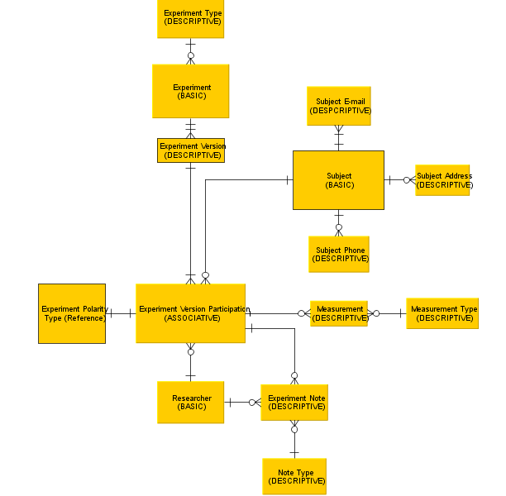

## RECORD DIAGRAM EXAMPLES (page 1 of 3)

|  |  |  |  |  |  |
| --- | --- | --- | --- | --- | --- |
| RESEARCHER entity |  |  | SUBJECT entity |  |  |
| **researcherID** | **researcherName** |  | **subjectID** | **subjectLastName** | **subjectFirstName** |
| **PK** |  |  | **PK** |  | |
| 101 | Ralph Waldo |  | 10000 | Smith | Bob |
| 102 | Sam Smith |  | 99999 | Harris | John |
| 103 | Joe Bob |  | 23450 | Fey | Mia |

|  |  |  |  |  |  |  |  |  |  |  |
| --- | --- | --- | --- | --- | --- | --- | --- | --- | --- | --- |
| SUBJECT PHONE entity | |  | | | |  | | |  | |
| **subjectID** | | **lineNo** | | | | **phone#** | | | **phoneType** | |
| **PK** | | | | | |  | | |  | |
| 10000 | | 1 | | | | 555-555-1235 | | | Home | |
| 99999 | | 1 | | | | 234-543-7890 | | | Cell | |
| 99999 | | 2 | | | | 234-589-1348 | | | Home | |
| SUBJECT E-MAIL entity | |  | | |  | | | | |
| **subjectID** | | **emailNo** | | | **subjectEmail** | | | | |
| **PK** | | | | |  | | | | |
| 10000 | 1 | | | | [smith@smith.com](mailto:smith@smith.com) | | | | |
| 99999 | 1 | | | | [harris@harrisguy.net](mailto:harris@harrisguy.net) | | | | |
| 99999 | 2 | | | | [crazyfrisbee@harris.com](mailto:crazyfrisbee@harris.com) | | | | |
| SUBJECT ADDRESS entity | | | |  | | |  |  | | | |  |  |  |  |
| **subjectID** | | | | **addressNo** | | | **streetNumber** | **streetName** | | | | **City** | **State** | **zip** | **addressType** |
| **PK** | | | | | | |  |  | | | |  |  |  |  |
| 10000 | | | 1 | | | | 100 | Soldier's Field Blvd. | | | | Boston | MA | 23140 | home |
| 23450 | | | 1 | | | | 230 | West St. | | | | Cambridge | MA | 23451 | school |
| 23450 | | | 2 | | | | 450 | South Blvd. | | | | Allston | MA | 34231 | business |

|  |  |  |  |
| --- | --- | --- | --- |
| EXPERIMENT entity |  |  |  |
| **experimentID** | **expType** | **expPolarity_On** | **polarityDescription** |
| **PK** | **FK** |  |  |
| 100 | VMR | TRUE | "screen cursor rotation" |
| 200 | FF | TRUE | "force field direction" |
| 300 | MM | FALSE | Null |

**RECORD DIAGRAM EXAMPLES (page 2 of 3)**

|  |  |
| --- | --- |
| EXPERIMENT_TYPE entity |  |
| **experimentType** | **experimentType_description** |
| **PK** |  |
| VMR | "Visuomotor Rotation Task" |
| FF | "Force Field Task with Robot Arm" |
| MM | "Motor Math task with weighted blocks" |

|  |  |  |
| --- | --- | --- |
| EXPERIMENT_VERSION entity |  |  |
| **experimentID** | **versionID** | **versionDescription** |
| **PK** | |  |
| **FK** |  |  |
| 100 | 1 | "generalization task" |
| 100 | 2 | "sin waves" |
| 300 | 1 | "subtraction version" |

|  |  |  |  |  |  |  |  |  |
| --- | --- | --- | --- | --- | --- | --- | --- | --- |
| EXP_VER_PARTICIPATION entity (first ½ of table) | | |  |  |  |  |  |  |
| **experimentID** | **versionID** | **subjectID** | **polarityType** | **date** | **start_Time** | **end_Time** | **payment…** |
| **PK** | | |  |  |  |  |  |
| **FK** | |  | **FK** |  |  |  |  |
| 100 | 1 | 10000 | P | 10/20/2014 | 13:00 | 15:00 | $30.00 |
| 100 | 2 | 23450 | N | 3/2/2011 | 9:00 | 12:00 | $45.00 |
| 300 | 1 | 23450 | Null | 4/3/2012 | 10:00 | 1:00 | $45.00 |

|  |  |  |  |  |  |  |  |
| --- | --- | --- | --- | --- | --- | --- | --- |
| EXP_VER_PARTICIPATION entity **(second ½)** | | | |  |  |  |  |
| **(…experimentID** | **versionID** | **subjectID)** | **Gender** | **matlabInitials** | **handedness** | **age** | **researcherID** |
| **PK** | | |  |  |  |  |  |
| **FK** | |  |  |  |  |  | **FK** |
| 100 | 1 | 10000 | M | bsm | R | 24 | 101 |
| 100 | 2 | 23450 | F | mfe | L | 25 | 102 |
| 300 | 1 | 23450 | F | mfe | L | 26 | 103 |

|  |  |  |  |  |  |  |  |  |
| --- | --- | --- | --- | --- | --- | --- | --- | --- |
| EXP_PARTICIPANT_NOTES entity | | |  |  |  |  |  |  |
| **experimentID** | **versionID** | **subjectID** | **noteNo** | **Note** | **noteType** | **noteDate** | **noteTime** | **researcherID** |
| **PK** | | | |  |  |  |  |  |
| **FK** | | |  |  | **FK** |  |  | **FK** |
| 100 | 1 | 10000 | 1 | "moved too slowly" | SER | 10/20/2014 | 13:20 | 101 |
| 100 | 2 | 23450 | 2 | "bad at VMR" | SER | 3/2/2011 | 9:30 | 102 |
| 300 | 1 | 23450 | 3 | "program froze" | MAL | 4/3/2012 | 10:30 | 103 |

**RECORD DIAGRAM EXAMPLES (page 3 of 3)**

|  |  |
| --- | --- |
| NOTE_TYPE Entity |  |
| **noteType** | **noteType_meaning** |
| **PK** |  |
| SER | subject error |
| MAL | malfunction |
| GEN | General |

|  |  |  |  |  |  |  |
| --- | --- | --- | --- | --- | --- | --- |
| MEASUREMENT entity |  |  |  |  |  |  |
| **experimentID** | **versionID** | **subjectID** | **measureNo** | **dataDouble** | **dataString** | **measureType** |
| **PK** | | | |  |  |  |
| **FK** | | |  |  |  | **FK** |
| 100 | 1 | 10000 | 1 | 89.5 | null | p1_angle |
| 100 | 1 | 10000 | 2 | 78.4 | null | p2_angle |
| 100 | 1 | 10000 | 3 | 74.3 | null | p2_angle |
| 100 | 2 | 10000 | 1 | 15.4 | null | arm length1 |
| 100 | 2 | 10000 | 2 | 15.4 | null | arm length2 |

|  |  |  |
| --- | --- | --- |
| MEASURE_TYPE entity | |  |
| **measureType** | **measure_detail** | **units** |
| **PK** |  |  |
| p1_angle | angle of tricep to vertical | degrees |
| p2_angle | angle of forearm to vertical | degrees |
| arm length1 | shoulder to elbow | inches |
| arm length2 | elbow to middle knuckle | inches |

|  |  |
| --- | --- |
| POLARITY_TYPE reference entity | |
| **polarityType** | **polarity** |
| **PK** |  |
| P | positive |
| N | negative |

**Index Page:**

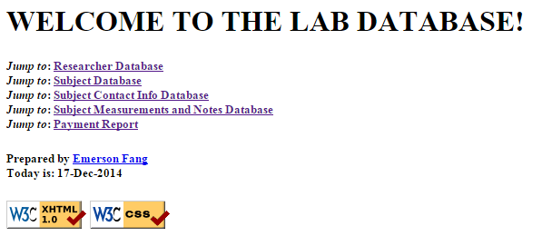

## Researcher Database Page:

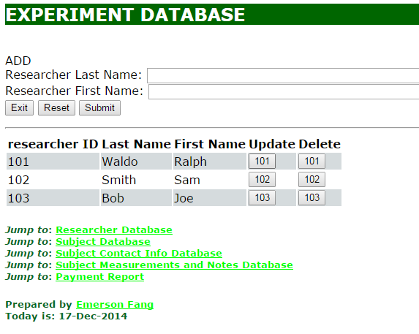

## Subject Database:

## 

## Subject Contact Info Database:

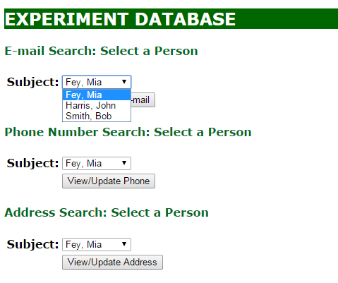

## 

## Subject Measurements and Notes Database:

## 

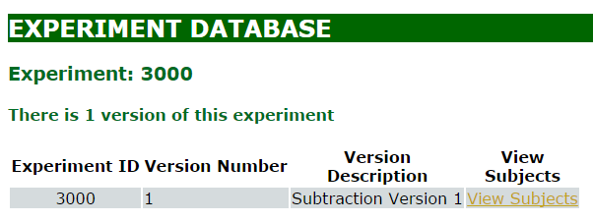

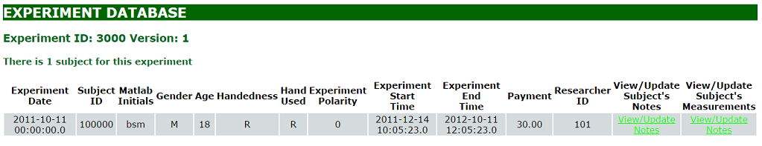

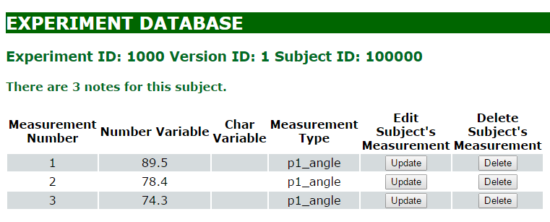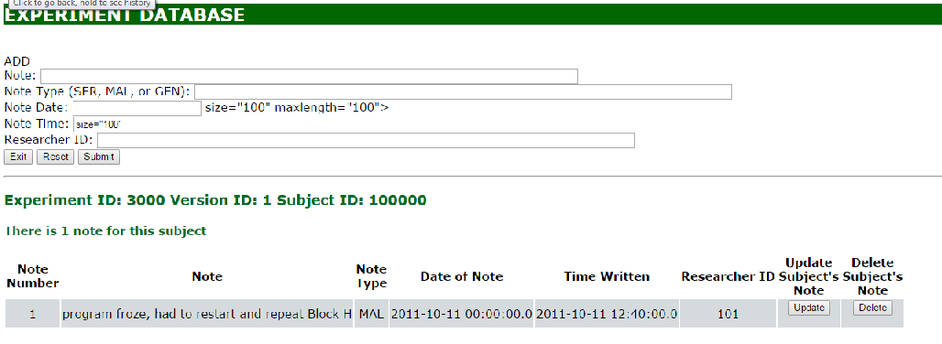

## Payment Report:

## 