This Week`s progress

Extract metadata from all pictures
Extracted all metadata using exiftool. There are two empty pictures with size 0b(11_HH_26_4_18/.../IMG_1109.JPG and 72_HH_1_6_18/.../IMG_0009.JPG). Apart from these two empty pictures, there are 418745 pictures collected. In summary, 12 different labels presents in those pictures. I use value 1 if label Human Presence presents. I merge label contact1, contact2 and contact3 into one label named contact and use value 1, 2, 3 to represent them respectively. I also merged Sp into species1 and merged Site into placeID. In the end the possible labels that a picture may have are "placeID", "species1". "Human.Presence", "contact", "species2", "species3", "Sp" and "n".

There are 60652 pictures that have no labels, which is about 14.48% of the dataset. For these pictures, I use the first number in the folder name to represent the place ID. The folder distribution of pictures with no tags is illustrated below:

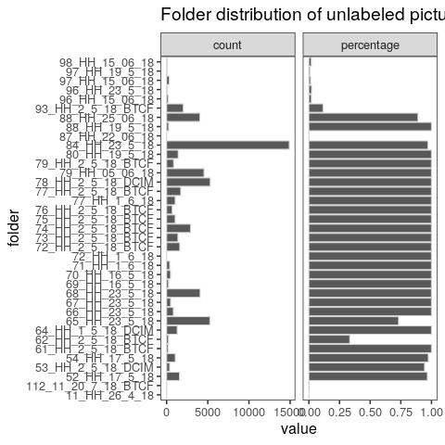

The site distribution of labeled pictures is shown below. There are 136 sites in total. But only 121 of them have labeled pictures. Particularly, only 39 of them contains human images.

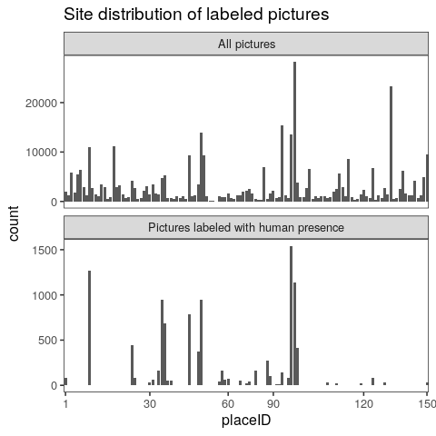

The below plots are site distributions of pictures labeled with human presence and species. The latter one is for each species. DogDog indicates pictures with 2 dog labels.
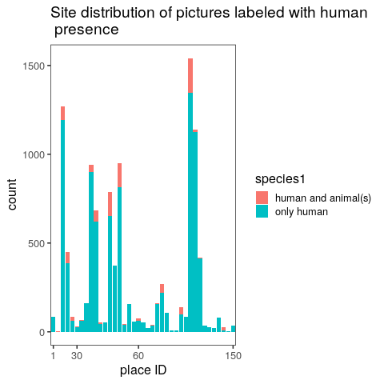
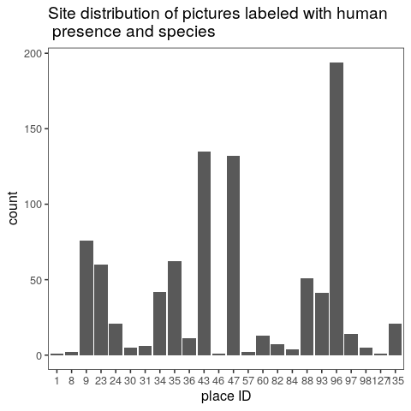

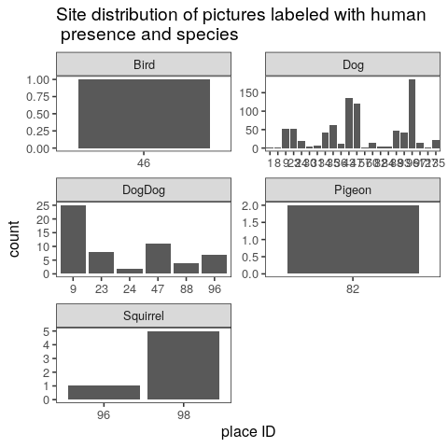

And this is the time distribution of images labeled with human presence.




