This Week`s progress

Update original metadata using calibration data
The calibration dataset contains metadata of 57634 images. 3236 images are missing in the original dataset. I ignored those missing data(since there are no pictures) and substitute the others with calibration dataset.

Seperate Prometheus and Reconyx
I extracted camera brand and camera model from pictures. There are 181906 of “Prometheus” and 236056 of “Reconyx”. Within brand “Reconyx”, there are three camera model HC500 HYPERFIRE(69063), HC600 HYPERFIRE(85782) and PC800 PROFESSIONAL(81211).

I also extract the sequence label. Only “Reconyx” have sequence label. There are 27886 images which has sequence label with value “0 of 0”.

Contact
There are only 4062 pictures labeled with contact(either 1,2, or 3). I checked the amount of pictures labeled with “contact” for each camera brand.For Reconyx data, There are 1647 pictures have label “contact1”, 81 pictures that have label “contact2”, and 4 pictures that have label “contact3”.For Prometheus data, There are 1764 pictures have label “contact1”, 36 pictures that have label “contact2”.

But I found out that label “contact1” only means the first individual in a sequence. For example a fox:
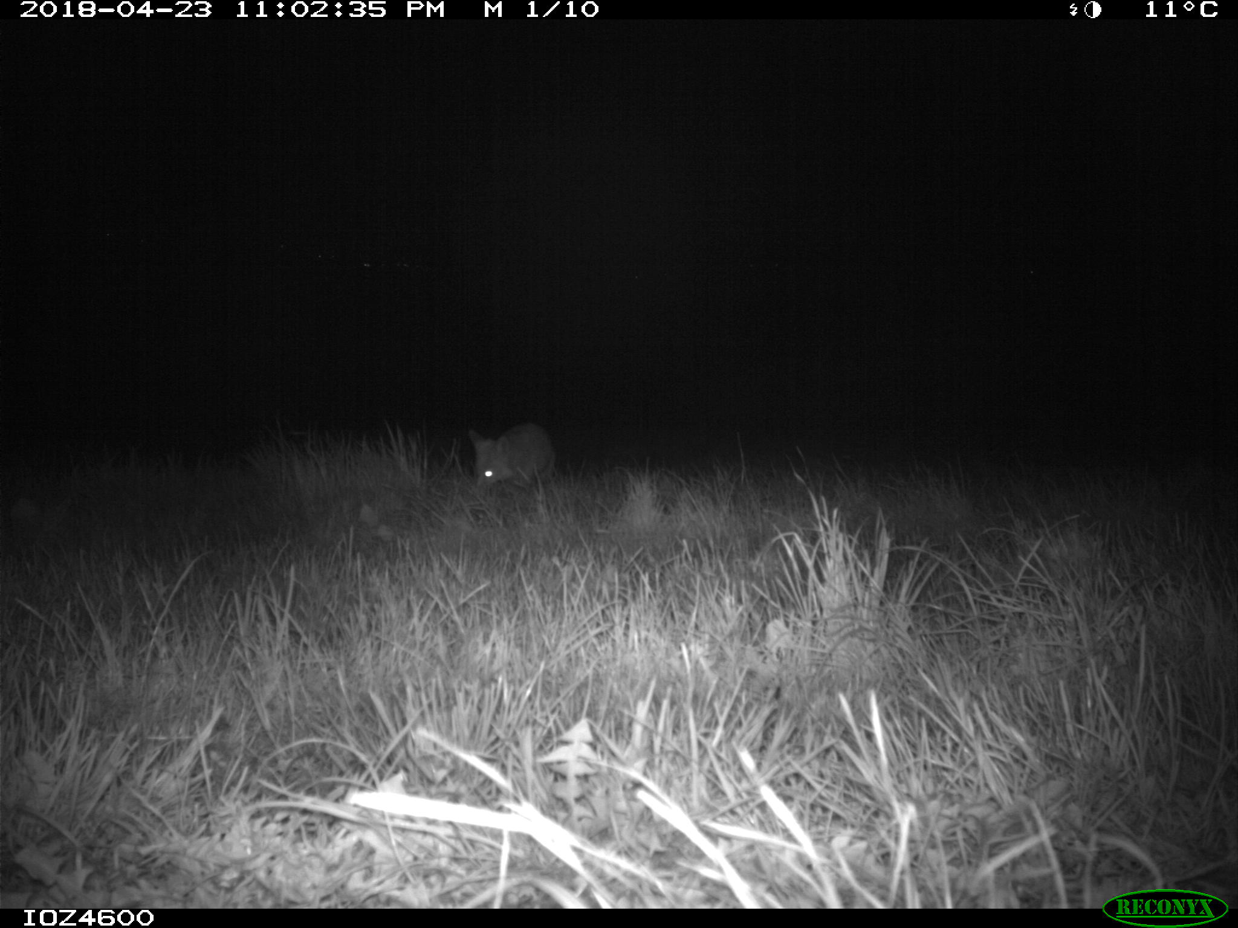

Some of the human images are labeled with “Human Presence”. But many of them doesn`t.

Questions:
- I still tried to install openpose on the school server this week. But some packages can`t be install without root permission. So I`d like to know if the google server is set up and how could I access it?

Sorry I didn`t do much in this week. I only update the original data using the calibration dataset. I think I really need to set up the environment run some code now.

