I created a test dataset using the calibration data. The dataset contains 9481 human images and 9481 non-human images. I ran both 3 models on the dataset. The confusion matrix of each model is shown as below:

BODY25 model
Predicted 0 1
Actual
0.0 6404 3077
1.0 3264 6217

{'accuracy': 0.6655943465879127,
'precision': 0.6689261889391005,
'recall': 0.6557325176669128,
'f1score': 0.6622636484687084}
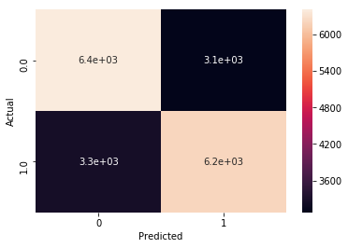

COCO model
Predicted 0 1
Actual
0.0 6518 2963
1.0 3478 6003

{'accuracy': 0.6603206412825652,
'precision': 0.6695293330359134,
'recall': 0.6331610589600253,
'f1score': 0.6508375345584648}
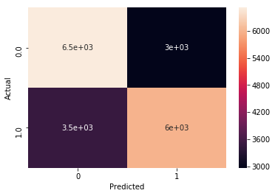

MPI model
Predicted 0 1
Actual
0.0 9345 136
1.0 6923 2558

{'accuracy': 0.6277291424955174,
'precision': 0.949517446176689,
'recall': 0.26980276342158,
'f1score': 0.42020533880903493}

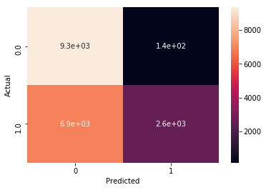

The execution times are roughly 6418 seconds(COCO), 4827 seconds(BODY25), and 6333 seconds(MPI),

I tried to run on the whole dataset. But it failed on some images since they are too large. I`m currently tried to compressed those images and hopefully I could get the result few days later.

