Extracted all skeleton data

There are 70,954 images that contain complete human skeleton data(at least 15 points). And the total number of complete human skeletons is 102,654. The following figures are the time distribution of skeletons and geographical heatmap.

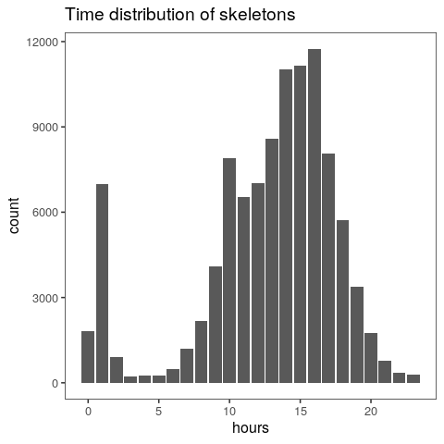

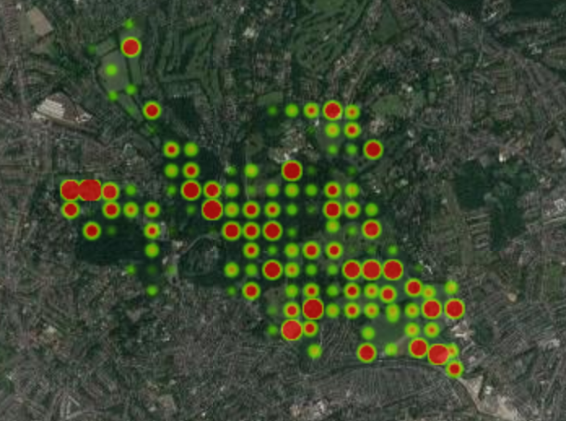

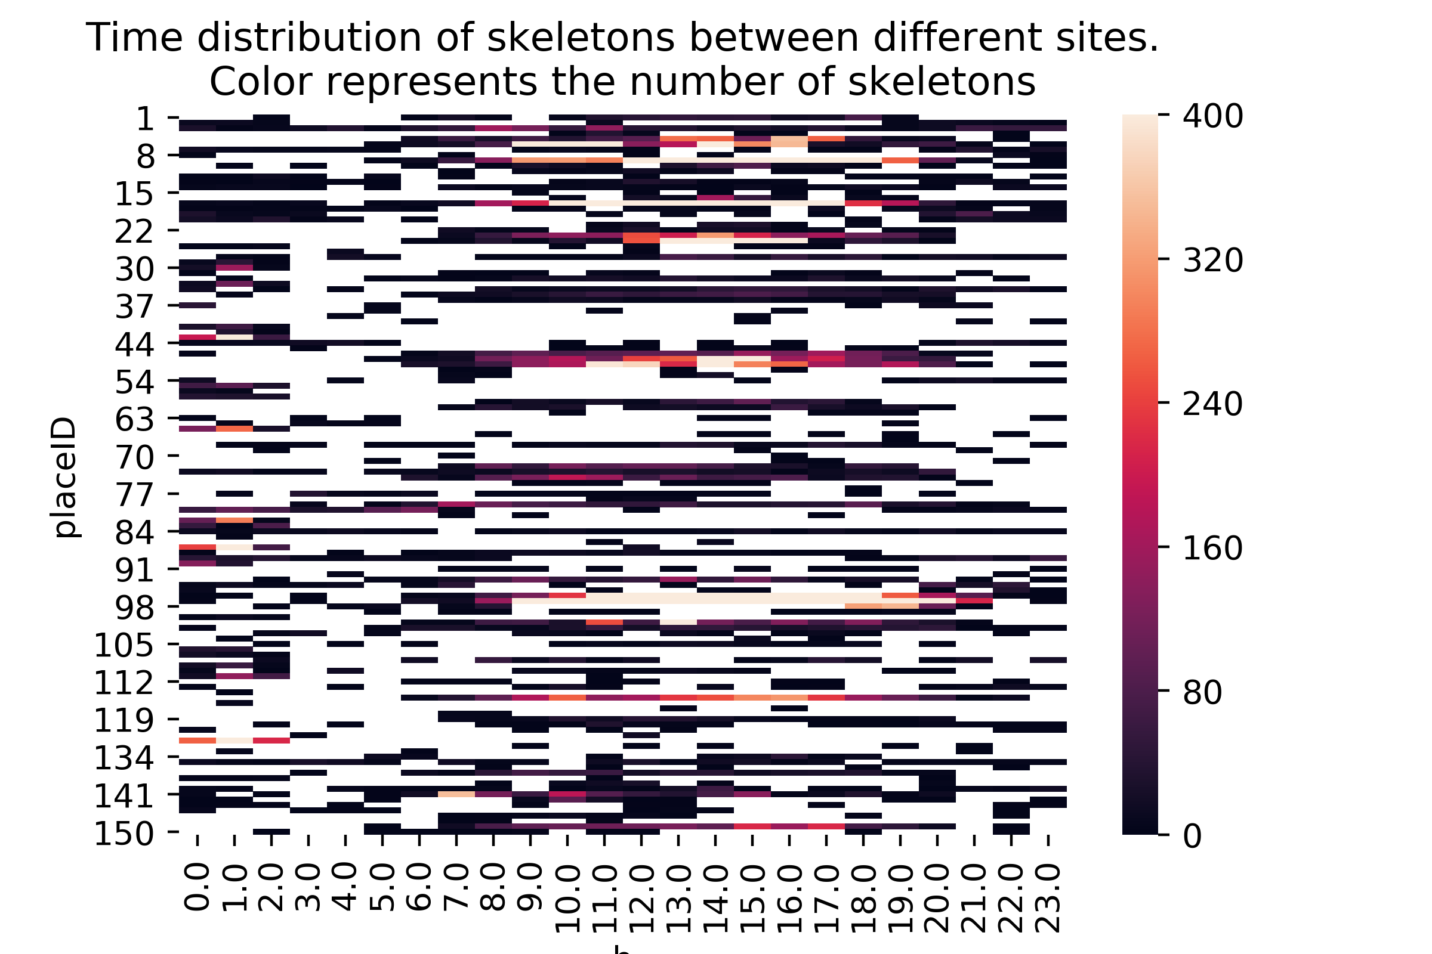

Clustering
Already down:
Each human skeleton is transformed into a linear graph in which the vectices are represented by line segments. A Laplacian matrix is constructed using the values of the angles between adjacent segments. L = D - A.

The eigenvalues and eigenvectors of the Laplacian matrix are calculated.

Next step:
Calculate spectral matrix using eigenvalues and eigenvectors.
Calculate the elementary symmetric polynoms.

The principal component method for the data representation in the space of smaller dimensions.

Using K-means to clustering the points

Question:
I `d like to have some advice on what I could do after I get the clustering results? And what if the results are bad?

Activity patterns

Quantifying levels of animal activity using camera trap data.

