- Shiya`s classifier
An Error occurred when running the classifer.
It seems that one or more images are
- Clustering
I found out that the openpose tool works poorly on grayscales. Here is an example(no human in the origianl data):
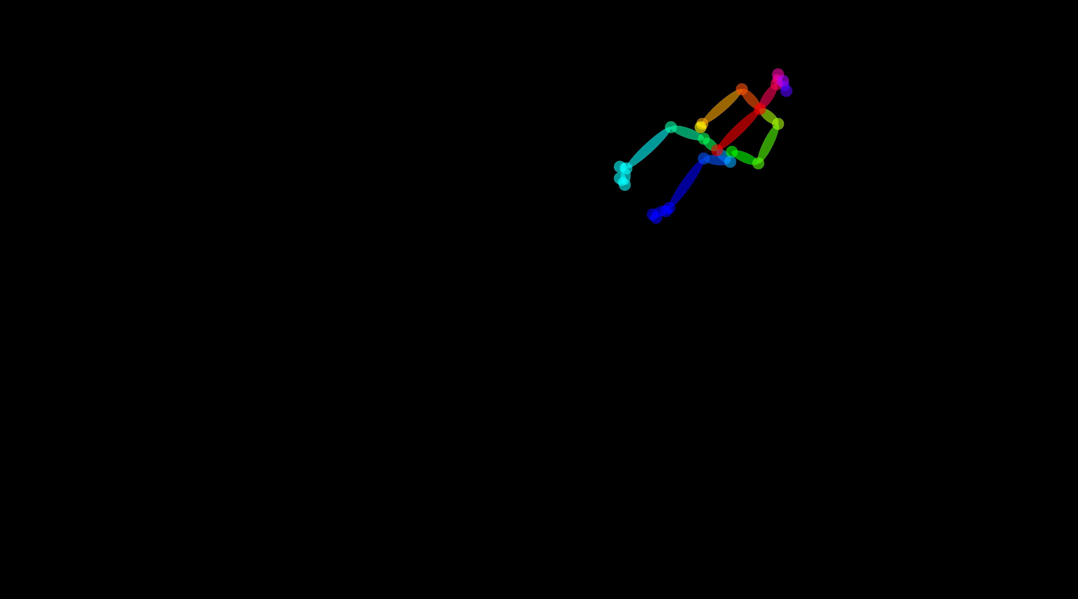

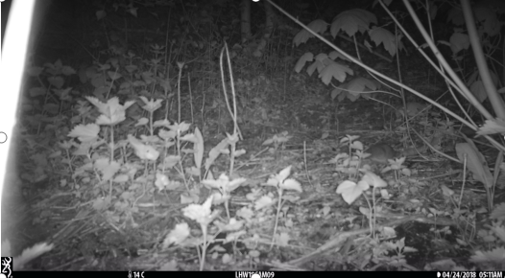

Since it works fine at day time, I only used image between 7am and 7pm and only skeleton data in image of every 45 seconds are used during clustering.

The silhouette score for different number of poses are:

For n_clusters = 2, silhouette score is 0.3361826414004594)

For n_clusters = 3, silhouette score is 0.33788240504853007)

For n_clusters = 4, silhouette score is 0.35833552782881384)

For n_clusters = 5, silhouette score is 0.3618297923832352)

For n_clusters = 6, silhouette score is 0.3650356374982716)
Below are the scatter plot for the clustering results(clustered into 2 poses, 4 poses, and 5 poses repectively).
