I got the results from the classifier. If I consider the classified results as actual values and results from Openpose as predicted values, the confusion matrix for all pictures is shown below.(1: human image, 0: non-human image)
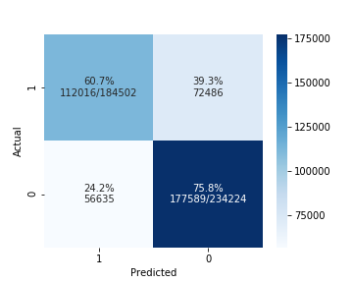
{'accuracy': 0.6916336697506245,
'precision': 0.6641881755815263,
'recall': 0.6071262100139836,
'f1score': 0.634376601642914}

I used skeleton data that has all 15 keypoints during the clustering. When we consider only the images which contain at least 15 human keypoints as human images, in other words, increasing the threshold to accept an image as a human image, the confusion matrix changes as:
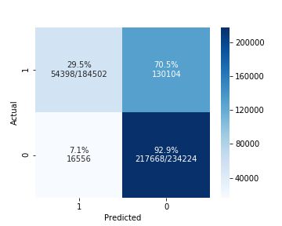
{'accuracy': 0.6497470899824707,
'precision': 0.7666657270907912,
'recall': 0.29483691233699366,
'f1score': 0.4258893899536515}

- Listen to the audio record and find out what analysis you should do
- Organize your code
- Organize your reference(you should have at least 50 references)
- Organize your report structure

- Compare shiya`s classifier and the openpose tool(confusion matrix on test dataset)
- Find the best p and keypoints for openpose to find the maximum accuracy.
- Figure out why the openpose tool has such bad performance in greyscale images. Is there a better way to ?
- Find the time and site influences on openpose.(geopraphic rates) perhaps fiting them into a glm?
- Listen to the audio.
- Organize your code
- Start writing report

