I use confusion matrix to describe the human detection performance for each classifier on the same set of test data.
Confusion matrix for OpenPose classifier is shown below:
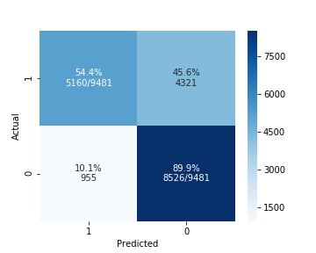
{'accuracy': 0.721759308089864,
'precision': 0.8438266557645135,
'recall': 0.5442463875118658,
'f1score': 0.6617081302898179}

And Confusion matrix for Shiya`s classifier is shown below:
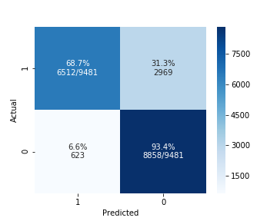
{'accuracy': 0.8105685054319165,
'precision': 0.9126839523475824,
'recall': 0.6868473789684633,
'f1score': 0.783822821376986}

While Shiya`s classifier achieves an higher accuracy of 0.81, both of these 2 classification models hold an unsatisfactory recall(0.54 and 0.68 respectively).

To discover the time distribution of misclassified images. I plot the count of misclassified images against time:

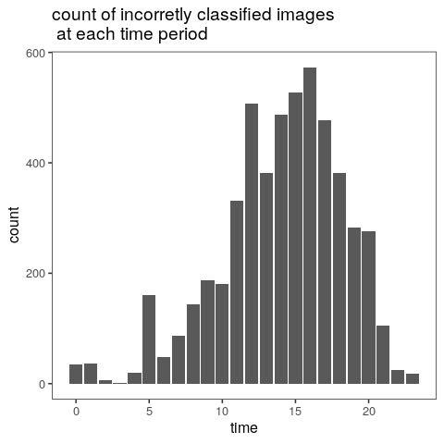

For all 418,723 images, there are 115,488 of them having mismatched classified results from 2 classifiers. If we consider the results from Shiya`s classifier as ground truth, then the Openpose`s performance can be evaluated by:
{'accuracy': 0.7241899776224378,
'precision': 0.7547920727745289,
'recall': 0.5540481945995165,
'f1score': 0.6390255490194853}

The below barplot shows the count of images that have mismatched classified results from 2 classifiers at each time period:

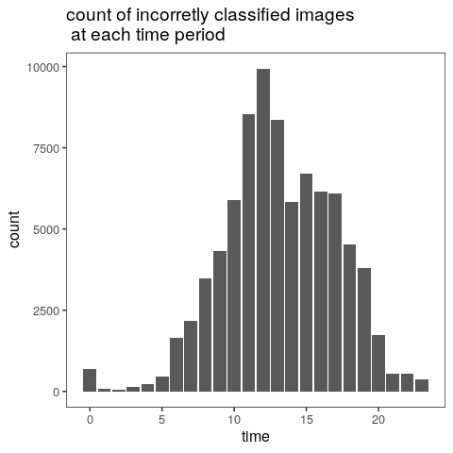

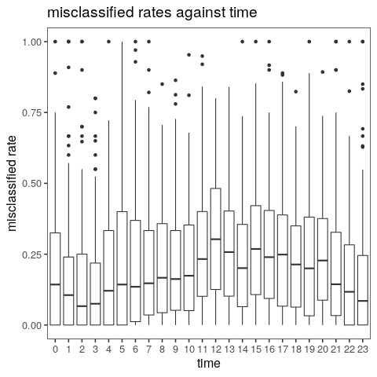

I use a LMM to investigate whether different sites over time explain variation in the percentage of misclassified images(results of 2 classifiers are different).
Linear mixed model fit by REML ['lmerMod']
Formula: percentage ~ time + (1 | placeID)
Data: total_diff

REML criterion at convergence: -751

Scaled residuals:
Min 1Q Median 3Q Max
-2.4569 -0.6649 -0.1841 0.4731 4.6084

Random effects:
Groups Name Variance Std.Dev.
placeID (Intercept) 0.009755 0.09877
Residual 0.039078 0.19768
Number of obs: 2758, groups: placeID, 136

Fixed effects:
Estimate Std. Error t value
(Intercept) 0.196185 0.021722 9.032
time1 -0.009227 0.028139 -0.328
time2 -0.026927 0.028633 -0.940
time3 -0.038477 0.028202 -1.364
time4 0.009625 0.029126 0.330
time5 0.041113 0.027798 1.479
time6 0.016339 0.027147 0.602
time7 0.031730 0.026893 1.180
time8 0.033554 0.026856 1.249
time9 0.022965 0.026570 0.864
time10 0.025537 0.026700 0.956
time11 0.078110 0.026576 2.939
time12 0.115142 0.026570 4.334
time13 0.077093 0.026563 2.902
time14 0.039529 0.026490 1.492
time15 0.081589 0.026515 3.077
time16 0.079507 0.026700 2.978
time17 0.071279 0.026741 2.666
time18 0.031661 0.026861 1.179
time19 0.049655 0.027048 1.836
time20 0.049368 0.027150 1.818
time21 0.031221 0.027530 1.134
time22 -0.010525 0.027853 -0.378
time23 -0.021248 0.028031 -0.758

Grassland tree woods

