
Demo Program in C for Linux
Configuration – Single reader Multi-port

- Open the file “RD1_PortConfig.txt” for antenna port configuration of CSL reader 1.
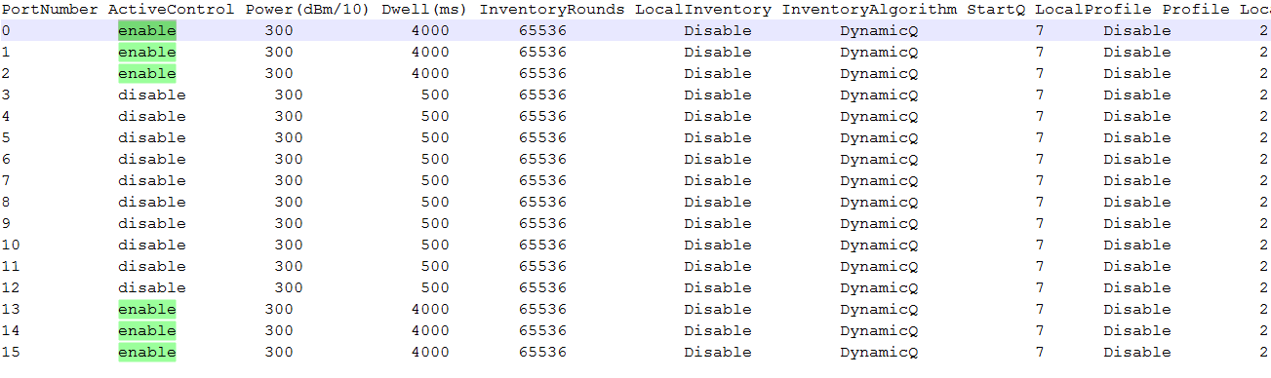
- To enable port 0, 1, 2, 13, 14, 15 in CSL reader 1, set “enable” in the column “Active Control” in the line the PortNumber.

- Set “300” in Power (dBn/10) for each port.
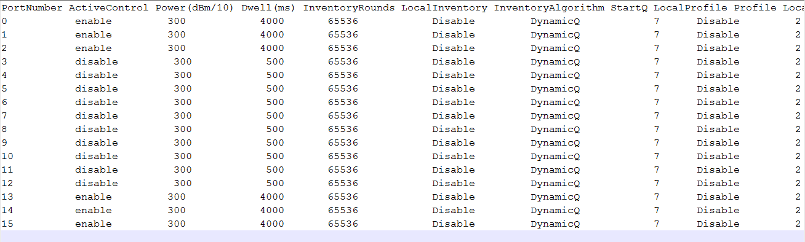
- Set Dwell Time (Dwell (ms)) for each port. Here we set Dwell to “4000” (4 seconds)

- Save file “RD1_PortConfig.txt”.

- Open file “config_SrMp.txt” for single reader, multi-port configuration.
- Enter the IP Address of the reader, “-tag”, “-loop”, Country (“-country HK”), power (“-power 300”),
Dwell Time (“-dwellTime 6000”), Port Configuration with file (“-portconf RD1_PortConfig.txt”) as follow:
Reader IP Address
Country : Hong Kong
Power
Dwell Time
Reader Port Configuration

Please refer to “Parameter_Usage.txt” in the main directory for the usage of parameter in detail.
Please use a new line for parameter entry of new reader.

- Save file “config_SrMp.txt”.
- Open batch file “cslcmd.sh” and enter “./example -conf config_SrMp.txt” in the file.

- Copy and replace “RD1_PortConfig.txt”, “config_SrMp.txt” and “cslcmd.sh” in the main directory with Demo Program “example”
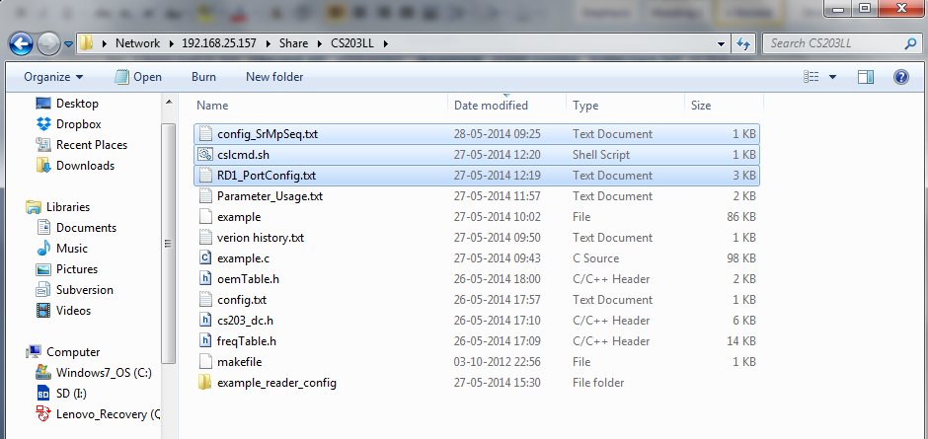

- Type “./cslcmd.sh” in command window to run Demo Program “example” in Linux platform.
- In summary, Appendix A, B, C shows the content of cslcmd.sh, config_SrMp.txt and RD1_PortConfig.txt respectively.

Appendix A: cslcmd.sh

This file only contains 1 line:

./example -conf config_SrMp.txt

Appendix B: config_SrMp.txt

This file can contain 1 line or multiple lines. Each line contains 1 reader configuration.

192.168.25.210 -tag -loop -country HK -power 300 -dwellTime 6000 -portconf RD1_PortConfig.txt

Appendix C: RD1_PortConfig.txt

This file only contains 16 lines. It represents the antenna ports setting of the reader.
From 2nd to 16th line, each line contains 1 antenna port setting with Port Number.

PortNumber ActiveControl Power(dBm/10) Dwell(ms) InventoryRounds LocalInventory InventoryAlgorithm StartQ LocalProfile Profile LocalChannel Channel
0 enable 300 4000 65536 Disable DynamicQ 7 Disable 2 Disable 1
1 enable 300 4000 65536 Disable DynamicQ 7 Disable 2 Disable 3
2 enable 300 4000 65536 Disable DynamicQ 7 Disable 2 Disable 1
3 disable 300 500 65536 Disable DynamicQ 7 Disable 2 Disable 3
4 disable 300 500 65536 Disable DynamicQ 7 Disable 2 Disable 4
5 disable 300 500 65536 Disable DynamicQ 7 Disable 2 Disable 1
6 disable 300 500 65536 Disable DynamicQ 7 Disable 2 Disable 2
7 disable 300 500 65536 Disable DynamicQ 7 Disable 2 Disable 3
8 disable 300 500 65536 Disable DynamicQ 7 Disable 2 Disable 4
9 disable 300 500 65536 Disable DynamicQ 7 Disable 2 Disable 1
10 disable 300 500 65536 Disable DynamicQ 7 Disable 2 Disable 2
11 disable 300 500 65536 Disable DynamicQ 7 Disable 2 Disable 3
12 disable 300 500 65536 Disable DynamicQ 7 Disable 2 Disable 4
13 enable 300 4000 65536 Disable DynamicQ 7 Disable 2 Disable 2
14 enable 300 4000 65536 Disable DynamicQ 7 Disable 2 Disable 4
15 enable 300 4000 65536 Disable DynamicQ 7 Disable 2 Disable 2

