
Demo Program in C for Linux
Configuration – Set Country for reader

- Open file “config_Cty.txt” for multi-reader, single-port.
- User can define the country where the reader operate (“-country HK”) as follow:
Reader IP Address
Country : Hong Kong
Power
Dwell Time

Please refer to “Parameter_Usage.txt” in the main directory or Appendix C of this document for the list of Countries / Regions available in detail.

- Save file “config_Cty.txt”.
- Open batch file “cslcmd.sh” and enter “./example -conf config_Cty.txt” in the file.

- Copy and replace “config_Cty.txt” and “cslcmd.sh” in the main directory with Demo Program “example”
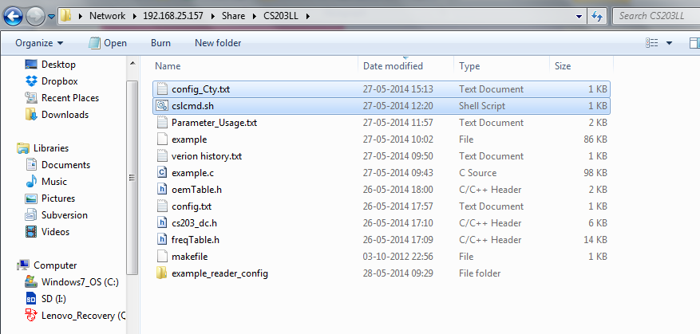

- Type “./cslcmd.sh” in command window to run Demo Program “example” in Linux platform.
- In summary, Appendix A, B show the content of cslcmd.sh and config_Cty.txt respectively.
- Appendix C shows the list of Countries / Regions available.

Appendix A: cslcmd.sh

This file only contains 1 line:

./example -conf config_Cty.txt

Appendix B: config_Cty.txt

This file can contain 1 line or multiple lines. Each line contains 1 reader configuration.

192.168.25.210 -tag -loop -country HK -power 300 -dwellTime 6000
192.168.25.204 -tag -loop -country HK -power 300 -dwellTime 6000
…….

Appendix C: List of Countries / Regions in Parameter_Usage.txt

Unitied state : FCC
Europe : ETSI
India : IN
G800 : G800
Australia : AU
Brazil 1 : BR1
Brazil 2 : BR2
Hong Kong : HK
Thailand : TH
Singapore : SG
Malaysia : MY
South Africa : ZA
Indonesia : ID
China : CN / CN1 / CN2 / CN3 / CN4 / CN5 / CN6 / CN7 / CN8 / CN9 / CN10 / CN11 / CN12
Taiwan : TW
Japan : JP

