Look across all previously generated figures and tables and write at least three observations or inferences that can be made from the data.

1. Based on the scatter plot, one could infer that the average tumor volume increased as mouse weight increased for the Capomulin regimen.

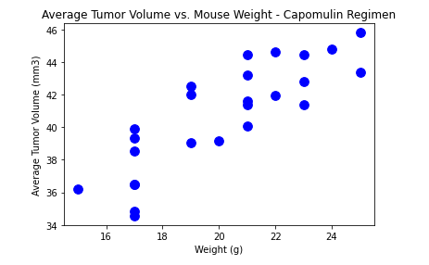

1. Based on the data summary table, drug regimens Capomulin and Ramicane might be drugs worth doing additional research on. They have the lowest mean, median, and variance. Additionally, their standard deviations and SEMs are the smallest, potentially meaning these drugs’ data set are less variant as compared to the other drugs being tested.

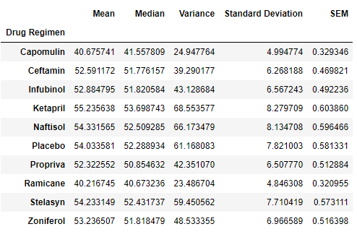

1. There are slightly more male mice in the study than female mice. However, the difference of 50.6% male and 49.4% female, is not statistically significant enough to infer if one gender is favored in the study over the other, as they are nearly distributed equally.

