1 = ok

2 = A: ok B:

3 = ok

4 =

At4

Questão 1

C

Questão 2

A

package copy;

public class Xcopy {

public static void main(String[] args) {

int orig = 42;

Xcopy x = new Xcopy();

int y = x.go(orig);

System.out.println(orig + " " + y);

}

int go(int arg) {

arg = arg * 2;

return arg;

}

}

B

package clock;

public class Clock {

String time;

void setTime(String t) {

time = t;

}

String getTime() {

return time;

}

}

class ClockTestDrive{

public static void main(String[] args) {

Clock c = new Clock();

c.setTime("1245");

String tod = c.getTime();

System.out.println("time:"+tod);

}

}

Questão 3

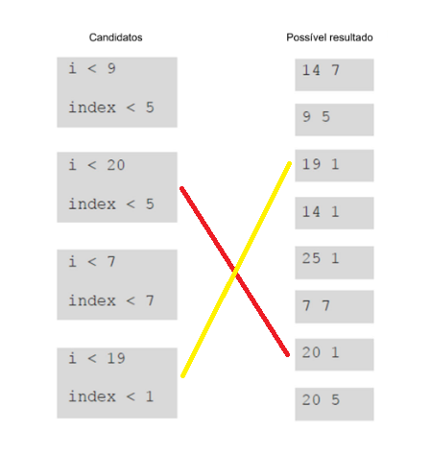

Questão 4

**public** **class** Puzzel4 {

**public** **static** **void** main(String[] args) {

**int** number = 1;

**int** i = 0;

**while** (i < 6) {

number = number * 10;

i = i + 1;

}

**int** result = 0;

i = 6;

**while** (i > 0) {

i = i - 1;

result = result +

}

System.out.println("result " + result);

}

/*}

class {

int intValue;

doStuff(int ){

if (intValue > 100) {

return

}else {

return

}*/

}

//}