# 附录

## 其他应用场景详述

### 互助链架构应用于保险流程的优化

Blockchain’s value for Insurance

External Reporting

Claims

Post Bind

Accounting & Settlement

Placing

## 

***Blockchain has the potential to drive simplicity and efficiency through the establishment of new financial services infrastructure and processes across all of the key aspects of the insurance value chain***.

Operational simplification: Reduces manual efforts to reconcile and resolve disputes;

Counterparty risk reduction: Agreements codified and executed in a shared, immutable environment;

Liquidity and capital improvement: Can reduce locked-in capital and provides increased transparency;

Regulatory efficiency improvement: Enables real-time monitoring;

Clearing and settlement time reduction: May reduce some third parties supporting transaction verification / validation and accelerates settlement;

Fraud minimization: Helps with asset provenance and transaction history within a single source;

**Insurance Administration:**

Today:

1. Manual processes between multiple parties (Insurance provider, benefits administrator, employer, employee, service provider network, etc)
2. Protracted coordination of business transactions between business network participants
3. Different versions of the same data in multiple systems of record, leading to added costs and lengthy disputes
4. Error prone verification processes for eligibility and benefits

With Blockchain:

1. Manual process are automated by sharing plan participant, entitlement and claim data
2. Smart contracts computationally encode participant registration and verification rules
3. Shared data and smart contract computations reduce downstream disputes
4. Benefits verification based on multiple data sources readily available to all service providers

#### Blockchain’s Value for Insurance

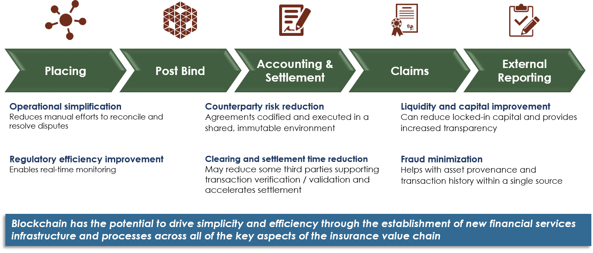

#### Blockchain Network Participants

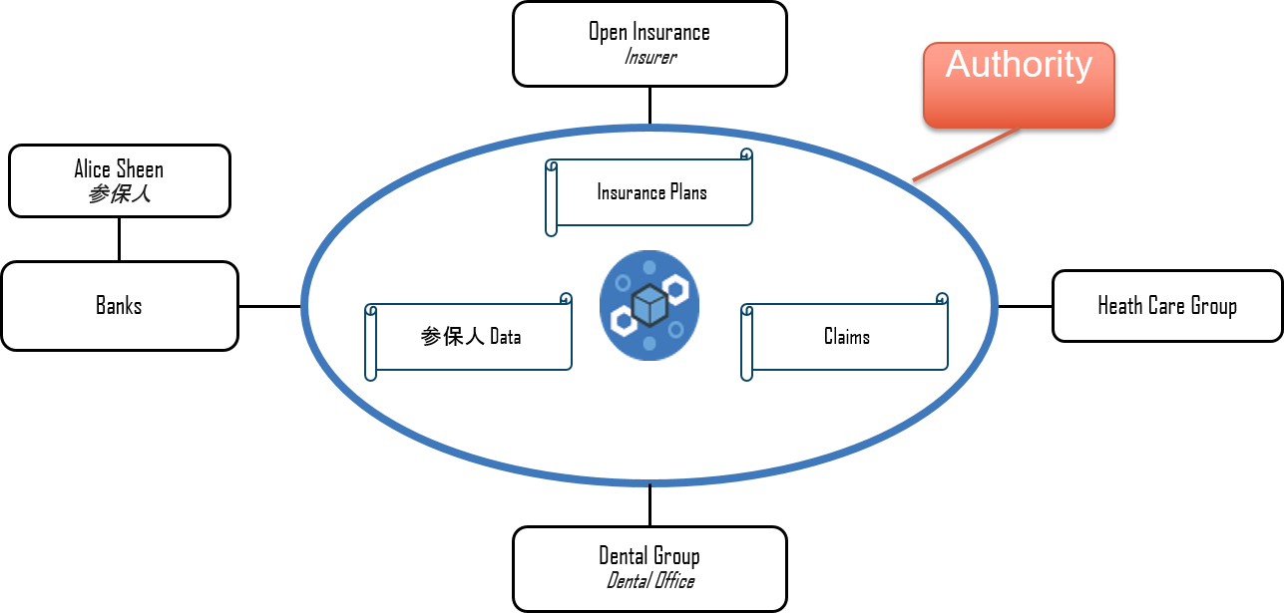

#### 应用场景一（互助保险）

Client registers on mutual insurance exchange and create own wallet

* verify personal information
* link bank account to exchange
* setup private key and wallet for policyholder and beneficiary
* System maintenance cost and Blockchain gas
* Investments and reinsurance

Client buys ETH or BTC coins from exchange

* Exchange prepares quote based on client request on coverage
* Smart Contract is initialized between each policyholders to mutually cover each other

Client shops on life insurance coverage on exchange and quote premium in mutual insurance coin

Client buys mutual insurance coin (smart contract) to engage with current mutual insurance policyholders

* Smart contract distributes new coverage coins equally to each current policyholders
* Each current policyholder gets new coverage coins portion and agrees to lock it until coverage expires or payout as part of death claims

Blockchain broadcast event

Smart contract executes based on survivorship certificate and expires coverage between policyholders and unlock mutual insurance coverage

Smart contract executes based on death certificate and mutual policyholders pays mutual insurance coin to beneficiary wallet

Plan Participant Onboarding (Insurance Sales): Interactions between Plan Sponsor and Plan Administrator to on-board Plan Participants is often cumbersome and error prone

Role of Blockchain:

* Records required plan participant information directly from Plan Sponsor’s HR systems
* Makes data available to all blockchain participants on a real-time basis reduces possibility of dispute
* Improves client satisfaction and reduces costs

#### 应用场景3

Coverage Verification:

Lack of ready availability can:

- Delay provision of coverage upfront

- Involve cumbersome manual discussions

- Require upfront payment despite coverage

Role of Blockchain:

* Provides immediate access to coverage information and current plan participant status
* Smart contracts verify plan participant coverage immediately, and avoid creation of payment disputes after the appointment occurs

#### 应用场景4

Claim Submission:

Initial submission and filing process can:

- Allow erroneous submissions

- Result in dispute resolution

- Delay payment times

Role of Blockchain:

* Provides smart contracts that capture key contractual elements of the underlying policy and flag claim errors before submission
* Gives all permissioned parties access to claim data
* Provides immediate access to more relevant data and reduces the time required to make business decisions

### 互助链架构应用于房屋贷款审批及投资平台

#### Mutual Chain Mortgage Origination: Processes are timely, costly and can result in search errors, which generate transactional risk

# 

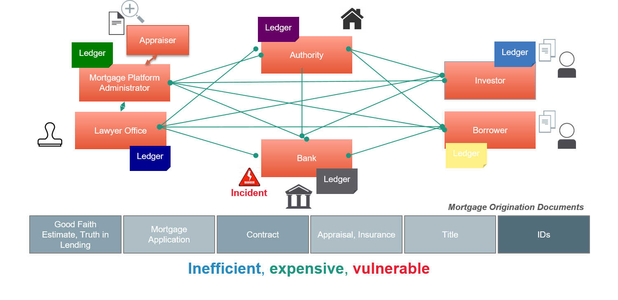

#### Mutual Chain A shared ledger between involved parties can increase trust, speed of execution, auditability and cost













 