**Nama : Kholiq Amrulloh**

**Nim : 16650072**

**BRIEF**

**Background information :**

Industry

Physical Fitness

**App description** :

Stream live and/or pre-recorded fitness classes. Classes such as yoga, kickboxing, HIIT bootcamp, zumba...etc are available in the comfort of your own home.

Existing website :

Unspecified

**Visual style :**

Style/theme ideas

We want to leave the style to be up to the designers imagination. Colors are up to the designer as well. However, the app will cater to both men and women. So we want to make it unisex, but with a little more emphasis on women. Also, we will be testing the app on an iPhone 6s. So the design should take the screen size of the standard 6s into account (not the 6s plus)

**Inspirational websites**

Unspecified

Content details

**App name** :

FitStream

**Screen descriptions**

First off I want to say we are open to any ideas the designer has. What we are writing here is just our vision, but we are more than welcome if you (as a professional UI/UX designer) have ways to make it better.

1st Screen - Login Screen Login will have a User ID and Password, a forgot password, login button, login with facebook, and login with google. We really like the ones with a picture as the background with a color/gradient overlay or a blurred background. The home screen may have a logo, but at the very least some text saying FitStream in it. For now, it's perfectly okay to just include it as text for demonstration purposes. If the designer is choosing to do a background image, I would like the image to be either a class/ group of people or both a male and a female.

2nd Screen - Browse Screen The browse screen has three parts to it: Classes that are live right now, categories, and a tab bar.

- Classes live now: we were thinking of being a carousel or a single row horizontal collection.  
- Categories section: we REALLY like Spotifys category tiles seen in the browse section of Spotifys app (see attached image). Basically these would be the categories of fitness classes: Yoga, kickboxing, HIIT, Boot camp, Spin, Zumba..etc

- Tab bar: the tab bar will have 4 tabs: Home, Browse, Search, and More (similar to facebooks more)

3rd Screen Video Listings Screen

From the Browse screen, users can select a category. Once they select a category they will be brought to this screen that will contain all of the available videos within that category. We are very open to ideas for this screen.

4th Screen Video Details Screen

After the user selects a video from either the "classes live now" section of the Browse screen, or after a user selects a video from the video listings screen, they will be brought to the Video details screen. One thing that this screen needs to have is a button to "cast" it to their TV using google chromecast. We are open to ideas on the design for this screen as well.

**Device type**

iPhone

**What to avoid**

cartoons and vibrant colors

Other

Attachments

VIDEO PAPER PROTOTYPE :

Link :

MOCKUP DESAIN :

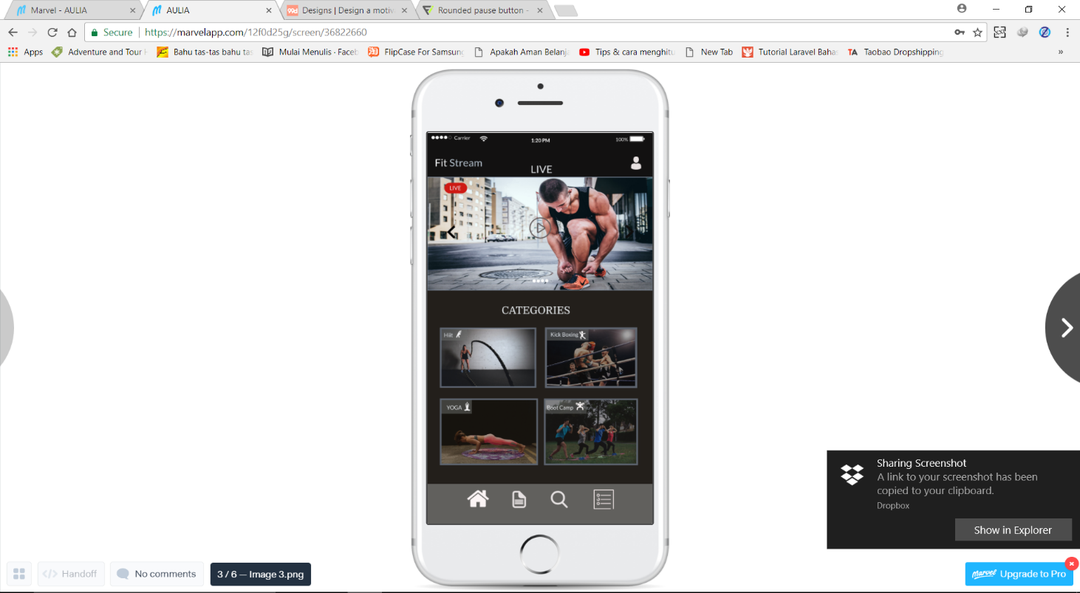

Link :

EVALUATION :

Usability testing :

|  |  |  |  |
| --- | --- | --- | --- |
|  |  | ya | tidak |
| 1 | Apakah aplikasi ini berjalan dengan baik |  |  |
| 2 | Apakah masih terdapat bug dalam aplikasi ini |  |  |
| 3 | Apakah desain aplikasi ini sangat menarik |  |  |
| 4 | Apakah aplikasi ini dapat membantu anda |  |  |
| 5 | Apakah aplikasi ini cocok untuk semua kalangan |  |  |

usability

POIN Dari 5 Pertanyaan dari 5 user:

User 1 : Y Y Y YY= 5

User 2 : Y Y Y Y T = 4

User 3 : Y Y T T T = 2

User 4 : T T T Y Y = 3

User 5 : Y T T T T = 1

NIlai = 15 Dari 25

Nilai Adalah : 3

Fungsional testing :

|  |  |  |  |  |  |
| --- | --- | --- | --- | --- | --- |
| No | Question | 1 | 2 | 3 | 4 |
| 1 | fitur aplikasi ini sudah berjalan dengan baik |  |  |  |  |
| 2 | Fitur Live streaming sangat menarik |  |  |  |  |
| 3 | Pemutar Video online dapat berjalan |  |  |  |  |
| 4 | Keamanan akun sudah baik |  |  |  |  |
| 5 | Kategori fitstream sudah sangat tepat |  |  |  |  |
| 6 | Tab menu berjalan sesuai fungsinya |  |  |  |  |
| 7 | Fitur community sangat membantu |  |  |  |  |

Keterangan :

1. tidak setuju

2. kurang setuju

3. setuju

4. sangat setuju

POIN VIEW

Hasil Dari Jawaban 5 User

User 1 : 2, 4, 4, 4, 4 =18

User 2 : 1, 1, 4, 4, 3= 13

User 3 : 4, 4, 4, 2, 1= 15

User 4 : 3, 4, 4, 2, 1= 14

User 5 : 1, 1, 4, 1, 3= 10

Nila nya adalah : 70