**Detailed Component Selection**

*Suspension Selection*

It was decided that the design would incorporate a fully suspended bike for two reasons. The first of them, was the fact that incorporating electrical components could increase the weight by up to 25 kg. Secondly, reducing the vibrations acting on these electrical components will prolong their lifetime (Muetze & C.Tan, 2007).

The choice for the front suspension was quite simple. The team decided to go forward with a classical front fork suspension system. This is simple, affordable, and efficient. Since the design was not intended for a performance bike, the required system needed only to fit two criteria: quality and affordability. Following these guidelines, the team chose SR Suntour XCR-RL Fork Suspension. This choice was made based on the reliability of the company and the specifications detailed for the specific product (SR Suntour, 2018).

However, a design problem was encountered when considering the rear suspension. Most available rear suspension designs are made for high-performance bicycles such as mountain bikes. These types of bicycles often have “futuristic” and “sporty” frames. This was a problem because the design had to incorporate rear suspension into a classical frame; something which isn’t too common in industry. After considering a series of suspension designs, it was determined that a Hort-link (four-bar) design would be incorporated (Stott, 2017). This decision was made for two reasons: The Horst-link was one of the view designs which had some similarity to our frame choice, and this design left lots of options in terms for suspension designers when considering values such as the instant centre (IC), anti-squat, pedal kick-back, and anti-rise. Design regarding the IC is further analysed in the calculations section.

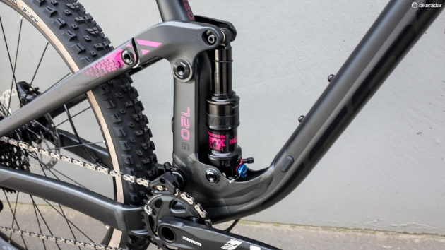The Horst-link design is a suspension design where the rear axle is indirectly connected to the main frame via a system of pivot points which allow the rear wheel to compress the dampener. As the dampener compresses, the rear axle moves upwards relative to the static main frame. A basic example of this design is shown below in Figure 1.

Figure 1: The conventional Horst-link design.

A few differences may be noted between the frame required for a conventional Horst-link design and the team’s frame of choice. There is a difference in the angle of orientation of the top rear axle between both designs. Our frame requires a significantly greater angle. However, this is not a problem, as this can be altered, and the dampener can be set beneath the seat. The orientation of the top axle will be selected such that it appears to be a continuation of the horizontal bar of the main frame. Due to the small dimensions of the dampener, this will not affect the ease of mounting and dismounting the vehicle. Furthermore, the design in Figure 1 has two predominant pivot points, at the connection to the main frame and the connection to the dampener. However, due to the increased geometry of the pedals due to the incorporation of the electric motor, we must also incorporate another crucial pivot point at the pedal clearance. This will enable the whole of the rear axle to move in a circular fashion around this connection point; with the positioning being dictated by the dampener compression. Furthermore, the dampener will have to be relatively stiff to avoid humungous deflections, as this would not go well together with a classic frame. The final integration into the 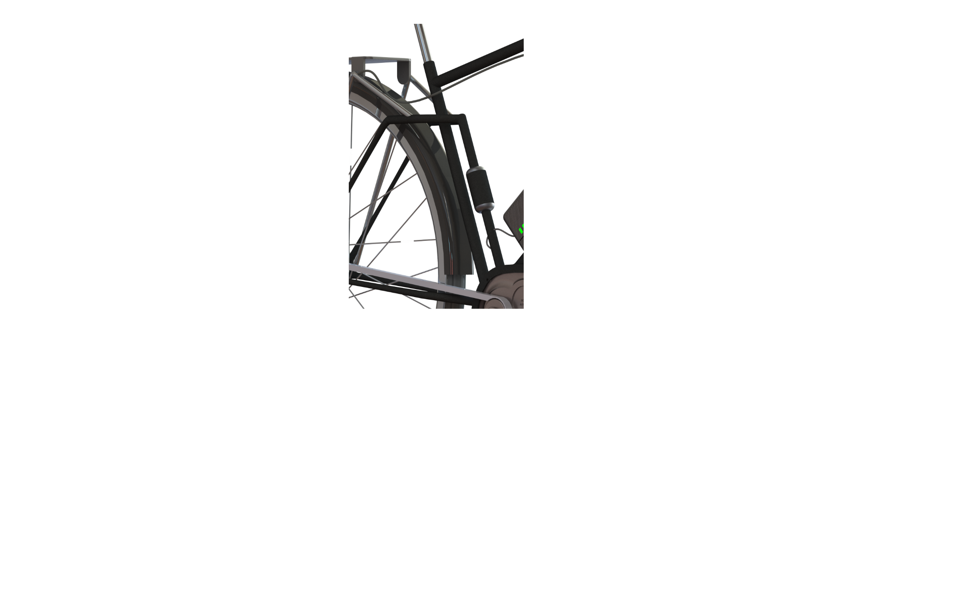design, modelled in CAD, is shown below.

Figure 2: Rear suspension integrated into classic bike frame (using Solidworks).

In terms of the selection of the dampener, the same criteria apply as for the front suspension: a quality product with a requirement of average performance. For this purpose, the team decided to go with the M2R Rear Shock Absorber 270mm due to its reputation in the market, performance, and reduced dimensions (M2R, 2018).

*Electrical Drivetrain Selection*

When considering the electrical drivetrain, the first decision was to decide on the type of motor to be incorporated into the design. The available options where: AC motors, DC motors, and brushless DC (BLDC) motors. AC motors are rarely used within the electric bicycle market due to the requirement of inverters, for converting AC to DC, which add extra mass. However, the market is split when it comes to selecting between a DC and BLDC motor. When comparing both, BLDC motors prove to require a greater investment due to being more complicated, however, they are quieter, more powerful, and last longer. Furthermore, DC motors are not good at constant speed control. Keeping in mind the project’s target quality, and the fact that it is designed for city use where a good constant speed control is necessary, the team decided to proceed with a BLDC motor (Raghunath, 2014).

Once the type of motor was selected, the following step was to consider where the motor would be mounted onto the frame. As specified in the morphological analysis, the following options where considered: belt-drive transmission, direct drive, frame mounted motor, wheel mounted disk motor, hub motor, and a friction-based shaft. Upon simple consideration and market analysis, this extensive list was narrowed down to two options: frame mounted and hub motors. Initially, hub motors were given preference due to their simplicity, as they required no interaction with the primary chain; leading to minimal maintenance. However, hub motors contribute towards the total un-sprung weight of the vehicle. Un-sprung weight increases rotational inertia, which negatively impacts the acceleration and driving dynamics of the vehicle (Fenske, 2013). This could be fixed by using high-tech materials, such as composites, for the wheel and rim; nonetheless, the team decided to go with the simpler option to avoid unnecessary complications. Therefore, a frame mounted motor was chosen. These motors provide good power transfer without complications but require an additional chain and planetary gears which increase the sprung weight of the vehicle (Raghunath, 2014).

When it came to motor power selection, not much design freedom was left, as EU standards set the maximum power to 250W (DIN EN 15194, 2017). A more powerful motor requires a battery with a greater capacity. However, the usage of a 250W motor within the EU market is standard within the industry, with very few products offering less powerful motors. Furthermore, one of our leading user requirements was to provide a vehicle which would enable a man to commute to work without arriving sweaty. Therefore, a powerful motor will require minimal physical effort. Hence, despite this requiring a battery with a greater capacity, a 250W motor was chosen.

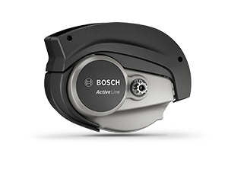Following the previous characteristic specifications: 250W BLDC frame mounted motor, the team analysed the market for potential candidates. The electric bicycle motor market is segmented between Bosch, Yamaha, Shimano, and Panasonic. Upon inspecting the brand reputations, and the products they offered, a clear candidate rose: Bosch. First, Bosch is the most common electric bicycle motor brand, and its past and future performance have moulded a reputation of quality and reliability. Furthermore, Bosch has a branch of motors which have been optimised for city use: Bosch’s Active Line. Within this line, the company offers the Active Line, and Active Line Plus, with the only difference being a greater initial torque in the latter. Since motor acceleration is not essential within city use (most of the driving will take place at constant speed), Bosch’s Active Line was chosen. Furthermore, the motor offers four different driving modes, which include city optimisation and efficiency, giving the user greater freedom when choosing his desired driving experience. The selection is shown in the Figure 3 (Bosch, 2018).

Figure 3: The chosen 250W BLDC frame-mounted motor – Bosch’s Active Line.

When considering the rest of the electrical drivetrain, an early decision was made to select components from Bosch. This would ensure our product having a highly compatible drivetrain with fully warranty, which would further simplify design and possibly result in greater cost reductions during bulk ordering. When considering the battery, many possibilities were considering, including: lead-acid (sealed), lithium-ion, NiCD, and NiMH. However, after looking at the advantages and disadvantages of each, the team decided to follow the industry standard: lithium-ion (Raghunath, 2014). As the vehicle would be used for commuting to work and back within the city, it was deemed that the required range was not too big. First, charging ports are generally available at both work and home. Furthermore, commutes within the city are not expected to be too big. Therefore, it was deemed that a range of 40 km would be adequate. Using Bosch’s provided battery performance, shown in Figure 4, a selection of a 300Wh lithium-ion battery was made, along with the 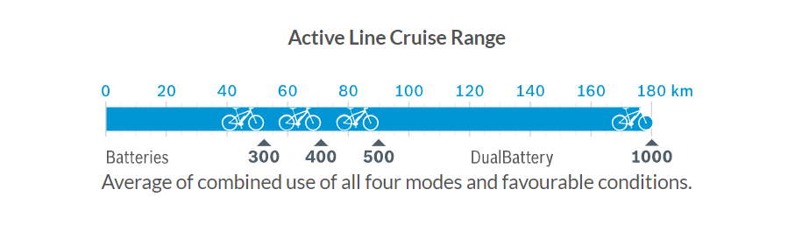corresponding Bosch charger (Bosch, 2018).

Figure 4: Active Line cruise range information provided by Bosch.

*Further Component Selection*

|  |
| --- |
| Other components require only basic performance. |
| Selected component must still offer high quality. |
| Selected brand must have a good reputation within the sector. |

The previous two components (electrical drivetrain, and suspension) have resulted in most of the available budget being invested into them, as well be shown in the cost analysis (Chapter X). Therefore, to keep costs within the target range specified in the PDS, the rest of the component selection has been carried keeping the following criteria in mind:

The frame, wheel, and wheel hub were designed in house due to these components being relatively simple to manufacture. In house design guarantees quality on top of reducing costs. Further information regarding the material selection for these components is provided in the following chapter. However, other components such as tyres, seats, handlebars, chains, and headlights are too specialised to manufacture. Therefore, these will be purchased from external suppliers, which are specialised and experienced.

- Tyres:Schwalbe tyres were selected due to the company’s experience and reputation within the bicycle market. The brand offers tyres, which have been specifically designed for city use. Furthermore, their tyres can be purchased optimised for e-bikes; improving driving dynamics. Therefore, the investment was made into their tyres, specifically, Schwalbe Marathon GreenGuard City 26 in. tyres (Schwalbe, 2018).

- Seat:For the seat, the PDS required a leather comfort saddle, which will further improve the user’s driving experience and comfort. For this purpose, the Bioflex Websprung Gents Comfort saddle was chosen because it fulfils the PDS, is designed specifically for men, and offers a cost-effective solution which remains visually appealing (ExtraUK, 2018).

- Handlebar:Similarly, the handlebar had to offer comfort and integrate into the rest of the bicycle design. For this purpose, the Raleigh RNH361 Trekking Comfort Handlebar – Silver was selected. A special request will have to be made when purchasing this product, as the design requires leather grips. This slightly larger investment will result in both leather seats and handlebar grips: an iconic look for classical bikes (Raleigh 2018).

- Brakes:The PDS required disk brakes, because rim bakes are not enough for electric bicycles due to their increased weight from the electrical drivetrain. However, within the range of available disk brakes, the cheapest ones will be sufficient for city use. Therefore, Clarks Cycle Systems have been selected as a provider due to their experience and reliability. Specifically, the Clarks CMD-11 Mechanical Disc Brake + Rotor have been chosen for the design.

- Other:   
Further non-crucial components have also been specified for the design, however, due to their low importance, no explanation has been given regarding the choice. Nonetheless, it can be noted that Shimano components were frequently selected due to the company’s size and experience within the general bicycle market (Shimano, 2018). The following table provides a list of the chosen components.

|  |  |
| --- | --- |
| bike component | component choice |
| chain | Shimano HG93 (9 speed) Roller Chain |
| headlight | Bobbin Retro Front Light |
| bolts | Stainless Steel Thread Hexagon Bolts |
| pannier rack | Tortec Velocity Rear Pannier Rack - Silver |
| brake handles | Shimano BL M425 Acera Complete Brake Lever |
| mudguards | SKS Bluemels Mudguard Set |
| cables | Shimano PTFE Coated Stainless Steel Inner Wire |

Table 1: Detailing the choice of non-crucial bicycle components.

**Material Selection**

Throughout most vehicle markets, the predominantly used materials are: titanium, steel, and aluminium. In general, titanium is an expensive material, which offers the best strength to density ratio. Aluminium is an affordable material, which offers a good strength to density ratio. And finally, steel is the cheapest option, offering the worst strength to density ratio. A visual comparison of the three materials is offered in Figure 5 below.

Figure 5: Figure comparing the cost in pounds per unit yield strength for specific metals used within the vehicle industry. Values used are not for specific alloys, but rather an average of the material itself (using Excel).

The intended use of the electrically assisted bike is within the city; therefore, the components will not demand any significant performance. As mentioned previously, a great investment was made into two components, therefore, the material selection must be done by trying to keep costs at a minimum whilst maintaining quality and reliability. Keeping this in mind, titanium was disqualified as it is used in expensive high-performing bicycles. Although aluminium is more expensive than steel (usually 150% the price), it was determined that it was an acceptable investment due to the increased strength to density ratio. Furthermore, aluminium is also more cost effective when considering both Young’s modulus and the elastic modulus. The aluminium used for specific components will be discussed in the following sections.

Throughout the following processes, data and prices were extracted from CES software (Cambridge Engineering Selector, 2018). Any other sources have been clearly referenced.

*Frame material:*

From preliminary market analysis, it was determined that the most common alloys used for the frame were 6061-T6 aluminium and 7005-T6 aluminium. The T6 temper was chosen for both alloys due to its cost-effective enhancement. 7005-T6 is used in less expensive frames. It has very similar properties to 6061-T6, with the primary difference being 6061-T6’s smaller density (2700 kg/m3 as opposed to 2780 kg/m3). Additionally, 7005-T6 does not have to be precipitation hardened, it is simply air hardened. It was decided that the slight density advantage offered by 6061-T6 over 7005-T6 did not justify the larger investment. Furthermore, 7005-T6 has an ease of welding and manufacture. Therefore, the bike frame will be welded 7005-T6 aluminium pipes. Specifically, gas metal arc (MIG) welding was chosen due to its low cost, simplicity, and material compatibility. 7005-T6 is susceptible to corrosion; therefore, the paint coating will have to include some anti-corrosive properties, slightly increasing the cost of the paint (MakeItFrom, 2018).

*Wheel & hub material:*

Due to the specific geometries of the wheel and hub, the material selection process gave priority to the manufacturing properties, rather than the mechanical properties. The simplest method of manufacturing the wheel and hub is through casting. Upon some preliminary research, it was determined that cast aluminium was the best for this purpose, specifically AlSi10Mg due to its superior mechanical properties. AlSi10Mg will be used for both the wheel and the hub. Furthermore, low-pressure die-casting has been chosen for manufacturing due to its low cost and high material compatibility.

**References**

Bosch. (2018). https://www.bosch-ebike.com/en/products. Web

CES Selector. (2018). Cambridge Engineering Selector. *Cambridge University*. Software [using   
 University of Glasgow license].

ExtraUK. (2018). https://www.extrauk.co.uk/product/list/Bioflex/Mens. Web.

Fenske, Jason. (2013). Rotational Inertia – Effects on Horsepower. *Youtube.* Video.

MakeItFrom. (2018). https://www.makeitfrom.com/compare/6061-T6-Aluminium/7005-T6-   
 Aluminium. Web.

M2R. (2018). https://www.made2race.co.uk. Web.

Muetze, Annet & C. Tan, Ying. (2007). Electric Bicycles - A performance evaluation. *IEE Industry Applications Magazine*. PDF.

Raghunath, Srivatsa. (2014). Hardware Design Considerations for an Electric Bicycle using a BLDC   
 Motor. *Texas Instruments*. PDF.

Rayleigh. (2018). https://www.raleigh.co.uk/. Web.

Schwalbe. (2018). https://www.schwalbe.com/en-GB/tour-reader/marathon.html. Web.

Shimano. (2018). https://bike.shimano.com/en-US/home.html. Web.

SR Suntour. (2018). https://www.srsuntour-cycling.com/home. Web.

Stott, Seb. (2017). The ultimate guide to mountain bike rear suspension systems. *Bikeradar*. Web.