**Detailed Component Selection**

*Suspension Selection*

It was decided that the design would incorporate a fully suspended bike for two reasons. The first of them, was the fact that incorporating electrical components could increase the weight by up to 25 kg. Secondly, reducing the vibrations acting on these electrical components will prolong their lifetime (Muetze & C.Tan, 2007).

The choice for the front suspension was quite simple. The team decided to go forward with a classical front fork suspension system. This is simple, affordable, and efficient. Since the design was not intended for a performance bike, the required system needed only to fit two criteria: quality and affordability. Following these guidelines, the team chose SR Suntour XCR-RL Fork Suspension. This choice was made based on the reliability of the company and the specifications detailed for the specific product (SR Suntour, 2018).

However, a design problem was encountered when considering the rear suspension. Most available rear suspension designs are made for high-performance bicycles such as mountain bikes. These types of bicycles often have “futuristic” and “sporty” frames. This was a problem because the design had to incorporate rear suspension into a classical frame; something which isn’t too common in industry. After considering a series of suspension designs, it was determined that a Hort-link (four-bar) design would be incorporated (Stott, 2017). This decision was made for two reasons: The Horst-link was one of the view designs which had some similarity to our frame choice, and this design left lots of options in terms for suspension designers when considering values such as the instant centre (IC), anti-squat, pedal kick-back, and anti-rise. Design regarding the IC is further analysed in the calculations section.

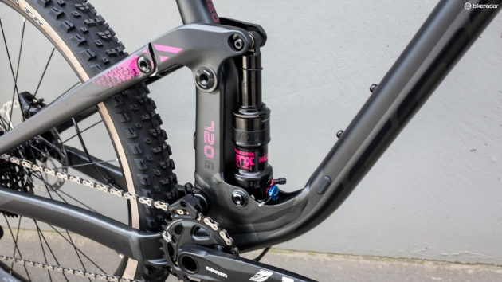The Horst-link design is a suspension design where the rear axle is indirectly connected to the main frame via a system of pivot points which allow the rear wheel to compress the dampener. As the dampener compresses, the rear axle moves upwards relative to the static main frame. A basic example of this design is shown below in Figure 1.

Figure 1: The conventional Horst-link design.

A few differences may be noted between the frame required for a conventional Horst-link design and the team’s frame of choice. There is a difference in the angle of orientation of the top rear axle between both designs. Our frame requires a significantly greater angle. However, this is not a problem, as this can be altered, and the dampener can be set beneath the seat. The orientation of the top axle will be selected such that it appears to be a continuation of the horizontal bar of the main frame. Due to the small dimensions of the dampener, this will not affect the ease of mounting and dismounting the vehicle. Furthermore, the design in Figure 1 has two predominant pivot points, at the connection to the main frame and the connection to the dampener. However, due to the increased geometry of the pedals due to the incorporation of the electric motor, we must also incorporate another crucial pivot point at the pedal clearance. This will enable the whole of the rear axle to move in a circular fashion around this connection point; with the positioning being dictated by the dampener compression. Furthermore, the dampener will have to be relatively stiff to avoid humungous deflections, as this would not go well together with a classic frame. This design will be shown physically later.

In terms of the selection of the dampener, the same criteria apply as for the front suspension: a quality product with a requirement of average performance. For this purpose, the team decided to go with the M2R Rear Shock Absrober 270mm due to its reputation in the market, performance, and reduced dimensions (M2R, 2018).

*Electrical Drivetrain Selection*

*Further Component Selection*

References:

M2R. (2018). http://www.made2race.co.uk. Web.

Muetze, Annet & C. Tan, Ying. (2007). Electric Bicycles - A performance evaluation. *IEE Industry Applications Magazine*. PDF.

SR Suntour. (2018). http://www.srsuntour-cycling.com/home/. Web.

Stott, Seb. (2017). The ultimate guide to mountain bike rear suspension systems. *Bikeradar*. Web.