Brief Market Analysis

Electric bicycles, also referred to as e-bikes, are bicycles that are fitted with an electric motor which helps the user to gain momentum. They make use of chargeable batteries, depending on their sizes and capacities. There are many different categories of e-bikes, such as peddle assist, throttle on demand, speed pedelec and electric moped.

E-bikes have been and are continuing to be the highest selling electrical assisted vehicle on the planet, with nearly 35 million unit sales forecast in 2016. Many factors are behind this reason of high-sales, such as its lower cost relative to cars, do not require any licensing, and improvements in other technologies, mainly on the Lithium ion, or Li-ion battery, making it cheaper and lighter. This shows that e-bikes are uniquely positioned to be a primary benefactor of this trend.

Regional Trends

Within the regional trends, the global e-bike markets are well-positioned towards huge growths, primarily within the Li-ion battery section. Although sealed lead-acid (SLA) batteries continue to represent the largest segment of e-bikes due to lower costs and popularity in China, the market share of this type of battery will decrease significantly over the next few years, because of the bad environmental impacts and the increasing performances from Li-ion batteries. The e-bike industries are driven from the high urbanization rates, improvements in technologies of batteries and bicycling infrastructure, aggressive energy rules and policies, low cost and many others. However, the low costs in gasoline, low consumer awareness, and high costs relatively to traditional bicycles have impacted restricting sales in some markets.

The Asia-Pacific excluding Japan (APEJ) region is expected to lead the global e-bike sales industry. However in China, the world’s largest market within the annual sales of the e-bikes using SLA batteries, are expected to have their sales decline because of the market saturation and laws and bans on e-bikes use in large areas of major cities like Beijing, Shanghai, etc. However, sales of Li-ion e-bikes will grow significantly over the forecast period due to the strong support from the government towards the technology.

The Asia-Pacific excluding Japan (APEJ) region is expected to lead the global e-bike sales industry.

In the other side of the world, Western Europe continues to achieve a steady significant growth in the e-bike industries, with Germany alone having 535,000 unit sales in 2015, from 480,000 in 2014. According to Navigant Research, the e-bike sales are expected to naturally replace bicycle purchases in Western Europe.

In North America, the e-bike market was relatively flat in 2015 because of the low retail gasoline prices. Nevertheless, the United States still has a huge potential for e-bikes due to its enormous bicycle market, which is roughly 16 million sales per year.

Overall, the global e-bike market is projected to grow at 0.4% compound annual growth rate, or CAGR, within the forecast period from 2016 until 2025. Compound annual growth rate is used to measure the growth over multiple time periods. The slow growing CAGR is largely due to China’s anticipated decline in annual unit sales, stated previously, at -0.8% CAGR. Excluding China however, the CAGR growth will be around 8.2%. This shows that it is expected to achieve a strong growth, rising from 3.3 million annual unit sales in 2016 to nearly 6.8 million units by 2025. This growth is expected to occur mostly in Western Europe and within Asia Pacific, including Japan. The graphs below (*Figure 1, Figure 2*) shows the annual e-bike sales of different regions within the period of 2016 until 2025. *Figure 1* shows the comparison of China with the Rest of the World, while *Figure 2* shows mainly the countries that are highly investing the e-bike markets.

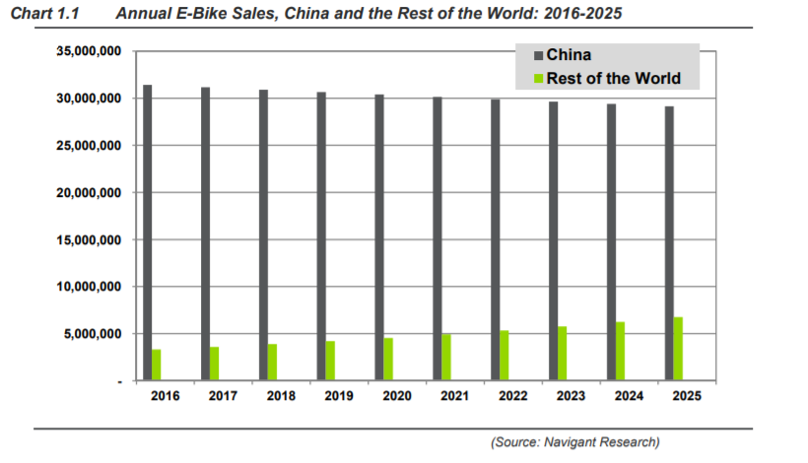

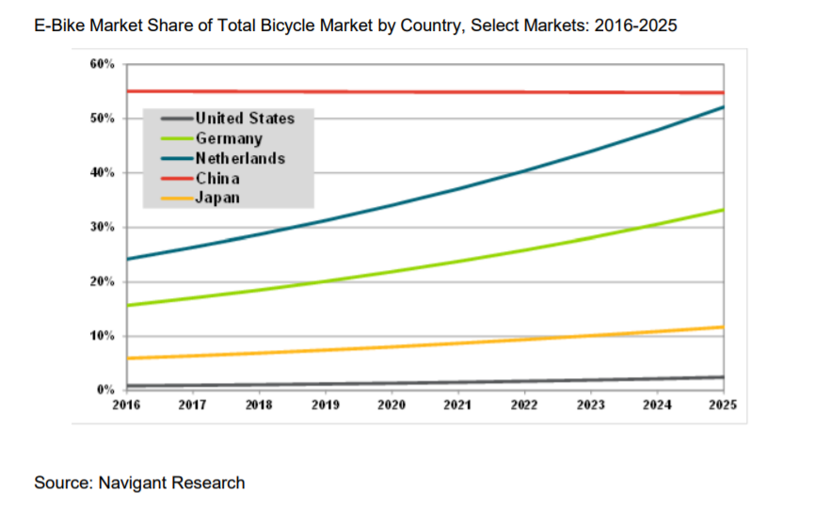

Running Costs

The global e-bikes market research report has profiled many key companies in the market. Companies such as Robert Bosch GmbH, Panasonic Corp, Samsung SDI Co., Ltd., and many others are keenly interested in increasing their investments toward e-bikes. The list below is just some of the few companies already within the e-bike industry.

**Company Profiles**

* Robert Bosch GmbH
* Accell Group N.V.
* Giant Manufacturing Co., Ltd.
* Derby Cycle Holding GmbH
* Jiangsu Xinri E-Vehicle Co. Ltd
* Panasonic Corp.
* Bionx International Corporation
* Mahindra & Mahindra Ltd.
* Samsung SDI Co., Ltd.
* Prodeco Technologies Llc
* Others

From the researches of some of these companies, the costs of the different types of e-bikes are shown below (*table 1*)

|  |  |  |
| --- | --- | --- |
| **Type of Electrical Bicycle** | **Average Cost ($)** | **Range ($)** |
| **Cruisers Bicycle** | 3050 | 1500 – 7900 |
| **Mountain Bicycle** | 4150 | 1200 – 9000 |
| **Road Bicycle** | 4750 | 1900 – 8000 |
| **City Bicycle** | 2800 | 1200 – 8000 |
| **Folding Bicycle** | 1750 | 700 – 5000 |
| **Cargo Bicycle** | 3300 | 1700- 6000 |

From the table above, it is shown that the average cost of the city e-bike within the different industries is $2800 with a range of $1200 to $8000, fitting the range category of our e-bike, later calculated below.