Applied Multi-Agent Learning & Imperfect Information Games: Lessons from Libratus and Pluribus (and their foundations)

Mauricio Garcia

University of Texas - Austin

February 2025

ABSTRACT
This paper traces the evolution of game-solving AI from perfect-information milestones (DeepBlue, AlphaGo) to the cutting edge of imperfect-information and multi-agent learning (Libratus, Pluribus). We review the core concepts: Nash equilibrium, minimax, and Counterfactual Regret Minimization, then show how abstraction, blueprint strategies, and real-time subgame solving enable superhuman performance in two- and multi-player no-limit Texas Hold’em poker. Finally, we distill key lessons about tractability versus exploitability, the necessity of live adaptation against human opponents, and the future role of richer opponent modeling and interactive interfaces.

INTRODUCTION
In the realm of artificial intelligence, games have long served as benchmarks for measuring progress and testing new algorithms.
In 1997, IBM's DeepBlue made history by defeating world chess champion Garry Kasparov, marking a significant milestone in perfect-information games. However, the challenge of imperfect-information games, where players must make decisions with hidden information, remained a formidable frontier.
In January 2017, 20 years later, Carnegie Mellon University's Libratus became the first AI to defeat professional players in heads-up no-limit Texas Hold'em poker, a benchmark for imperfect-information game solving.
This achievement was followed by another breakthrough in July 2019, when Carnegie Mellon University and Meta AI researchers developed Pluribus, an AI capable of winning in multiplayer poker games against professional players.
These advancements not only demonstrate the potential of AI in complex computational game-solving environments but also highlight the evolving capabilities of AI systems: DeepBlue's strategic depth in perfect-information games, Libratus's mastery of two-player imperfect-information scenarios, and Pluribus's ability to navigate the intricate dynamics of multiplayer interactions, showcasing the progress in multi-agent learning.

HISTORICAL CONTEXT - DEEPER DIVE

ADVANCEMENTS IN GAME SOLVING MODELS
The evolution of artificial intelligence in game-solving has been marked by a series of groundbreaking achievements, each pushing the boundaries of what machines can accomplish in strategic environments.

- DeepBlue: A Milestone in Perfect-Information Games
This journey began with IBM's DeepBlue, which, in 1997, became the first computer system to defeat a reigning world chess champion, Garry Kasparov. Chess, a perfect-information game, provided a structured environment where both players had complete visibility of the game state. DeepBlue's success was largely attributed to its brute-force search capabilities, evaluating millions of positions per second, combined with sophisticated heuristics to prune the search space effectively.

- AlphaGo: Advancing AI with Deep Learning
Following DeepBlue, another significant milestone came with Google's AlphaGo, which achieved a historic victory over 18-time world champion Go player, Lee Sedol, in 2016. Go, unlike chess, presents a vastly larger search space and requires a more nuanced understanding of strategy and intuition. AlphaGo's success was driven by the integration of deep neural networks and the Monte Carlo tree search, allowing it to evaluate positions and potential moves with unprecedented accuracy. This combination enabled AlphaGo to learn and improve its strategies through self-play, marking a shift from brute-force computation to more sophisticated learning techniques.

- Transition to Imperfect-Information Games…
These advancements in perfect-information games laid the groundwork for tackling more complex games characterized by hidden information. Unlike chess and Go, where all information is visible to both players, imperfect-information games like poker involve uncertainty and require players to make decisions based on incomplete information. This introduces additional layers of complexity, as players must account for hidden variables and potential deception by opponents.

- Libratus and Pluribus: Mastering Imperfect-Information Games
Libratus and Pluribus exemplify this progress. Libratus's victory in Texas Hold'em poker demonstrated that AI could achieve superhuman performance in two-player imperfect-information games. Pluribus extended this success to multiplayer settings, showcasing the potential of AI to handle even more complex interactions involving multiple agents.

IMPERFECT INFORMATION GAMES
Look into older imperfect information games, older, and can write history about this (milestones). This visualization I found can guide this text.
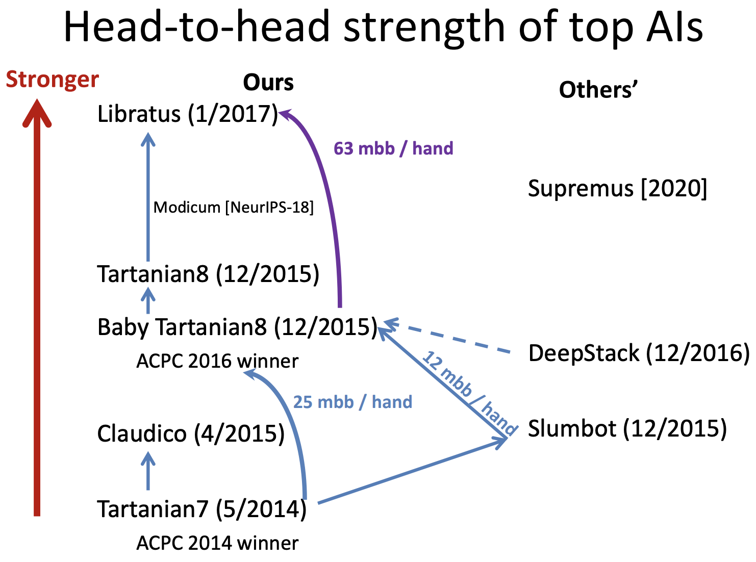

MULTI-AGENT LEARNING
Look into older/other multi-agent learning examples & research areas, can write history about this (milestones)

BROADER IMPLICATIONS
These models have not only advanced the field of AI but have also paved the way for applications in real-world scenarios where decision-making under uncertainty is crucial. From negotiations and cybersecurity to financial markets and strategic planning, the techniques developed for game solving are increasingly being adapted to address challenges in diverse domains.

ABOUT TEXAS HOLD'EM POKER
Texas Hold'em is one of the most popular and strategically complex variants of poker, making it an ideal testing ground for artificial intelligence research in imperfect-information games. The game is played with a standard 52-card deck and involves multiple players, each with private "hole cards" and shared community cards. Additionally, "poker" refers to the general card game played with multiple players at a table, while "heads up poker" specifically means a poker game played between only two players.

WHY IT IS A USEFUL IMPERFECT INFORMATION GAME:
- Each player's hole cards are private. This creates uncertainty about the opponents’ hands. Players must infer the possible holdings of others based on their actions and betting patterns.
- Deceptive or Strategic Maneuvers: Bluffing, semi-bluffing, and slow-playing (a player plays a strong hand weakly to encourage opponents to stay in the pot) are all techniques that can be played. Players must balance aggression with caution.
- The dynamics throughout the game change. For example, the community cards can completely change the strength of a player’s hand.
- The decision-making processes in poker mirror those in many real-world scenarios, such as negotiations, financial markets, competitive business environments, etc.. To elaborate, players must weigh risks and rewards, anticipate the actions of others, and make decisions with incomplete information.

Rules:
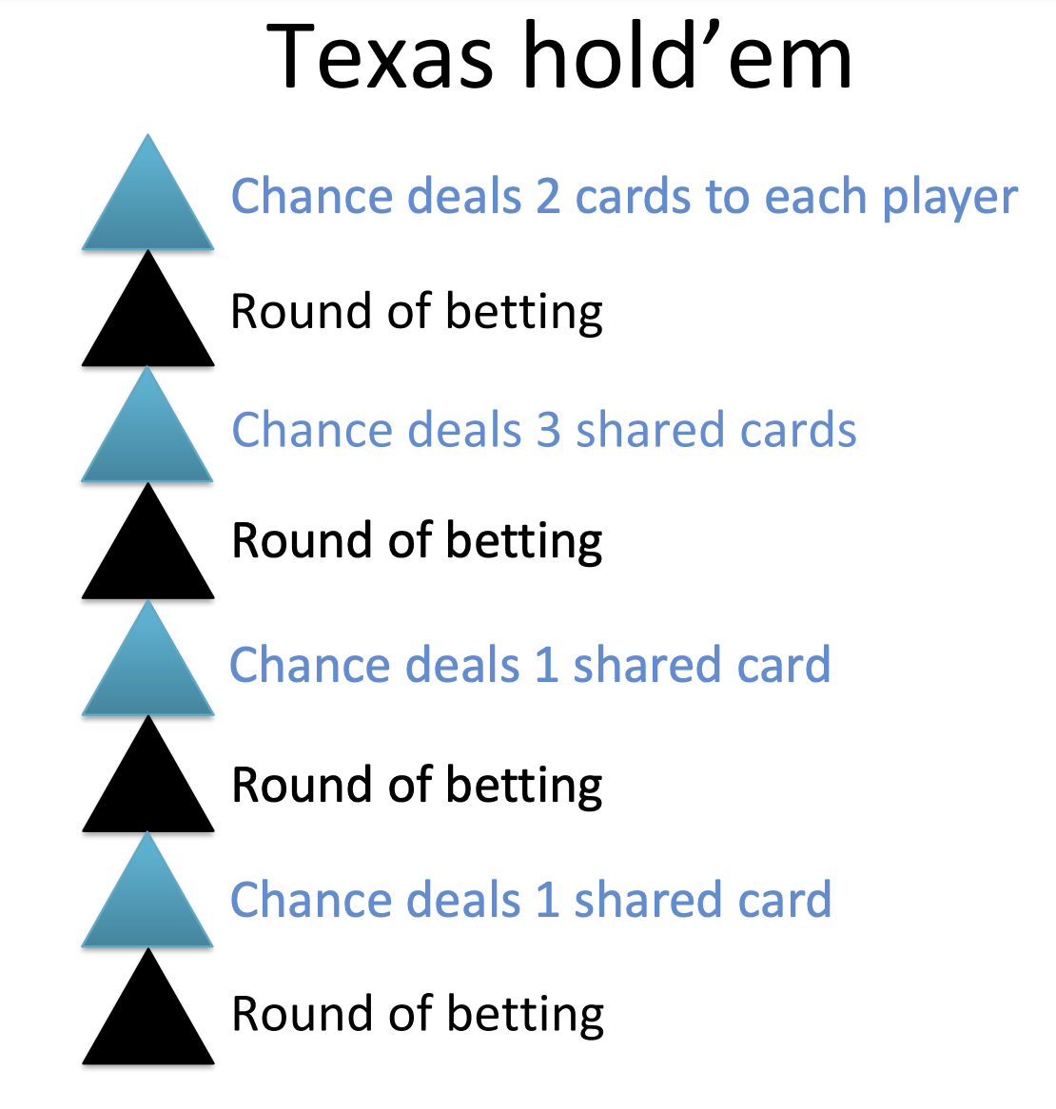

KEY FOUNDATIONAL CONCEPTS USED TO BUILD LIBRATUS & PLURIBUS:

EQUILBRIUM CONCEPTS:

NASH EQUILIBRIUM:

Definition:
Nash equilibrium is a game theory concept that describes when no player can improve their outcome by changing their strategy. It represents a stable state where each player's strategy is optimal given the strategies of all other players.

Application in AI:
In the context of poker, Nash equilibrium provides a framework for developing strategies that are robust against exploitation.

VON NEUMANN’S MINIMAX THEOREM:

Definition:
Originally developed by John von Neumann before WW2, the minimax theorem is a foundational pillar of game theory. It states that in zero-sum games, there exists a strategy for each player that minimizes their maximum possible loss, effectively balancing offensive and defensive considerations.
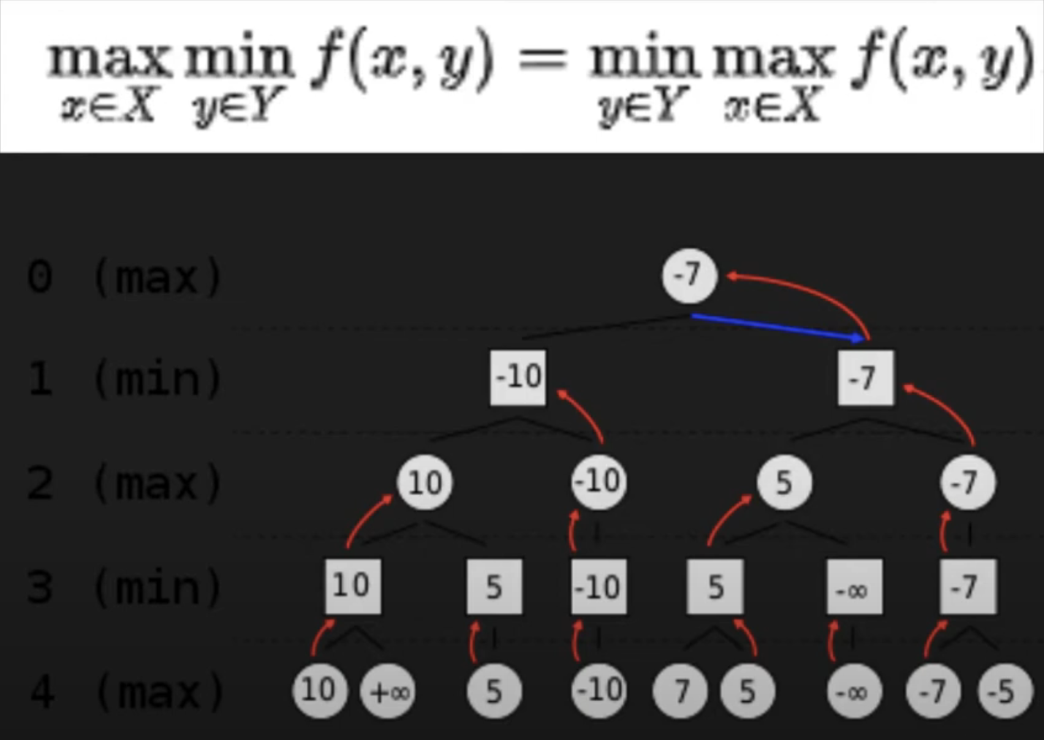

Why it is relevant, although not explicitly mentioned in the main research papers:
While the minimax theorem is not explicitly mentioned in the research papers, its principles are relevant to heads-up poker, which is treated as a zero-sum game. Libratus leverages these principles to develop strategies that minimize potential losses while maximizing gains.

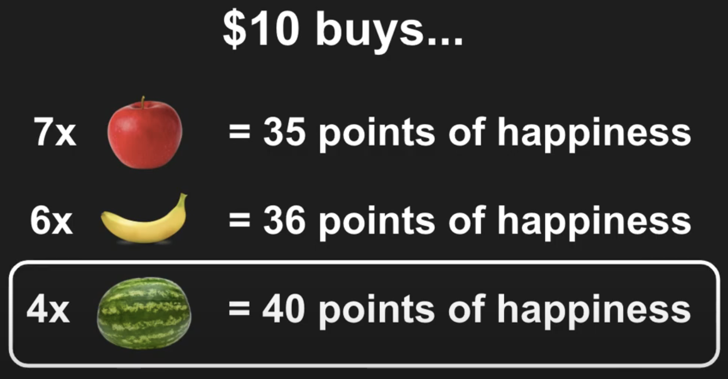


COUNTERFACTUAL REGRET MINIMIZATION (CFR):
CFR is particularly suited for games where players don't have complete information about the state of the game, like in poker, where players only see their own cards. The core concept is to minimize the "regret" a player feels for not choosing a different action at each decision point, considering the possible outcomes based on the counterfactual scenario.

HOW IT WORKS:
CFR works by repeatedly traversing the game tree, calculating regrets for each action at each decision point, and adjusting the player's strategy based on these regrets. A key element of CFR is calculating the "reach probability" of each decision point, which represents the likelihood of reaching that point in the game based on the current strategies.

Step by step:

Initialize:
  - Start with a uniform random strategy for each player at every decision point.

Traverse the game tree:
  - For each iteration, traverse the game tree from the root node, calculating the reach probability at each decision point.

Calculate regrets:
  - At each decision point, calculate the "regret" for each action, which represents the difference in expected utility if that action had been chosen instead of the one that was chosen.

Update strategy:
  - Based on the calculated regrets, adjust the player's strategy at each decision point using a "regret-matching" mechanism, giving higher probabilities to actions with higher regrets.

Repeat:
  - Continue iterating through the game tree, updating strategies based on calculated regrets until convergence is reached (regrets become negligible).

LIBRATUS:

SUMMARY:
Libratus is an AI system developed by Noam Brown and Tuomas Sandholm at Carnegie Mellon University, designed to play heads-up (two-player) no-limit Texas Hold'em poker. In a 20-day, 120,000-hand competition, Libratus defeated four top human specialist professionals, marking a significant milestone in AI's ability to handle imperfect-information games (Brown & Sandholm, 2018). This achievement demonstrated that AI could achieve superhuman performance in strategic environments characterized by hidden information and uncertainty.

HOW IT WORKS (HIGH LEVEL):
- Libratus uses application-independent techniques to compute a blueprint for the overall strategy, flesh out details for subgames reached during play, and improve upon potential weaknesses identified by opponents (Brown & Sandholm, 2018).

Abstraction (and Blueprint Strategy):
  - The first module of Libratus computes an abstraction of the game, simplifying it while retaining strategic aspects (for example, $100 is not so different to $101). This process reduces the complexity of the game while preserving its essential strategic elements.
  - The abstraction allows Libratus to develop a comprehensive strategy for the early stages of the game, known as the "blueprint strategy." For the later stages, this blueprint provides a general framework that can be refined as the game progresses.

Nested Subgame Solving:
  - When a later part of the game is reached, Libratus constructs a finer-grained abstraction for that subgame and solves it in real time. This nested subgame solving ensures that the solution fits within the larger blueprint strategy, providing a provable safety guarantee.

Self-Improving Algorithm:
  - Libratus enhances the blueprint strategy by filling in missing branches and computing game-theoretic strategies for those branches. This self-improvement is guided by the opponents' actual moves, suggesting where in the game tree such filling is worthwhile..
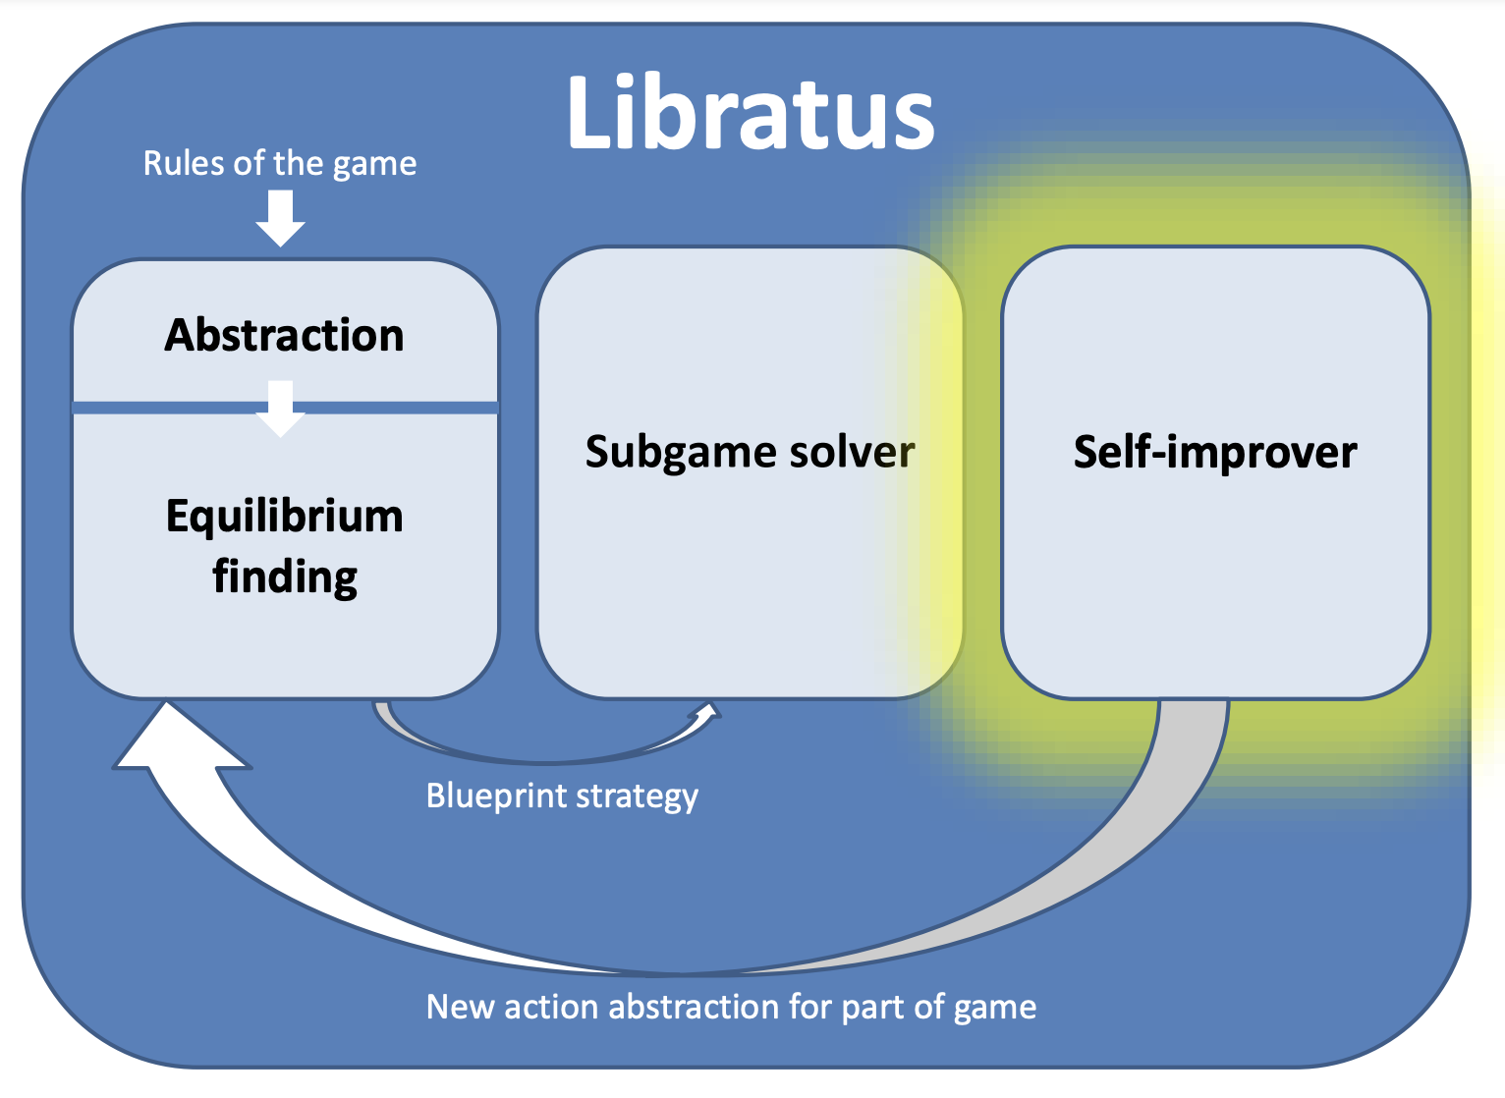

HOW IT OVERCOMES THE IMPERFECT INFORMATION OBSTACLE:
Libratus effectively addresses the challenge of imperfect information by employing a combination of abstraction, real-time subgame solving, and self-improvement. The abstraction process reduces the complexity of the game, allowing Libratus to focus on strategically significant decisions without being overwhelmed by the vast number of possible game states. By using nested subgame solving, Libratus can refine its strategy in real time, adapting to the specific circumstances of each hand. This approach ensures that Libratus can manage the uncertainty inherent in poker, making informed decisions even when some information is hidden. The self-improving algorithm further enhances Libratus's ability to adapt by learning from opponents' actions and refining its strategy accordingly (Brown & Sandholm, 2018).

RELATION TO MULTI-AGENT LEARNING:
Libratus is related to multi-agent learning primarily through its use of self-play to refine its strategies. While it is not a multi-agent system in the traditional sense of interacting with multiple autonomous agents simultaneously, Libratus does simulate interactions with an opponent to improve its strategy. This process involves learning from the actions and potential strategies of a single opponent, which is a form of multi-agent learning. By iteratively playing against itself, Libratus can explore a wide range of scenarios and adapt its strategy to optimize performance.

LIMITATIONS:
- Specific to two-player games
- Computational Demands
- Libratus does not explicitly exploit opponents’ weaknesses. Instead, it focuses on maintaining a robust strategy that is difficult to exploit, which may limit its ability to capitalize on specific opponent tendencies.

STRENGTHS:
- Does a diverse range of betting sizes, from small bets to large all-ins. It can make it difficult for opponents to predict Libratus’s hand strength based solely on bet size (adds unpredictability).
- In any given situation, Libratus can choose from multiple bet sizes.
  - This can allow it to tailor its strategy to the specific context of the hand (therefore optimizing based on the current game state and other variables like opponent behavior).
- “Limping” (calling the big blind rather than raising), “donk betting” (betting into the previous round’s aggressor). These strong tactics can catch opponents off guard and disrupt their expectations.
- “Perfect balance” via maintaining equilibrium. Causes the agent to not be as easily exploitable.
- A mixed strategy uses probability distributions over possible actions rather than committing to a single deterministic approach. This randomness is important because it makes it challenging for opponents to predict Libratus’s next move.
- Probability distribution over players’ hands, not just “range-based”.
- Near-perfect subgame play; great use of “blockers” (cards that reduce the likelihood of opponents having certain hands)

FUTURE WORK DIRECTIONS:

PLURIBUS:

SUMMARY:
Pluribus is an AI system developed by Noam Brown and Tuomas Sandholm, in collaboration with Facebook AI Research, designed to play six-player no-limit Texas Hold'em poker. It represents a significant advancement in AI's ability to handle multiplayer imperfect-information games. In a series of experiments, Pluribus consistently defeated elite human professionals (and by a large margin), demonstrating its capability to navigate the complex interactions of multiplayer poker (Brown & Sandholm, 2019).

HOW IT WORKS (HIGH LEVEL):
Pluribus begins by running Monte Carlo Counterfactual Regret Minimization (MCCFR) in self-play to produce an offline “blueprint” strategy for the entire six-player game. Unlike full CFR, MCCFR samples a subset of actions at each decision point, dramatically reducing computation while still driving regrets toward equilibrium. To keep the blueprint tractable, Pluribus also applies action and information abstraction, grouping similar bet sizes and merging analogous game states.
Once play begins against human or AI opponents, Pluribus uses its precomputed blueprint as a safe, high-level plan but then refines it in real time. Whenever the current hand reaches a decision point, Pluribus conducts a shallow, focused search over that subgame, again using abstraction, to adjust its strategy to the specific situation. This two-phase approach (offline blueprint + online subgame search) balances scalability with responsiveness.
Because multiplayer Nash equilibria can be prohibitively expensive to compute, and may not even yield the best practical performance, Pluribus does not target an exact equilibrium. Instead, it relies on its blueprint for overall safety and its localized real-time solutions to exploit opportunities as they arise. Crucially, however, Pluribus does not continuously learn or track opponent tendencies during a match; its robustness comes from the combination of a sound blueprint and judicious, on-the-fly subgame refinement rather than from opponent-specific adaptation.

HOW IT OVERCOMES THE IMPERFECT INFORMATION OBSTACLE:
Pluribus is designed to work in multi-agent environments (multiplayer poker). It must navigate interactions with multiple players, each with their own strategies and objectives. This setting inherently involves multi-agent dynamics, as Pluribus must consider the potential actions and strategies of several opponents simultaneously. It refines its strategies through self-play, where it plays against copies of itself. This process allows Pluribus to explore a wide range of scenarios and develop strategies that are robust in a multiplayer context. By simulating interactions with multiple agents, Pluribus effectively engages in a form of multi-agent learning during its training phase. Also accomplishes this due to robust pre-computed strategies.

RELATION TO MULTI-AGENT LEARNING:
Pluribus exemplifies multi-agent learning by navigating interactions with multiple players, each with their own strategies and objectives. This requires the AI to adapt and learn from the actions of several agents simultaneously, demonstrating the potential of AI to learn and adapt in dynamic, competitive environments. Pluribus also plays against other iterations of itself, which can be considered multi-agent learning as well.

LIMITATIONS:
While Pluribus demonstrates strong empirical performance (beating Poker professionals decisively), achieving equilibrium in multiplayer games is more challenging, and its strategies are not guaranteed to be optimal in all scenarios (even if equilibrium is found).. Importantly, Pluribus plays a fixed strategy and does not adapt to the observed tendencies of opponents during live play. This design choice focuses on maintaining a robust overall strategy rather than exploiting specific opponent weaknesses.

COST TO USE:
The blueprint strategy for Pluribus was computed in 8 days on a 64-core server for a total of 12,400 CPU core hours. It required less than 512 GB of memory. At current cloud computing spot instance rates, this would cost about $144 to produce.
This is in sharp contrast to all the other recent superhuman AI milestones for games, which used large numbers of servers and/or farms of graphics processing units (GPUs).
More memory and computation would enable a finer-grained blueprint that would lead to better performance but would also result in Pluribus using more memory or being slower during real-time search.
set the size of the blueprint strategy abstraction to allow Pluribus to run during live play on a machine with no more than 128 GB of memory while storing a compressed form of the blueprint strategy in memory.

STRENGTHS:
- It is extremely computationally efficient. It achieves this incredible performance with relatively modest computational resources compared to other AI systems like AlphaGo.
- Pluribus maintains a strong, consistent strategy that is difficult for human opponents to exploit.
- Through real-time search and abstraction, Pluribus can adapt its strategy to the specific context of each game situation, though it does not adapt based on opponent behavior (which could be a strength).

FUTURE WORK DIRECTIONS:
- Developing methods to exploit specific opponent tendencies while maintaining a robust overall strategy could enhance Pluribus's performance. If a more offensive profile was developed (aka adapting based on opponent behavior), Pluribus could be even better. This is worth exploring.

CONCLUSION
Over the last two decades, AI has progressed from brute-force search in perfect-information games (DeepBlue) to deep learning plus tree search (AlphaGo) and, most recently, to rigorously grounded, game-theoretic approaches for hidden-information environments (Libratus and Pluribus). At the heart of these breakthroughs is the realization that:
- Abstraction dramatically reduces complexity. Grouping similar bet sizes or hand patterns lets CFR-based algorithms solve otherwise intractable poker variants.
- Blueprint + subgame Solving provides a safe, high-level plan online while allowing real-time refinement in the critical decision points you actually reach.
- Live Adaptation (via opponent modeling or repeated subgame solves) is essential to exploit human tendencies and guard against non-stationary bluff patterns—pure equilibrium play alone isn’t enough.

REFERENCES:
- Brown, N., & Sandholm, T. (2018). Superhuman AI for heads-up no-limit poker: Libratus overcomes human talent. Science, 359(6374), 418–424. https://doi.org/10.1126/science.aao1733
- Brown, N., & Sandholm, T. (2019). Pluribus: The first AI to beat pros in multiplayer no-limit Texas hold ’em poker. Science, 365(6456), 885–890. https://doi.org/10.1126/science.aay2400
- Campbell, M., Hoane, A. J., Jr., & Hsu, F. H. (2002). Deep Blue. Artificial Intelligence, 134(1–2), 57–83. https://doi.org/10.1016/S0004-3702(01)00129-1
- Silver, D., Huang, A., Maddison, C. J., Guez, A., Sifre, L., Van Den Driessche, G., ... & Hassabis, D. (2016). Mastering the game of Go with deep neural networks and tree search. Nature, 529, 484–489. https://doi.org/10.1038/nature16961
- Kuhn, H. W. (1950). A simplified two-person poker. In H. W. Kuhn & A. W. Tucker (Eds.), Contributions to the theory of games (Vol. I, pp. 97–103). Princeton University Press.

More DeepBlue:
  - https://www.sciencedirect.com/science/article/pii/S0004370201001291

Google AlphaGo:
  - https://www.nature.com/articles/nature16961

Nash:
  - https://search.lib.utexas.edu/discovery/openurl?institution=01UTAU_INST&vid=01UTAU_INST:SEARCH&rft.aulast=Nash&rft.volume=54&url_ver=Z39.88-2004&rft_id=info:doi%2F10.2307%2F1969529&rft.date=1951&rft.spage=286&rft.jtitle=Ann.%20Math.&rft.aufirst=J.&rft.atitle=Non-Cooperative%20Games&rft.title=Ann.%20Math.
  - https://www.jstor.org/stable/1969529?origin=crossref&seq=1

Neumann:
  - https://link.springer.com/article/10.1007/BF01448847
  - Helpful video: https://www.youtube.com/watch?v=NrJpVhuieK4&ab_channel=AbdelazizBahnasy
- Libratus video explanation
  - https://www.youtube.com/watch?v=2dX0lwaQRX0
- https://en.wikipedia.org/wiki/Lee_Sedol
- http://modelai.gettysburg.edu/2013/cfr/cfr.pdf

