**Problem Definition Report**

**Intelligent Ground Vehicle Competition:**

**GoBot**

Anna Cao

Emma Caraher

Kanghyun Choi

Qianru Jia

ME 463

January 24th, 2017

**Table of Contents**

**Executive Summary** **2**

**Problem Definition** **3**

**Background and Motivation** **3**

**Competition Rules** **3**

**Discussion** **4**

Physics 4

Proposed Solution 4

**Future Plans** **7**

Gantt Chart 7

**Team Organization** **7**

**Conclusion** **8**

**Reference** **8**

# Executive Summary

Throughout this report, the problem will be defined and the design process will be outlined. The problem being addressed involves the improvement on autonomous cars. Autonomous cars are convenient and could greatly reduce the number of accidents every year. A good autonomous car should not only stay within the lanes and follow traffic laws but should also be able to avoid any and all obstacles. This project will design and build such a vehicle. The vehicle’s design will follow all of the requirements outlined in the Intelligent Ground Vehicle Competition (IGVC), which gives a dimension requirement, a weight requirement, a speed requirement, and the use of a wireless e-stop, a mechanical e-stop, and safety lights.

The robot must be able to avoid obstacles, so the movement needs to be smooth and easy. The robot must also be able to drive on different types of ground, including grass and wet ground, so the robot must be able to generate enough traction to move along the path. The current considered possibilities for ground propulsion include using wheels or using tracks. Wheels would allow for free movement in all directions, whereas tracks would not be able to turn very easily. On the other hand, wheels have a smaller contact area on the ground and thus will slip more easily, whereas tracks have a larger contact area and will not slip as much.

The robot must be able to sense and avoid obstacles, so a good sensor is needed. A depth sensor and an ultrasonic sensor are both viable options. The depth sensor has a wider range of view, so will be able to detect more obstacles. However, the depth sensor is also quite a bit more expensive.

Project responsibilities are distributed evenly among team members. Anna and Gabe will focus on the mechanical design, the CAD model, and the simulation. Emma will focus on software design, depth sensor input, and decision making. Sally will focus on the electronic design. For the first half of the semester, tasks will mostly be separated. For the second half of the semester, the team member will join to assemble a final working prototype.

# **Problem Definition**

More and more companies are getting interested in making autonomous cars. Following lane lines and traffic rules are a very important first step in the process, but this is not the only step. In order for the autonomous car to be safe, the car needs to be able to sense anomalies and react intelligently to them. This includes potholes, pedestrians, traffic cones, traffic, and much more. They could be in the middle of the road, but the car shouldn’t run them over. The next step in the autonomous car design process is implementing a way to avoid these obstacles intelligently and continue along the path. This project is in pursuit of this goal.

# **Background and Motivation**

Most, if not all, automotive companies are currently developing their own autonomous car technology. Even a few IT companies have started their own research on this, such as Google’s Waymo. Using various sensors, such as the GPS, radar, lidar, and camera, the autonomous vehicle needs to control and drive itself.

The Gobot is motivated from Intelligent Ground Vehicle Competition (IGVC). IGVC is a competition for undergraduate and graduate students to design and construct an autonomous vehicle. IGVC is an annual competition beginning in 1993 and is usually held at Oakland University in Rochester, Michigan.

# **Engineering Requirement**

The IGVC has several requirement design requirements. The vehicle must be considered a ground vehicle, so it must be powered by something connected to the ground. The vehicle must be between three and seven feet wide, two and four feet long, and no more than six feet tall. The speed of the vehicle must be between one and five miles per hour during an uninterrupted stretch of road. For the entire path, the average speed of the vehicle must be at least one mile per hour. The vehicle must be able to carry a payload of up to twenty pounds. For safety, the vehicle must implement a wireless e-stop, a mechanical e-stop, and safety lights.

The IGVC has a few aspects they are looking for when judging the competition. The vehicle should never be completely outside of the track. It is allowable to be slightly outside when avoiding an obstacle. The vehicle should be able to autonomously navigate from a given starting position to a given ending position. The vehicle must be able to autonomously and intelligently avoid different obstacles along the path.

Due to the constrained budget, the GoBot will be scaled down to a third of the competition’s original requirements. The vehicle will be approximately one foot long, six inches wide, and six inches tall. The speed requirement may also be scaled down to 0.3 miles per hour on average. The payload will be reduced to six pounds.

**Discussion**

## Physics

The GoBot is a fully autonomous unmanned ground robotic vehicle. The main powertrain of the GoBot is going to be a DC motor. Since the payload is limited, the DC motor should be sufficient for this design. Since the purpose of the Gobot is to navigate around outdoor obstacles, sensors and a controller will be mounted on the vehicle.

The free body diagram for the vehicle is shown below. Forces like gravity, normal force, driving force (forward and backward) and friction should be taken into consideration. The slipping friction is neglected during the calculation but may be added back in the final design. The friction factor is assumed to be in the reasonable range of 0.2-0.5. The weight of GoBot will be decided by the combined weight of robotic platform and payload. The maximum weight for the payload is twenty pounds.



Figure 1. Free body diagram of GoBot

## Proposed Solution

GoBot contains a software program, a robotic platform, DC gear motors, an e-stop, safety lights, sensors, and a frame. Some of the possible designs are discuss discussed below:

The current considered possibilities for ground propulsion include using wheels (especially the Omni-wheel platform) or using tracks. The advantages and disadvantages of each platform are listed in Table 2.

|  |  |  |
| --- | --- | --- |
|  | Wheel Robot | Tracked Robot |
| Advantage | * Simple design and construction * Abundance of choices * Can move in all directions (only for omni wheel) * Usually low cost compare to other methods | * Constant contact with the ground prevents slipping * Evenly distributed weight |
| Disadvantage | * May lose traction (Slip) * Small contact area | * Limited choice * High mechanical complexity * More stress on motor due to internal friction * Don’t handle terrain as well |

The robot must be able to sense and avoid obstacles, so a good sensor is needed. A depth sensor and an ultrasonic sensor are both viable options.

The key elements of a depth sensor are an infrared-light projector and a low resistance infrared light camera. The projector projects a pattern of IR light on the surrounding objects as a sea of dots, the IR camera detects the dots, and the sensor processor works out the depth from the displacement of dots. Dots are spread out on near objects and dense for far objects.

According to the market research, a compelled depth sensor is expensive but the simple IR sensor is low cost. It is possible to use various IR sensors instead of purchasing the high accurate depth sensor to accomplish the project. The advantage of the IR sensor is the low cost while the disadvantage is that the detect range is respectively smaller than other methods.

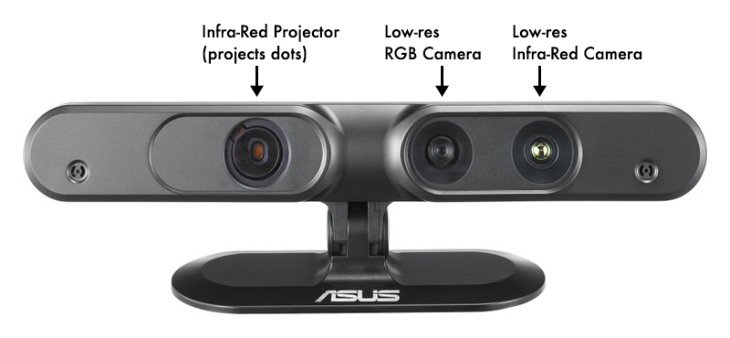

Figure 2. Depth sensor

Ultrasonic sensor uses acoustics to measure the time between when a signal is sent and when the echo is received back. The advantage of ultrasonic sensor includes it can measure several meters distance and low cost. The disadvantage is the reflectivity of different materials impacts the result.

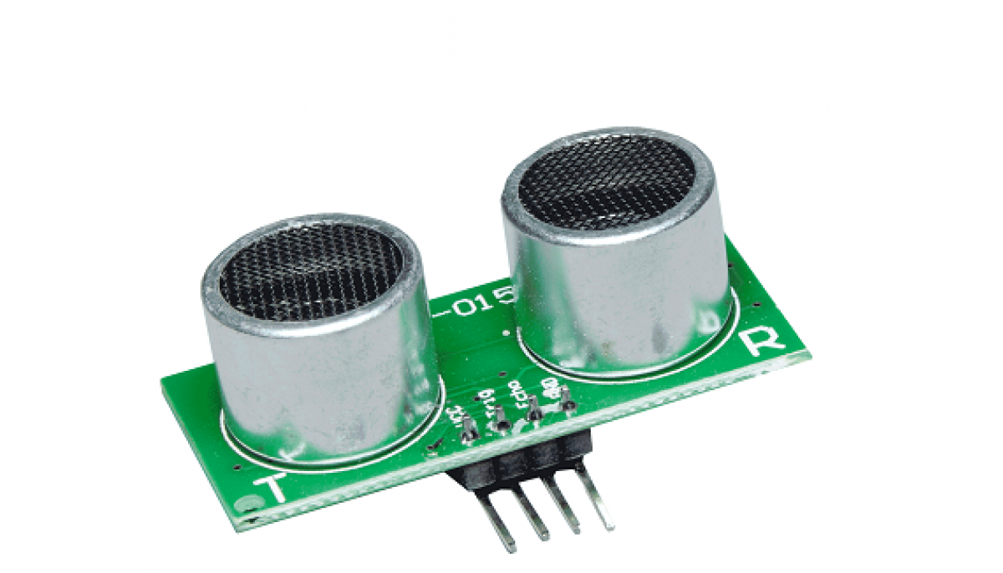

Figure 3. Ultrasonic sensor

The selection of actuator is decided by the total mass, the number of motors, the robot velocity, the wheel radius, the supply voltage and so on. A *Drive motor sizing tool* will be used to decide the DC gear motor for GoBot.

# **Future Plans**

## Gantt Chart

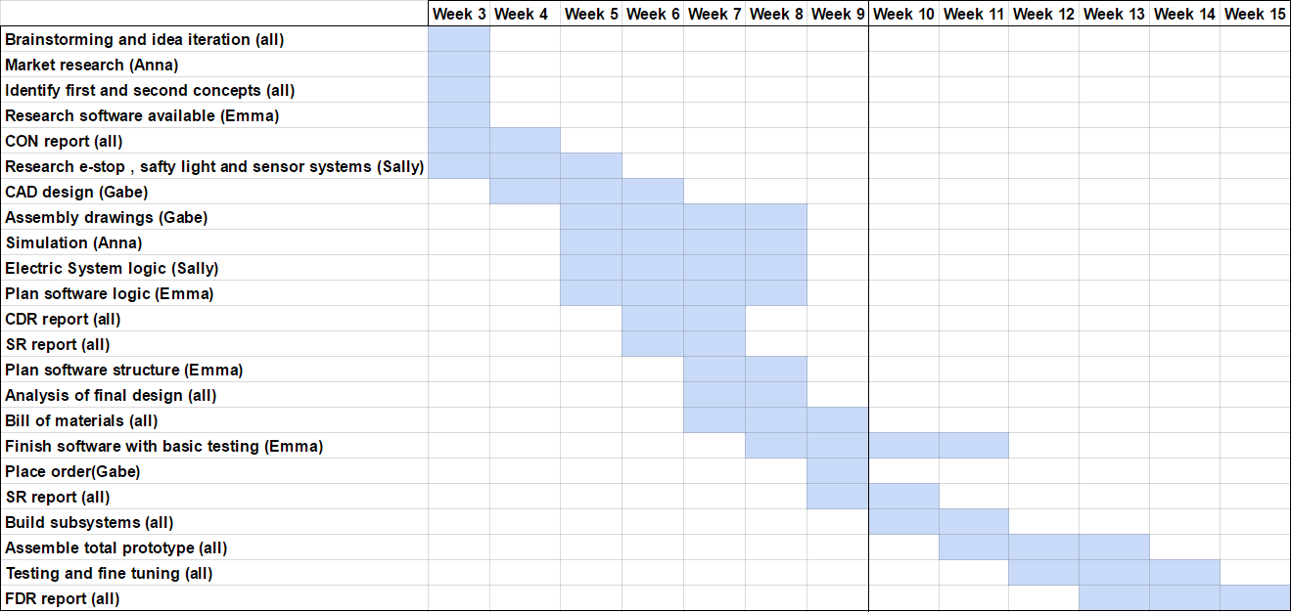

Figure 4. Gantt Chart

We plan to finish the above tasks in during the weeks specified in Figure 4. Before the concept report, we plan to have all basic research done. This includes market research, material research, frame idea generation, and software research. Before the critical design report, we plan to have all design specification finished. This includes completed CAD drawings, simulation, controls logic, and software logic. These also continue a little after the report so that we can revise due to suggestions from the CDR. Once this is all lined out, we can finalize all items needed and finish the bill of materials. At this point, there is Spring Break, which is identified by the black vertical line.

After Spring Break, we begin the assembly process, starting with separate working systems and moving to total assembly. Finally, we will be testing the prototype and making fixes if necessary. Finally, we will be writing the report.

# **Team Organization**

Several tasks will involve all of the team members, but others are divided up between us. The tasks we all work on include report writing, assembly, testing, brainstorming, and analysis. Emma’s tasks include software design and implementation and proofreading reports. Kanghyun’s tasks include CAD designs and assembly drawings. Qianru’s tasks include electronic system design and the inclusion of e-stops and safety lights. Anna’s tasks include research, such as market research and material design, and helping with CAD simulations.

# **Conclusion**

This problem is the current inability for autonomous vehicles to detect obstacles and intelligently navigate around them. The GoBot attends to address this as well as implementing several safety mechanisms as well as maintaining a low cost of production. As a guideline, the GoBot will adhere to the IGVC’s vehicle requirements. For the overall design, either wheels or tracks will be used. For the sensor, either the depth sensor or the IR sensor will be used. For the motor, a DC gear motor will be used. Future plans include CAD design, electric system and software design, bill of material, and the final prototype building.

# 

# 

# 

# 

# **Reference**

[1] Drive Motor Sizing Tool. Retrieved January 22, 2017, from http://www.robotshop.com/blog/en/drive-motor-sizing-tool-9698

[2] McWilliams, A. (1970, August 11). Andrew McWilliams. Retrieved January 22, 2017, from <https://jahya.net/blog/how-depth-sensor-works-in-5-minutes/>

[3] High Accuracy Ultrasonic Sensor. (n.d.). Retrieved January 22, 2017, from <http://www.progressiveautomations.com/lc-217?gclid=CjwKEAiAqozEBRDJrPem0fPKtX0SJAD5sAyH_V5-pgZMDnbGI4odyl5Y4trEv1qqyN8ia13WKetbCRoCr67w_wcB>