# **Structural Metrics Analysis:**

## ***1. Summary Report***

This analysis extracts five key structural metrics from airborne LiDAR data over a site in Kenya.  
- Mean Canopy Height: Proxy for aboveground biomass and carbon stocks.  
- 90th Percentile Canopy Height (P90): Captures dominant canopy strata.  
- Standard Deviation of Height: Indicates vertical heterogeneity.  
- Foliage Height Diversity (FHD): Measures complexity of vertical foliage distribution.  
- Canopy Cover Fraction (CC): Quantifies horizontal heterogeneity by the proportion of vegetation above 1 m.  
LiDAR-derived vegetation structure metrics **mean height**, **height variability (std_height)**, **90th percentile height (p90_height)**, **foliage height diversity (FHD)**, and **canopy cover effectively** quantify vertical and horizontal complexity in savanna ecosystems. In this study, low **p90** and **canopy cover** values clustered in some grid cells, indicating open grasslands dominated by short vegetation. Higher **p90**, **FHD**, and **cover** in other areas revealed woody patches with taller, multi-layered vegetation, suggesting greater structural and biodiversity potential.

**FHD** highlighted transition zones with layered shrubs and trees, while **p90 heatmaps** marked the distribution of tall tree clusters. The **combined structure map** distinguished structural classes: open grasslands (low p90, low cover), mixed savannas (moderate values), and dense woodlands (high p90, high cover).

**Conclusion:**  
The data reveal spatial heterogeneity in vegetation structure across the savanna landscape, with implications for biodiversity, carbon and land management. Areas with intermediate canopy cover and high FHD may support greater species richness. These LiDAR metrics provide a powerful, objective basis for mapping savanna structure and guiding ecological conservation or restoration planning.

## ***Generated Outputs***

***- Histogram:***

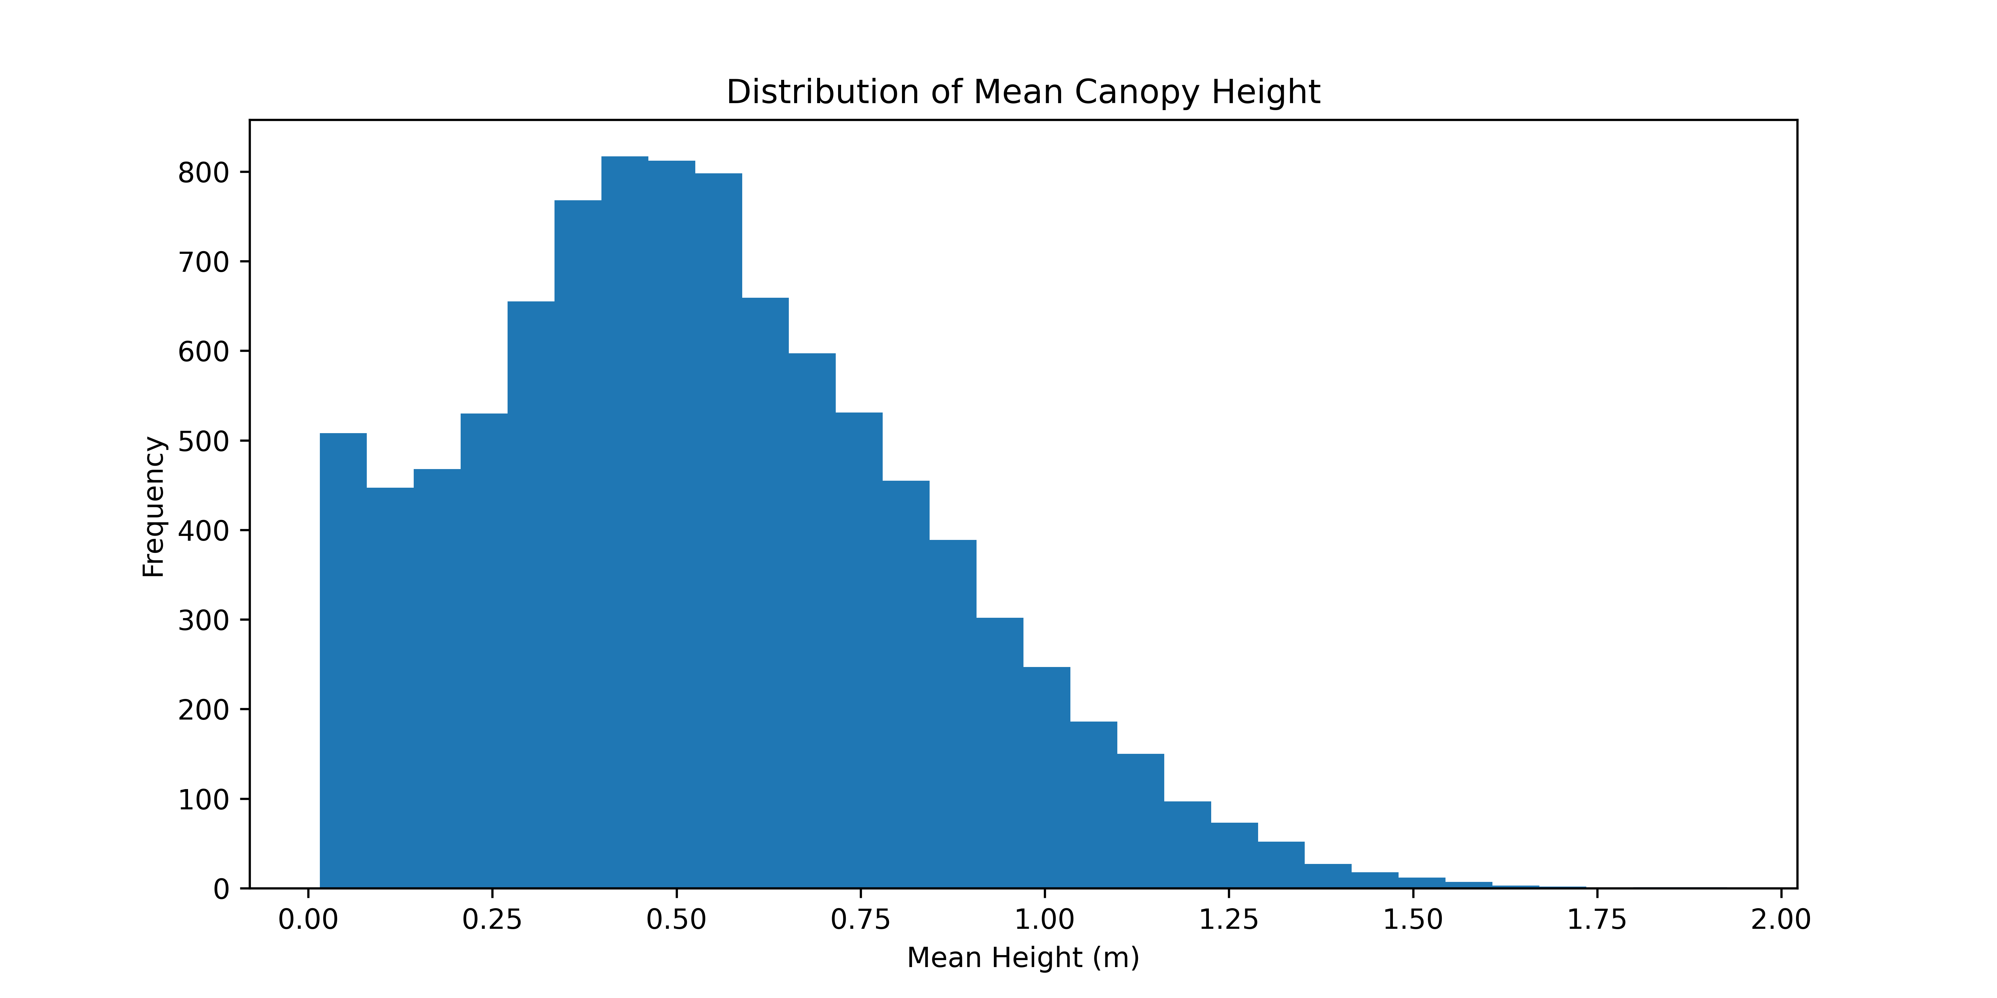

- ***P90 Height Map (vertical structure)***

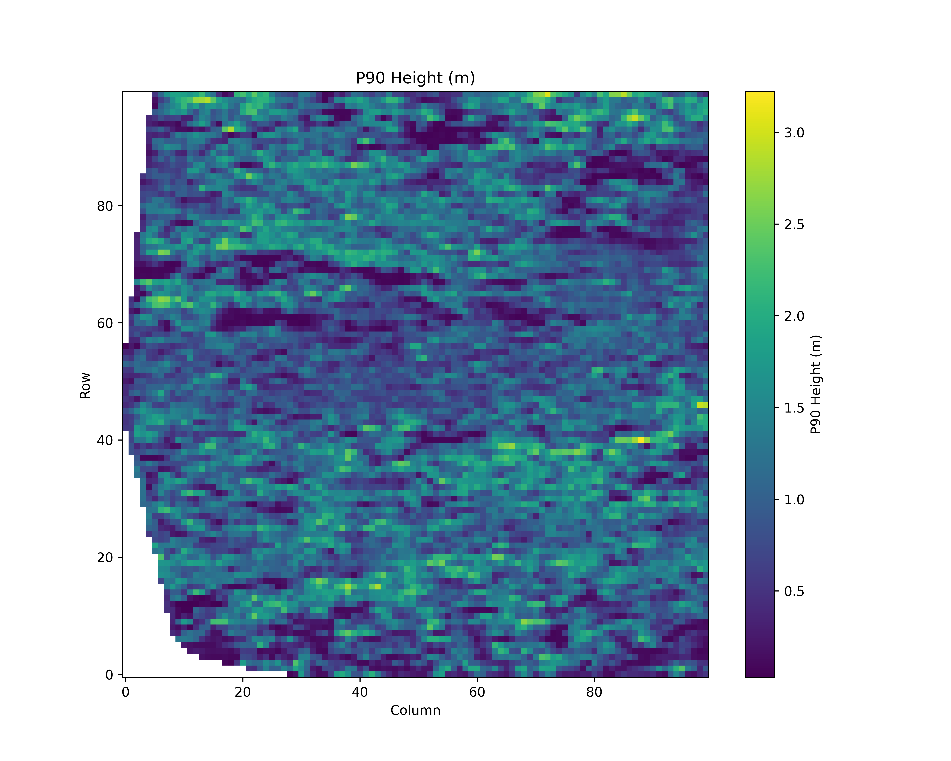

***- FHD Map (vertical structure)***

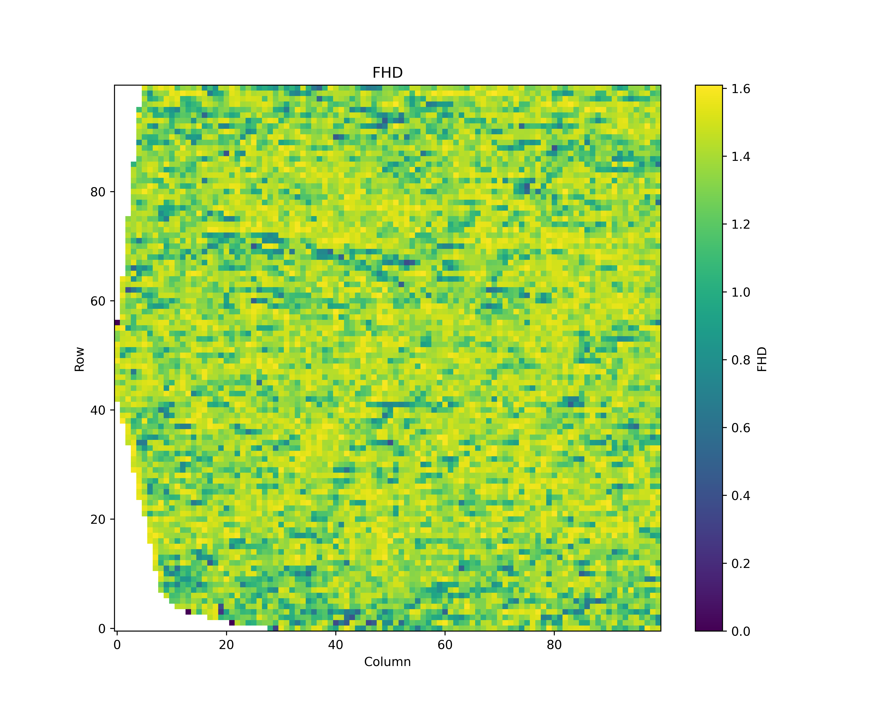

- ***Canopy Cover(horizontal structure)***

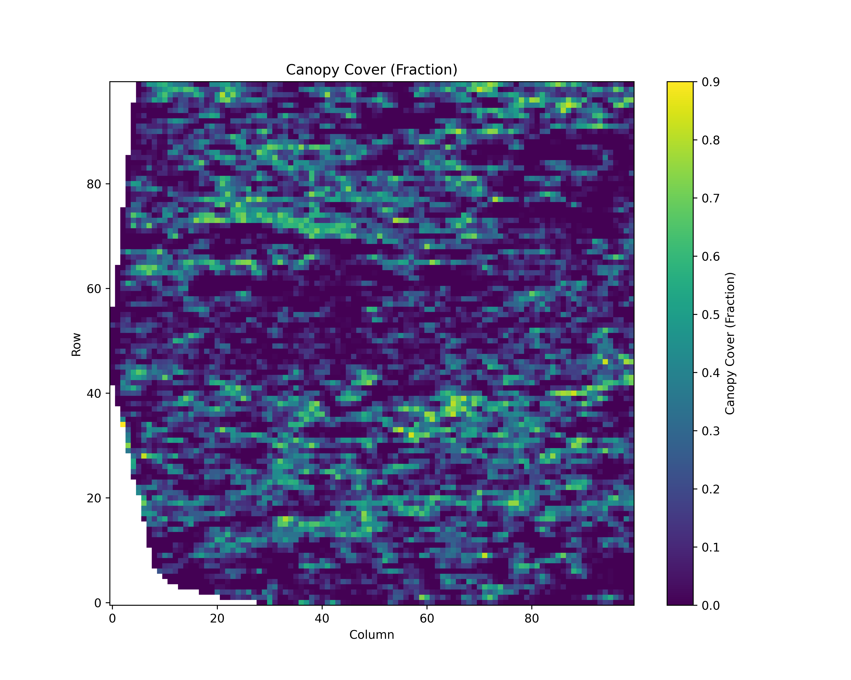

***References:***

1. Lefsky, M. A., Cohen, W. B., Parker, G. G., & Harding, D. J. (2002). Lidar remote sensing for ecosystem studies.
2. Michael Palace, Franklin Sullivan, Mark J. Ducey, Jonas Mota e Silva,(2015). Estimating forest structure in a tropical forest using field measurements, a synthetic model and discrete return lidar data.
3. Atkins, J. W (2022). Scale dependency of lidar‐derived forest structural diversity. Methods in Ecology and Evolution.